Erik Barns

11/24/15

CSC372

**Android Application Documentation**

For my final project I created an application called “Bubble Chat.” Bubble Chat in its current form is a concept app for a social networking application. Bubble Chat aims to provide communication with friends through pictures and drawings. This medium has been used before, but what Bubble Chat provides that is unique is the space in which we socialize.

Bubble Chat focuses primarily on group communication. Users would have a Bubble Room in which they could select to send their drawings and pictures to. Users will have various rooms for different groups of friends. Inside the room the user generated content is converted into bubbles which float around the room and interact with the users gyroscope orientation. The Bubble Room is supposed to be fun and colorful with content. Bubble Chat doesn’t aim to provide a serious and effective form of communication but instead provide a humorous alternative to vast amount of group messaging and social media applications.

The main reasoning behind using bubble as the carrier of content was because of how they could move in a digital environment and because of their lifespan as physical objects. Bubbles are delicate objects and eventually must pop. Our lives are already oversaturated with content there’s often no need for every camera snap to be eternally stored on servers and phones. Ideally users could select an amount of time they want their bubble to last. After the allotted time has expired the bubble will pop from the Bubble Room and be deleted.

In its current state Bubble Chat is a front end app that mimics the functionality of a single user. The user can take a picture or make a drawing which automatically inserts into the single Bubble Room that exists at this point. After 200 seconds that bubble pops, a predetermined value that is hard coded. The core functionality of the application is in place and accurately demos the overarching concept of the application. Bubble Chat has a lot of room to grow. Many features could be refined to present a more slick and comprehensive application.

**Key Features:**

* Take a picture using the camera and choose to submit the picture to the Bubble Room or delete the picture. The image will be cropped into a circle and transformed into a byte array.
* 2D drawing. Draw a simple picture in a limited selection of colors on a canvas and add it to the Bubble Room. The drawing is cropped into a circle and transformed into a byte array.
* Custom Surfaceview class which converts byte arrays into shape objects. This class transforms and adjusts the bubbles direction and speed in relation to the gyroscope sensors from the phone.
* Onclick of the bubble, a new intent loads with the bubble enlarged and stable on the screen for viewing purposes.
* Toast message upon adding a new bubble to the Bubble Room
* Using drawables as buttons with images changing on state of focus.
* Using drawables to create shapes or borders for various layout components.
* Using android spinner and adapted list to choose colors for the room background and drawing color.

**Unfinished Features:**

* Drawing with multiple colors in one drawing. Can only draw with one color at a time. Color customization is a detail that doesn’t drastically impact the initial functionality of the application therefore I did not dedicate much time or resources towards developing a polished color picker.
* User selected time for bubble lifespan. Currently bubble lifetime is predetermined. Ideally after a user creates a bubble a new intent would load that gives them a list of rooms they can add it to as well as life time options.
* Bubbles bouncing off each other. Bubbles are currently not aware of one another's presence in the room. I suspect that implementing this could be similar to loading a bubbles image onclick. I must determine by the radius of the shapes if any two bubbles are touching and then adjust their movement accordingly.

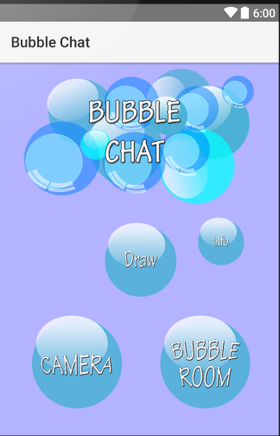

This is the opening screen to Bubble Chat. From here the user can select to draw, snap a picture, check out a small info page on Bubble Chat or visit the Bubble Room. Each button is a drawable selector that upon being pressed loads another image to resemble a popped bubble.

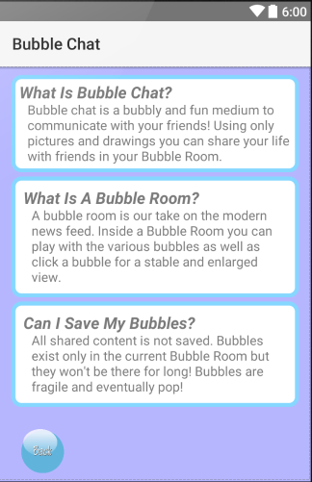

This is the information page on

Bubble Chat. This page provides a small amount of explanation to the basic functionality of the application.

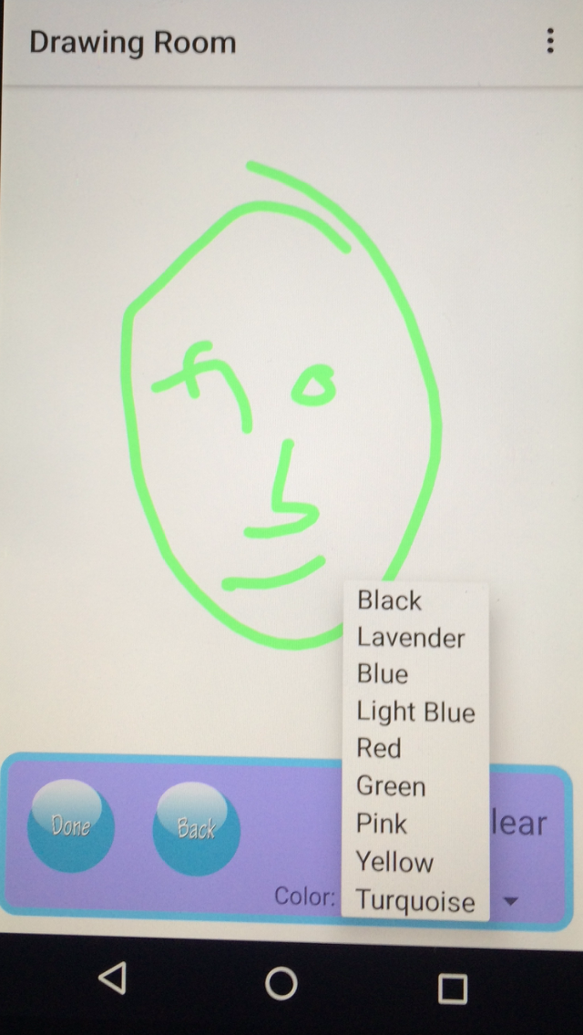

This is the Drawing Room which can be accessed from the home page. Users can draw a picture using only black at this stage in the app. If they are unsatisfied with the drawing and want to try again the canvas can be cleared. The user can select “Done” to submit the drawing or back to cancel the drawing and return to the home screen.

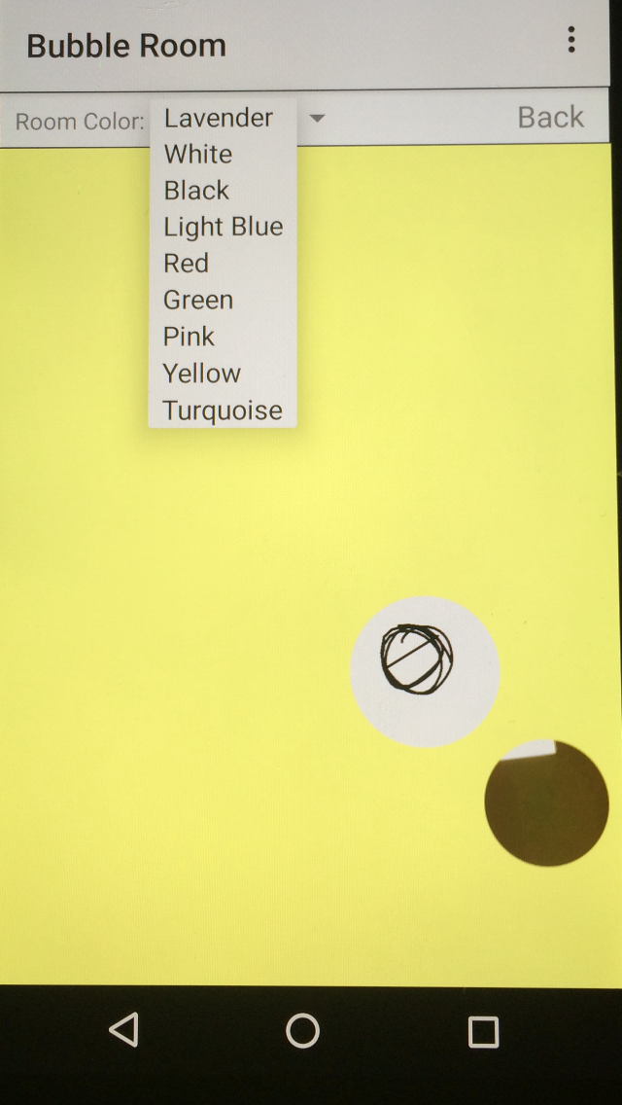

Here we can see an example of the Bubble Room that is populated with images and drawings. The bubbles initial positions are randomly generated once the page is loaded and from there on they are controlled by the gyroscope sensors of the phone. The Bubble Room color can be customized for personal preference

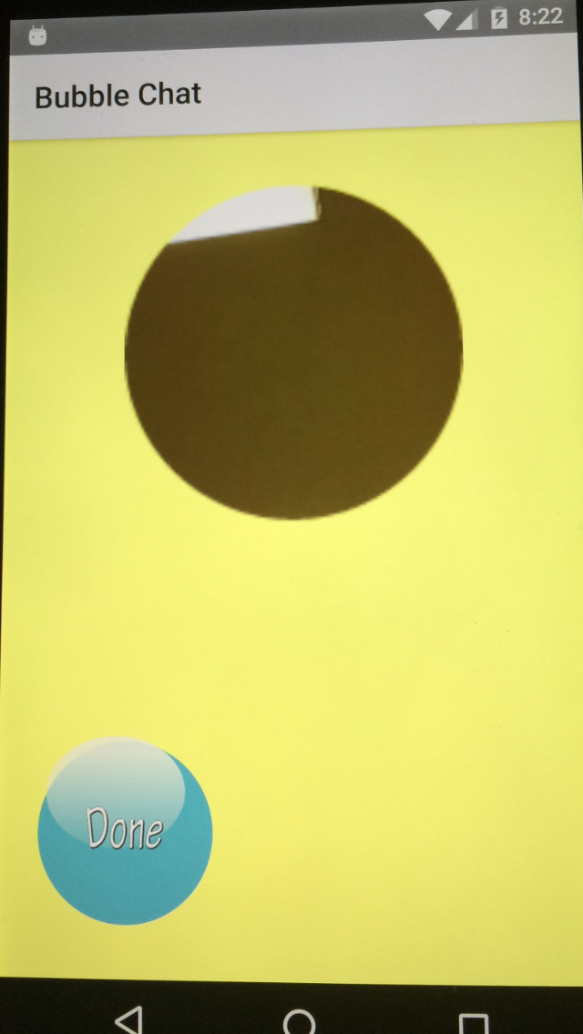

Here is a demo view of what a selected bubble looks like. The user taps the bubble they want to view and the app will create a new intent for each bubble that was in the position of the tap. When the user is done they can return to the Bubble Room.

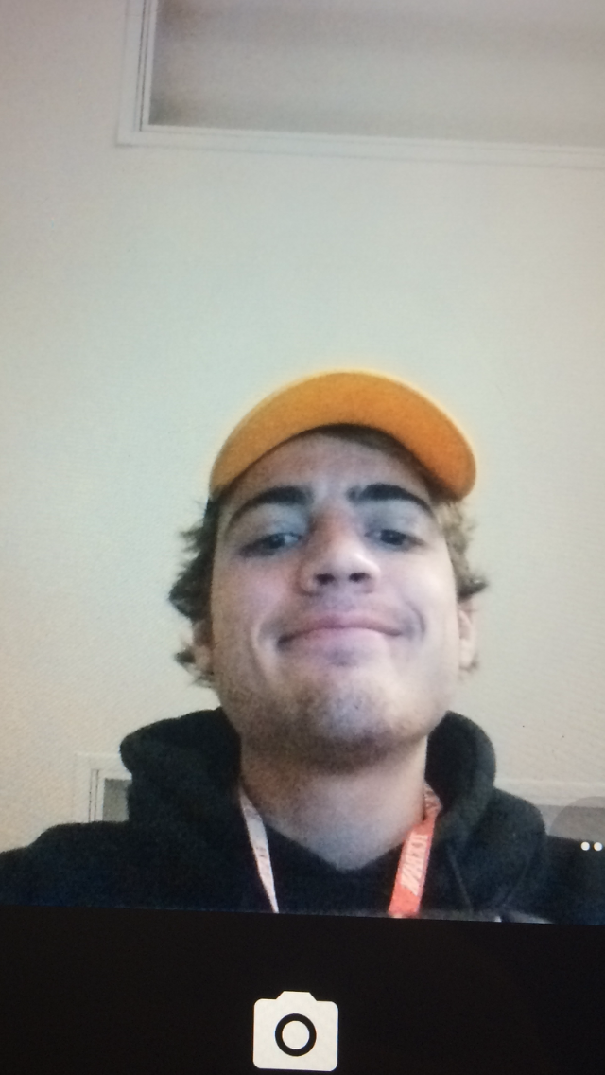

Lastly here is a view of the default camera activity that is created upon the start of the camera button from the home screen. After taking the picture the user is prompted to confirm the picture or try again. The confirmed picture is then cropped and converted into a byte array to later become a bubble.