The illusion of control: Spatial and temporal variability greatly exceed experimental treatment effects on grassland community composition

OR

The illusion of control: an assessment of the magnitude and predictors of compositional variation in grasslands around the globe

Jonathan D. Bakker, Claire E. Wainwright, Jeremiah A. Henning, Rachel M. Mitchell, Jodi N. Price, Ellen Esch, Evan E. Batzer, Timothy J. Ohlert, Juan Alberti, Carlos Arnillas, Suzanne Prober, Eric Seabloom, …

190806

Target Journal: *Ecology*

Updates:

* Re-wrote results section to reflect new figure order, question structure, and removed the cluster analysis
* Reordered the data analysis section to reflect to figure order and removed cluster.
* Reordered figures, adding in new Figure 2 and kept figure S2 in the supplemental.
* Added Figure XX for consideration. This shows magnitude of compositional variation vs. percent due to turnover. Note that sites span all four quadrats (high compositional variation with high turnover, high compositional variation with low turnover, low compositional variation with high turnover, and low compositional variation with low turnover).

# Abstract (current 331 words)

Compositional changes in response to global change drivers must be interpreted against background levels of spatial and temporal variation. For example, it may be difficult to detect the effects of experimental treatments where spatial or temporal variation are considerable. However, few studies have examined the relative importance of these sources of variation at a global scale. We analyzed abundance- and incidence-based metrics of plant community composition at 49 grassland sites in 14 countries to examine the magnitude of within-site compositional variation and its drivers. Each site had an identical experimental and sampling design: 8 nutrient addition treatments x 24 plots x 4 years (pre-treatment plus 3 years post-treatment). We examined the relationships between each of these composition metrics and multiple site-level explanatory variables (management history, gamma diversity, plant productivity, local variation in productivity, and climate variables). Finally, we quantified how the variation within each site was partitioned among spatial, temporal, and treatment-related sources. Overall, compositional change was considerable, even for unfertilized control plots over time and spatially, among plots in the pretreatment year. In other words, the underlying assumption of stable control plots as well as the homogeneity of the landscape in treatment randomization was an illusion. Additionally, we found more of the compositional change was due to changes in the dominant species relative to rare species. The site-level species pool (gamma diversity) was a key driver of compositional variation, particularly in terms of how much of the change was due to species turnover. Productivity, local variation, annual temperature range, and mean annual precipitation were also important for different aspects of compositional variation. Treatment effects were small relative to those due to temporal and spatial sources. Sites were classified into four groups with similar patterns of compositional partitioning. Our results demonstrate the importance of using multiple measures of compositional variation, relating that variation to site-level predictors, and understanding how that variation is partitioned among sources. These results have clear implications for monitoring programs and efforts to detect management-related effects on composition.

# Introduction

Biodiversity underpins many critical ecosystem properties, including productivity (Grace et al. 2016), function (Naeem and Wright 2003), and stability and resilience (Tilman et al. 2006). Continental- and global-scale studies have demonstrated that anthropogenic activities can have considerable impacts on biodiversity, which in turn impact ecosystem functions and services (Díaz et al. 2006, Hautier et al. 2015, Grab et al. 2019). Biodiversity has typically been quantified using univariate measures like richness, but these do not account for the many ways biodiversity can respond to dynamic environments. For instance, Hillebrand et al. (2018) found that complete species turnover was decoupled from species richness, emphasizing the need for community assessment beyond changes in the number of taxa. As a result, recent studies have emphasized the importance of moving beyond univariate metrics to better understand community response to environmental change (Jones et al. 2017, Yuccoz et al. 2018, Magurran et al. 2018, Avolio et al. 2015).

Community composition is particularly sensitive to environmental change because it incorporates taxon identity and thus can distinguish communities based on differences in taxon identity and/or abundance (Smith et al. 2009). The compositional variation between two sample units (hereafter termed plots) is a summary of how dissimilar they are from one another in terms of the *n* taxa present in either or both plots. The dissimilarity matrix reflecting pair-wise comparisons among a set of plots is often used to create ordinations, but quantitative analysis methods (e.g., Anderson 2001) are also increasingly used.

Decisions about how to calculate compositional variation allow the researcher to emphasize different aspects of the community and biological processes that structure biodiversity (Table 1). For example, a dissimilarity metric based on presence-absence data emphasizes colonization and extinction processes, whereas one that is based on abundance data also accounts for changing growth patterns of taxa. Further, dissimilarity metrics can be partitioned to quantify the importance of processes such as turnover and nestedness (*See Table 1 for details;* Baselga 2010, 2013). For example, balanced variation in abundance reflects substitution, such that, individuals of one species in a plot are substituted by the same number of individuals of another species in another plot.

To understand the processes that shape communities, we also have to consider whether plots are being compared spatially or temporally and therefore the potential factors that could drive differences among them. For example, contemporaneous comparisons of species turnover among plots can demonstrate the effects of spatial heterogeneity such as soil characteristics and micro-climate (Cleland et al. 2013, Pennington et al. 2017), while comparisons of the same plot at different times can demonstrate successional changes (Clements 1916, Maggi et al. 2011) or changes in weather (Walker et al. 2006), resource availability (Inouye & Tilman 1988, 1995; Owensby et al. 1999), and disturbance regimes (Milchunas and Lauenroth 1993).

Of course, both spatial and temporal variation are scale-dependent. Here, we focus on small scales: spatial variation from one plot to another, within a site, and temporal variation over the first four years of an experiment. While many studies have examined small-scale variation in composition, few have been able to robustly examine spatial and temporal variation by comparing their relative importance among multiple sites. Doing so is necessary because these sources of variation directly affect our ability to distinguish the impacts of anthropogenic disturbances. We illustrate this with a thought experiment. Consider a disturbance that is applied to a site and strongly impacts a single species (for example, the disturbance might be a specialized herbivore). Spatially, the community-level impact of the disturbance relates to the distribution of the impacted species, and therefore will be stronger if that species is widespread than if it has a limited distribution. By definition, species are more likely to be widespread at a site with low beta diversity, thus it will be easier to detect the disturbance effects at a site with low spatial variation in composition compared to sites with high spatial variation. Temporally, the community-level impact of the disturbance depends on the response of the impacted species and the ability of other species to respond to the reduced abundance of the impacted species, such as by colonizing the area. There are more opportunities for other species to respond at a site with high than low temporal variation in composition – for example, there will be more opportunities for species to be established (or lost) from an annual-dominated system compared to a perennial-dominated system. Therefore, it will be easier to detect the disturbance effects at a site with high temporal variation in species composition. Taken together, anthropogenic disturbances should be easiest to detect at sites with low spatial and high temporal variation in composition.

Together, the above considerations highlight a need to understand compositional patterns within multiple sites. We used a global collaborative experiment, the Nutrient Network (NutNet; Borer et al. 2014), to examine compositional variation in 49 grassland plant communities. Our study had a consistent methodology to ensure that differences among sites were not related to sampling intensity or to differences in how potential drivers of variation were measured. To focus our attention at small spatial scales and avoid being overwhelmed by the substantial compositional differences among sites, we assessed composition separately for each site and then compared compositional patterns among sites. We addressed three key questions: **First, what processes drive compositional variability and what is its magnitude? Second, how do site-level biotic and abiotic contexts drive these processes? Finally, do sites differ in the contribution of spatial, temporal, nutrient treatment-mediated effects, and their interactions on plant composition and turnover?**

# Methods

Data were gathered within NutNet’s multiple-nutrient addition experiment. The experimental approach is summarized in Borer et al. (2014). At each site, plots are 5 × 5 m and are separated by at least 1 m. Eight factorial combinations of nitrogen (N), phosphorus (P), and potassium (K) were added annually. We measured plant community composition in one permanent, randomly selected 1 × 1 m subplot per plot, visually estimating cover for each plant species. Additionally, we measured plant productivity as total aboveground biomass (live and dead) within two 0.1 m2 strips (0.1 × 1 m) per plot. Biomass was clipped, dried at 60 °C to a constant mass, and weighed.

We restricted our attention to sites that met three criteria: i) each nutrient combination was tested in 1 plot per block and in at least 3 blocks per site, ii) plots were measured during 4 consecutive growing seasons (pre-treatment and 3 years of treatment) and iii) every plot was measured every year. Sites that established more than 3 blocks were subsetted, usually by using the first 3 blocks. The resulting dataset had an identical structure for every site: 8 nutrient combinations × 3 blocks = 24 plots, and 24 plots × 4 years = 96 plot-year combinations. Forty-nine sites met our criteria, providing 4,704 site-plot-year combinations for this analysis. These sites span 14 countries on 6 continents (Table S1; Figure S1).

Analyses of compositional change are sensitive to taxonomic differences. We reviewed the nomenclature within each site to ensure consistent naming over time (NutNet’s nomenclature system also aims for consistency across sites, but this was not necessary for our analysis). Taxonomic adjustments were made in about two-thirds of sites, usually by aggregating taxa at the genus level when individuals were not identified to species in all years (Table S2). For brevity, however, we refer to taxa as “species” throughout the manuscript. The resulting dataset consists of ~ 56,500 records from ~ 1,530 species.

We calculated several site-level variables that we hypothesized might relate to the magnitude and partitioning of within-site compositional variation: management history, gamma diversity, plant productivity, local variation in productivity, and climate. Management history was coded as a binary variable based on whether site leads reported that the site was managed, burned, grazed, or subject to anthropogenic disturbances. Gamma diversity was quantified as the total number of taxa recorded in the 96 plot-year combinations at the site, after the above taxonomic adjustments. Plant productivity was calculated as the average total aboveground plant biomass (g m-2) in unfertilized plots (both pre-treatment data from all plots, and control plots over time). Local variation in productivity was calculated as the coefficient of variation in total biomass in unfertilized plots. Climate was summarized via mean annual temperature (°C), standard deviation in temperature (°C), annual temperature range (°C), mean temperature of the wettest quarter (°C), mean annual precipitation (mm), seasonality (coefficient of variation of precipitation), and N deposition (kg N ha-1 yr-1). We tested each variable against the four community composition metrics identified below (see Table S3), and retained those variables that were significantly related to one or more metrics (*P* < 0.05) for inclusion in further analyses. Five variables met this criterion: gamma diversity, productivity, local variation in productivity, annual temperature range, and mean annual precipitation.

## Statistical analysis

All analyses were done in R (version 3.5.1). Key required packages are listed where appropriate below.

We analyzed composition separately for each site. Composition was expressed as a site-plot-year × species matrix, with the abundance (percent cover) of each species as the element in the matrix. This matrix was used to calculate an abundance-based dissimilarity matrix within each site (96 × 96; 8 treatments (control, N, P, K, NP, NK, PK, NPK) × 3 blocks × 4 years) using the Bray-Curtis dissimilarity index (Table 1). The composition matrix was also relativized to presence/absence data and used to calculate an incidence-based dissimilarity matrix using the Sorensen dissimilarity index. Each dissimilarity matrix is a numerical summary of the compositional differences among the plot-years within the site.

*Question 1: what processes drive compositional variability and what are their magnitude?*

We expressed the overall magnitude of compositional variation at each site as the mean dissimilarity for the site (i.e., across all plot-year combinations). This value was compared to simple measures of spatial and temporal variation in composition, where spatial variation was calculated as the mean dissimilarity among plots in the pre-treatment year, and temporal variation as the mean dissimilarity of the control plots among years (calculated separately for each control plot and then averaged together). We used a linear mixed model to test for differences between these three measures of variation (overall, spatial, temporal), with site included as a random effect. This process was repeated for the abundance- (Bray-Curtis) and incidence-based (Sorenson) metrics as well as the decomposed abundance- and incidence- based metrics to understand how turnover is influencing overall, spatial, and temporal variation (Table 1). Each type of dissimilarity was decomposed into two aspects using the bray.part and beta.pair functions (betapart package, v.1.5.1; Baselga et al. 2018). Since these aspects are additive, we did not analyze them both but rather expressed the importance of one aspect as a percentage of the total dissimilarity. Specifically, we focused on the percentage of abundance-based variation attributable to balanced variation in abundance, and the percentage of incidence-based variation attributable to species turnover (Table 1). The result of each of these calculations was a dissimilarity matrix in which the elements are the percentage of compositional change associated with one aspect of compositional variation.

*Question 2:**how do site-level biotic and abiotic contexts drive these processes?*

We tested how the overall magnitude of compositional variation (Bray-Curtis dissimilarity, Sorenson dissimilarity, balanced-variation, and species turnover) was related to the potential site-level explanatory variables (gamma diversity, productivity, local variation, annual temperature range, and mean annual precipitation). We used model selection (stepAIC function; MASS package, v.7.3-51; Venables and Ripley 2002) to identify models that balanced parsimony with explanatory power, and specified BIC as the model selection criterion with *k* equal to the log of the number of sites.

*Question 3: do sites differ in the contribution of spatial, temporal, nutrient treatment-mediated effects, and their interactions on plant composition and turnover?*

Subsetting a dissimilarity matrix allows us to summarize compositional differences associated with different factors. For example, this was done in Questions 1 and 2 for spatial variation (using pre-treatment data) and temporal variation (using control plots over time). Here, we partitioned the entire dissimilarity matrix to quantify the relative importance of different sources for explaining compositional differences at a site (Appendix S1). Our consistent design enabled us to distinguish seven sources of variation within sites: block (spatial; three levels), year (temporal; four levels), nutrient addition (eight levels), and the two- and three-way interactions among these factors (Table 2). We used PERMANOVA (Anderson 2001) as coded in the adonis function (vegan package, v.2.5-3; Oksanen et al. 2018) to express how much of the compositional variation at a site was due to each source. We expressed the variation associated with each source as a proportion of the total variation and compiled these proportions into a site × source matrix (49 × 7). This process was repeated for each type of dissimilarity (abundance-based, incidence-based) and their constituent aspects (percent change due to balanced variation, percent change due to species turnover). For our purposes here, we did not test the statistical significance of these sources.

To investigate patterns of compositional partitioning across sites, we applied Principal Components Analysis (PCA; princomp function) to express the differences among sites in how composition is partitioned in as few dimensions as possible. This procedure was conducted on all four diversity metrics (abundance-based, incidence-based, balanced variation, species turnover). We compared metrics in terms of the average amount of variation explained by each source.

# Results

## Question 1: What processes drive compositional variability and what are their magnitude?

Sites exhibited considerable variation in abundance-based variation: overall mean Bray-Curtis dissimilarity ranged from 0.23 to 0.78. On average, the abundance-based dissimilarity between any two plot-years at a site was 0.55 (Figure 1A). Overall dissimilarity was significantly higher than spatial dissimilarity (pre-treatment data from all 24 plots; mean = 0.48) and even higher than temporal dissimilarity (control plots over time; mean = 0.38).

Incidence-based dissimilarities were lower than abundance-based dissimilarities: overall mean Sorensen dissimilarity ranged from 0.22 to 0.56 among sites, with an average of 0.38. Overall dissimilarity was significantly higher than spatial dissimilarity (mean = 0.33), which was also significantly higher than temporal dissimilarity (mean = 0.25; Figure 1B).

Abundance-based compositional change was mostly due to turnover of individuals (balanced variation), which accounted for between 52% and 96% of the variation at different sites. On average, balanced variation explained 83% of the variation (Figure 1C). Balanced variation accounted for the same amount of compositional variation when considering only spatial dissimilarity (83%) but significantly less of the variation when considering only temporal dissimilarity (71%).

Incidence-based compositional change was dominated by species turnover. Species turnover accounted for between 27% and 88% of the variation at different sites, with an average of 69% (Figure 1D). As with balanced variation in abundance, species turnover accounted for similar amounts of variation when considering only spatial dissimilarity (70%) but significantly less of the variation when considering temporal dissimilarity (57%).

Question 2: How do site-level biotic and abiotic contexts drive these processes?

Model selection relating compositional variation to explanatory variables suggested that the relationships were strongly contingent on the community metrics used (Table 3, Figure 2). Mean abundance-based variation (Bray-Curtis) was negatively related to productivity (adjusted R2 = 0.113; Table 3; Figure 2). Total incidence-based compositional variation was positively related to gamma diversity, annual temperature range, and local variation in productivity (adjusted R2 = 0.504; Table 3; Figure 2; Figure S3). Productivity reduced abundance-based variation, but species occurrence was positively related to species pool and heterogeneity of temperature and productivity.

Balanced variation (abundance-based) was positively related to gamma diversity and to mean annual precipitation (adjusted R2 = 0.370; Figure 2; Table 3). The percent of incidence-based variation due to species turnover was positively related to gamma diversity and annual temperature range, and negatively related to productivity (adjusted R2 = 0.705; Table 3; Figure 2; Figure S4). Thus, turnover in both incidence-based and abundance-based metrics is higher in sites with larger species pools and greater in higher rainfall sites (abundance-based) and annual temperature range (incidence-based). However, species turnover is lower in sites with higher plant productivity.

## Question 3: Do sites differ in the contribution of spatial, temporal, and nutrient treatment-mediated effects on plant composition and turnover?

The more spatial or temporal variation present within a site, the more difficult it is to detect turnover due to fertilization treatments (Figure 3). At some sites, composition is shifting through space, while some sites composition is responding through time (Figure 3A,4B). The percent of total variation attributed to different sources were similar in both Bray-Curtis and Sorensen dissimilarity metrics. The largest source of variation was due to treatment effects within blocks (*i.e.*, the block × nutrient interaction), followed by variation among years and site-level nutrient effects (Figure 4). Together, these sources accounted for ~60% of the compositional variation within sites. The smallest sources of variation were the block × year interaction and the year × nutrient interaction.

The two aspects of compositional variation (balanced variation, species turnover) on average had more unexplained variation (Block × year × nutrient) than the Bray-Curtis and Sorensen dissimilarity metrics (Figure 4). Sites varied in the amount of abundance-based and incidence-based turnover driven by year-to-year change, however the contribution of spatial effects, nutrient effects, and their interactions with time did not vary much across sites (Figure 3C, 3D). Our ability to distinguish sites based on their sources of variation was also more limited (Figure 3C, 3D, 4).

# Discussion

Global change alters biotic and abiotic factors, which has led to shifts in plant species composition worldwide (e.g., Smith et al 2009). However, before we can distinguish the effects of anthropogenic change, we need to better understand background levels of spatial and temporal variability within communities. Our results demonstrate that background spatial and temporal compositional variation is more substantial than generally realized: composition changed substantially in unfertilized control plots over time, and was even more variable spatially within the pre-treatment year. Our results also demonstrate the value of assessing multiple metrics of compositional variation, particularly its magnitude and aspects. Furthermore, our results suggest that it may be possible to estimate the amount of compositional variation at other grassland sites based on characteristics of the plant community and the climate. We expand on these topics below and end by articulating some implications of this study for ecological monitoring and management.

## Spatial and Temporal Variation in Composition Within Communities

Plant community composition varied strongly within sites, both spatially among plots and temporally across sampling years. Greater community variability in space can promote greater temporal variability in species abundances (Collins et al. 2018, Wilcox et al. 2017, Hodapp et al. 2018). However, spatial and temporal variation are not equivalent, and our results demonstrate considerable differences among sites in the relative importance of these sources of variation. These sources of variation reflect the influences of different abiotic and biotic factors. For example, spatial variation may reflect abiotic factors such as heterogeneity in environmental conditions or edaphic properties (Tilman 1994) and biotic factors such as dispersal patterns, plant size, or differences in herbivore densities. Of course, spatial variation is also scale dependent – some sites had very large variation among blocks while others had considerable variation within blocks. Temporal variation may reflect successional trajectories, abiotic factors such as variability in weather patterns, biotic factors such as the longevity of individual species and interactions with co-occurring plants and symbionts, and ecological drift (could cite lots of papers here; Vellend 2016). Spatial and temporal variation may also be affected by disturbances (e.g., Hobbs and Mooney 1995) but, other than our experimentally imposed nutrient addition treatments, we are not aware of plot-level disturbances within sites.

At most sites, temporal and spatial variation in composition greatly exceeded the variation associated with three years of experimental nutrient addition treatments. Similarly, Harpole et al. (2016) found as much compositional variation among plots that received a single nutrient addition as between control and nutrient addition plots (their Figure 4B). Similar findings have been reported for microbial communities where treatment effects (drought and nitrogen) explained between 2-6% of total compositional variation with comparatively greater amounts of variation explained by seasonal and annual variation (14-39%, Matulich et al. 2015). Our study focused on the first three years of our experimental treatments, so treatment effects were likely just starting to become pronounced. We expect that treatment effects would account for more of the variation if tracked over longer time frames (Cardinale et al. 2007, Reich et al. 2012).

Other analyses have expressed compositional change differently. For example, Hautier et al. (2018) and Hodapp et al. (2018) calculated spatial variation separately for each block. We found that few sites had large compositional change among blocks (Table 5; Figure 3B), suggesting that site-level averages are appropriate for most sites.

## Metrics of Compositional Variation

Compositional data are complex, multivariate data structures. It is necessary to go beyond univariate measures like species richness, but it would also be unrealistic to assume that a single metric would suffice to explain compositional data. Our results demonstrate some of the insights that can be generated by examining compositional variation using multiple metrics. The metrics examined here give different insights into the structure of these communities, particularly with respect to the differences among sites.

Bray-Curtis dissimilarities were larger than Sorensen dissimilarities, indicating that changes were more pronounced in the dominant than the rare species within sites. Similarly, the percent of compositional variation that was due to colonization or extinction by new species was lower than the percent due to changes in the abundance of extant species. These patterns suggest that spatial and temporal variation in background plant community composition similarly impact rare and dominant taxa, even though underlying biotic and abiotic drivers may differ between the rare and dominant taxa.

The relative importance of sources were consistent for the two types of dissimilarities and the two aspects of compositional variation, but differed remarkably between these two groups of metrics (Table 4). Time accounted for much more of the variation in how much compositional variation was present at a site than for how much of that variation was due to species turnover, but the year x nutrient interaction exhibited the opposite pattern.

Species turnover and balanced variation were both more important spatially than temporally: values were lower for control plots over time than for pre-treatment plots, and there were no differences between pre-treatment values and the overall mean values for a site. However, our results indicate that grassland community dynamics are dominated by species turnover: even in control plots, well over half of the compositional variation was due to species turnover (Figure 2C). This finding is consistent with a recent meta-analysis (Soininen et al. 2018). Future research could identify additional ways to understand compositional variation, such as by differentiating species colonizations and extinctions in temporal time series.

## Predicting Compositional Metrics

Our sites are located around the globe and differ in many biotic and abiotic contexts. For example, productivity ranged from 33 to 1692 g m-2 and annual temperature range from 15 to 45 °C. Nonetheless, our results suggest that site-level compositional patterns are not stochastic and therefore that compositional metrics are at least somewhat predictable, though further work on this topic is clearly warranted. Abundance-based and incidence-based metrics differed in terms of how well they can be predicted, and which biotic and abiotic variables predicted them. The models for abundance-based metrics had substantially poorer fits than those for incidence-based metrics (Table 3), presumably because it is more difficult to predict whether species change in abundance than to predict whether they are present or not.

Gamma diversity, the total number of species encountered within the 96 plot-year combinations at a site, was a significant positive predictor for most metrics, particularly those that are incidence-based. By using a consistent design to calculate gamma diversity at all sites, we avoided methodological differences that would have skewed this metric, such as sampling more plots or more years in some sites than others. We interpret gamma diversity as an index of the broader species pool in the area and not as an upper limit on the number of taxa at a site. For example, we expect that gamma diversity will continue to increase with study duration (White et al. 2006). Greater numbers of available species enable the community to respond to variable climatic conditions and spatial heterogeneity. This suggests high gamma diversity may buffer some of the effects of global change at least by mediating species loss (Harpole et al. 2016). Several other studies that have explored compositional variation within NutNet sites have focused on mean plot-level diversity (alpha diversity; e.g., Hautier et al. 2018; Hodapp et al. 2018), but our results suggest that it may be useful to also consider the background level of species diversity in which plots reside.

Site-level productivity had complex relationships with compositional variation. On the one hand, it had stronger effects on the establishment and persistence of individual species than on their abundance (species turnover vs. balanced variation; Table S3). On the other hand, it was not associated with the overall magnitude of incidence-based variation but was negatively related to abundance-based variation. The negative relationship with abundance-based composition could be because productive sites are dominated by a few highly competitive species that experience less variation in abundance (Wedin and Tilman 1990).

Productivity was calculated as a site-level mean, but sites also differed in local variation in productivity. Variation in productivity in unfertilized plots related to compositional variation within the site, though the patterns are somewhat complex: local variation was predictive of abundance-based metrics when tested individually (though these effects were not retained after model selection) and of incidence-based dissimilarity only when added to a model that already included gamma diversity and annual temperature range. Patterns also trended in opposite directions: sites with more local variation experienced more compositional variation but less of this variation was due to balanced variation in abundance. Local variation in productivity is a surrogate for differences in soil chemistry, resource availability, disturbance history, initial species composition and many other edaphic characteristics of the plots. Future work should seek to distinguish these factors and explore other measures of intra-site variability. For example, Hodapp et al. (2018) expressed edaphic variability using plot-level soil chemistry and light measurements, but these variables were not evaluated in our study as they are not available for all sites.

Climate can be represented in many ways, including annual mean values (Hodapp et al. 2018) or conditions during seasons of plant growth (Grace et al. 2016). We chose to represent climate by four temperature-related variables and two precipitation-related variables that were relatively uncorrelated with one another (true? cite?). These variables had different effects and varied greatly in predictive ability, suggesting the importance of considering multiple ways of expressing climate. Mean annual temperature was not predictive, but sites with low seasonal variation (annual temperature range) experienced lower incidence-based variation, suggesting that there is less variation in temperate regions (agree?). Grasslands in these regions may, for example, be more strongly dominated by perennial species. Conversely, mean annual precipitation was predictive for abundance-based metrics: wetter sites experienced less abundance-based (Bray-Curtis) dissimilarity, and more of the compositional change was due to balanced variation in abundance whereas drier sites experienced a higher amount of broad taxa abundance gains and losses (abundance gradients).

Nitrogen deposition is positively correlated with aboveground net primary productivity (Stevens et al. 2015) yet we found that it had no effect on any measure of compositional variation, suggesting that while nitrogen affects plant growth, it may not affect the recruitment or loss of species from the community. However, global estimates of nitrogen deposition are not easily down-scaled to accurately reflect site conditions.

## Monitoring and Management Implications

The results of this study have implications for monitoring programs and for our ability to detect effects of management actions.

*Monitoring*: There is a growing global collective of ecosystem observatories (NEON, TERN, SAEON, etc.), and these observatories require efficient programs to detect ecological changes, including for biodiversity, across wide ecological gradients. Monitoring programs often are pressured to collect data more efficiently, often by simplifying the type of data that is collected. We urge that ecological monitoring programs collect species-specific abundance data as this maintains the option to understand multiple facets of composition. For example, abundance data can be converted to presence-absence data during analysis, but not *vice versa*. During analysis, we encourage researchers to intentionally include multiple metrics to assess different aspects of compositional variation.

The considerable variation in composition among grasslands—both overall and in terms of how it was partitioned among sources—was striking given our methodological efforts to reduce it: subsetting the data so that all sites had an identical analytical structure, and reviewing taxonomic assignments within every site for ‘spurious’ compositional changes over time. Our results suggest that studies in which spatial or temporal aspects of the design differ among sites should verify whether these differences affect the conclusions. A consistent sampling design is always an asset.

The lower dissimilarity values in control plots over time highlights the value of repeat measurements of permanent plots. However, our results also clearly demonstrate that even control plots change considerably and rapidly. This highlights the value of BACI designs for monitoring programs (ref), so that planned comparisons can be made with both control and pretreatment conditions. As these grasslands continue to be monitored, future investigations could assess whether the results of this study can predict future dynamics. For example, will sites with similar patterns of compositional partitioning in this study continue to have similar patterns over time? Are sites with different patterns more likely to diverge in composition over time?

*Management*: Although the goal of this analysis was not to test the effects of management activities (nutrient addition) on composition, nutrient-related factors were small relative to spatial and temporal variation within sites. Furthermore, the relative importance of large- and small-scale spatial and of temporal sources of variation directly impacts the ability to detect management-related effects.

Accounting for spatial variation requires a baseline knowledge of the system and community composition. This information is easier to obtain than information about temporal variation, and thus spatial variation can be anticipated to some extent during the design, implementation, and analysis of a project. Large-scale sources of spatial variation can be incorporated into experimental designs through blocking, as was done here. However, these blocks accounted for a sizable proportion of the compositional variation at only a few sites and thus are not as helpful at most sites in this study.

Small-scale sources of variation (e.g., within blocks) are more difficult to account for during analysis. In a conventional ANOVA, the unexplained variation within blocks forms the denominator for the treatment test statistic. All else being equal, a site with more small-scale variation will therefore have a smaller test statistic and it will be more difficult to detect treatment effects than in a site with low small-scale variation. Replication within blocks may help estimate treatment effects more accurately. Sampling across different spatial scales may also help account for small-scale spatial variation, but requires higher sampling effort and intensity. Re-measuring permanent plots reduces the effect of spatial variation compared to establishing new temporary plots at each measurement date, but our results clearly indicate that this is not a complete solution: large compositional changes occurred even in control plots over time.

Temporal variation can be considerable but is difficult to anticipate – for example, we generally do not know the seasonal conditions that will occur during an experiment. Treatment effects will manifest as changes in taxa turnover and abundance shifts above and beyond the year-to-year variability in plant community composition. A site with high temporal variation due to species turnover may be more responsive to treatments if, for example, there are more opportunities for treatments to create the conditions for new species to establish. This reinforces the value of long-term studies to understand compositional change and its effects on ecosystem functions and services. For example, treatment effects may strengthen over time. We focused on the first four years of our experiment, but a logical extension will be to analyze sites over longer time frames and test if the effect of nutrient addition increases over time.

## Conclusions

By using a consistent approach to quantify and partition compositional variation in grassland sites around the world, we demonstrated the dynamic nature of these communities, both spatially and temporally. We found that background spatial and temporal variability in plant community composition exceed the short-term effects of nutrient addition. However, we also found strong differences among sites – for example, some are dominated by large- or small-scale spatial variation whereas others are dominated by temporal variation. Compositional variation can be expressed using multiple metrics that provide insight into different facets of the community, and that reflect different ecological processes. Our results suggest a reasonable ability to predict site-level compositional metrics based on gamma diversity, productivity, local variation in productivity, and climate variables. Monitoring programs and efforts to distinguish management-related effects from background levels of variation require that researchers account for spatial and temporal variation when designing, establishing, monitoring, and analyzing communities over time.

# Acknowledgements

We thank…

# References

Avolio, M. L., S. E. Koerner, K. J. La Pierre, K. R. Wilcox, G. W. T. Wilson, M. D. Smith, and S. L. Collins. 2014. Changes in plant community composition, not diversity, during a decade of nitrogen and phosphorus additions drive above-ground productivity in a tallgrass prairie. Journal of Ecology 102:1649-1660.

Avolio, M. L., K. J. La Pierre, G. R. Houseman, S. E. Koerner, E. Grman, F. Isbell, D. S. Johnson, and K. R. Wilcox. 2015. A framework for quantifying the magnitude and variability of community responses to global change drivers. Ecosphere 6:280. <http://dx.doi.org/10.1890/ES15-00317.1>

Baldeck, C. A., M. S. Colgan, J. B. Féret, S. R. Levick, R. E. Martin, and G. P. Asner. 2014. Landscape-scale variation in plant community composition of an African savanna from airborne species mapping. Ecological Applications 24:84-93.

Baselga, A., 2010. Partitioning the turnover and nestedness components of beta diversity. Global Ecology and Biogeography 19:134-143.

Baselga, A., 2013. Separating the two components of abundance-based dissimilarity: balanced changes in abundance vs. abundance gradients. Methods in Ecology and Evolution 4:552-557.

Bertrand, R., J. Lenoir, C. Piedallu, G. R. Dillon, P. De Ruffray, C. Vidal, J. C. Pierrat, and J. C. Gégout. 2011. Changes in plant community composition lag behind climate warming in lowland forests. Nature 479:517-520.

Cardinale, B. J., J. P. Wright, M. W. Cadotte, I. T. Carroll, A. Hector, D. S. Srivastava, M. Loreau, and J. J. Weis. 2007. Impacts of plant diversity on biomass production increase through time because of species complementarity. Proceedings of the National Academy of Sciences of the United States of America 104:18123-18128.

Clay, K., J. Holah, and J. A. Rudgers. 2005. Herbivores cause a rapid increase in hereditary symbiosis and alter plant community composition. Proceedings of the National Academy of Sciences of the United States of America 102:12465-12470.

Cleland, E. E., S. L. Collins, T. L. Dickson, E. C. Farrer, K. L. Gross, L. A. Gherardi, L. M. Hallett, R. J. Hobbs, J. S. Hsu, L. Turnbull, and K. N. Suding. 2013. Sensitivity of grassland plant community composition to spatial vs. temporal variation in precipitation. Ecology 94:1687-1696.

Clements, F. 1916. Plant Succession: An Analysis of the Development of Vegetation. Publication 242. Carnegie Institution, Washington, USA

Cottenie, K. 2005. Integrating environmental and spatial processes in ecological community dynamics. Ecology Letters 8:1175-1182.

Dearborn, K. D., and R. K. Danby. 2017. Aspect and slope influence plant community composition more than elevation across forest–tundra ecotones in subarctic Canada. Journal of Vegetation Science 28:595-604.

Díaz, S., J. Fargione, F. S. Chapin, and D. Tilman. 2006. Biodiversity loss threatens human well-being. PLoS Biology 4:e277.

Grab, H., M. G. Branstetter, N. Amon, K. R. Urban-Mead, M. G. Park, J. Gibbs, E. J. Blitzer, K. Poveda, G. Loeb, and B. N. Danforth. 2019. Agriculturally dominated landscapes reduce bee phylogenetic diversity and pollination services. Nature 363:282-284.

Grace, J. B., T. M. Anderson, E. W. Seabloom, E. T. Borer, P. B. Adler, W. S. Harpole, Y. Hautier, H. Hillebrand, E. M. Lind, M. Pärtel, J. D. Bakker, Y. M. Buckley, M. J. Crawley, E. I. Damschen, K. F. Davies, P. A. Fay, J. Firn, D. S. Gruner, S. M. Prober, and M. D. Smith. 2016. Productivity and plant species richness. Nature xxx:1-10.

Grace, J. B., T. M. Anderson, E. W. Seabloom, E. T. Borer, P. B. Adler, W. S. Harpole, Y. Hautier, H. Hillebrand, E. M. Lind, M. Partel, J. D. Bakker, Y. M. Buckley, M. J. Crawley, E. I. Damschen, K. F. Davies, P. A. Fay, J. Firn, D. S. Gruner, A. Hector, J. M. H. Knops, A. S. MacDougall, B. A. Melbourne, J. W. Morgan, J. L. Orrock, S. M. Prober, and M. D. Smith. 2016. Integrative modelling reveals mechanisms linking productivity and plant species richness. Nature 529:390-393.

Hautier, Y., D. Tilman, F. Isbell, E. W. Seabloom, E. T. Borer, and P. B. Reich. 2015. Anthropogenic environmental changes affect ecosystem stability via biodiversity. Science 348:336-340.

Hillebrand, H., B. Blasius, E. T. Borer, J. M. Chase, J. A. Downing, B. K. Eriksson, C. T. Filstrup, W. S. Harpole, D. Hodapp, S. Larsen, A. M. Lewandowska, E. W. Seabloom, D. B. Van de Waal, and A. B. Ryabov. 2018. Biodiversity change is uncoupled from species richness trends: Consequences for conservation and monitoring. Journal of Applied Ecology 55:169-184.

Hobbs, R. J., and H. A. Mooney. 1995. Spatial and temporal variability in California annual grassland: results from a long-term study. Journal of Vegetation Science 6:43-56.

Hooper, D. U., and P. M. Vitousek. 1998. The effects of plant composition and diversity on ecosystem processes. Science 277:1302-1305.

Inouye, R. S., and D. Tilman, 1988. Convergence and divergence of old‐field plant communities along experimental nitrogen gradients. Ecology 69:995-1004.

Inouye, R. S., and D. Tilman. 1995. Convergence and divergence of old‐field vegetation after 11 yr of nitrogen addition. Ecology 76:1872-1887.

Jones et al. 2017. Species re-ordering, not changes in richness, drives long-term dynamics in grassland communities. Ecology Letters 20:1556-1565.

Maggi, E., Bertocci, I., Vaselli, S. and Benedetti-Cecchi, L. (2011) Connell and Slatyer's models of succession in the biodiversity era. *Ecology*, *92*(7), pp.1399-1406

Magurran et al. 2018. Divergent biodiversity change within ecosystems. Proc Natl Acad Sci USA 115:1843-1847.

Matulich et al. 2015. Temporal variation overshadows the response of leaf litter microbial communities to simulated global change. The ISME Journal 9:2477-2489.

Milchunas, D. G., and W. K. Lauenroth. 1993. Quantitative effects of grazing on vegetation and soils over a global range of environments. Ecological Monographs 63:327-366.

Naeem, S., and J. P. Wright. 2003. Disentangling biodiversity effects on ecosystem functioning: deriving solutions to a seemingly insurmountable problem. Ecology Letters 6:567-579.

Oksanen, J., G. Blanchet, M. Friendly, R. Kindt, P. Legendre, D. McGlinn, P. R. Minchin, R. B. O'Hara, G. L. Simpson, P. Solymos, M. H. H. Stevens, S. E., and W. H. 2018. vegan: community ecology package. v. 2.5-3.

Owensby, C. E., J. M. Ham, A. K. Knapp, and L. M. Auen. 1999. Biomass production and species composition change in a tallgrass prairie ecosystem after long-term exposure to elevated atmospheric CO2. Global Change Biology 5:497-506.

Pennington, V. E., K. A. Palmquist, J. B. Bradford, and W. K. Lauenroth. 2017. Climate and soil texture influence patterns of forb species richness and composition in big sagebrush plant communities across their spatial extent in the western U.S. Plant Ecology 218:957-970.

Reich, P. B., D. Tilman, F. Isbell, K. Mueller, S. E. Hobbie, D. F. B. Flynn, and N. Eisenhauer. 2012. Impacts of biodiversity loss escalate through time as redundancy fades. Science 336:589-592.

Sax, D. F., and S. D. Gaines. 2003. Species diversity: from global decreases to local increases. Trends in Ecology & Evolution 18:561-566.

Smith et al. 2009. A framework for assessing ecosystem dynamics in response to chronic resource alterations induced by global change. Ecology 90:3279-3289.

Soininen, J., J. Heino, and J. Wang. 2018. A meta‐analysis of nestedness and turnover components of beta diversity across organisms and ecosystems. Global Ecology and Biogeography 27:96-109.

Tilman, D. 1994. Competition and biodiversity in spatially structured habitats. Ecology 75:2-16.

Tilman, D., F. Isbell, and J. M. Cowles. 2014. Biodiversity and ecosystem functioning. Annual Review of Ecology, Evolution, and Systematics 45:471-493.

Tilman, D., P. B. Reich, and J. M. H. Knops. 2006. Biodiversity and ecosystem stability in a decade-long grassland experiment. Nature 441:629-632.

Vellend, M., 2016. The theory of ecological communities (MPB-57) (Vol. 75). Princeton University Press, Princeton, NJ.

Venables, W. N., and B. D. Ripley. 2002. Modern applied statistics with S. Springer-Verlag, New York, NY.

Walker, M. D., C. H. Wahren, R. D. Hollister, G. H. R. Henry, L. E. Ahlquist, J. M. Alatalo, M. S. Bret-Harte, M. P. Calef, T. V Callaghan, A. B. Carroll, H. E. Epstein, I. S. Jónsdóttir, J. A. Klein, B. Magnússon, U. Molau, S. F. Oberbauer, S. P. Rewa, C. H. Robinson, G. R. Shaver, K. N. Suding, C. C. Thompson, A. Tolvanen, Ø. Totland, P. L. Turner, C. E. Tweedie, P. J. Webber, and P. A. Wookey. 2006. Plant community responses to experimental warming across the tundra biome. Proceedings of the National Academy of Sciences of the United States of America 103:1342–6.

Wang, S., and M. Loreau. 2016. Biodiversity and ecosystem stability across scales in metacommunities. Ecology Letters 19:510-518.

Wedin, D. A., and D. Tilman. 1990. Species effects on nitrogen cycling: a test with perennial grasses. Oecologia 84:433-441.

White et al. 2006.

Wilcox, K. R., et al. 2017. Asynchrony among local communities stabilizes ecosystem function of metacommunities. Ecology Letters 20:1534-1545.

Yoccoz et al. 2018. Biodiversity may wax or wane depends?? on metrics or taxa. Proceedings of the National Academy of Sciences 115: 1681-1683.

Table 1. Metrics of compositional variation used in this study.

|  |  |  |
| --- | --- | --- |
| Metric | Formula | Notes |
| Type of dissimilarity |  | Overall magnitude of dissimilarity between two plots. |
| Abundance-based (Bray-Curtis) |  | Gives more weight to more abundance species. |
| Incidence-based (Sorensen) |  | Gives equal weight to all species. |
| Aspect of variation |  | How much of the compositional variation between two plots is due to gains or losses |
| Balanced Variation (%) |  | Balanced variation is the abundance-based analogue of Simpson’s index, reflecting turnover of individuals rather than species. Here, it is expressed as a percentage of the total abundance-based dissimilarity; the remainder is due to unidirectional abundance gradients (abundance-based analogue to nestedness). See Baselga (2013) for details. |
| Species Turnover (%) |  | Simpson’s index reflects species turnover. Here, it is expressed as a percentage of the total incidence-based dissimilarity; the remainder is due to nestedness. See Baselga (2010) for details. |

Terminology follows Baselga (2010, 2013): , , , *a* is the number of species common to both sites, *b* is the number of species that occur at the first site but not the second, and *c* is the number of species that occur at the second site but not the first.

Table 2. Sources used to partition compositional variation within sites, and the loadings associated with the first two principal components from a PCA conducted on the relative importance of each source with respect to abundance-based compositional variation (Bray-Curtis dissimilarity) for 49 sites. Data from each site had the same experimental structure (3 blocks, 8 plots per block, 4 years). Loadings above 0.4 are in bold font, and positive loadings are in italics.

|  |  |  |  |
| --- | --- | --- | --- |
| Source | Interpretation | PC1 (Temporal) | PC2 (Spatial) |
| Block | Spatial variation among blocks | *0.37* | ***0.76*** |
| Year | Temporal (year-to-year) variation | **-0.69** | -0.13 |
| Nutrient Addition (Nutrient) | Overall treatment effect | *0.22* | -0.27 |
| Block × Year | Temporal variation differs among blocks | -0.04 | *0.13* |
| Block × Nutrient | Spatial variation among nutrient treatments within blocks. Since there is no replication of nutrient treatments within blocks, this reflects variation within blocks. | ***0.52*** | **-0.56** |
| Year × Nutrient | Treatment effect changes over time | -0.15 | 0.04 |
| Block × Year × Nutrient | Treatment effect changes over time and among blocks | -0.22 | 0.04 |
| Proportion of variance |  | 0.577 | 0.242 |
| Cumulative proportion |  | 0.577 | 0.819 |

Table 3. Model results relating mean site-level values for various metrics of compositional variation to site-level explanatory variables. Coefficients are reported for those site-level explanatory variables added through model selection (conducted separately for each metric). The overall adjusted R2 for each model is also reported. Simple linear models relating each variable to each metric of compositional variation are reported in Table S3.

|  |  |  |  |  |  |  |  |
| --- | --- | --- | --- | --- | --- | --- | --- |
| Metric | Intercept | log(S) | Product-ivity | Local Variation in Productivity | Annual Temperature Range | Mean Annual Precip. | Model R2 (adj.) |
| Type of dissimilarity |  |  |  |  |  |  |  |
| Abundance-based (Bray-Curtis) | 0.605 |  | -0.0001 |  |  |  | 0.113 |
| Incidence-based (Sorensen) | -0.276 | 0.123 |  | 0.0011 | 0.0049 |  | 0.504 |
| Aspect of variation |  |  |  |  |  |  |  |
| Balanced Variation (%) | 0.338 | 0.111 |  |  |  | 0.00009 | 0.370 |
| Species Turnover (%) | -0.154 | 0.219 | -0.0001 |  | 0.0027 |  | 0.705 |

A) B)

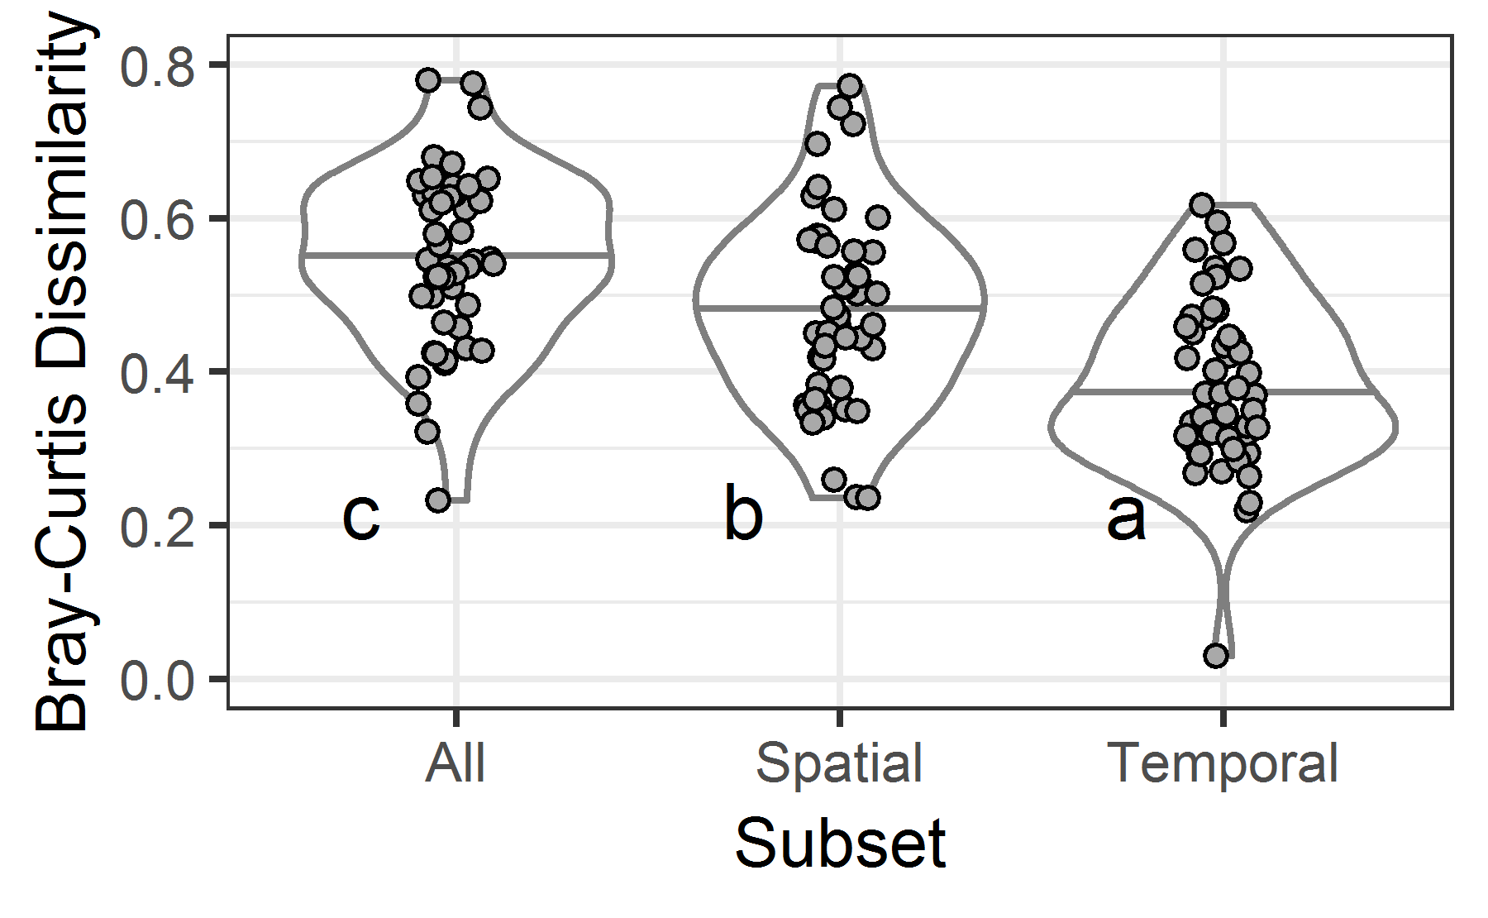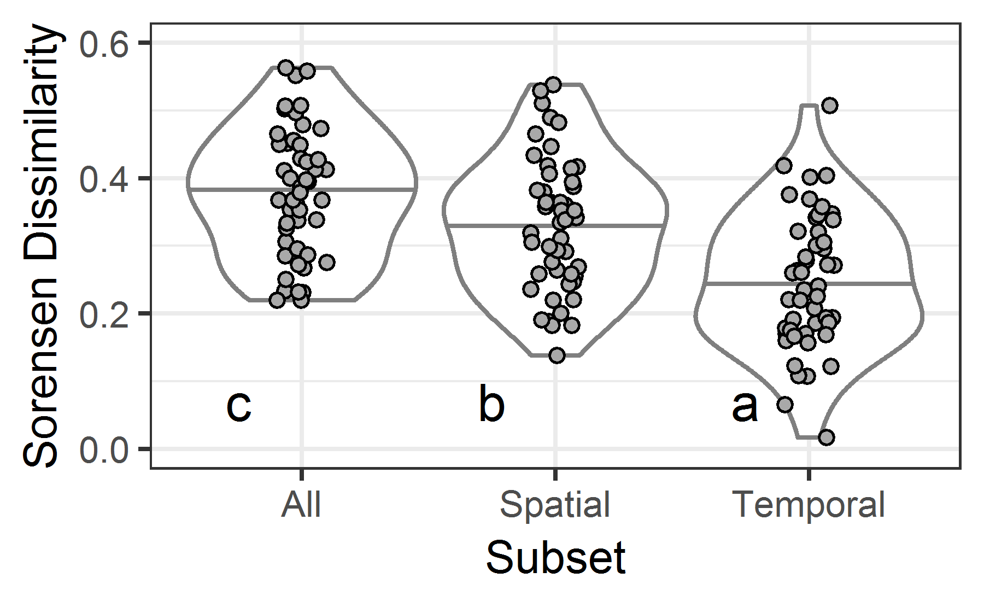

C) D)

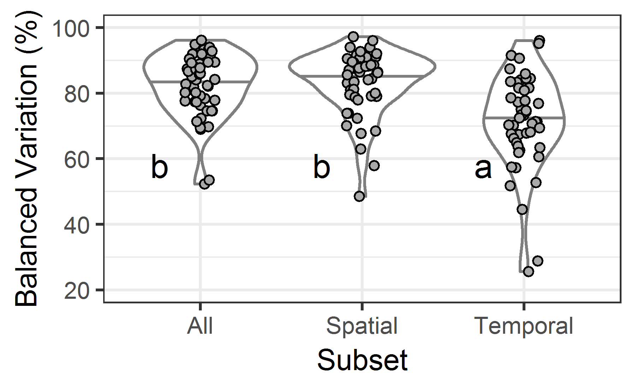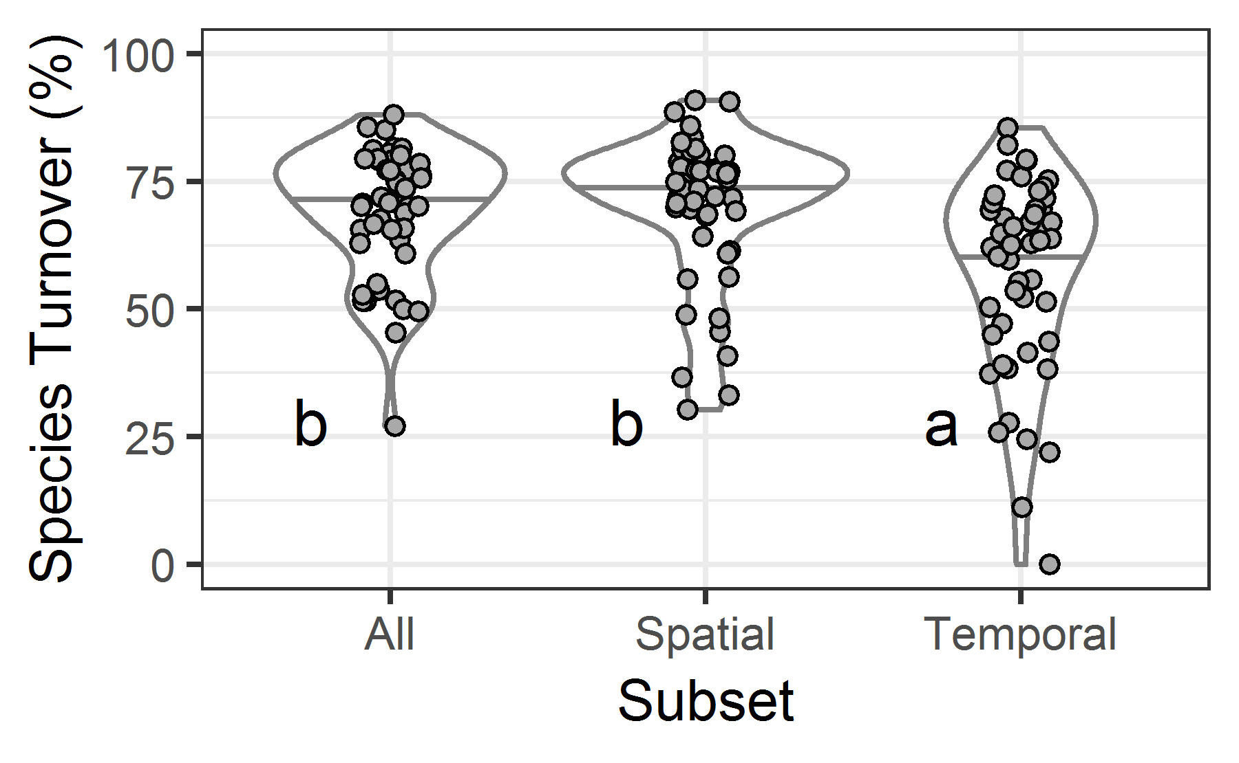

Figure 1. Four metrics of compositional variation, summarized for each site based on all plot-year combinations (All), pretreatment plots only (Spatial) and control plots over time (Temporal). The metrics are (A) abundance-based (Bray-Curtis) dissimilarity, (B) incidence-based (Sorensen) dissimilarity, (C) the percentage of Bray-Curtis dissimilarity that is due to balanced variation in abundance among species, and (D) the percentage of Sorensen dissimilarity that is due to species turnover. Within each subset, each site is shown as a point. Horizontal lines denote median values within the violin plots. Different lowercase letters indicate statistically significant differences among subsets (α = 0.05). Note that vertical axis differs among graphs.

To do: make vertical axis range the same within each row?

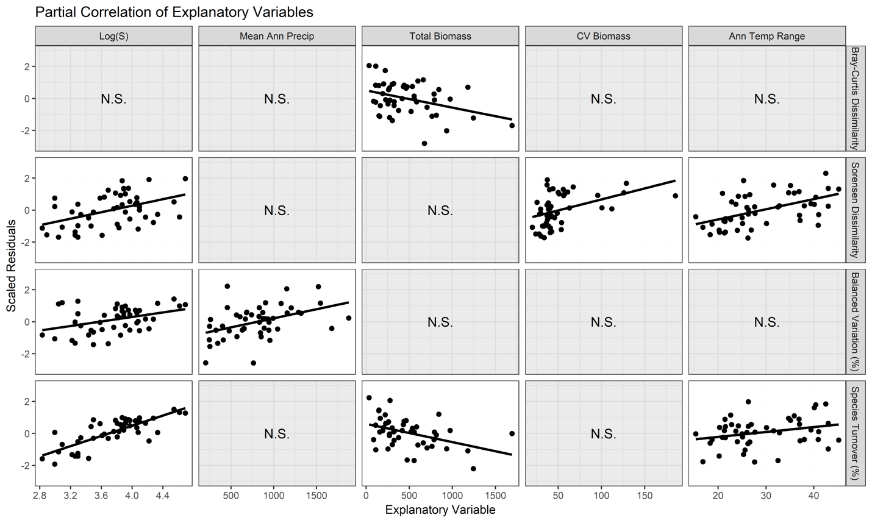

Figure 2. Partial correlation plots relating potential site-level explanatory variables to each compositional metric. From left to right, panels show the relationship between scaled model residuals and explanatory variables when added sequentially in stepwise model selection, beginning with a null model consisting only of an intercept. Panels with solid lines show explanatory variables that were included in model selection (Table 3); explanatory variables not included labelled "N.S", not significant.

A) B)

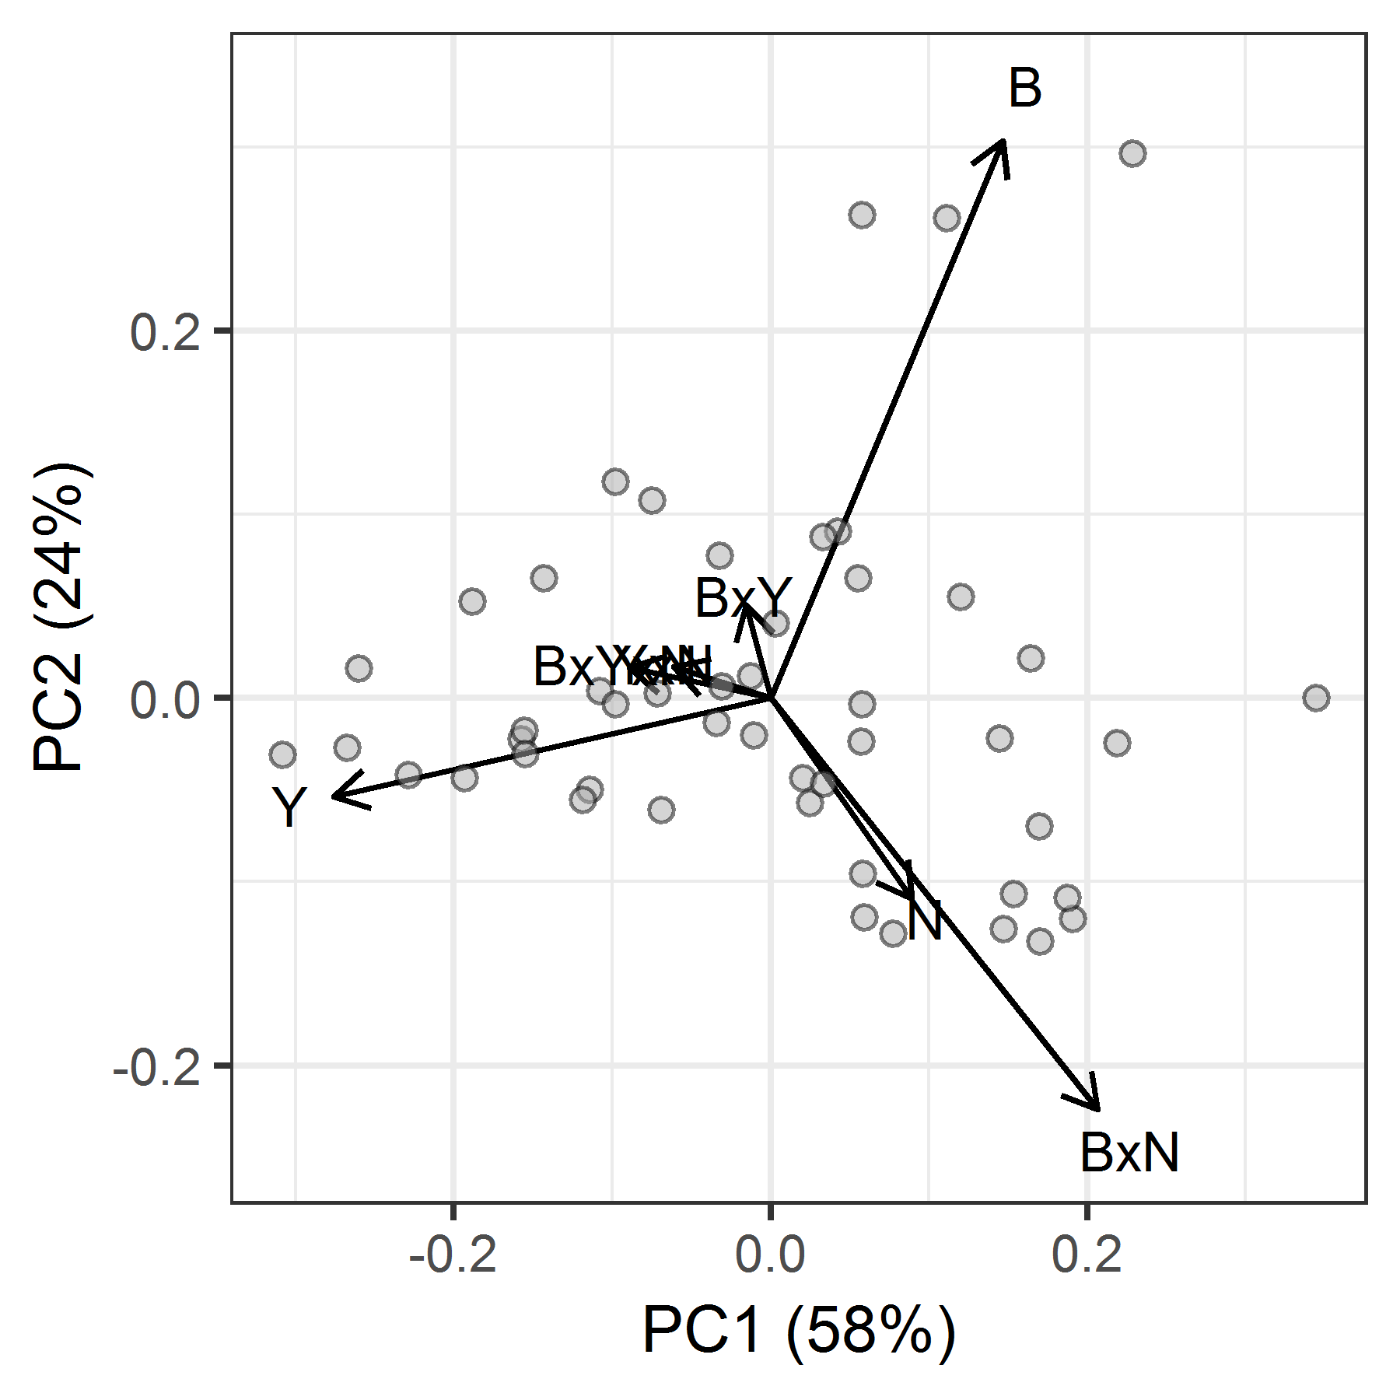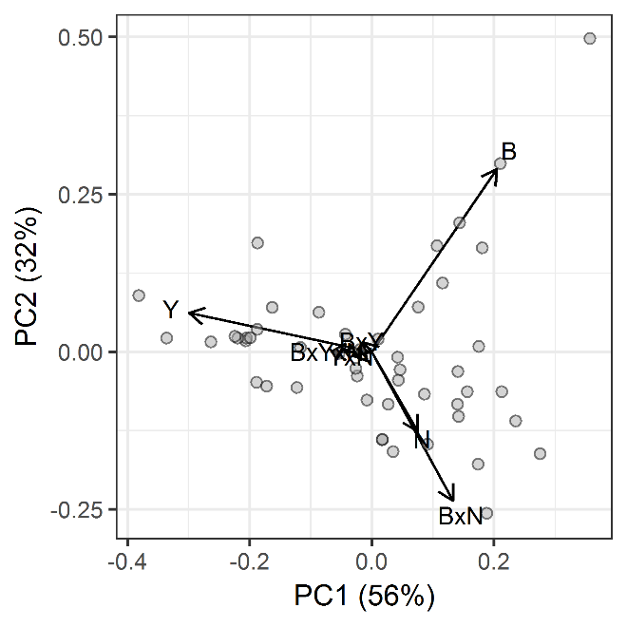

C) D)

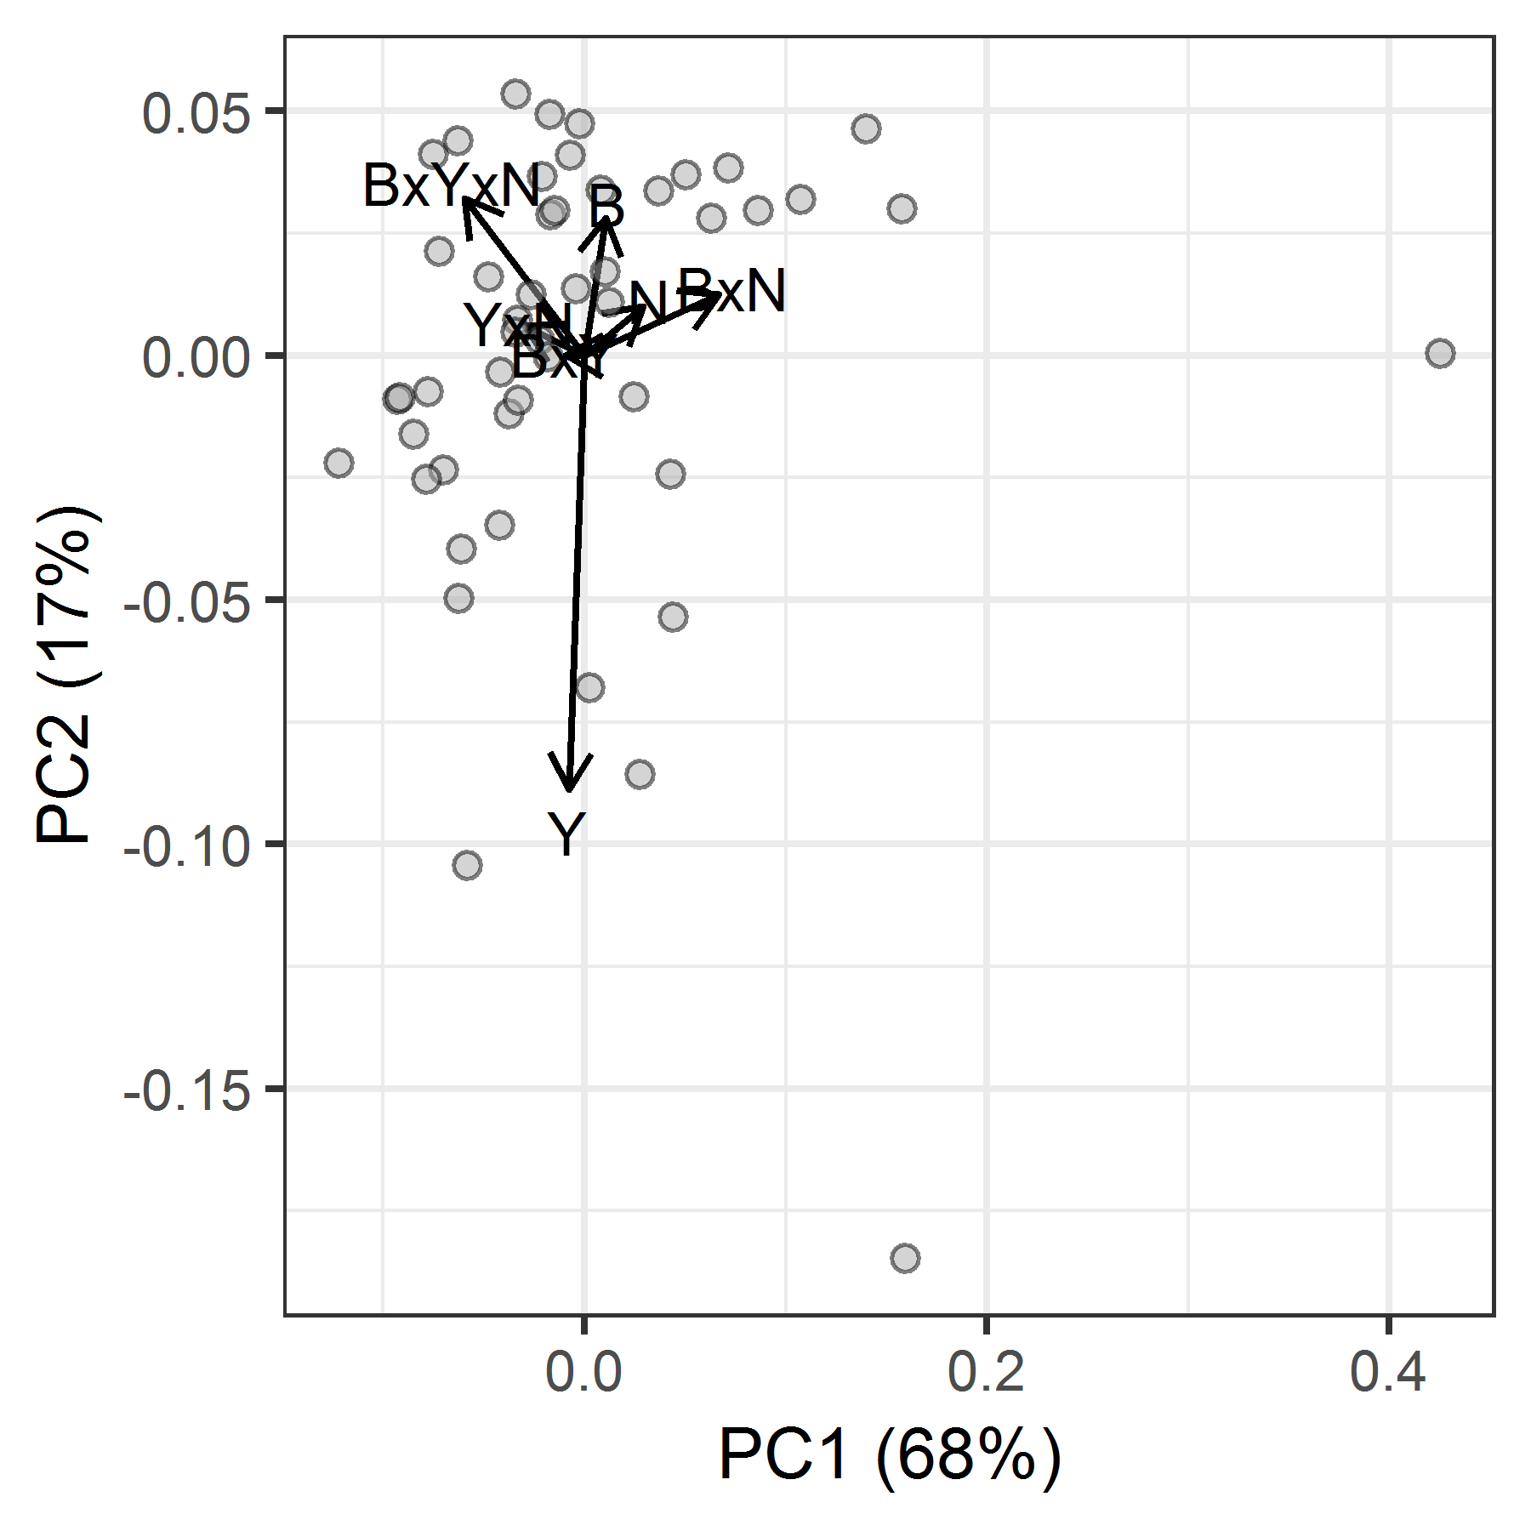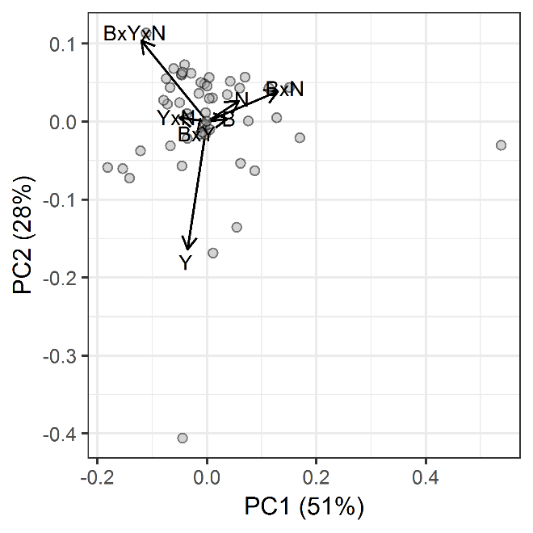

Figure 3. First two principal components of the sources of variation in (A) abundance-based (Bray Curtis) compositional variation, (B) incidence-based (Sorensen) compositional variation, (C) percentage of abundance-based variation due to balanced variation, and (D) percentage of incidence-based variation due to species turnover. The variation within each compositional metric was partitioned separately for each site and expressed as a proportion of the total variation at the site. Each symbol is a site. Vectors indicate the direction in which each source of compositional variation (B: block; N: Nutrient; Y: Year) increases. Loadings for abundance-based compositional variation are reported in Table 2.

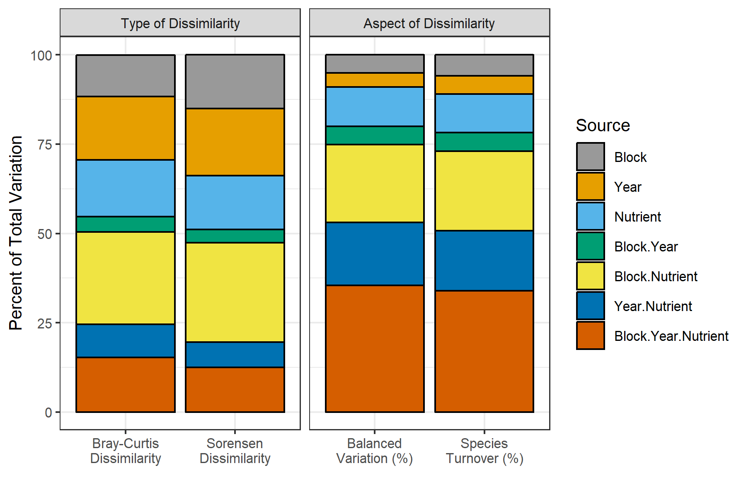

Figure 4. Partitioning of compositional variation among sources, where compositional variation is expressed as Bray-Curtis or Sorensen dissimilarity or as the percentage of compositional variation due to balanced variation in abundance or to species turnover. Data are percentages of the total variation in a given site, and are averaged across all sites.

# Supplementary Information

Table S1. Sites included in this analysis.

Table S2. Taxonomic adjustments, by site.

Table S3. Results of simple linear models relating potential site-level explanatory variables to each compositional metric.

Figure S1. Study site locations around the globe.

Figure S2. Simple linear models relating potential site-level explanatory variable to each compositional metric

Figure S3. Partitioning of abundance-based (Bray-Curtis) compositional variation, by site.

Appendix S1. Illustration of how a dissimilarity matrix can be partitioned to express variation associated with different sources.

Appendix S2. PCA of four metrics of compositional variation among sites.

Table S1. Sites included in this analysis, including potential site-level explanatory variables and details of which blocks or plots were omitted to maintain an identical experimental structure in all sites (asterisks indicate omissions based on recommendations from site leads). Fenced plots are not referenced here, but were omitted from all sites where fences were installed. Potential explanatory variables are defined in Table S3.

| **Site code** | **Country** | **Elev.** | **Manage.** | **S** | **Prod.** | **Local Var.** | **MAT** | **TEMP_ VAR** | **ATR** | **TEMP_ WET_Q** | **MAP** | **MAP_ VAR** | **Omitted** |
| --- | --- | --- | --- | --- | --- | --- | --- | --- | --- | --- | --- | --- | --- |
| arch.us | US | 8 | 1 | 48 | 419 | 42 | 22.7 | 413 | 24 | 27.3 | 1205 | 60 | - |
| bogong.au | AU | 1760 | 0 | 37 | 522 | 30 | 6 | 490 | 21 | 0.1 | 1678 | 26 | - |
| burrawan.au | AU | 425 | 0 | 33 | 277 | 63 | 18.2 | 497 | 26 | 23.9 | 643 | 41 | - |
| burren.ie | IE | 112 | 1 | 76 | 475 | 39 | 9.8 | 376 | 17 | 7.7 | 1320 | 22 | - |
| cbgb.us | US | 275 | 1 | 48 | 843 | 37 | 9.3 | 1122 | 42 | 20.4 | 871 | 46 | Blocks 4, 5, 6 * |
| cdcr.us | US | 270 | 0 | 49 | 269 | 56 | 6.3 | 1216 | 45 | 20.5 | 740 | 53 | Blocks 4, 5 |
| cdpt.us | US | 965 | 0 | 50 | 163 | 96 | 9.6 | 1007 | 43 | 19.6 | 456 | 63 | Blocks 1, 5, 6 * |
| cereep.fr | FR | 83 | 1 | 58 | 535 | 26 | 10.8 | 585 | 24 | 16.5 | 632 | 9 | - |
| chilcas.ar | AR | 15 | 0 | 68 | 1243 | 37 | 15.1 | 498 | 25 | 20.8 | 955 | 26 | - |
| comp.pt | PT | 200 | 1 | 57 | 203 | 39 | 16.6 | 516 | 26 | 11.7 | 564 | 63 | - |
| cowi.ca | CA | 50 | 0 | 18 | 676 | 54 | 10.4 | 488 | 21 | 5.2 | 762 | 65 | - |
| elliot.us | US | 200 | 0 | 33 | 192 | 112 | 17.7 | 389 | 25 | 13.6 | 344 | 92 | - |
| ethass.au | AU | 104 | 1 | 20 | 112 | 126 | 24 | 625 | 32 | 31 | 203 | 66 | - |
| frue.ch | CH | 995 | 1 | 27 | 763 | 41 | 7 | 626 | 24 | 14.7 | 1546 | 23 | - |
| gilb.za | ZA | 1748 | 1 | 72 | 272 | 24 | 14.1 | 290 | 22 | 17.4 | 943 | 69 | - |
| hall.us | US | 194 | 1 | 38 | 974 | 51 | 13.8 | 871 | 37 | 13.5 | 1289 | 15 | - |
| hart.us | US | 1508 | 0 | 36 | 147 | 57 | 7.7 | 747 | 36 | 9.8 | 259 | 25 | - |
| hero.uk | UK | 60 | 0 | 46 | 813 | 42 | 10.2 | 469 | 20 | 7.8 | 668 | 17 | - |
| hnvr.us | US | 271 | 1 | 43 | 559 | 30 | 6.5 | 1000 | 39 | 18.5 | 1044 | 12 | - |
| jena.de | DE | 320 | 1 | 59 | 706 | 34 | 8.6 | 668 | 26 | 15.1 | 654 | 20 | - |
| kbs.us | US | 288 | 0 | 46 | 662 | 40 | 8.8 | 1001 | 38 | 19.8 | 903 | 25 | Blocks 4, 5 |
| kibber.in | IN | 4241 | 0 | 20 | 33 | 129 | -1.5 | 1064 | 40 | -14.9 | 400 | 41 | - |
| kilp.fi | FI | 700 | 1 | 53 | 226 | 36 | -3.3 | 858 | 30 | 7.8 | 569 | 33 | Block 4 |
| kiny.au | AU | 90 | 0 | 47 | 568 | 134 | 15.6 | 517 | 27 | 12.4 | 408 | 22 | - |
| koffler.ca | CA | 301 | 1 | 26 | 933 | 32 | 6.3 | 1032 | 37 | 18.1 | 853 | 20 | Plots 9, 11, 17, 21, 34, 36 * |
| konz.us | US | 440 | 1 | 65 | 376 | 33 | 12.1 | 1031 | 41 | 22 | 889 | 51 | - |
| lancaster.uk | UK | 180 | 1 | 21 | 157 | 41 | 8 | 437 | 19 | 5.9 | 1522 | 25 | - |
| look.us | US | 1500 | 0 | 28 | 253 | 100 | 6.9 | 490 | 21 | 2.5 | 1877 | 66 | - |
| marc.ar | AR | 6 | 0 | 53 | 793 | 37 | 14.3 | 465 | 23 | 19.9 | 907 | 20 | Plots 6, 8, 11, 17 * |
| mtca.au | AU | 285 | 0 | 50 | 111 | 37 | 17.7 | 534 | 28 | 12.6 | 324 | 51 | Block 4 * |
| ping.au | AU | 338 | 1 | 22 | 259 | 46 | 16.3 | 507 | 26 | 10.5 | 456 | 64 | - |
| pinj.au | AU | 38 | 1 | 27 | 1180 | 56 | 20 | 402 | 21 | 24.4 | 1085 | 44 | - |
| potrok.ar | AR | 150 | 1 | 32 | 148 | 36 | 6.6 | 420 | 23 | 3.7 | 249 | 21 | - |
| rook.uk | UK | 60 | 0 | 26 | 254 | 53 | 10.1 | 471 | 20 | 7.8 | 685 | 17 | - |
| sage.us | US | 1920 | 0 | 44 | 221 | 61 | 5.8 | 688 | 35 | -2.2 | 831 | 74 | - |
| sedg.us | US | 550 | 0 | 32 | 556 | 30 | 15.6 | 427 | 28 | 11.2 | 478 | 96 | Plots 7, 10, 17, 18, 27, 28 |
| sereng.tz | TZ | 1536 | 0 | 60 | 325 | 41 | 21.9 | 76 | 15 | 22.6 | 827 | 57 | - |
| sevi.us | US | 1600 | 0 | 40 | 86 | 67 | 13.1 | 847 | 43 | 22.9 | 252 | 66 | Plots laid out in completely randomized design. Assigned to five pseudo-blocks, as spatially contiguous as possible, and omitted those from pseudo-blocks 2 and 4. * |
| shps.us | US | 910 | 1 | 60 | 111 | 49 | 5.3 | 970 | 41 | 14.1 | 246 | 41 | Block 4 |
| sier.us | US | 197 | 0 | 49 | 302 | 44 | 16.3 | 665 | 32 | 9 | 936 | 87 | Blocks 4, 5 |
| smith.us | US | 62 | 0 | 45 | 465 | 20 | 10.2 | 475 | 21 | 5 | 605 | 39 | - |
| spin.us | US | 271 | 1 | 27 | 585 | 37 | 12.5 | 882 | 37 | 21 | 1152 | 17 | - |
| summ.za | ZA | 679 | 1 | 101 | 325 | 28 | 18.4 | 250 | 18 | 21.4 | 944 | 57 | Plots 1, 10, 15, 16, 21, 30 |
| temple.us | US | 184 | 0 | 58 | 788 | 40 | 19.4 | 752 | 33 | 23.2 | 877 | 29 | Plots 19, 20 * |
| trel.us | US | 200 | 0 | 17 | 1692 | 28 | 11.1 | 1027 | 40 | 21.2 | 992 | 25 | - |
| ukul.za | ZA | 842 | 1 | 109 | 600 | 50 | 17.7 | 347 | 27 | 21.4 | 832 | 65 | Plots 8, 10, 19, 20, 25, 30 |
| unc.us | US | 141 | 1 | 52 | 440 | 40 | 14.9 | 796 | 35 | 23.9 | 1157 | 11 | - |
| valm.ch | CH | 2320 | 0 | 94 | 318 | 42 | 0.1 | 639 | 25 | 8 | 681 | 26 | - |
| yarra.au | AU | 19 | 1 | 25 | 303 | 39 | 17.3 | 465 | 26 | 22.4 | 844 | 33 | Block 4 |

Table S2. Taxonomic adjustments, by site.

Taxonomic consistency is particularly important for compositional analysis as the assignment of an organism to different names (e.g., *Poa pratensis* in one year, *Poa* sp. in another year) artificially increases the taxonomic distance among observations. Taxonomic adjustments were identified in two stages.

First, data were summarized in a taxon x year matrix where the data were the number of plots each taxon occurred in. This matrix was organized by family, and was reviewed to identify possible errors such as where a taxa was present in all but one year or where multiple species from the same genus were identified in some years but data were only identified to the genus level in other years.

Second, possible adjustments were evaluated by looking at the data from individual plots over time to see if the taxa to be combined were present on the same plot in different years. Possible adjustments were rejected if, for example, the taxa were both recorded in the same plot in the same year.

These changes are based on all taxonomic data for these sites as in the ‘full-cover-02-August-2019.csv’ data file. Note that some taxonomic inconsistencies involve later years or plots that were omitted from this particular analysis, but all adjustments are reported here for completeness. In addition to the adjustments detailed here, observations were omitted if they related to non-vascular taxa or non-living categories, or were not assigned to a genus.

| **Site** | **Analysis Code** | **Also Includes** |
| --- | --- | --- |
| arch.us | *Carphephorus* sp. | *Carphephorus carphephorus* |
|  | *Solidago* sp*.* | *Solidago fistulosa* |
|  | *Cyperus retrorsus* | *Cyperus* sp. |
|  | *Rhynchospora* sp. | *Rhynchospora fascicularis*, *Rhynchospora filifolia* |
|  | *Scleria* sp. | *Scleria pauciflora*, *Scleria reticularis* |
|  | *Ludwigia* sp. | *Ludwigia alata*, *Ludwigia pilosa*, *Ludwigia suffruticosa* |
|  | *Andropogon virginicus* | *Andropogon* sp., *Andropogon virginicus* var. *glaucus*, *Andropogon virginicus* var. *virginicus* |
|  | *Axonopus* sp. | *Axonopus furcatus* |
|  | *Panicum* sp. | *Panicum agrostoides*, *Panicum hemitomon* |
| bogong.au | *Erigeron* sp. | *Erigeron bellidioides*, *Erigeron nitidus* |
|  | *Microseris lanceolata* | *Microseris* sp. |
|  | *Phebalium squamulosum* | *Phebalium squamulosum* ssp. *ozothamnoides* |
| burrawan.au |  | No changes |
| burren.ie | *Dactylorhiza* sp. | *Dactylorhiza fuchsii*, *Dactylorhiza maculata* |
|  | *Rosa spinosissima* | *Rosa xanthina* |
| cbgb.us | *Cirsium* sp. | *Cirsium arvense*, *Cirsium vulgare* |
|  | *Helianthus* *grosseserratus* | *Helianthus* sp. |
|  | *Solidago canadensis* | *Solidago* sp. |
|  | *Symphyotrichum pilosum* | *Symphyotrichum* sp. |
|  | *Solanum carolinense* | *Solanum* sp. |
| cdcr.us | *Chenopodium* *album* | *Chenopodium* sp. |
|  | *Symphyotrichum boreale* | *Aster* sp. |
|  | *Conyza canadensis* | *Erigeron canadensis* |
|  | *Erigeron strigosus* | *Erigeron* sp. |
|  | *Rudbeckia hirta* | *Rudbeckia hirta* var. *pulcherrima*, *Rudbeckia* sp. |
|  | *Tragopogon dubius* | *Tragopogon* sp. |
|  | *Carex* sp. | *Carex scoparia* |
|  | *Cyperus* sp. | *Cyperus filiculmis*, *Cyperus grayi*, *Cyperus lupulinus*, *Cyperus schweinitzii* |
| cdpt.us |  | No changes |
| cereep.fr | *Myosotis* sp. | *Myosotis arvensis, Myosotis ramosissima* |
|  | *Silene latifolia* ssp. *alba* | *Silene latifolia* |
|  | *Crepis* sp. | *Crepis setosa* |
|  | *Senecio jacobaea* | *Jacobaea vulgaris* |
|  | *Picris hieracioides* | *Picris* sp. |
|  | *Trifolium* sp. | *Trifolium arvense*, *Trifolium campestre*, *Trifolium dubium*, *Trifolium pratense*, *Trifolium repens* |
|  | *Vicia* sp. | *Vicia cracca*, *Vicia hirsuta*, *Vicia lathyroides*, *Vicia sativa*, *Vicia sativa* ssp. *nigra*, *Vicia sepium*, *Vicia tetrasperma* |
|  | *Erodium cicutarium* | *Erodium* sp. |
|  | *Geranium molle* | *Geranium* sp. |
|  | *Hypericum* sp. | *Hypericum maculatum* ssp. *obtusiusculum*, *Hypericum perforatum* |
|  | *Agrostis* sp. | *Agrostis canina*, *Agrostis gigantea* |
|  | *Arrhenatherum elatius* | *Arrhenatherum elatius* ssp. *bulbosum* |
|  | *Bromus hordeaceus* | *Bromus* sp., *Bromus pectinatus*, *Bromus racemosus* |
|  | *Festuca rubra* | *Festuca arundinacea*, *Festuca* sp. |
|  | *Poa* *pratensis* | *Poa pratensis* ssp. *latifolia*, *Poa* sp., *Poa trivialis* |
|  | *Rumex acetosella* | *Rumex* sp. |
| chilcas.ar | *Bromus brachyantherus* | *Bromus auleticus* |
| comp.pt | *Crepis* sp. | *Crepis capillaris, Crepis vesicaria* |
|  | *Hypochaeris glabra* | *Hypochaeris*, *Leontodon taraxacoides* |
|  | *Trofolium glomeratum* | *Trifolium* sp. |
|  | *Erodium* sp. | *Erodium* *aethiopicum, Erodium botrys, Erodium cicutarium* |
|  | *Orobanche minor* | *Orobanche* sp. |
|  | *Plantago bellardi* | *Plantago bellardii* |
|  | *Vulpia bromoides* | *Vulpia* |
| cowi.ca |  | No changes |
| elliot.us | *Juncus dubius* | *Juncus* sp. |
| ethass.au | *Portulaca intraterranea* | *Portulaca* sp. |
| frue.ch |  | No changes |
| gilb.za |  | No changes |
| hall.us | *Rubus allegheniensis* | *Rubus* sp. |
| hart.us | *Allium acuminatum* | *Allium* sp. |
|  | *Agoseris glauca* | *Agoseris* sp. |
|  | *Crepis* sp. | *Crepis occidentalis* |
|  | *Astragalus filipes* | *Astragalus* sp. |
|  | *Lupinus uncialis* | *Lupinus* sp. |
| hero.uk |  | No changes |
| hnvr.us | *Calystegia sepium* | *Ipomoea* sp. |
|  | *Carex gracillima* | *Carex* sp. |
| jena.de |  | No changes |
| kbs.us | *Melilotus officinalis* | *Melilotus officinalis* ssp. *alba*, *Melilotus* sp. |
|  | *Trifolium repens* | *Trifolium* |
|  | *Setaria pumila* | *Setaria* sp. |
|  | *Malus* sp. | *Prunus* sp. |
|  | *Acer negundo* | *Acer* sp. |
| kibber.in | *Elymus longiaristatus* | Unknown grass sp. |
|  | *Polygonum* sp. | *Polygonum aviculare* |
| kilp.fi | *Scorzoneroides autumnalis* | *Leontodon autumnalis* var. *taraxaci* |
|  | *Empetrum nigrum* | *Empetrum nigrum* ssp. *hermaphroditum* |
|  | *Ranunculus acris* | *Ranunculus acris* ssp. *pumilus* |
| kiny.au | *Arthropodium minus* | *Arthropodium* sp. |
|  | *Atriplex semibaccata* | *Atriplex* sp. |
|  | *Maireana enchylaenoides* | *Maireana* sp. |
|  | *Rhodanthe corymbiflora* | *Rhodanthe* sp. |
|  | *Sonchus oleraceus* | *Sonchus* sp., *Sonchus asper* |
|  | *Crassula sieberiana* | *Crassula* sp. |
|  | *Trifolium sp.* | *Trifolium*, *Trifolium dubium*, *Trifolium glomeratum*, *Trifolium arvense* |
|  | *Avena barbata* | *Avena* sp., *Avena fatua* |
|  | *Bromus rubens* | *Bromus* sp. |
|  | *Lolium* sp. | *Lolium perenne*, *Lolium rigidum* |
|  | *Rytidosperma* sp. | *Rytidosperma* |
|  | *Vulpia* sp. | *Vulpia bromoides* |
| koffler.ca | *Carex* sp. | *Carex plantaginea* |
| konz.us | *Solidago missouriensis* | *Solidago canadensis* |
|  | *Euphorbia nutans* | *Euphorbia marginata, Euphorbia serpens*, *Euphorbia spathulata* |
|  | *Baptisia bracteata* | *Baptisia australis* |
|  | *Calylophus serrulatus* | *Calylophus* sp. |
|  | *Muhlenbergia racemosa* | *Muhlenbergia cuspidata* |
| lancaster.uk |  | No changes |
| look.us | *Carex pensylvanica* | *Carex hoodii* |
|  | *Galium oreganum* | *Galium* sp. |
| marc.ar |  | No changes |
| mtca.au | *Hordeum murinum* | *Hordeum murinum* ssp. *leporinum* |
|  | *Stipa* sp. | *Stipa nitida*, *Stipa trichophylla* |
| ping.au |  | No changes |
| pinj.au | *Medicago* sp. | *Medicago polymorpha* |
| potrok.ar |  | No changes |
| rook.uk |  | No changes |
| sage.us |  | No changes |
| sedg.us | *Trifolium* sp. | *Trifolium microcephalum* |
| sereng.tz | *Kyllinga* sp. | *Kyllinga alba, Kyllinga nervosa* |
|  | *Dactyloctenium* *aegyptium* | *Dactyloctenium* sp. |
| sevi.us | *Salsola kali* | *Salsola kali* ssp. *tragus* |
|  | *Euphorbia* sp. | *Euphorbia exstipulata*, *Euphorbia fendleri*, *Euphorbia serpyllifolia*, *Euphorbia serrula* |
|  | *Sphaeralcea* sp. | *Sphaeralcea coccinea, Sphaeralcea hastulata, Sphaeralcea polychroma*, *Sphaeralcea wrightii* |
|  | *Aristida sp.* | *Aristida adscensionis, Aristida purpurea* |
|  | *Sporobolus* sp. | *Sporobolus contractus*, *Sporobolus cryptandrus*, *Sporobolus flexuosus* |
| shps.us | *Lappula occidentalis* var. *occidentalis* | *Lappula redowskii* |
|  | *Antennaria dimorpha* | *Antennaria* sp. |
|  | *Poa secunda* | *Pseudosclerochloa rupestris* |
| sier.us | *Torilis sp.* | *Torilis, Torilis arvensis*, *Torilis nodosa* |
|  | *Triteleia* *hyacinthina* | *Brodiaea sp., Dichelostemma capitatum, Dichelostemma multiflorum, Dichelostemma volubile, Triteleia laxa, Triteleia* sp., Unknown Liliaceae |
|  | *Plagiobothrys nothofulvus* | *Plagiobothrys* sp. |
|  | *Cardamine oligosperma* | *Cardamine* sp. |
|  | *Centaurea melitensis* | *Centaurea solstitialis* |
|  | *Hemizonia congesta* | *Hemizonia* |
|  | *Aster* sp. | Unknown Asteraceae |
|  | *Convolvulus arvensis* | *Convolvulus* sp. |
|  | *Lupinus* | *Lupinus bicolor*, *Lupinus nanus* |
|  | *Trifolium dubium* | *Trifolium* sp. |
|  | *Vicia sativa* | *Vicia* sp. |
|  | *Erodium* sp. | *Erodium botrys*, *Erodium cicutarium, Erodium moschatum* |
|  | *Clarkia* *purpurea* | *Clarkia* sp. |
|  | *Hordeum murinum* | *Hordeum marinum* |
|  | *Linanthus* sp. | *Linanthus bicolor*, *Linanthus parviflorus* |
|  | *Galium* sp. | *Galium aparine*, *Galium parisiense*, *Galium porrigens* |
| smith.us | *Brodiaea coronaria* | *Triteleia grandiflora* |
|  | *Symphoricarpos albus* | *Symphoricarpos albus* var. *laevigatus* |
|  | *Taraxacum campylodes* | *Crepis capillaris* |
| spin.us | *Carex* sp. | Unknown Cyperaceae |
| summ.za | *Sebaea* sp. | *Sebaea grandis* |
|  | *Eulophia* sp. | *Eulophia tenella* |
| temple.us | *Polytaenia nuttallii* | *Polytaenia texana* |
|  | *Torilis arvensis* | *Torilis* sp. |
|  | *Lactuca serriola* | *Lactuca* sp. |
|  | *Agalinis fasciculata* | *Agalinis* sp. |
| trel.us | *Bromus inermis* | *Bromus* sp. |
| ukul.za | *Pachycarpus* sp. | *Pachycarpus asperifolius, Pachycarpus* *scaber* |
|  | *Acacia nilotica* ssp. *kraussiana* | *Acacia* sp. |
|  | *Chamaecrista* sp. | *Chamaecrista comosa, Chamaecrista plumosa* |
|  | *Crotalaria* sp. | *Crotalaria globifera* |
|  | *Albuca setosa* | *Albuca* |
|  | *Hypericum* sp. | *Hypericum aethiopicum* ssp. *sonderi* |
|  | *Leonotis leonurus* | *Leonotis ocymifolia* var. *raineriana* |
|  | *Solanum* sp. | *Solanum americanum*, *Solanum mauritianum*, *Solanum panduriforme*, *Solanum retroflexum* |
| unc.us | *Erigeron* sp. | *Erigeron annuus*, *Erigeron strigosus* |
|  | *Solidago pinetorum* | *Solidago* sp. |
|  | *Panicum* sp. | *Panicum dichotomum*, *Panicum linearifolium* |
|  | *Smilax rotundifolia* | *Smilax bona-nox* |
| valm.ch |  | No changes |
| yarra.au | *Vicia* sp. | *Vicia sativa* |
|  | *Dichelachne* sp. | *Dichelachne squamulosum* |
|  | *Paspalum* sp. | *Paspalum dilatatum, Paspalum notatum* |

Table S3. Results of simple linear models relating potential site-level explanatory variable to each compositional metric. Shown is the *P*-value associated with each model. Values < 0.10 are underlined, and those < 0.05 are in bold. Models with *P* < 0.05 for any variable were included in the model selection process.

|  |  |  |  |  |  |  |  |  |  |  |  |  |
| --- | --- | --- | --- | --- | --- | --- | --- | --- | --- | --- | --- | --- |
|  |  | |  | | **Type of Dissimilarity** | | | |  | **Aspect of dissimilarity** | | |
| **Explanatory Variable** | **Abbrev.** | **Units** | | **Abundance-based**  **(Bray-Curtis)** | | **Incidence-based (Sorensen)** |  | **Balanced Variation**  **(%)** | | | **Species Turnover**  **(%)** |
| Gamma diversity | log(S) |  | | 0.117 | | **0.001** |  | **<0.001** | | | **<0.001** |
| Productivity | Prod. | g m-2 | | **0.010** | | 0.753 |  | 0.824 | | | **0.023** |
| Local Variation in Productivity | Local Var. | % | | **0.013** | | 0.067 |  | **0.009** | | | 0.610 |
| Mean annual temperature | MAT | °C | | 0.593 | | 0.212 |  | 0.851 | | | 0.521 |
| Standard deviation in temperature | TEMP_VAR | °C | | 0.485 | | 0.096 |  | 0.762 | | | 0.833 |
| Annual temperature range | ATR | °C | | 0.157 | | **0.003** |  | 0.571 | | | 0.494 |
| Mean temperature, wettest quarter | TEMP_WET_Q | °C | | 0.550 | | 0.071 |  | 0.753 | | | 0.992 |
| Mean annual precipitation | MAP | mm | | **0.047** | | 0.162 |  | **0.011** | | | 0.342 |
| Seasonality (CV of precipitation) | MAP_VAR | % | | 0.206 | | 0.208 |  | 0.257 | | | 0.867 |
| Nitrogen deposition | N_Dep | kg N ha-1 yr-1 | | 0.516 | | 0.415 |  | 0.084 | | | 0.834 |
| Management | Manage. | 0, 1 | | 0.569 | | 0.378 |  | 0.255 | | | 0.849 |

A)

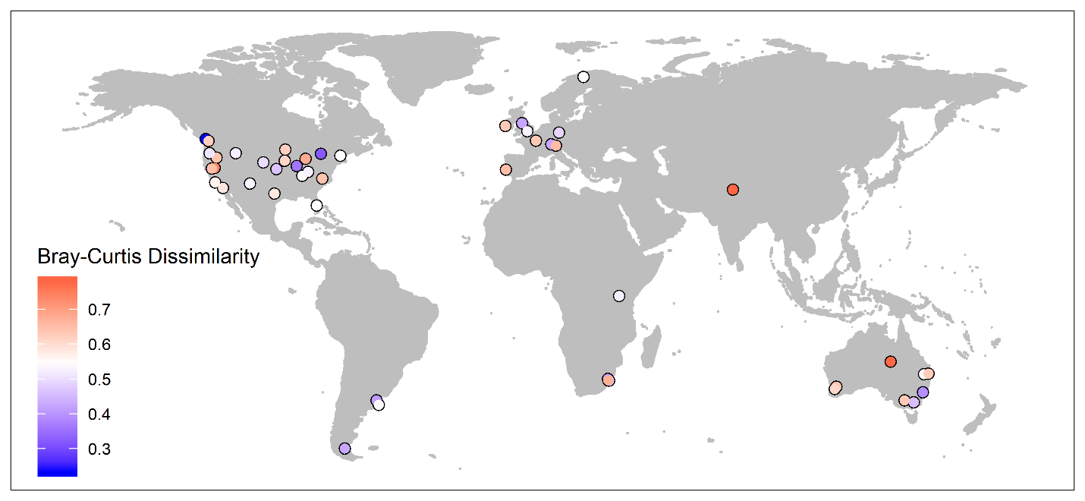

B)

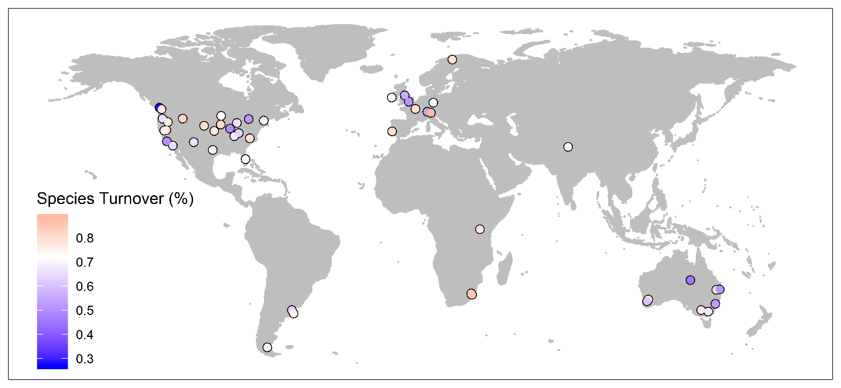

Figure S1. Study site locations around the globe. Sites are coded by (A) magnitude of abundance-based compositional variation and by (B) the percentage of compositional change due to species turnover. Detailed characteristics of each site are provided in Table S1.

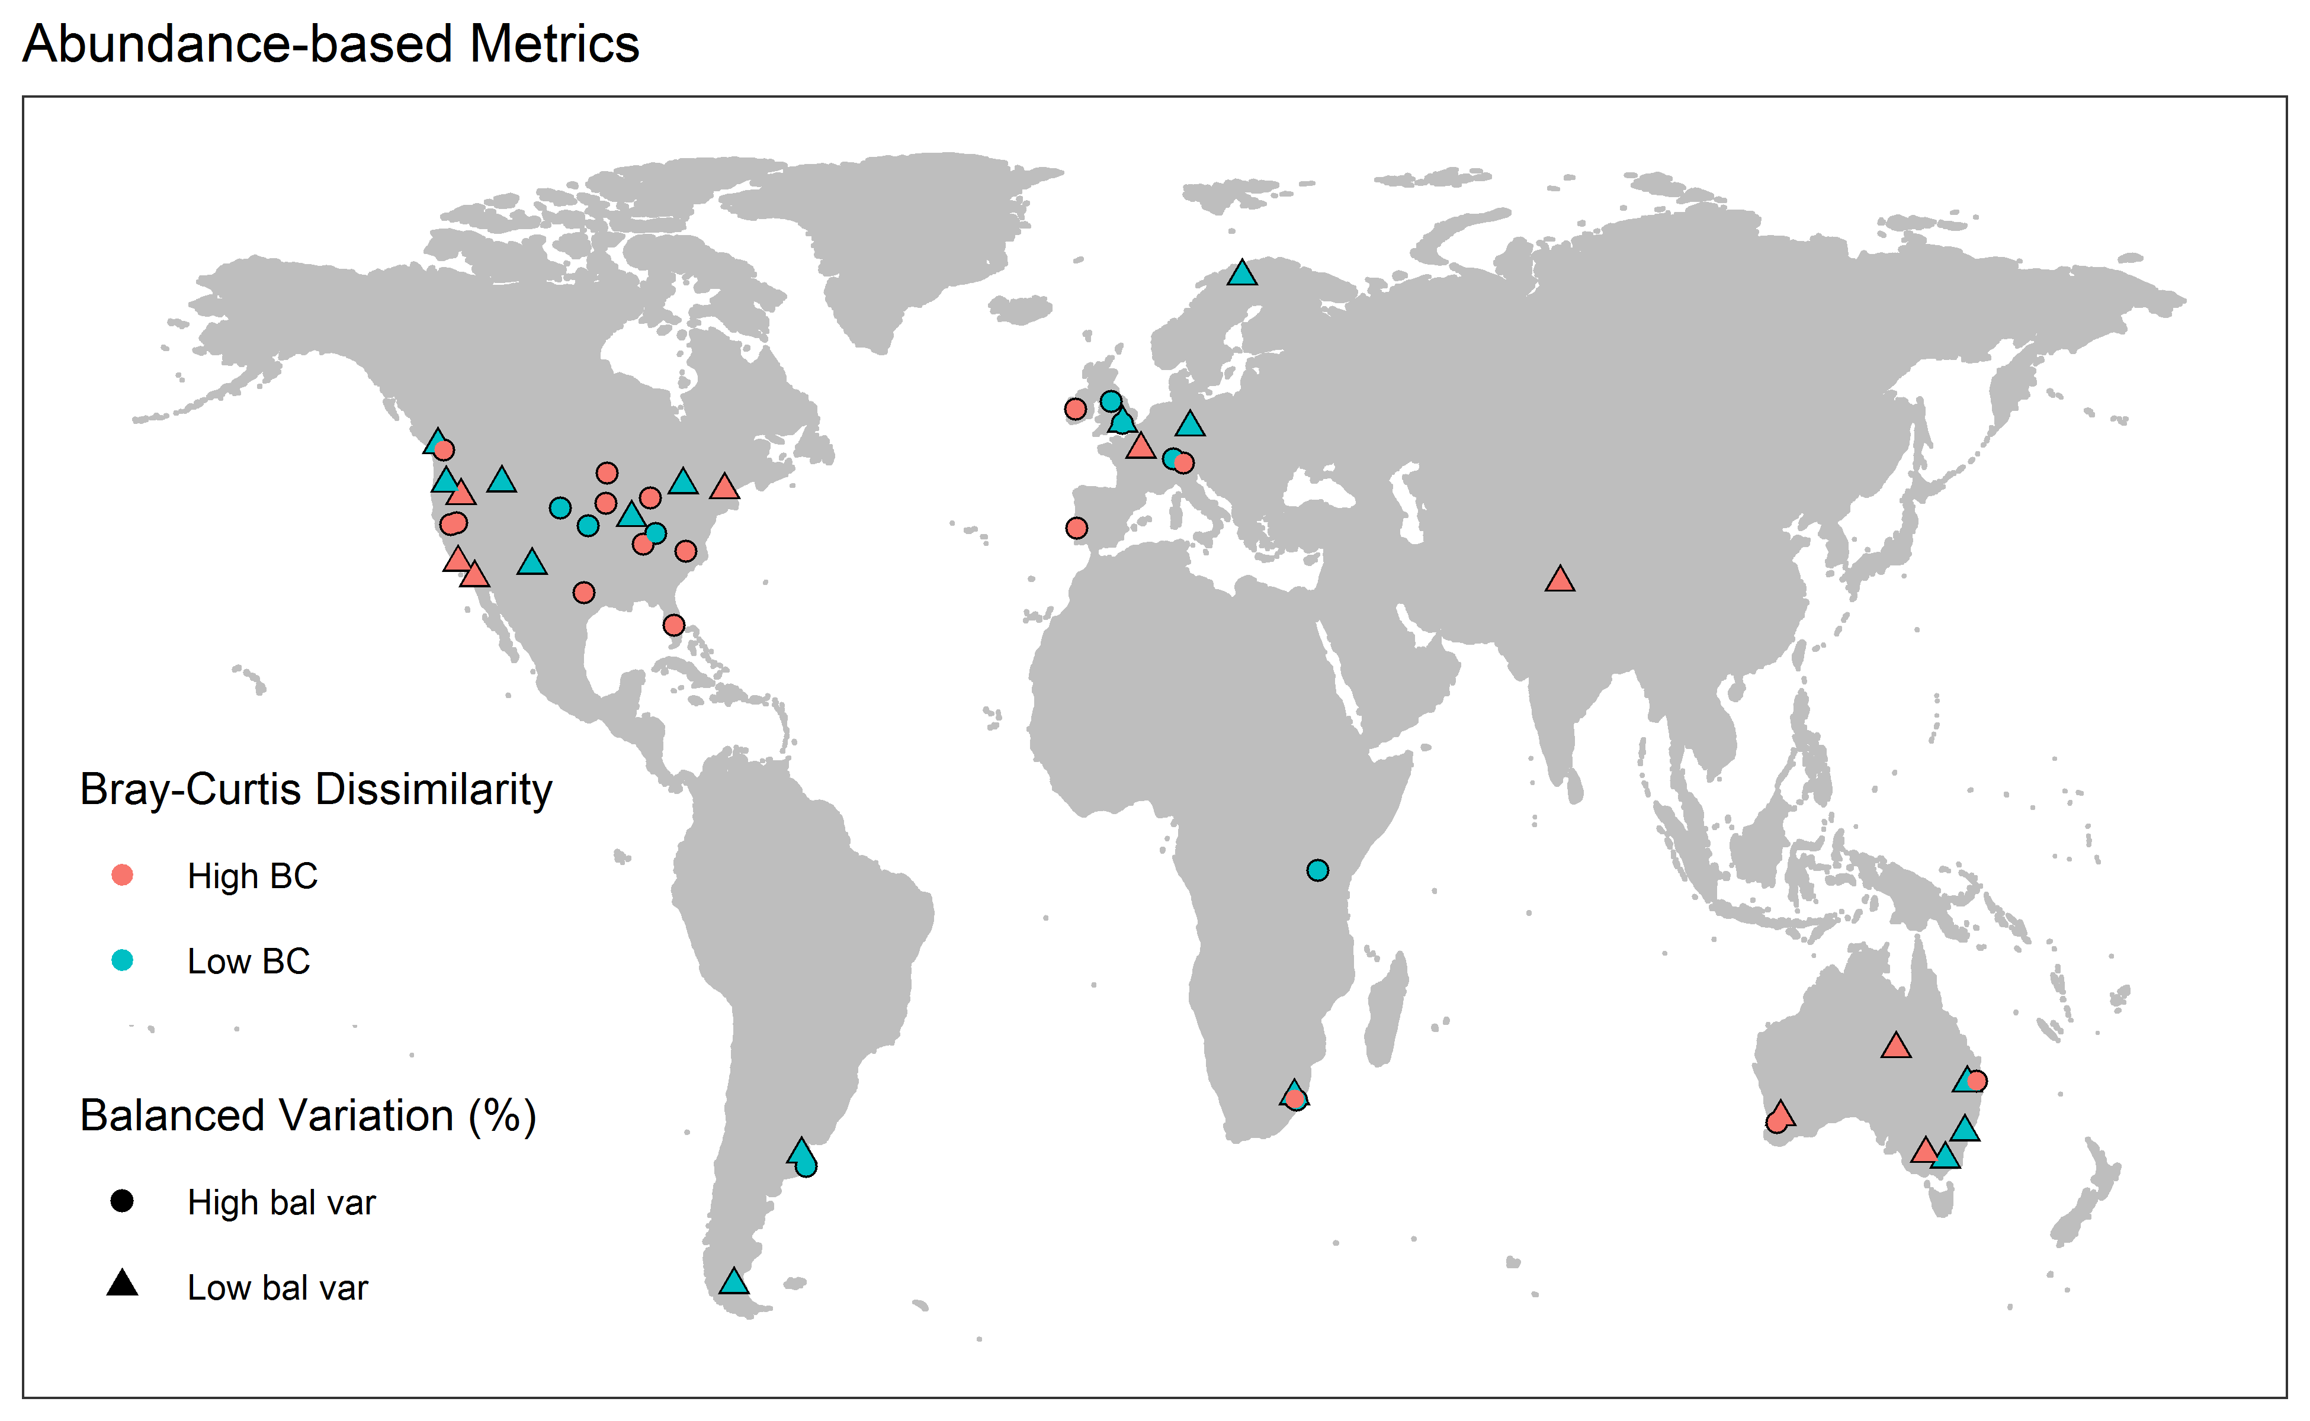

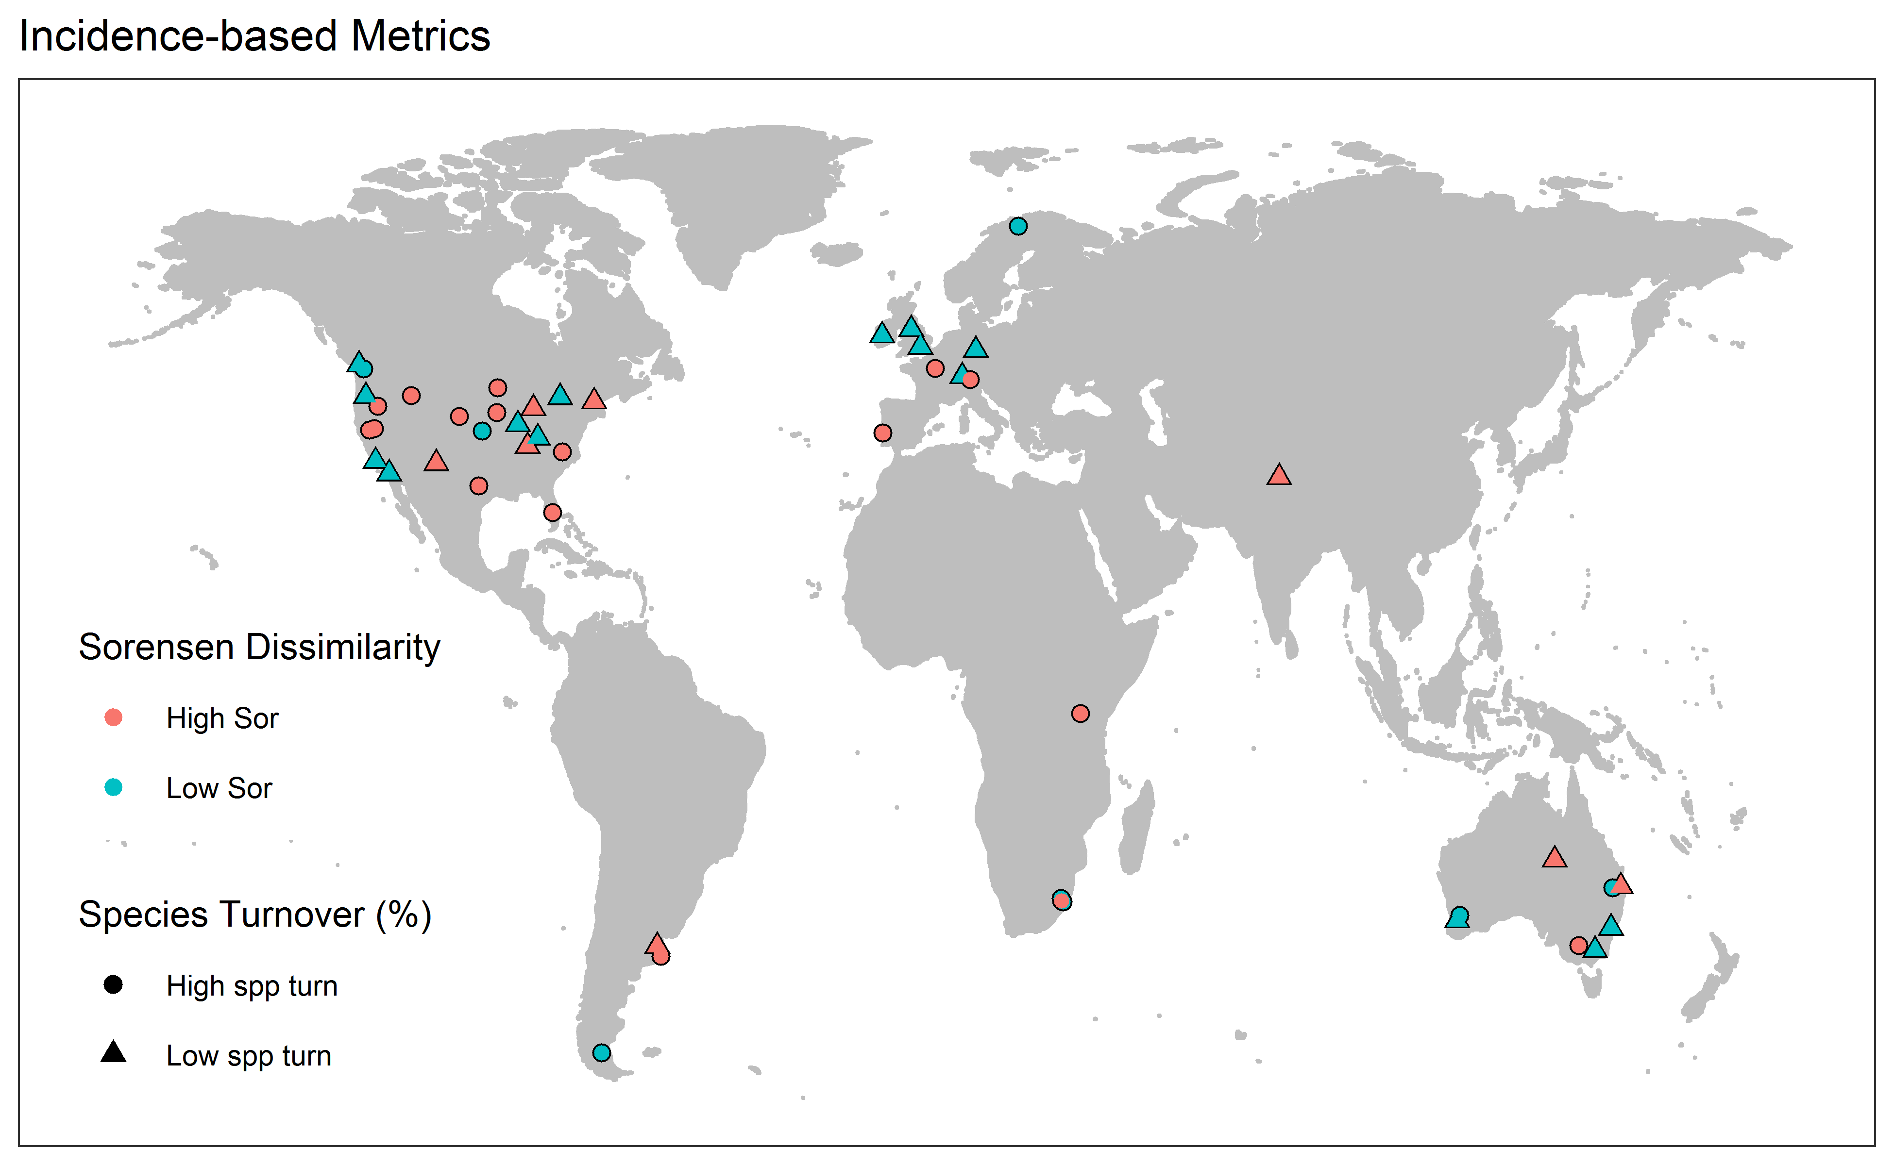

Figure S1.alt. Study site locations around the globe. Sites are coded by abundance- and incidence-based metrics in the top and bottom graphs. Detailed characteristics of each site are provided in Table S1.

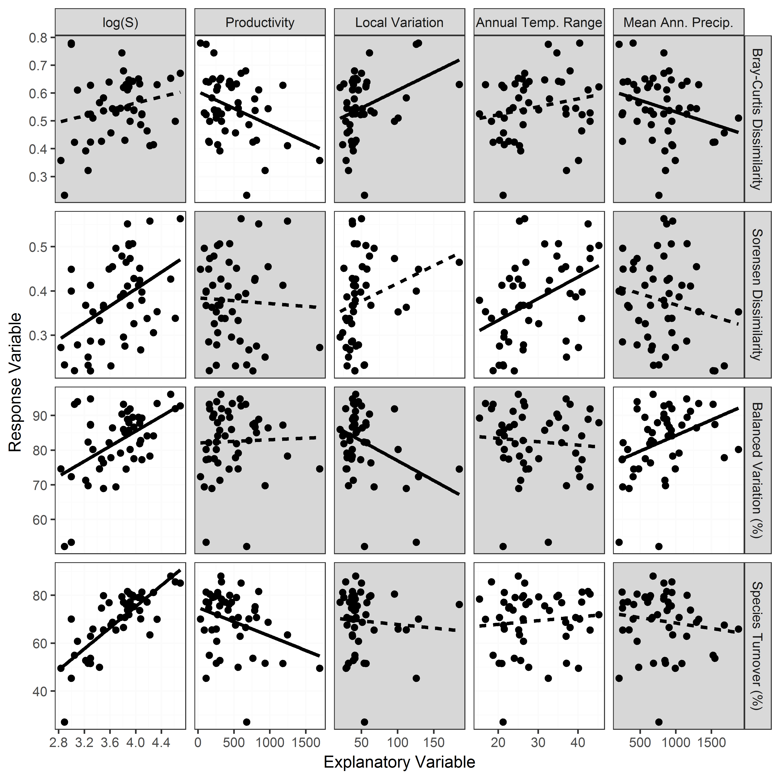

Figure S2. Results of simple linear models relating potential site-level explanatory variable to each compositional metric. Panels with solid lines indicate statistically significant (P ≤ 0.05) relationships as identified through simple linear regression (Table S3). White panels were included in the final models resulting from a model selection process (Table 3).

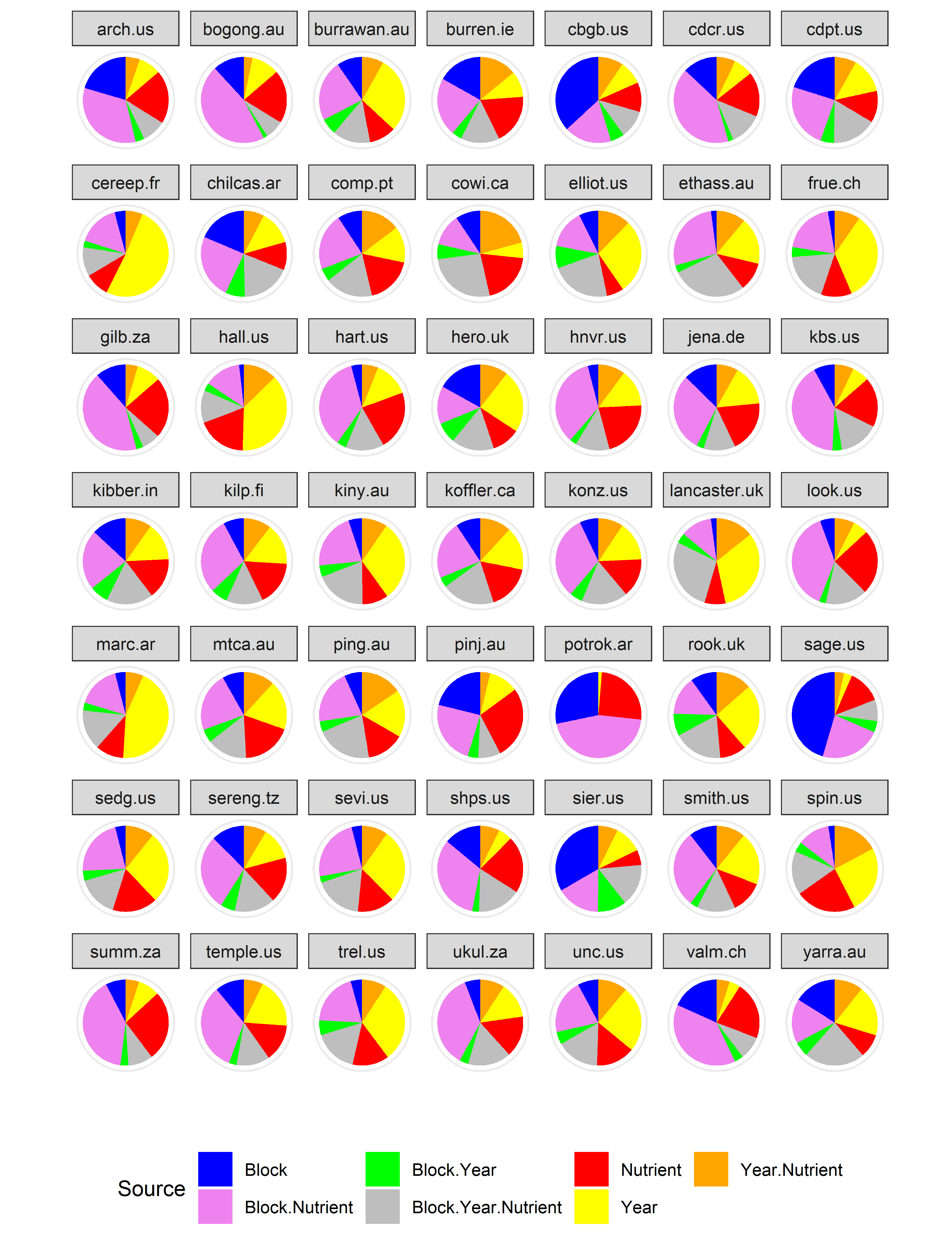

Figure S3. Partitioning of abundance-based compositional variation, by site.

**Appendix S1. Illustration of how a dissimilarity matrix can be partitioned to express variation associated with different sources.**

Here is a small dataset comparing species richness (S) in four plots. Two plots occur in each of two blocks, and a nutrient addition treatment is applied within each block. The objective is to partition the variation in species richness into three sources: that among blocks, that among nutrient treatments, and that which is not explained by either term (conceptually, this is equivalent to the block x nutrient interaction).

|  |  |  |  |
| --- | --- | --- | --- |
| Block | Nutrient | Plot | S |
| 1 | N | 2 | 18 |
| 1 | Control | 6 | 20 |
| 2 | N | 19 | 19 |
| 2 | Control | 11 | 28 |

Express S as a distance matrix showing the difference in richness (i.e., distance) between every pair of plots:

|  |  |  |  |  |
| --- | --- | --- | --- | --- |
|  | Plot 2 | Plot 6 | Plot 19 | Plot 11 |
| Plot 2 |  |  |  |  |
| Plot 6 | 2 |  |  |  |
| Plot 19 | 1 | 1 |  |  |
| Plot 11 | 10 | 8 | 9 |  |

The sum of the squared distances from plots to their centroid is equal to the sum of the squared inter-point distances divided by the number of plots (Anderson 2001). For example, the total variation (SST) is the sum of the squared distance matrix divided by 4:

SST = (22 + 12 + 12 + 102 + 82 + 92) / 4 = 62.75

Follow the same procedure to calculate the variation within different subsets of the distance matrix:

Variation within blocks (SSWB) = (22 + 92) / 2 = 42.5

Variation within nutrient treatments (SSWN) = (12 + 82) / 2 = 32.5

Calculate the variation associated with every term via subtraction:

| **Source** | **df** | **Calculation** | **SS** |
| --- | --- | --- | --- |
| Among Block | 1 | SST - SSWB | 20.25 |
| Among Nutrient treatments | 1 | SST - SSWN | 30.25 |
| Residual (aka Block x Nutrient interaction) | 1 | SST - SSWB - SSWN | 12.25 |
| Total | 3 | SST | 62.75 |

This partitioning can be confirmed by analyzing the data via PERMANOVA:

Call:

adonis(formula = dist.S ~ Block + Nutrient, data = appendix, permutations =0)

Permutation: free

Number of permutations: 0

Terms added sequentially (first to last)

Df SumsOfSqs MeanSqs F.Model R2 Pr(>F)

Block 1 20.25 20.25 1.6531 0.32271

Nutrient 1 30.25 30.25 2.4694 0.48207

Residuals 1 12.25 12.25 0.19522

Total 3 62.75 1.00000

The partial R2 values for each term document how variation in richness is partitioned among sources. *P*-values are not reported here as they are not necessary for partitioning.

Since this example used a univariate response and Euclidean distances, it can also be confirmed by a conventional ANOVA:

summary(aov(S ~ Block + Nutrient, data = appendix))

Df Sum Sq Mean Sq F value Pr(>F)

Block 1 20.25 20.25 1.653 0.421

Nutrient 1 30.25 30.25 2.469 0.361

Residuals 1 12.25 12.25

Since this partitioning is applied to the distance matrix, it can be used with univariate or multivariate data, and with a distance matrix calculated from any distance measure. We applied the same principles to our data, which consisted of the multivariate compositional data from 96 plot-year combinations (i.e., 3 blocks x 4 years x 8 nutrient treatments) at a site. These data were expressed as a 96 x 96 dissimilarity matrix and the compositional variation was partitioned across the seven sources using PERMANOVA.

**Literature Cited**

Anderson, M.J. 2001. A new method for non-parametric multivariate analysis of variance. *Austral Ecology* 26:32-46.

**Appendix S2. PCA of four metrics of compositional variation among sites.**

We created a set of four variables (mean abundance-based dissimilarity, mean incidence-based dissimilarity, mean balanced variation (percentage of Bray-Curtis dissimilarity), mean species turnover (percentage of Sorensen dissimilarity)) for each site. We conducted a PCA on this 49 × 4 matrix to identify orthogonal PCs. Loadings above 0.5 are in bold font, and positive loadings are in italics.

|  |  |  |  |  |
| --- | --- | --- | --- | --- |
| Variable | PC1 | PC2 | PC3 | PC4 |
| Type of dissimilarity |  |  |  |  |
| Abundance-based (Bray-Curtis) | ***0.51*** | ***0.61*** | ***0.51*** | *0.33* |
| Incidence-based (Sorensen) | *0.41* | *0.40* | -0.45 | **-0.69** |
| Aspect of dissimilarity |  |  |  |  |
| Balanced Variation (%) | *0.36* | **-0.54** | ***0.59*** | -0.49 |
| Species Turnover (%) | ***0.67*** | -0.42 | -0.44 | *0.43* |
| Variance Explained (%) | 58.8 | 21.7 | 11.9 | 7.6 |
| Cumulative Variance Explained (%) | 58.8 | 80.5 | 92.4 | 100.0 |

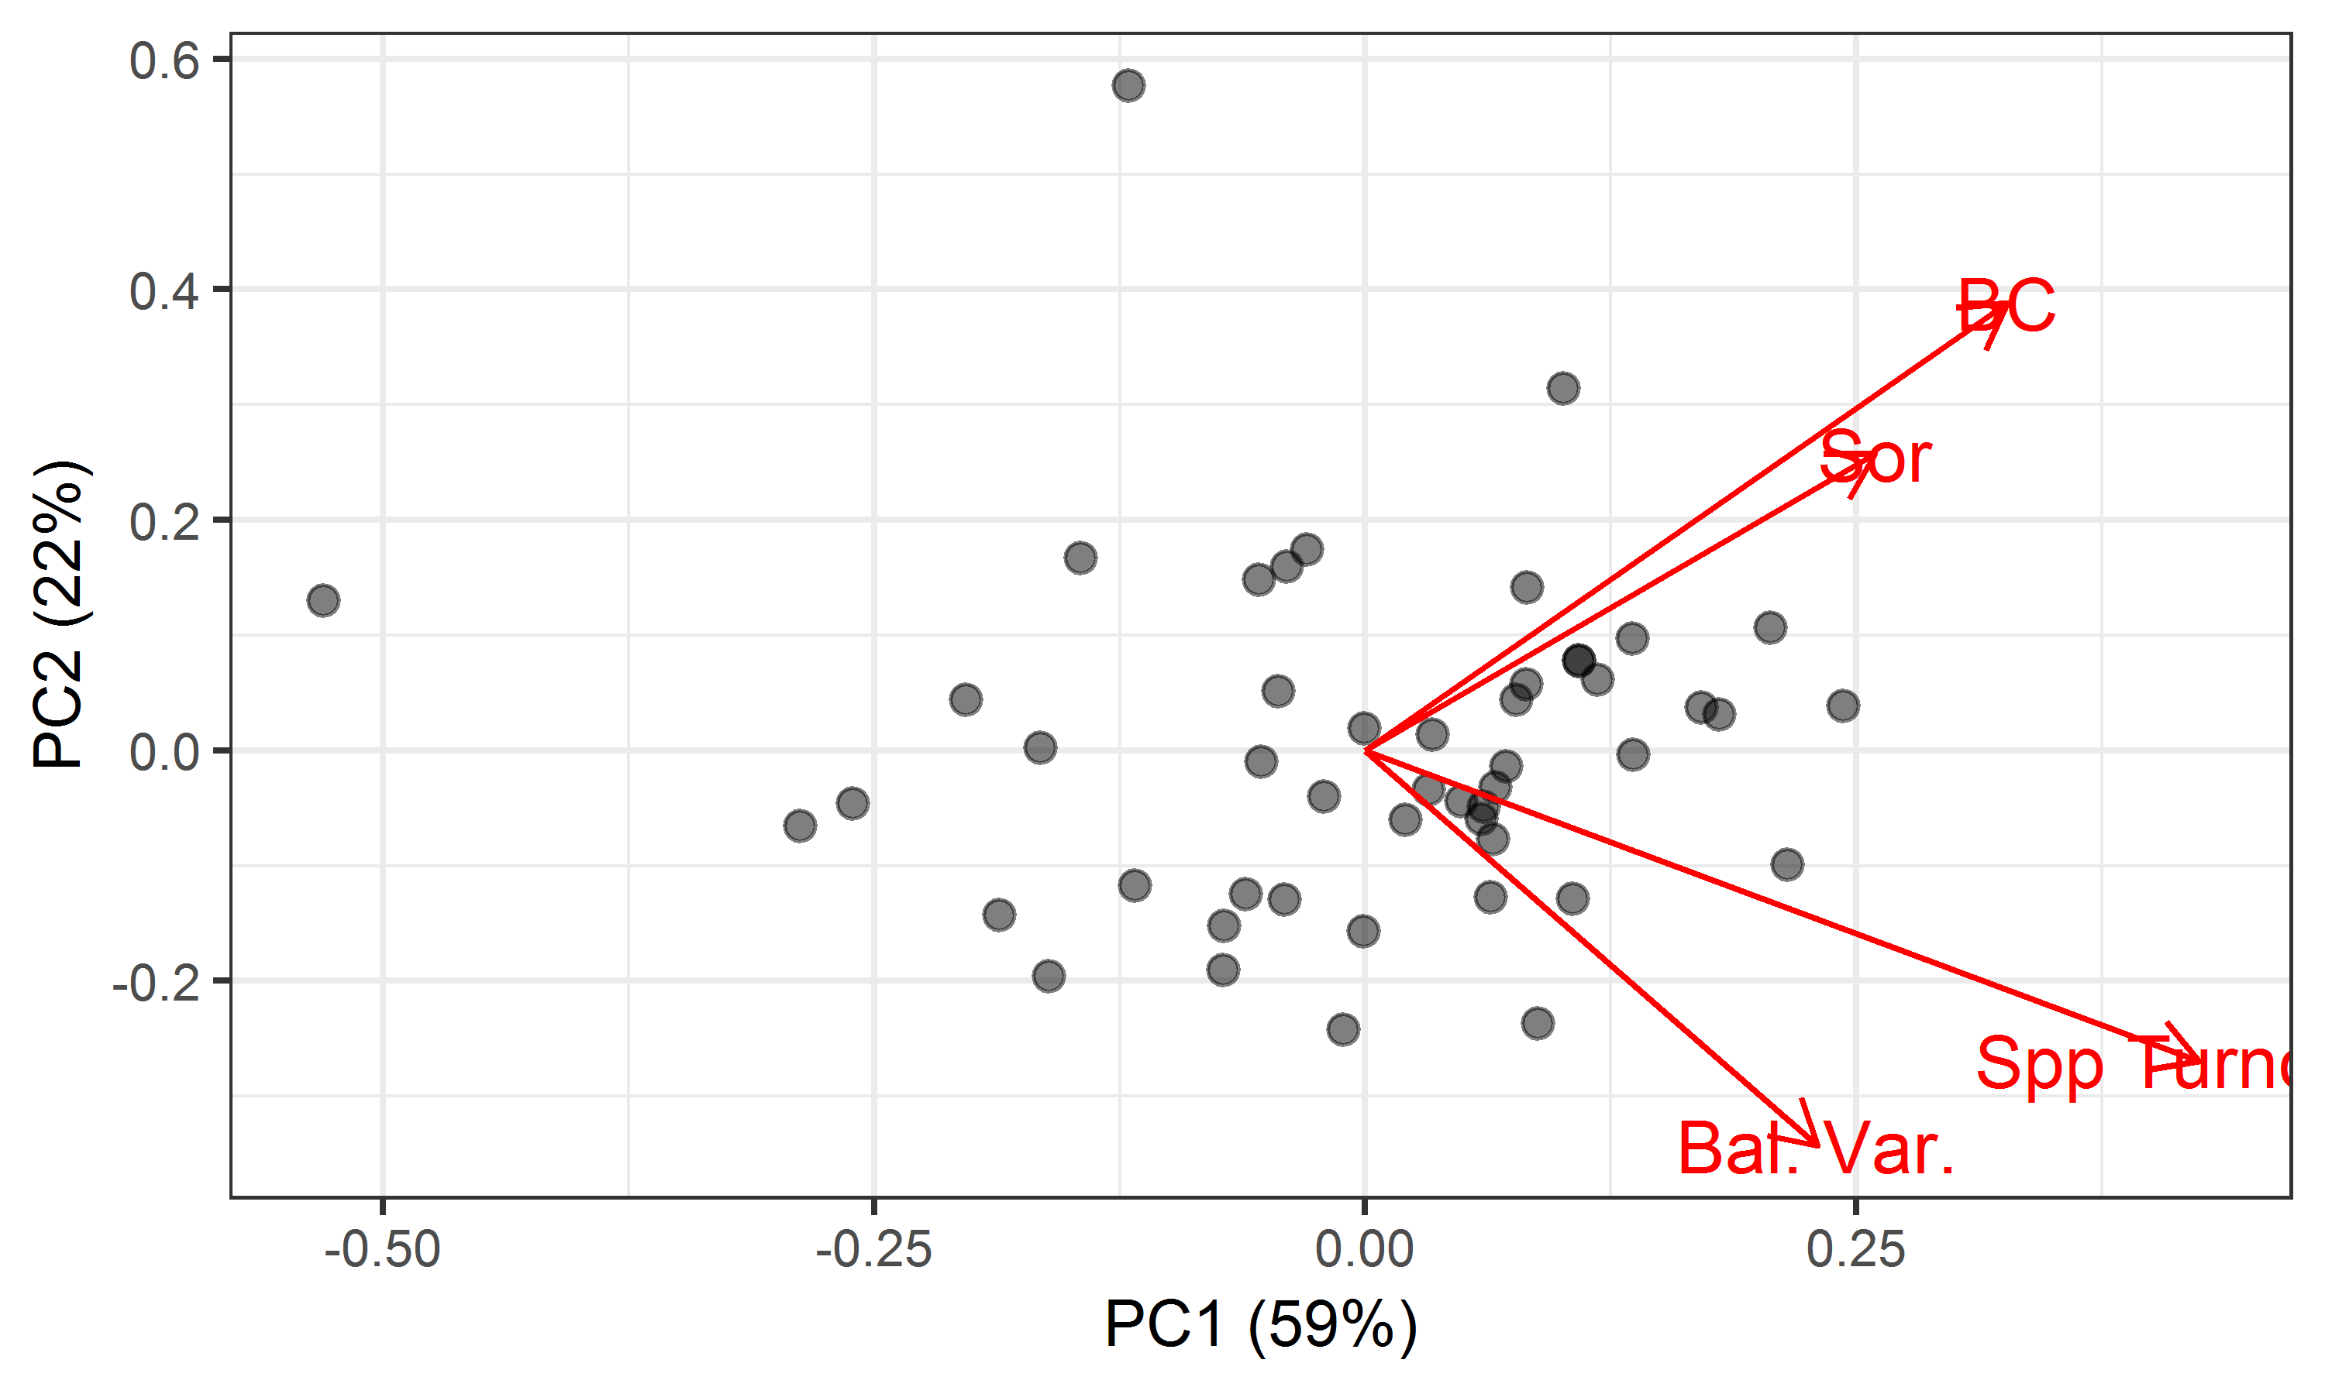

Note the site in the upper left corner of the biplot, cowi.ca, which is very different from all other sites on PC1, and the site at the top, ethass.au, which is very different from all other sites on PC2.

Each principal component (PC) is orthogonal to the others and can be analyzed independently. The below table has the same structure as Table S3.

|  |  |  |  |  |  |  |
| --- | --- | --- | --- | --- | --- | --- |
| **Explanatory Variable** | **Abbrev.** | **Units** | **PC1 (59%)** | **PC2 (22%)** | **PC3 (12%)** | **PC4 (7%)** |
| Gamma diversity | log(S) |  | **<0.001** | **0.014** | 0.050 | 0.831 |
| Productivity | Prod. | g m-2 | **0.040** | 0.447 | 0.956 | **<0.001** |
| Local variation in productivity | Local Var. | % | 0.638 | **<0.001** | 0.482 | 0.294 |
| Mean annual temperature | MAT | °C | 0.910 | 0.201 | 0.971 | 0.140 |
| Standard deviation in temperature | TEMP_VAR | °C | 0.504 | 0.250 | 0.434 | 0.350 |
| Annual temperature range | ATR | °C | 0.162 | **0.043** | 0.132 | 0.220 |
| Mean temperature, wettest quarter | TEMP_WET_Q | °C | 0.783 | 0.922 | 0.209 | **0.008** |
| Mean annual precipitation | MAP | mm | 0.333 | **0.007** | 0.063 | **0.010** |
| Seasonality (CV of precipitation) | MAP_VAR | % | 0.683 | **0.041** | 0.640 | 0.885 |
| Nitrogen deposition | N_Dep | xxx | 0.869 | 0.125 | 0.157 | 0.292 |
| Management | Manage. | 0, 1 | 0.944 | 0.157 | 0.437 | 0.913 |

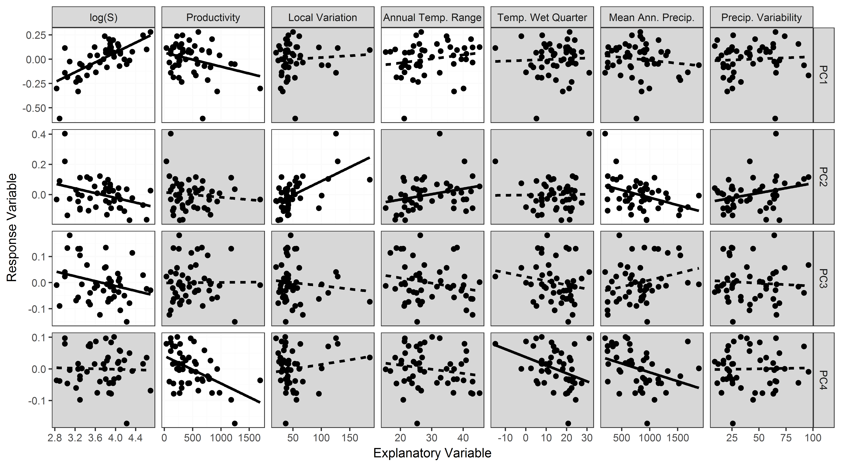

Figure X. Results of simple linear models relating potential site-level explanatory variable to each of the principal components derived from a PCA of the four compositional metrics. Panels with solid lines indicate statistically significant (P ≤ 0.05) relationships as identified through simple linear regression (previous page). White panels were included in the final models resulting from a model selection process (below).

Table X. Model results relating principal component scores derived from a PCA of the four compositional metrics to site-level explanatory variables. Coefficients are reported for those site-level explanatory variables added through model selection (conducted separately for each metric). The overall adjusted R2 for each model is also reported. Simple linear models relating each variable to each metric of compositional variation are reported earlier in this appendix.

|  |  |  |  |  |  |  |  |  |
| --- | --- | --- | --- | --- | --- | --- | --- | --- |
| PC | Explanation | Intercept | log(S) | Product-ivity | Local Variation in Productivity | Annual Temperature Range | Mean Annual Precip. | Model R2 (adj.) |
| PC1 | High values = more magnitude + more turnover | -1.053 | 0.255 | -0.00012 |  | 0.0054 |  | 0.574 |
| PC2 | High values = more magnitude + less turnover | 0.191 | -0.055 |  | 0.0014 |  | -0.00007 | 0.396 |
| PC3 | High values = more abundance-based metrics, less incidence-based metrics | 0.174 | -0.047 |  |  |  |  | 0.060 |
| PC4 | High values = less Sorensen dissimilarity. Opposing patterns for types of metrics x abundance/incidence basis … analogous to an interaction? | 0.041 |  | -0.00009 |  |  |  | 0.232 |

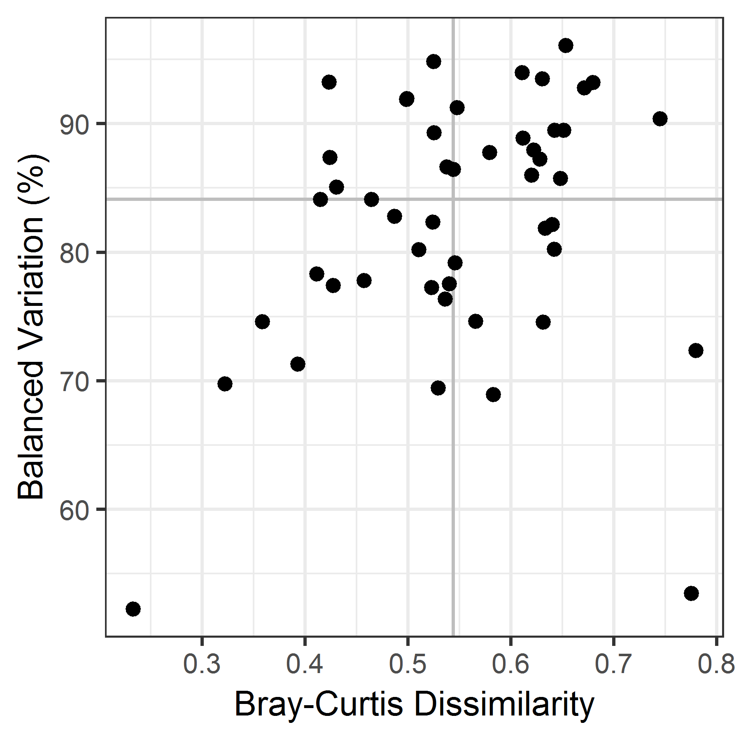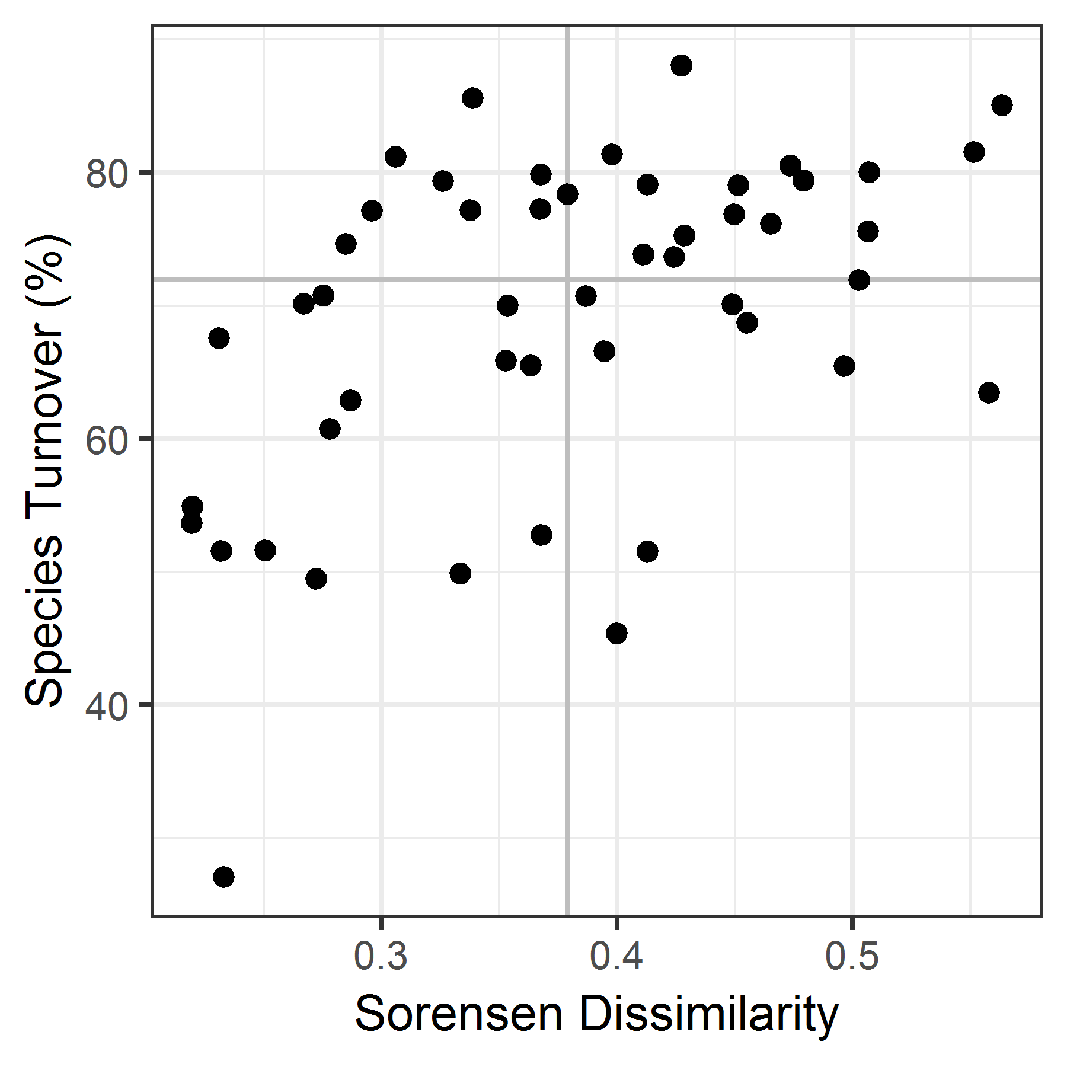

Figure XX. Relationship between magnitude of composition variation (horizontal axes) and the percentage of that compositional variation due to species turnover (vertical axes). In each graph, points are sites. Vertical and horizontal lines are the median values for each variable. Note that axis scales differ among graphs.

To do: Could also use these quadrants to code sites in Figure S1. For example, sites with high variation and high turnover, high variation but low turnover, etc.

Results: Note that sites span all four quadrats (high compositional variation with high turnover, high compositional variation with low turnover, low compositional variation with high turnover, and low compositional variation with low turnover).