**Title: Dimensionality of nutrient enrichment response in global grasslands** (will make more compelling)

**Authors:** Evan Batzer, Siddharth Bharath,…

**Key Question:**

**Key Reading:** Suggestions here would be good – Harpole et al. 2016 + 2017? Or is that redundant for NutNet folks? Donohue et al. (2013) is a good background for methodology, but less so for key concepts.

**Bonus Reading:** As above

**Feedback Requested:** To be determined

I think the key issues are:

1. Assessing clarification needed for analysis approach
2. Suggested analyses and followups, particularly:
   1. Value / ability to include trait data such as plant height
   2. Ways to better disentangle site-by-site variation
   3. Better propagation of observation uncertainty – permutation tests of PC loading, etc.
3. General assistance with writing + broader context

**Abstract**

Tradeoffs across multi-dimensional niche space are thought to be key drivers of species diversity. In grassland systems, experimental manipulations of multiple soil resources produce declines in species richness through collapse in niche dimensionality. Two sets of tradeoffs are hypothesized to govern species responses to nutrient enrichment in grasslands – contrasts between above- and below-ground investment and specialization on individual soil resources. The former implies that a single axis characterizes species responses to addition of all limiting soil resources, while the latter suggests that species responses are of higher dimension. Here, we assess the dimensionality of species responses to experimental fertilization of three different nutrient treatments across xx grassland sites around the world. We find evidence for a single dominant axis describing fertilization response, indicating that species abundances change in similar fashion across multiple treatments. However, consistent deviations from this general relationship by plant functional groups imply that specialization on different soil resources acts as an important secondary driver. Our results demonstrate that grassland species may be described along a single gradient of fertilization response, implying a general tradeoff between above- vs. below-ground investment. While this finding suggests that anthropogenic enrichment of many nutrients may result in similar compositional shifts, these changes are moderated by community functional diversity.

**Introduction**

1. Variation in occupied niche space is theorized to be an important driver of species coexistence in plant communities. In many systems, there are several relevant axes of variation, producing a multi-dimensional niche space.
2. Human activities are causing large shifts in the availability of key resources that interact with species’ occupied niches to produce change in the diversity and composition of plant communities. Resource enrichment, in particular, has been theorized to drive biodiversity loss by collapsing niche dimensionality – the reduction in relevant variation across key niche axes.
3. While niche space may be high dimensional, species responses to resource enrichment may be characterized by far lower dimensionality; plant physiological adaptations are likely to generate positively or negatively correlated responses to different resource additions, which may be characterized by a small number of key axes of variation.
4. Previous work using Nutrient Network data has demonstrated the importance of multiple limiting resources across global grasslands. These studies have shown the effects of multiple nutrient addition on aggregate community attributes, such as biomass or diversity, but less is known of abundance change at the species level.
5. Here, we assess the dimensionality of species responses to experimental fertilization by different nutrients. Are species responses correlated across fertilization treatments?

**Methods**

1. We selected sites with sufficient experimental duration to detect compositional change – 5+ years of experimental fertilization, with pre-treatment year.
2. Fit multiple linear regression models to plots with single nutrient addition treatments (+N, +P, +Kµ) and control plots. Extracted the estimated rate of change in species abundance per year of treatment to allow standardization of response across sites with different experimental durations.
3. For each site, calculated correlations between community vectors of change in different nutrient enrichment treatments – estimated responses for all species present within a site.
4. Decompose estimated responses using PCA, characterize shape and dimensionality using principal components and associated eigenvalues (Figure 1 for reference).
5. Examine pairwise correlations between responses, and analyze the role of functional group variation in the distribution therein.

**Results**

1. A majority of sites showed significant (*P < 0.05)* compositional changes in all three fertilization treatments (+N, +P, +Kµ), though the magnitude of compositional change varied with nutrient identity (Figure 2). On average, N enrichment was estimated to have the largest effect on species composition, followed by P, and Kµ.
2. PCA of compositional responses across all sites exhibited a relatively low-dimensional pattern; the first principal component accounted for 60% of the total variation in species responses (Figure 3, Table 1). Responses to fertilization were positively correlated, indicating that species may be considered to be general positive or negative responders to fertilization.
3. Pairwise comparisons show that this general relationship varies depending on functional group, however (Figure 4). Legumes, in particular, show significant deviations in response from other dominant functional groups, graminoids and forbs, where legume responses to P and K are greater than would be expected given species N response (Table 2). This finding suggests some degree of specialization by this functional group on utilizing available P and K, as would be expected given their ability to fix nitrogen.
4. Sites also show a significant degree of variation – bivariate correlations in compositional response vary from extremely positive to slightly negative (Figure 5).
   1. Disentangling this site-by-site variation is a focus of further exploration.

**Discussion**

1. Human-driven changes to environmental systems often occur across many dimensions, whether through disturbance, disease, or nutrient loading. However, their realized effect on biotic composition depends on interactions with the existing community.
   1. Constraints on physiological adaptations are likely to make species respond positively or negatively to suites of different environmental stressors.
2. We find evidence that plant responses to fertilization of different resources are often correlated in direction, though magnitudes may differ.
   1. Certain physiological tradeoffs may govern this, such as differences in plant above- and below-ground investment
3. As a result, effects of fertilization by different nutrients may be expected to compound, selecting for the same set of species
   1. Plant response to fertilization appears largely a function of resource supply, rather than resource identity.
4. Other ecosystem attributes, such ecosystem functions, seem to show similar patterns of low dimensionality in response to removal of key consumers (Donohue et al. 2013).
   1. Despite diverse changes to many systems, correlated responses to stressors may result in general biotic homogenization.
5. This section, in particular, would benefit from more attention

**References**

Donohue, I., O. L. Petchey, J. M. Montoya, A. L. Jackson, L. Mcnally, M. Viana, K. Healy, M. Lurgi, N. E. O’Connor, and M. C. Emmerson. 2013. On the dimensionality of ecological stability. Ecology Letters 16:421–429.

Harpole, W. S., L. L. Sullivan, E. M. Lind, J. Firn, P. B. Adler, E. T. Borer, J. Chase, P. A. Fay, Y. Hautier, H. Hillebrand, A. S. MacDougall, E. W. Seabloom, J. D. Bakker, M. W. Cadotte, E. J. Chaneton, C. Chu, N. Hagenah, K. Kirkman, K. J. La Pierre, J. L. Moore, J. W. Morgan, S. M. Prober, A. C. Risch, M. Schuetz, and C. J. Stevens. 2017. Out of the shadows: multiple nutrient limitations drive relationships among biomass, light and plant diversity. Functional Ecology 31:1839–1846.

Harpole, W. S., L. L. Sullivan, E. M. Lind, J. Firn, P. B. Adler, E. T. Borer, J. Chase, P. A. Fay, Y. Hautier, H. Hillebrand, A. S. MacDougall, E. W. Seabloom, R. Williams, J. D. Bakker, M. W. Cadotte, E. J. Chaneton, C. Chu, E. E. Cleland, C. D’Antonio, K. F. Davies, D. S. Gruner, N. Hagenah, K. Kirkman, J. M. H. Knops, K. J. La Pierre, R. L. McCulley, J. L. Moore, J. W. Morgan, S. M. Prober, A. C. Risch, M. Schuetz, C. J. Stevens, and P. D. Wragg. 2016. Addition of multiple limiting resources reduces grassland diversity. Nature 537:93–96.

**Figure 1:**

Conceptual diagram illustrating low dimensional (a-c) and high dimensional (d-f) community responses to enrichment of nitrogen (N), phosphorous (P), and potassium and other micronutrients (K). In a low dimensional system, species responses to different limiting nutrients are strongly inter-correlated (a). The resulting 3-dimensional visualization of these species responses (b) are captured by a linear ellipsoid, which may be decomposed in a principal components analysis (PCA) where a single dominant eigenvector, “PC1”, accounts for a large proportion of the overall variance. In a high-dimensional system, species responses to different limiting resources are not correlated (d), producing a spherical ellipsoid in 3-dimensional space (e). The resulting PCA decomposition shows more even apportioning of variance across the three eigenvectors (f).

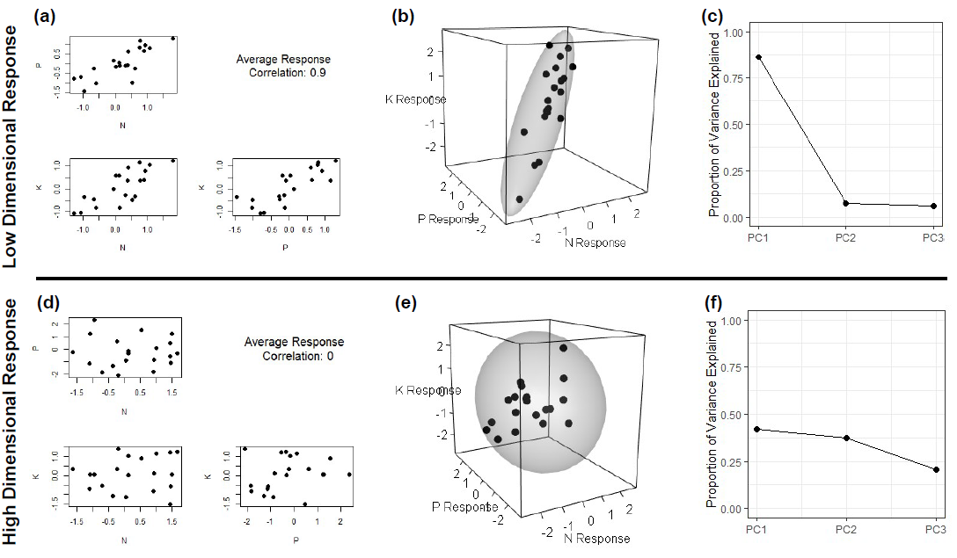

**Figure 2:**

1. Frequency of sites exhibiting significant (p < 0.05) effects of experimental fertilization on plant community composition. Of 50 total sites, 35 showed significant compositional changes to all three fertilization treatments, while 1 site showed non-significant compositional responses to all fertilization treatments.
2. Rate of estimated fertilization-driven change in species composition. The rate of total compositional change was calculated as the magnitude of the vector of estimated species response coefficients, estimating net change in log2-transformed species cover per log-transformed of treatment. Higher values indicate greater overall rate of compositional change.

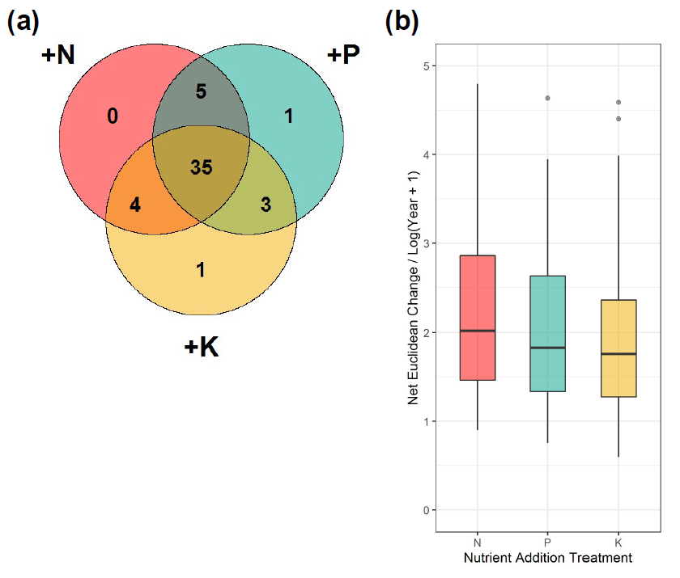

**No Response**

**1**

**Figure 3**

Three-dimensional visualization of species responses to fertilization treatments (Figure 3a) and associated principal components analysis (PCA) screeplot (Figure 3b). Positive correlations between estimated species responses produce an ellipsoid with a dominant first axis, as a majority of the overall response variation may be captured by the first eigenvector (Table 1). Permutation-based test of the magnitude of the first eigenvalue (PC1) is statistically significant (*p* < 0.01), indicating that the observed response pattern exhibits lower dimensionality than would be expected at random.

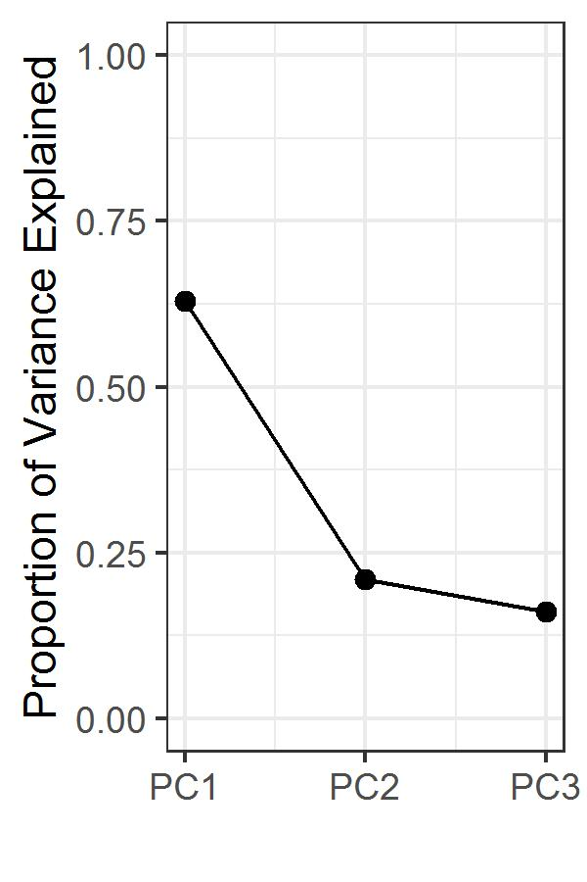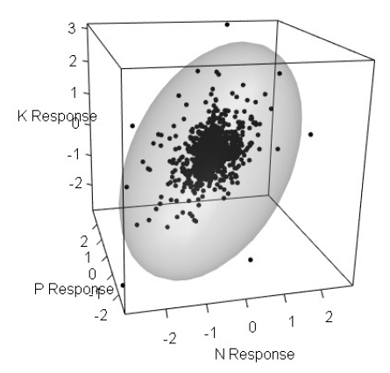

**(a)**

**(b)**

**Table 1**

Results of principal components analysis (PCA) of species responses to experimental fertilization treatments. Eigenvectors show positive variable loadings on the first principal component of all treatment responses, indicating that positively correlated responses to treatment form a dominant pattern in the data. However, once the general relationship of the first principal component is accounted for, second and third PC’s suggest that a multivariate tradeoff may be present.

|  |  |  |  |  |
| --- | --- | --- | --- | --- |
| Principal Component Analysis | |  |  |  |
|  | PC1 | | PC2 | PC3 |
| Eigenvalue | 0.43 | | 0.25 | 0.22 |
| Proportion of Variance | 0.63 | | 0.21 | 0.16 |
| Cumulative Proportion | 0.63 | | 0.84 | 1.00 |
|  |  | |  |  |
| Eigenvectors |  | |  |  |
|  | PC1 | | PC2 | PC3 |
| N response | 0.64 | | -0.76 | 0.10 |
| K response | 0.53 | | 0.35 | -0.78 |
| P response | 0.55 | | 0.55 | 0.62 |

**Figure 4**

Major axis (MA) regression plots demonstrating pairwise correlations between estimated fertilization treatment responses. For each subplot, individual points represent estimated species responses to different limiting resources, colored by species functional group. Colored lines indicate best-fit lines produced by MA regression. Slope coefficients and contrasts between functional groups are presented in Table 2. Axes are displayed at log2 scale, such that a 1-unit increase corresponds to a doubling of species estimated cover.

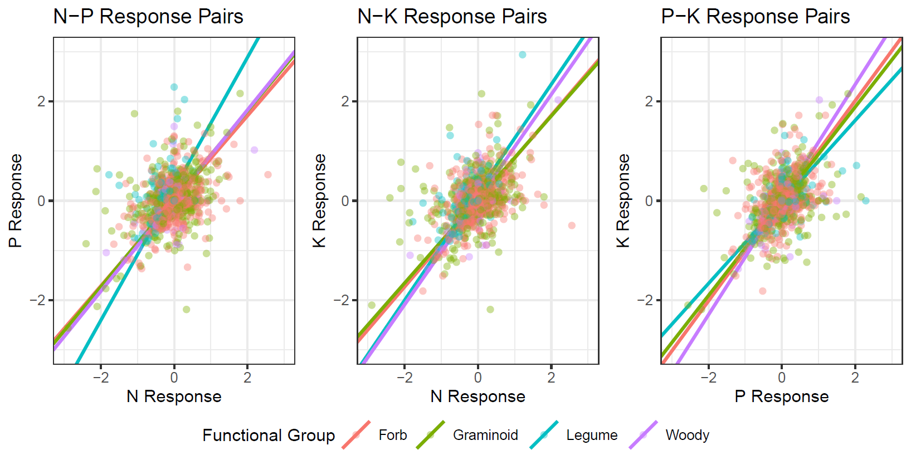

**Table 2**

Results of SMA model fitting to pairwise treatment responses. For each pairwise combination of treatment response coefficients, the within-group model R-squared, group slope, and post-hoc group labeling is presented. Groups where fitted slopes varied significantly (P < 0.05) were assigned different labels. P-values adjusted for multiple comparison using the Sidak correction. Generally, leguminous species often show distinct responses relative to other functional groups, particularly between estimated N and P response coefficients. Legumes appear to show greater specialization to P than other nutrients, exhibiting more extreme responses than would be expected given overall trends.

|  |  |  |  |  |  |  |  |  |  |  |
| --- | --- | --- | --- | --- | --- | --- | --- | --- | --- | --- |
|  |  | N - P | | | N - K | | | P - K | | |
| Functional Group | *n* | R-squared | Slope | Group | R-squared | Slope | Group | R-squared | Slope | Group |
| Forb | 1479 | 0.18 | 0.86 | 1 | 0.20 | 0.86 | 1 | 0.19 | 1.01 | 1 |
| Graminoid | 670 | 0.20 | 0.89 | 1 | 0.15 | 0.84 | 1 | 0.19 | 0.95 | 12 |
| Legume | 241 | 0.10 | 1.32 | 2 | 0.22 | 1.09 | 2 | 0.36 | 0.82 | 2 |
| Woody | 112 | 0.32 | 0.91 | 1 | 0.47 | 1.06 | 2 | 0.41 | 1.16 | 1 |

**Figure 5**

Histograms depicting the frequency of observed treatment response correlations across sites. For all three possible pairs of treatment responses, sites show positive average correlations between species responses to fertilization treatments. However, sites show significant variation in their observed treatment response correlations, ranging between moderately negatively correlated responses (-0.5) to very strongly positively correlated responses (>0.9).



**Appendix 1: Sites used in analysis**

|  |  |  |  |  |  |  |  |
| --- | --- | --- | --- | --- | --- | --- | --- |
|  | **site_code** | **site_name** | **continent** | **country** | **n_years** | **n_obs** | **first_nutrient_year** |
| 1 | azi.cn | Azi | Asia | CN | 5 | 60 | 2008 |
| 2 | bldr.us | Boulder South Campus | North America | US | 9 | 72 | 2009 |
| 3 | bnch.us | Bunchgrass (Andrews LTER) | North America | US | 12 | 142 | 2008 |
| 4 | bogong.au | Bogong | Australia | AU | 11 | 132 | 2010 |
| 5 | burrawan.au | Burrawan | Australia | AU | 12 | 144 | 2009 |
| 6 | cbgb.us | Chichaqua Bottoms | North America | US | 10 | 239 | 2010 |
| 7 | cdcr.us | Cedar Creek LTER | North America | US | 12 | 240 | 2008 |
| 8 | cdpt.us | Cedar Point Biological Station | North America | US | 12 | 288 | 2008 |
| 9 | cereep.fr | CEREEP - Ecotron IDF | Europe | FR | 7 | 84 | 2013 |
| 10 | chilcas.ar | Las Chilcas | South America | AR | 7 | 84 | 2014 |
| 11 | comp.pt | Companhia das Lezirias | Europe | PT | 8 | 96 | 2013 |
| 12 | cowi.ca | Cowichan | North America | CA | 12 | 144 | 2008 |
| 13 | elliot.us | Elliott Chaparral | North America | US | 11 | 130 | 2009 |
| 14 | ethass.au | Ethabuka (South Site) | Australia | AU | 7 | 80 | 2014 |
| 15 | frue.ch | Fruebuel | Europe | CH | 8 | 96 | 2009 |
| 16 | hall.us | Hall's Prairie | North America | US | 8 | 96 | 2008 |
| 17 | hart.us | Hart Mountain | North America | US | 6 | 72 | 2008 |
| 18 | hero.uk | Heronsbrook (Silwood Park) | Europe | UK | 7 | 84 | 2008 |
| 19 | hopl.us | Hopland REC | North America | US | 12 | 141 | 2008 |
| 20 | jena.de | JeNut | Europe | DE | 5 | 60 | 2015 |
| 21 | kbs.us | Kellogg Biological Station LTER | North America | US | 5 | 100 | 2014 |
| 22 | kibber.in | Kibber (Spiti) | Asia | IN | 8 | 96 | 2012 |
| 23 | kilp.fi | Kilpisjärvi | Europe | FI | 6 | 80 | 2014 |
| 24 | kiny.au | Kinypanial | Australia | AU | 11 | 132 | 2008 |
| 25 | koffler.ca | Koffler Scientific Reserve at Joker's Hill | North America | CA | 9 | 108 | 2011 |
| 26 | konz.us | Konza LTER | North America | US | 11 | 132 | 2008 |
| 27 | lancaster.uk | Lancaster | Europe | UK | 10 | 120 | 2009 |
| 28 | look.us | Lookout (Andrews LTER) | North America | US | 12 | 144 | 2008 |
| 29 | marc.ar | Mar Chiquita | South America | AR | 8 | 93 | 2012 |
| 30 | mcla.us | Mclaughlin UCNRS | North America | US | 12 | 144 | 2008 |
| 31 | mtca.au | Mt. Caroline | Australia | AU | 11 | 176 | 2009 |
| 32 | ping.au | Pingelly Paddock | Australia | AU | 6 | 72 | 2014 |
| 33 | pinj.au | Pinjarra Hills | Australia | AU | 5 | 60 | 2014 |
| 34 | rook.uk | Rookery (Silwood Park) | Europe | UK | 7 | 84 | 2008 |
| 35 | sage.us | Sagehen Creek UCNRS | North America | US | 7 | 84 | 2008 |
| 36 | saline.us | Saline Experimental Range | North America | US | 10 | 120 | 2008 |
| 37 | sava.us | Savannah River | North America | US | 6 | 48 | 2008 |
| 38 | sedg.us | Sedgwick Reserve UCNRS | North America | US | 11 | 132 | 2008 |
| 39 | sereng.tz | Serengeti | Africa | TZ | 5 | 60 | 2009 |
| 40 | sgs.us | Shortgrass Steppe LTER | North America | US | 12 | 142 | 2008 |
| 41 | shps.us | Sheep Experimental Station | North America | US | 10 | 160 | 2008 |
| 42 | sier.us | Sierra Foothills REC | North America | US | 12 | 232 | 2008 |
| 43 | smith.us | Smith Prairie | North America | US | 10 | 120 | 2008 |
| 44 | spin.us | Spindletop | North America | US | 12 | 144 | 2008 |
| 45 | temple.us | Temple | North America | US | 10 | 120 | 2008 |
| 46 | trel.us | Trelease | North America | US | 10 | 120 | 2009 |
| 47 | ukul.za | Ukulinga | Africa | ZA | 10 | 120 | 2010 |
| 48 | unc.us | Duke Forest | North America | US | 5 | 60 | 2008 |
| 49 | valm.ch | Val Mustair | Europe | CH | 10 | 120 | 2009 |
| 50 | yarra.au | Yarramundi | Australia | AU | 6 | 96 | 2015 |