**Title: The “Neutral Theory” of Niche Dimensionality**

**Authors:** Evan Batzer, Siddharth Bharath,…

**Key Question:** To what degree are compositional responses to experimental fertilization dependent on nutrient identity?

**Key Reading:** Harpole et al. (2016)**,** Cardinale et al. (2009)

**Bonus Reading:** Donohue et al. (2013) *for a similar methodological approach*

**Feedback Requested:**

1. *Site PIs:*

Please visit the following Shiny App web application to view site-specific results: <https://ebatzer.shinyapps.io/NN-Dimensionality/>

Site-specific results can be queried using a drop-down menu at the heading of the page. All figures and tables will update accordingly, though it may take a few seconds.

Do treatment effects and estimated species responses mirror your observations?

1. *Conceptual Basis and Methodology:*

Do conceptual figures (1a, 1b) and methods sufficiently explain the approach to this analysis? What additional topics should be addressed? What changes to figures or the basic description would be helpful?

1. *Results and Discussion:*

Attempts to explain site-by-site variation are limited in this outline (Figure 6). Before making a more concerted attempt to test potential predictors, some more discussion would be helpful: What features might make a site more or less likely to exhibit similar compositional responses to different nutrients?

Implications of this study are broad and may have implications for the study of plant coexistence, global change, or research methodology. Suggestions to tie this study into a broader context would be welcome.

**Abstract**

Multiple nutrient addition in grassland systems is theorized to alter species composition and diversity through tradeoffs across various niche axis. However, these niche axes may vary in both type and number, depending on site characteristics, community composition, and physiological constraints on competing species. The dimensionality of species responses to nutrient enrichment – variation responses across multiple treatments – may capture these interacting trade-offs.

Here, we use data from NutNet sites containing 5+ years of observation to evaluate the trajectories of compositional change in response to N, P, and K fertilizer treatments. Using a geometric approach, we test the validity of a “neutral” expectation of niche dimensionality, in which species responses are identical to all resource addition treatments. Generally, species responses are captured effectively by this one-dimensional response, though exhibit consistent deviations across sites and functional groups. Together, these results suggest that multiple trade-off mechanisms act simultaneously to structure community composition in grassland systems.

**Introduction**

1. In plant systems, coexistence among species with shared limiting resources is thought to be a function of trade-offs in resource use and uptake. Together, these limiting resources form part of a species niche, classically defined as a multi-dimensionalspace consisting of all environmental variables that may influence an organism’s performance.
2. Tradeoffs across different niche axes will be bounded by the number of these limiting resources; diversity loss following nutrient enrichment may be interpreted as a reduction in *niche dimensionality*, where a formerly limiting nutrient no longer affects plant growth (Harpole and Tilman 2007, Harpole et al. 2016).
3. Across grassland systems, experimental nutrient manipulations have shown that plant biomass is often simultaneously limited by multiple belowground resources (Fay et al. 2015). While the enrichment of one limiting nutrient may collapse a corresponding niche axis, the realized effects of this enrichment on community composition need not be unique for each nutrient added.
4. Instead, changes in community composition will depend on physiological constraints, environmental characteristics, and local interactions that control the space occupied by each species on different niche axes. While certain traits may cause a species to compete more effectively for one resource at the expense of others, some adaptations may increase fitness across multiple niche axes simultaneously.
5. Changes in plant community composition and diversity driven by fertilization have often been understood through a lens of a trade-off in above- vs. below-ground competition (DeMalach and Kadmon 2017). Nutrient enrichment is thought to shift resource limitation from mineral nutrients to light, defined by asymmetric competition where taller, faster growing species exclude smaller ones (Dybzinski and Tilman 2007, Hautier et al. 2009). This one-dimensional trade-off assumes similar community outcomes following multiple soil nutrient addition treatments; physiological constraints on root investment and morphology are likely to increase plant absorption of multiple mineral nutrients simultaneously, at the expense of investment in photosynthetic tissues (Chapin 1980).
6. However, growing evidence suggests that plant community responses to fertilizer enrichment may also be governed by multi-dimensional trade-offs in competition for belowground nutrients (Harpole et al. 2017). Variation in plant stoichiometry and nutrient acquisition strategy may produce specialization for one or more resources, leading to variable community outcomes under different nutrient addition treatments. Nitrogen fixation by leguminous species, for example, may confer enhanced performance under elevated phosphorous or potassium concentrations, but yield limited benefits following application of nitrogen fertilizer.
7. Critically, the degree to which compositional changes are characterized by one- or many-dimensional responses to treatment will depend on the properties of interacting species at a given site. Because nutrient-driven changes in species abundance depend on a species’ ability to reduce nutrient concentrations relative to its competitors (Tilman 1987), greater variation in competitive ability in a local species pool may increase the probability that the set of best performing species differs between treatments. Similarly, the importance of light competition is known to depend on productivity (Hautier et al. 2018); highly productive sites may select for effective competitors prior to treatment, constraining the effect of tradeoffs driven by differences in above- and below-ground investment
8. To understand these multiple, interacting processes, we aim to assess the *response dimensionality* of Nutrient Network sites following multiple nutrient enrichment – defined as the variation in species responses to collapse of different niche dimensions.
9. Using a geometric approach (Figure 1), we compare observed changes in species abundance to a “neutral” expectation, where responses are identical across all treatment types, once controlling for differences in their overall magnitude of effect. This neutral expectation thus forms an effective null model to determine the predictive power of a one-dimensional pattern of response, while deviations from this relationship highlight the species and site characteristics that produce multi-dimensional tradeoffs.
10. We hypothesize:
    * Responses to nutrient enrichment will be generally defined by a one-dimensional relationship, where species consistently increase or decrease in abundance;
    * Species will exhibit correlated deviations from this relationship as a function of resource uptake strategy or functional group;
    * Sites which are more productive or diverse prior to treatment will be characterized by greater response dimensionality.

**Methods**

1. Sites with sufficient experimental duration to detect compositional change were selected for analysis. Data were filtered to single nutrient enrichment treatments (+N, +P, +Kµ) and control plots in all sites with 5+ years of experimental fertilization, including pre-treatment year.
2. Given that species abundances often form lognormal distributions in natural communities, species abundances were transformed using a log2 transformation prior to model fitting (Anderson et al. 2006). This transformation provides responses on a more natural response scale and closer adherence to model assumptions.
3. For each *species within a site*, we fit the following linear model:



Where the abundance of a species is estimated as a function of the log-transformed number of years of nutrient treatment *i*, while accounting for site-level temporal and spatial variation present in year *j* and block *k*. Models were fit simultaneously for all species within a site using multiple linear regression. Total magnitude of all coefficients were then tested for significance using permutation-based tests. Model fitting conducted using RRPP (Collyer and Adams 2018).

1. Treatment coefficients were then extracted for all species within a site, forming estimates of species responses to one log-year of nutrient enrichment.

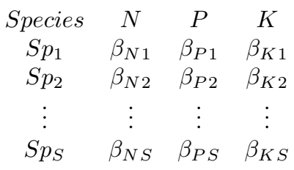

1. For each site, aggregate treatment effect on community abundance of all species present was calculated using the Euclidean (L2) norm of response coefficients. Community response to nitrogen, for example, was calculated by:

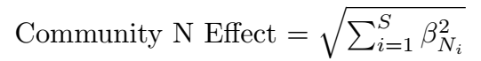

For all species, *S,* present within a site.

1. We then filtered these coefficients to those species present in at least 20% of all plots present within a site for comparison of nutrient response coefficients. Due to variation in average coefficient value, these were Z-transformed to standardize responses across nutrient treatments.
2. To evaluate dimensionality of nutrient enrichment response, we performed a geometric analysis similar to that of Cardinale et al. (2009). Coefficient values observed across 3 dimensions (N response, P response, K response) were projected onto a 1:1:1 vector that assumes identical species responses to each treatment (Figure 1). Residual deviations from this vector were then projected onto a coordinate basis orthogonal to this 1:1:1 response vector.

This change of basis can be expressed by the following matrix, where vectors are standardized to unit length.

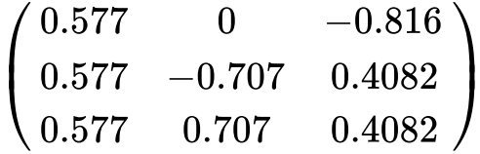

**Results**

1. A majority of sites showed significant (*P < 0.05)* compositional changes to all three fertilization treatments (+N, +P, +Kµ), though the magnitude of compositional change varied with nutrient identity (Figure 2). Once accounting for site-level variation, average community responses to N enrichment was found to be significantly (*P < 0.05*) larger than either P or K enrichment, which did not differ significantly from one another.
2. Pairwise comparisons show generally positively correlated responses to nutrient enrichment (Figure 3). Legumes, however, show significant deviations in response from other dominant functional groups, graminoids and forbs, where legume responses to P are greater than would be expected given species N response (Table 2). This finding suggests some degree of specialization by this functional group on utilizing available P and K.
3. Projection of 3-dimensional species responses to a one-dimensional vector captured a majority (58.4%) of total response variance (Figure 4). This proportion was found to be highly statistically significant (*P < 0.01*) relative to random permutations, in which responses were shuffled within species at each site. Moreover, this 1:1:1 pattern of nutrient response is remarkably similar to inherent patterns in the data revealed by PCA, which explains a nearly identical proportion of total response variance (58.9%).
4. Deviations from this neutral expectation exhibit correlated patterns with respect to plant functional group (Figure 5). Leguminous species occupied a different mean position on Axis 3 than other functional groups, correlated with more positive responses to P and K than a neutral expectation, and more negative responses to N (Table 2).
5. Site-level variation in the fraction of response variance captured by neutral expectation varied considerably. Of four predictors tested, pre-treatment site biomass showed the only significant relationship with response dimensionality across sites with significant magnitudes of response to all treatment types.

**Discussion**

1. Across sites, we find evidence that plants respond similarly to different nutrient enrichment treatments. The strength of this “null” expectation indicates that species are likely to exhibit adaptations that confer advantages under generally low or high fertility.
2. However, deviations from this relationship found across sites and functional groups indicate that multiple trade-offs interact to control community responses to nutrient enrichment. Specialization on certain resources by leguminous species and considerable between-site variance indicate that response dimensionality depends on species-specific stoichiometry and environmental context.
3. Our approach is a useful, broadly generalizable approach to understanding community trajectories following multiple experimental treatments. Evidence suggests that many ecosystem functions, such as productivity and invasion resistance, may exhibit similar one-dimensional patterns of change (Donohue et al. 2013). Dimensionality can be a tool to understand how stressors interact with other drivers of community composition and may be extended to larger suites of treatments.

**References**

Anderson, M. J., K. E. Ellingsen, and B. H. McArdle. 2006. Multivariate dispersion as a measure of beta diversity. Ecology Letters 9:683–693.

Cardinale, B. J., H. Hillebrand, W. S. Harpole, K. Gross, and R. Ptacnik. 2009. Separating the influence of resource “availability” from resource “imbalance” on productivity-diversity relationships. Ecology Letters 12:475–487.

Chapin, F. S. 1980. The Mineral Nutrition of Wild Plants. Annual Review of Ecology and Systematics 11:233–260.

Collyer, M. L., and D. C. Adams. 2018. RRPP : An r package for fitting linear models to high- ­ dimensional data using residual randomization. Methods in Ecology and Evolution:1772–1779.

DeMalach, N., and R. Kadmon. 2017. Light competition explains diversity decline better than niche dimensionality. Functional Ecology 31:1834–1838.

Donohue, I., O. L. Petchey, J. M. Montoya, A. L. Jackson, L. Mcnally, M. Viana, K. Healy, M. Lurgi, N. E. O’Connor, and M. C. Emmerson. 2013. On the dimensionality of ecological stability. Ecology Letters 16:421–429.

Dybzinski, R., and D. Tilman. 2007. Resource use patterns predict long-term outcomes of plant competition for nutrients and light. American Naturalist 170:305–318.

Fay, P. A., S. M. Prober, W. S. Harpole, J. M. H. Knops, J. D. Bakker, E. T. Borer, E. M. Lind, A. S. MacDougall, E. W. Seabloom, P. D. Wragg, P. B. Adler, D. M. Blumenthal, Y. M. Buckley, C. Chu, E. E. Cleland, S. L. Collins, K. F. Davies, G. Du, X. Feng, J. Firn, D. S. Gruner, N. Hagenah, Y. Hautier, R. W. Heckman, V. L. Jin, K. P. Kirkman, J. Klein, L. M. Ladwig, Q. Li, R. L. McCulley, B. A. Melbourne, C. E. Mitchell, J. L. Moore, J. W. Morgan, A. C. Risch, M. Schütz, C. J. Stevens, D. A. Wedin, and L. H. Yang. 2015. Grassland productivity limited by multiple nutrients. Nature Plants 1:1–5.

Harpole, W. S., L. L. Sullivan, E. M. Lind, J. Firn, P. B. Adler, E. T. Borer, J. Chase, P. A. Fay, Y. Hautier, H. Hillebrand, A. S. MacDougall, E. W. Seabloom, J. D. Bakker, M. W. Cadotte, E. J. Chaneton, C. Chu, N. Hagenah, K. Kirkman, K. J. La Pierre, J. L. Moore, J. W. Morgan, S. M. Prober, A. C. Risch, M. Schuetz, and C. J. Stevens. 2017. Out of the shadows: multiple nutrient limitations drive relationships among biomass, light and plant diversity. Functional Ecology 31:1839–1846.

Harpole, W. S., L. L. Sullivan, E. M. Lind, J. Firn, P. B. Adler, E. T. Borer, J. Chase, P. A. Fay, Y. Hautier, H. Hillebrand, A. S. MacDougall, E. W. Seabloom, R. Williams, J. D. Bakker, M. W. Cadotte, E. J. Chaneton, C. Chu, E. E. Cleland, C. D’Antonio, K. F. Davies, D. S. Gruner, N. Hagenah, K. Kirkman, J. M. H. Knops, K. J. La Pierre, R. L. McCulley, J. L. Moore, J. W. Morgan, S. M. Prober, A. C. Risch, M. Schuetz, C. J. Stevens, and P. D. Wragg. 2016. Addition of multiple limiting resources reduces grassland diversity. Nature 537:93–96.

Harpole, W. S., and D. Tilman. 2007. Grassland species loss resulting from reduced niche dimension. Nature 446:791–793.

Hautier, Y., P. a Niklaus, and A. Hector. 2009. Competition for light causes plant biodiversity loss after eutrophication. Science (New York, N.Y.) 324:636–638.

Hautier, Y., E. Vojtech, and A. Hector. 2018. The importance of competition for light depends on productivity and disturbance. Ecology and Evolution 8:10655–10661.

Tilman, D. 1987. Secondary succession and the pattern of plant dominance along experimental nitrogen gradients. Ecological Monographs 57:189–214.

Anderson, M. J., K. E. Ellingsen, and B. H. McArdle. 2006. Multivariate dispersion as a measure of beta diversity. Ecology Letters 9:683–693.

Cardinale, B. J., H. Hillebrand, W. S. Harpole, K. Gross, and R. Ptacnik. 2009. Separating the influence of resource “availability” from resource “imbalance” on productivity-diversity relationships. Ecology Letters 12:475–487.

Chapin, F. S. 1980. The Mineral Nutrition of Wild Plants. Annual Review of Ecology and Systematics 11:233–260.

Collyer, M. L., and D. C. Adams. 2018. RRPP : An r package for fitting linear models to high- ­ dimensional data using residual randomization. Methods in Ecology and Evolution:1772–1779.

DeMalach, N., and R. Kadmon. 2017. Light competition explains diversity decline better than niche dimensionality. Functional Ecology 31:1834–1838.

Donohue, I., O. L. Petchey, J. M. Montoya, A. L. Jackson, L. Mcnally, M. Viana, K. Healy, M. Lurgi, N. E. O’Connor, and M. C. Emmerson. 2013. On the dimensionality of ecological stability. Ecology Letters 16:421–429.

Dybzinski, R., and D. Tilman. 2007. Resource use patterns predict long-term outcomes of plant competition for nutrients and light. American Naturalist 170:305–318.

Fay, P. A., S. M. Prober, W. S. Harpole, J. M. H. Knops, J. D. Bakker, E. T. Borer, E. M. Lind, A. S. MacDougall, E. W. Seabloom, P. D. Wragg, P. B. Adler, D. M. Blumenthal, Y. M. Buckley, C. Chu, E. E. Cleland, S. L. Collins, K. F. Davies, G. Du, X. Feng, J. Firn, D. S. Gruner, N. Hagenah, Y. Hautier, R. W. Heckman, V. L. Jin, K. P. Kirkman, J. Klein, L. M. Ladwig, Q. Li, R. L. McCulley, B. A. Melbourne, C. E. Mitchell, J. L. Moore, J. W. Morgan, A. C. Risch, M. Schütz, C. J. Stevens, D. A. Wedin, and L. H. Yang. 2015. Grassland productivity limited by multiple nutrients. Nature Plants 1:1–5.

Harpole, W. S., L. L. Sullivan, E. M. Lind, J. Firn, P. B. Adler, E. T. Borer, J. Chase, P. A. Fay, Y. Hautier, H. Hillebrand, A. S. MacDougall, E. W. Seabloom, J. D. Bakker, M. W. Cadotte, E. J. Chaneton, C. Chu, N. Hagenah, K. Kirkman, K. J. La Pierre, J. L. Moore, J. W. Morgan, S. M. Prober, A. C. Risch, M. Schuetz, and C. J. Stevens. 2017. Out of the shadows: multiple nutrient limitations drive relationships among biomass, light and plant diversity. Functional Ecology 31:1839–1846.

Harpole, W. S., L. L. Sullivan, E. M. Lind, J. Firn, P. B. Adler, E. T. Borer, J. Chase, P. A. Fay, Y. Hautier, H. Hillebrand, A. S. MacDougall, E. W. Seabloom, R. Williams, J. D. Bakker, M. W. Cadotte, E. J. Chaneton, C. Chu, E. E. Cleland, C. D’Antonio, K. F. Davies, D. S. Gruner, N. Hagenah, K. Kirkman, J. M. H. Knops, K. J. La Pierre, R. L. McCulley, J. L. Moore, J. W. Morgan, S. M. Prober, A. C. Risch, M. Schuetz, C. J. Stevens, and P. D. Wragg. 2016. Addition of multiple limiting resources reduces grassland diversity. Nature 537:93–96.

Harpole, W. S., and D. Tilman. 2007. Grassland species loss resulting from reduced niche dimension. Nature 446:791–793.

Hautier, Y., P. a Niklaus, and A. Hector. 2009. Competition for light causes plant biodiversity loss after eutrophication. Science (New York, N.Y.) 324:636–638.

Hautier, Y., E. Vojtech, and A. Hector. 2018. The importance of competition for light depends on productivity and disturbance. Ecology and Evolution 8:10655–10661.

Tilman, D. 1987. Secondary succession and the pattern of plant dominance along experimental nitrogen gradients. Ecological Monographs 57:189–214.

**Figure 1:**

Geometric approach used to evaluate dimensionality of resource response. Species responses to the addition of three different limiting nutrients are projected onto a vector where responses are assumed to be identical to one another (Dimension 1; Figure 1a). Proportional variance in species responses captured by this projection forms a measure of *niche dimensionality* bounded between (0,1) where low-dimensional (linear) responses are perfectly captured by this projection. Higher dimensional patterns manifest as lower proportions of variance captured by this projection, such as spherical patterns, where treatment responses are uncorrelated with one another, or relationships orthogonal to this 1:1:1 vector where pairs of responses are correlated to one another, but both negatively correlated to a third. Residual variation not captured by this projection may be visualized on an orthogonal coordinate system to illustrate *in what manner* species deviate from a null expectation (Figure 1b).

`

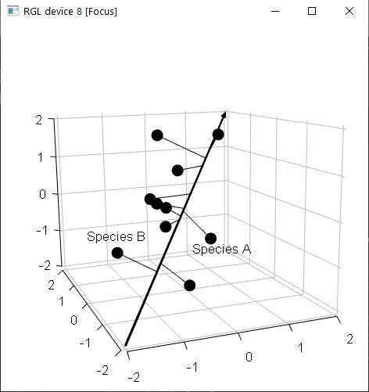

Dimension 1

(1:1:1)

N Response

P Response

K Response

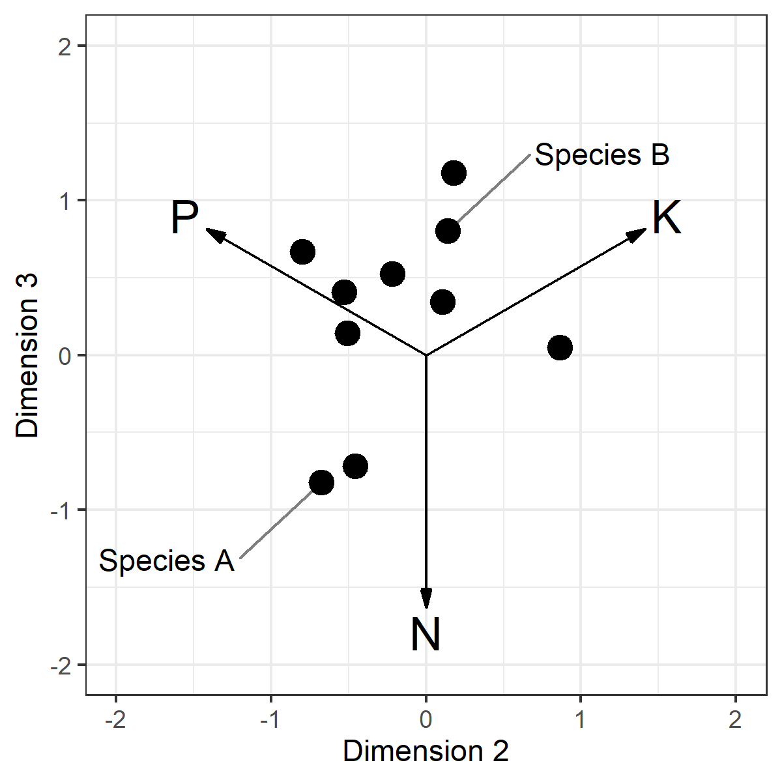

**(a)**

**(b)**

**Figure 2:**

1. Frequency of sites exhibiting significant (p < 0.05) effects of experimental fertilization on plant community composition. Of 50 total sites, 35 showed significant compositional changes to all three fertilization treatments, while 1 site showed non-significant compositional responses to all fertilization treatments.
2. Rate of estimated fertilization-driven change in species composition, prior to standardization of response coefficients. The rate of total compositional change was calculated as the magnitude of the vector of estimated species response coefficients, estimating net change in log2-transformed species cover per log-transformed year of treatment. Higher values indicate greater overall rate of compositional change.

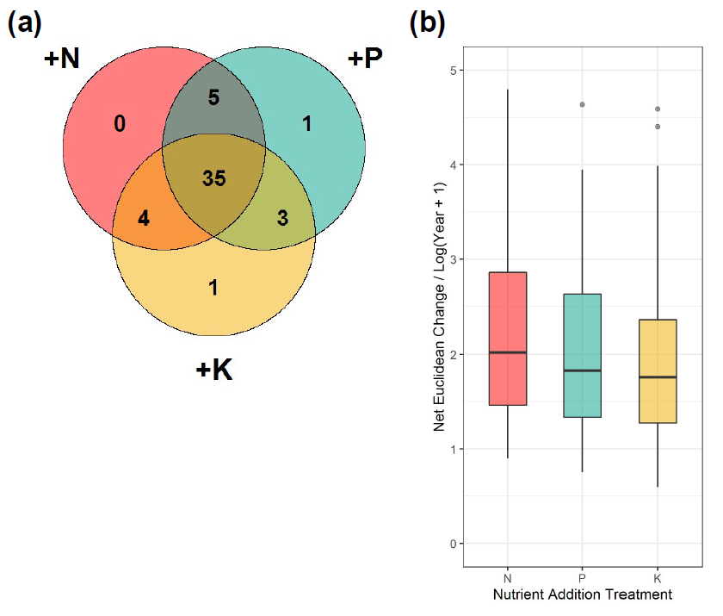

**No significant response:**

**1**

**Figure 3**

Major Axis (MA) regression plots demonstrating pairwise correlations between estimated fertilization treatment responses. For each subplot, individual points represent estimated species responses to different limiting resources, colored by species functional group. Colored lines indicate best-fit lines produced by MA regression. Slope coefficients and contrasts between functional groups are presented in Table 2. Axes are displayed at log2 scale, such that a 1-unit increase corresponds to a doubling of species estimated cover.

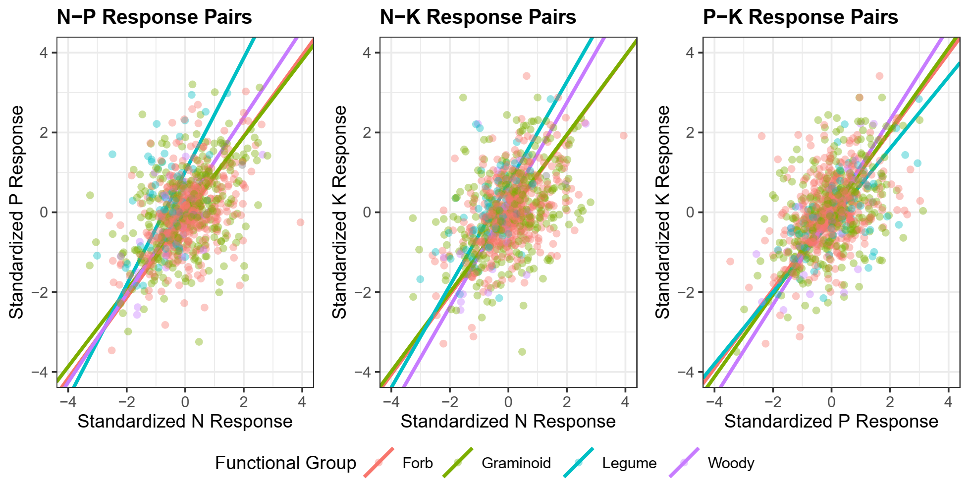

**Figure 4**

Three-dimensional visualization of species responses to fertilization treatments. Each point represents observed species responses within each site. Neutral expectation assuming equivalent response to all three nutrients (1:1:1 vector) is highlighted in black.

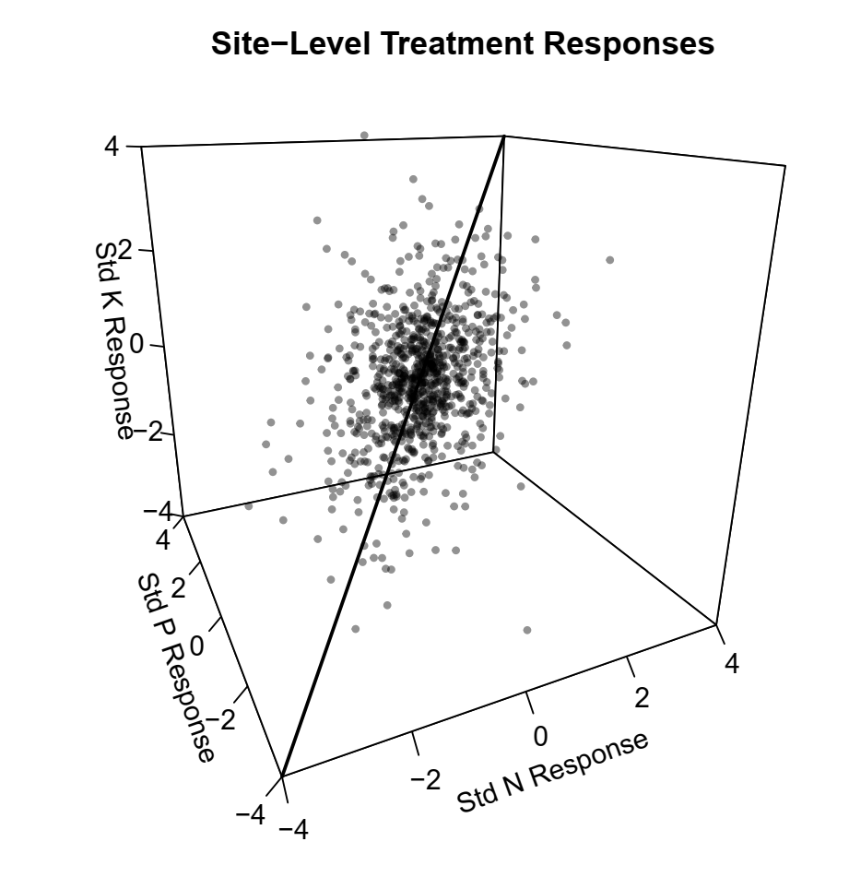

**Figure 5**

Residual variation in species responses to fertilization not captured by neutral (1:1:1) projection. Labelled vectors reflect treatment coefficient loadings on coordinate system. Points colored by functional group.

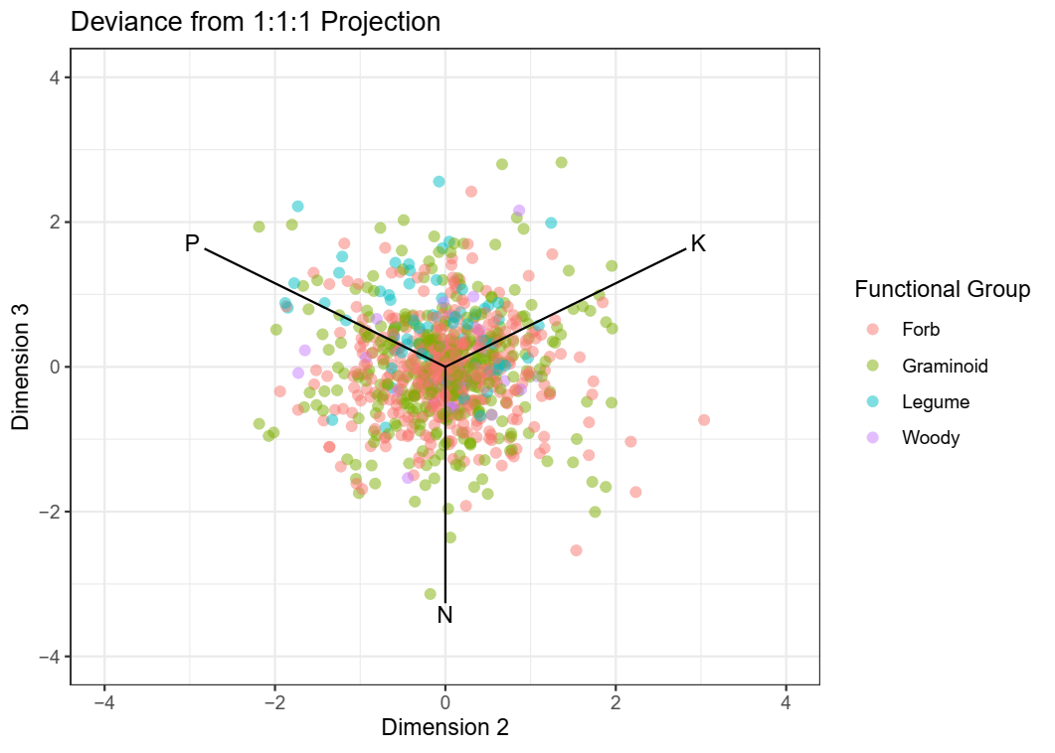

**Figure 6**

Proportion of total variance within sites captured by neutral (1:1:1) projection. Sites plotted are those with significant (*P < 0.05*) responses to all three nutrient addition treatments (+N, +P, +Kµ). Pretreatment mean plot biomass and mean percent light interception calculated from data collected at each site prior to start of fertilization treatment. Percent variance captured shows the strongest correlation with pre-treatment plot biomass (ρ = -0.42, *P =* 0.01), though this result is on the margin of statistical significance accounting for multiple comparisons using the Sidak correction. All other relationships were non-significant.

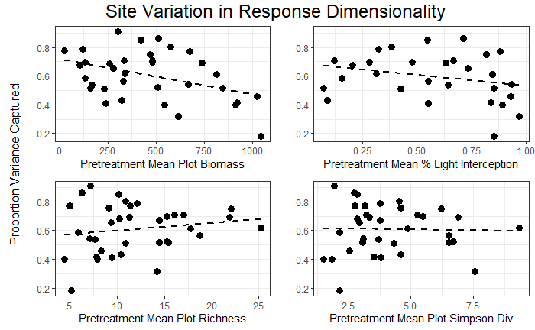

**Table 1**

Results of Major Axis (MA) model fitting to pairwise treatment responses. For each pairwise combination of treatment response coefficients, the within-group model R-squared, group slope, and post-hoc group labeling is presented. Groups where fitted slopes varied significantly (P < 0.05) were assigned different labels. P-values adjusted for multiple comparison using the Sidak correction. Generally, leguminous species show distinct responses relative to other functional groups, particularly between estimated N and P response coefficients. Legumes appear to show greater specialization to P than other nutrients, exhibiting more extreme responses than would be expected given overall trends.

|  |  |  |  |  |  |  |  |  |  |  |
| --- | --- | --- | --- | --- | --- | --- | --- | --- | --- | --- |
|  |  | N - P | | | N – K | | | P - K | | |
| Functional Group | *n* | R-squared | Slope | Group | R-squared | Slope | Group | R-squared | Slope | Group |
| Forb | 429 | 0.20 | 1.01 | 1 | 023 | 1.00 | 1 | 0.20 | 0.99 | 1 |
| Graminoid | 322 | 0.16 | 0.96 | 1 | 0.16 | 0.99 | 1 | 0.22 | 1.03 | 1 |
| Legume | 72 | 0.14 | 1.42 | 2 | 0.28 | 1.28 | 1 | 0.29 | 0.90 | 1 |
| Woody | 25 | 0.37 | 1.01 | 12 | 0.37 | 1.28 | 1 | 0.44 | 1.17 | 1 |

**Table 2**

Mean functional group response coefficients when projected onto a new coordinate basis. Permutation-based contrasts between group means revealed significant differences (*P < 0.05*) in Dimension 3.

|  |  |  |  |  |
| --- | --- | --- | --- | --- |
| Functional Group | Forb | Graminoid | Legume | Woody |
| Dimension 1 Mean | 0.027 | 0.037 | -0.167 | -0.643 |
| Dimension 2 Mean | 0.029 | -0.002 | -0.16 | -0.033 |
| Dimension 3 Mean | *-0.0761* | *-0.0241* | *0.5552* | *0.0761* |

**Appendix 1: Sites used in analysis**

|  |  |  |  |  |  |  |  |  |
| --- | --- | --- | --- | --- | --- | --- | --- | --- |
|  | **site_code** | **site_name** | **continent** | **country** | **n_years** | **n_obs** | **first_nutrient_year** | **Dimensionality** |
| 1 | azi.cn | Azi | Asia | CN | 5 | 60 | 2008 | 0.908511 |
| 2 | bldr.us | Boulder South Campus | North America | US | 9 | 72 | 2009 | 0.86228 |
| 3 | bnch.us | Bunchgrass (Andrews LTER) | North America | US | 12 | 142 | 2008 | 0.850111 |
| 4 | bogong.au | Bogong | Australia | AU | 11 | 132 | 2010 | 0.804558 |
| 5 | burrawan.au | Burrawan | Australia | AU | 12 | 144 | 2009 | 0.788664 |
| 6 | cbgb.us | Chichaqua Bottoms | North America | US | 10 | 239 | 2010 | 0.774297 |
| 7 | cdcr.us | Cedar Creek LTER | North America | US | 12 | 240 | 2008 | 0.772684 |
| 8 | cdpt.us | Cedar Point Biological Station | North America | US | 12 | 288 | 2008 | 0.763026 |
| 9 | cereep.fr | CEREEP - Ecotron IDF | Europe | FR | 7 | 84 | 2013 | 0.755334 |
| 10 | chilcas.ar | Las Chilcas | South America | AR | 7 | 84 | 2014 | 0.751164 |
| 11 | comp.pt | Companhia das Lezirias | Europe | PT | 8 | 96 | 2013 | 0.751119 |
| 12 | cowi.ca | Cowichan | North America | CA | 12 | 144 | 2008 | 0.712587 |
| 13 | elliot.us | Elliott Chaparral | North America | US | 11 | 130 | 2009 | 0.706411 |
| 14 | ethass.au | Ethabuka (South Site) | Australia | AU | 7 | 80 | 2014 | 0.705988 |
| 15 | frue.ch | Fruebuel | Europe | CH | 8 | 96 | 2009 | 0.70099 |
| 16 | hall.us | Hall's Prairie | North America | US | 8 | 96 | 2008 | 0.698769 |
| 17 | hart.us | Hart Mountain | North America | US | 6 | 72 | 2008 | 0.694679 |
| 18 | hero.uk | Heronsbrook (Silwood Park) | Europe | UK | 7 | 84 | 2008 | 0.690745 |
| 19 | hopl.us | Hopland REC | North America | US | 12 | 141 | 2008 | 0.689974 |
| 20 | jena.de | JeNut | Europe | DE | 5 | 60 | 2015 | 0.685955 |
| 21 | kbs.us | Kellogg Biological Station LTER | North America | US | 5 | 100 | 2014 | 0.683988 |
| 22 | kibber.in | Kibber (Spiti) | Asia | IN | 8 | 96 | 2012 | 0.673375 |
| 23 | kilp.fi | Kilpisjärvi | Europe | FI | 6 | 80 | 2014 | 0.655366 |
| 24 | kiny.au | Kinypanial | Australia | AU | 11 | 132 | 2008 | 0.653078 |
| 25 | koffler.ca | Koffler Scientific Reserve at Joker's Hill | North America | CA | 9 | 108 | 2011 | 0.619081 |
| 26 | konz.us | Konza LTER | North America | US | 11 | 132 | 2008 | 0.618339 |
| 27 | lancaster.uk | Lancaster | Europe | UK | 10 | 120 | 2009 | 0.612569 |
| 28 | look.us | Lookout (Andrews LTER) | North America | US | 12 | 144 | 2008 | 0.586363 |
| 29 | marc.ar | Mar Chiquita | South America | AR | 8 | 93 | 2012 | 0.586352 |
| 30 | mcla.us | Mclaughlin UCNRS | North America | US | 12 | 144 | 2008 | 0.564602 |
| 31 | mtca.au | Mt. Caroline | Australia | AU | 11 | 176 | 2009 | 0.55608 |
| 32 | ping.au | Pingelly Paddock | Australia | AU | 6 | 72 | 2014 | 0.54321 |
| 33 | pinj.au | Pinjarra Hills | Australia | AU | 5 | 60 | 2014 | 0.535962 |
| 34 | rook.uk | Rookery (Silwood Park) | Europe | UK | 7 | 84 | 2008 | 0.521642 |
| 35 | sage.us | Sagehen Creek UCNRS | North America | US | 7 | 84 | 2008 | 0.517487 |
| 36 | sava.us | Savannah River | North America | US | 6 | 48 | 2008 | 0.516382 |
| 37 | sedg.us | Sedgwick Reserve UCNRS | North America | US | 11 | 132 | 2008 | 0.511408 |
| 38 | sereng.tz | Serengeti | Africa | TZ | 5 | 60 | 2009 | 0.457245 |
| 39 | sgs.us | Shortgrass Steppe LTER | North America | US | 12 | 142 | 2008 | 0.441942 |
| 40 | shps.us | Sheep Experimental Station | North America | US | 10 | 160 | 2008 | 0.431204 |
| 41 | sier.us | Sierra Foothills REC | North America | US | 12 | 232 | 2008 | 0.415934 |
| 42 | smith.us | Smith Prairie | North America | US | 10 | 120 | 2008 | 0.411079 |
| 43 | spin.us | Spindletop | North America | US | 12 | 144 | 2008 | 0.408039 |
| 44 | temple.us | Temple | North America | US | 10 | 120 | 2008 | 0.405102 |
| 45 | trel.us | Trelease | North America | US | 10 | 120 | 2009 | 0.4012 |
| 46 | ukul.za | Ukulinga | Africa | ZA | 10 | 120 | 2010 | 0.399551 |
| 47 | unc.us | Duke Forest | North America | US | 5 | 60 | 2008 | 0.316679 |
| 48 | valm.ch | Val Mustair | Europe | CH | 10 | 120 | 2009 | 0.265733 |
| 49 | yarra.au | Yarramundi | Australia | AU | 6 | 96 | 2015 | 0.181069 |

**Appendix 2:**

