**Figure 1**

Conceptual diagram illustrating the method used to assess dimensionality of community enrichment response.

(a) *Bivariate relationships between responses:* In this hypothetical example, a community of 3 species is subject to enrichment by three different resources. Estimated responses to these nutrients are standardized such that the total magnitude of community response to each nutrient is of unit length. The line illustrates the null hypothesis of proportionally identical responses; Species 1 (*Sp1*) exhibits comparatively stronger responses to N treatment than either P or K.

(b) *Three-dimensional representation of responses:* The responses above are presented as a three-dimensional plot, with the vector ***y*** representing the null hypothesis. The vector of responses estimated for *Sp1*, ***x1*,** is projected onto ***y****,* producing the projection, ***a­1***, and rejection, ***b1***. The coordinates of this projection vector, ***a­1***, correspond to the average response of *Sp1* recorded across all three nutrients. Projection and rejection vectors for *Sp2* and *Sp3* may be calculated in a similar fashion and used to evaluate response dimensionality at the community scale. In this community, strong positive correlation across all three treatment dimensions yielded low overall response dimensionality, *D* = 0.04.

(c) *Two-dimensional plot of rejection vectors:*Residual elements of the response vector not captured by projection onto ***y*** may be visualized in two dimensions, *b1* and *b2*. Corresponding to relationships shown in bivariate plots, rejection elements of *Sp1* have large values in the second rejection dimension, *b2*, reflecting proportionally stronger responses to N enrichment than other treatments.

**Figure 2**

(a) Frequency of sites exhibiting significant (*P < 0.05*) effects of nutrient (N, P, or Kµ) fertilization on plant community composition. Of 49 total sites, 37 showed significant compositional changes to at least one of three fertilization treatments, while 12 sites showed non-significant compositional responses to all nutrient manipulations.

(b) Rate of estimated fertilization-driven change in species composition, prior to standardization of response coefficients. The rate of total compositional change was calculated as the magnitude of the vector of estimated species response coefficients, as net Euclidean change in log2-transformed community cover per year of treatment. Higher values indicate greater overall rate of compositional change.

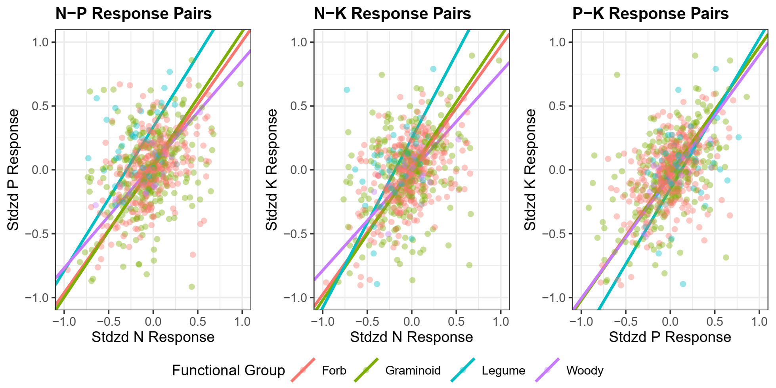

**Figure 3**

Visualization of pairwise relationships between plant responses to nutrient addition treatments. Each point refers to a unique site x species combination, colored by functional group. Lines correspond to results of semi major axis (SMA) regression applied to each functional group.

|  |  |  |  |  |  |  |  |  |  |  |
| --- | --- | --- | --- | --- | --- | --- | --- | --- | --- | --- |
|  |  | N-P | | | N-K | | | P-K | | |
| Functional Group | n | Slope | Intercept | R2 | Slope | Intercept | R2 | Slope | Intercept | R2 |
| Forb | 307 | 0.985 | 0.022 | 0.203 | 0.973 | -0.003 | 0.206 | 0.988 | -0.025 | 0.213 |
| Graminoid | 241 | 1.040 | 0.043 | 0.108 | 1.034 | 0.013 | 0.114 | 0.994 | -0.029 | 0.272 |
| Legume | 46 | 1.125 | 0.335 | 0.032ns | 1.325 | 0.246 | 0.100 | 1.178 | -0.149 | 0.085 |
| Woody | 18 | 0.813 | 0.044 | 0.756 | 0.777 | -0.011 | 0.631 | 0.955 | -0.053 | 0.666 |

**Table 1**

Summary of semi major axis (SMA) regression model fits to each of 3 pairwise comparisons of response to fertilization treatment. A majority of models captured significantly more variation (P < 0.05) in response than models assuming no correlation between treatment responses; models with non-significant fits are denoted by superscript “ns”.

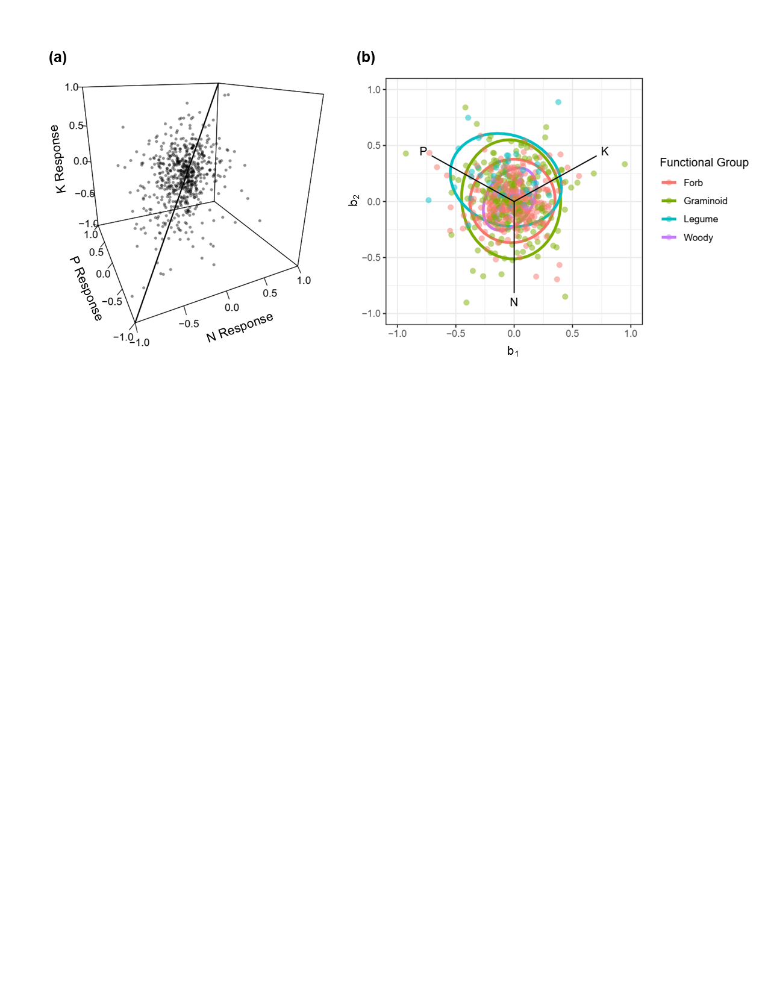

**Figure 4**

(a) Three-dimensional visualization of species responses to nutrient enrichment across all sites, with line corresponding to 1:1:1 vector (*y*)assuming proportionally equal responses.

(b) Residual deviation from 1:1:1 vector displayed in two dimensions (*b­1, b2*) orthogonal to *y*. Points are colored by functional group with 95% confidence ellipses centered on group means.

|  |  |  |  |
| --- | --- | --- | --- |
| Functional Group |  |  |  |
| Forb | -0.0331 | -0.0181 | *0.0081* |
| Graminoid | -0.0561 | -0.0211 | *0.0211* |
| Legume | -0.0051 | -0.0871 | *0.2062* |
| Woody | -0.0581 | -0.0371 | *0.0221* |

**Table 2**

Mean coordinate position of functional groups along 1:1:1 vector () and residual components (. Superscripts correspond to significant (P < 0.05) contrasts between functional group means in each dimension.

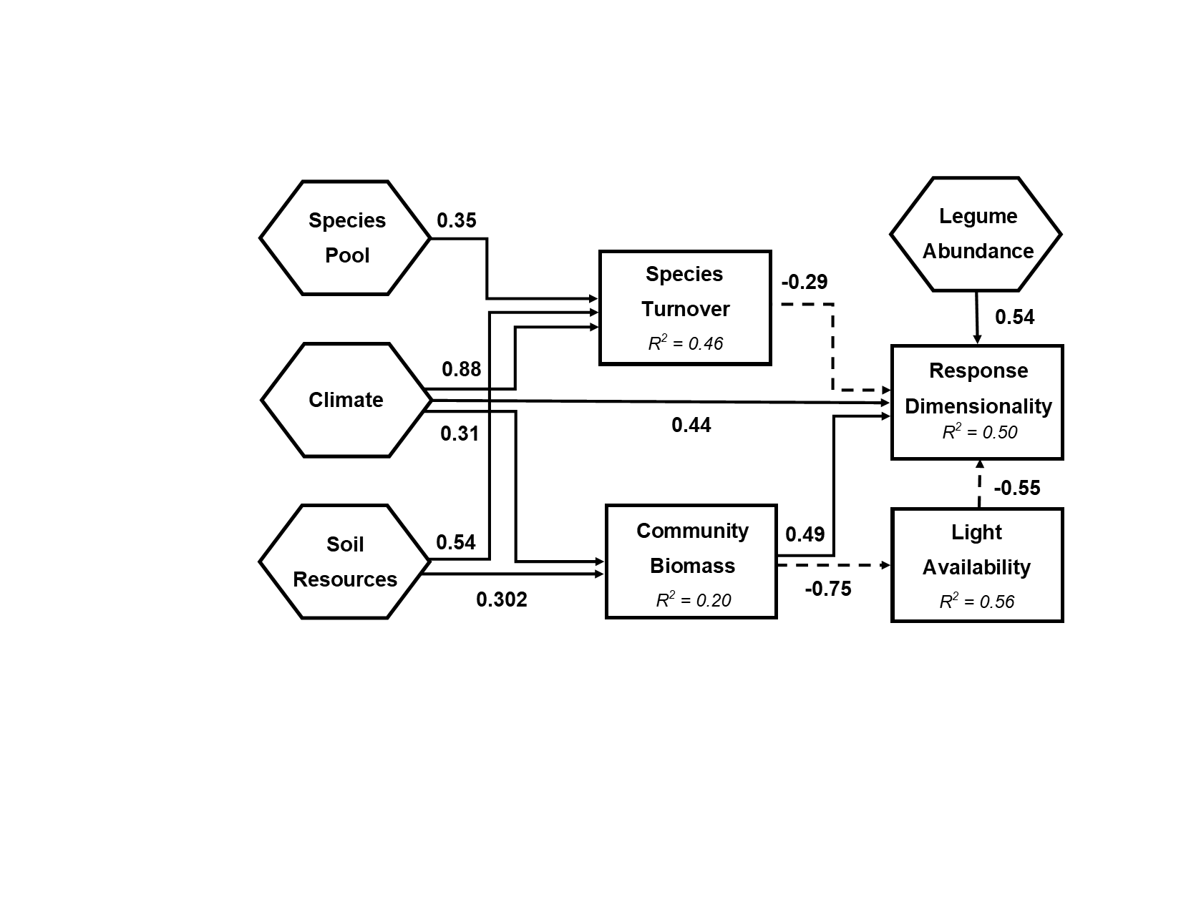

**Figure 5**

Visual representation of structural equation model (SEM) used to evaluate pre-treatment site factors that explain variation in community response dimensionality (*D*) following multiple nutrient enrichment. All statistically significant (P < 0.05) pathways are presented. Solid lines correspond to positive effects, while dashed lines correspond to negative effects. Chi-square test statistic = 23.408 on 20 degrees of freedom indicates close model-data fit (P = 0.269; Comparative Fit Index = 0.943).

**Appendix 1**: Table of sites included in analysis.

|  |  |  |  |  |  |  |  |  |  |
| --- | --- | --- | --- | --- | --- | --- | --- | --- | --- |
| **Site Name** | **Continent** | **Country** | **Habitat** | **First Year** | **Last Year** | **Total Years** | **MAP** | **MAT** | **Taxa** |
| Azi | Asia | CN | alpine grassland | 2007 | 2012 | 5 | 711 | 1.36 | 43 |
| Bogong | Australia | AU | alpine grassland | 2009 | 2019 | 11 | 1678 | 5.98 | 19 |
| Boulder South Campus | North America | US | shortgrass prairie | 2008 | 2016 | 9 | 487 | 9.90 | 9 |
| Bunchgrass (Andrews LTER) | North America | US | montane grassland | 2007 | 2018 | 12 | 1618 | 6.77 | 10 |
| Burrawan | Australia | AU | semiarid grassland | 2008 | 2019 | 12 | 643 | 18.22 | 10 |
| Cedar Creek LTER | North America | US | tallgrass prairie | 2007 | 2018 | 12 | 740 | 6.34 | 8 |
| Cedar Point Biological Station | North America | US | shortgrass prairie | 2007 | 2019 | 13 | 456 | 9.64 | 12 |
| CEREEP - Ecotron IDF | Europe | FR | old field | 2012 | 2018 | 7 | 632 | 10.82 | 16 |
| Chichaqua Bottoms | North America | US | tallgrass prairie | 2009 | 2019 | 11 | 871 | 9.26 | 6 |
| Companhia das Lezirias | Europe | PT | annual grassland | 2012 | 2019 | 8 | 564 | 16.58 | 26 |
| Cowichan | North America | CA | old field | 2007 | 2018 | 12 | 762 | 10.45 | 5 |
| Elliott Chaparral | North America | US | annual grassland | 2008 | 2019 | 11 | 344 | 17.71 | 6 |
| Ethabuka (Main Camp) | Australia | AU | desert grassland | 2013 | 2019 | 7 | 192 | 24.06 | 4 |
| Ethabuka (South Site) | Australia | AU | desert grassland | 2013 | 2019 | 7 | 203 | 23.95 | 3 |
| Fruebuel | Europe | CH | pasture | 2008 | 2015 | 8 | 1546 | 6.96 | 15 |
| Hall's Prairie | North America | US | tallgrass prairie | 2007 | 2014 | 8 | 1289 | 13.83 | 4 |
| Hart Mountain | North America | US | shrub steppe | 2007 | 2012 | 6 | 259 | 7.75 | 11 |
| Heronsbrook (Silwood Park) | Europe | UK | mesic grassland | 2007 | 2013 | 7 | 668 | 10.17 | 19 |
| Hopland REC | North America | US | annual grassland | 2007 | 2019 | 13 | 1065 | 13.24 | 19 |
| Jena | Europe | DE | grassland | 2013 | 2018 | 6 | 654 | 8.57 | 18 |
| Kibber (Spiti) | Asia | IN | alpine grassland | 2011 | 2018 | 8 | 400 | -1.45 | 7 |
| Kilpisjärvi | Europe | FI | tundra grassland | 2013 | 2018 | 6 | 569 | -3.25 | 24 |
| Kinypanial | Australia | AU | semiarid grassland | 2007 | 2018 | 11 | 408 | 15.59 | 8 |
| Koffler Scientific Reserve at Joker's Hill | North America | CA | pasture | 2010 | 2019 | 10 | 853 | 6.28 | 10 |
| Konza LTER | North America | US | tallgrass prairie | 2007 | 2019 | 13 | 889 | 12.08 | 17 |
| Lancaster | Europe | UK | mesic grassland | 2008 | 2017 | 10 | 1522 | 8.01 | 10 |
| Las Chilcas | South America | AR | mesic grassland | 2013 | 2019 | 7 | 955 | 15.09 | 8 |
| Lookout (Andrews LTER) | North America | US | montane grassland | 2007 | 2018 | 12 | 1877 | 6.90 | 8 |
| Mar Chiquita | South America | AR | grassland | 2011 | 2018 | 8 | 907 | 14.32 | 14 |
| Mclaughlin UCNRS | North America | US | annual grassland | 2007 | 2019 | 13 | 936 | 13.97 | 8 |
| Mt. Caroline | Australia | AU | savanna | 2008 | 2018 | 11 | 324 | 17.75 | 15 |
| Pingelly Paddock | Australia | AU | old field | 2013 | 2018 | 6 | 456 | 16.28 | 10 |
| Pinjarra Hills | Australia | AU | pasture | 2013 | 2018 | 5 | 1085 | 19.99 | 5 |
| Rookery (Silwood Park) | Europe | UK | mesic grassland | 2007 | 2013 | 7 | 685 | 10.13 | 12 |
| Saana | Europe | FI | montane grassland | 2014 | 2019 | 6 | 521 | -2.60 | 25 |
| Sagehen Creek UCNRS | North America | US | montane grassland | 2007 | 2013 | 7 | 831 | 5.83 | 16 |
| Savannah River | North America | US | savanna | 2007 | 2012 | 6 | 1184 | 17.43 | 12 |
| Sedgwick Reserve UCNRS | North America | US | annual grassland | 2007 | 2017 | 11 | 478 | 15.58 | 4 |
| Sevilleta LTER | North America | US | desert grassland | 2007 | 2018 | 12 | 252 | 13.06 | 5 |
| Sheep Experimental Station | North America | US | shrub steppe | 2007 | 2016 | 10 | 246 | 5.32 | 18 |
| Shortgrass Steppe LTER | North America | US | shortgrass prairie | 2007 | 2018 | 12 | 369 | 8.95 | 6 |
| Sierra Foothills REC | North America | US | annual grassland | 2007 | 2019 | 13 | 936 | 16.31 | 7 |
| Smith Prairie | North America | US | mesic grassland | 2007 | 2016 | 10 | 605 | 10.18 | 25 |
| Spindletop | North America | US | pasture | 2007 | 2019 | 13 | 1152 | 12.48 | 9 |
| Temple | North America | US | tallgrass prairie | 2007 | 2016 | 10 | 877 | 19.40 | 15 |
| Trelease | North America | US | tallgrass prairie | 2008 | 2017 | 10 | 992 | 11.07 | 5 |
| Ukulinga | Africa | ZA | mesic grassland | 2009 | 2018 | 10 | 832 | 17.65 | 17 |
| Val Mustair | Europe | CH | alpine grassland | 2008 | 2019 | 11 | 681 | 0.13 | 30 |
| Yarramundi | Australia | AU | mesic grassland | 2014 | 2019 | 6 | 844 | 17.32 | 5 |

**Appendix 2:** Results of mixed effects linear modeling used to compare magnitude of community response.

Linear mixed model fit by REML. t-tests use Satterthwaite's method ['lmerModLmerTest']

Formula: Magnitude ~ Trt + (1 | site_code)

Random effects:

Groups Name Variance Std.Dev.

site_code (Intercept) 0.07252 0.2693

Residual 0.02379 0.1543

Number of obs: 147, groups: site_code, 49

Fixed effects:

Estimate Std. Error df t value Pr(>|t|)

(Intercept) 0.50544 0.04434 67.48122 11.400 < 2e-16 ***

N 0.09660 0.03116 96.00000 3.100 0.00254 **

P 0.04803 0.03116 96.00000 1.541 0.12659

---

Signif. codes: 0 ‘***’ 0.001 ‘**’ 0.01 ‘*’ 0.05 ‘.’ 0.1 ‘ ’ 1

Correlation of Fixed Effects:

(Intr) TrtN

N -0.351

P -0.351 0.500

Type III Analysis of Variance Table with Satterthwaite's method

Sum Sq Mean Sq NumDF DenDF F value Pr(>F)

Trt 0.22862 0.11431 2 96 4.8041 0.01027 *

---

Signif. codes: 0 ‘***’ 0.001 ‘**’ 0.01 ‘*’ 0.05 ‘.’ 0.1 ‘ ’ 1

**Appendix 3**

a) Bivariate relationships between treatments colored by species lifespan

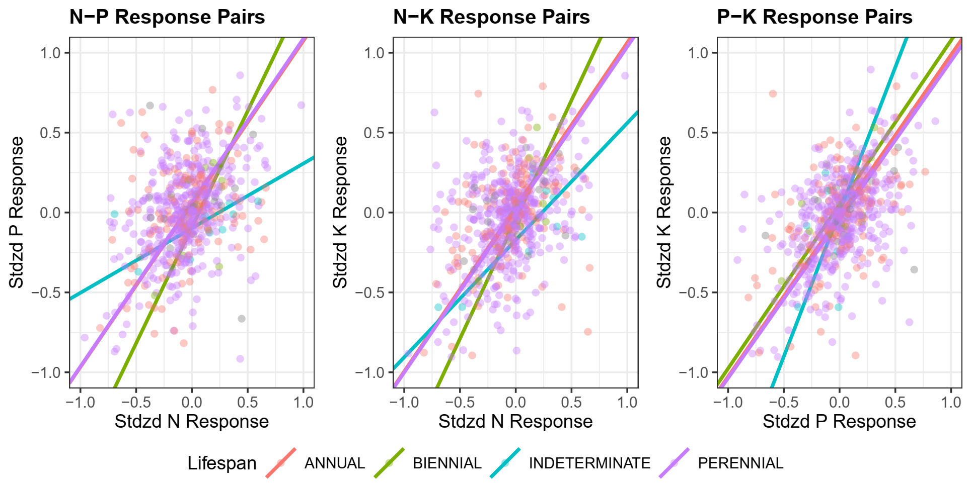

b) Bivariate relationships between treatments colored by provenance (introduced / native)

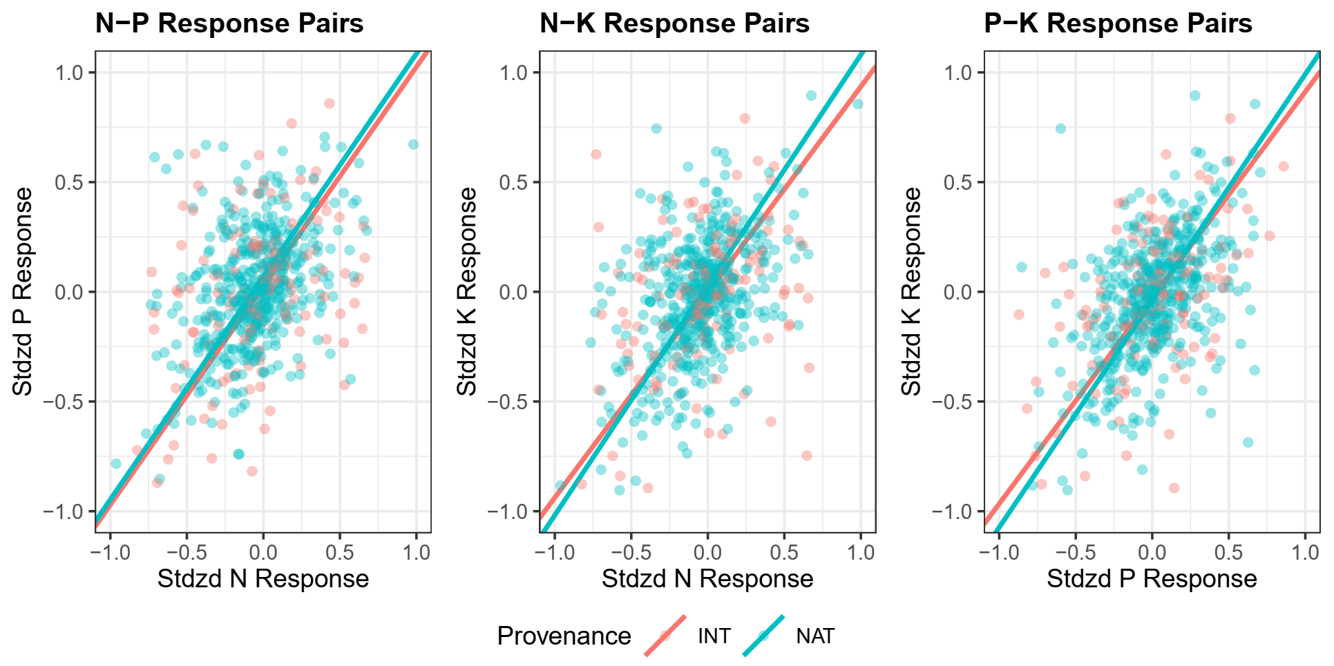

**Appendix 4:** Table of sites, pairwise correlations between community responses to different treatments (ρ), rate of community change in response to treatment (Δ), and estimated response dimensionality (D). Significant (P < 0.05) magnitudes of community response are labelled with “*” and italicized. Sites with non-significant (P < 0.05) responses to all treatments are highlighted in red.

|  |  |  |  |  |  |  |  |
| --- | --- | --- | --- | --- | --- | --- | --- |
| **Site Name** | **ρ(N-P)** | **ρ(N-K)** | **ρ(P-K)** | **ΔN** | **ΔP** | **ΔK** | ***D*** |
| Azi | 0.40 | 0.68 | 0.47 | 1.30 | 1.35 | 1.44 | 0.32 |
| Bogong | 0.28 | 0.59 | 0.57 | *0.44\** | *0.42\** | *0.38\** | 0.35 |
| Boulder South Campus | -0.06 | 0.05 | 0.67 | 0.44 | *0.56\** | 0.44 | 0.52 |
| Bunchgrass (Andrews LTER) | 0.22 | 0.67 | 0.52 | 0.25 | *0.46\** | *0.43\** | 0.35 |
| Burrawan | 0.26 | 0.32 | -0.03 | 0.17 | 0.20 | 0.17 | 0.54 |
| Cedar Creek LTER | 0.43 | 0.14 | 0.57 | *0.53\** | 0.18 | 0.22 | 0.41 |
| Cedar Point Biological Station | 0.20 | 0.18 | 0.43 | *0.36\** | *0.23\** | *0.27\** | 0.49 |
| CEREEP - Ecotron IDF | 0.13 | 0.15 | 0.61 | *1.12\** | 0.91 | *1.12\** | 0.47 |
| Chichaqua Bottoms | 0.48 | 0.57 | 0.60 | *0.30\** | 0.25 | *0.27\** | 0.30 |
| Companhia das Lezirias | 0.44 | 0.20 | 0.38 | *1.15\** | *1.10\** | 0.75 | 0.44 |
| Cowichan | -0.30 | 0.66 | -0.01 | 0.12 | *0.27\** | 0.17 | 0.59 |
| Elliott Chaparral | 0.50 | -0.12 | 0.66 | 0.22 | 0.26 | 0.27 | 0.44 |
| Ethabuka (Main Camp) | -0.08 | 0.57 | 0.28 | 0.28 | *0.83\** | 0.43 | 0.50 |
| Ethabuka (South Site) | 0.77 | 0.88 | 0.92 | *0.59\** | 0.32 | 0.52 | 0.09 |
| Fruebuel | 0.58 | 0.15 | 0.49 | *1.05\** | *0.99\** | *0.83\** | 0.40 |
| Hall's Prairie | 0.56 | 0.58 | 0.04 | *1.13\** | *0.66\** | *0.68\** | 0.40 |
| Hart Mountain | 0.91 | 0.46 | 0.50 | *0.96\** | 0.73 | 0.57 | 0.25 |
| Heronsbrook (Silwood Park) | 0.21 | 0.60 | 0.28 | *1.03\** | 0.67 | 0.66 | 0.42 |
| Hopland REC | 0.33 | 0.75 | 0.58 | *1.01\** | 0.49 | *0.68\** | 0.30 |
| Jena | -0.25 | 0.06 | 0.20 | *0.97\** | 0.62 | 0.64 | 0.67 |
| Kibber (Spiti) | 0.30 | 0.48 | 0.74 | 0.25 | 0.26 | 0.27 | 0.33 |
| KilpisjÃ¤rvi | 0.40 | 0.22 | 0.80 | *1.03\** | 0.78 | 0.46 | 0.35 |
| Kinypanial | -0.08 | 0.23 | 0.84 | 0.16 | 0.32 | 0.26 | 0.45 |
| Koffler Scientific Reserve at Joker's Hill | 0.32 | 0.60 | 0.53 | *0.88\** | *0.65\** | *0.54\** | 0.34 |
| Konza LTER | 0.29 | 0.23 | 0.55 | *0.43\** | 0.28 | 0.37 | 0.43 |
| Lancaster | 0.55 | 0.57 | 0.57 | 0.44 | 0.38 | 0.38 | 0.29 |
| Las Chilcas | 0.71 | 0.55 | 0.83 | *0.78\** | 0.52 | *0.84\** | 0.20 |
| Lookout (Andrews LTER) | 0.66 | 0.88 | 0.86 | *0.38\** | *0.39\** | *0.50\** | 0.13 |
| Mar Chiquita | 0.75 | 0.54 | 0.60 | 0.62 | 0.58 | 0.60 | 0.25 |
| Mclaughlin UCNRS | 0.51 | 0.24 | 0.24 | 0.41 | 0.33 | 0.38 | 0.45 |
| Mt. Caroline | 0.67 | 0.71 | 0.60 | *0.67\** | *0.62\** | *0.52\** | 0.23 |
| Pingelly Paddock | 0.46 | -0.08 | -0.29 | 0.74 | *1.28\** | 0.61 | 0.65 |
| Pinjarra Hills | 0.55 | 0.25 | 0.81 | 0.78 | 1.06 | 0.77 | 0.31 |
| Rookery (Silwood Park) | 0.80 | 0.74 | 0.80 | *0.99\** | *1.50\** | 0.73 | 0.15 |
| Saana | 0.61 | 0.56 | 0.62 | *1.25\** | *0.98\** | *1.09\** | 0.27 |
| Sagehen Creek UCNRS | 0.12 | 0.49 | 0.17 | 0.63 | 0.49 | 0.45 | 0.49 |
| Savannah River | 0.42 | 0.12 | 0.38 | 0.76 | 0.99 | 0.55 | 0.46 |
| Sedgwick Reserve UCNRS | 0.61 | 0.84 | 0.94 | *0.38\** | *0.39\** | *0.36\** | 0.14 |
| Sevilleta LTER | 0.80 | 0.92 | 0.94 | *0.36\** | 0.14 | 0.14 | 0.08 |
| Sheep Experimental Station | -0.11 | 0.53 | -0.12 | *0.28\** | 0.17 | 0.21 | 0.60 |
| Shortgrass Steppe LTER | -0.01 | 0.36 | 0.53 | *0.43\** | *0.26\** | 0.10 | 0.47 |
| Sierra Foothills REC | -0.38 | 0.23 | 0.59 | 0.34 | 0.24 | 0.29 | 0.57 |
| Smith Prairie | 0.15 | 0.15 | 0.06 | *0.53\** | *0.47\** | 0.35 | 0.59 |
| Spindletop | 0.66 | 0.14 | 0.20 | 0.24 | 0.25 | *0.60\** | 0.44 |
| Temple | 0.28 | 0.24 | 0.50 | 0.41 | *0.61\** | 0.55 | 0.44 |
| Trelease | -0.27 | -0.51 | 0.48 | *0.55\** | 0.28 | 0.23 | 0.73 |
| Ukulinga | 0.17 | -0.06 | 0.51 | *0.58\** | *0.51\** | *0.75\** | 0.53 |
| Val Mustair | 0.56 | 0.40 | 0.45 | *0.45\** | *0.57\** | 0.30 | 0.35 |
| Yarramundi | 0.75 | 0.65 | 0.20 | 0.36 | 0.36 | *0.65\** | 0.31 |