**Nutrient Use Trade-offs Write-up**

Date: 10/9/2019

**Overview:**

Trade-offs in ecological theory are ubiquitous; assumed constraints on phenotypes are thought to explain the diversity of species and functional forms in many environments. The core notion of a trade-off – in which strong performance under some circumstances is balanced with poor performance in another – has played a central role in understanding community assembly and resource limitation in plant communities. To facilitate plant coexistence in variable environments, trade-offs in resource use assume that a plant’s ability to reduce the concentration of one limiting resource (e.g. soil nitrogen) is negatively correlated with its ability to reduce another (e.g. light).

In the context of the Nutrient Network, many grasslands worldwide are limited by multiple soil resources. Manipulations of nitrogen, phosphorous, and potassium (+ micronutrients) have shown that the biomass of these communities often responds positively to the enrichment of two or more of these fertilizers which, in turn, is correlated with loss of species richness. Harpole et al. (2016) interpreted these findings as a loss of niche dimensionality, where additions of multiple limiting nutrients reduces their relevant variation, leading to fewer available niches to facilitate species coexistence.

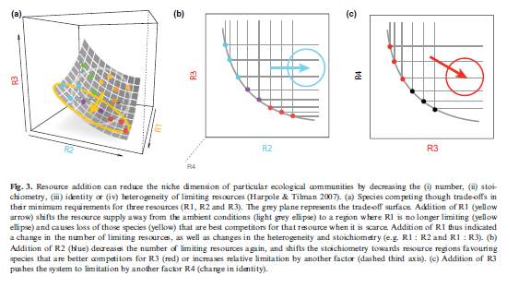These findings reflect two competing theories on how resource use trade-offs govern community assembly. The first, emphasized by a commentary by Harpole et al (2017), suggests that species differ in their R* values for the three fertilizer treatments and low R* values along one resource axis are correlated with high R* values along others. The second, extending from root:shoot ratios examined in Cleland et al. (2019), is a trade-off between belowground vs. aboveground biomass distribution and resource use – namely, that fertilization shifts resource limitation from belowground resources (N, P, K) to light. In this case, a single species is likely to be limited by multiple belowground resources, rather than exhibiting a trade-off between them.

When communities respond to multiple limiting nutrients, these two theories suggest different outcomes for community change occurring at the species level. In the first, species responses to different nutrient additions should be uncorrelated (or negatively correlated) between treatments, as each moves the environment across a different axis of resource limitation. In the second, species responses to different nutrient addition treatments should be correlated with one another, as fertilization moves species across a single resource competition axis related to soil resources vs. light.

Figure from Harpole et al. (2017), showing one theoretical explanation for observed loss of niche dimensionality, where species R* for one resource is negatively correlated with R* for other resources.

Sites may exist upon a continuum between these two extremes, where soil resource limitation operates across one axis or several. Attributes of the biotic environment – larger species pools, greater pre-treatment diversity, and presence of certain functional groups – may provide the foundation on which tradeoffs operate, as attributes of the abiotic environment – pre-treatment vegetation heterogeneity and water limitation – may generate the variation needed for trade-offs to evolve.

Here, we aim to determine how multiple resource limitation drives changes in species composition across the nutrient network – whether single or multiple nutrient use axes govern community responses to fertilization, and how sites vary in these responses.

Questions:

1. Across sites, which single-nutrient fertilization treatments (N / P /K+µ) produce change in species composition?
2. Are community responses to different resources correlated with one another? Are particular nutrient addition treatments more correlated in their response than others?
3. Are plant responses to nutrient enrichment well described by a single axis or multiple? Do certain plant functional groups deviate from this general relationship?

Methods:

* To all sites containing > 4 years of nutrient addition treatments + pre-treatment year, I fit the following equation:



Where species cover at a given time (YSpeciesCover) is a function of the log-transformed number years of fertilization treatment (BNutrient *Log(YrTrt + 1)), the random annual variation in abundances within a site (BYrFactor), and random effects of block. This model fit better than using a linear effect of treatment, as the log-transformed model better captured the saturating effects commonly found in nutrient enrichment.

This model was fit to all species in each site using RRPP (Collyer and Adams). The significance of aggregate community response to each nutrient enrichment treatment was tested with 9999 random permutations of residuals used to generate a pseudo-F statistic.

Individual response coefficients for each species (BNutrient) were extracted to assess correlations between site-level community change and individual-level responses to each nutrient. To determine the dimensionality of fertilization response, a PCA was constructed

Correlations between individual-level measures of nutrient response were analyzed using standard major axis (SMA) regression to better account for the uncertainty associated with measures of nutrient response.

**Results:**

1. **Significance of nutrient addition treatment by site**

Model fitting indicates that multiple nutrients significantly altered community composition at many sites. Nitrogen fertilization generated community change at roughly 75% of sites, followed by phosphorous addition (65%) and potassium + micronutrient addition (55%). Sites where pairs of nutrients (NP + NK + PK) both had significant effects were common, and roughly 35% of sites showed significant responses to all 3 nutrients (NPK).

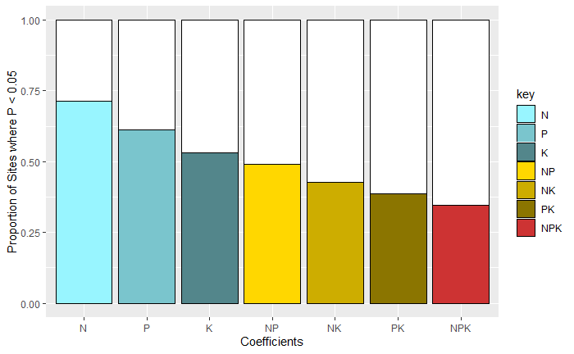

1. **Individual Site Correlations**

Trajectories of change in response to different nutrient addition treatments tended to be positively correlated among all three nutrient addition pairs. Figures below show histograms of the estimated correlation coefficient between pairwise trajectories of community change where both fertilization treatments involved had significant (p < 0.05) effects on community composition (in blue) and where 1 or fewer fertilization treatments had significant effects (red). There appears to be no difference in the distributions of correlation coefficients between these two groups – responses appear to be correlated between all nutrient addition pairs, regardless of their magnitude.

Example figures of different plots show site-by-site variation in correlations of nutrient responses. These NMDS visualizations of different sites are not direct representations of correlation in response, but demonstrate that sites can vary in how correlated these treatments are. The first example, “Rookery (Silwood Park)”, shows an example where all three nutrient addition treatments (trt_N, trt_P, trt_K) had very correlated responses to one another. The second, “Bunchgrass (Andrews LTER)”, shows an example where the three nutrient addition treatments tended to have very different effects on communities, exhibiting a high dimensional fertilization response. Measures correlations between vectors are shown in the bottom left of each ordination figure.

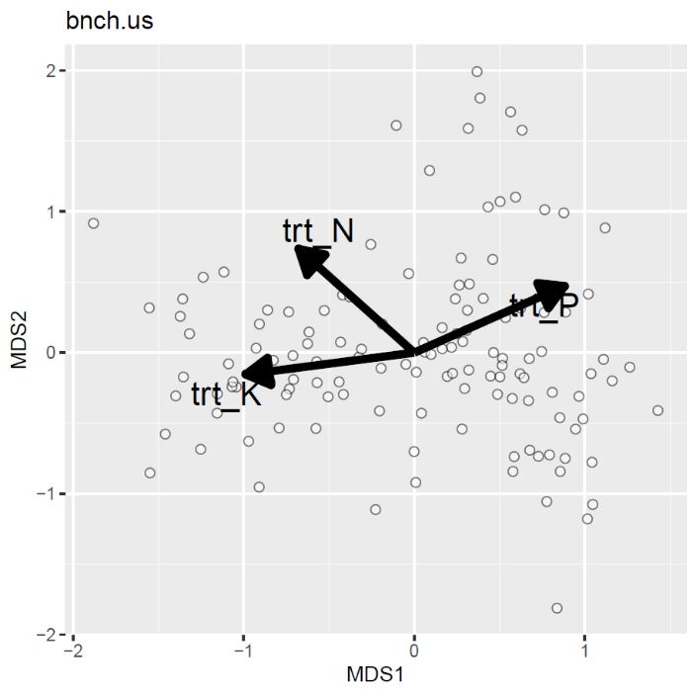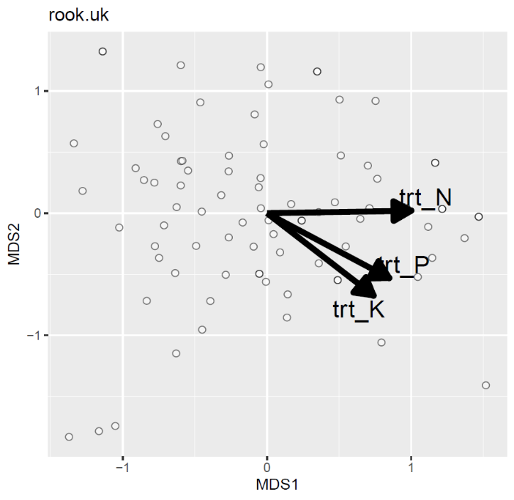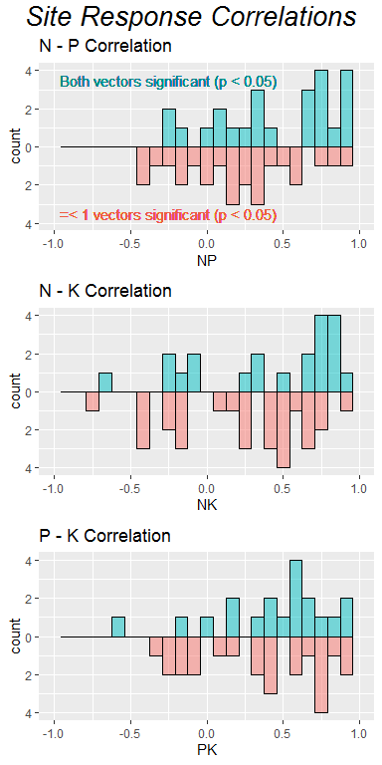

**NP: -0.25**

**NK: 0.37**

**PK: -0.56**

**NP: 0.9**

**NK: 0.87**

**PK: 0.84**

1. **Overall site correlation in nutrient addition response**

The following figure below shows a 3D scatterplot of the individual (species-level) community responses to different fertilization treatments, along with a PCA conducted on the matrix of these responses. This figure itself isn’t particularly interpretable, but reflects the theoretical background established by Harpole et al. (2017).

What is clear from these two figures is that species responses to fertilization tend to be distributed across a single axis, rather than several. This is to be expected given the positive pairwise correlations, but is further emphasized by the PCA, which shows that a single axis (PC1) can describe ~62% of the total variation in plant species responses to fertilization of three different types.

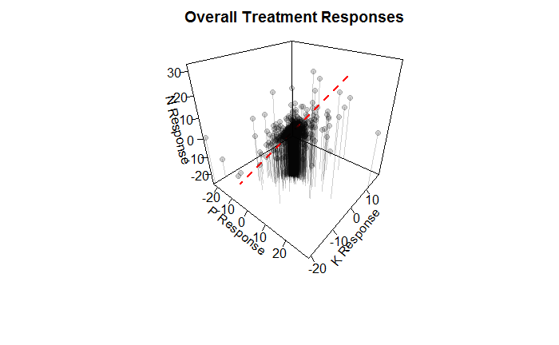

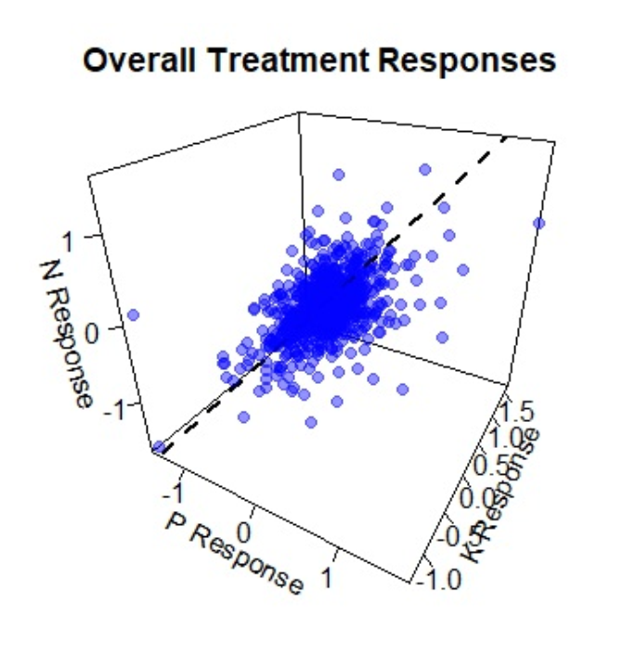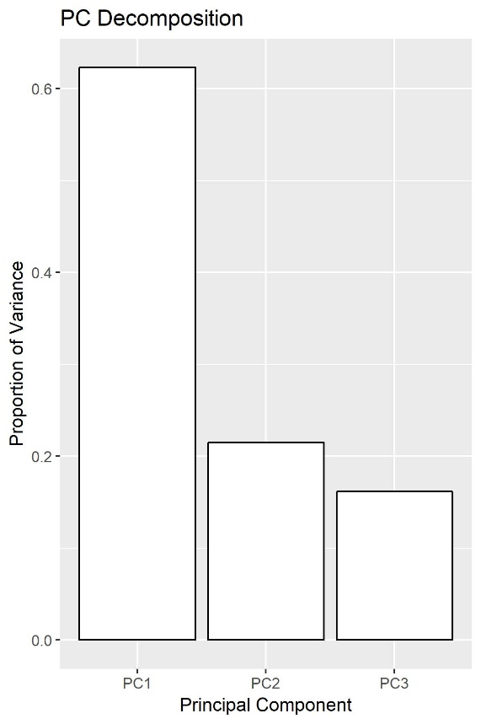

1. **Estimated correlations in response coefficients of species across all 3 fertilizer treatments (ΔCover / Log(Year Treatment))**

Responses to different nutrients are not constant across functional groups of species, however. The following figures show the shape of the relationship between response coefficients of these different groups. Some interesting patterns appear to emerge:

1. Legumes tend to have stronger responses to the addition of P and K than they do to N (blue lines).
2. Forbs tend to respond more strongly to N than would be predicted by their responses to P and K.
3. Graminoids tend to respond strongest to N, as well.



Comparisons of slope coefficients for these SMA regression plots is shown below. Slopes are labelled by contrasts applied to slope coefficients, correcting for multiple comparisons (similar to groupings in a standard ANOVA analysis).

|  |  |  |  |  |  |  |  |  |  |  |
| --- | --- | --- | --- | --- | --- | --- | --- | --- | --- | --- |
|  |  | **N - P** | | | **N - K** | | | **P - K** | | |
| **Functional Group** | ***n*** | **R2** | ***P*** | **Slope** | **R2** | ***P*** | **Slope** | **R2** | ***P*** | **Slope** |
| Forb | 1592 | 0.178 | 0.000 | 0.656C | 0.007 | 0.001 | 0.678B | 0.110 | 0.000 | 1.033B |
| Graminoid | 723 | 0.210 | 0.000 | 0.850B | 0.122 | 0.000 | 0.738B | 0.212 | 0.000 | 0.868C |
| Legume | 265 | 0.070 | 0.000 | 1.495A | 0.047 | 0.000 | 1.140A | 0.207 | 0.000 | 0.763C |
| Woody | 128 | 0.068 | 0.003 | 0.932B | 0.069 | 0.003 | 1.190A | 0.481 | 0.000 | 1.277A |

1. **Environmental / biotic determinants of correlation**

To better understand what causes site-level variations in the strength of correlation between different nutrient addition treatments, I constructed some simple bivariate plots that show the strength of correlation in community response (N-P, N-K, P-K) vs. the observed site species pool, the variation in site mean annual precipitation, and the coefficient of variation of biomass at the site before treatment (as a proxy of spatial heterogeneity). As before, blue dots represent sites where both nutrients caused community change, red indicates where 1 or fewer did.

I see few clear patterns here, unfortunately.

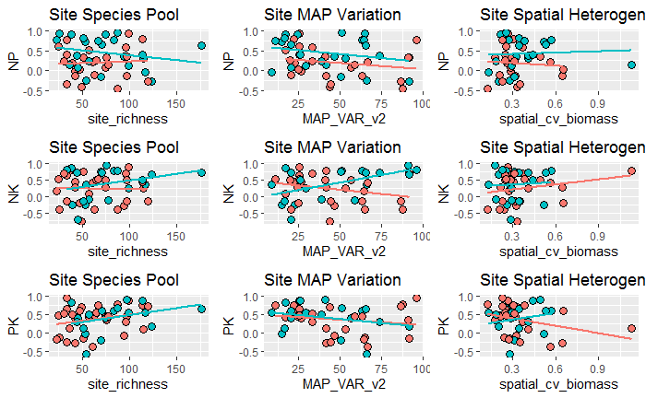

**Follow-ups:**

A few other analyses could be useful, both as curiosities and in determining what causes this site-by-site variation.

1. How consistent are responses within species? For those species present in multiple sites, are responses consistent, both in magnitude and direction?
2. Is site functional group diversity (e.g. Shannon entropy of the relative abundance of the different functional groups) a good predictor of correlation strength between different nutrient addition treatments?

Appendix:

1. Table of sites included in this analysis