Title: Dimensionality of nutrient enrichment response in global grasslands
Authors: Evan Batzer, Siddharth Bharath,…
Key Question: To what degree are compositional responses to experimental fertilization dependent on nutrient identity?
Key Reading: Harpole et al. (2016), (2017)
Bonus Reading: Donohue et al. (2013)

Feedback Requested:
- Are conceptual figures sufficiently detailed to describe analysis approach and expected patterns?
- At this point, site-level variation is not discussed much beyond a basic characterization. Additional space seems limited, but would be happy to expand if some follow-ups seem particularly compelling. Some attempts to characterize site responses by correlation with certain features (richness, productivity, light interception) show no strong patterns.
- In this analysis, to what degree are we interested in whether nutrient effects differ in their magnitude across sites + species vs. to what degree are we interested purely in the directionality of change? On average, sites respond strongest to N addition, followed by P and K, though these differences are most pronounced on the site scale. Without standardizing responses, differences in the magnitude of change may imply low-dimensional patterns, even if trajectories of change are very different from one another. Here, I’ve decided to rescale responses in two ways – 1) when performing the global PCA and major axis regressions, I’ve z-scored all estimated response coefficients. 2) When looking at site-level patterns, I’ve z-scored estimated responses within a site to allow for better comparisons of the 3-dimensional response “shape” across sites. Would benefit from additional discussion.
- After fitting model coefficients, species were filtered based on occupancy in each site. Not wanting to characterize community responses based on a large number of transient taxa, species observed in 33% or more of all samples within a site were kept. Core appear to be qualitatively similar across different methods of filtering (occupancy in control plots, greater than X percent cover). Input on preferred filtering rationale would be helpful.

Abstract
Multiple nutrient addition in grassland systems is theorized to alter species composition and diversity through tradeoffs across a number of niche axes. Following fertilization by different nutrients, compositional change may be characterized by its dimensionality to assess whether species responses fall along a single axis or exhibit treatment-specific patterns that relate to key tradeoffs – light interception vs. belowground resource acquisition and multidimensional belowground competition, respectively. Here, we use data from NutNet sites containing 5+ years of observation to evaluate the trajectories of compositional change in response to N, P, and K fertilizer treatments. Generally, species show a one-dimensional responses, where species responses to nutrient treatments are correlated with one another. However, deviations from this relationship occur in a consistent manner across different functional groups, indicating that species are able to specialize in the capture of particular resources. Together, our results suggest that these multiple mechanisms of compositional change act simultaneously in grassland systems.
Introduction
- Anthropogenic nutrient enrichment is known to be a major driver of compositional change in plant systems. By altering the availability of shared limiting resources, multiple nutrient enrichment operates on a multi-dimensional niche space where plant species exhibit trade-offs across a number of different axes. Chief among these are trade-offs between acquisition of belowground resources vs. competition for light, and trade-offs in the utilization of different soil nutrients. These mechanisms are expected to operate simultaneously, to varying degrees of strength.
- A species’ position across multiple trade-off axes may be linked to physiological characteristics. Differences in the ability to acquire light vs. soil resources is observed to correlate with root:shoot ratio and maximum height, for example, while specialization on soil resources may arise through variation in plant stoichiometric ratios and metabolic demands, such as in leguminous species associated with nitrogen fixing symbiotes.
- The extent to which these different tradeoffs operate in terrestrial systems will govern compositional responses to multiple nutrient enrichment; the dimensionality of compositional response may not mirror the dimensionality of resources added. When the dimensionality of compositional change is low, species responses will be captured by a single axis of change where effects of different fertilizers are all directionally similar. High response dimensionality, on the other hand, indicates that direction of species’ responses to fertilization depends strongly on the identity of the resource added.
- The dimensionality of community response to resource addition, in turn, is likely to control resulting changes in key ecosystem properties. Low dimensional responses will favor similar sets of taxa across a variety of nutrient identities, potentially leading to biotic homogenization even when nutrient inputs are heterogeneous. In contrast, high dimensional responses that depend on nutrient identity, result in varied outcomes under different stressors.
- Here, we assess the dimensionality of compositional response to experimental fertilization.
Methods
- Selected sites with sufficient experimental duration to detect compositional change – filtered to sites with 5+ years of experimental fertilization, with pre-treatment year. To better align with model assumptions, standardized species abundances using log₂ transformation (Anderson et al. 2006)
- Fit multiple linear regression models to plots with single nutrient addition treatments (+N, +P, +Kµ) and control plots. Extract model coefficients that correspond to the estimated rate of change in species abundance per year of treatment. Note: conceptually, this is a similar approach to redundancy analysis (RDA), but where fitted values are calculated for a single unit change in predictors and standardized
- Standardize response coefficients across all sites and decompose estimated responses using PCA. Characterize shape and dimensionality using principal components and associated eigenvalues (see Figure 1 for reference).
- Examine pairwise correlations between responses and analyze the role of functional group variation in the distribution therein.
- Standardize response coefficients within sites and decompose site-level variation in responses using PCA. Characterize sites as in (3), calculate the angle of deviation between a site-level PC1 vector and global PC1 vector to measure the similarity of site-level patterns to the global PCA.
Results
- A majority of sites showed significant (P < 0.05) compositional changes to all three fertilization treatments (+N, +P, +Kµ), though the magnitude of compositional change varied with nutrient identity (Figure 2). On average, N enrichment was estimated to have the largest effect on species composition, followed by P, and K.
- PCA of compositional responses exhibited a relatively low-dimensional pattern; the first principal component accounted for 60% of the total variation in species responses (Figure 3, Table 1). Responses to fertilization were positively correlated, indicating that species may be considered to be general positive or negative responders to fertilization.
- Pairwise comparisons show that this general relationship varies depending on functional group, however (Figure 4). Legumes, in particular, show significant deviations in response from other dominant functional groups, graminoids and forbs, where legume responses to P and K are greater than would be expected given species N response (Table 2). This finding suggests some degree of specialization by this functional group on utilizing available P and K, as would be expected given their ability to fix nitrogen.
- Sites, in general, also share this same 1-dimensional pattern of response, often in a relatively similar direction to that of the global pattern. However, site-level variation is present (Figure 5).

Discussion
- Human-driven changes to environmental systems often occur across many dimensions, whether through disturbance, disease, or nutrient loading. Despite these multidimensional patterns of change, realized effect on biotic composition depends on interactions with the existing community.
  - Constraints on physiological adaptations are likely to make species respond positively or negatively to suites of different environmental stressors.
- We find evidence that plant responses to fertilization of different resources are often correlated in direction. However, deviations from these patterns exhibit patterns with respect to species functional groups.
- Together, these results suggest that two niche tradeoffs may be operating simultaneously in grassland systems -- a dominant, one-dimensional tradeoff related to light competition, as well as secondary tradeoffs driven by variation in species ability to utilize different limiting nutrients.
- In general, one might expect similar trajectories of compositional change in response to nutrient enrichment, independent of the nutrient identity. Multi-dimensional tradeoffs may cause some variation, particularly when communities consist of a diverse mix of different plant functional groups.
- Response dimensionality is a useful concept to understand compositional responses to different elements of system change. Evidence suggests that many ecosystem functions, such as productivity and invasion resistance, may exhibit similar one-dimensional patterns of change (Donohoe et al. 2013). Dimensionality can be a tool to understand how stressors interact with other drivers of community composition, and may be extended to larger suites of treatments.

References
Anderson, M.J., Ellingsen, K.E. & McArdle, B.H. 2006. Multivariate dispersion as a measure of beta diversity. Ecology Letters 9, 683--693.
Coyle, J. R., Hurlbert Allen H., and E. P. White. 2013. Opposing Mechanisms Drive Richness Patterns of Core and Transient Bird Species. The American Naturalist: 181:E83–E90
Donohue, I., O. L. Petchey, J. M. Montoya, A. L. Jackson, L. Mcnally, M. Viana, K. Healy, M. Lurgi, N. E. O’Connor, and M. C. Emmerson. 2013. On the dimensionality of ecological stability. Ecology Letters 16:421–429.
Harpole, W. S., L. L. Sullivan, E. M. Lind, J. Firn, P. B. Adler, E. T. Borer, J. Chase, P. A. Fay, Y. Hautier, H. Hillebrand, A. S. MacDougall, E. W. Seabloom, J. D. Bakker, M. W. Cadotte, E. J. Chaneton, C. Chu, N. Hagenah, K. Kirkman, K. J. La Pierre, J. L. Moore, J. W. Morgan, S. M. Prober, A. C. Risch, M. Schuetz, and C. J. Stevens. 2017. Out of the shadows: multiple nutrient limitations drive relationships among biomass, light and plant diversity. Functional Ecology 31:1839–1846.
Harpole, W. S., L. L. Sullivan, E. M. Lind, J. Firn, P. B. Adler, E. T. Borer, J. Chase, P. A. Fay, Y. Hautier, H. Hillebrand, A. S. MacDougall, E. W. Seabloom, R. Williams, J. D. Bakker, M. W. Cadotte, E. J. Chaneton, C. Chu, E. E. Cleland, C. D’Antonio, K. F. Davies, D. S. Gruner, N. Hagenah, K. Kirkman, J. M. H. Knops, K. J. La Pierre, R. L. McCulley, J. L. Moore, J. W. Morgan, S. M. Prober, A. C. Risch, M. Schuetz, C. J. Stevens, and P. D. Wragg. 2016. Addition of multiple limiting resources reduces grassland diversity. Nature 537:93–96.

Figure 1:
Conceptual diagram illustrating low dimensional (a-c) and high dimensional (d-f) community responses to enrichment of nitrogen (N), phosphorous (P), and potassium and other micronutrients (K). In a low dimensional system, species responses to different limiting nutrients are strongly inter-correlated (a). The resulting 3-dimensional visualization of these species responses (b) are captured by a linear ellipsoid, which may be decomposed in a principal components analysis (PCA) where a single dominant eigenvector, “PC1”, accounts for a large proportion of the overall variance (c). In a high-dimensional system, species responses to different limiting resources are not correlated (d), producing a spherical ellipsoid in 3-dimensional space (e). The resulting PCA decomposition shows more even apportioning of variance across the three eigenvectors (f).
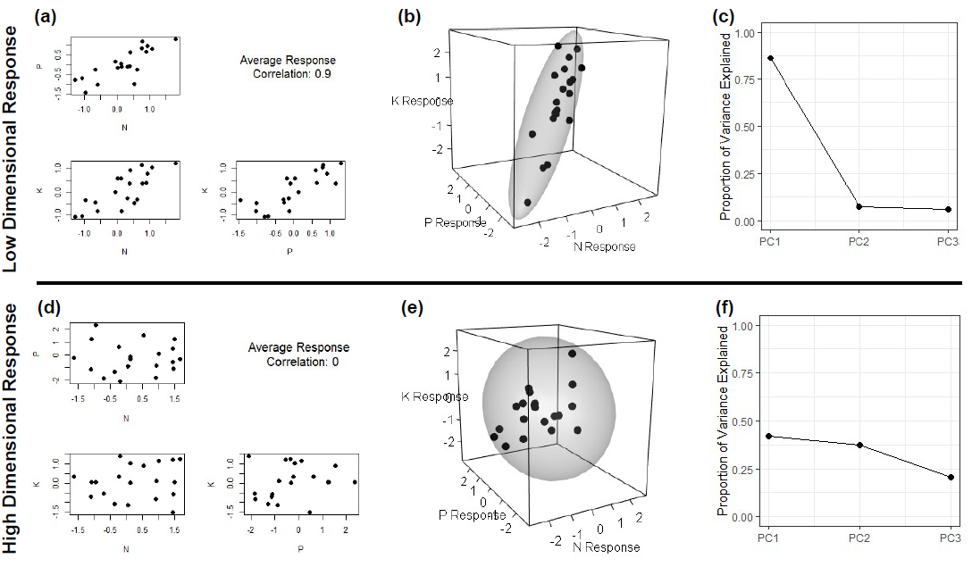
Figure 2:
- Frequency of sites exhibiting significant (p < 0.05) effects of experimental fertilization on plant community composition. Of 50 total sites, 35 showed significant compositional changes to all three fertilization treatments, while 1 site showed non-significant compositional responses to all fertilization treatments.
- Rate of estimated fertilization-driven change in species composition. The rate of total compositional change was calculated as the magnitude of the vector of estimated species response coefficients, estimating net change in log₂-transformed species cover per log-transformed year of treatment. Higher values indicate greater overall rate of compositional change.
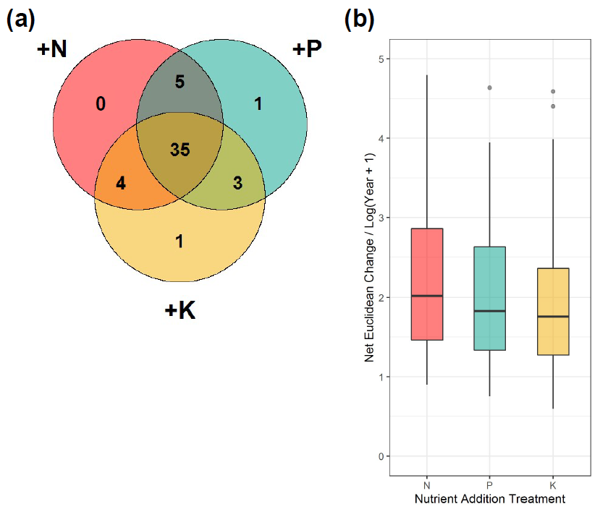
No significant response:
1
Figure 3
Three-dimensional visualization of species responses to fertilization treatments (Figure 3a) and associated principal components analysis (PCA) screeplot (Figure 3b). Positive correlations between estimated species responses produce an ellipsoid with a dominant first axis, as a majority of the overall response variation may be captured by the first eigenvector (Table 1). Permutation-based test of the magnitude of the first eigenvalue (PC1) is statistically significant (p < 0.01), indicating that the observed response pattern exhibits lower dimensionality than would be expected at random.
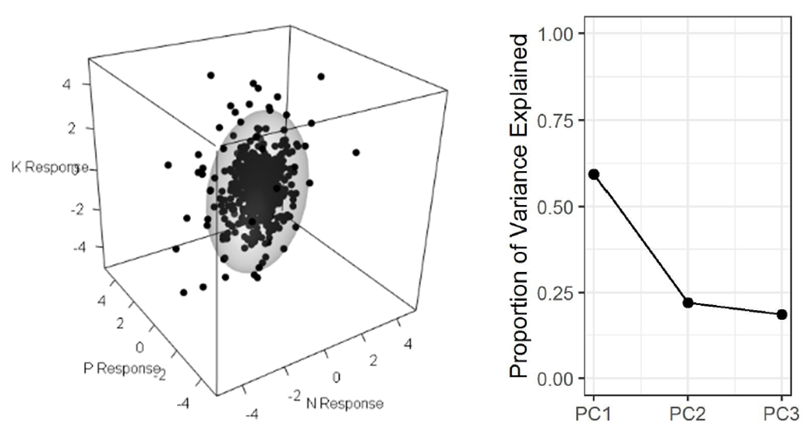
(b)
(a)

Table 1
Results of principal components analysis (PCA) of species responses to experimental fertilization treatments. Eigenvectors show positive variable loadings on the first principal component of all treatment responses, indicating that positively correlated responses to treatment form a dominant pattern in the data.
Principal Component Analysis
 | PC1 |  | PC2 | PC3
Eigenvalue | 1.36 |  | 0.77 | 0.74
Proportion of Variance | 0.62 |  | 0.20 | 0.18
Cumulative Proportion | 0.62 |  | 0.82 | 1.00
Eigenvectors
 | PC1 |  | PC2 | PC3
N response | 0.57 |  | -0.79 | 0.21
K response | 0.58 |  | 0.57 | 0.59
P response | 0.59 |  | 0.21 | -0.78

Figure 4
Major Axis (MA) regression plots demonstrating pairwise correlations between estimated fertilization treatment responses. For each subplot, individual points represent estimated species responses to different limiting resources, colored by species functional group. Colored lines indicate best-fit lines produced by MA regression. Slope coefficients and contrasts between functional groups are presented in Table 2. Axes are displayed at log₂ scale, such that a 1-unit increase corresponds to a doubling of species estimated cover.

Note: An alternative way to get at a similar concept would be to plot the second and third PC dimensions, colored by functional group – this would be used to determine if tradeoffs exist, once we’ve accounted for the general relationship captured by the first axis.

Table 2
Results of Major Axis (MA) model fitting to pairwise treatment responses. For each pairwise combination of treatment response coefficients, the within-group model R-squared, group slope, and post-hoc group labeling is presented. Groups where fitted slopes varied significantly (P < 0.05) were assigned different labels. P-values adjusted for multiple comparison using the Sidak correction. Generally, leguminous species show distinct responses relative to other functional groups, particularly between estimated N and P response coefficients. Legumes appear to show greater specialization to P than other nutrients, exhibiting more extreme responses than would be expected given overall trends.

 |  | N - P |  |  | N - K |  |  | P - K
Functional Group | n | R-squared | Slope | Group | R-squared | Slope | Group | R-squared | Slope | Group
Forb | 288 | 0.20 | 0.98 | 1 | 0.16 | 1.03 | 1 | 0.17 | 1.05 | 12
Graminoid | 236 | 0.22 | 1.00 | 1 | 0.15 | 0.97 | 1 | 0.19 | 0.97 | 12
Legume | 45 | 0.12 | 1.60 | 2 | 0.14 | 1.33 | 1 | 0.29 | 0.83 | 1
Woody | 15 | 0.74 | 0.74 | 1 | 0.83 | 1.11 | 1 | 0.76 | 1.50 | 2
Figure 5
Histograms depicting the fraction of variance captured by the dominant eigenvector (PC1) across sites, and the angle of deviation between the dominant eigenvector of site-level PCA and dominant eigenvector of global PCA. Variance captured by PC1 across sites shows evidence for a generally 1-dimensional pattern of response to experimental fertilization, often occurring in a direction very similar to the pattern found across all datapoints. However, in both cases, there is significant variation among sites.
Note: Additional exploration here has not been particularly successful – there is no significant relationship between these two measures, and additional tests vs. site-level covariates of interest (productivity, richness, light penetration pre-treatment) hasn’t yielded significant results.

Appendix 1: Sites used in analysis
 | site_code | site_name | continent | country | n_years | n_obs | first_nutrient_year
1 | azi.cn | Azi | Asia | CN | 5 | 60 | 2008
2 | bldr.us | Boulder South Campus | North America | US | 9 | 72 | 2009
3 | bnch.us | Bunchgrass (Andrews LTER) | North America | US | 12 | 142 | 2008
4 | bogong.au | Bogong | Australia | AU | 11 | 132 | 2010
5 | burrawan.au | Burrawan | Australia | AU | 12 | 144 | 2009
6 | cbgb.us | Chichaqua Bottoms | North America | US | 10 | 239 | 2010
7 | cdcr.us | Cedar Creek LTER | North America | US | 12 | 240 | 2008
8 | cdpt.us | Cedar Point Biological Station | North America | US | 12 | 288 | 2008
9 | cereep.fr | CEREEP - Ecotron IDF | Europe | FR | 7 | 84 | 2013
10 | chilcas.ar | Las Chilcas | South America | AR | 7 | 84 | 2014
11 | comp.pt | Companhia das Lezirias | Europe | PT | 8 | 96 | 2013
12 | cowi.ca | Cowichan | North America | CA | 12 | 144 | 2008
13 | elliot.us | Elliott Chaparral | North America | US | 11 | 130 | 2009
14 | ethass.au | Ethabuka (South Site) | Australia | AU | 7 | 80 | 2014
15 | frue.ch | Fruebuel | Europe | CH | 8 | 96 | 2009
16 | hall.us | Hall's Prairie | North America | US | 8 | 96 | 2008
17 | hart.us | Hart Mountain | North America | US | 6 | 72 | 2008
18 | hero.uk | Heronsbrook (Silwood Park) | Europe | UK | 7 | 84 | 2008
19 | hopl.us | Hopland REC | North America | US | 12 | 141 | 2008
20 | jena.de | JeNut | Europe | DE | 5 | 60 | 2015
21 | kbs.us | Kellogg Biological Station LTER | North America | US | 5 | 100 | 2014
22 | kibber.in | Kibber (Spiti) | Asia | IN | 8 | 96 | 2012
23 | kilp.fi | Kilpisjärvi | Europe | FI | 6 | 80 | 2014
24 | kiny.au | Kinypanial | Australia | AU | 11 | 132 | 2008
25 | koffler.ca | Koffler Scientific Reserve at Joker's Hill | North America | CA | 9 | 108 | 2011
26 | konz.us | Konza LTER | North America | US | 11 | 132 | 2008
27 | lancaster.uk | Lancaster | Europe | UK | 10 | 120 | 2009
28 | look.us | Lookout (Andrews LTER) | North America | US | 12 | 144 | 2008
29 | marc.ar | Mar Chiquita | South America | AR | 8 | 93 | 2012
30 | mcla.us | Mclaughlin UCNRS | North America | US | 12 | 144 | 2008
31 | mtca.au | Mt. Caroline | Australia | AU | 11 | 176 | 2009
32 | ping.au | Pingelly Paddock | Australia | AU | 6 | 72 | 2014
33 | pinj.au | Pinjarra Hills | Australia | AU | 5 | 60 | 2014
34 | rook.uk | Rookery (Silwood Park) | Europe | UK | 7 | 84 | 2008
35 | sage.us | Sagehen Creek UCNRS | North America | US | 7 | 84 | 2008
36 | saline.us | Saline Experimental Range | North America | US | 10 | 120 | 2008
37 | sava.us | Savannah River | North America | US | 6 | 48 | 2008
38 | sedg.us | Sedgwick Reserve UCNRS | North America | US | 11 | 132 | 2008
39 | sereng.tz | Serengeti | Africa | TZ | 5 | 60 | 2009
40 | sgs.us | Shortgrass Steppe LTER | North America | US | 12 | 142 | 2008
41 | shps.us | Sheep Experimental Station | North America | US | 10 | 160 | 2008
42 | sier.us | Sierra Foothills REC | North America | US | 12 | 232 | 2008
43 | smith.us | Smith Prairie | North America | US | 10 | 120 | 2008
44 | spin.us | Spindletop | North America | US | 12 | 144 | 2008
45 | temple.us | Temple | North America | US | 10 | 120 | 2008
46 | trel.us | Trelease | North America | US | 10 | 120 | 2009
47 | ukul.za | Ukulinga | Africa | ZA | 10 | 120 | 2010
48 | unc.us | Duke Forest | North America | US | 5 | 60 | 2008
49 | valm.ch | Val Mustair | Europe | CH | 10 | 120 | 2009
50 | yarra.au | Yarramundi | Australia | AU | 6 | 96 | 2015

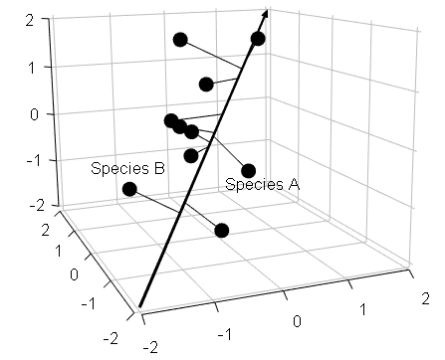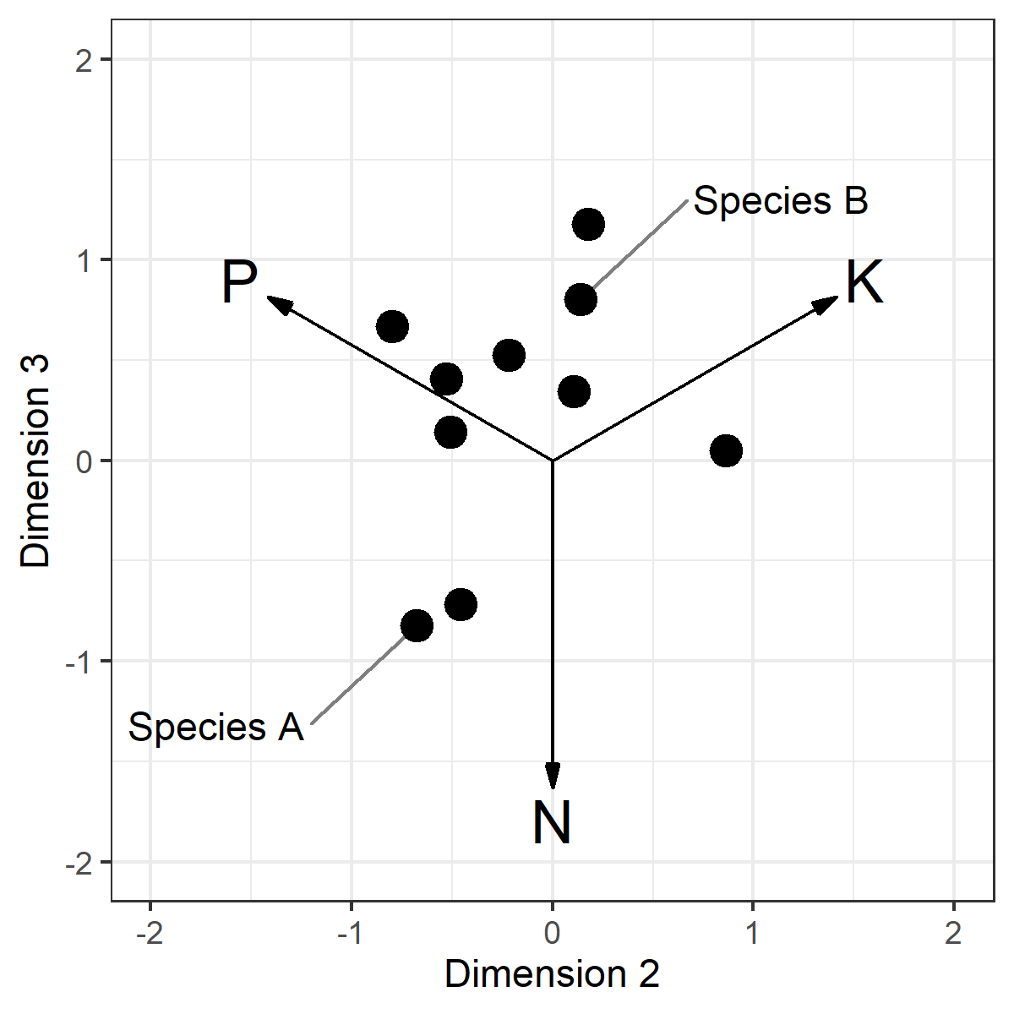
Dimension 1
(1:1:1)
K Response
P Response
N Response

