The illusion of control: Spatial variation in composition complicates detection of fertilizer effects

Jonathan D. Bakker, Claire E. Wainwright, Jeremiah Henning, …

180726

Target Journal: Ecology

Abstract
Community composition varies in response to many different factors. For example, spatial variation may reflect differences in colonization history and abiotic conditions, while temporal variation may reflect interannual weather patterns and successional dynamics. When spatial and/or temporal variation are considerable, it may be difficult to detect or understand the effects of management actions. Therefore, we examined the relative importance of spatial and temporal sources of variation, and why they differ among sites. We analyzed compositional data from 41 grassland sites from the Nutrient Network, a globally distributed collaborative experiment. At each site, nitrogen (N), phosphorus (P), and potassium plus micronutrients (K+) were applied in a replicated, factorial design to 24 plots (8 treatments; 1 replicate plot per block; 3 blocks). Plant composition was assessed annually for 4 years (pre-treatment plus 3 years post-treatment) in each plot. Sites were analyzed separately due to large compositional differences among them. Compositional dissimilarity was quantified using Bray-Curtis distance. Using an identically structured subset of the plots at each site (3 blocks, 1 treatment plot per block, 4 years; n = 96 plot-years), we partitioned the variation in plant community composition and determined the percentage of variation associated with each term (block, treatment, year, and interactions). Next, we compared the patterns of variation partitioning using Principal Component Analysis, and related to potential explanatory variables. Treatment effects were assessed for statistical significance using PERMANOVA. Overall, we found that most of the variation in community composition (>80%) was explained by two PCs, one strongly related to temporal variation (year) and the other to spatial variation (block, block:treatment). Temporal variation (PC1) was positively related to site elevation and size of the species pool, but spatial variation (PC2) was not related to any of the explanatory variables. Treatment effects on composition were weak relative to temporal and spatial variation. One or more fertilizer treatments had a significant main effect on composition in about half of sites. Other sites had significant interactions between fertilizers and time, though about a quarter of sites had no fertilizer effects. N was the fertilizer that resulted in compositional change at the most sites, followed by P and then K+, though all fertilizer combinations had significant effects at one or more sites. This study demonstrates that temporal and spatial variation in composition often greatly exceed the variation associated with fertilizer treatments, and can confound the detection of treatment-related compositional changes. The effects of P were stronger at sites that exhibit high temporal variation in composition. Model selection indicated that the strength of the effect of some fertilizers was related to climatic variables or other site-level variables. Managers need to understand the relative importance of these sources and incorporate them into monitoring strategies, such as when deciding how many plots to establish, whether to use permanent or temporary plots, and how many years to monitor them. Future work should examine whether temporal and treatment-related, compositional-change reflect directional change, divergence, or convergence.

Introduction
Biodiversity underpins many ecosystem functions and services. Biodiversity is threatened by various human activities. Global studies have improved our understanding of the impacts of human activities on biodiversity as well as its consequences on ecosystem functioning and service provisioning. There is a growing global collective of ecosystem observatories (NEON, TERN, SAEON etc), and these observatories require efficient programs to detect ecological change, including for biodiversity.
Biodiversity can be expressed in several ways. Much work has focused on simple univariate metrics like richness, though recent work has emphasized the importance of moving beyond these to understand compositional changes (Hillebrand et al. 2018; other citations). Composition incorporates taxon identity, and can also incorporate abundance – communities with the same richness could differ in species identity, abundances, or both. This complexity is reflected in how composition is expressed: instead of a single univariate response for each sample unit, differences from one sample unit to another are expressed as a dissimilarity, and the set of dissimilarities among all sample units are summarized in a distance matrix. This
Accurate assessments of biodiversity at global scales need to understand variation within local sites. Natural sources of variation include spatial variation – differences in composition from one plot to another – and temporal variation – variation in composition over time. Spatial variation is often driven by edaphic conditions and can occur at different spatial scales. Temporal variation can reflect changing conditions such as weather patterns but can also reflect successional dynamics. [add another sentence or two about what we know about these sources of variation – and their potential predictors?].
Global assessments often do not just consider spatial and temporal variation, but also seek to understand the effects of anthropogenic sources of variation such as management actions. Management actions influence composition based on their differential effects on species – favoring some species over others. However, the magnitude of management-related variation, and our ability to detect it, may depend on the natural compositional variation of the site. For example, if a site contains high spatial variation in composition, then management actions will only be detectable if they have consistently affected a range of species. In contrast, if a site contains low spatial variation in composition, then management actions can be detectable if they affect those species that are widespread across the site. Similarly, if a site contains high temporal variation in composition, such as an annual grassland where the community is re-established each year, then there are many opportunities for species to be established or lost and thus it should be relatively ‘easy’ to detect management actions. In contrast, a site with low temporal variation, such as a stable community dominated by perennials, may have fewer opportunities for compositional change – changes in relative abundance may be more likely than changes in species identity – and thus management actions are less likely to be detectable.
Composition directly affects ecosystem services such as productivity, pollination, and nutrient cycling. Thus, understanding how composition varies within sites, and how controls on composition vary among sites, could have implications for ecosystem management and for the societal benefits provided. We used a global collaborative experiment, the Nutrient Network (NutNet), to examine compositional variation within grassland plant communities and to compare within-site variation among sites (composition was assessed separately for each site as the sites span such a wide ecological range that among-site compositional differences would have obscured within-site differences). We explored three questions: First, how do sites compare in terms of their within-site compositional variation? Second, which sites have similar patterns in terms of how much of the compositional variation is attributable to spatial, temporal, and management-related sources? Third, how does nutrient addition alter composition, and are these effects related to site-level characteristics?

Methods
Data were gathered through NutNet’s multiple-nutrient addition experiment. The experimental approach is summarized in Borer et al. (2014). At each site, plots are 5 x 5 m and are separated by at least 1 m. Briefly, eight factorial combinations of nitrogen, phosphorus, and potassium are added to each site annually.
Sampling follows a standardized protocol (Borer et al. 2014). We measured plant community composition in one permanent, randomly selected 1 x 1 m subplot per plot, visually estimating cover for each plant species. Sites were sampled once or twice during the growing season, depending on the perceived intra-annual variation in species occurrence. Here, we focused on sites where plant community composition had been collected during four growing seasons (pre-treatment plus 3 years of treatment) and that had at least 3 treatment blocks, giving us a total of 41 sites spanning 12 countries on 6 continents (Table S1; Figure 1).
Analyses of compositional change are sensitive to taxonomic differences. We reviewed the nomenclature at each site to ensure consistent naming over time (the Nutrient Network nomenclature system also aims for consistency across sites but this was less important in our analysis). Taxonomic adjustments were made in about three-quarters of sites, usually by combining species at the genus level (Table S2). The resulting dataset consists of ~ 50,000 records from ~ 1,400 taxa.
We calculated several potential site-level variables that we thought might be related to the magnitude and partitioning of within-site compositional variation: elevation, management history, gamma diversity, productivity, spatial variation in edaphic characteristics, climate, and compositional partitioning. Site elevation (m) was log-transformed; this variable is not an ecological driver but rather is correlated with many other variables. Management history was coded as a binary variable based on whether there were records of the site being managed or burned or grazed or subject to anthropogenic disturbances. The size of the species pool (gamma diversity) was quantified as the total number of taxa recorded in the 96 plot-year combinations at the site (after the above taxonomic adjustments). Productivity was calculated as the average live biomass (g m⁻²) in unfertilized plots. Spatial variation in edaphic characteristics was calculated as the coefficient of variation in live biomass in unfertilized plots. Climate was indexed as five principal components derived from a PCA of 23 climate-related variables (Table S3). Finally, the compositional partitioning described below identified three clusters of sites that differ in primary source of variation.

Statistical analysis
All analyses were done in R (version 3.5.1), with packages listed where appropriate.
To ensure that differences in plant community composition among sites was not related to differences in how the experiment was implemented at different sites, such as differences in the number of blocks, we first subsetted the data to include only those sites that met two criteria: i) all 8 combinations of nutrient addition were tested in one plot per block and 3 blocks per site, and ii) every plot was measured every year. Sites that established one or two additional blocks were reduced to this structure by selecting 3 blocks. Two sites had six blocks each; these were divided into two groups of 3 blocks each following advice from the site leads (maybe include cite leads as personal communication); each group was treated as a site. The resulting dataset contained 24 plots per site x 4 years = 96 plot-year combinations per site and was available for 43 sites, for a total of 4,128 site-plot-year combinations. As noted above, we analyzed composition separately for each site. Composition was expressed as a site-plot-year x taxon matrix and relativized by site-plot-year total. The composition matrix was then converted to a distance matrix using the Bray-Curtis distance measure. The distance matrix for each site contains a numerical summary of all of the compositional differences among the plot-years within it – spatial variation among plots, temporal variation of plots over time, variation related to nutrient addition treatments, and interactions among these factors.
Question 1: The overall magnitude of compositional variation was expressed as the mean Bray-Curtis distance for each site. This value was compared to the expected amount of spatial and temporal variation in composition, where spatial variation was calculated as the mean Bray-Curtis distance among all plots in the pre-treatment year, and temporal variation as the mean Bray-Curtis distance among all control plots in all years. We used a linear mixed model with site as a random effect to test whether these three types of distances differed.
Question 2: The PERMANOVA technique (Anderson 2001) can partition a distance matrix and express how much of the variation is associated with each of the different sources. In the context of our analysis, there were seven sources: block (spatial; 3 levels), year (temporal; 4 levels), nutrient addition (8 levels), and the interactions between them. PERMANOVA is available in R through the adonis function (vegan package), which we used to calculate how much of the variation within the distance matrix was associated with each source. Since these sources account for all of the variation, we expressed the variation associated with each as a proportion of the total variation. We compiled the proportion of variance explained by each factor into a site x term matrix (43 x 7) and applied two procedures to this matrix to enable comparisons among sites. First, we used hierarchical cluster analysis (hclust function) to classify groups of sites with similar patterns of compositional partitioning. Second, we used Principal Components Analysis (PCA; princomp function) to express the differences among sites in as few dimensions as possible.
Because principal components are orthogonal, they can be analyzed separately. We tested whether the score for each site along each principal component were related to the potential explanatory variables identified above, using model selection (stepAIC function; MASS package) to identify models that balanced parsimony with explanatory power. We used BIC as the model selection criterion with k equal to the log of the number of sites.
Question 3: Partitioning of a distance matrix is not a statistical test. PERMANOVA-type statistical tests are permutation-based and therefore require specification of the correct error terms. Here, we were interested in whether the individual nutrient combinations affected composition, so we tested them separately rather than as a single factor as was done above. We used a two-step sequence as appropriate for a split-plot or repeated measures design (Anderson et al. 2008). First, we tested the main effects of nutrient addition as whole-plot effects. Since each plot was measured in four years, its centroid in the compositional space was calculated using Principal Coordinates Analysis (PCoA). The resulting matrix of 24 plots (8 nutrient combinations × 3 blocks) was analyzed for nutrient addition main effects; block was included in all models to account for spatial variation, and the residual (aka block x nutrient interaction) was the denominator for the test statistic. Second, we tested time and its interactions between nutrient combinations as split-plot effects. For this analysis, the full distance matrix (96 plot-years) was analyzed in a model which included plot ID (24 levels) to account for inter-plot variation (this term was not evaluated as it was already tested in the whole-plot analysis, but was included to account for plot-level variation), year (4 levels), the block x year interaction, and the interactions of time with each nutrient combination. The residual (aka block x year x nutrient interaction) was the denominator for the test statistic. The amount of variation accounted for by each term (partial R²) and the associated P-value were recorded. Statistical significance was assessed using 9999 permutations with α = 0.05. The number of sites exhibiting significant nutrient or nutrient x year effects were tallied. Model selection was used to determine whether differences among sites in the amount of variation associated with each term could be accounted for by the potential explanatory variables as described above for principal components.

Results

Question 1: Magnitude of Compositional Variation
Sites exhibited considerable compositional variation. On average, the Bray-Curtis distance between any two plot-years at a site was 0.53 (Figure 2A). In comparison, the average spatial variation (comparing pre-treatment data from all 24 plots at a site) was 0.47, and the average temporal variation (comparing variation among control plots over time) was 0.48.
Among sites, mean compositional variation ranged from 0.17 to 0.73. Model selection indicated that the amount of compositional variation was related to productivity and gamma diversity (BIOCLIM.5 was also marginally significant). More productive sites exhibited less compositional variation, as did sites with smaller species pools (Figure 2B).

Question 2: Compositional Partitioning
Two PCs accounted for 82% of the compositional variation (Figure 3A). The first PC was strongly related to time and the second to block (Table 1). Thus, temporal and spatial variation were the largest sources of compositional variation within sites. Surprisingly, nutrient combinatios did not account for very much of the variation in community composition within most sites (Table 1). Hierarchical cluster analysis identified three strong clusters of sites (Figure S1). These clusters aligned with the primary sources of compositional variation: much of the compositional variation related to temporal changes in one cluster, to spatial variation among blocks in a second cluster, and to spatial variation within blocks (i.e., the Block x Nutrient interaction) in a third cluster (Figure 3B).
Site scores along the Temporal PC were related to elevation and to size of the species pool (adjusted R² = 0.397; Figure 3C). Higher elevation sites exhibited lower temporal variation, and sites with smaller species pools were more likely to exhibit high temporal variation in composition.
Site scores along the Spatial PC were related to within-site variability in productivity (adjusted R² = 0.096; Figure 3D). Sites with more variable productivity were also more likely to have a greater percentage of their compositional variation within blocks.

Nutrient Addition Effects
Statistically significant main effects of nutrient addition were detected in 47% of sites, and Year x Nutrient Addition interactions were detected in 63% of sites (Figure 4A). Nutrient addition had no significant effect on composition – alone or in interaction with Year – in about one quarter (26%) of sites. Most of the other sites had one or two significant terms (Table 2; Table S4).
Nutrients were more likely to be significant individually rather than in combination with other nutrients, though every combination was statistically significant in at least one site (Figure 4B). Interactions with time were more often statistically significant than were main effects of nutrients. Nitrogen (% of sites) was the most common fertilizer responded to, followed by P (% of sites) and then K+ (% of sites). The least responsive nutrient combination was NP; composition changed in a statistically significant manner in response to this treatment at a single site.
Differences among sites in the amount of compositional variation accounted for by each nutrient combination, as expressed as its partial R² value, are related in part to site-level explanatory variables (Table 3). These models accounted for up to a third of the variation among sites; the best-fitting models related to patterns associated with P and with PK. Different explanatory variables were often selected for different nutrient combinations and for models of Nutrient main effects compared to models of Nutrient x Year interactions. For example, the amount of compositional change accounted for by P was greater in sites in the ‘Temporal’ cluster than in either of the spatial clusters and was also greater in in warm, dry sites than in cool, wet sites (Figure 5A). The amount of compositional change accounted for by the P x Year interaction was even more strongly associated with the ‘Temporal’ cluster and was also greater in sites with low productivity (Figure 5B).

Discussion
Our results demonstrate strong differences among sites in terms of the magnitude and sources of compositional variation. Some of these differences are explainable by, or related to, differences among sites in productivity and other variables. Recognizing these differences has implications in terms of how sensitive sites are to management actions and our ability to detect the effects of those actions.

Sites Differ in Magnitude of Compositional Variation
Our sites are located around the globe and differ in many different respects. By subsetting our data so that all sites had identical analytical structures (3 blocks x 8 plots x 4 years = 96 plot-year combinations), we ensured that any differences we detected were not a result of differences in number of blocks or other design elements. We also made site-specific taxonomic adjustments to avoid ‘spurious’ compositional changes over time. Even with this control, sites differed considerably in terms of how much compositional variation was documented within them.
Magnitude of variation was related to productivity…
Magnitude of variation was also related to gamma diversity…

Sites Differ in Sources of Variation
In addition to differing in terms of how much compositional variation they contain, sites also differ in terms of the factors that account for that variation. Three clusters…
Explanatory variables associated with partial R² of each nutrient combination…
Interestingly, the fewest sites responded to the NP combination even though that combination has been shown to limit productivity (Fay) and richness (Harpole) at multiple sites. Consistency of effects – compare to Phil, Stan (Table S4)

Management and Monitoring Implications
The results of this study have implications for our ability to detect effects of management actions and for our monitoring programs.
Management implications: Nutrient addition effects are small relative to spatial and temporal variation within sites but may strengthen over time; additional research needed. These sites continue to be monitored, so future research could assess whether the three clusters identified here are predictors of long-term nutrient addition effects.
Monitoring implications: Patterns of spatial and temporal variation in composition can be accommodated to some extent during monitoring. For example, it is well recognized that re-measuring permanent plots reduces the effect of spatial variation compared to establishing new temporary plots at each measurement date. However, even though this is exactly what we did, the natural variation from one plot to another and the variation on the same plots over time were very similar (Figure 2A). It is possible that spatial and temporal variation would have differential effects on the two aspects of compositional variation, turnover and changes in abundance (Baselga citation). For example, we might expect species turnover to be more prevalent spatially and changes in abundance to be more prevalent temporally.
For example, spatial and temporal variation can affect our ability to detect treatment effects, depending on how they are incorporated into the experimental design and analysis. Large-scale sources of spatial variation can be incorporated into experimental designs through blocking, while small-scale sources (e.g., variation within blocks) are not explainable by such factors and therefore increase the unexplained variation that forms the denominator for the treatment test statistic and thus reduces the size of the text statistic.
Temporal variation can be accounted for by re-measuring permanent plots as opposed to measuring new temporary plots at each date. However, our results demonstrate that permanent plots are not a complete solution: there was very large compositional change in control plots over time even though the same plots were re-measured each time. Temporal changes were ubiquitous – the main effect of Year was the only term that was statistically significant for every site.
Considerable variation in composition – more than implied by use of ‘control’ treatment. Even untreated plots changed about 50% in composition over time.

Conclusions

Acknowledgements
We thank…

References
Hillebrand, H., B. Blasius, E. T. Borer, J. M. Chase, J. A. Downing, B. K. Eriksson, C. T. Filstrup, W. S. Harpole, D. Hodapp, S. Larsen, A. M. Lewandowska, E. W. Seabloom, D. B. Van de Waal, and A. B. Ryabov. 2018. Biodiversity change is uncoupled from species richness trends: Consequences for conservation and monitoring. Journal of Applied Ecology 55:169-184.

Table 1. Loadings associated with the first two principal components from a PCA of the components of compositional variation for 43 sites with the same experimental structure (3 blocks, 8 plots per block, 4 years) at each site. Loadings above 0.4 are in bold font, and positive loadings are in italics. Loadings with an absolute value < 0.1 are not shown.

Source | PC1 (Temporal) | PC2 (Spatial)
Block | 0.31 | 0.79
Year | -0.71 | -0.14
Nutrient Addition | 0.21 | -0.28
Block x Year |  | 0.11
Block x Nutrient Addition | 0.55 | -0.51
Year x Nutrient Addition | -0.14
Block x Year x Nutrient Addition | -0.17
Proportion of variance | 0.55 | 0.27
Cumulative proportion | 0.55 | 0.82

Table 2. Number of sites with statistically significant effects of year and varying numbers of nutrient combinations.

Term | Main Effect | Interaction with Time | Either
Year | 43 | - | -
Number of Nutrients
0 | 23 | 16 | 11
1 | 15 | 19 | 11
2 | 4 | 5 | 17
3 | 1 | 3 | 1
4 | 0 | 0 | 0
5 | 0 | 0 | 2
6 | 0 | 0 | 1
7 | 0 | 0 | 0

Table 3. Explanatory variables associated with partial-R² of nutrient combinations, either as main effects or in interaction with time, as determined by model selection. Potential explanatory variables were management, log.elevation, live_mass, live_mass_CV, log.S, BIOCLIM.1, BIOCLIM.2, BIOCLIM.3, BIOCLIM.4, BIOCLIM.5, and cluster (3 groups identified from cluster analysis of sources of compositional variation). A few examples of these patterns are shown in Figure 5.

 | Main Effect |  |  | Interaction with Time
Term | Explanatory Variables | R² |  | Explanatory Variables | R²
N | Log.elevation | 0.14 |  | -
P | Cluster, BIOCLIM.1 | 0.31 |  | Cluster, live_mass | 0.32
K | live_mass_CV | 0.10 |  | Cluster | 0.19
NP | - |  |  | -
NK | Management | 0.11 |  | Live_mass | 0.13
PK | Log.elevation, BIOCLIM.1 | 0.29 |  | Log.S, management | 0.33
NPK | Log.elevation, BIOCLIM.2 | 0.23 |  | BIOCLIM.5 | 0.10

Figure 1. Study site locations around the globe. Detailed characteristics of each site are provided in Supplementary Table S1. [need to update]

Figure 2. (A) Mean compositional variation among all plot-year combinations, among control plots over time, or among all plots in the pre-treatment year. Data are shown as jittered points and as violin plots with horizontal lines denoting the medians. (B) Mean compositional variation at each site relates to site productivity (P = 0.003) and gamma diversity (P = 0.044); BIOCLIM.5 (not shown) was also marginally significant (P = 0.059).

Figure 3. (A) Principal components related to sources of compositional variation. Each symbol is a site, and vectors indicate the directions in which each source of compositional variation increases. Loadings are reported in Table 1. (B) Hierarchical cluster analysis identifies three clusters of sites – the dendrogram is in Figure S1. (C) Location along the Temporal PC relates to site elevation (P < 0.001) and size of the species pool (P = 0.011). (D) Location along the Spatial PC relates to within-site variability in productivity, expressed as the CV of pre-treatment biomass values (P = 0.024).

Figure 4. (A) Percentage of sites with at least one statistically significant nutrient combination, either as a main effect, in interaction with time, or in either role. (B) Percentage of sites with statistically significant effects of each nutrient combination, either as a main effect or in interaction with time.

Figure 5. (A) The amount of compositional variation accounted for by the addition of P is a function of BIOCLIM.1 and cluster identity (Figure 3B). Symbol and line colors correspond to the clusters. Dark symbols indicate sites where the effect of P was statistically significant. Positive values of BIOCLIM.1 indicate sites that are warmer and drier, and negative values indicate sites that are cooler and wetter. (B) The amount of compositional variation accounted for by the P x Year interaction is a function of site productivity and the cluster to which the site is classified.

Figure 1

A) B)

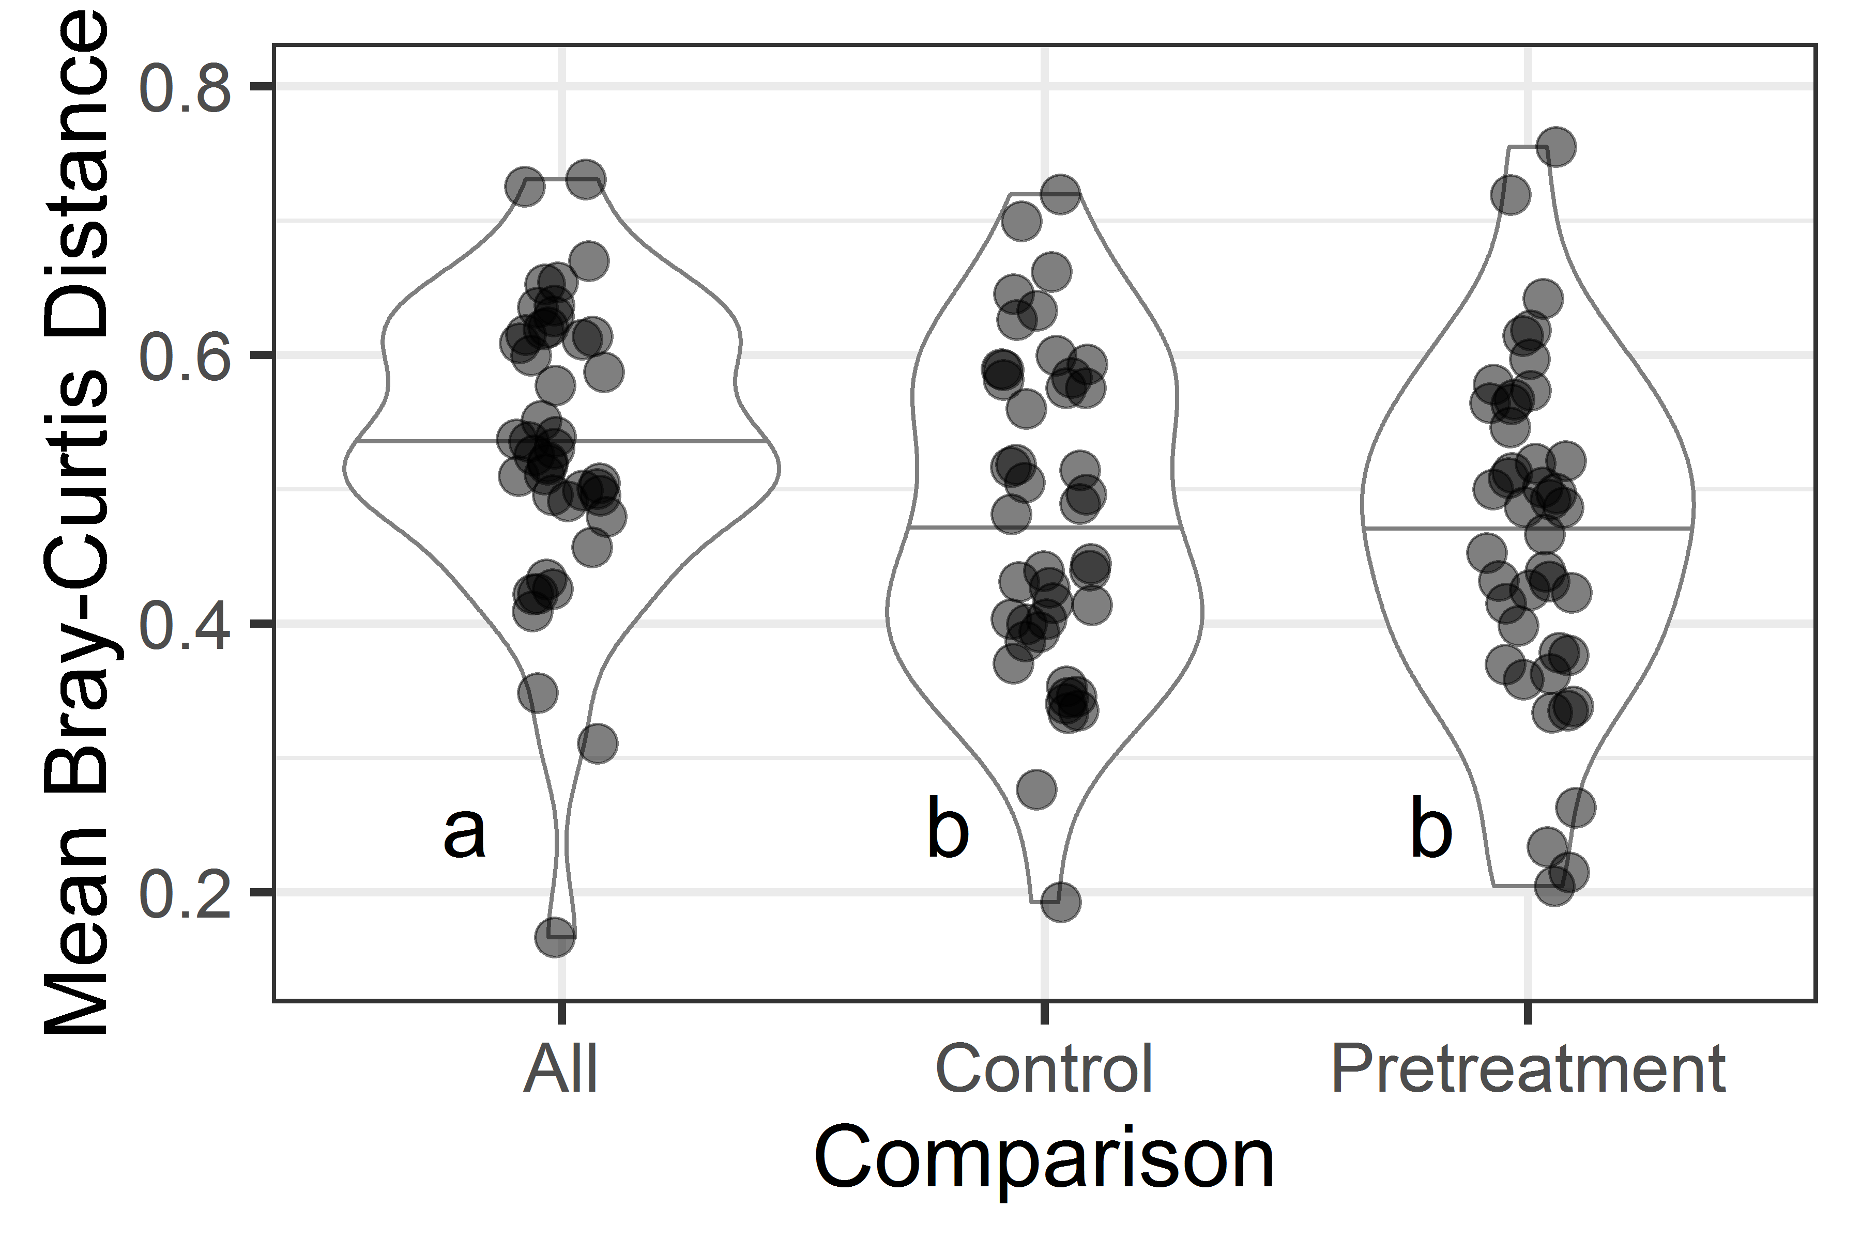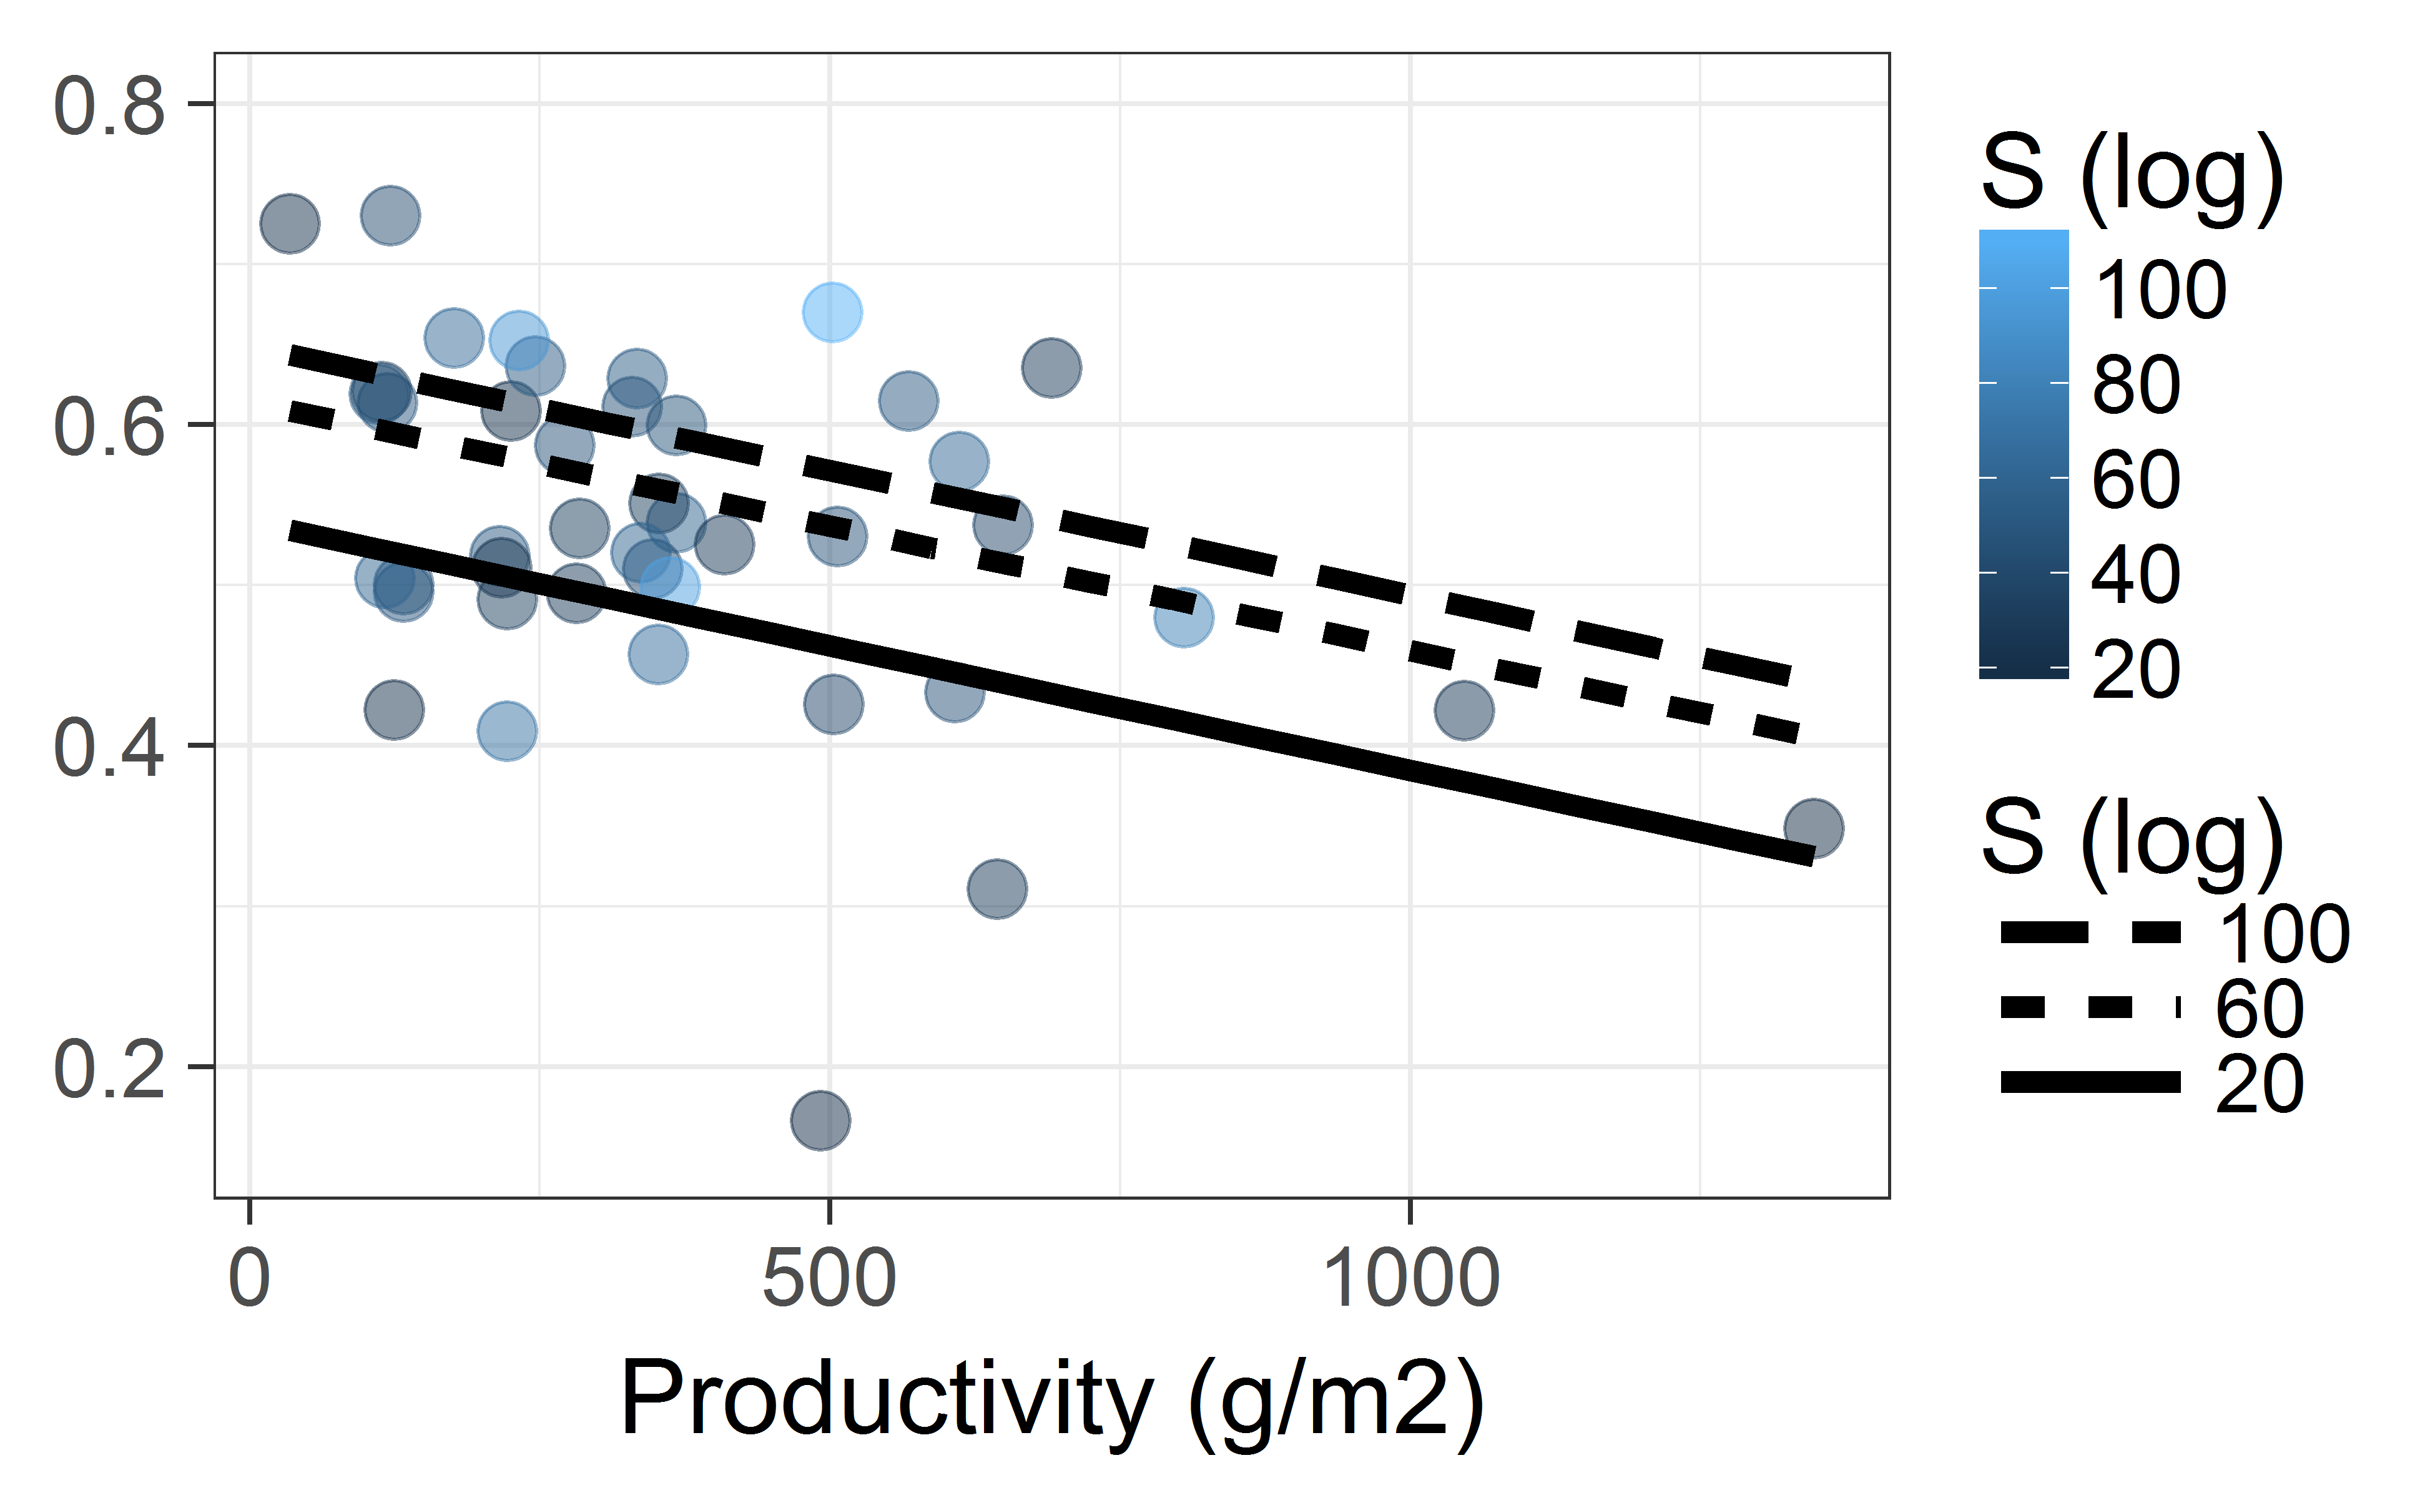

Figure 2

A) B)

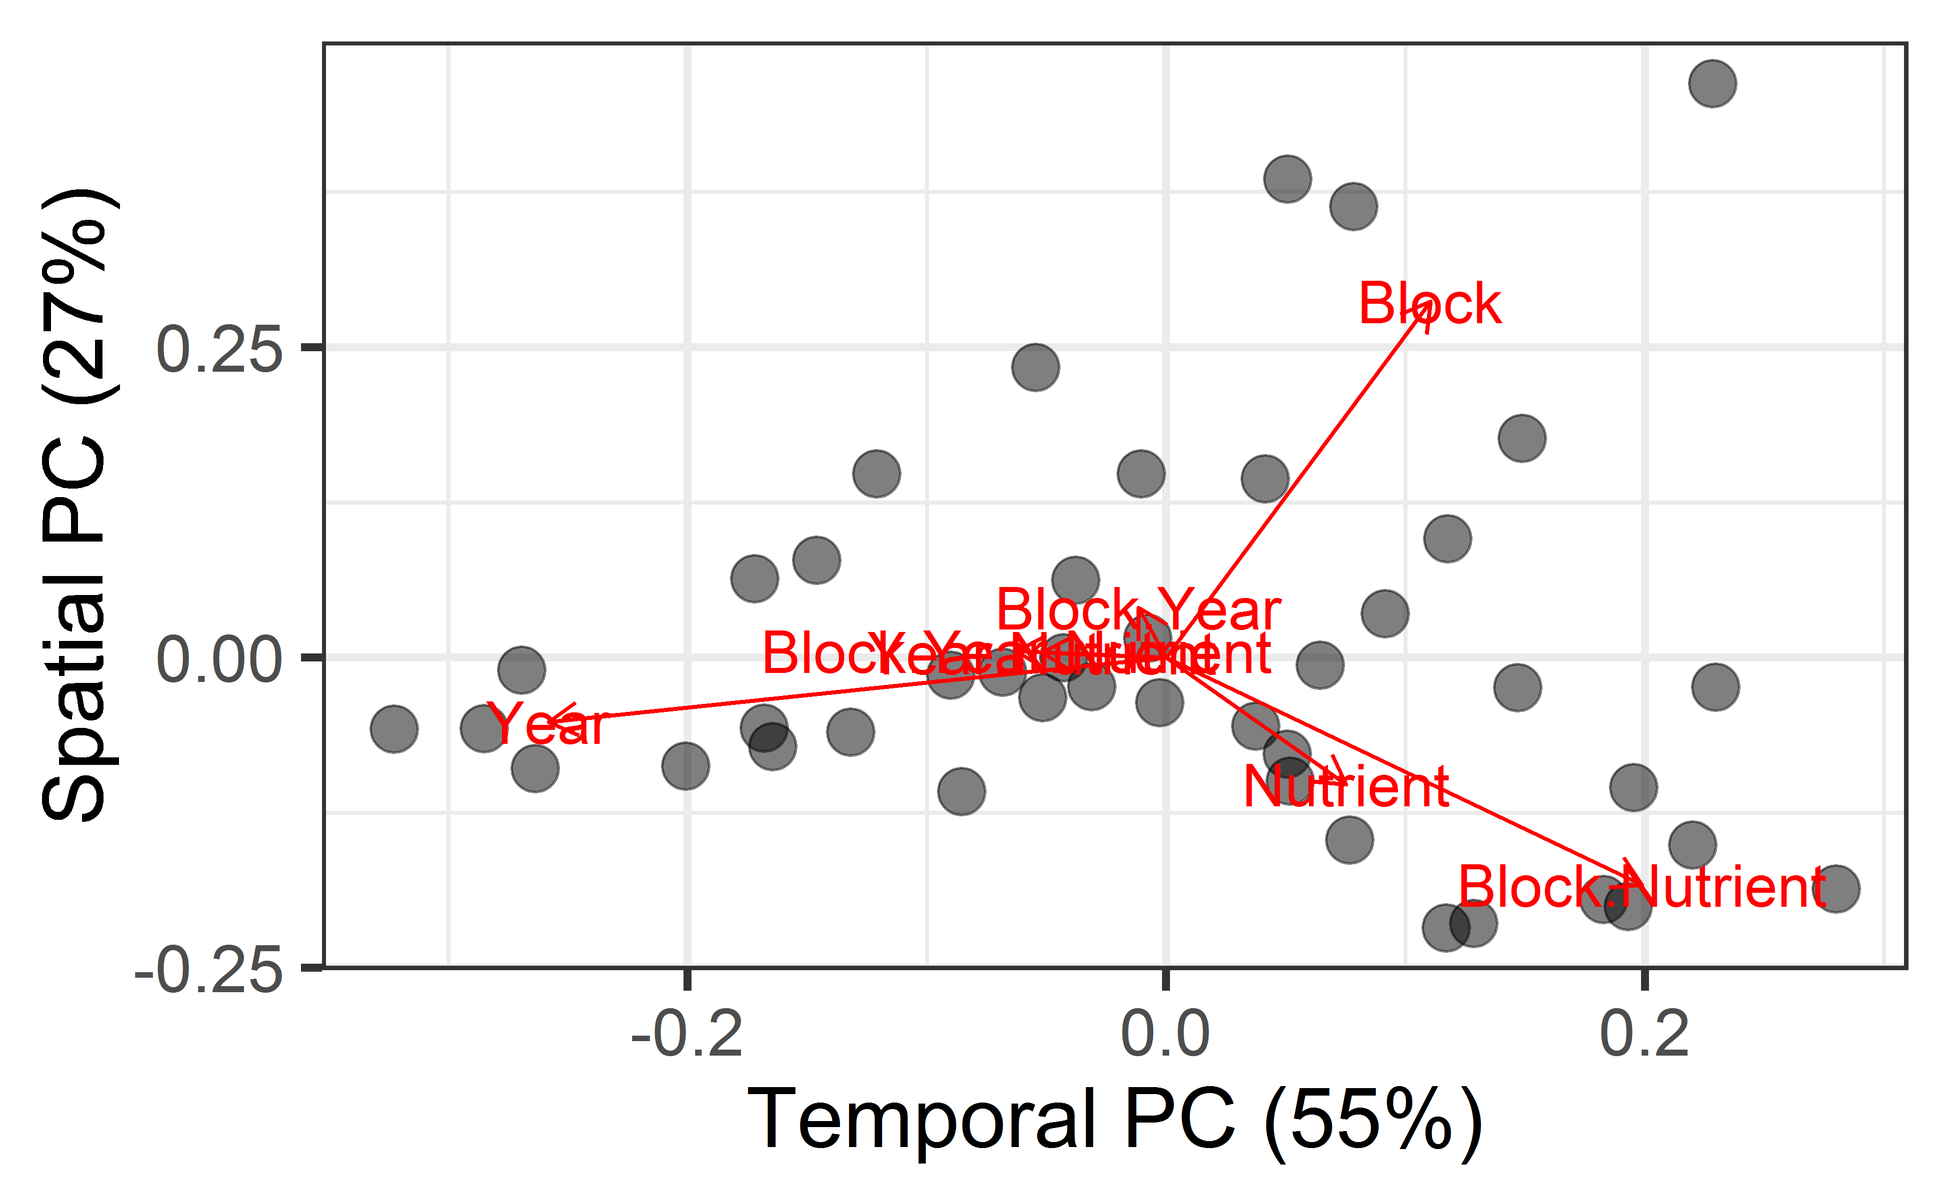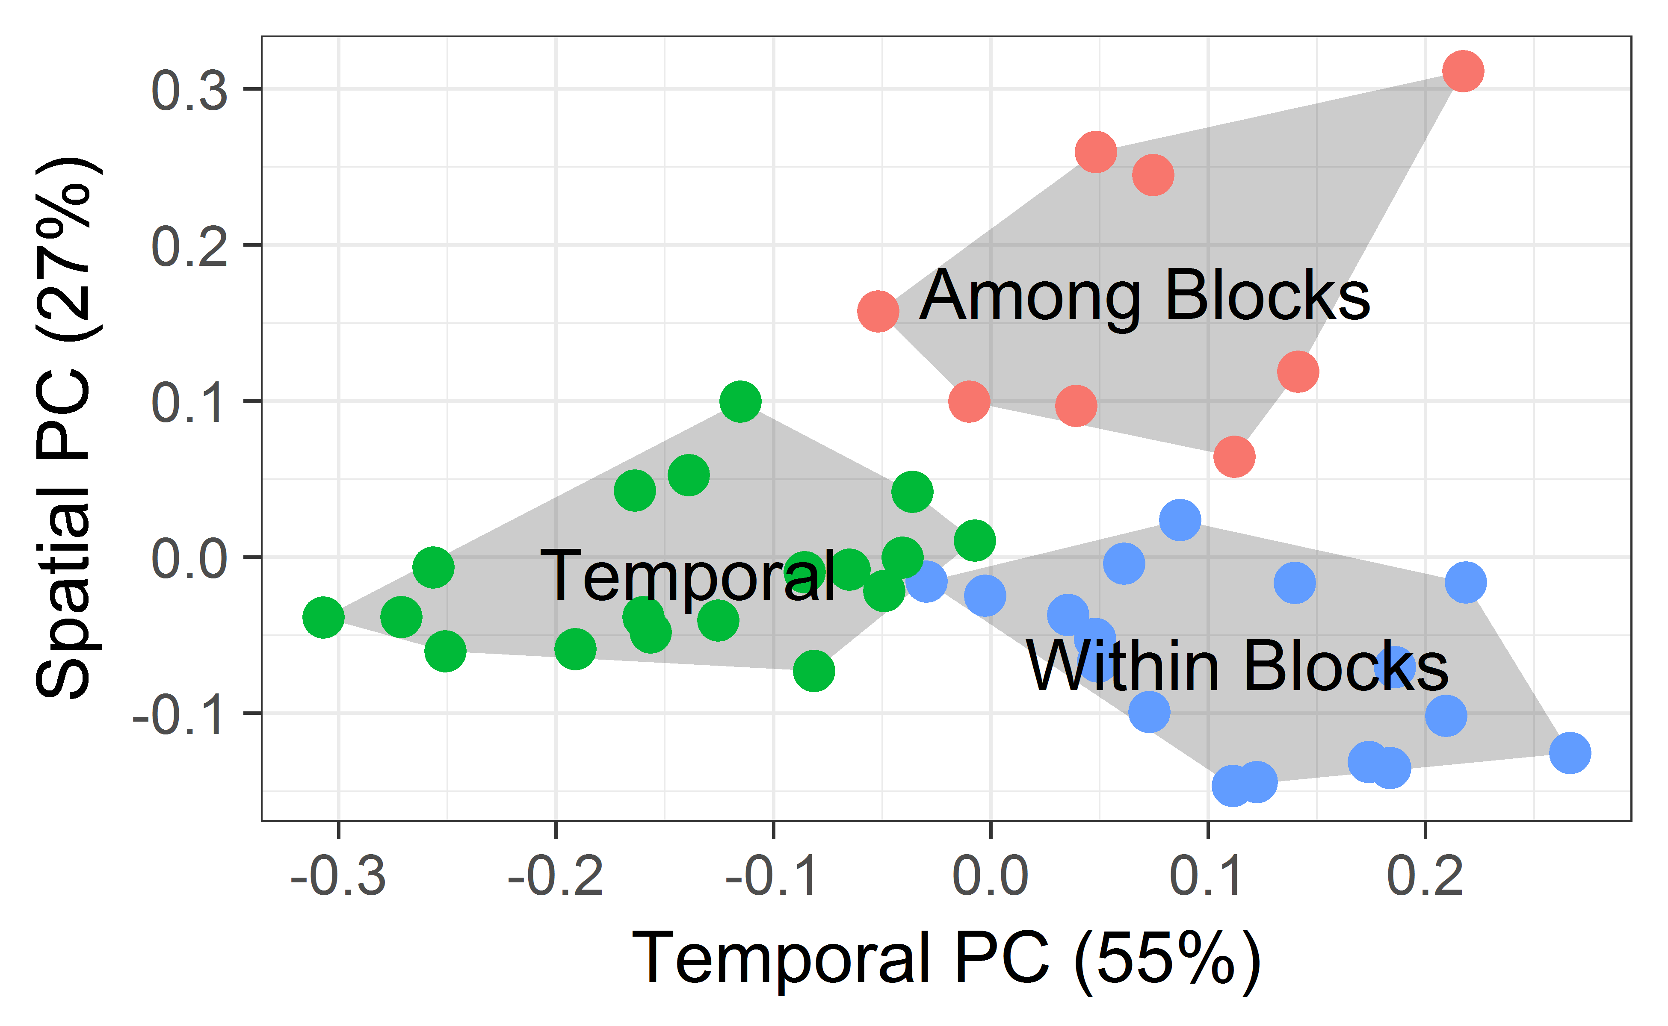

C) D)

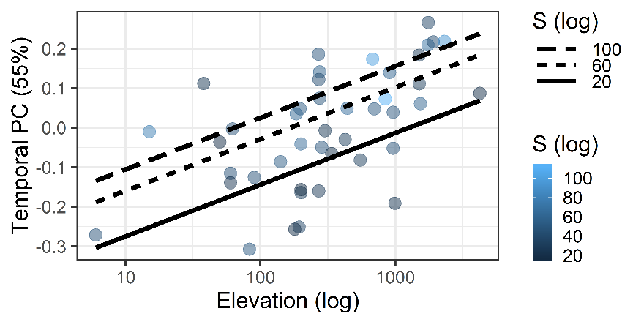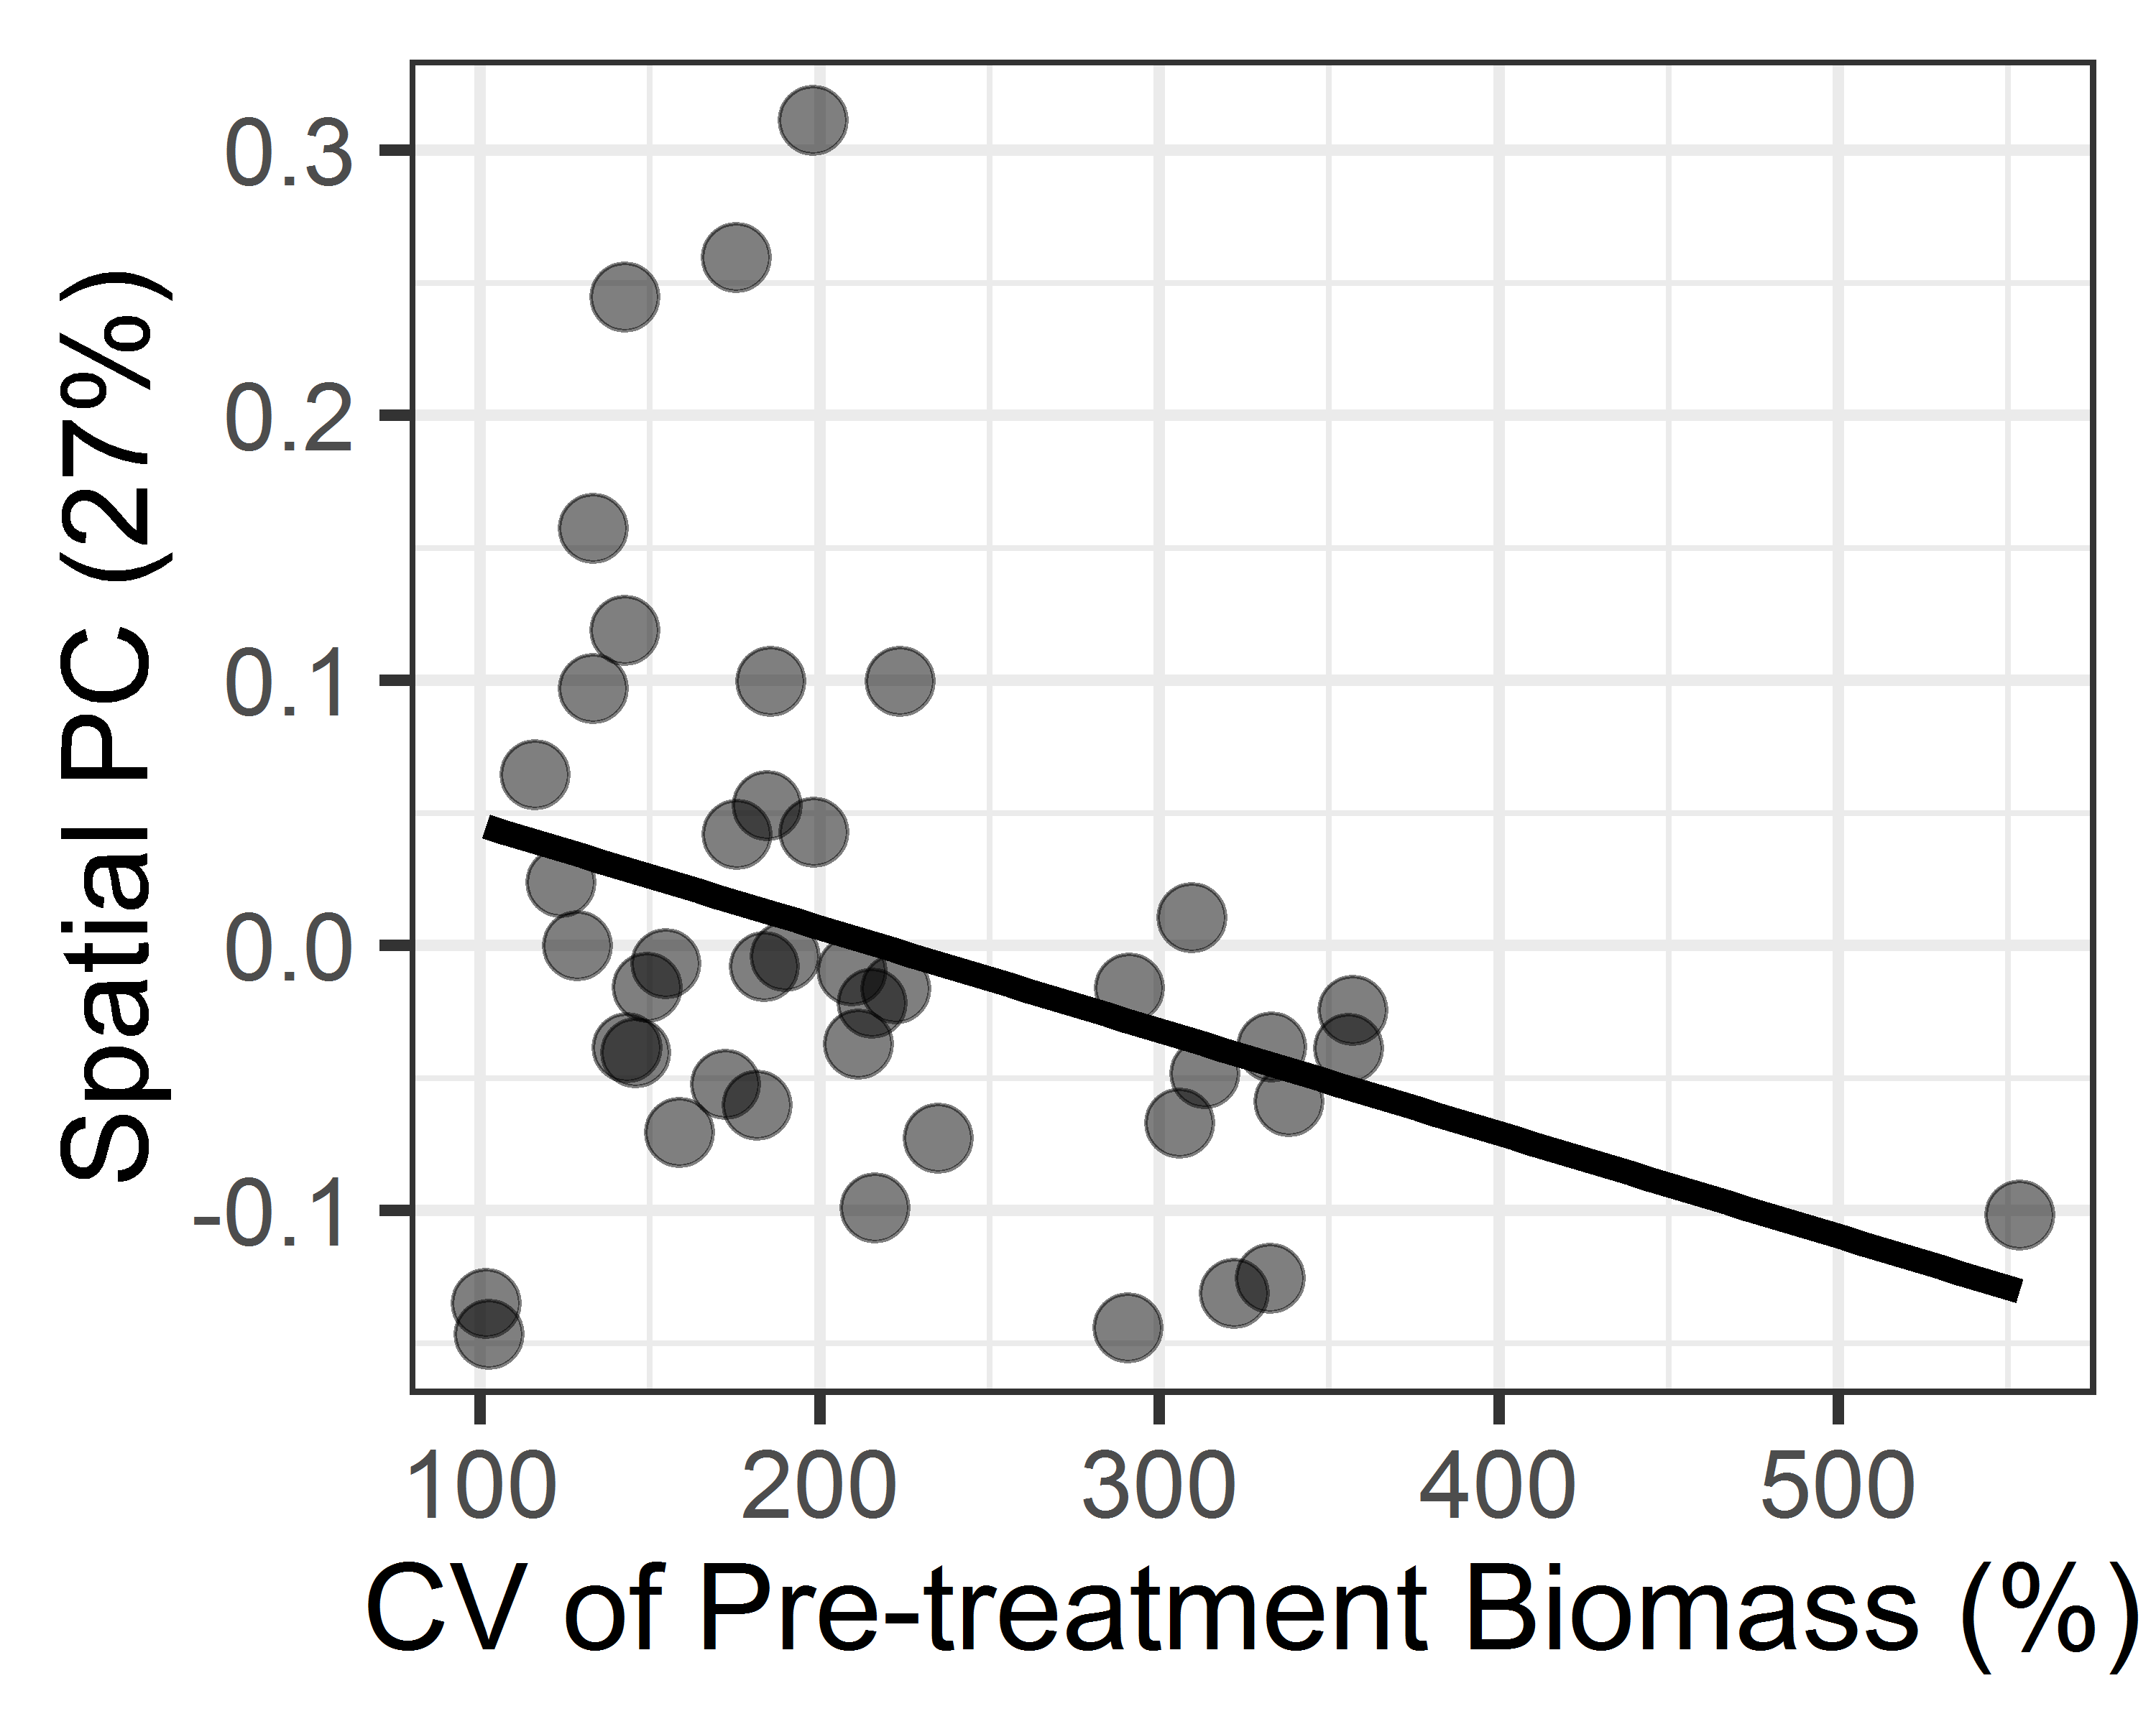

Figure 3

A) B)

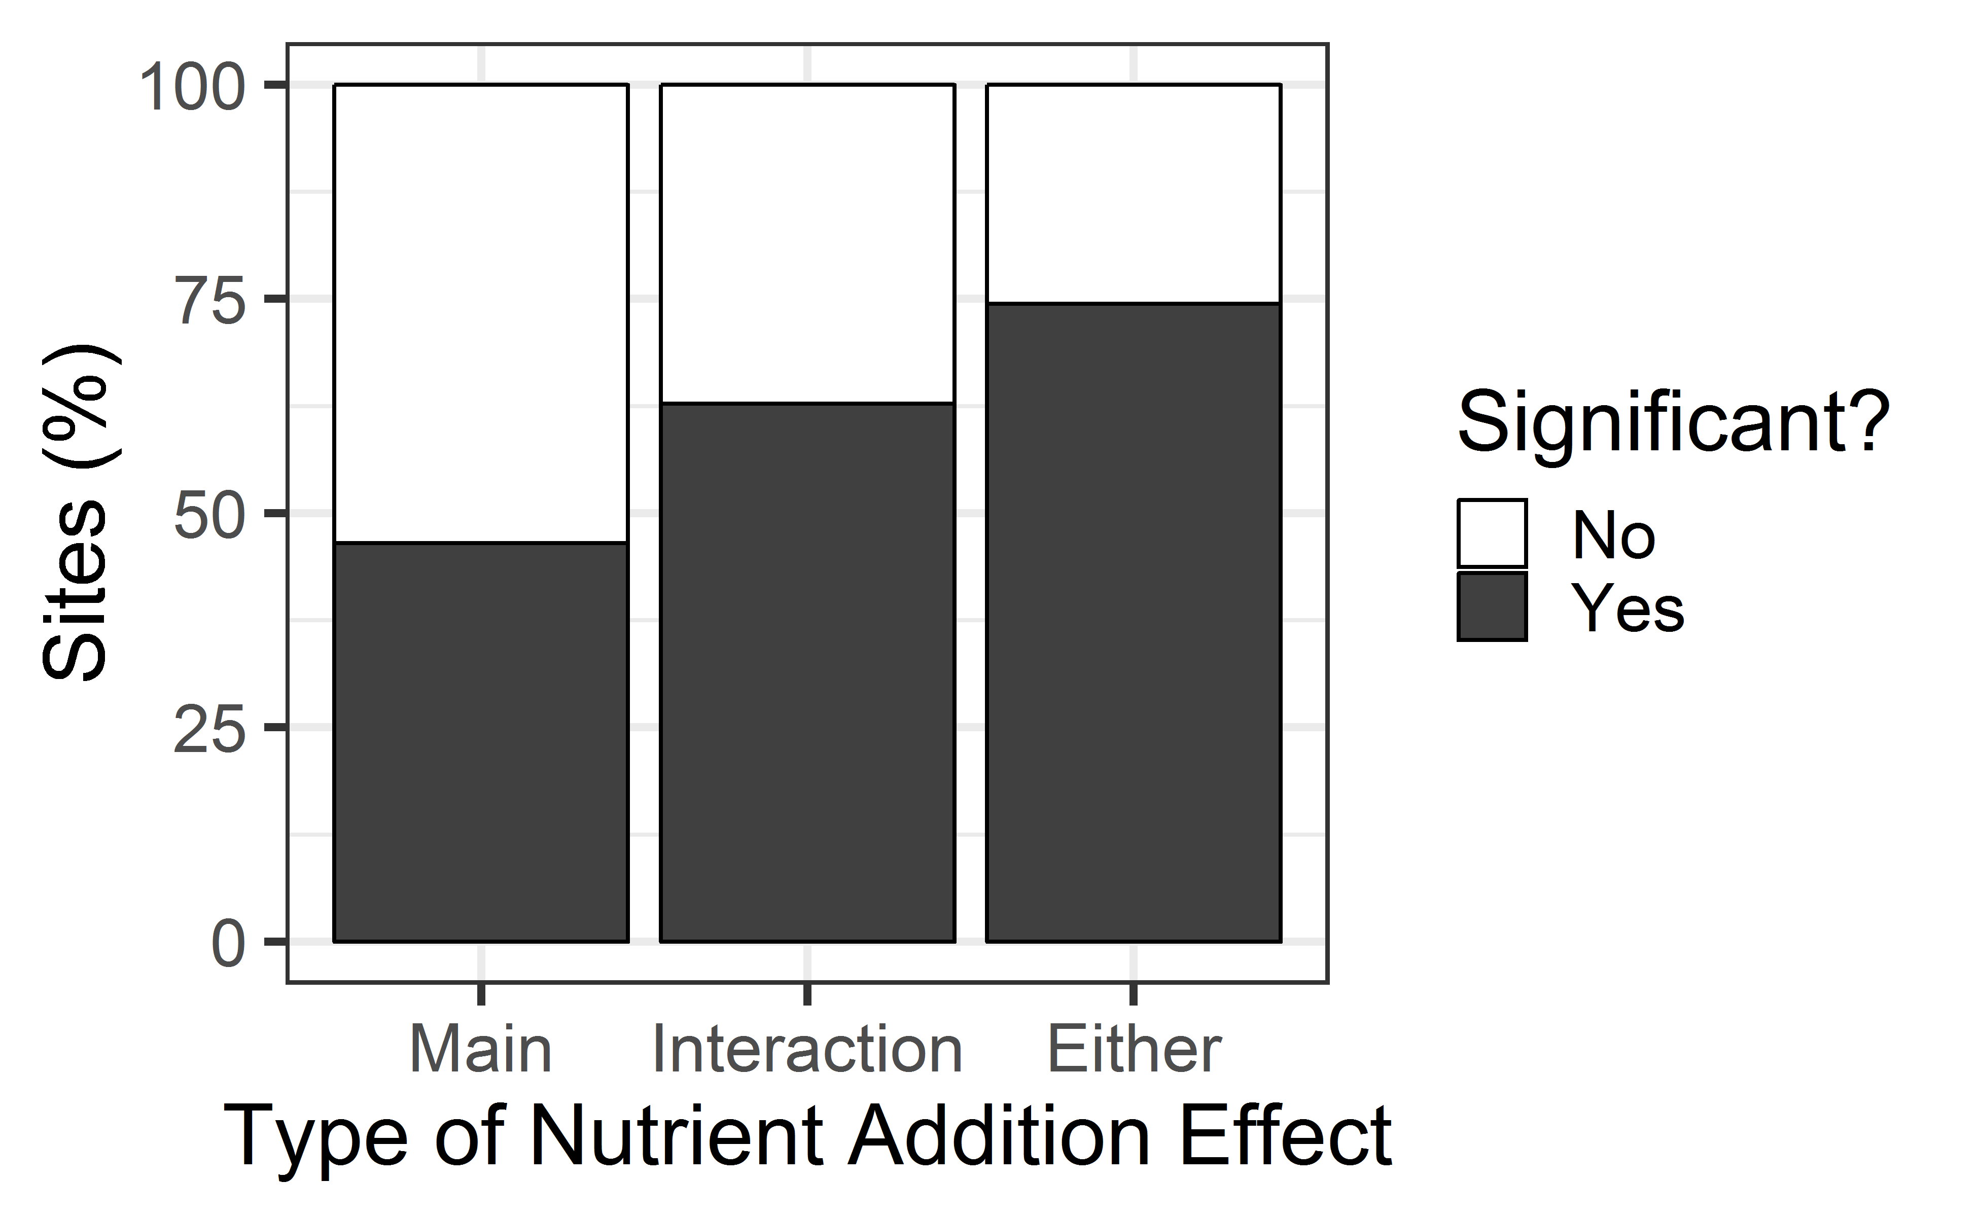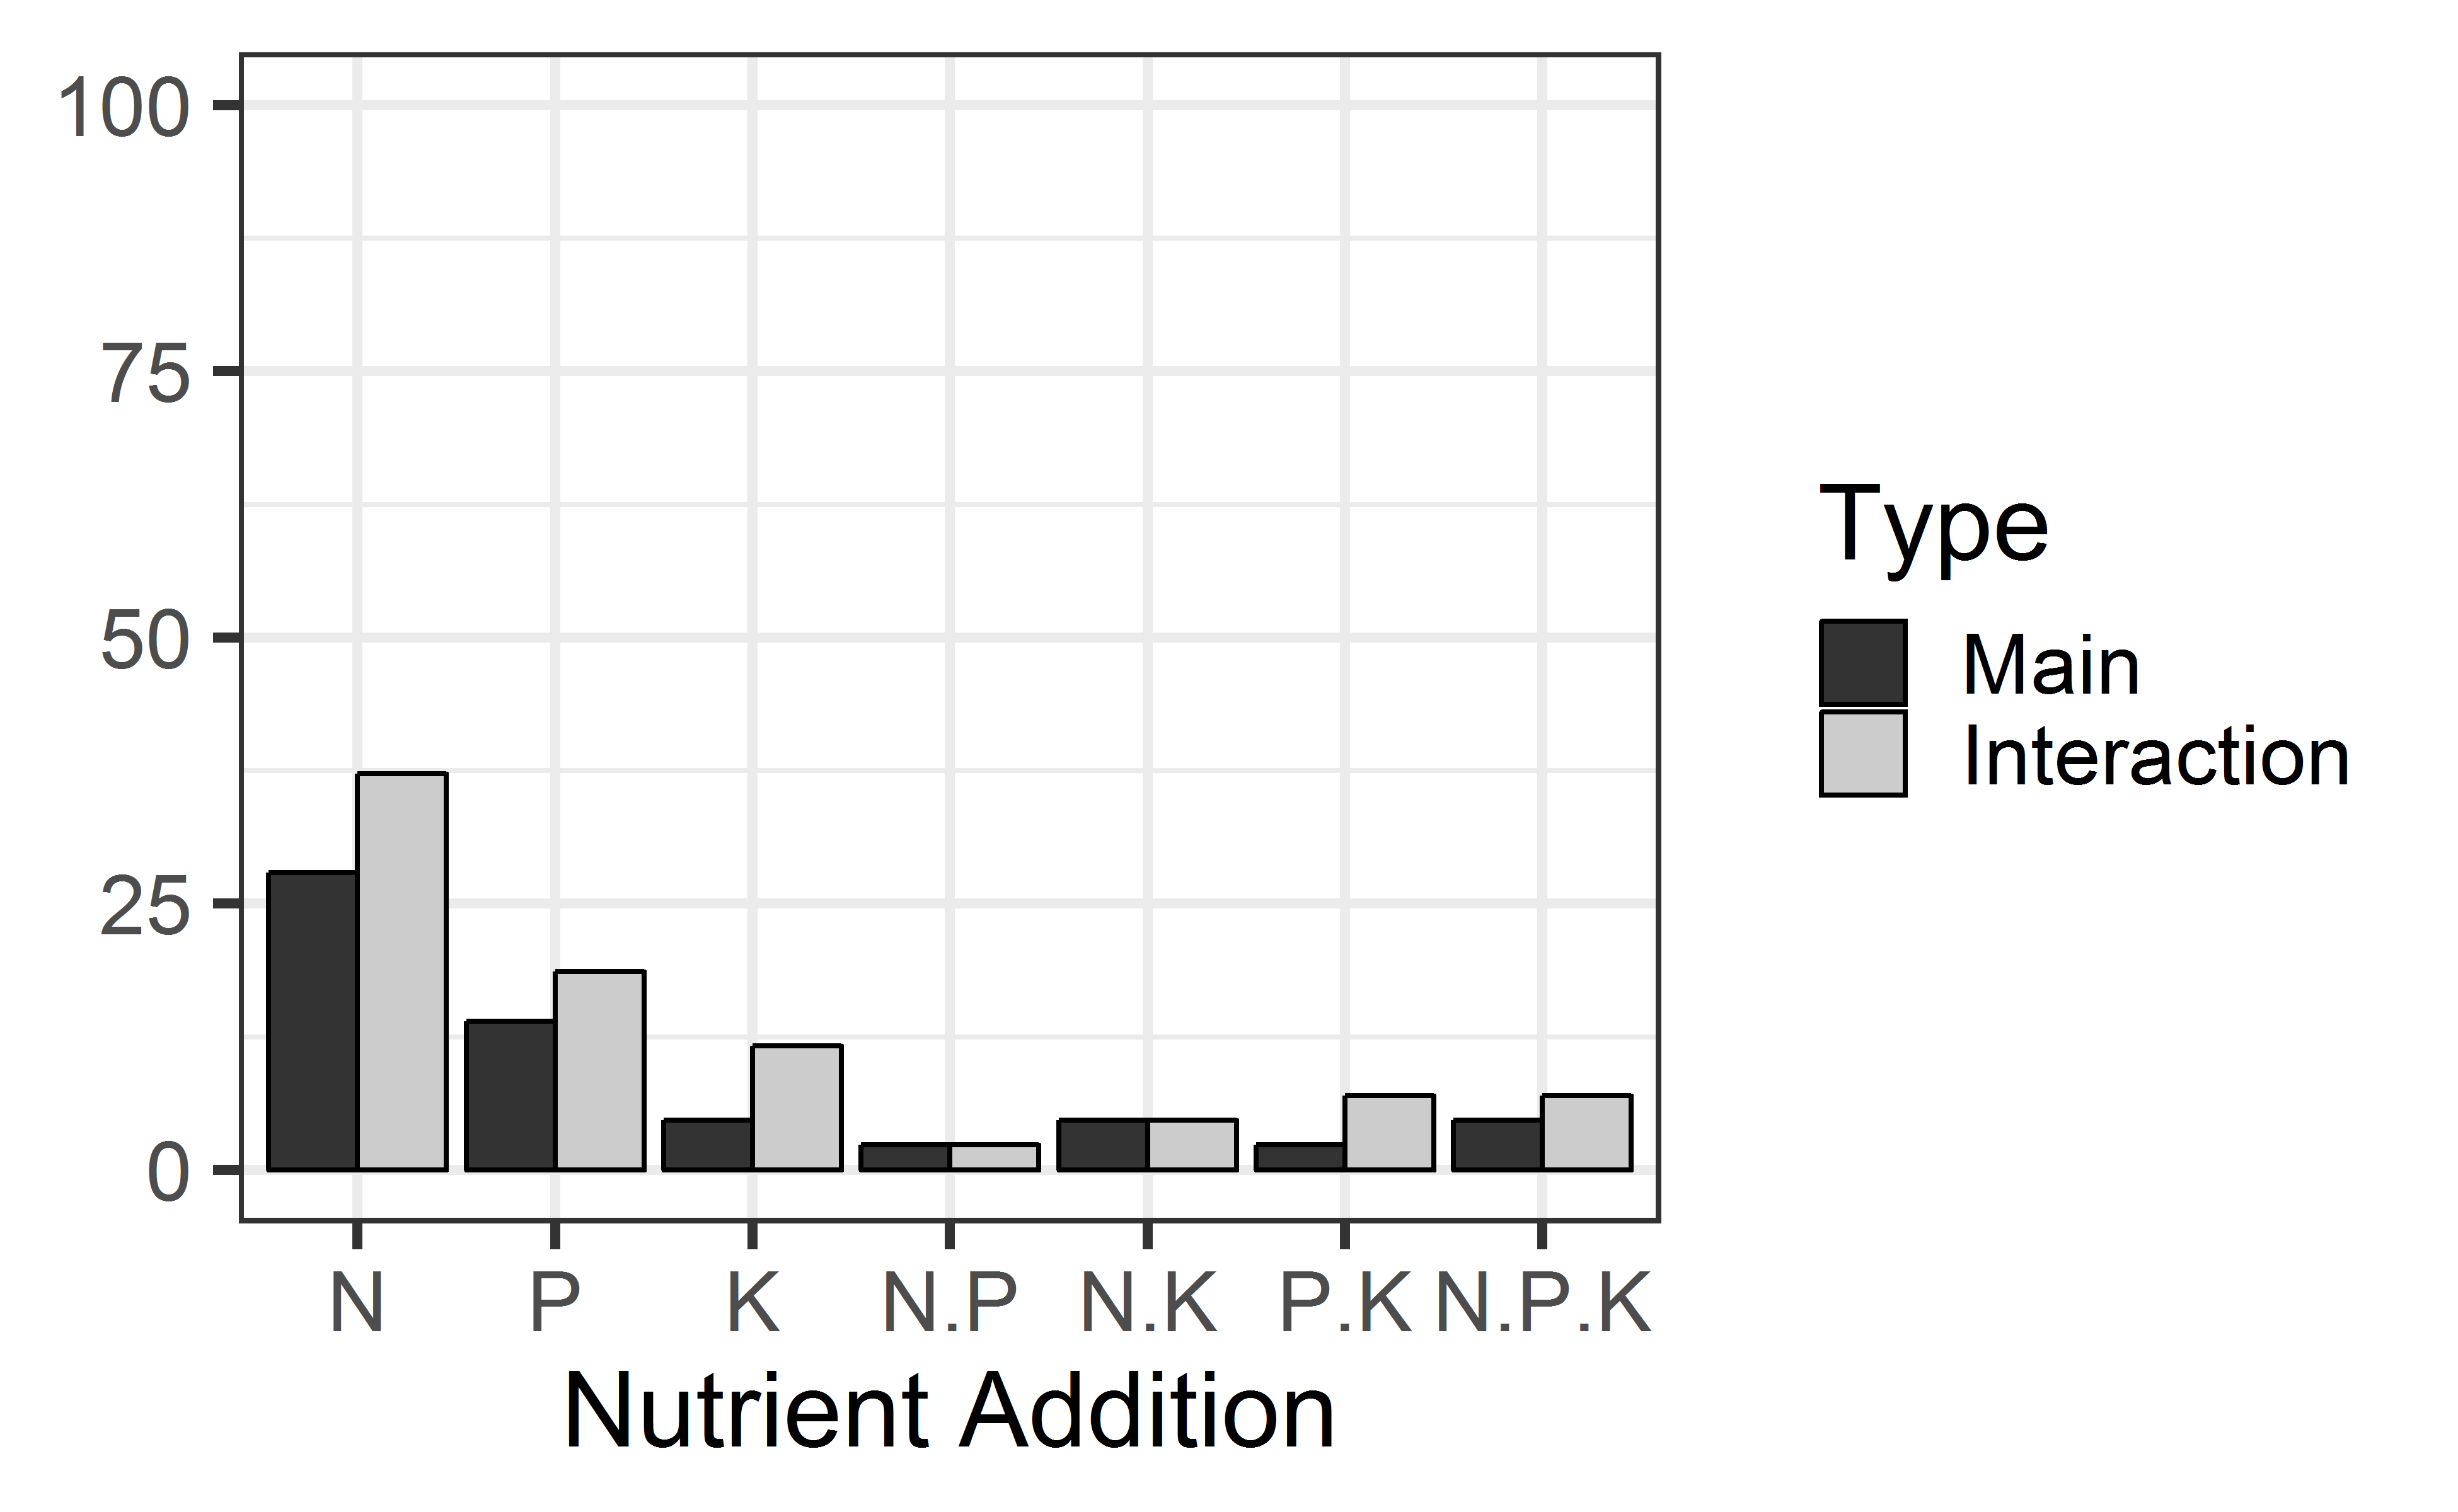

Figure 4

A) B)
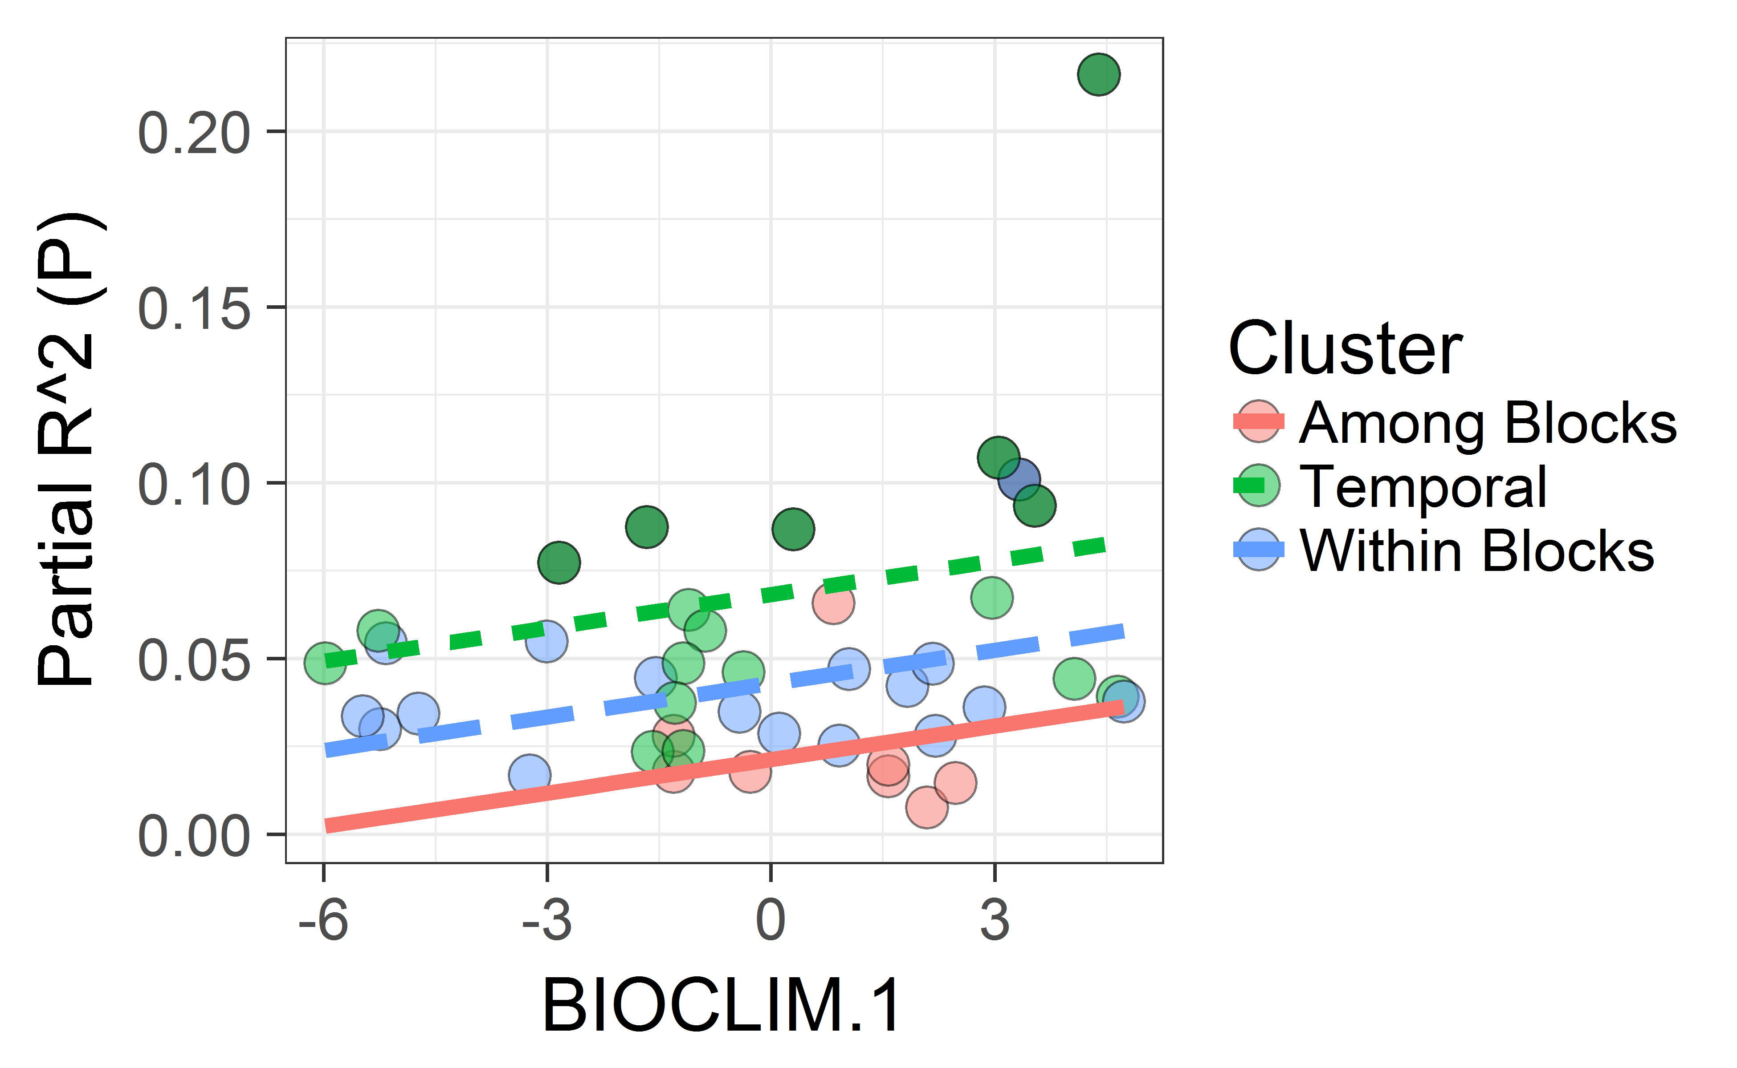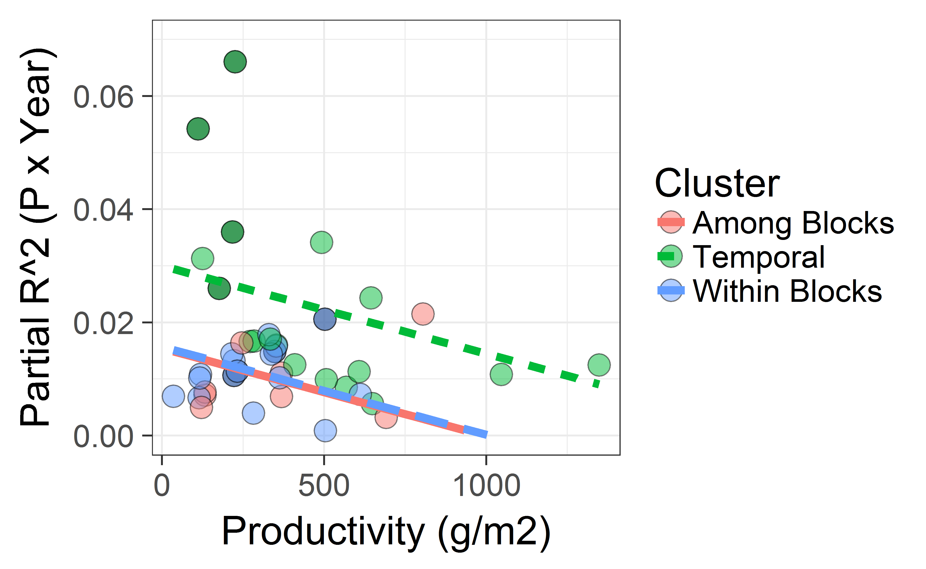

Figure 5

Supplementary Information

Table S1. Sites included. [to be added]

Site
Bogong.au
…

Table S2. Taxonomic adjustments. [table incomplete – examples are shown below in the ‘Includes’ column. This is based on all taxonomic data for these sites as in the April 9, 2018 data file. Note that not all changes are strictly necessary for an analysis of years 0-3; some of the taxonomic inconsistencies involve later years.]

Site | Analysis Code | Includes
bogong.au | Erigeron sp. | Erigeron bellidioides, Erigeron nitidus, Erigeron sp.
burrawan.au |  | No changes
cbgb.us¹ | Cirsium sp. | Cirsium arvense, Cirsium sp., Cirsium vulgare
 | Helianthus sp. | Helianthus grosseserratus, Helianthus pauciflorus, Helianthus sp.
 | Solidago canadensis | Solidago canadensis, Solidago sp.
 | Solanum carolinense | Solanum carolinense, Solanum sp.
cdcr.us | Chenopodium sp. | Chenopodium album, Chenopodium sp.
 | Conyza canadensis | Erigeron canadensis, Conyza canadensis
 | Erigeron sp. | Erigeron sp., Erigeron strigosus
 | Tragopogon dubius | Tragopogon dubius, Tragopogon sp.
 | Rudbeckia hirta | Rudbeckia hirta, Rudbeckia hirta var. pulcherrima, Rudbeckia sp.
 | Carex sp. | Carex scoparia, Carex sp.
 | Cyperus sp. | Cyperus filiculmis, Cyperus grayi, Cyperus lupulinus, Cyperus schweinitzii, Cyperus sp.
cdpt.us¹ |  | No changes
cereep.fr | Myosotis sp.
 | Crepis sp.
 | Senecio vulgaris
 | Taraxacum sp.
 | Carex sp.
 | Trifolium sp.
 | Vicia sp.
 | Erodium sp.
 | Geranium sp.
 | Hypericum sp.
 | Agrostis sp.
 | Arrhenatherum elatius
 | Bromus sp.
 | Festuca sp.
 | Holcus lanatus
 | Poa sp.
 | Ranunculus sp.
 | Prunus sp.
chilcas.ar | Bromus brachyantherus
comp.pt | Unknown Asteraceae sp.
 | Erodium sp.
 | Orobanche sp.
 | Plantago bellardi
cowi.ca |  | No changes
elliot.us | Juncus sp.
frue.ch |  | No changes
gilb.za | Pearsonia sp.
 | Hypoxis sp.
 | Dierama sp.
hall.us | Rubus sp.
hart.us | Allium sp.
 | Agoseris sp.
 | Crepis sp.
 | Astragalus sp.
 | Lupinus sp.
hero.uk |  | No changes
hnvr.us | Carex sp.
kibber.in | Unknown
 | Polygonum sp.
kilp.fi | Scorzoneroides autumnalis
 | Empetrum nigrum
 | Ranunculus acris
kiny.au | Arthropodium sp.
 | Atriplex sp.
 | Rhodanthe sp.
 | Sonchus sp.
 | Crassula sp.
 | Trifolium sp.
 | Unknown
 | Avena sp.
 | Bromus sp.
 | Lolium sp.
 | Rytidosperma sp.
 | Vulpia sp.
koffler.ca | Carex sp.
konz.us | Solidago sp.
 | Muhlenbergia cuspidate
lancaster.uk |  | No changes
look.us | Galium sp.
marc.ar | Eryngium sp.
 | Carex bonariensis
 | Carex vixdentata
 | Veronica peregrine
 | Lythrum hyssopifolium
 | Festuca arundinacea
mtca.au | Stipa sp.
ping.au |  | No changes
pinj.au | Medicago sp.
rook.uk |  | No changes
sage.us | Carex sp.
sedg.us | Trifolium sp.
sereng.tz | Justicia sp.
 | Kyllinga sp.
 | Dactyloctenium sp.
 | Cycnium sp.
shps.us | Antennaria sp.
 | Poa secunda
sier.us | Torilis sp.
 | Triteleia sp.
 | Unknown Asteraceae sp.
 | Plagiobothrys sp.
 | Cardamine sp.
 | Convolvulus sp.
 | Trifolium sp.
 | Vicia sp.
 | Erodium sp.
 | Clarkia sp.
 | Linanthus sp.
 | Galium sp.
smith.us | Symphoricarpos albus
spin.us |  | No changes
summ.za | Sebaea sp.
 | Eulophia sp.
temple.us | Polytaenia nuttallii
 | Asclepias sp.
 | Gaillardia sp.
 | Lactuca sp.
 | Liatris sp.
 | Sporobolus sp.
trel.us | Bromus sp.
ukul.za | Pachycarpus sp.
 | Acacia sp.
 | Chamaecrista sp.
 | Albuca setosa
 | Hypericum sp.
 | Solanum sp.
unc.us | Erigeron sp.
 | Solidago sp.
 | Panicum sp.
valm.ch |  | No changes
¹ treated as two sites, each with 3 blocks of 30 plots.
Table S3. Climate was represented by 23 variables: 19 BIOCLIM variables plus mean annual potential evapotranspiration (PET; from CGIAR-CSI), the difference between mean annual rainfall and PET, an Aridity Index, and modeled N deposition. Since many of these variables are correlated, they were combined via PCA into five principal components that together account for 93% of the variation in climate. Loadings associated with these principal components are reported here. Loadings above 0.3 are in bold font, and positive loadings are in italics. Loadings with an absolute value < 0.1 are not shown.

Source | BIOCLIM 1 | BIOCLIM 2 | BIOCLIM 3 | BIOCLIM 4 | BIOCLIM 5
MAT | 0.27 | 0.20 | 0.20
MAT range | 0.24 | -0.14 |  | 0.28
ISO | 0.23 | 0.23 | -0.11 | -0.11 | -0.17
Temp_var |  | -0.33 |  | 0.30 | 0.14
Max temp | 0.28 |  | 0.22 | 0.26
Min temp | 0.18 | 0.32 | 0.10 | -0.19
Annual temp range |  | -0.34 |  | 0.36 | 0.10
Temp, wettest quarter | 0.14 |  | 0.40 | 0.11 | -0.29
Temp, driest quarter | 0.19 | 0.27 |  |  | 0.39
Temp, warmest quarter | 0.25 |  | 0.27 | 0.22 | 0.15
Temp, coldest quarter | 0.23 | 0.29 |  | -0.12
MAP | -0.20 | 0.28 | 0.11 | 0.28
Precip, wettest month | -0.11 | 0.29 | -0.11 | 0.37 | -0.14
Precip, driest month | -0.21 |  | 0.35 |  | 0.25
MAP var | 0.16 |  | -0.35 | 0.24 | -0.29
Precip, wettest quarter | -0.13 | 0.29 |  | 0.36 | -0.14
Precip, driest quarter | -0.21 | 0.13 | 0.34 |  | 0.25
Precip, warmest quarter | -0.12 |  | 0.35 |  | -0.53
Precip, coldest quarter | -0.12 | 0.27 | -0.18 | 0.24 | 0.38
Rain_PET | -0.32 | 0.15
AI | -0.30 | 0.16
PET | 0.30 |  | 0.13 | 0.18
N deposition | -0.19 |  | 0.24 | -0.10
Proportion of variance | 0.36 | 0.25 | 0.16 | 0.11 | 0.05
Cumulative proportion | 0.36 | 0.61 | 0.77 | 0.88 | 0.93
Abbreviations: MAT = mean annual temperature; ISO = isothermality; MAP = mean annual precipitation; PET = potential evapotranspiration; AI = Aridity index
Table S4. Comparison of results for fertilizer effects on productivity, richness, and composition.
Composition: Rows shaded grey were not included in this analysis. In the columns associated with each nutrient combination, cells that are highlighted in yellow indicate significant effects of that fertilizer combination on species composition – either as a main effect and/or as an interaction with Year.
Productivity: Fay et al. tested main and two-way interactions, not NPK. Calculated treatment effect sizes as ln (treatment / control). Columns with ‘F’ indicate significant effects of that nutrient combination on productivity (Fay et al. 2015).
Richness: Harpole results… .

 | Limited by multiple nutrients? (True or False) |  | Nutrient Combination |  |  |  |  |  |  | Included in analysis? (Y or blank)
Site | Productivity (Harpole) | Composition (this study) | N | P | K | NP | NK | PK | NPK | Fay | This study
Azi.cn | F |  | F |  |  | F | F |  |  | Y
Barta.us | T |  |  |  |  | F |  |  |  | Y
Bldr.us | T |  |  | F |  | F | F | F |  | Y
Bnch.us | T |  |  |  |  |  | F |  |  | Y
Bogong.au | T | F |  |  |  | F | F | F |  | Y | Y
Burrawan.au | F | T |  | F |  | F |  |  |  | Y | Y
Cbgb.us | T | T |  |  | F |  |  |  |  | Y | Y
Cdcr.us | T | F | F |  |  | F | F | F |  | Y | Y
Cdpt.us | T | F | F | F | F | F | F |  |  | Y | Y
Cereep.fr |  | F |  |  |  |  |  |  |  |  | Y
Chilcas.ar |  | F |  |  |  |  |  |  |  |  | Y
Comp.pt |  | F |  |  |  |  |  |  |  |  | Y
Cowi.ca | T | F |  |  |  |  | F |  |  | Y | Y
Elliot.us | T | F |  |  |  | F |  |  |  | Y | Y
Frue.ch | F | T | F |  |  | F | F |  |  | Y | Y
Gilb.za | T | F | F | F |  | F | F | F |  | Y | Y
Hall.us | T | F | F |  |  | F |  |  |  | Y | Y
Hart.us | T | F |  | F |  | F | F | F |  | Y | Y
Hero.uk | T | F |  |  |  |  |  |  |  | Y | Y
Hnvr.us | F | T |  |  |  |  |  |  |  | Y | Y
Hopl.us | T |  |  |  |  |  |  |  |  | Y
Kibber.in | T | F |  |  |  |  |  |  |  |  | Y
Kilp.fi |  | T |  |  |  |  |  |  |  |  | Y
Kiny.au | T | F |  |  |  | F | F | F |  | Y | Y
Koffler.ca | T | F |  |  |  |  |  |  |  |  | Y
Konz.us | F | F |  |  |  | F |  |  |  | Y | Y
Lancaster.uk | F | T | F | F | F | F | F | F |  | Y | Y
Look.us | T | F |  |  | F | F | F |  |  | Y | Y
Marc.ar | T | F |  |  |  |  |  |  |  |  | Y
Mcla.us | T |  |  |  |  |  |  |  |  | Y
Mtca.au | T | F |  | F |  | F |  | F |  | Y | Y
Pape.de | F
Ping.au |  | F |  |  |  |  |  |  |  |  | Y
Pinj.au |  | F |  |  |  |  |  |  |  |  | Y
Rook.uk | F | T |  | F |  |  |  | F |  | Y | Y
Sage.us | T | F | F | F |  | F | F |  |  | Y | Y
Saline.us | T |  |  |  |  | F |  |  |  | Y
Sava.us | T |  |  |  | F | F |  | F |  | Y
Sedg.us | T | T | F |  |  | F | F |  |  | Y | Y
Sereng.tz | T | T |  |  |  |  |  |  |  | Y | Y
Sevi.us | T |  |  |  |  |  |  |  |  | Y
Sgs.us | T |  |  |  |  |  |  |  |  | Y
Shps.us | F | F |  | F |  | F |  |  |  | Y | Y
Sier.us | T | F |  |  |  |  |  |  |  | Y | Y
Smith.us | T | F |  | F |  | F | F |  |  | Y | Y
Spin.us | T | T | F |  |  | F | F |  |  | Y | Y
Summ.za | T | F |  |  |  | F | F |  |  | Y | Y
Temple.us | T | F |  |  |  |  |  |  |  | Y | Y
Trel.us | F | T |  |  |  |  |  |  |  | Y | Y
Ukul.za |  | F | F |  |  | F | F |  |  | Y | Y
Unc.us | T | F |  | F |  | F | F | F |  | Y | Y
Valm.ch | T | T |  |  |  |  |  |  |  | Y | Y

Figure S1. Dendrogram showing classification of sites on the basis of how compositional variation is partitioned among 7 sources (block, year, nutrient, and interactions therein).

