Likely need to reduce? Figures/tables likely best worth keeping highlighted.

Tables:
Table 1:
Table 2:
Table 3:
Table 4:

Figures:
Figure 1:
- 1st panel shows mean annual precipitation in mm, with average from 1983 – 2018 as a dashed line
- 2nd panel shows the value of the SPEI index over the course of our study, standardized relative to climate patterns from 1983 – 2018.
- 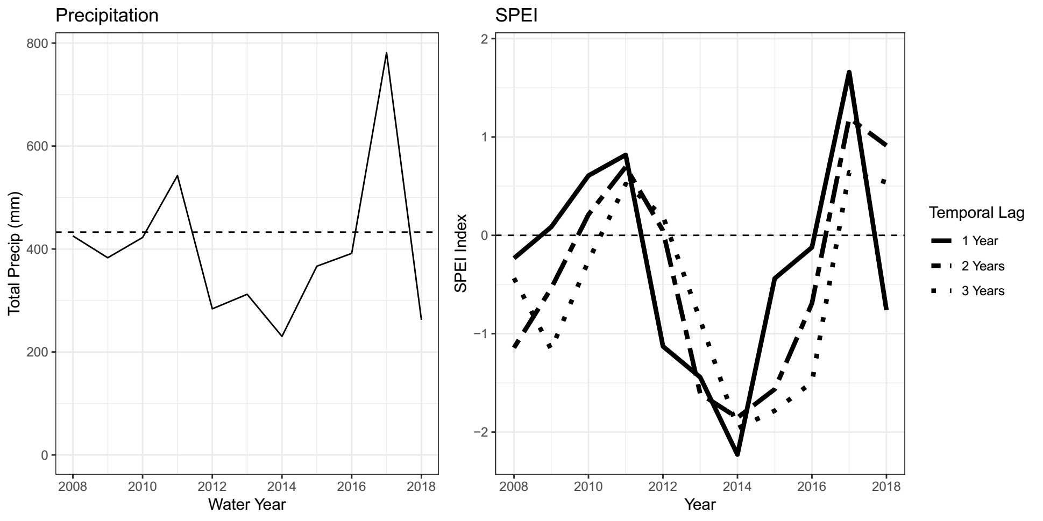

Figure 2: 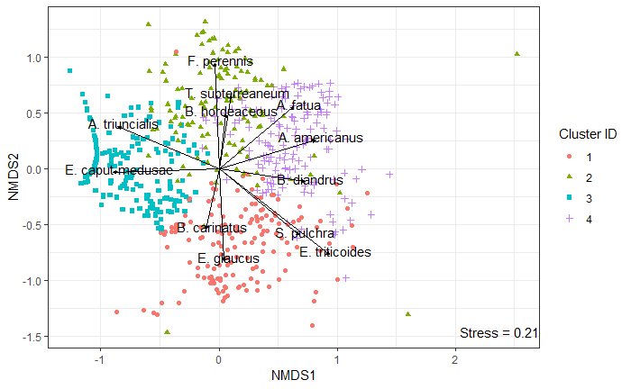
Figure 3:
Figure 4:
Figure 5:
Figure 6
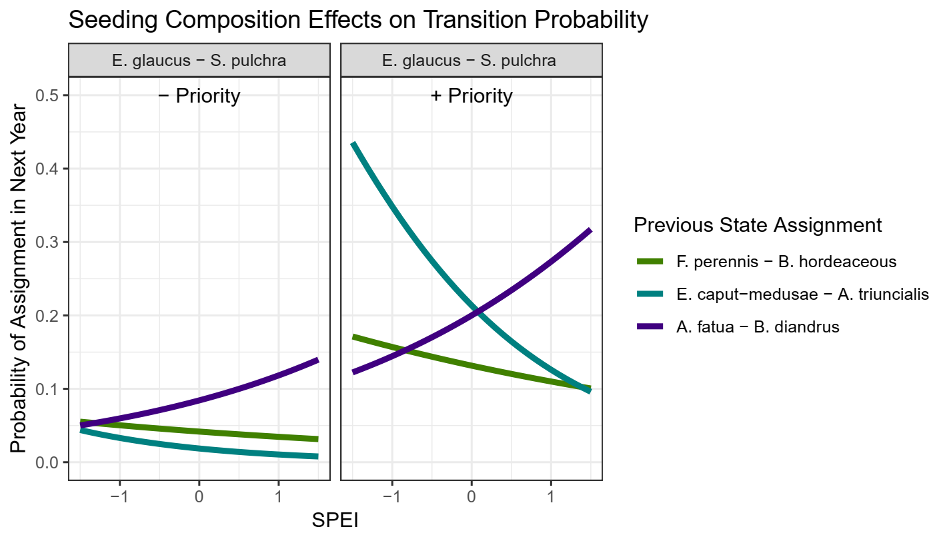
Figure 7

References:
Resilience and Management
Dudney, J., Hobbs, R. J., Heilmayr, R., Battles, J. J., & Suding, K. N. (2018). Navigating Novelty and Risk in Resilience Management. Trends in Ecology & Evolution, 33(11), 863–873. https://doi.org/10.1016/j.tree.2018.08.012

State and Transition Models
Allen-Diaz, B., & Bartolome, J. W. (1998). Sagebrush – Grass Vegetation Dynamics : Comparing Classical and State-Transition Models. Ecological Applications, 8(3), 795–804.
Bagchi, S., Briske, D. D., Wu, X. B., McClaran, M. P., Bestelmeyer, B. T., & Fernández-Giménez, M. E. (2012). Empirical assessment of state-and-transition models with a long-term vegetation record from the Sonoran Desert. Ecological Applications, 22(2), 400–411. https://doi.org/10.1890/11-0704.1
Briske, D. D., Bestelmeyer, B. T., Stringham, T. K., & Shaver, P. L. (2008). Recommendations for development of resilience-based state-and-transition models. Rangeland Ecology and Management, 61(4), 359–367. https://doi.org/10.2111/07-051.1
Briske, D. D., Fuhlendorf, S. D., & Smeins, F. E. (2003). Vegetation dynamics on rangelands: A critique of the current paradigms. Journal of Applied Ecology, 40(4), 601–614. https://doi.org/10.1046/j.1365-2664.2003.00837.x
Briske, D. D., Illius, A. W., & Anderies, J. M. (2017). Nonequilibrium Ecology and Resilience Theory. In D. D. Briske (Ed.), Rangeland Systems: Processes, Management and Challenges (pp. 197–227). https://doi.org/10.1007/978-3-319-46709-2_6
Jackson, R. D., & Bartolome, J. W. (2002). A state-transition approach to understanding nonequilibrium plant community dynamics in Californian grasslands. Plant Ecology, 162(1), 49–65. https://doi.org/10.1023/A:1020363603900
Stein, C., Harpole, W. S., & Suding, K. N. (2016). Transitions and invasion along a grazing gradient in experimental California grasslands. Ecology, 97(9), 2319–2330. https://doi.org/10.1002/ecy.1478
Stringham, T. K., Krueger, W. C., & Shaver, P. L. (2003). State and Transition Modeling: An Ecological Process Approach. Journal of Range Management, 56(2), 106. https://doi.org/10.2307/4003893
Climate and Plant Communities
Clary, J. (2008). Rainfall seasonality determines annual/perennial grass balance in vegetation of Mediterranean Iberian. Plant Ecology, 195(1), 13–20. https://doi.org/10.1007/s11258-007-9294-9

California Annual Grasslands
Corbin, J. D., & D’Antonio, C. M. (2010). Not novel, just better: Competition between native and non-native plants in California grasslands that share species traits. Plant Ecology, 209(1), 71–81. https://doi.org/10.1007/s11258-010-9722-0
Elmendorf, S. C., & Harrison, S. P. (2009). Temporal variability and nestedness in California grassland species composition. Ecology, 90(6), 1492–1497. https://doi.org/10.1890/08-1677.1
Harpole, W. S., Potts, D. L., & Suding, K. N. (2007). Ecosystem responses to water and nitrogen amendment in a California grassland. Global Change Biology, 13(11), 2341–2348. https://doi.org/10.1111/j.1365-2486.2007.01447.x
Jackson, R. D., & Bartolome, J. W. (2002). A state-transition approach to understanding nonequilibrium plant community dynamics in Californian grasslands. Plant Ecology, 162(1), 49–65. https://doi.org/10.1023/A:1020363603900
Pitt, M. D., & Heady, H. F. (1978). Responses of annual vegetation to temperature and rainfall patterns in northern California. Ecology, Vol. 59(No. 2 (Mar., 1978)), 336–350 (article consists of 15 pages). https://doi.org/10.2307/1936378
Prugh, L. R., Deguines, N., Grinath, J. B., Suding, K. N., Bean, W. T., Stafford, R., & Brashares, J. S. (2018). Ecological winners and losers of extreme drought in California. Nature Climate Change, 8(9), 819–824. https://doi.org/10.1038/s41558-018-0255-1
Seabloom, E. W., Harpole, W. S., Reichman, O. J., & Tilman, D. (2003). Invasion, competitive dominance, and resource use by exotic and native California grassland species. Proceedings of the National Academy of Sciences of the United States of America, 100(23), 13384–13389. https://doi.org/10.1073/pnas.1835728100
Uricchio, L. H., Daws, S. C., Spear, E. R., & Mordecai, E. A. (2019). Priority Effects and Nonhierarchical Competition Shape Species Composition in a Complex Grassland Community. The American Naturalist, 193(2), 213–226. https://doi.org/10.1086/701434
Wainwright, C. E., HilleRisLambers, J., Lai, H. R., Loy, X., & Mayfield, M. M. (2019). Distinct responses of niche and fitness differences to water availability underlie variable coexistence outcomes in semi‐arid annual plant communities. Journal of Ecology, 107(1), 293–306. https://doi.org/10.1111/1365-2745.13056

