**Tables:**

**Table 1:**

Species mixtures used in initial plot seeding. Distinctions between “Native”, “Naturalized”, and “Invasive” species groups reflect species origins in California grasslands.

|  |  |  |
| --- | --- | --- |
| Native | Naturalized | Invasive |
| *Acmispon americanus* | *Avena fatua* | *Aegilops triuncialis* |
| *Bromus carinatus* | *Bromus hordeacous* | *Elymus caput-medusae* |
| *Elymus glaucus* | *Festuca perennis var. multiflorum* |  |
| *Elymus triticoides* | *Trifolium subterraneum* |  |
| *Festuca microstachys* |  |  |
| *Lupinus bicolor* |  |  |
| *Poa secunda* |  |  |
| *Stipa pulchra* |  |  |

**Table 2:**

Parameter estimates of the best fit multi-state model (Model 6; Table 4). For each state assignment, potential state assignments in subsequent years (Transitions) and their associated probabilities (+/- 95% confidence intervals) are reported. Effects of covariates are reported as hazard ratios, the relative rate at which transition will occur relative to control. In this case, Temporal Priority hazard ratios refer to the rate at which a plot transitions to a state assignment represented in a plot’s initial seeding mixture; drought stress hazard ratios reflect the rate at which a plot transitions to a given state assignment per unit increase in SPEI. Statistically significant (*p < 0.05)* covariate effects are highlighted in bold.

|  |  |  |  |  |  |  |
| --- | --- | --- | --- | --- | --- | --- |
| State Transition Probability | | |  | Covariate Hazard Ratios | | |
| Assignment | Transition | Probability |  | Temporal Priority |  | Drought Stress (SPEI) |
| State 1  *Native Perennials* | State 1 | 0.74 (0.65,0.8) |  | - |  | - |
| State 2 | 0.05 (0.03,0.08) |  | 4.77^ |  | 0.8 |
| State 3 | 0.05 (0.03,0.1) |  | 2.96 |  | 0.95 |
| State 4 | 0.16 (0.11,0.23) |  | 1.53 |  | 0.86 |
| State 2  *Festuca –*  *B. hordeaceous Annuals* | State 1 | 0.07 (0.04,0.11) |  | 3.31^ |  | 0.83 |
| State 2 | 0.58 (0.48,0.65) |  | - |  | - |
| State 3 | 0.16 (0.11,0.23) |  | 1.71 |  | 1.41 |
| State 4 | 0.2 (0.14,0.27) |  | 0.54 |  | 0.71 |
| State 3  *Invasive Annuals* | State 1 | 0.06 (0.03,0.11) |  | **12.74\*\*** |  | **0.56\*** |
| State 2 | 0.04 (0.02,0.07) |  | 0.55 |  | 0.55^ |
| State 3 | 0.83 (0.75,0.88) |  | - |  | - |
| State 4 | 0.08 (0.05,0.12) |  | **3.26\*** |  | **0.56\*** |
| State 4  *Avena – B. diandrus Annuals* | State 1 | 0.09 (0.06,0.15) |  | **2.53\*** |  | **1.43\*** |
| State 2 | 0.11 (0.08,0.17) |  | 0.77 |  | 1.02 |
| State 3 | 0.06 (0.04,0.11) |  | 1.93 |  | 0.98 |
| State 4 | 0.73 (0.65,0.79) |  | - |  | - |

*^ p < 0.1; * p < 0.05; ** p < 0.01*

**Figures**

**Figure 1:**

Variation in total water year drought severity (A) and frequencies of state assignments (B) from 2008-2018. Average drought stress (SPEI = 0) between 1983-2008 is presented as a dotted line in panel A. Drought in California from 2012-2016 included several years of substantially below-average water availability, including a single year with recorded drought stress greater than two standard deviations beyond historic norms (SPEI < -2).

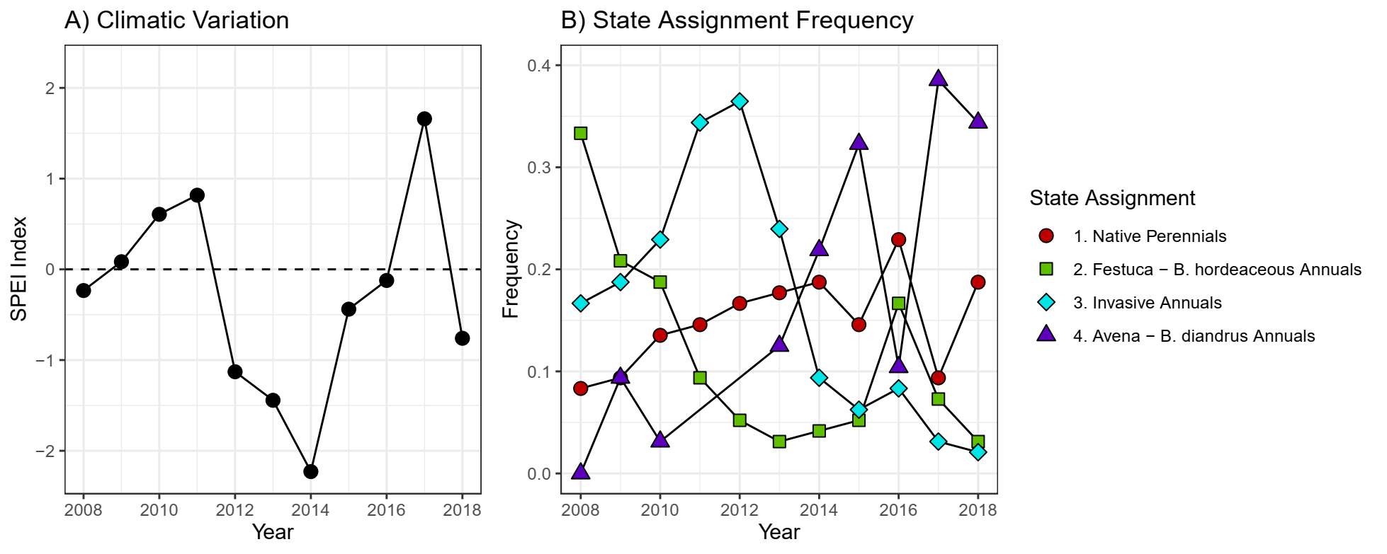

**Figure 2:**

Visualization of clustering assignments and results of indicator species analysis following K-medoids clustering. Non-metric multidimensional scaling (NMDS) ordination was conducted on all community observations from 2008 – 2018 (*n* =560). Pairwise community distance was calculated using Bray-Curtis dissimilarity index. Species vectors correspond to taxa that were found to be significantly associated (*p* < 0.05) with state assignments using indicator species analysis. High values of the indicator species statistic reflect strong associations between a taxon and a given state assignment. *P*-values calculated using 1,000 permutations.

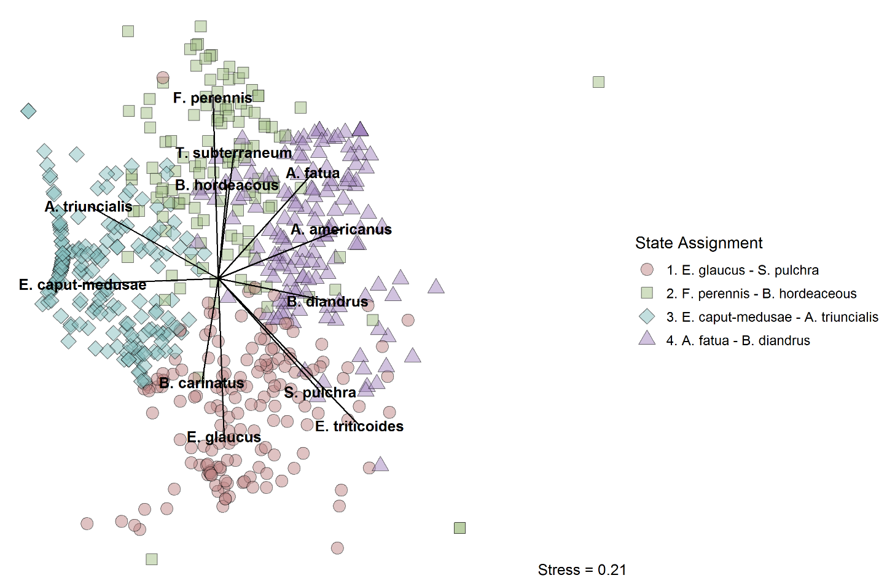

|  |  |  |  |
| --- | --- | --- | --- |
| State | Species | Statistic | *P*-value |
| 1 | *E. glaucus* | 0.801 | 0.001 |
| *S. pulchra* | 0.574 | 0.001 |
| *B. carinatus* | 0.548 | 0.001 |
| *F. microstachys* | 0.284 | 0.001 |
| 2 | *F. perennis* | 0.825 | 0.001 |
| *B. hordeaceus* | 0.723 | 0.001 |
| *T. subterraneum* | 0.607 | 0.001 |
| 3 | *E. caput-medusae* | 0.871 | 0.001 |
| *A. triuncialis* | 0.741 | 0.001 |
| 4 | *A. fatua* | 0.819 | 0.001 |
| *B. diandrus* | 0.553 | 0.001 |
| *E. triticoides* | 0.303 | 0.036 |
| *A. americanus* | 0.274 | 0.011 |

**Figure 3:**

State-transition representation of fitted multi-state model coefficients at baseline, assuming no effects of temporal priority and average drought stress (SPEI = 0). Labels refer to the probability a plot transitions between 2 different state assignments (arrows) or the probability a plot retains its assignment (circles) in consecutive years. Circles and arrows are scaled in diameter or color, respectively, by the probability of state assignment transition.

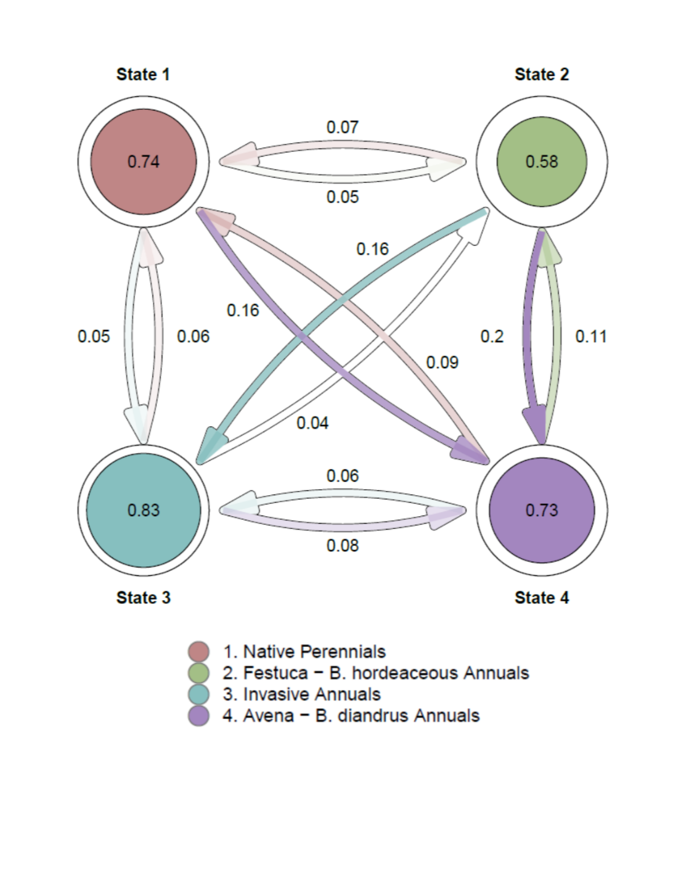

**Figure 4:**

The effects of temporal priority and drought stress on the probability of transition of a plot to the *Native Perennial* state given other previous state assignments.Transition probabilities presented are a function of drought stress (SPEI) and whether native species were included/absent from the seeded species mixture (+/- Priority). Solid lines indicate significant (*p* < 0.05) covariate effects of both SPEI and priority; dashed lines correspond to non-significant effects.



**Appendices**

**Appendix 1:**

Output of permutational ANOVA (PerMANOVA) and NMDS ordination of species abundances in the first year of the experiment (2008). Multivariate ANOVA indicates a strong effect of initial seeding treatment, as well as clustering of communities across treatments. NMDS ordination was constructed through ordination of all observed communities, while the figure presents a subset of points corresponding to the first year of observation.

PerMANOVA:

|  |  |  |  |  |  |  |
| --- | --- | --- | --- | --- | --- | --- |
| **Source** | **DF** | **SS** | **MS** | **F** | **R-squared** | **Pr (>F)** |
| Seeding composition | 6 | 12.0487 | 2.0081 | 32.815 | 0.8 | 0.001 |
| Residual | 49 | 2.9986 | 0.19928 |  |  |  |
| Total | 55 | 15.0473 | 1 |  |  |  |

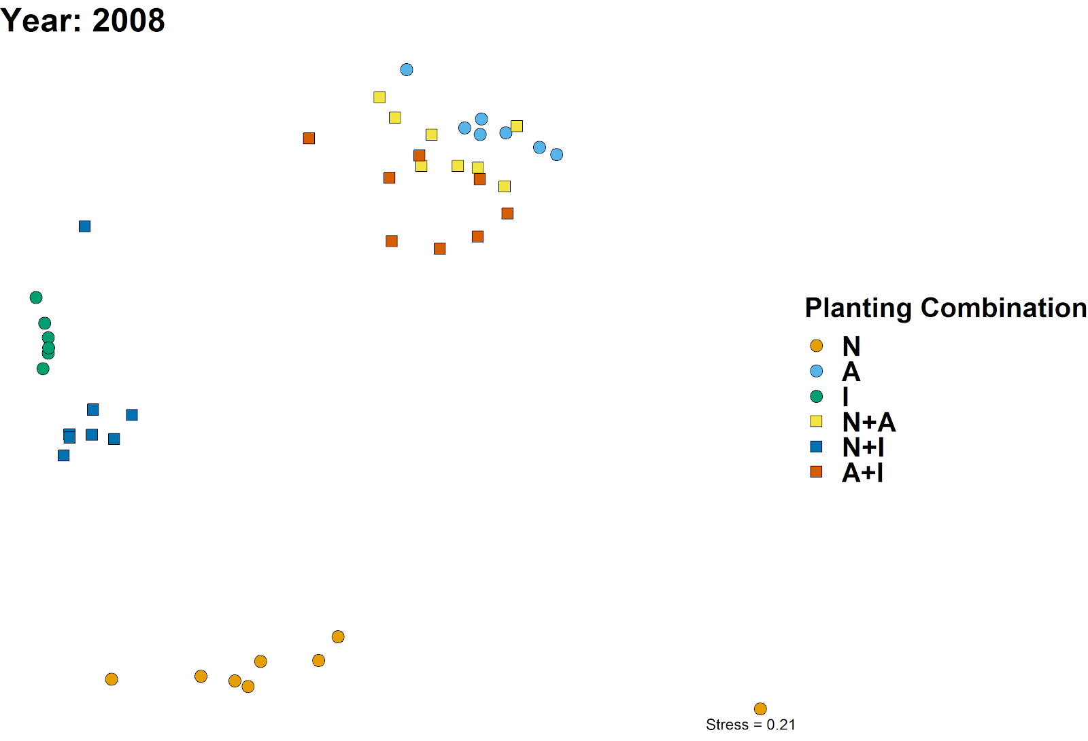

**Appendix 2:**

Heuristics used to determine best number of clusters to use in partitioning, *K*.

Summary of the best performing *K* for 8 different clustering indices:

|  |  |  |  |  |  |  |  |  |
| --- | --- | --- | --- | --- | --- | --- | --- | --- |
| Index | Hartigan | CH | Beale | KL | Cindex | DB | Silhouette | Duda |
| *Best K* | 4 | 4 | 4 | 7 | 8 | 7 | 7 | 4 |
| Value | 76.30 | 176.75 | -2.02 | 3.83 | 0.31 | 1.40 | 0.30 | 1.19 |

Rank summary table of performance across different clustering indices:

|  |  |  |  |  |  |  |  |  |  |  |  |  |  |  |  |  |
| --- | --- | --- | --- | --- | --- | --- | --- | --- | --- | --- | --- | --- | --- | --- | --- | --- |
| K | Hartigan | Rk | CH | Rk | Beale | Rk | KL | Rk | Cindex | Rk | DB | Rk | Sil. | Rk | Duda | Rk |
| 2 | 133.88 | 9 | 163.10 | 3 | 2.70 | 8 | 1.22 | 5 | 0.50 | 9 | 1.69 | 9 | 0.21 | 9 | 0.82 | 9 |
| 3 | 128.56 | 5 | 166.15 | 2 | 1.96 | 7 | 1.12 | 6 | 0.45 | 8 | 1.59 | 8 | 0.23 | 8 | 0.86 | 7 |
| 4 | **52.25** | **1** | **176.75** | **1** | **-2.02** | **1** | 3.09 | 2 | 0.42 | 7 | 1.49 | 6 | 0.26 | 7 | **1.19** | **1** |
| 5 | 70.00 | 7 | 156.78 | 5 | 5.41 | 9 | 0.70 | 8 | 0.40 | 6 | 1.42 | 3 | 0.27 | 6 | 0.70 | 8 |
| 6 | 84.36 | 6 | 153.65 | 6 | -2.03 | 2 | 0.87 | 7 | 0.36 | 4 | 1.48 | 5 | 0.30 | 2 | 1.20 | 3 |
| 7 | 28.88 | 2 | 159.70 | 4 | 1.12 | 6 | **3.83** | **1** | 0.36 | 5 | **1.40** | **1** | **0.30** | **1** | 0.92 | 6 |
| 8 | 63.54 | 8 | 147.31 | 9 | -3.12 | 3 | 0.39 | 9 | **0.31** | **1** | 1.50 | 7 | 0.27 | 5 | 1.34 | 4 |
| 9 | 48.78 | 4 | 150.17 | 7 | -2.06 | 5 | 1.42 | 4 | 0.33 | 3 | 1.47 | 4 | 0.29 | 3 | 1.20 | 5 |
| 10 | 25.57 | 3 | 149.47 | 8 | -9.33 | 4 | 2.24 | 3 | 0.32 | 2 | 1.42 | 2 | 0.28 | 4 | 4.20 | 2 |

Clustering Index Ranking Method:

1. Hartigan: Choose value K with maximum index difference between K and K-1

2. CH: Choose maximum value among orders of K considered

3. Beale: Choose minimum value of K such that the critical value of the index is less than alpha = 0.05. Other values whose critical value is less than alpha are ranked in order of significance.

4. KL: Choose maximum value among orders of K considered

5. Cindex: Choose minimum value among orders of K considered

6. DB (Davies and Bouldin): Choose minimum value among orders of K considered

7. Silhouette: Choose maximum value among orders of K considered

8. Duda: Choose minimum value of K such that the critical value of the index is less than alpha = 0.05. Other values whose critical value is less than alpha are ranked in order of significance.

**Appendix 3:**

Relative abundance of species across vegetation state assignments. Values refer to the average abundance of each species (+/- standard error) for observed communities assigned to each state. Species that served as significant (*P* < 0.05) indicators of each state type are highlighted using “*” and colored by representative state. On average, indicator species of each vegetation state accounted for 75% of the cumulative relative abundance of observed communities.

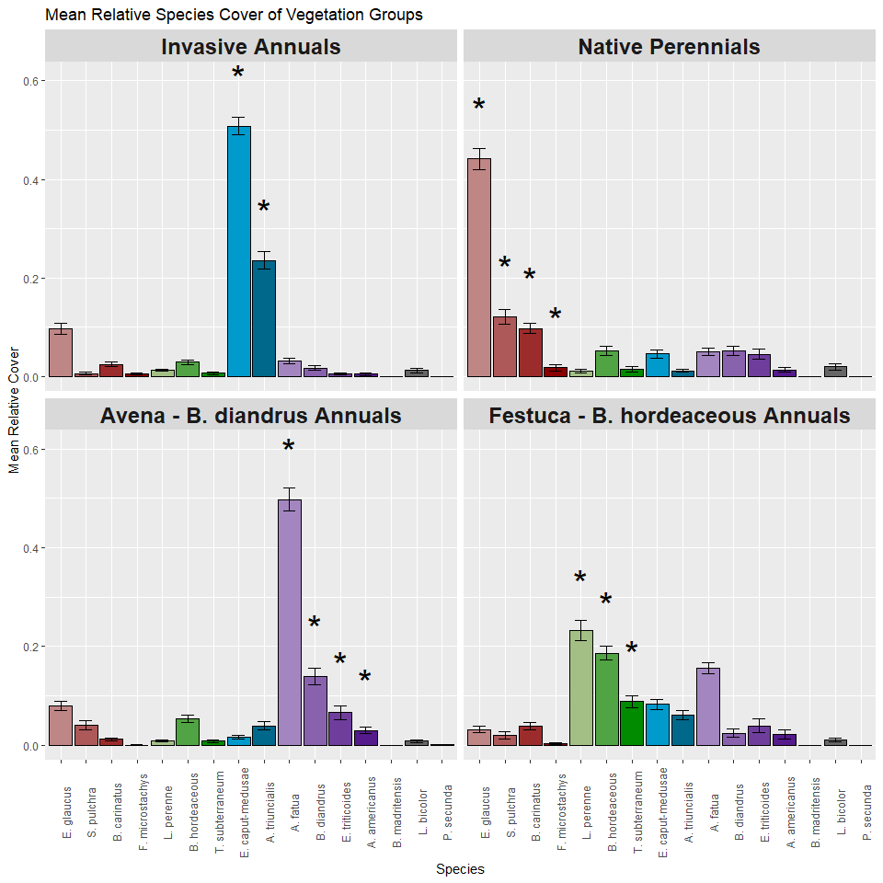

**Appendix 4:**

Contingency table of observed transitions between state assignments between 2008-2018. For each plot observation of a state assignment in year *t* (rows), data shows the frequency of state assignments (columns) of the same plot in a subsequent year (*t + 1*). Diagonal values represent the frequency of a given state retaining its assignment (persistence), while off-diagonal values represent transitions in state assignment. Changes in assignment frequency were highly non-random (χ2 = 392.017, df = 9, *P <* 0.001).

|  |  |  |  |  |
| --- | --- | --- | --- | --- |
|  | *To* |  |  |  |
| *From* | Native perennial | F. perennis – B.hordeaceous | Invasive Annual | A. fatua –  B. diandrus |
| Native perennial | 95 | 8 | 7 | 29 |
| F. perennis – B.hordeaceous | 10 | 50 | 30 | 29 |
| Invasive Annual | 25 | 11 | 115 | 22 |
| A. fatua –  B. diandrus | 19 | 21 | 7 | 76 |

**Appendix 5:**

Plot-level shifts in state assignment over time. For each observed community (grid cell), the state assignment of a community is presented as a function of initial seeding treatment (row) and time (column).

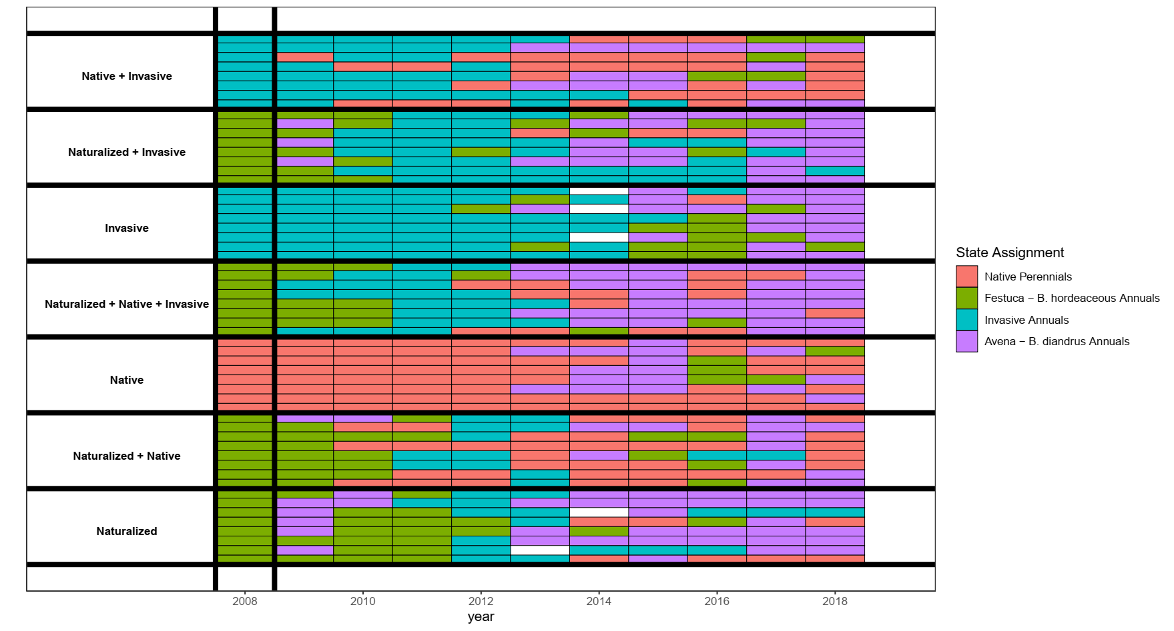

**Appendix 6:**

AIC model comparison used to select the best fit multi-state model from a series of candidates. Covariates include “Priority Effects” – the effect of initial seeding mixture representation of indicator species correlated with cluster assignments – and “1-“, “2-“, and “3-year SPEI” – a standardized measure of drought stress computed over 1, 2, and 3 cumulative water year intervals, respectively. DF corresponds to the number of parameters estimated within the transition matrix, including baseline transition probabilities and effects of covariates. The best fit model (Model 6) is highlighted in bold.

|  |  |  |  |  |  |  |  |
| --- | --- | --- | --- | --- | --- | --- | --- |
|  |  | Covariates | | | | |  |
| Model | DF | Priority Effects | 1 Year SPEI | 2 Year SPEI | 3 Year SPEI | ΔAIC | AIC |
| 1 | 12 |  |  |  |  | 35.31 | 1289.98 |
| 2 | 24 | X |  |  |  | 6.16 | 1260.83 |
| 3 | 24 |  | X |  |  | 31.82 | 1286.49 |
| 4 | 24 |  |  | X |  | 31.76 | 1286.43 |
| 5 | 24 |  |  |  | X | 28.00 | 1282.67 |
| **6** | **36** | **X** | **X** |  |  | **0.00** | **1254.67** |
| 7 | 36 | X |  | X |  | 3.92 | 1258.59 |
| 8 | 36 | X |  |  | X | 0.25 | 1254.92 |