**Tables:**

**Table 1:**

Species mixtures used in initial plot seeding. Distinctions between “Native”, “Naturalized”, and “Invasive” species groups reflect species origins in California grasslands.

|  |  |  |
| --- | --- | --- |
| Native | Naturalized | Invasive |
| *Acmispon americanus* | *Avena fatua* | *Aegilops triuncialis* |
| *Elymus glaucus* | *Bromus hordeacous* | *Elymus caput-medusae* |
| *Elymus triticoides* | *Festuca perenne var. multiflorum* |  |
| *Festuca microstachys* | *Trifolium subterraneum* |  |
| *Lupinus bicolor* |  |  |
| *Poa secunda* |  |  |
| *Stipa pulchra* |  |  |

**Table 2:**

Results of indicator species analysis using state assignments generated from K-medoids clustering. High “Statistic” values reflect strong associations between a taxon and a given state assignment. *P*-values were calculated using 1,000 permutations.

|  |  |  |  |
| --- | --- | --- | --- |
| Cluster | Species | Statistic | *P*-value |
| 1 | *E. glaucus* | 0.801 | 0.001 |
| *S. pulchra* | 0.574 | 0.001 |
| *B. carinatus* | 0.548 | 0.001 |
| *F. microstachys* | 0.284 | 0.001 |
| 2 | *L. perenne* | 0.825 | 0.001 |
| *B. hordeacous* | 0.723 | 0.001 |
| *T. subterraneum* | 0.607 | 0.001 |
| 3 | *E. caput-medusae* | 0.871 | 0.001 |
| *A. triuncialis* | 0.741 | 0.001 |
| 4 | *A. fatua* | 0.819 | 0.001 |
| *B. diandrus* | 0.553 | 0.001 |
| *E. triticoides* | 0.303 | 0.036 |
| *A. americanus* | 0.274 | 0.011 |

**Table 3:**

Contingency table of observed transitions between state assignments between 2008-2018. For each plot observation of a state assignment in year *t* (rows), data shows the frequency of state assignments (columns) of the same plot in a subsequent year (*t + 1*). Diagonal values represent the frequency of a given state retaining its assignment (resistance), while off-diagonal values represent transitions in state assignment. Changes in assignment frequency were highly non-random (χ2 = 392.017, df = 9, *P <* 0.001).

|  |  |  |  |  |
| --- | --- | --- | --- | --- |
|  | To |  |  |  |
| From | State 1 | State 2 | State 3 | State 4 |
| State 1 | 95 | 8 | 7 | 29 |
| State 2 | 10 | 50 | 30 | 29 |
| State 3 | 25 | 11 | 115 | 22 |
| State 4 | 19 | 21 | 7 | 76 |

**Table 4:**

AIC model comparison used to select the best fit multi-state model from a series of candidates. Covariates include “Priority Effects” – the effect of initial seeding mixture representation of indicator species correlated with cluster assignments – and “1-“, “2-“, and “3-year SPEI” – a standardized measure of drought stress computed over 1, 2, and 3 cumulative water year intervals, respectively. DF corresponds to the number of parameters estimated within the transition matrix, including baseline transition probabilities and effects of covariates. The best fit model (Model 6) is highlighted in bold.

|  |  |  |  |  |  |  |  |
| --- | --- | --- | --- | --- | --- | --- | --- |
|  |  | Covariates | | | | |  |
| Model | DF | Priority Effects | 1 Year SPEI | 2 Year SPEI | 3 Year SPEI | ΔAIC | AIC |
| 1 | 12 |  |  |  |  | 35.31 | 1289.98 |
| 2 | 24 | X |  |  |  | 6.16 | 1260.83 |
| 3 | 24 |  | X |  |  | 31.82 | 1286.49 |
| 4 | 24 |  |  | X |  | 31.76 | 1286.43 |
| 5 | 24 |  |  |  | X | 28.00 | 1282.67 |
| **6** | **36** | **X** | **X** |  |  | **0.00** | **1254.67** |
| 7 | 36 | X |  | X |  | 3.92 | 1258.59 |
| 8 | 36 | X |  |  | X | 0.25 | 1254.92 |

**Table 5:**

Parameter estimates of the best fit multi-state model (Model 6; Table 3). For each state assignment, potential state assignments in subsequent years (Transitions) and their associated probabilities (+/- 95% confidence intervals) are reported. Effects of covariates are reported as hazard ratios, the relative rate a transition will occur relative to control. In this case, temporal priority hazard ratios refer to the rate a plot transitions to a state assignment represented in a plot’s initial seeding mixture; drought stress hazard ratios reflect the rate a plot transitions to a given state assignment per unit increase in SPEI. Statistically significant (*p < 0.05)* covariate effects are highlighted in bold.

|  |  |  |  |  |  |  |
| --- | --- | --- | --- | --- | --- | --- |
| State Transition Probability | | |  | Covariate Hazard Ratios | | |
| Assignment | Transition | Probability |  | Temporal Priority |  | Drought Stress (SPEI) |
| State 1 | State 1 | 0.74 (0.65,0.8) |  | - |  | - |
| State 2 | 0.05 (0.03,0.08) |  | *4.77^* |  | 0.8 |
| State 3 | 0.05 (0.03,0.1) |  | 2.96 |  | 0.95 |
| State 4 | 0.16 (0.11,0.23) |  | 1.53 |  | 0.86 |
| State 2 | State 1 | 0.07 (0.04,0.11) |  | *3.31^* |  | 0.83 |
| State 2 | 0.58 (0.48,0.65) |  | - |  | - |
| State 3 | 0.16 (0.11,0.23) |  | 1.71 |  | 1.41 |
| State 4 | 0.2 (0.14,0.27) |  | 0.54 |  | 0.71 |
| State 3 | State 1 | 0.06 (0.03,0.11) |  | **12.74\*\*** |  | **0.56\*** |
| State 2 | 0.04 (0.02,0.07) |  | 0.55 |  | *0.55^* |
| State 3 | 0.83 (0.75,0.88) |  | - |  | - |
| State 4 | 0.08 (0.05,0.12) |  | **3.26\*** |  | **0.56\*** |
| State 4 | State 1 | 0.09 (0.06,0.15) |  | **2.53\*** |  | **1.43\*** |
| State 2 | 0.11 (0.08,0.17) |  | 0.77 |  | 1.02 |
| State 3 | 0.06 (0.04,0.11) |  | 1.93 |  | 0.98 |
| State 4 | 0.73 (0.65,0.79) |  | - |  | - |

*^ p < 0.01; * p < 0.05; ** p < 0.01*

**Figures**

**Figure 1:**

Non-metric multidimensional scaling (NMDS) representation of all community observations from 2008 – 2018 (*n*  = 560). Pairwise community distance was calculated using Bray-Curtis dissimilarity index. Species vectors correspond to taxa which were found to be significantly associated (*p* < 0.05) with state assignments using indicator species analysis.

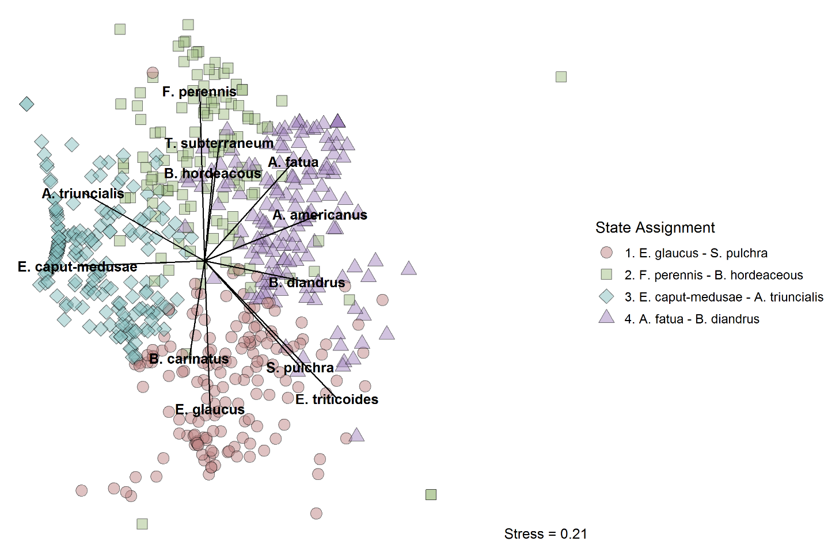

**Figure 2:**

Variation in total water year precipitation (A) and frequencies of state assignments (B) from 2008-2018.

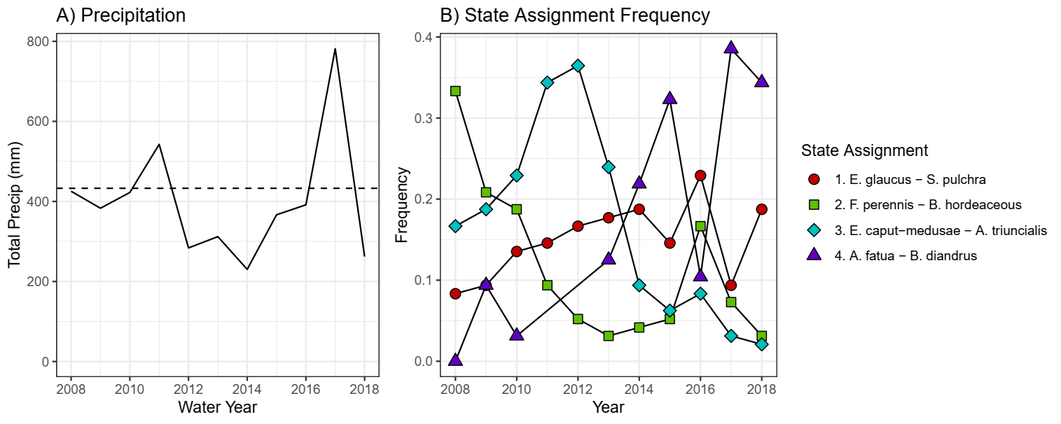

**Figure 3:**

State-transition representation of fitted multi-state model coefficients. Labels refer to the probability a plot transitions between 2 different state assignments (arrows) or the probability a plot retains its assignment (circles) in consecutive years. Circles and arrows are scaled in width or diameter, respectively, by the probability of state assignment transition.

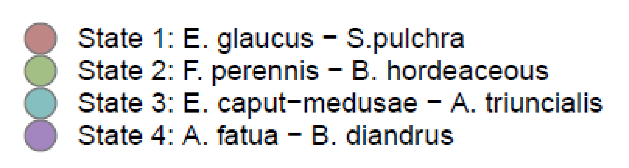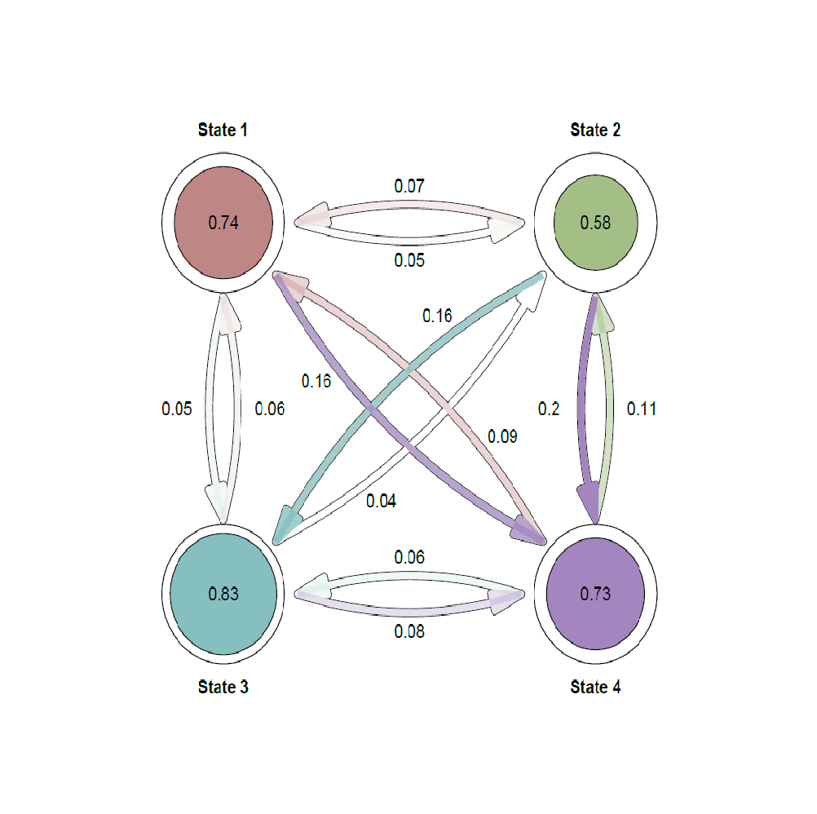

**Figure 4:**

The effects of temporal priority and drought stress on the probability of transiton to *State 1* from *States 2, 3,* and *4*.Transition probability presented as a function of SPEI and whether native species included/absent from the seeded species mixture (+/- Priority). Solid lines indicate significant (*p* < 0.05) covariate effects of both SPEI and priority; dashed lines correspond to non-significant effects.

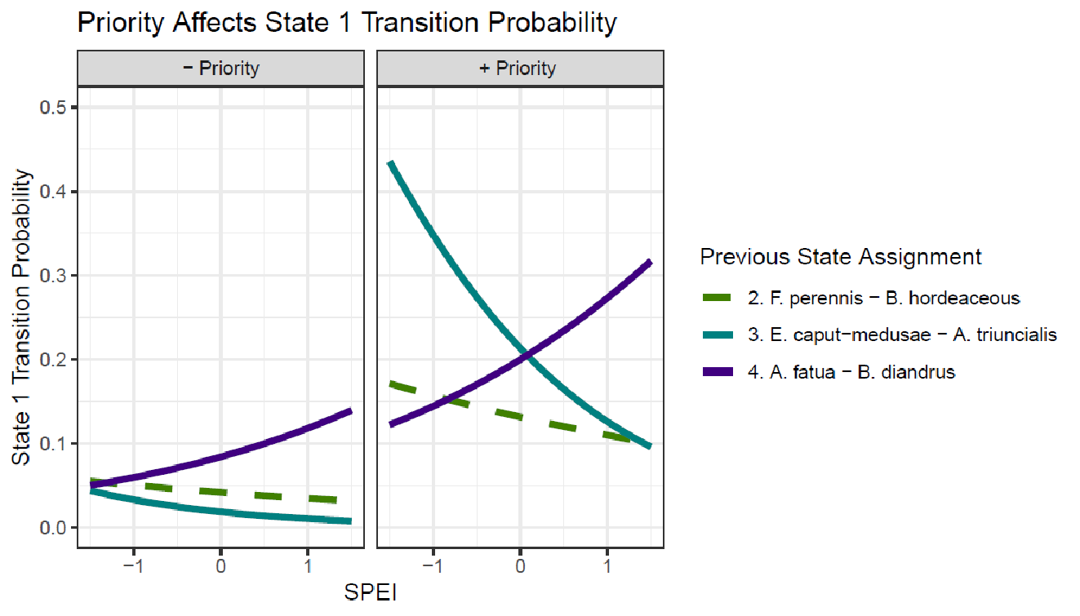

**Appendices**

**Appendix 1:**

Plot-level shifts in state assignment over time.

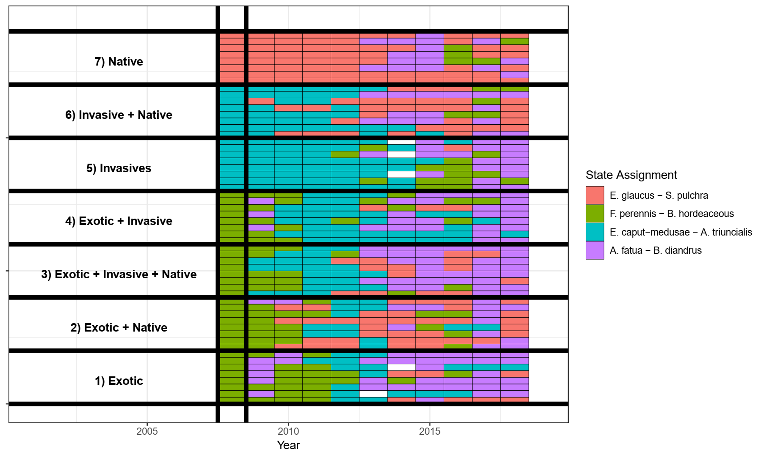

**Appendix 2:**

Output of permutational ANOVA, NMDS ordination of species abundances in the first year of the experiment (2008).

PerMANOVA Output:

|  |  |  |  |  |  |  |
| --- | --- | --- | --- | --- | --- | --- |
| **Source** | **DF** | **SS** | **MS** | **F** | **R-squared** | **Pr (>F)** |
| Seeding composition | 6 | 12.0487 | 2.0081 | 32.815 | 0.8 | 0.001 |
| Residual | 49 | 2.9986 | 0.19928 |  |  |  |
| Total | 55 | 15.0473 | 1 |  |  |  |

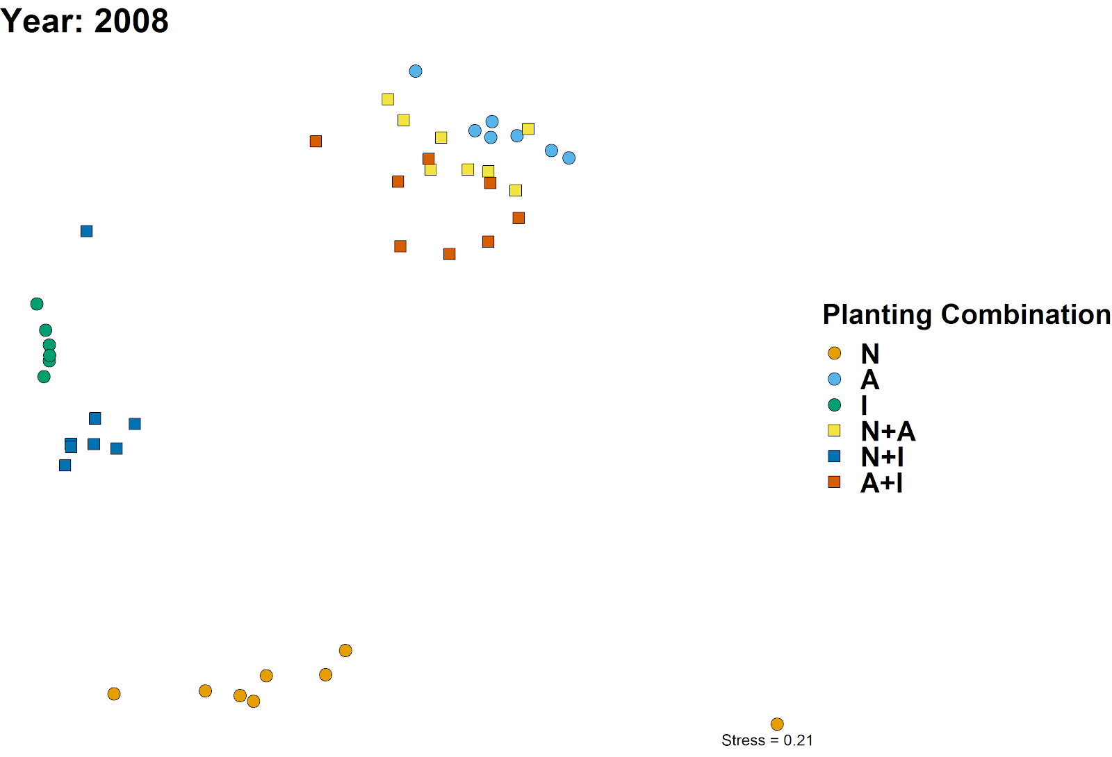

**Appendix 3:**

Heuristic data used to determine best number of clusters to use in partitioning, *K*.

Summary of the best performing *K* for 8 different clustering indices:

|  |  |  |  |  |  |  |  |  |
| --- | --- | --- | --- | --- | --- | --- | --- | --- |
| Index | Hartigan | CH | Beale | KL | Cindex | DB | Silhouette | Duda |
| *Best K* | 4 | 4 | 4 | 7 | 8 | 7 | 7 | 4 |
| Value | 76.30 | 176.75 | -2.02 | 3.83 | 0.31 | 1.40 | 0.30 | 1.19 |

Rank summary table of performance across different clustering indices:

|  |  |  |  |  |  |  |  |  |  |  |  |  |  |  |  |  |
| --- | --- | --- | --- | --- | --- | --- | --- | --- | --- | --- | --- | --- | --- | --- | --- | --- |
| K | Hartigan | Rk | CH | Rk | Beale | Rk | KL | Rk | Cindex | Rk | DB | Rk | Sil. | Rk | Duda | Rk |
| 2 | 133.88 | 9 | 163.10 | 3 | 2.70 | 8 | 1.22 | 5 | 0.50 | 9 | 1.69 | 9 | 0.21 | 9 | 0.82 | 9 |
| 3 | 128.56 | 5 | 166.15 | 2 | 1.96 | 7 | 1.12 | 6 | 0.45 | 8 | 1.59 | 8 | 0.23 | 8 | 0.86 | 7 |
| 4 | **52.25** | **1** | **176.75** | **1** | **-2.02** | **1** | 3.09 | 2 | 0.42 | 7 | 1.49 | 6 | 0.26 | 7 | **1.19** | **1** |
| 5 | 70.00 | 7 | 156.78 | 5 | 5.41 | 9 | 0.70 | 8 | 0.40 | 6 | 1.42 | 3 | 0.27 | 6 | 0.70 | 8 |
| 6 | 84.36 | 6 | 153.65 | 6 | -2.03 | 2 | 0.87 | 7 | 0.36 | 4 | 1.48 | 5 | 0.30 | 2 | 1.20 | 3 |
| 7 | 28.88 | 2 | 159.70 | 4 | 1.12 | 6 | **3.83** | **1** | 0.36 | 5 | **1.40** | **1** | **0.30** | **1** | 0.92 | 6 |
| 8 | 63.54 | 8 | 147.31 | 9 | -3.12 | 3 | 0.39 | 9 | **0.31** | **1** | 1.50 | 7 | 0.27 | 5 | 1.34 | 4 |
| 9 | 48.78 | 4 | 150.17 | 7 | -2.06 | 5 | 1.42 | 4 | 0.33 | 3 | 1.47 | 4 | 0.29 | 3 | 1.20 | 5 |
| 10 | 25.57 | 3 | 149.47 | 8 | -9.33 | 4 | 2.24 | 3 | 0.32 | 2 | 1.42 | 2 | 0.28 | 4 | 4.20 | 2 |

**Appendix 4:**

Relative abundance of species by vegetation group. Bars presented are means +/- 1 SE.

