**State-change manuscript outline:**

**Broad background – Non-equilibrium dynamics**

* Many natural systems are characterized by nonequilibrium community dynamics
* Most notably in systems with non-stationarity in environmental conditions, long-term population dynamics may not be expected to reach a stable equilibrium; fluctuations are a function of the system, rather than a perturbation from some stable equilibrium (Chesson 2018).
  + In an era of rapid environmental change, understanding changes to non-equilibrium dynamics is increasingly important.
* This non-equilibrium perspective of community dynamics has been particularly adopted in arid and semiarid rangeland systems, where interactions between climate patterns, competition, and contingency produce dramatic shifts in vegetation over both space and time.
  + Traditional range succession models often fail to predict vegetation change in these systems, where communities do not follow a deterministic trajectory toward a “climax” plant community.
  + Instead, community dynamics in annual grasslands are often conceptualized by reversible and irreversible transitions between a series of discrete “states” and “phases”.

**On STMs**

* State and transition models (STMs) that attempt to conceptualize turnover between discrete states have emerged as useful tools for rangeland management by capturing:
  + 1) Species indicators of different vegetation states
  + 2) Drivers of transition between states
  + 3) State resilience – the likelihood of a community retaining its state in a subsequent observation
* In a management context, an understanding of states, transitions, and resilience guides land use practice.
  + Management and restoration are often directed toward coaxing pre-existing states into more favorable ones. Once established, estimated state resilience provides a basis for targeted interventions.
* While a key conceptual tool for management of rangeland systems, empirical tests of state and transition models has been limited. State-change models are primarily developed on the basis of expert opinion, which may benefit from a quantitative evaluation to identify:
  + 1) Relevance of states in partitioning total variance in community composition
  + 2) Transition and resilience probabilities
    - For examples, see Bagchi et al. (2013), Jackson and Bartolome (2005), and Stein et al. (2018).

**California Annual Grasslands**

* California grasslands have long been a focal system in the study of nonequilibrium dynamics. Composed primarily of exotic annual species, these grasslands readily shift between dominant groups of taxa (George et al. 1992).
* In California grasslands, distinctions are often made 3 key groups of species:
  + 1) Naturalized exotic annual grasses that now compose a majority of grassland vegetation in the state.
  + 2) Native perennial grasses and forbs thought to once cover much of the state’s grassland habitat
  + 3) A set of highly invasive annual grasses that are rapidly expanding throughout California rangelands.
* Past work has shown that transitions between key indicators of annual rangeland type depend on environmental conditions, management actions, and order of community assembly.
  + Seasonal patterns of precipitation and temperature can exert considerable control over dynamics at the seedling stage. Annual grasses germinate rapidly with winter rains and outcompete other taxa in the absence of periodic droughts that may favor native grasses and forbs.
  + Native perennial grasses are thought to be highly recruitment limited, though strong competitors once established.
  + Exotic annuals (and invasive grasses, in particular) appear to exhibit strong priority effects through changes in nutrient cycling and deposition of thick litter layers that impede competitor establishment.

**Need some sort of transition here**

* In the past decade, California has experienced climatic extremes, including a historic drought that provided XX% of normal winter rain between 2012-2016. As the effect of climate change mount, current projections include significant increases in the frequency and intensity of drought events in California. In a system where environmental variation acts as a strong driver of vegetation dynamics, quantitative tests of STMs are needed to effectively predict and adapt to changes in the near future.
* To quantitatively assess the use of STMs in California grasslands, we use data from an experiment consisting of the three key grassland states – naturalized, native, and invasive species – planted in all 1, 2, and 3 group combinations.
* With consistent yearly observations from 2008 – 2018, this data encompasses a range of climatic variation, including both the driest period (2011 – 2014) and wettest winter in Northern California history. By tracking the vegetation composition of each assembled community, we aim to ask:
  + What states best partition observed variance in plant community composition? What species define these states?
  + Are transitions between states characterized by continuous, reversible changes or non-reversible changes?
  + How do key drivers of community composition (assembly order and climate) govern transitions between states?

**Materials and Methods:**

Study site

* Field plantings were conducted in research fields at the University of California, Davis (38.545751, -121.784780). Soil information, land use history, etc.
* Prior to planting, soil was disked, irrigated, and received a broad-spectrum herbicide (glyphosate) to remove the existing seed bank.
* Three planting mixtures were established based on existing state-change models of California grassland systems, or common delineation between community types (Table 1). For all possible 1-, 2-, and 3-group planting combinations, we established eight 1.5m x 1.5m plots (2.25 m2; 56 plots total).
* What is the detail for planting amount and number of seeds added?
* In each growing season from 2008 – 2018, total areal cover of all species was estimated visually to the nearest 10%. Cover observations for each species were captured at maximum percent cover to account for variation in species phenology.



Weather data

* Weather data was provided by a local California Irrigation Management Information System (CIMIS) monitoring station in Davis, CA (38.535694, -121.777636). CIMIS automated dataloggers collect weather data on a minute-by-minute basis, including air temperature, soil temperature, precipitation, solar radiation, vapor pressure, and wind speed. We aggregated these data into monthly intervals, where we calculated SPEI, a standardized metric of drought stress (*D­i*) at a given timepoint, *i*:



* Where *Pi*represents observed precipitation and *ETo­i*represents estimated evapotransporation. *ETo* was calculated using the Penman-Monteith equation, defined as:



* Where *Rn* is net radiation, *G* is soil heat flux, *(es – ea)* isthe vapor pressure deficit of air, *ρi* is the mean air density at constant pressure, *cp* is the specific heat of air, Δ is the slope of the saturation vapor pressure temperature relationship, γ is the psychometric constant, and *rs*and *ra* are the surface and aerodynamic resistances (FAO).
* SPEI offers flexible, variable timescale estimations of drought stress that can be used to quantify the effects of multi-year climate patterns (Prugh et al. 2018). For each year between 1980 and 2018, we calculated SPEI for a single water year (November – May; 7 months), two consecutive water years (19 months), and three consecutive water years (31 months). We then standardized these values by fitting the drought index series to a log-logistic distribution. All SPEI calculations were performed using the package “spei”.

Delineation of States

* Per Bestelmeyer, “states” best partition the total variation in community composition observed within a given system. To this end, we chose to apply an unsupervised clustering algorithm (k-medioids clustering) to partition communities into discrete states. K-medoids clustering randomly selects k of n total datapoints as group “medoids” and computes the sum of distances between points and their associated medioid, based on Bray-Curtis dissimilarity. This algorithm then iteratively swaps these mediods and recalculates summed distance to achieve a solution that best captures the total variance of the data. R library used – “pam”.
* To determine the most appropriate number of states, we applied k-medioids clustering across values of *k* from 2-10. We then subjected the output of each of these runs to a battery of tests (list tests here, if needed); the value of *k* with the most consist performance across all tests was used to determine the number of clusters that best represented discrete partitions within this dataset. R library used – nbclust.
* Following the partition of states, we then conducted indicator species analysis to establish what species are associated with each state. Indicator species analysis was conducted using the “vegan” package.

****Construction of State-Transition Models

* Following the association of observations to discrete states, we fit a multistate model (aka Markov model) to the data. Multistate models represent systems where subjects transition between a set of discrete classes over time and may be uniquely suited to examining state and transition models through a statistical framework.
* In our analysis, we constructed a multistate model consisting of all states identified in clustering analysis, with probabilities fit to all possible transitions between states.
* To test for effects of initial planting composition and climatic variation on the probability of state transition and resilience, we added a series of covariates to multistate models that correspond to SPEI and the presence of state indicator species in the initial planting composition.
  + ****E.g, the probability of a transition between states 1 and 2, *q’12*, can be represented by:

‘

* + Where q12 is the baseline probability of a transition, and β1 and β2 are coefficients fit to recorded SPEI values and planting composition, respectively.
* After fitting models with and without SPEI and initial planting covariates for 1-, 2-, and 3-year drought indices, we then calculated AIC scores for each model. We selected the model with the lowest AIC score (ΔAIC < -2) as our best fit model. Further comparisons between subset models containing nested sets of parameters were made using likelihood ratio tests.
* Multistate model fitting and model selection was performed using the “msm” package.

**Results**

1. **NMDS of state assignments**

* Still need to fix the species labels on this

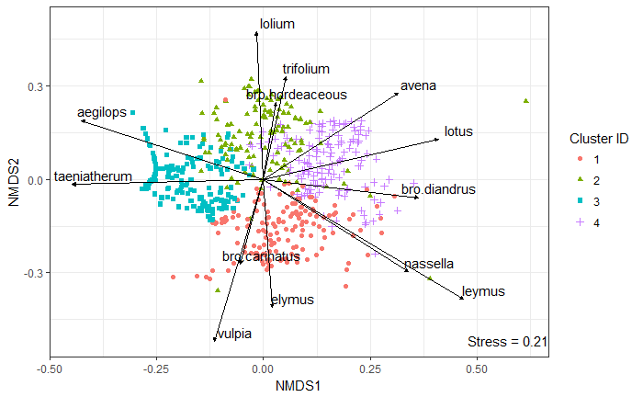

1. **Indicator species analysis table**

* As before, still need to fix the species labels on this



1. **Transition assignments over time and transition frequency table**



1. **SPEI Figure**

Show precipitation over time in one panel, with 1 year drought index, 2 year drought index, and 3 year drought indices (see Prugh paper for an example)

1. **AIC model selection table**

Model selection results. Which model is best for this data? Table consisting of:

* Null
* Priority
* Env
* Priority + Env

For the three different drought indices

1. **Stability probabilities**
2. **Transition probabilities**

**Discussion**

**References**

Briske, D. D., S. D. Fuhlendorf, and F. E. Smeins. 2005. Society for Range Management State-and-Transition Models , Thresholds , and Rangeland Health : A Synthesis of Ecological Concepts and Perspectives Author ( s ): D . D . Briske , S . D . Fuhlendorf and F . E . Smeins Published by : Society for Range Manage. Rangeland Ecology & Management 58:1–10.

Briske, D. D., B. T. Bestelmeyer, T. K. Stringham, and P. L. Shaver. 2008. Recommendations for development of resilience-based state-and-transition models. Rangeland Ecology and Management 61:359–367.

Briske, D. D., S. D. Fuhlendorf, and F. E. Smeins. 2003. Vegetation dynamics on rangelands: A critique of the current paradigms. Journal of Applied Ecology 40:601–614.

Clary, J. 2008. Rainfall seasonality determines annual/perennial grass balance in vegetation of Mediterranean Iberian. Plant Ecology 195:13–20.

Corbin, J. D., and C. M. D’Antonio. 2010. Not novel, just better: Competition between native and non-native plants in California grasslands that share species traits. Plant Ecology 209:71–81.

Elmendorf, S. C., and S. P. Harrison. 2009. Temporal variability and nestedness in California grassland species composition. Ecology 90:1492–1497.

Harpole, W. S., D. L. Potts, and K. N. Suding. 2007. Ecosystem responses to water and nitrogen amendment in a California grassland. Global Change Biology 13:2341–2348.

Henneman, C., N. E. Seavy, and T. Gardali. 2014. Restoring Native Perennial Grasses by Changing Grazing Practices in Central Coastal California. Ecological Restoration 32:352–354.

Prugh, L. R., N. Deguines, J. B. Grinath, K. N. Suding, W. T. Bean, R. Stafford, and J. S. Brashares. 2018. Ecological winners and losers of extreme drought in California. Nature Climate Change 8:819–824.

Seabloom, E. W., W. S. Harpole, O. J. Reichman, and D. Tilman. 2003. Invasion, competitive dominance, and resource use by exotic and native California grassland species. Proceedings of the National Academy of Sciences of the United States of America 100:13384–9.

**Supplemental Information**

1. **NBClust k selection test output**
2. **Visualization of the relative percent cover of all species by state assignment**

* Older figure, need to think of a better way to convey this information, if needed.



1. **Assignment changes by individual plot**

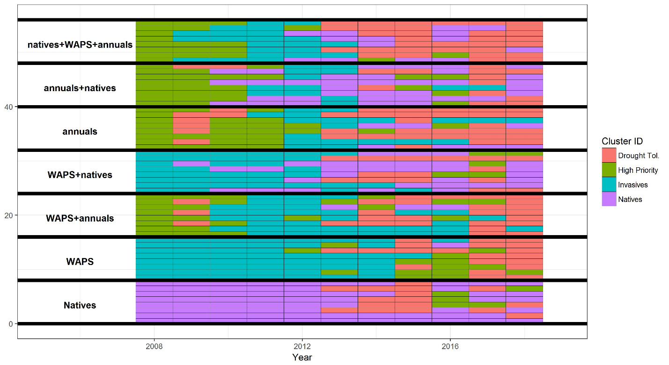

1. **MSM model output, estimated coefficients, visualized fits**

**References**