**State-change manuscript outline:**

**Broad background – Non-equilibrium dynamics**

* Many natural systems are characterized by nonequilibrium community dynamics
* Most notably in systems with non-stationarity in environmental conditions, long-term population dynamics may not be expected to reach a stable equilibrium; fluctuations are a function of the system, rather than a perturbation from some stable equilibrium (Chesson 2018).
  + In an era of rapid environmental change, understanding changes to non-equilibrium dynamics is increasingly important.
* This non-equilibrium perspective of community dynamics has been particularly adopted in arid and semiarid rangeland systems, where interactions between climate patterns, competition, and contingency produce dramatic shifts in vegetation over both space and time.
  + Traditional range succession models often fail to predict vegetation change in these systems, where communities do not follow a deterministic trajectory toward a “climax” plant community.
  + Instead, community dynamics in annual grasslands are often conceptualized by reversible and irreversible transitions between a series of discrete “states” and “phases”.

**On STMs**

* State and transition models (STMs) that attempt to conceptualize turnover between discrete states have emerged as useful tools for rangeland management by capturing:
  + 1) Species indicators of different vegetation states
  + 2) Drivers of transition between states
  + 3) State resilience – the likelihood of a community retaining its state in a subsequent observation
* In a management context, an understanding of states, transitions, and resilience guides land use practice.
  + Management and restoration are often directed toward coaxing pre-existing states into more favorable ones. Once established, estimated state resilience provides a basis for targeted interventions.
* While a key conceptual tool for management of rangeland systems, empirical tests of state and transition models has been limited. State-change models are primarily developed on the basis of expert opinion, which may benefit from a quantitative evaluation to identify:
  + 1) Relevance of states in partitioning total variance in community composition
  + 2) Transition and resilience probabilities
    - For examples, see Bagchi et al. (2013), Jackson and Bartolome (2005), and Stein et al. (2018).

**California Annual Grasslands**

* California grasslands have long been a focal system in the study of nonequilibrium dynamics. Composed primarily of exotic annual species, these grasslands readily shift between dominant groups of taxa (George et al. 1992).
* In California grasslands, distinctions are often made 3 key groups of species:
  + 1) Naturalized exotic annual grasses that now compose a majority of grassland vegetation in the state.
  + 2) Native perennial grasses and forbs thought to once cover much of the state’s grassland habitat
  + 3) A set of highly invasive annual grasses that are rapidly expanding throughout California rangelands.
* Past work has shown that transitions between key indicators of annual rangeland type depend on environmental conditions, management actions, and order of community assembly.
  + Seasonal patterns of precipitation and temperature can exert considerable control over dynamics at the seedling stage. Annual grasses germinate rapidly with winter rains and outcompete other taxa in the absence of periodic droughts that may favor native grasses and forbs.
  + Native perennial grasses are thought to be highly recruitment limited, though strong competitors once established.
  + Exotic annuals (and invasive grasses, in particular) appear to exhibit strong priority effects through changes in nutrient cycling and deposition of thick litter layers that impede competitor establishment.
* In the past decade, California has experienced climatic extremes, including a historic drought between 2013-2016. As the effect of climate change mount, current projections include significant increases in the frequency and intensity of drought events in California. In a system where environmental variation acts as a strong driver of vegetation dynamics, quantitative tests of STMs are needed to effectively predict and adapt to changes in the near future.
* To quantitatively assess the use of STMs in California grasslands, we use data from an experiment consisting of the three key grassland states – naturalized, native, and invasive species – planted in all 1, 2, and 3 group combinations.
* With consistent yearly observations from 2008 – 2018, this data encompasses a range of climatic variation, including both the driest period (2011 – 2014) and wettest winter in Northern California history. By tracking the vegetation composition of each assembled community, we aim to ask:
  + What states best partition observed variance in plant community composition? What species define these states?
  + What states arise with different planting composition mixtures? As these states are observed over time, are transitions between states characterized by continuous, reversible changes or non-reversible changes?
  + How do key drivers of community composition (assembly order and climate) govern transitions between states?

**Materials and Methods:**

Study site

* Field plantings were conducted in research fields at the University of California, Davis (38.545751, -121.784780). Soil information, land use history, etc.
* Prior to planting, soil was disked, irrigated, and received a broad-spectrum herbicide (glyphosate) to remove the existing seed bank.
* Three planting mixtures were established based on existing state-change models of California grassland systems, or common delineation between community types (Table 1). For all possible 1-, 2-, and 3-group planting combinations, we established eight 1.5m x 1.5m plots (2.25 m2; 56 plots total).
* What is the detail for planting amount and number of seeds added?
* In each growing season from 2008 – 2018, total areal cover of all species was estimated visually to the nearest 10%. Cover observations for each species were captured at maximum percent cover to account for variation in species phenology.



Weather data

* Weather data was provided by a local California Irrigation Management Information System (CIMIS) monitoring station in Davis, CA (38.535694, -121.777636). CIMIS automated dataloggers collect weather data on a minute-by-minute basis, including air temperature, soil temperature, precipitation, solar radiation, vapor pressure, and wind speed. We aggregated these data into monthly intervals, where we calculated SPEI, a standardized metric of drought stress (*D­i*) at a given timepoint, *i*:



* Where *Pi*represents observed precipitation and *ETo­i*represents estimated evapotransporation. *ETo* was calculated using the Penman-Monteith equation, defined as:



* Where *Rn* is net radiation, *G* is soil heat flux, *(es – ea)* isthe vapor pressure deficit of air, *ρi* is the mean air density at constant pressure, *cp* is the specific heat of air, Δ is the slope of the saturation vapor pressure temperature relationship, γ is the psychometric constant, and *rs*and *ra* are the surface and aerodynamic resistances (FAO).
* SPEI offers flexible, variable timescale estimations of drought stress that can be used to quantify the effects of multi-year climate patterns (Prugh et al. 2018). For each year between 1980 and 2018, we calculated SPEI for a single water year (November – May; 7 months), two consecutive water years (19 months), and three consecutive water years (31 months). We then standardized these values by fitting the drought index series to a log-logistic distribution. All SPEI calculations were performed using the package “spei”.

Delineation of States

* Due to intermittent invasions by agricultural weeds, community analyses were performed on a subset of the total community corresponding to species that were planted in our initial mixes, in addition to *Bromus diandrus*, a common naturalized annual grass. The resulting dataset captured 93% of the total vegetation abundance observed over the course of the experiment.
* Per Allen-Diaz and Bartolome (1997), quantitative generation of State-Transition models can be performed by algorithmic partitioning observed variance in vegetation composition. To this end, we chose to apply an unsupervised clustering algorithm (k-medioids clustering) across the total variation in community composition observed within our dataset. K-medoids clustering randomly selects *k* of *n* total datapoints as group “medoids” and computes the sum of distances between points and their associated medioid, based on Bray-Curtis dissimilarity. This algorithm then iteratively swaps these mediods and recalculates summed distance to achieve a solution that best captures the total variance of the data. R library used – “pam”.
* To determine the most appropriate number of states, we applied k-medioids clustering across values of *k* from 2-10. We then subjected the output of each of these runs to a battery of tests (list tests here, if needed); the value of *k* with the most consist performance across all tests was used to determine the number of clusters that best represented discrete partitions within this dataset. R library used – nbclust.
* Following the partition of states, we then conducted indicator species analysis to establish what species are associated with each state. Indicator species analysis was conducted using the “vegan” package.

****Construction of State-Transition Models

* Following the association of observations to discrete states, we fit a multistate model (aka Markov model) to the data. Multistate models represent systems where subjects transition between a set of discrete classes over time and may be uniquely suited to examining state and transition models through a statistical framework.
* In our analysis, we constructed a multistate model consisting of all states identified in clustering analysis, with probabilities fit to all possible transitions between states.
* To test for effects of initial planting composition and climatic variation on the probability of state transition and resilience, we added a series of covariates to multistate models that correspond to SPEI and the presence of state indicator species in the initial planting composition.
  + ****E.g, the probability of a transition between states 1 and 2, *q’12*, can be represented by:

‘

* + Where q12 is the baseline probability of a transition, and β1 and β2 are coefficients fit to recorded SPEI values and planting composition, respectively.
* After fitting models with and without SPEI and initial planting covariates for 1-, 2-, and 3-year drought indices, we then calculated AIC scores for each model. We selected the model with the lowest AIC score (ΔAIC < -2) as our best fit model. Further comparisons between subset models containing nested sets of parameters were made using likelihood ratio tests.
* Multistate model fitting and model selection was performed using the “msm” package.

**Results**

1. **SPEI Figure**

* I suppose this could also be in the methods part of the paper.
* 1st panel shows mean annual precipitation in mm, with average from 1983 – 2018 as a dashed line
* 2nd panel shows the value of the SPEI index over the course of our study, standardized relative to climate patterns from 1983 – 2018. These values are roughly scaled between -2 and 2, where a value of -2 is a historic drought, and a value of +2 is a historic wet period.
* Key takeaway here is that there was a really significant, measurable drought in 2012-2016. This isn’t surprising, but helpful to demonstrate that this metric is sensitive to these patterns, and does a good job of capturing the drought.
* Also interesting to note how the intensity of the drought varies depending on what sort of spatial lag we’re looking at. If we have a cumulative sum over 3 water years, for example, the drought extends all the way into 2017, but 2016 seems like a relatively normal water year.
* 2018 data seems surprisingly low. Is this a true value? Need to double-check. Also, curious why the 1 year temporal lag does not show the exact same pattern as the raw precip data. A couple possible reasons – the first is that the log-logistic data transformation standardizes the data in a way that skews the trend a little, the other is that focusing on November – May precip in the second panel ignores some early and late season precipitation that is captured in the first.

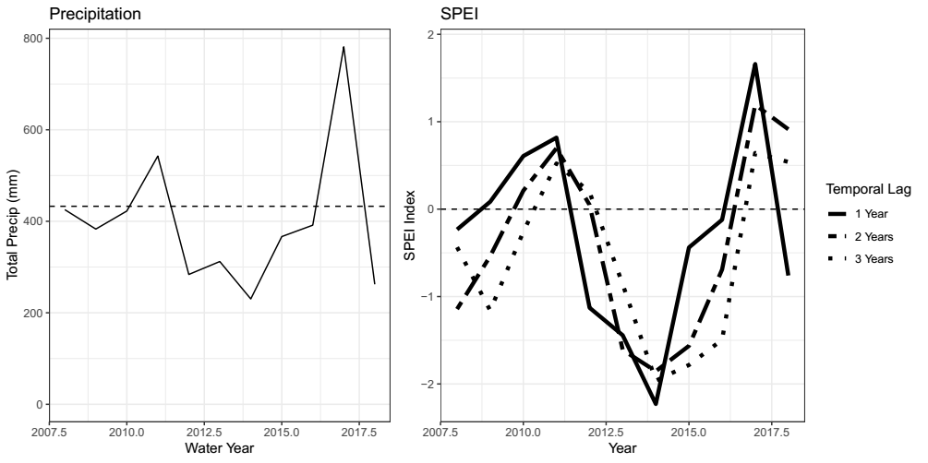

1. **NMDS of state assignments**

* Still need to fix the species labels to reflect modern taxonomy
* NMDS figure shows total variation in community composition for all observations between 2008 – 2018.
* This is not a particularly interesting figure itself, but represents the total amount of variation seen among communities over the course of sampling. **Makes more sense when accompanied by the next figure (indic. species analysis table)**

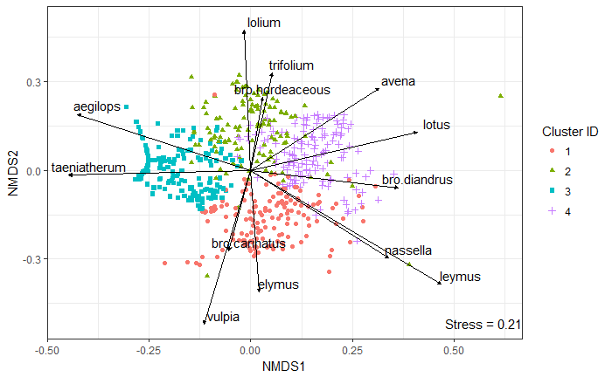

1. **Indicator species analysis table**

* As before, still need to fix the species labels on this
* Key point is that there seem to be four separate groups here, 3 of which that loosely fall along the native / invasive / exotic annual lines, but there seems to be a fourth group that is primarily annual exotics that are strong drought tolerators.



1. **Group assignments by individual plot**

* Will need to change the labels on the y-axis for this to reflect terminology used in methods section. Can also make the width of the bars smaller.
* This is a busy graph, but I think it’s important to highlight what states first arise when you vary planting composition, in part because the pattern is very clear.
  + Adding annuals to any planting mixture makes them a dominant part of the community in the first year
  + WAPS appear later on in all treatments where they are added, in addition to annuals (strong native resistance)
  + Natives rarely do well early on, but becoming bigger parts of the community later on.
* Suggestions on ways to improve readability of this figure?

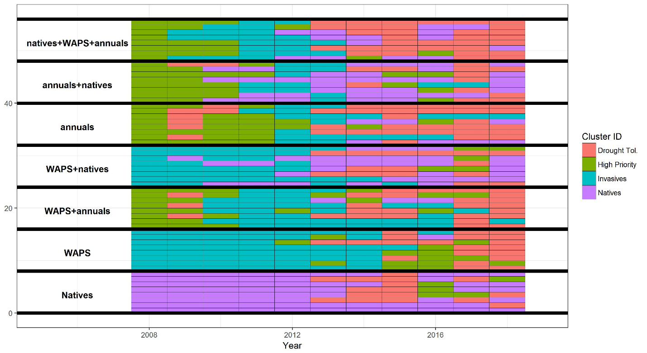

1. **Transition assignments over time and transition frequency table**

* Transitions appear to be frequent and widely distributed in this dataset. All possible transitions occurred, but some appear more common than others – natives appear to have rarely transitioned to groups 2 or 3, for example.



1. **AIC model selection table**

* Results of Markov model fitting and model selection. Compares models with the raw transition matrix frequencies, planting composition covariate, and multi-year drought covariates.
* Shows that the best fit model in this case (lowest AIC score) is one that contains covariates related to planting composition and 1 year drought. The 3 year drought model is also an acceptable alternative, and the 2 year drought model isn’t a whole lot worse than the other two.



1. **Stability probabilities**

* This figure shows the probability that a community with a given state assignment retains that assignment in the next year. Quantification of resilience.
* Generally, the pattern I see here is that:
  + The high priority state doesn’t stick around very long, regardless of drought stress
  + WAPS are very common in wet years, seem to do more poorly when conditions are dry
  + Natives are quite stable, but don’t show as strong of a drought response as other groups. They’re somewhat more stable when conditions are wetter.
  + Drought tolerators, unaspiringly, prefer drought conditions.
  + In all cases, more speciose planting mixtures decrease the odds of retaining your state over time.

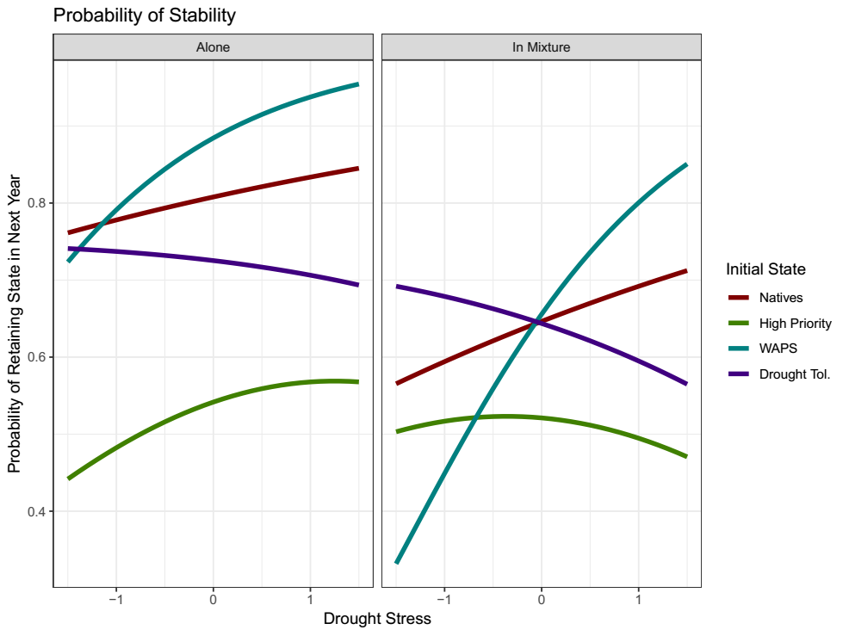

1. **Transition probabilities**

* The following figure shows the probability that a community in a given state transitions to a focal state in the next year. In this case, we have the focal states as rows, with odds of transition from previous states as colored lines. The columns show a split between whether that focal state was or was not represented in the initial planting. The states, in order, are natives, high priority, invasives, and drought tolerators.
* I think there are a few ways to clean up this figure to make it easier to interpret. I’d like to label each row with “Probability of Transition to Natives”, “Probability of Transition to Invasives”, etc.
  + Stein et al. split this same figure up into 12 separate graphs, with pairwise transitions between two states shown. However, this can be quite messy depending on the number of parameters in the model (they had just 1 quantitative variable, RDM).
  + Any other thoughts?
* My key takeaways:
  + Transitioning to native states is possible for all communities at some point, but only if they were able to colonize early on.
  + As before, communities often transition to WAPS when it’s wet, Drought tolerators when its dry.
  + While high priority species are well represented early on, it seems difficult for them to reappear when things are left mostly static.

**-** 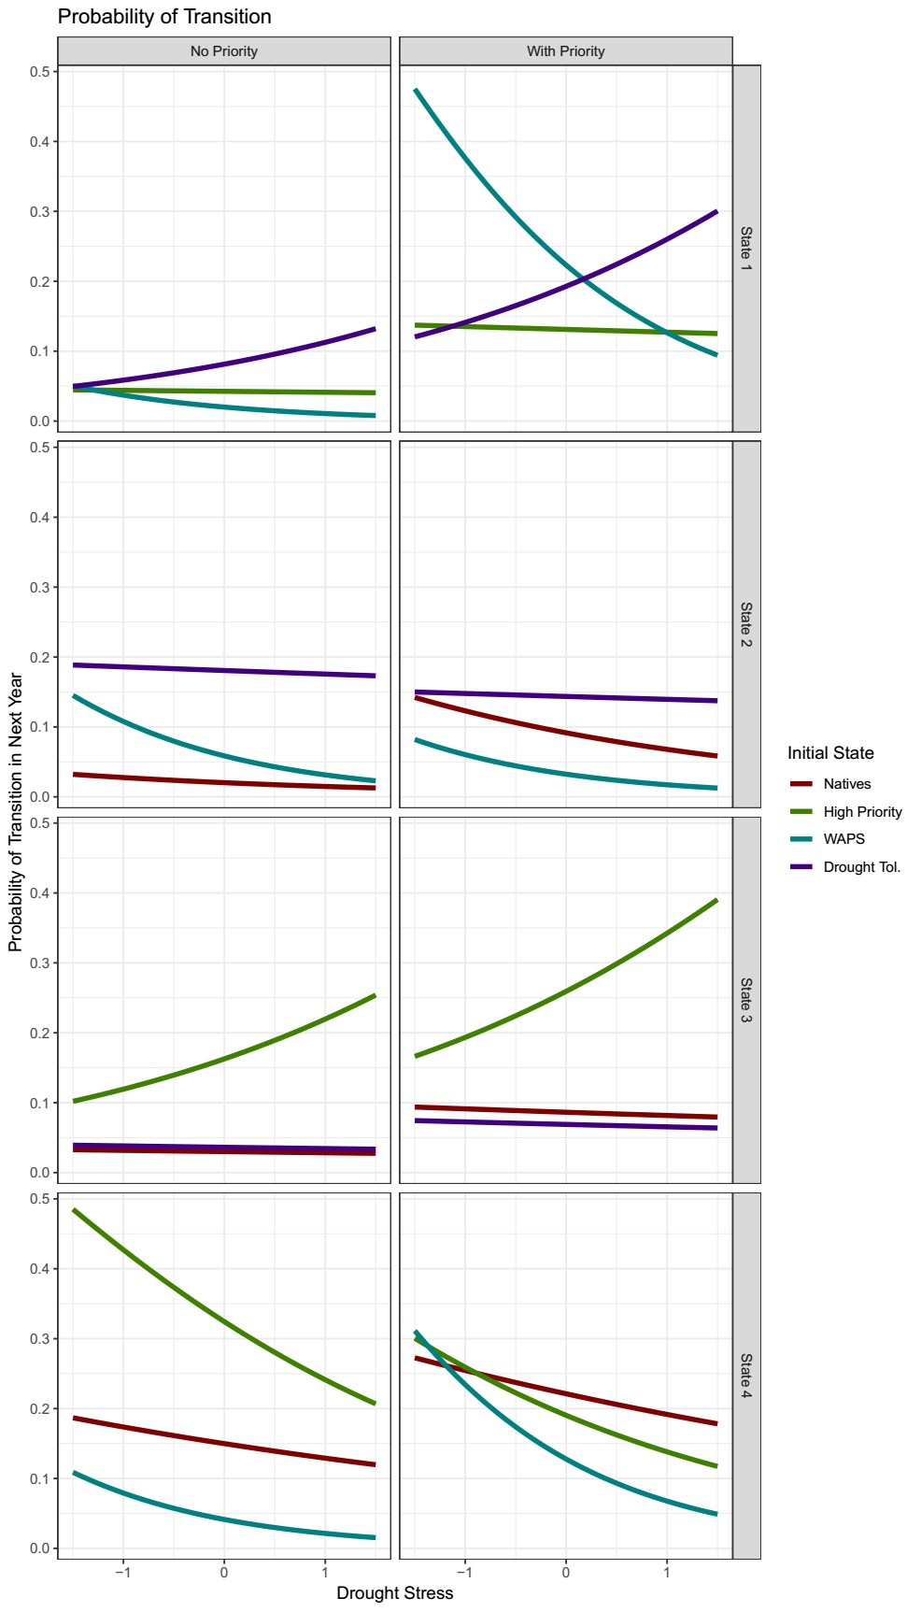

**Discussion**

*Revisiting previous questions:*

1. What states best partition observed variance in plant community composition? What species define these states?
   1. It seems that communities roughly follow the fluctuations in abundance predicted by the standard 3-state perspective of California annual grasslands (with the caveat being we planted them in this way!), with one key exception – there seem to be a subset of these species that do particularly well during and post drought that are distinct from the species that do well early on.
2. Are transitions between states characterized by continuous, reversible changes or non-reversible changes?
   1. We find that many transitions between communities are reversible and highly frequent, corresponding with our notion of these communities as being dominated by non-equilibrium dynamics.
   2. However, over the course of our experiment, we also found that certain states varied considerably in their resilience and transition direction. Native states appeared to be particularly stable, while others, such as high priority annual grasses, dominated many planting compositions early on, but were not particularly stable.
3. How do key drivers of community composition (assembly order and climate) govern transitions between states?
   1. Consistent with reported invasions of exotic annual grasses, transitions between annual dominated states and invasive species are frequent, particularly in wet years.
   2. However, severe drought appears to have dramatic effects on both the stability and persistence of different states. States dominated by invasive species, which exhibit later phenology, were likely to shift to a more drought-tolerant state when during the historic drought from 2014 – 2016.
   3. Assembly order continued to have large effects on patterns of community turnover, years after planting.
      1. This effect was most pronounced in “native” states – even when native species were not dominant early on, planting compositions that contained native species were more likely to transition to a native state later on. Conversely, communities that did not receive any native seed very rarely experienced a state transition.
         * Important for restoration; native species may appear when conditions are favorable, even if not abundant early on. Consistent with notions of spatial storage effects in perennial grasslands.
4. Some important caveats
   1. State-transition approaches are great at distilling down temporal community dynamics into groups of species that have similar patterns of abundance, but may not yield particularly nuanced insights.
      1. While interpretation of state-transition models can be informed by other studies of individual species dynamics, it’s difficult to determine within-state differences in species abundance in state change models. In our case, this may be an inability to determine whether species are responding to drought, or immediately afterword.
   2. This sort of analysis is limited to the scope of total community variation observed within a given time series of observations – quantitative analysis can be used to complement and test predictions made by expert models, not necessarily to create new models from scratch.
      1. Detection of environmental parameter effects depends on variation observed (what will happen with drought recovery, for example?)
      2. Limited to the species pool present in a given site. If state-transition models are meant to describe the phases and states that may appear within a given soil type or management context, these all need to be present to be tested in a quantitative fashion.

What states best partition observed variance in plant community composition? What species define these states?

* + Are transitions between states characterized by continuous, reversible changes or non-reversible changes?
  + How do key drivers of community composition (assembly order and climate) govern transitions between states?

**References**

Allen-Diaz, B., & Bartolome, J. W. (1998). Sagebrush – Grass Vegetation Dynamics : Comparing Classical and State-Transition Models. *Ecological Applications*, *8*(3), 795–804.

Bagchi, S., Briske, D. D., Wu, X. B., McClaran, M. P., Bestelmeyer, B. T., & Fernández-Giménez, M. E. (2012). Empirical assessment of state-and-transition models with a long-term vegetation record from the Sonoran Desert. *Ecological Applications*, *22*(2), 400–411. https://doi.org/10.1890/11-0704.1

Briske, D. D., Fuhlendorf, S. D., & Smeins, F. E. (2005). Society for Range Management State-and-Transition Models , Thresholds , and Rangeland Health : A Synthesis of Ecological Concepts and Perspectives Author ( s ): D . D . Briske , S . D . Fuhlendorf and F . E . Smeins Published by : Society for Range Manage. *Rangeland Ecology & Management*, *58*(1), 1–10. https://doi.org/10.2111/1551-5028(2005)58<1

Briske, D. D., Bestelmeyer, B. T., Stringham, T. K., & Shaver, P. L. (2008). Recommendations for development of resilience-based state-and-transition models. *Rangeland Ecology and Management*, *61*(4), 359–367. https://doi.org/10.2111/07-051.1

Briske, D. D., Fuhlendorf, S. D., & Smeins, F. E. (2003). Vegetation dynamics on rangelands: A critique of the current paradigms. *Journal of Applied Ecology*, *40*(4), 601–614. https://doi.org/10.1046/j.1365-2664.2003.00837.x

Clary, J. (2008). Rainfall seasonality determines annual/perennial grass balance in vegetation of Mediterranean Iberian. *Plant Ecology*, *195*(1), 13–20. https://doi.org/10.1007/s11258-007-9294-9

Corbin, J. D., & D’Antonio, C. M. (2010). Not novel, just better: Competition between native and non-native plants in California grasslands that share species traits. *Plant Ecology*, *209*(1), 71–81. https://doi.org/10.1007/s11258-010-9722-0

Crawford, J. A., Olson, R. A., West, N. E., Mosley, J. C., Michael, A., Whitson, T. D., … Boyd, C. S. (2018). Society for Range Management Ecology and Management of Sage-Grouse and Sage-Grouse Habitat Published by : Society for Range Management Stable URL : http://www.jstor.org/stable/4003949 Linked references are available on JSTOR for this article : Synthesis P, *57*(1), 2–19.

Elmendorf, S. C., & Harrison, S. P. (2009). Temporal variability and nestedness in California grassland species composition. *Ecology*, *90*(6), 1492–1497. https://doi.org/10.1890/08-1677.1

Everard, K., Seabloom, E. W., Harpole, W. S., & de Mazancourt, C. (2010). Plant Water Use Affects Competition for Nitrogen: Why Drought Favors Invasive Species in California. *The American Naturalist*, *175*(1), 85–97. https://doi.org/10.1086/648557

Gea-Izquierdo, G., Gennet, S., & Bartolome, J. W. (2007). Assessing plant-nutrient relationships in highly invaded Californian grasslands using non-normal probability distributions. *Applied Vegetation Science*, *10*(3), 343–350. https://doi.org/10.1111/j.1654-109X.2007.tb00433.x

Harpole, W. S., Potts, D. L., & Suding, K. N. (2007). Ecosystem responses to water and nitrogen amendment in a California grassland. *Global Change Biology*, *13*(11), 2341–2348. https://doi.org/10.1111/j.1365-2486.2007.01447.x

Henneman, C., Seavy, N. E., & Gardali, T. (2014). Restoring Native Perennial Grasses by Changing Grazing Practices in Central Coastal California. *Ecological Restoration*, *32*(4), 352–354. https://doi.org/10.3368/er.32.4.352

Jackson, R. D., & Bartolome, J. W. (2002). A state-transition approach to understanding nonequilibrium plant community dynamics in Californian grasslands. *Plant Ecology*, *162*(1), 49–65. https://doi.org/10.1023/A:1020363603900

Prugh, L. R., Deguines, N., Grinath, J. B., Suding, K. N., Bean, W. T., Stafford, R., & Brashares, J. S. (2018). Ecological winners and losers of extreme drought in California. *Nature Climate Change*, *8*(9), 819–824. https://doi.org/10.1038/s41558-018-0255-1

Seabloom, E. W., Harpole, W. S., Reichman, O. J., & Tilman, D. (2003). Invasion, competitive dominance, and resource use by exotic and native California grassland species. *Proceedings of the National Academy of Sciences of the United States of America*, *100*(23), 13384–9. https://doi.org/10.1073/pnas.1835728100

Stein, C., Harpole, W. S., & Suding, K. N. (2016). Transitions and invasion along a grazing gradient in experimental California grasslands. *Ecology*, *97*(9), 2319–2330. https://doi.org/10.1002/ecy.1478

**Supplemental Information**

1. **NBClust k selection test output**



1. **Visualization of the relative percent cover of all species by state assignment**

* Older figure, need to think of a better way to convey this information, if needed.



1. **MSM model output, estimated coefficients, visualized fits**

* Can also include the coefficient table, hazard ratios, etc.

