**State Change Manuscript Outline:**

**Introduction**

* + **Resilience and stability as important concepts**
* Global climate change is forecast to produce dramatic shifts in the frequency and magnitude of extreme climate events across ecosystems worldwide. Increased drought severity, wildfire intensity, and flooding are expected to significantly impact ecosystem structure and function.
* To better understand and adapt to these pressures, ecologists have increasingly focused on the concept of resilience – the ability of an ecosystem to resist change and self-reorganize following a disturbance (Holling 1973, 1986, Gunderson and Holling 2002, Folke 2006).
  + **It’s application to non-equilibrium dynamics** 
    - **Difficulty applying successional theory to certain systems not operating on a linear continuum, but fluctuate between discrete types**
* Resilience thinking presents a critical tool in understanding dynamics of change in systems that exhibit nonequilibrium between multiple states (Scheffer et al. 2001, Smith 2011, Angeler and Allen 2016). Rather than considering an ecosystem’s characteristics as a function of a deterministic process, attempts to capture this variation between multiple ecosystem types recognize the complex interplay between historical contingency, state resilience, and the biotic and abiotic factors that shape community dynamics.
  + **Approach is particularly valuable in arid and semi-arid rangelands**
    - **Construction of state-and-transition models as management tools**
* In particular, resilience thinking has provided a strong conceptual basis for arid and semi-arid rangelands, where traditional range models based on successional processes often failed to capture nonlinear community responses (Jackson and Bartolome 2002).
* Rather than relating rangeland condition to some ideal reference, range managers have turned to state and transition models (STMs), which describe vegetation change as a series of transitions between discrete community states. In doing so, managers attempt to identify the set of vegetation types that best capture relevant community variation in a system, and the forces that govern turnover between them.
* Increasingly, state and transition models are used to guide management in rangeland systems. And while a key conceptual tool, state and transition models suffer from several drawbacks that may limit their application—STMs are produced on the basis of expert opinion, requiring long-term monitoring and subject to observer biases.

**Reduce this section**

* As an alternative, STMs may be adapted into a quantitative framework that can be used to test predictions of non-equilibrium community dynamics in a familiar structure.
* The benefits of this approach are twofold:
  + First, by decomposing community variation into a series of discrete state types and probabilities of transition, quantitative STMs may effectively capture complex community dynamics in systems that resist assessment by more traditional analytical methods.
  + Second, quantitative STMs form a critical complement to their expert-driven counterparts. STMs are rarely tested with empirical data, and limited examples demonstrate strong evaluations that may be used to refine conceptual models and management recommendations.
* Moreover, quantitative methods exhibit greater ability to capture novel species assemblages that may arise as many systems respond to rapid environmental change.
  + **California as a model of non-equilibrium**
    - **Non-hierarchical competition**
    - **High sensitivity to environmental variation**

**California Annual Grasslands**

* California grasslands have long been a focal system in the study of nonequilibrium dynamics. Composed primarily of exotic annual species, these grasslands readily shift between dominant groups of taxa (George et al. 1992).
* Conceptually, California grassland vegetation has long been partitioned into several distinct groups, including those based on functional type (grasses, forbs, and legumes) and provenance (native and exotic species). More recently, distinctions are often made between:
  + 1) Naturalized exotic annual grasses that now compose a majority of vegetation in California’s grassland ecosystems.
  + 2) Native perennial grasses and forbs thought to once cover much of the state’s grassland habitat
  + 3) A set of highly invasive annual grasses that are rapidly expanding throughout California rangelands.
* In a state and transition perspective, the vegetation composition of California annual grasslands is a function of resilience and transition probability of each of these discrete community groups.
  + Competitive relationships among constituent species of each group may operate in a non-hierarchical fashion (Uricchio et al. 2018), where species abundances are strongly influenced by an interaction between priority effects and environmental drivers.
* **General conception of the different state types within this system**
  + **Notions of sensitivity to different environmental conditions, general state “stability”**
* Past work has established general patterns in group life history strategy that correlate with colonization ability, invasion resistance, and response to climatic variation (Corbin et al. 2007, Harpole et al. 2007, Abraham et al. 2009).
  + Exotic and native grasses exhibit pronounced differences in seed physiology, growth habit, and fecundity. Large-seeded exotic annuals germinate rapidly with the onset of winter rains and invest heavily in reproduction before senescence, producing germinable seed densities up to 100,000 seeds/m2 (Bartolome 1979).
  + Native grasses, on the other hand, often produce far fewer seeds of much lower mass that may fail to compete with annual grasses at early life stages. However, once established, hardy perennials are characterized by low mortality and long-term persistence without active disturbance (Seabloom et al. 2003).
  + Similarly to exotic annuals, invasive grasses produce seeds in high densities, though exhibit a later phenology and pronounced litter feedbacks that may inhibit growth of new colonists.
  + Through interaction with these different life history strategies, seasonal patterns of precipitation and temperature can exert considerable control over productivity and community composition in California grasslands (Pitt and Heady 1978, Reever Morghan et al. 2007). For example, periodic droughts early in the growing season are thought to result in significant mortality of annual grasses, while late-season rains may favor growth of invasive species.
* **Development of quantitative vegetation models using the state-and-transition framework can serve a number of key purposes.**
* To capture these complex dynamics, the development of quantitative state and transition models in California grasslands may provide a valuable assessment of both the number of distinct species group present in this system, and the influence of priority effects and climatic variation as drivers of community turnover.
  + Recent events underscore the need to predict vegetation change in non-equilibrium systems; Current climate projections emphasize increased duration and intensity of drought events in California which may act as critical tipping points in many ecosystems (Shaw et al. 2009, Pierce et al. 2012). A recent drought of historic magnitude has been shown to divide many species into distinct sets of “winners” and “losers”, with dramatic changes in productivity and biodiversity at the community level (Prugh et al. 2018).
  + As climatic variation is expected to increase in many systems globally, there is a clear need to provide analytical tools that can rapidly update core predictions as novel conditions present themselves.
* **General overview of study design and application**
* Here, we assess interactions between community assembly and climatic variation on vegetation composition in California annual grasslands across a 10-year period encompassing recent drought (2013-2016) and potential recovery. Using data from experimental plantings of three key grassland species groups – naturalized annual, native, and invasive species – we aim to test key assumptions of the resilience of different communities and the potential drivers of transition between them.
  + What “states” best partition observed variance in plant community composition? What species define these states?
  + What states arise with different planting composition mixtures? As these states are observed over time, are transitions between states characterized by continuous, reversible changes or non-reversible changes?
  + How do key drivers of community composition (assembly order and climate) govern transitions between states?

**Materials and Methods:**

Study site

* Field plantings were conducted in research fields at the University of California, Davis (38.545751, -121.784780). Previously used in crop production, these fields were left fallow from 1985 to the start of experimental plantings in 2007. 75% of field is composed of Reiff series soil (coarse-loamy, mixed, superactive, nonacid, thermic Mollic Xerofluvents); other soil present (< 25% of the area) is the Brentwood soil series (fine, smectitic, thermic Typic Haploxerepts) with a 0-2% slope (USDA Web Soil Survey, http://websoilsurvey.sc.egov.usda.gov).
* In the early fall of 2017, soil was disked, irrigated, and received a broad-spectrum herbicide (glyphosate) prior to planting to remove the existing seed bank.
* Three planting mixtures were established based on common delineations between vegetation types in California anna grasslands (Table 1). For all possible 1-, 2-, and 3-group planting combinations, we established eight 1.5m x 1.5m plots (2.25 m2; 56 plots total).
* In each 1.5 x 1.5 m plot, a total of 139 grams of seed was added. This seeding rate reflects an average of 8,000 plants/m2, a typical mature plant density in this system (Heady 1958). For each monotypic community (e.g. natives vs. invasives. Vs. naturalized), an equal proportion of seeds of each species was added. For community mixtures, an equal proportion of community type seed was added (e.g. in invasive + naturalized, 50% invasive, 50% naturalized seed), with equal proportion of individual species within each community type.
* In each growing season from 2008 – 2018, total areal cover of all species was estimated visually to the nearest 10%. Cover observations for each species were performed in mid-and late-spring to capture the season of maximum percent cover for each species, because any one sampling wouldn't account for variation in species phenology.



Weather data

* Weather data was provided by a local California Irrigation Management Information System (CIMIS) monitoring station in Davis, CA (38.535694, -121.777636). CIMIS automated dataloggers collect weather data on a minute-by-minute basis, including air temperature, soil temperature, precipitation, solar radiation, vapor pressure, and wind speed. We aggregated these data into monthly intervals, where we calculated Standardized Precipitation-Evapotranspiration Index (SPEI), a metric of drought stress (*D­*) at a given timepoint, *i*:



* Where *Pi*represents observed precipitation and *ETo­i*represents estimated evapotransporation. *ETo* was calculated using the Penman-Monteith equation, defined as:



* Where *Rn* is net radiation, *G* is soil heat flux, *(es – ea)* isthe vapor pressure deficit of air, *ρi* is the mean air density at constant pressure, *cp* is the specific heat of air, Δ is the slope of the saturation vapor pressure temperature relationship, γ is the psychometric constant, and *rs*and *ra* are the surface and aerodynamic resistances (FAO).
* SPEI offers flexible, variable timescale estimations of drought stress that can be used to quantify the effects of multi-year climate patterns (Vicente-Serrano et al. 2010).
* To provide context for climate patterns observed during our study, we calculated SPEI for a 35-year span between 2018 and 1983, the first year sufficient climate data was collected. For each year we calculated SPEI for a single water year (October – May; 8 months), two consecutive water years (20 months), and three consecutive water years (32 months) to compare the influence of cumulative drought on vegetation composition. We then standardized these values by fitting the drought index series to a log-logistic distribution, wherein scaled drought indices represent historic droughts (-2) to historic wet periods (+2).

**SPEI Figure**

* 1st panel shows mean annual precipitation in mm, with average from 1983 – 2018 as a dashed line
* 2nd panel shows the value of the SPEI index over the course of our study, standardized relative to climate patterns from 1983 – 2018.
* 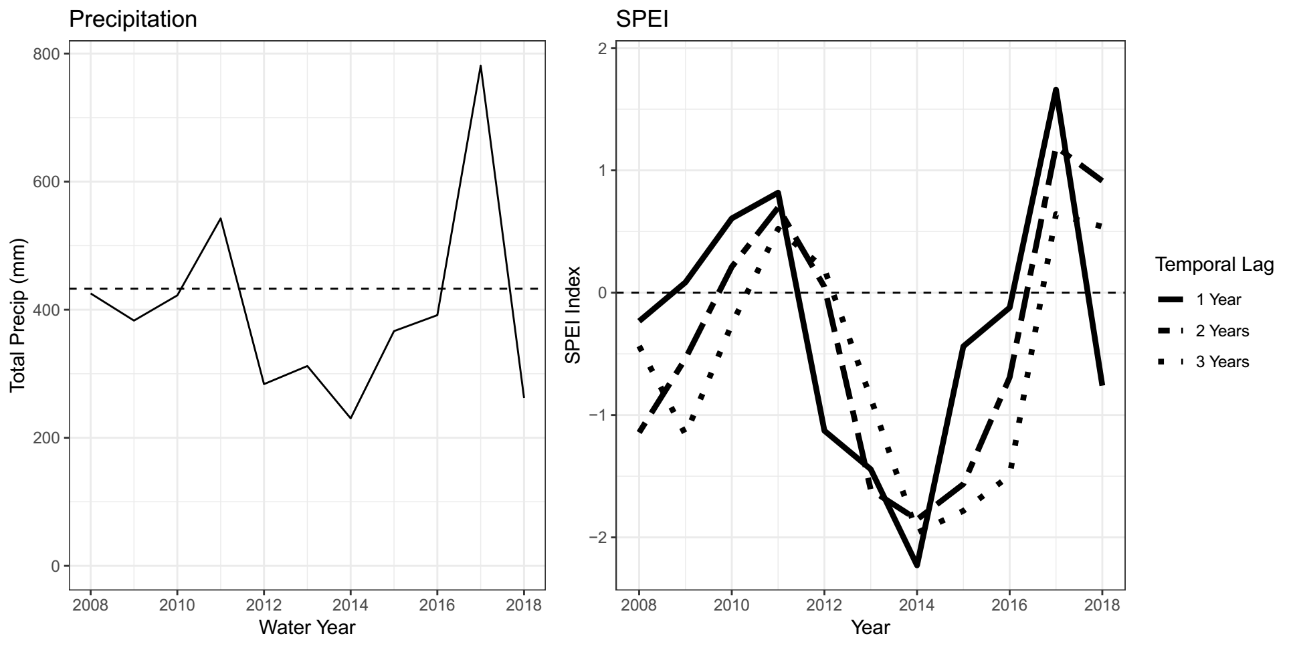
* All SPEI calculations were performed using the package “spei”.

****Construction of State-Transition Models

* Following the association of observations to discrete states, we fit a multistate model (Markov model) to the data. Multistate models represent systems where subjects transition between a set of discrete classes over time and may be uniquely suited to examining state and transition models through a statistical framework.

Delineation of States

* Due to intermittent invasions by agricultural weeds, community analyses were performed on a subset of the total community corresponding to species that were planted in our initial mixes, in addition to *Bromus diandrus*, a common naturalized annual grass that was self-recruited into the experiment during the drought. The resulting dataset captured 93% of the total vegetation abundance observed over the course of the experiment.
* To assign state types to each observation, we partitioned total community variation into a series of potential states using an unsupervised clustering algorithm, K-medioids clustering.
* K-medoids clustering randomly selects *k* of *n* total datapoints as group “medoids” and computes the sum of distances between points and their associated medioid, based on Bray-Curtis dissimilarity. This algorithm then iteratively swaps these mediods and recalculates summed distance to achieve a solution that best captures the total variance of the data
* To determine the most appropriate number of states, we applied k-medioids clustering across values of *k* from 2-10. We then subjected the output of each of these runs to a battery of tests—Hartigan, CH, Beale, KL, Cindex, DB, Silhouette, and Duda indices (Charrad et al. 2014). The value of *k* with the most consist performance across all tests was used to determine the number of clusters that best represented discrete partitions within this dataset.
* Following the partition of states, we then conducted indicator species analysis to establish what species are associated with each state.

**Modelling transition probabilities**

* Following we constructed a multistate model consisting of all states identified in clustering analysis, with probabilities fit to all possible transitions between states.
* To test for effects of initial planting composition and climatic variation on the probability of state transition, we added a series of covariates to multistate models that correspond to SPEI and the presence of state indicator species in the initial planting composition.
  + ****E.g, the probability that a community in state 1 will transition to state 2 in the next year of observation can be represented by:

‘

* + Where q12 is the baseline probability of a transition, and β1 and β2 are coefficients fit to recorded SPEI values and planting composition, respectively.
* After fitting models with and without SPEI and initial planting covariates for 1-, 2-, and 3-year drought indices, we then calculated AIC scores for each model. We selected the model with the lowest AIC score (ΔAIC < -2) as our best fit model. Further comparisons between subset models containing nested sets of parameters were made using likelihood ratio tests.
* Multistate model fitting and model selection was performed using the “msm” package.

**R packages:**

* Data were visualized using “ggplot2”.
* SPEI calculations were performed using the package “SPEI”. Clustering and diagnostics were generated using the packages “pam” and “nbclust”.
* Indicator species analysis was performed using “vegan”.
* Construction of multi-state models was conducted with the package “msm”
* All analyses were conducted in R version 3.06.

**Results**

1. **Cluster assignments**

* K-medoids clustering of community observations (56 plots x 10 years, n = 560) and assessment of cluster fit indicated that community variation was best partitioned using *k* = 4 unique cluster assignments (Appendix 1).

1. **NMDS of state assignments**

* Visualization of cluster assignments and associated species correlations was conducted through non-metric multidimensional scaling (NMDS).
  + Figure shows total variation in community composition for all observations between 2008 and 2018, in addition to clustering assignments. Shape and color of points indicate results of K-medoids clustering.
* Species vectors highlighted are those with significant (P < .05) cluster associations as calculated through indicator species analysis (Figure 3).
* There appears to be considerable similarities among certain groups of species vectors, in addition to some novel ones.
  + Some associations are predicted based on seed mix types and conceptual understanding of the system, such as A. triuncialis and E. caput-medusae, B. carinatus and E. glaucus; others less so, such as A. fatua and A. americanus.

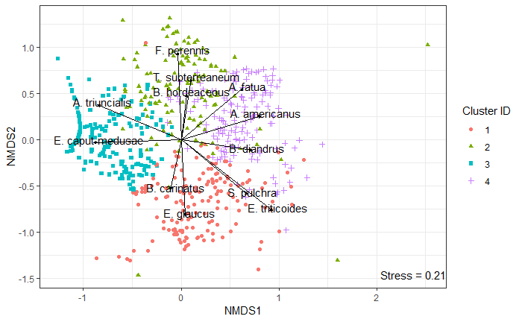

1. **Indicator species analysis table**
   1. Indicator species analysis of cluster assignment revealed several species-cluster associations, three of which appear to follow the general patterns of species provenance – Native species (cluster 1), naturalized annuals (cluster 2), and invasive species (cluster 3). However, the fourth cluster assignment is significantly correlated with a mixture of both naturalized and native species.
   2. Average percent cover of two strongest indicator species in each group is presented in Appendix 3.



1. **Cluster Assignment Frequency over Time plot**

* Tracking individual plot assignments over time demonstrates clear differences in state assignment based on seeding composition and non-random transition probabilities over time.
* Initial assignments:
  + Consistent with observed colonization ability of California vegetation types (annual, native, invasive), initial state assignments produced a clear pattern in species relative abundances following seeding.
  + All plots receiving a seed mixture containing naturalized species (mixture 2, 4, 6, and 7) received the same assignment, characterized by annual grasses *F. perennis*, *B. hordeaceous*, and annual legume *T. subterreaneum*.
  + Plots which received a seed mixture including invasive species in the absence of naturalized exotics (mixtures 1, 3) received the same cluster assignment, characterized by invasive grasses *E. caput-medusae* and *A. triuncialis*.
  + Native dominated state assignments, on the other hand, were only present in seeding mixes that solely contained native species (mixture 5).
* Transitions:
  + Communities demonstrated little stability in state assignment over the course of observation, though plots appeared to differ substantially in their transition direction and frequency based on seeding mixture and experiment duration.
  + In particular, the frequency of communities given a state 2 assignment (*F. perennis – B. hordeaceous*) dropped precipitously following the first year, often transitioning to an invasive dominated assignment in the 2nd through 5th years of the study, or a fourth assignment (*A. fatua – B. diandrus*)that became more common in the 7th and 8th years of observation. Given the presence of a moderate wet period (years 2-3) and a historic drought (years 4-8), changes in assignment frequency imply a relationship between community performance and environmental conditions.
  + Communities with native-dominated cluster assignments appeared to retain this configuration with greater fidelity than other assignments, but were unlikely to colonize plots that did not receive native species in the initial seeding mixture.

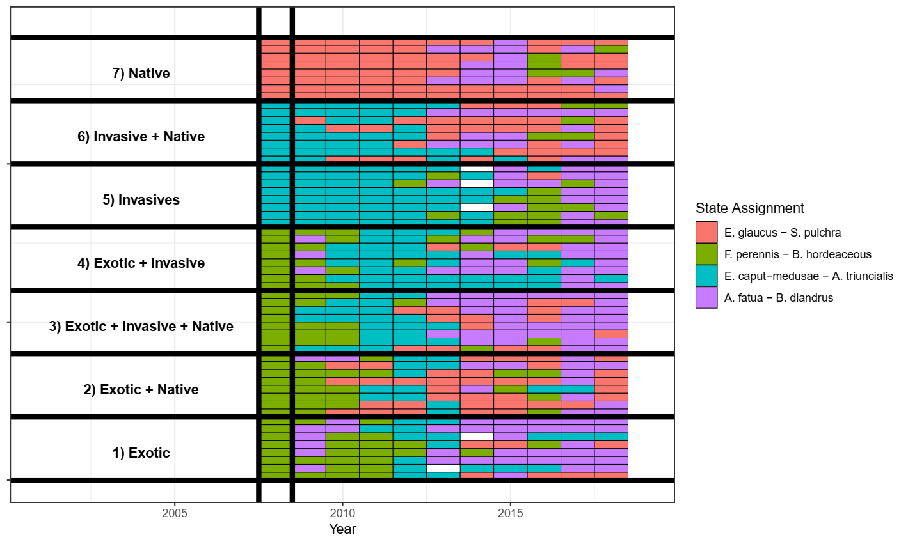

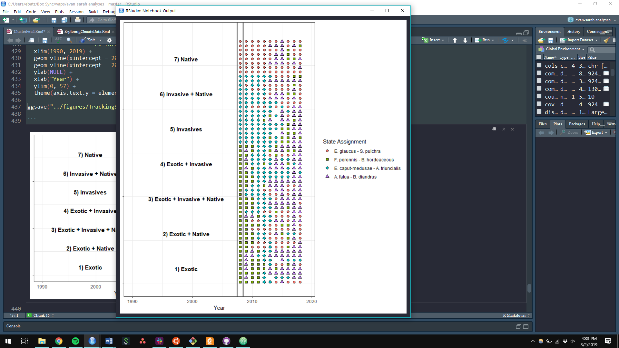

1. **Transition assignments over time and transition frequency table**

* To test associations between transition frequencies, we fit Markov state models to cluster assignment data.
* The following table shows the total number of transitions observed over the 10 years of sampling encompassed in this dataset (n = 554). Entries along the matrix diagonal represent communities which retained their previously identified state in a following year’s observation, while off-diagonal entries represent communities which have experienced a transition. This might be moved to the appendix?
* Interestingly, transitions appear to be frequent and widely distributed in this dataset. All possible transitions occurred, but some appear more common than others – natives (cluster 1) appear to have rarely transitioned to cluster 2 or 3, for example.
  + Most transitioning happens from cluster 4 (with similar shift to all 3 other clusters)



1. **AIC model selection table**

* Results of Markov model fitting and model selection. Compares models with the raw transition matrix frequencies, planting composition covariate, and multi-year drought covariates.
* Shows that the best fit model in this case (lowest AIC score) is one that contains covariates related to planting composition and 1 year drought. The 3 year drought model is also an acceptable alternative, and the 2 year drought model isn’t a whole lot worse than the other two.



**State Resilience**

* This figure shows the probability that a community with a given state assignment retains that assignment in the next year. Quantification of resilience.
* Generally, the pattern I see here is that:
  + The high priority state doesn’t stick around very long, regardless of drought stress
  + WAPS are very common in wet years, seem to do more poorly when conditions are dry
  + Natives are quite stable, but don’t show as strong of a drought response as other groups. They’re somewhat more stable when conditions are wetter.
  + Drought tolerators, unsurprisingly, prefer drought conditions.
  + In all cases, more speciose planting mixtures decrease the odds of retaining your state over time.

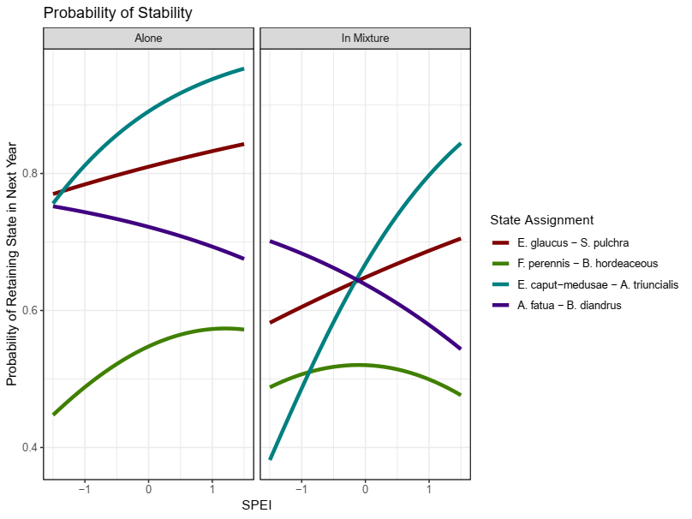

1. **Transition probabilities**

* The following figure shows the probability that a community in a given state transitions to a focal state in the next year. In this case, we have the focal states as rows, with odds of transition from previous states as colored lines. The columns show a split between whether that focal state was or was not represented in the initial planting. The states, in order, are natives, high priority, invasives, and drought tolerators.
* I think there are a few ways to clean up this figure to make it easier to interpret. I’d like to label each row with “Probability of Transition to Natives”, “Probability of Transition to Invasives”, etc.
  + Stein et al. split this same figure up into 12 separate graphs, with pairwise transitions between two states shown. However, this can be quite messy depending on the number of parameters in the model (they had just 1 quantitative variable, RDM).
  + Any other thoughts?
* My key takeaways:
  + Transitioning to native states is possible for all communities at some point, but only if they were able to colonize early on.
  + As before, communities often transition to WAPS when it’s wet, Drought tolerators when its dry.

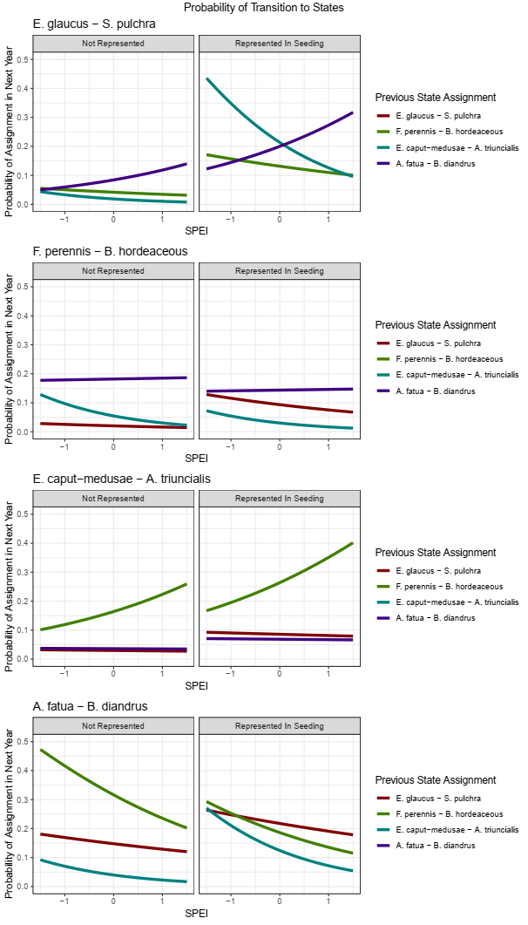

**Discussion**

* Given the study’s context within a historic drought, it is important to consider that this range of community variation we see may not be representative of the full scope.

*Revisiting previous questions:*

1. What states best partition observed variance in plant community composition? What species define these states?
   1. 3 of 4 state assignments roughly follow the general notion of divisions between native, exotic, and invasive annual grasses. However, a fourth distinct state appears to have emerged post the onset of a historic drought in 2012-2015. While other clusters are characterized by species that follow rough notions of pre-existing associations within the system, this new assemblage arising during the drought period is identified by both naturalized and native grasses that appear able to capitalize on the unique conditions produced by this event.
      1. This finding illustrates the power of partitioning methods to identify discrete vegetation types that may arise under novel circumstances in a given system. Conceptual notions of species “groups” which exhibit correlated fluctuations in abundance often form the basis for exploratory analysis and management action. While keen observers may be able to identify key vegetation types over the long-term, more sensitive quantitative approaches are better predisposed to capture these correlations when deviating from historical norms.
      2. However, we encourage caution in the interpretation of these approaches, which may be biased by the scale and duration of sampling; our study, characterized by a historic drought, is not likely to represent the full scope of environmental variation experienced within this system, and should serve to complement, not replace, traditional state-transition frameworks.
2. Are transitions between states characterized by continuous, reversible changes or non-reversible changes?
   1. As may be expected in a system characterized by non-equilibrium dynamics, transitions between vegetation clusters occurred frequently during the duration of sampling without clear convergence to a single community type.
   2. However, transition frequencies were not uniform across all groups, instead varying as a function of priority effects, environmental variation, and state assignment. In particular, these trends appear to broadly reflect established patterns of colonization ability, invasion resistance, and environmental affinity in constituent species.
      1. Exotic annual grasses which dominate cluster 1, for example, were able to quickly dominate communities when represented in seeding mixes. Despite initial colonization, cluster 1 assignments were characterized by low stability and quickly transitioned, often to cluster 2 (invasive species).
      2. This is in contrast two cluster 1, native perennial grasses, which were characterized by high stability across a variety of climatic conditions, but largely unable to compose a significant proportion of communities where they were not represented in initial seeding.
   3. We find that many transitions between communities are reversible and highly frequent, corresponding with our notion of these communities as being dominated by non-equilibrium dynamics.
   4. However, over the course of our experiment, we also found that certain states varied considerably in their resilience and transition direction. Native states appeared to be particularly stable, while others, such as high priority annual grasses, dominated many planting compositions early on, but were not particularly stable.
3. How do key drivers of community composition (assembly order and climate) govern transitions between states?
   1. Consistent with reported invasions of exotic annual grasses, transitions between annual dominated states and invasive species are frequent, particularly in wet years.
   2. However, severe drought appears to have dramatic effects on both the stability and persistence of different states. States dominated by invasive species, which exhibit later phenology, were likely to shift to a more drought-tolerant state when during the historic drought from 2014 – 2016.
   3. Assembly order continued to have large effects on patterns of community turnover, years after planting.
      1. This effect was most pronounced in “native” states – even when native species were not dominant early on, planting compositions that contained native species were more likely to transition to a native state later on. Conversely, communities that did not receive any native seed very rarely experienced a state transition.
         * Important for restoration; native species may appear when conditions are favorable, even if not abundant early on. Consistent with notions of spatial storage effects in perennial grasslands.
4. Some important caveats
   1. State-transition approaches are great at distilling down temporal community dynamics into groups of species that have similar patterns of abundance, but may not yield particularly nuanced insights.
      1. While interpretation of state-transition models can be informed by other studies of individual species dynamics, it’s difficult to determine within-state differences in species abundance in state change models. In our case, this may be an inability to determine whether species are responding to drought, or immediately afterword.
   2. This sort of analysis is limited to the scope of total community variation observed within a given time series of observations – quantitative analysis can be used to complement and test predictions made by expert models, not necessarily to create new models from scratch.
      1. Detection of environmental parameter effects depends on variation observed (what will happen with drought recovery, for example?)
      2. Limited to the species pool present in a given site. If state-transition models are meant to describe the phases and states that may appear within a given soil type or management context, these all need to be present to be tested in a quantitative fashion.

**References**

Allen-Diaz, B., & Bartolome, J. W. (1998). Sagebrush – Grass Vegetation Dynamics : Comparing Classical and State-Transition Models. *Ecological Applications*, *8*(3), 795–804.

Bagchi, S., Briske, D. D., Wu, X. B., McClaran, M. P., Bestelmeyer, B. T., & Fernández-Giménez, M. E. (2012). Empirical assessment of state-and-transition models with a long-term vegetation record from the Sonoran Desert. *Ecological Applications*, *22*(2), 400–411. https://doi.org/10.1890/11-0704.1

Briske, D. D., Fuhlendorf, S. D., & Smeins, F. E. (2005). Society for Range Management State-and-Transition Models , Thresholds , and Rangeland Health : A Synthesis of Ecological Concepts and Perspectives Author ( s ): D . D . Briske , S . D . Fuhlendorf and F . E . Smeins Published by : Society for Range Manage. *Rangeland Ecology & Management*, *58*(1), 1–10. https://doi.org/10.2111/1551-5028(2005)58<1

Briske, D. D., Bestelmeyer, B. T., Stringham, T. K., & Shaver, P. L. (2008). Recommendations for development of resilience-based state-and-transition models. *Rangeland Ecology and Management*, *61*(4), 359–367. https://doi.org/10.2111/07-051.1

Briske, D. D., Fuhlendorf, S. D., & Smeins, F. E. (2003). Vegetation dynamics on rangelands: A critique of the current paradigms. *Journal of Applied Ecology*, *40*(4), 601–614. https://doi.org/10.1046/j.1365-2664.2003.00837.x

Clary, J. (2008). Rainfall seasonality determines annual/perennial grass balance in vegetation of Mediterranean Iberian. *Plant Ecology*, *195*(1), 13–20. https://doi.org/10.1007/s11258-007-9294-9

Corbin, J. D., & D’Antonio, C. M. (2010). Not novel, just better: Competition between native and non-native plants in California grasslands that share species traits. *Plant Ecology*, *209*(1), 71–81. https://doi.org/10.1007/s11258-010-9722-0

Crawford, J. A., Olson, R. A., West, N. E., Mosley, J. C., Michael, A., Whitson, T. D., … Boyd, C. S. (2018). Society for Range Management Ecology and Management of Sage-Grouse and Sage-Grouse Habitat Published by : Society for Range Management Stable URL : http://www.jstor.org/stable/4003949 Linked references are available on JSTOR for this article : Synthesis P, *57*(1), 2–19.

Elmendorf, S. C., & Harrison, S. P. (2009). Temporal variability and nestedness in California grassland species composition. *Ecology*, *90*(6), 1492–1497. https://doi.org/10.1890/08-1677.1

Everard, K., Seabloom, E. W., Harpole, W. S., & de Mazancourt, C. (2010). Plant Water Use Affects Competition for Nitrogen: Why Drought Favors Invasive Species in California. *The American Naturalist*, *175*(1), 85–97. https://doi.org/10.1086/648557

Gea-Izquierdo, G., Gennet, S., & Bartolome, J. W. (2007). Assessing plant-nutrient relationships in highly invaded Californian grasslands using non-normal probability distributions. *Applied Vegetation Science*, *10*(3), 343–350. https://doi.org/10.1111/j.1654-109X.2007.tb00433.x

Harpole, W. S., Potts, D. L., & Suding, K. N. (2007). Ecosystem responses to water and nitrogen amendment in a California grassland. *Global Change Biology*, *13*(11), 2341–2348. https://doi.org/10.1111/j.1365-2486.2007.01447.x

Henneman, C., Seavy, N. E., & Gardali, T. (2014). Restoring Native Perennial Grasses by Changing Grazing Practices in Central Coastal California. *Ecological Restoration*, *32*(4), 352–354. https://doi.org/10.3368/er.32.4.352

Jackson, R. D., & Bartolome, J. W. (2002). A state-transition approach to understanding nonequilibrium plant community dynamics in Californian grasslands. *Plant Ecology*, *162*(1), 49–65. https://doi.org/10.1023/A:1020363603900

Prugh, L. R., Deguines, N., Grinath, J. B., Suding, K. N., Bean, W. T., Stafford, R., & Brashares, J. S. (2018). Ecological winners and losers of extreme drought in California. *Nature Climate Change*, *8*(9), 819–824. https://doi.org/10.1038/s41558-018-0255-1

Seabloom, E. W., Harpole, W. S., Reichman, O. J., & Tilman, D. (2003). Invasion, competitive dominance, and resource use by exotic and native California grassland species. *Proceedings of the National Academy of Sciences of the United States of America*, *100*(23), 13384–9. https://doi.org/10.1073/pnas.1835728100

Stein, C., Harpole, W. S., & Suding, K. N. (2016). Transitions and invasion along a grazing gradient in experimental California grasslands. *Ecology*, *97*(9), 2319–2330. https://doi.org/10.1002/ecy.1478

**Supplemental Information**

1. **NBClust k selection test output**



1. **Visualization of the relative percent cover of all species by state assignment**

* Older figure, need to think of a better way to convey this information, if needed.



1. **Mean cover across all plots of 2 most representative species per cluster**

An important caveat here when interpreting this graph – correlated responses in general do not demonstrate the same rationale that is used to generate clusters. While these are related, an aggregated visualization like this does not show the plot-levels trends that are used to generate clusters. High cover in a small subset of plots is more likely to produce cluster associations than a broadly-distributed species with low cover. This graph cannot discriminate between these patterns, but is interesting nonetheless.

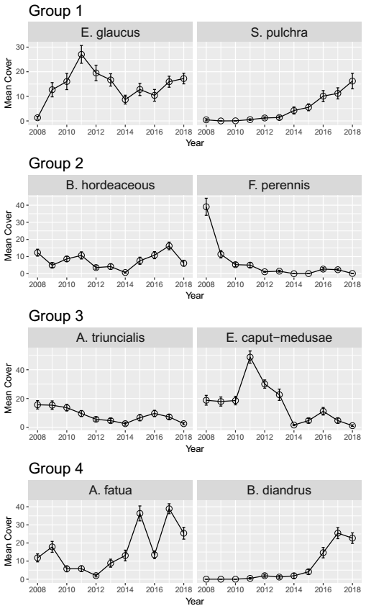

1. **MSM model output, estimated coefficients, visualized fits**

* Can also include the coefficient table, hazard ratios, etc.

