**WAPS Analysis Notes:**

**Functional Group Abundances:**

On the whole, there are very interesting patterns in functional group (WAPS, natives, annuals) abundance in each plot over time. Some planting compositions appear more stable than others

Over time, there appear to be different sets of fluctuations depending on who is planted initially.

Figures below show proportional abundance of different functional groups over time, with each subplot representing a different initial planting combination:

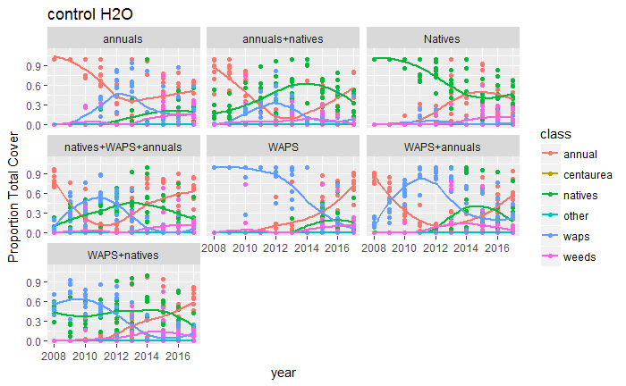

**Fig 1 – Functional group proportional abundance over time, control H2O**

There also seems to be some potential planting by water treatment interactions. Dry plots seeded only with annuals, for example, show limited changes over time and a roughly constant proportional abundance of annuals:

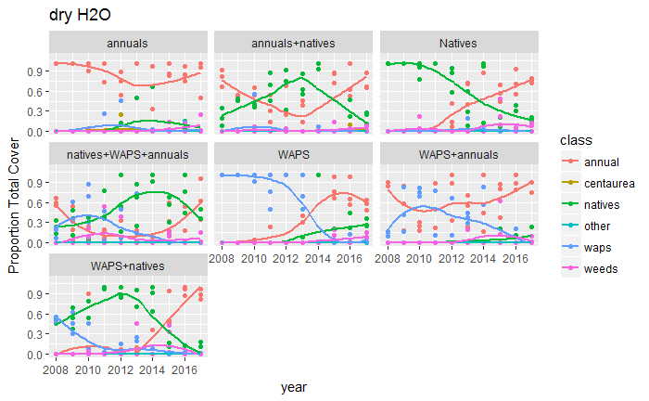

**Fig 2 – Functional group proportional abundance over time, dry H2O treatment**

**Species-Specific Change:**

For simplicity, the following figures will only show plots in the “control” water treatment. There are figures available for all treatment types, but they show quite similar patterns.

With a species-specific perspective on compositional change, however, patterns appear to be less clear – there is very little evidence for compositional stability on the species level. All communities appear to fluctuate over time, regardless of what community was planted first.

The figure below shows community dissimilarity relative to that same community in its first year (as Bray-Curtis dissimilarity, so a value of 0 means that assemblages are identical). Over time, we see that our communities are becoming more and more dissimilar to the community in the first year, for all treatments. The only exception might the WAPS planting group, but even these are not particularly “stable” – most dissimilarity values are greater than 0.5 in just a few years.

This plot indicates to me that all communities do not seem to remain static on the species level.

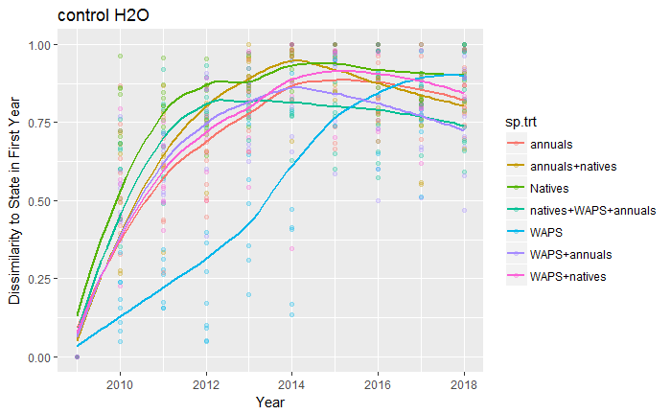

**Fig 3 – Compositional similarity to community in year 1 over time**

Despite this rapid change in community composition, there’s little evidence that communities are collapsing on one particular community confirmation.

The following plot shows the distance of each community to the centroid (“mean community”) of its block (containing all 7 species treatments) over time. The larger the value on the Y axis, the more “distinct” this community is from the rest of the communities in its block, with the mean dissimilarity being an estimate of the dispersion, or compositional beta-diversity, of plots within a block.

Despite the fact that communities are varying substantially through time, the mean level of dispersion (black line) in each year is fairly consistent. The relative distinctiveness of each community can be gauged by the individual colored lines, which relate to the sp.trt column. Native communities (green line) seem to be the most distinctive in the first year relative to other seed mixtures, while annual mixtures (purple, cyan, orange, and red) lines are all relatively non-distinct, suggesting these have similar species compositions in year 1.

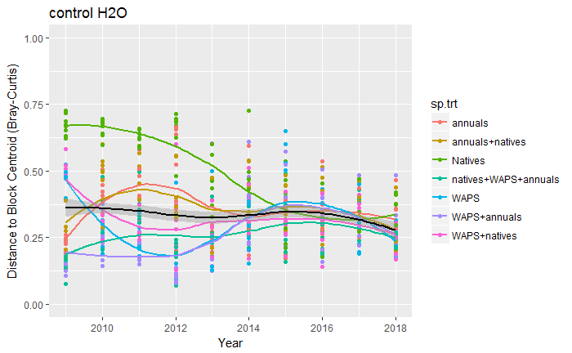

**Fig 4 – Compositional dispersion within blocks over time**

Given that communities seem to vary substantially over time relative to their initial state (Fig 3), yet don’t seem to experience any difference in mean block similarity (Fig 4), another key question to ask is whether different plots of the same treatment are varying in a way that is random or more deterministic. If plots are just fluctuating randomly, we should see that plots start with similar species compositions, then increase in dissimilarity over time.

Like the previous figure, dissimilarity here is plotted on the Y-axis, but *relative to all other plots of the same species planting treatment rather than within a block*.There is some evidence that dissimilarity increases over time, though this pattern may not be particularly strong. Moreover, the relative amount of dissimilarity is quite low – mean dissimilarity values between plots of a treatment rarely reach above 0.35.

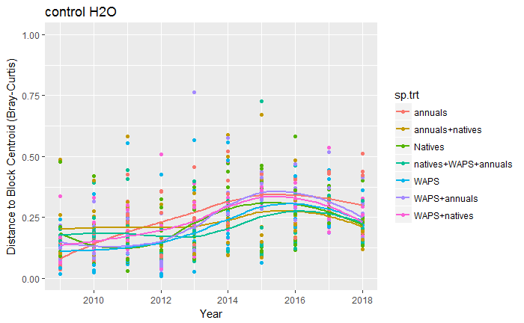

**Fig 5 – Compositional dissimilarity within sp.trt type over time**

**Together, these plots suggest:**

* **No planting composition is static.**
* **Communities are not collapsing on a particular community confirmation over time.**
* **Plots of the same initial planting treatment retain a substantial amount of similarity in composition, despite not resembling their initial planted state.**

To explore this data, it may make sense to use a state-transition framework for analysis. There are some good examples of doing so here in California:

* Stein et al. (2016) *Ecology*
* Bagchi et al. (2013) *Journal of Applied Ecology*
* Jackson and Bartolome (2002) *Plant Ecology*

Instead of trying to examine these community patterns as either total functional group abundances (coarse scale) or species-specific patterns (fine scale), state-change models might be able to find a happy medium where species-level community patterns are organized into discrete “states” that can be associated with the abundances of different taxa.

In this way, it would be possible to ask what species seem to be most important in determining states, what seems to govern transition between states, and how priority effects can have long-term effects on state transitions.

**State-Change Models**

* In brief, this technique involves:
  + Assigned groups to different states using a clustering algorithm
  + Assessing what species are most associated with different states with indicator species analysis
  + Quantifying whether these groups explain a relevant portion of variation
  + Comparing frequencies of change or stasis using contingency tables.

As a rough first attempt, I’ve replicated a portion of the analysis from Stein et al. (2016).

Assigning clusters: To assign “states”, Stein et al. (2016) utilized a hierarchical clustering algorithm that seeks out relevant distinctions in the data just based on community data. There are a number of different ways to cluster communities and determine what number of clusters is best. Here, I’ve just chosen a simple clustering algorithm, K-means partitioning, which attempts to just find the best splits for K groups in the data. It turns out that 3 is the best number of groups to use in this data based on the Kalinski Criterion metric that the vegan package provides. An NMDS plot of all plot compositions over time shows the distinctions between groups:

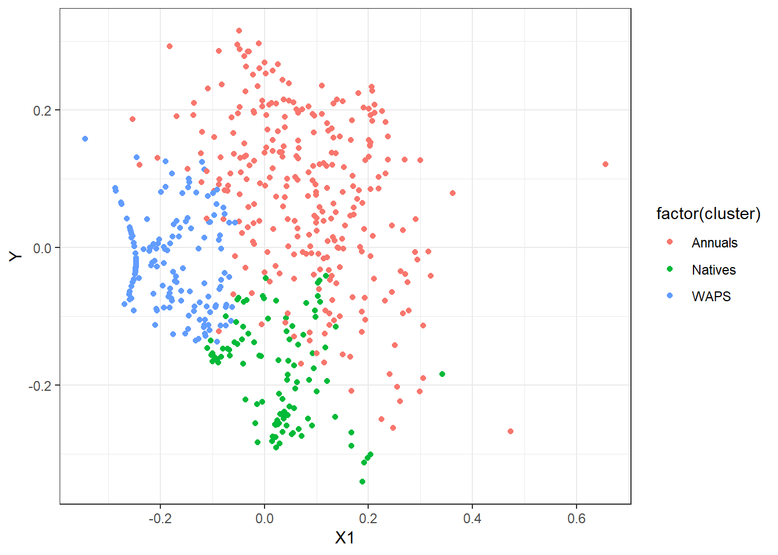

**Fig 6 – NMDS visualization of plot communities, control H20, all years**

Running the K-means algorithm on its own does not provide a species-level justification for the clusters formed, but a simple indicator species analysis can provide some biological meaning. In this case, we see that groups seem to follow functional group plantings, though the 1st group, which I’ve called “annuals” also contains a few native species. This isn’t necessarily surprising, given that we imposed some structure on the communities with initial plantings, but can signify whether certain elements of each mix are showing up as “distinctive” or not.

|  |  |  |  |  |  |  |  |  |
| --- | --- | --- | --- | --- | --- | --- | --- | --- |
| **Group** | **1** |  | **Group** | **2** |  | **Group** | **3** |  |
| “Annuals” | stat | p.value | “Natives” | stat | p.value | “WAPS” | stat | p.value |
| avena | 0.812 | 0.001 | elymus | 0.9 | 0.001 | taeniatherum | 0.881 | 0.001 |
| bro.hordeaceous | 0.581 | 0.001 | bro.carinatus | 0.542 | 0.001 | aegilops | 0.817 | 0.001 |
| lolium | 0.529 | 0.001 | nassella | 0.376 | 0.017 |  |  |  |
| bro.diandrus | 0.483 | 0.001 |  |  |  |  |  |  |
| trifolium | 0.432 | 0.001 |  |  |  |  |  |  |
| leymus | 0.363 | 0.006 |  |  |  |  |  |  |
| lotus | 0.354 | 0.001 |  |  |  |  |  |  |
| vicia | 0.351 | 0.006 |  |  |  |  |  |  |
| bindweed | 0.287 | 0.005 |  |  |  |  |  |  |
| senecio | 0.187 | 0.035 |  |  |  |  |  |  |
| hordeum.sp | 0.174 | 0.032 |  |  |  |  |  |  |

**Table 1 – Species indicator analysis of clusters created by K-means clustering**

If we just look at the relative frequency of states over time, we see patterns that closely mirror the functional group abundances presented earlier in the document. Annual states seem most common in the first year, WAPS dominate those mixtures where either WAPS or WAPS + Natives are planted, and native states are only assigned when planted singly.

Over time, however, we see that these states are not static. Annuals go through a period in 2011-2013 where natives and WAPS become more common, but return to dominance in 2015-2017.

**Note: There were a few plots with 0 recorded cover in 2013 + 2014 and were not assigned a state, hence why the number of plots are not constant over time.**

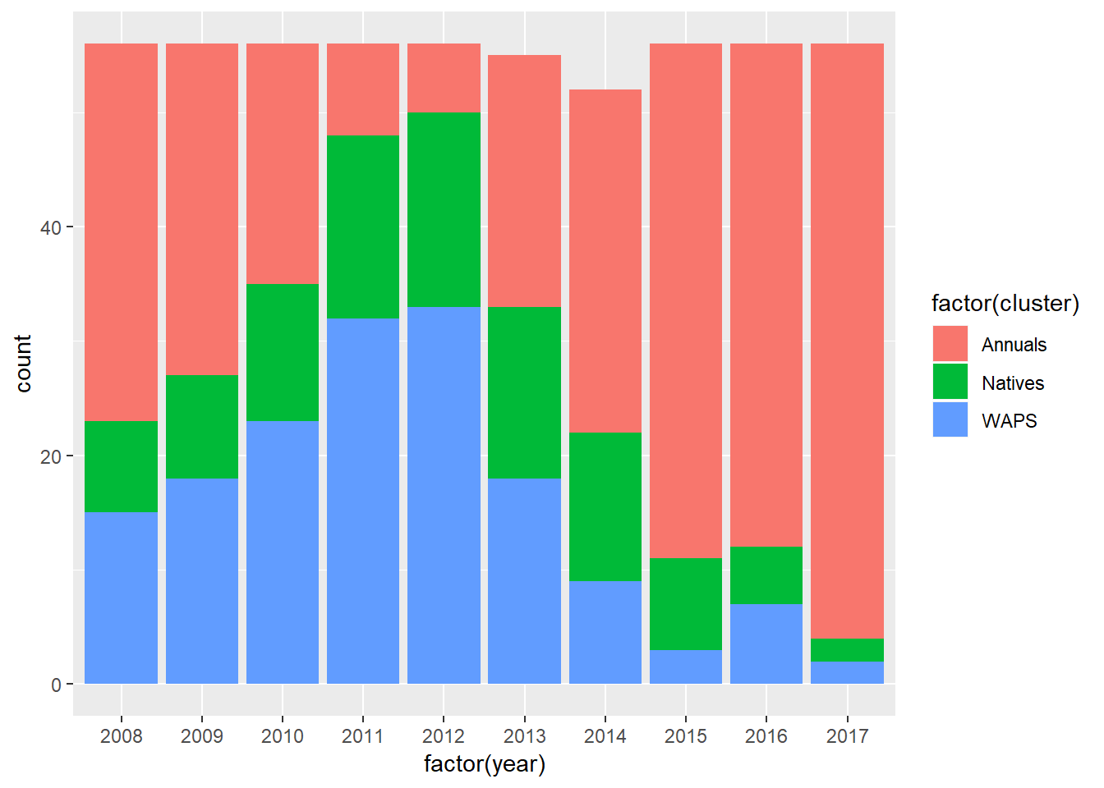

**Fig 7 – Counts of each cluster type by year, control treatments**

There are a number of ways to assess how state changes occur – if we are relating the likelihood of change to some quantitative value (e.g. precipitation or biomass production in a previous year), we could use a multiple logistic regression, or contingency tables, as noted in Stein et al:

|  |  |  |  |  |
| --- | --- | --- | --- | --- |
|  |  | Next Year | | |
| Current Year |  | WAPS | Natives | Annuals |
| WAPS |  |  |  |
| Natives |  |  |  |
| Annuals |  |  |  |

Where the odds of state stability or transition can be described by counts at each state within the above matrix. There are a number of potential statistics that can be used to determine whether transitions to or from different states are more or less likely than if they occur at random.

**I think there are a number of questions that might be able to be addressed that incorporate elements of priority effect and state change frameworks:**

* In the first year of planting, what states are most likely to arise from different seeding treatments?
  + When combinations of seeds are planted (e.g. WAPS + Annuals), which of the two groups “wins” in the first year?
* Which planting compositions are most stable over time?
* When communities transition, what state do they transition to? Are shifts in states unidirectional or bidirectional?
* What environmental characteristics are most likely to prompt state change? Is transition to certain states more likely in dry years, wet years, and from communities which produced little biomass the previous year (much work has shown that communities may vary with residual dry matter)?
* Does initial seeding mixture influence the directionality of state change? Are certain transitions between groups only possible when priority effects