State Change Outline:

* Introduction to annual grasslands:
  + History of the three groups of species in annual grasslands
    - Natives (what did they even look like?)
    - Naturalized annuals
    - Invasive species
  + Annual grasslands as a system
    - No clear patterns of succession, even in the absence of:
      * Grazing
      * Fire
      * Any consistent disturbance…
  + However, this lack of succession does not mean that species composition is “fixed”
    - Dramatic shifts in plant communities are thought to be mediated by year-to-year climatic variation.
    - Annual life history places a ton of emphasis on seedling dynamics – communities dramatically thin themselves after germination. Between 1-10% of the total community survives to peak productivity.
      * Droughts, particularly longer-term events, can have large effects on
        + Seed production
        + Seedling survival (within-year droughts)
        + Competitive interactions
* State-change models:
  + To make sense of these fluctuations in annual rangelands, land managers have often turned to state-change models:
* 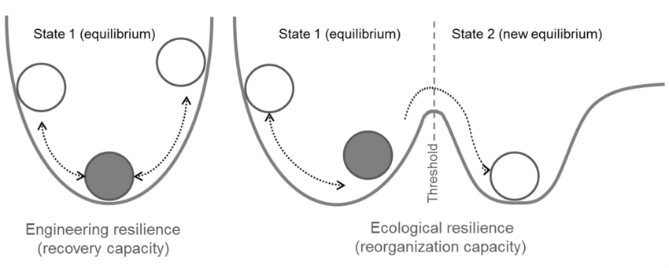
  + In these models, managers attempt to categorize communities into discrete “states”, represented by the ball on a surface. Transition between states is moderated by some force that “pushes” the ball in different directions. The stronger the force, the more the ball is pushed. The more resistant a state is to some change, the deeper the “cup” in the surface.
* While these models are great conceptually, they can be hard to put into practice when analyzing data, particularly when we are considering multiple state types.
  + Reliance on “expert models”, which are based on qualitative observation, rather than a more quantitative approach.
  + Recently, a few approaches to developing state-transition models have appeared, which utilize classification techniques to “discover” states within the total amount of variance of community composition observed.
* Introduction to WAPS experiment:
  + Look up specific details
  + 3 unique species groups planted in a factorial combination in 2008
  + Community sampling at every year
* When we have extensive time-series of community compositions, we can use these quantitative approaches to ask questions, like:
  + What are the relevant states in a community? Do the distinctions between native species / naturalized annuals / recent invaders characterize the major shifts we see in community composition?
    - What species define these communities?
  + What mediates transitions between communities?
    - Are transitions between transitions between states unidirectional? Bidirectional?
    - How do priority (contingency) effects contribute to state change?
      * What states arise from planting mixtures?
      * Is state-change more likely between elements of the planting mixture?
* Slide 1:
  + Visualizing community differences (NMDS):
    - Where things start
    - Where things end up
    - How they get there (animation)
* Slide 2:
  + K-means classification
    - How many states best classify the total community variance we see?
  + NMDS plot, colored by classification
* Slide 3:
  + Indicator species analysis
  + What defines each community?
* Slide 4:
  + Change of states by planting type over time
    - Note the states that arise
    - Note transitions and frequency
* Fitting Markov / Multi-State models to the data
  + Markov models describe transitions between discrete data types by a matrix of transition probabilities.

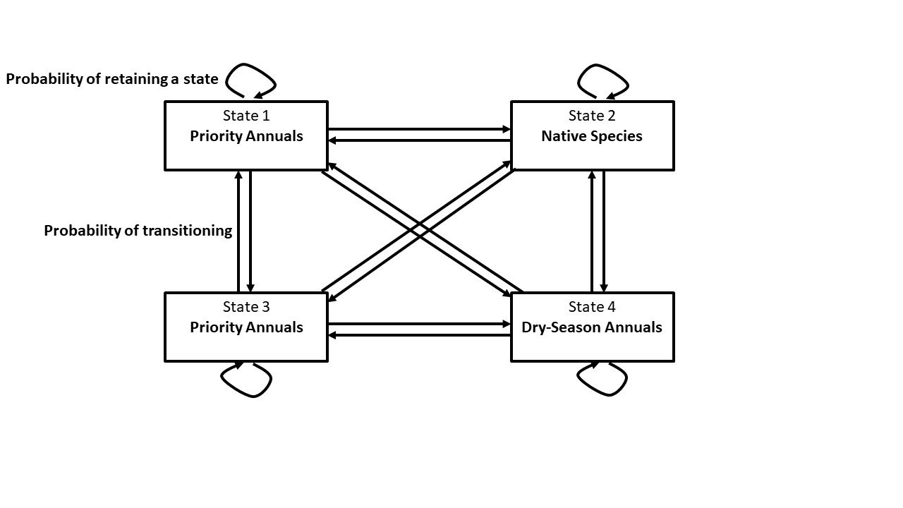

* Can use this to quantify whether:
  + Some states are more stable than others
  + Whether environmental covariates / different planting communities change these transition probabilities
* Results of comparative model fitting
  + Null
  + With priority
  + With environmental correlation
  + With both
* Interpretation of figures:
  + Stability probability as a function of precipitation
    - Greater stability, the greater the depth of the cup
  + Transition probability as a function of precipitation
    - Greater transition odds, shallower response change surface
* Conclusions:
  + Introduction history does not necessarily correlate with ecological niche
    - While it may be convenient to think of these different species based on either their historical context or effects on agriculture, perhaps we need to consider subdividing them into different groups.
  + Transitions between groups appear to be mediated by climatic patterns
    - Particularly among dominant species
  + Historical contingency and priority can be very important for transition probabilities
    - Particularly for native species restoration,

Questions:

* What are the relevant states in a community? Do the distinctions between native species / naturalized annuals / recent invaders characterize the major shifts we see in community composition?
  + What species define these communities?
* What mediates transitions between communities?
  + Are transitions between transitions between states unidirectional? Bidirectional?
  + How do priority (contingency) effects contribute to state change?
    - What states arise from planting mixtures?
    - Is state-change more likely between elements of the planting mixture?