Nutrient Use Trade-offs:

**Overview:**

Trade-offs in ecological theory are ubiquitous; assumed constraints on phenotypes are thought to explain the diversity of species and functional forms in many environments. The core notion of a trade-off – in which strong performance under some circumstances is balanced with poor performance in another – has played a central role in understanding community assembly and resource limitation in plant communities. To facilitate plant coexistence in variable environments, trade-offs in resource use assume that a plant’s ability to reduce the concentration of one limiting resource (e.g. soil nitrogen) is negatively correlated with the ability to reduce another (e.g. light).

In the context of the Nutrient Network, the many grasslands worldwide is limited by multiple soil resources. Manipulations of nitrogen, phosphorous, and potassium (+ micronutrients) have shown that the biomass of these communities respond positively to the enrichment of two or more of these fertilizers which, in turn, is correlated with loss of species richness. Harpole et al. (20XX) interpreted these findings as a loss of niche dimensionality, where additions of multiple limiting nutrients reduces their relevant variation, leading to fewer available niches to facilitate species coexistence.

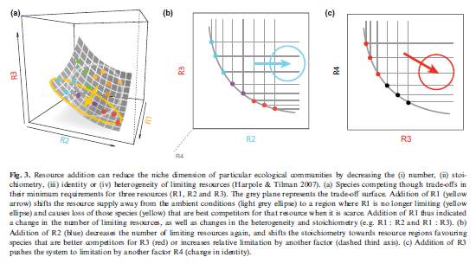These findings reflect two competing theories on how resource use trade-offs govern community assembly. The first, emphasized by a commentary by Harpole et al (2017), suggests that species differ in their R* values for the three fertilizer treatments and low R* values along one resource axis are correlated with high R* values along others. The second, implied by Cleland et al. (2019), is a trade-off between belowground vs. aboveground biomass distribution and resource use – namely, that fertilization shifts resource limitation from belowground resources (N, P, K) to light. In this case, a single species is likely to be limited by multiple belowground resources, rather than exhibiting a trade-off between them.

Figure from Harpole et al. (2017)

When communities respond (in aggregate) to multiple limiting nutrients, these two theories suggest different outcomes for community change at the species level. In the first, community change should be uncorrelated (or negatively correlated) between communities that have received different nutrient treatments, as each moves across a different axis of resource limitation. In the second, community responses to different nutrient addition treatments should be correlated with one another, as fertilization moves communities across a single resource competition axis related to soil resources vs. light.

Sites may exist upon a continuum between these two extremes, where soil resource limitation operates across one axis or several. Attributes of the biotic environment –larger species pools, greater pre-treatment diversity, and presence of certain functional groups – may provide the foundation on which tradeoffs operate, as attributes of the abiotic environment – pre-treatment vegetation heterogeneity and water limitation – may generate the variation needed for trade-offs to evolve.

Here, we aim to determine how multiple resource limitation drives changes in species composition across the nutrient network – whether single or multiple nutrient use axes govern community responses to fertilization, and how sites vary in these responses.

Questions:

1. Across sites, which single-nutrient fertilization treatments (N / P /K+µ) produce change in species composition?
2. Are community responses to different resources correlated with one another? Are particular nutrient addition treatments more correlated in their response than others?
3. Are plant responses to nutrient enrichment well described by a single axis or multiple? Do certain plant functional groups deviate from the general relationship?

Methods:

* To all sites containing > 4 years of nutrient addition treatments + pre-treatment year, I fit the following equation:



Where species cover at a given time (YSpeciesCover) is a function of the log-transformed number years of fertilization treatment (BNutrient *Log(YrTrt + 1)), the random annual variation in abundances within a site (BYrFactor), and random effects of block. This model fit better than using a linear effect of treatment, as the log-transformed model better captured the saturating effects commonly found in nutrient enrichment.

This model was fit to all species in each site using RRPP. The significance of aggregate community response to each nutrient enrichment treatment was tested with 9999 random permutations of residuals used to generate a pseudo-F statistic.

Individual response coefficients for each species (BNutrient) were extracted to assess correlations between site-level community change and individual-level responses to each nutrient. To determine the dimensionality of fertilization response, a PCA was constructed

Correlations between individual-level measures of nutrient response were analyzed using standard major axis (SMA) regression to better account for the uncertainty associated with measures of nutrient response.

Results:

1. Significance of nutrient addition treatment by site
2. Overall site correlation in nutrient addition response
   1. Individual site correlations?

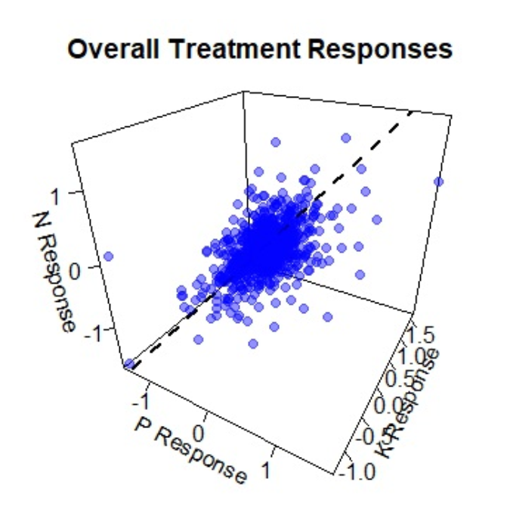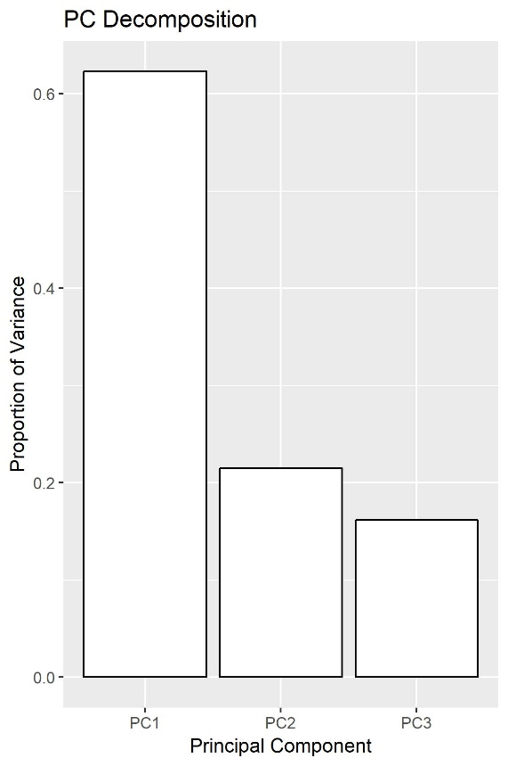

**Figure 2.** Estimated response coefficients of species across all 3 fertilizer treatments (ΔCover / Log(Year Treatment))

1. Pairwise variations in response by functional group
2. Site-by-site variations relative to functional group
3. Environmental / biotic determinants of correlation
   1. Make sure to show significant vs. nonsignificant magnitudes

Appendix:

1. Table of sites included in this measure