**Lifecycle**

Here is the state machine diagram for a Service order. Each order state is described in the table below.

The order item states are the same as the order ones except ‘Partial’ status which is not available for service order item.

Note that the order and order item states are tightly linked and need to be consistent (see table below):

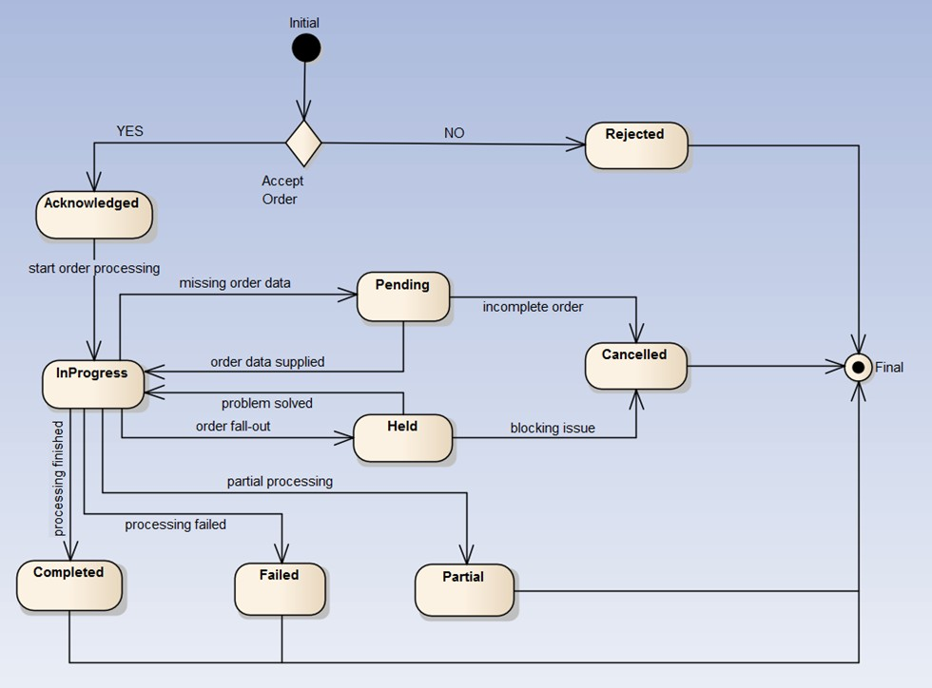

The following table provides service order state and service order item state description:

The following table provides service order state and service order item state description:

|  |  |
| --- | --- |
| Acknowledged | The Acknowledged state is where an order has been received and has passed message and basic business validations. |
| In Progress | The In Progress state is when service delivery has started. |
| Cancelled | The Cancelled state is where an In-Flight Order has been successfully cancelled. |
| Completed | The Completed state is where an order has complete provision and the service is now active. |
| Rejected | The Rejected state is where: |

Service State model:

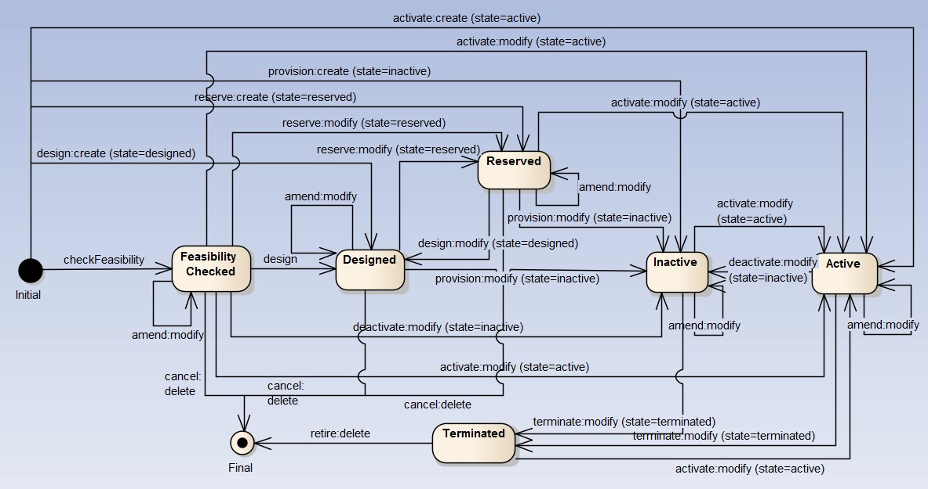

Note: ‘Feasability Checked’ should not be managed through service order. A dedicated API provides service qualification; This API is part of the pre-ordering domain.

|  |  |  |
| --- | --- | --- |
| **source service state** | **action** | **target service state** |
| **blank** | add | Designed (valued in order item service state) Reserved (valued in order item service state) Inactive (valued in order item service state)  Active – by default |
| **Designed** | modify | Reserved (valued in order item service state) Inactive (valued in order item service state)  Designed– by default |
| **Designed** | delete | *not relevant…service removed* |
| **Reserved** | delete | *not relevant…service removed* |
| **Inactive** | modify | Terminated (valued in order item service state)  Active (valued in order item service state) Inactive– by default |
| **Active** |  | Active – by default  Terminated (valued in order item service state) Inactive (valued in order item service state) |
| **Terminated** | delete | *not relevant…service removed* |

*Note*: when action ‘no change’ is used we did not expect any state change.