**LAB 2 ASSIGNMENT**

**ARAPALLY EBENEZER ANAND**

**16161673**

**Task 1**

In Task1 of Lab 2, a file has been generated using the Android device and the sensor tag. The file has been uploaded to the Github. The name of the file is sensor.txt

**Task 2**

In Task2, the file that we got from the android device is uploaded to the HBase and the result is stored in the

A table has been created and here is the screenshot of it

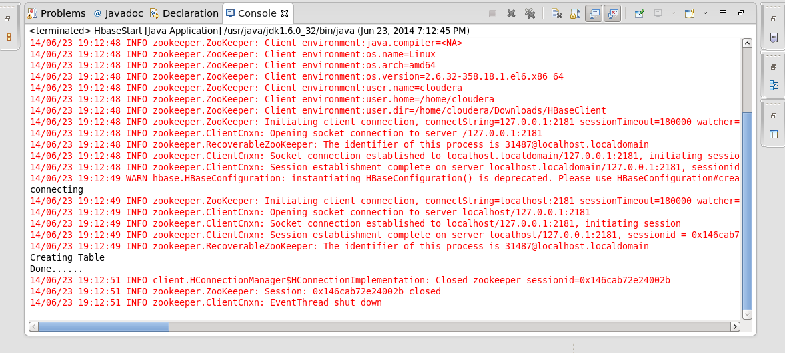

Data has been inserted into the table and here is the screenshot

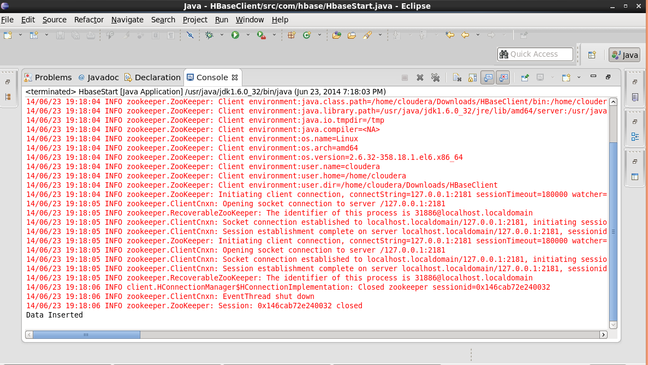

Here are the screenshots of the data that has been retrieved

