**User Manual**

**System Requirements:**

Operating System: Android

Android Version Support: JellyBean to KitKat

Memory required: 256MB

Internet Connection: Yes

Bluetooth Connection: Yes

External Tools: BLE Sensor Tag

**Goal:**

The main goal of our application is to detect the emotions of the user based on his hand gestures. Depending on your emotions we shall detect certain places to visit in order to revive yourselves. This application doesn’t require any user registration.

**Gesture Patterns:**

In our application we will be detecting five gestures and each gesture represents an emotion. The five gestures which we use for emotion detection are:

1. Facepalm Hand gesture is represented as worried
2. Weeping Hand gesture is represented as Sad
3. Stomp hand gesture is represented as Irritated
4. Punch hand gesture is represented as Angry.
5. High Five hand gesture is represented as Happy.

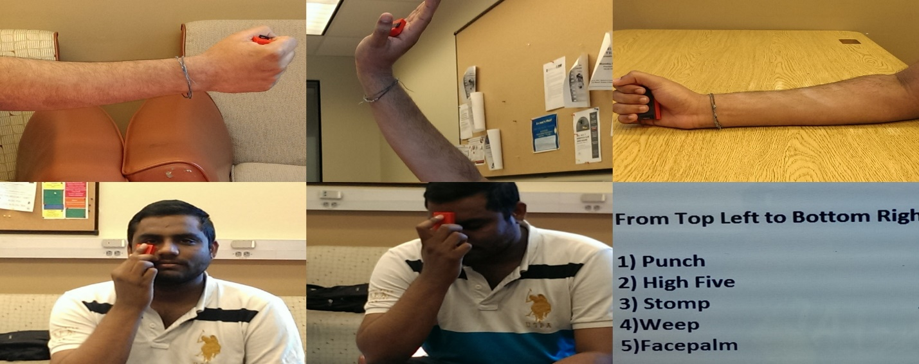

Figure 1Different Gestures

**Guidelines:**

1. Please download the WhatToDo.apk file from the below link and install it on your mobile device.
   1. <https://github.com/SaiKishoreBandaru/BigDataAnalytics_FinalProject_EmotionSensor/blob/master/WhatToDo/bin/WhatToDo.apk>
2. Once you have installed the application, Launch the application by clicking or tapping on WhatToDo icon displayed in the applications list on your device.
3. Now the application takes certain time to load, make sure your Bluetooth is on and also the BLE Sensor Tag is connected to your mobile device.
4. Once the application has started click on the “Start Recognition” button and make a hand gesture.

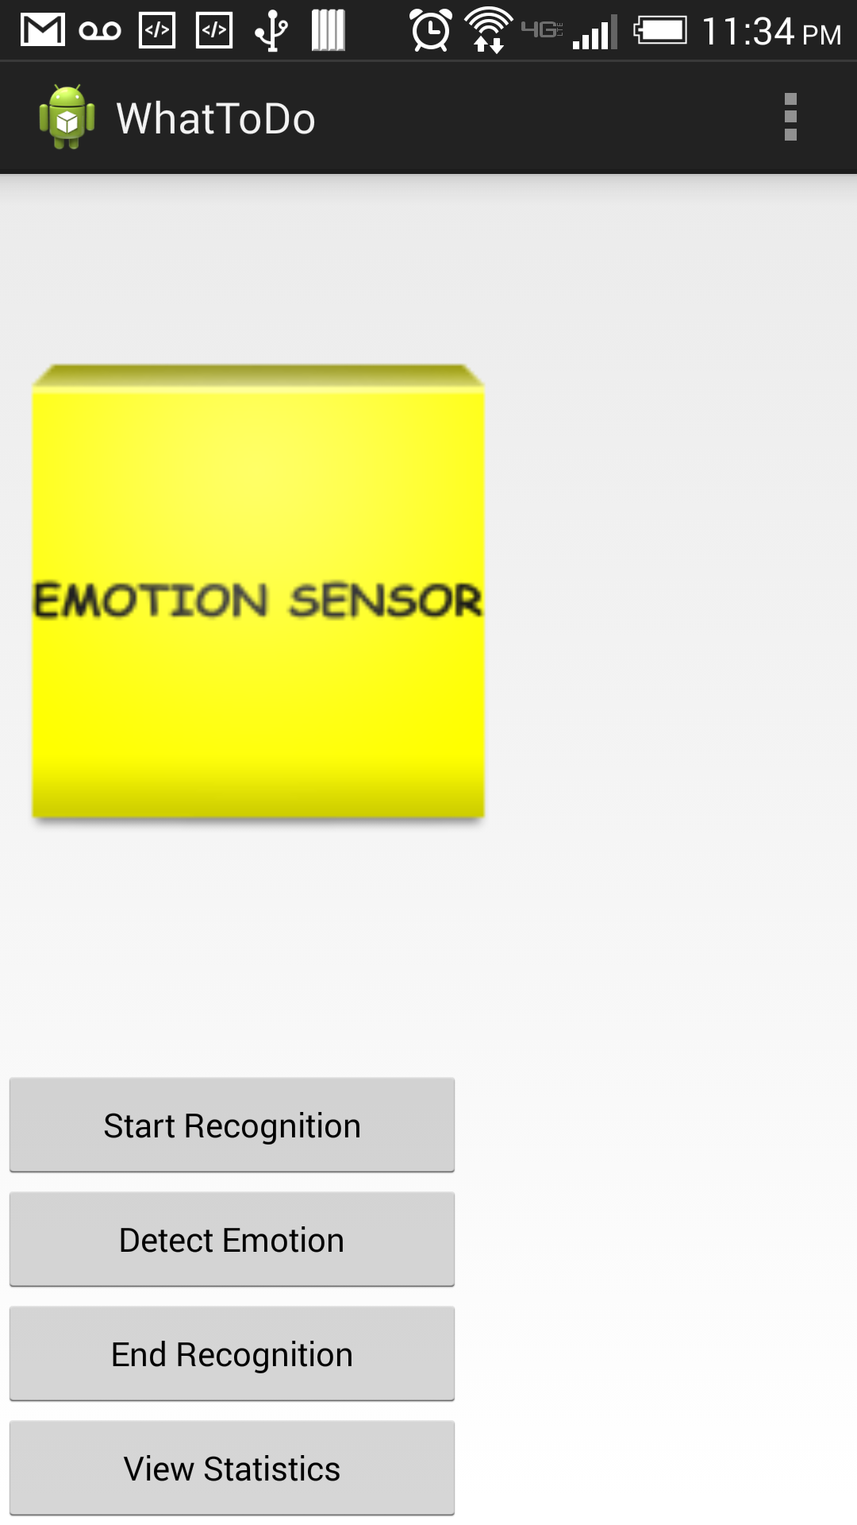

Figure 2Start recognition

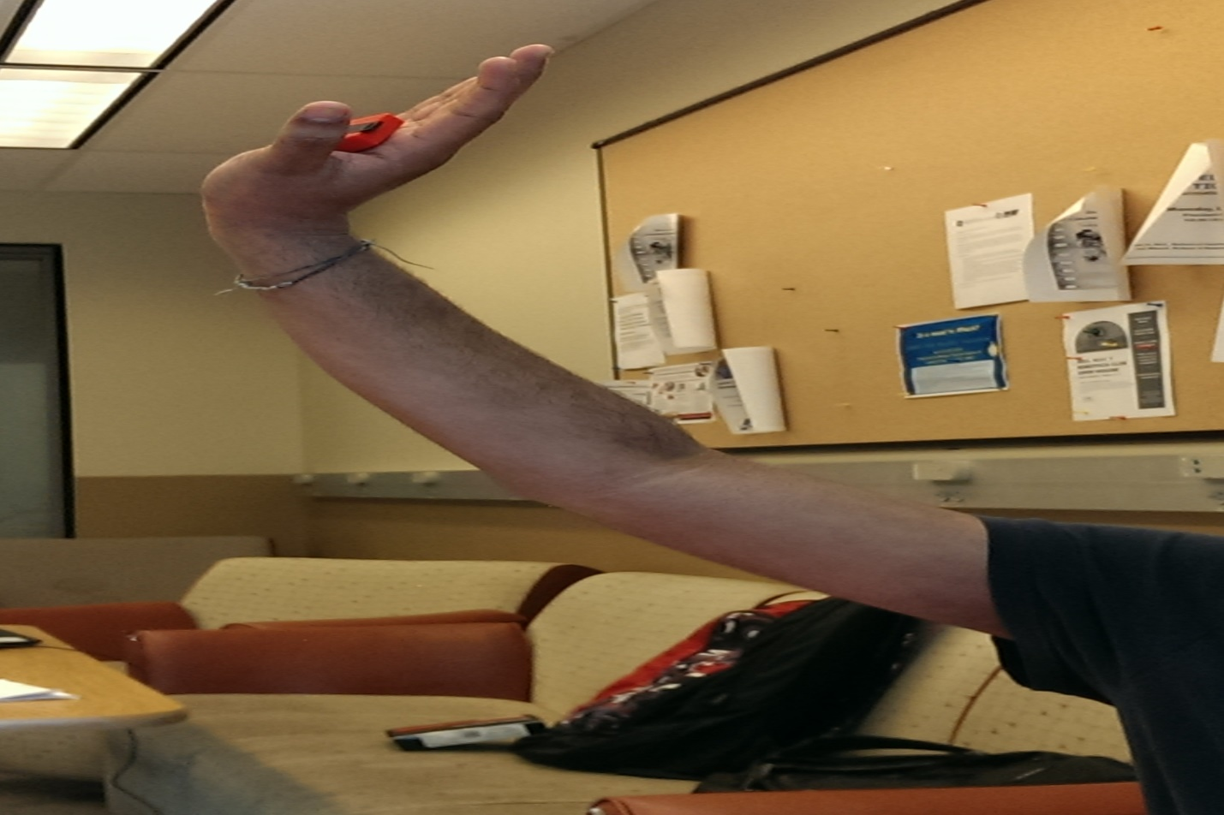

Figure 3Sample Hand Gesture

1. Once you are done with the making of hand gesture, click on “End Recognition” button.
2. Please be idle for couple of seconds and click on “Detect Emotion” button to identify your current mood.
3. Now you will be shown with a page which depicts your current mood and also button “WhatToDo” at the bottom.

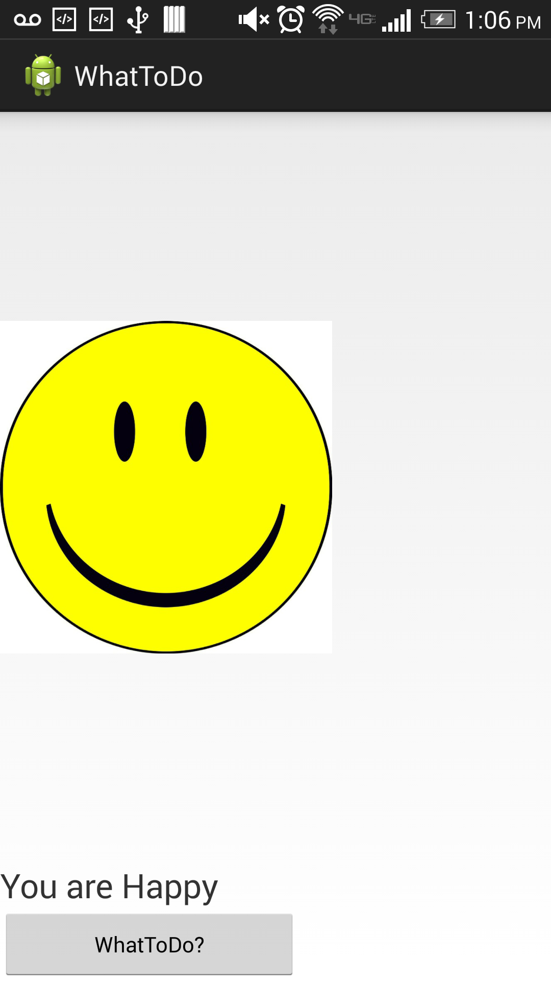

Figure 4EMotion

1. Now to see the places which we recommend you to visit to get revived will be displayed on clicking the “WhatToDo” button
2. Once you click on WhatToDo button, in order to distinguish between the users, we have placed three buttons. Now click on the appropriate button to view results of recommendations.

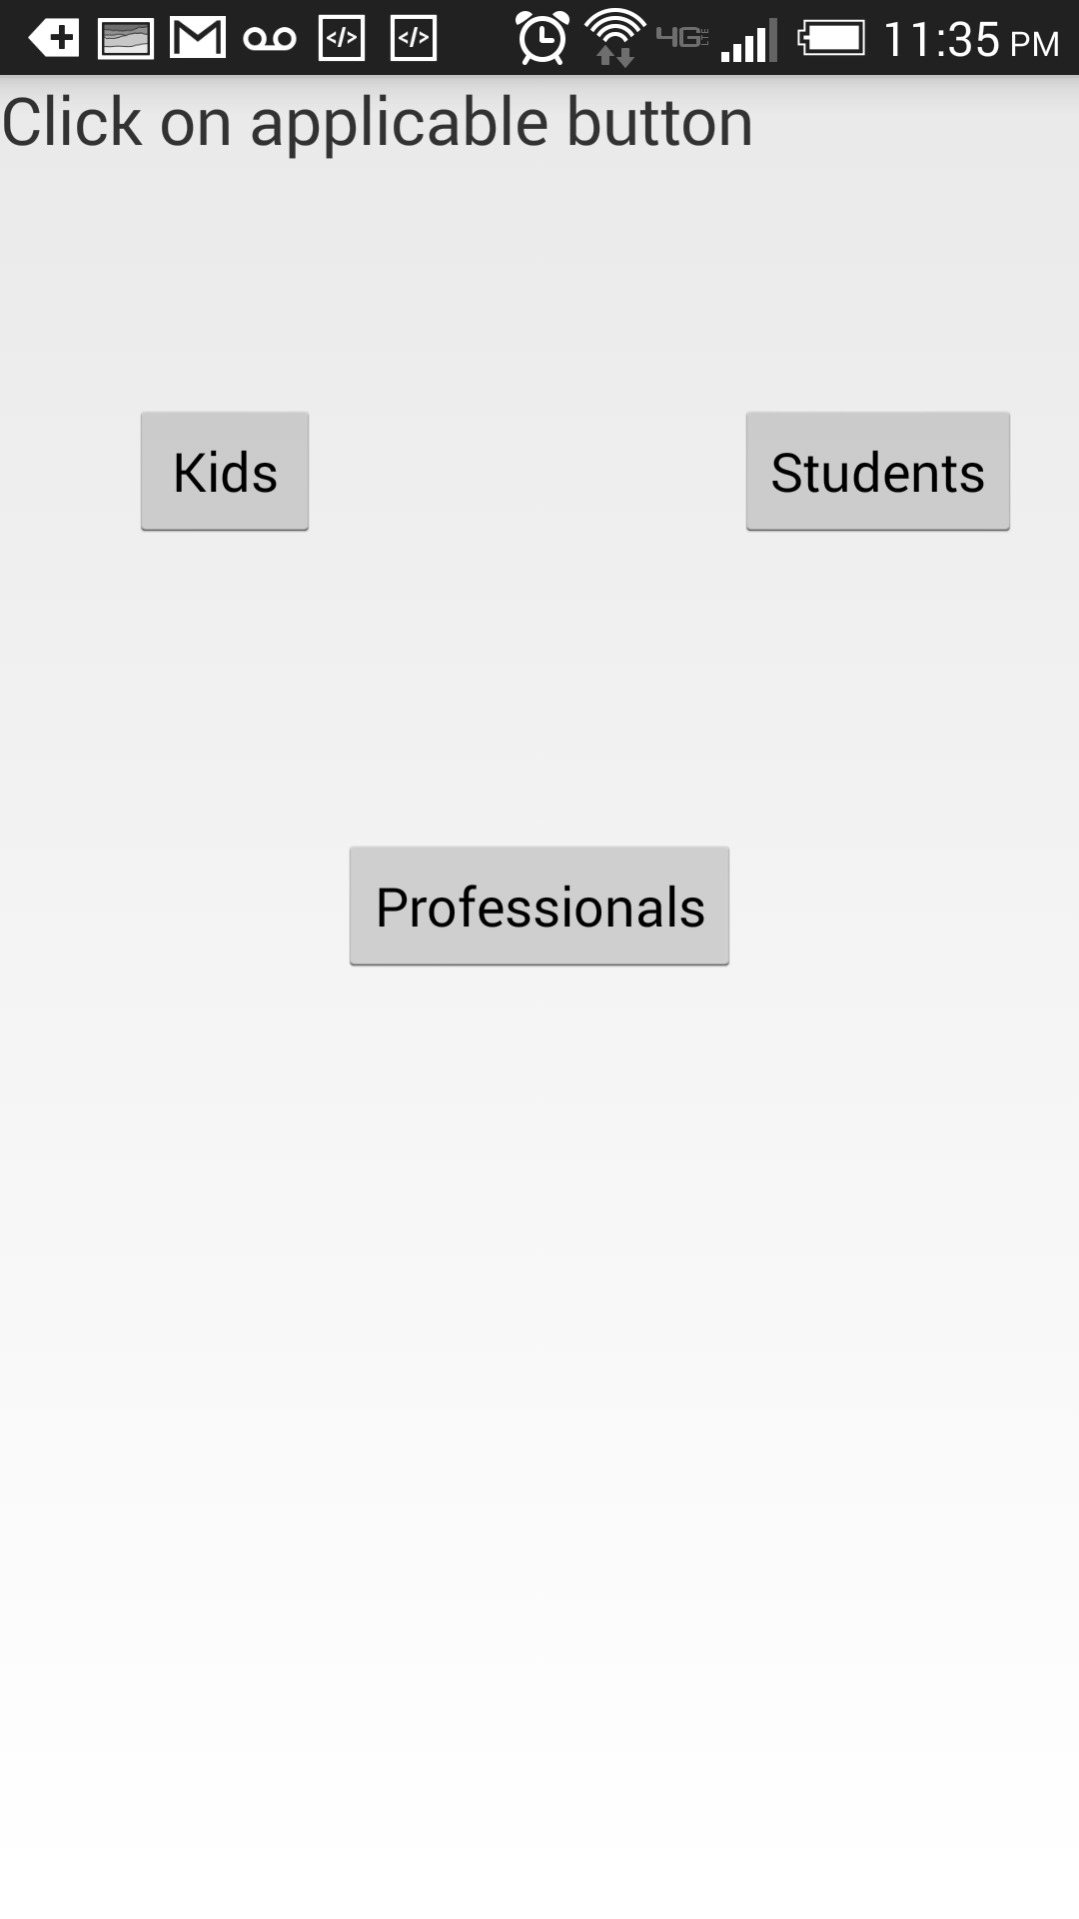

Figure 5Distinguishing the users

1. Now you can see a list of places suggested, which are being represented in red. The blue icon indicates your current location.

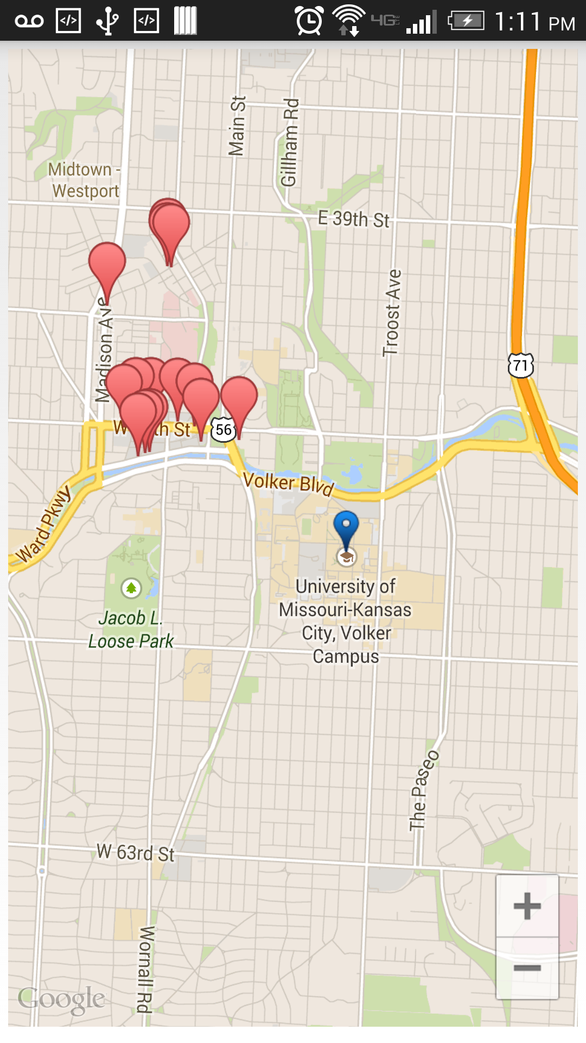

Figure 6Places to visit

1. On clicking a red label it shows you the location name.

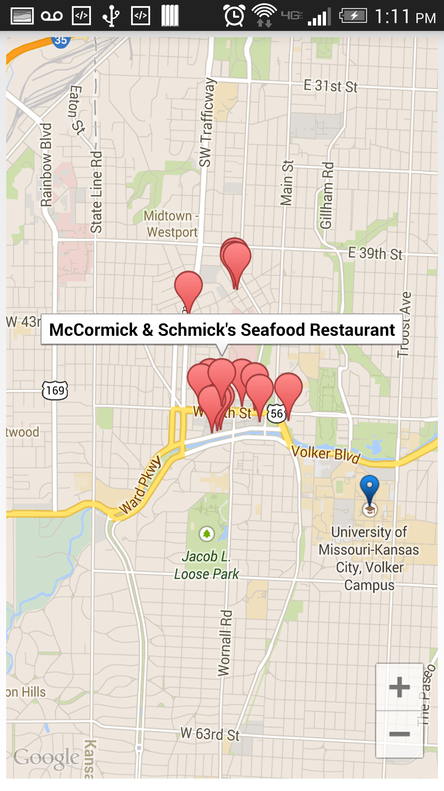

Figure 7Place to visit with name

1. Now in order to view your entire day results please click on the View Statistics button on the home page.
2. Now you will be displayed with a bar chart which shows in which mood you are in at which time.
3. Here we also recommend certain places to visit based on your overall day recordings.

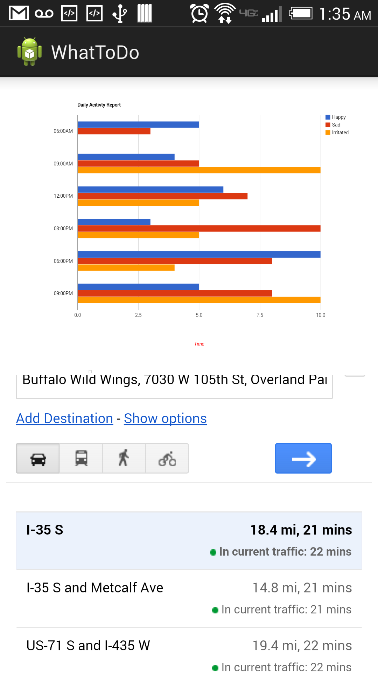

Figure 8Day Report

**Troubleshooting:**

* Whenever there is an issue of wrong emotion detection make sure your mobile device Bluetooth is on.
* Refresh the application if the application goes down.
* Make sure you use the sensor tag in such a way that the tip of the sensor tag points to direction of your fingers.