1) In this I took datasets about song recommender. when we execute this, it shows the songs that one would be willing to listen after selecting a particular song.
Posted the source code in a '.rar' file in Github.
Here I am posting the screenshots of my execution
Source code:
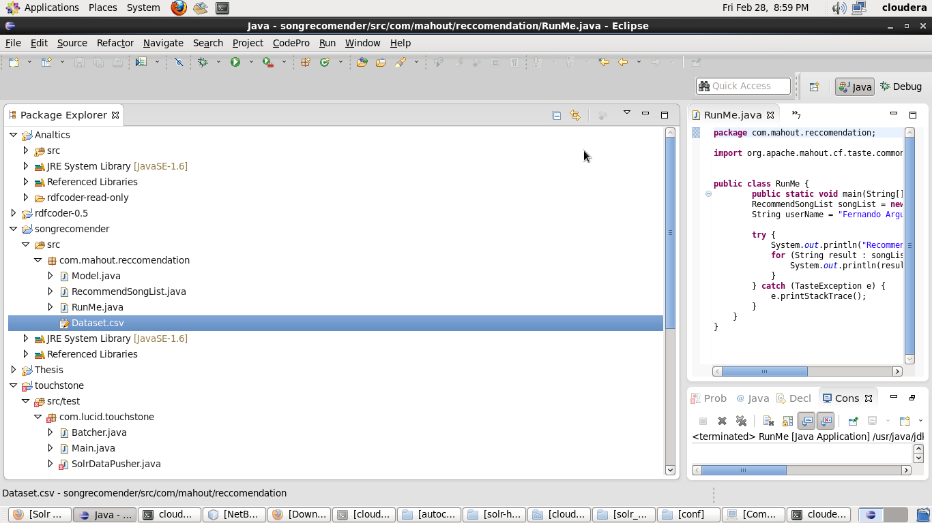

Mahout classification:
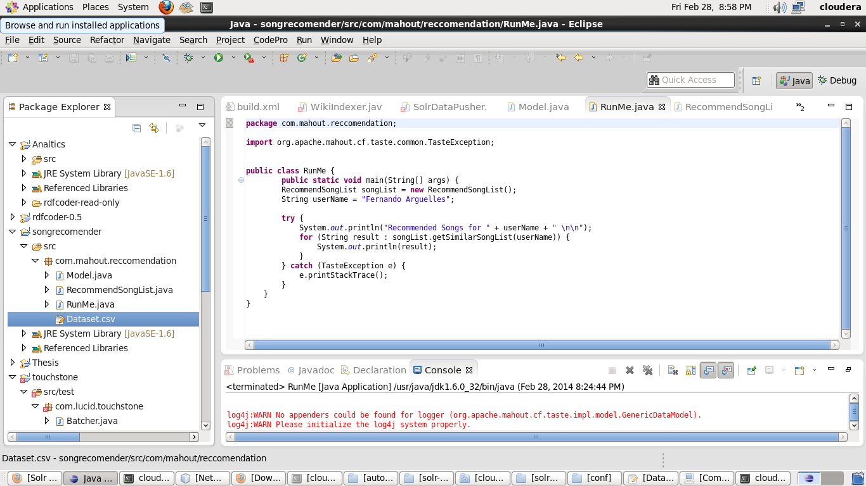

Recommender Code:
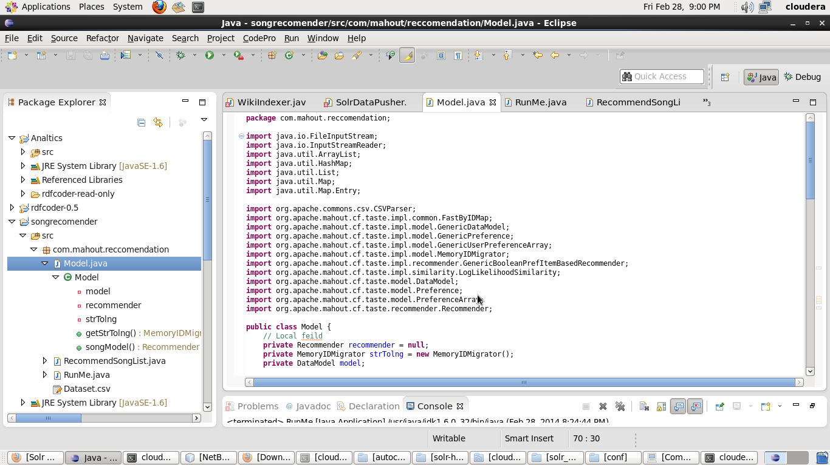
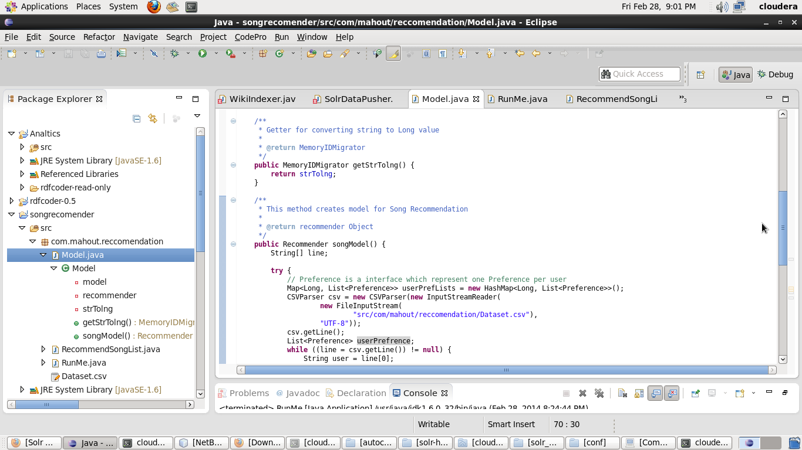
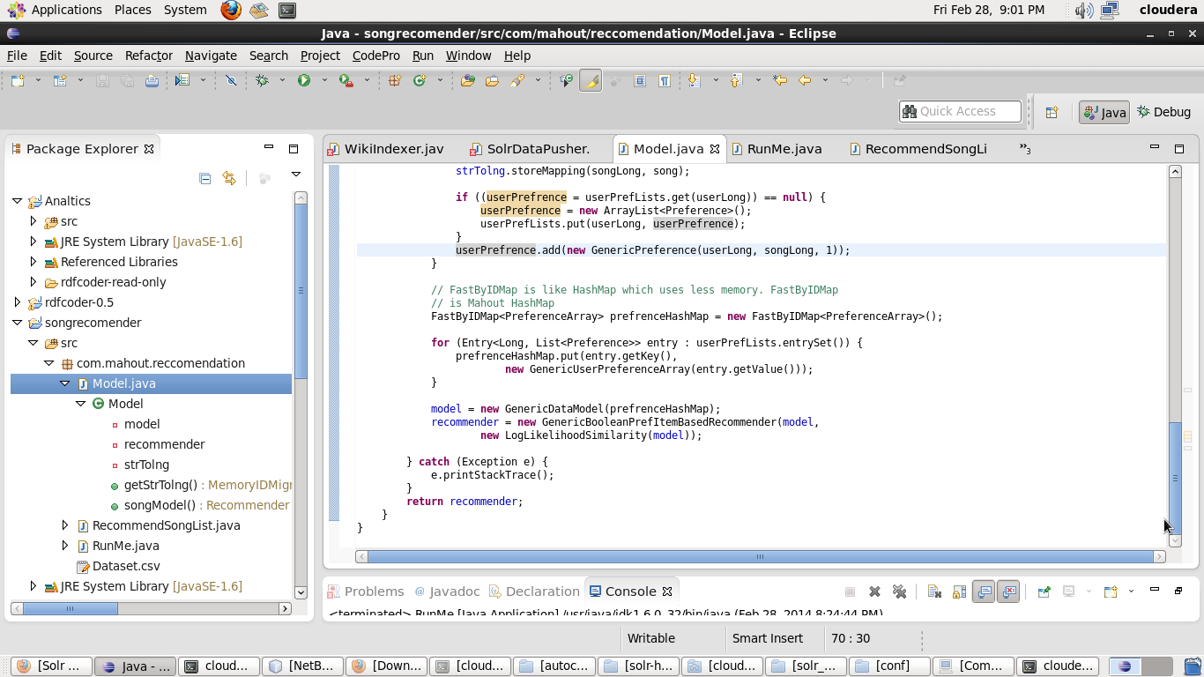

Datasets:
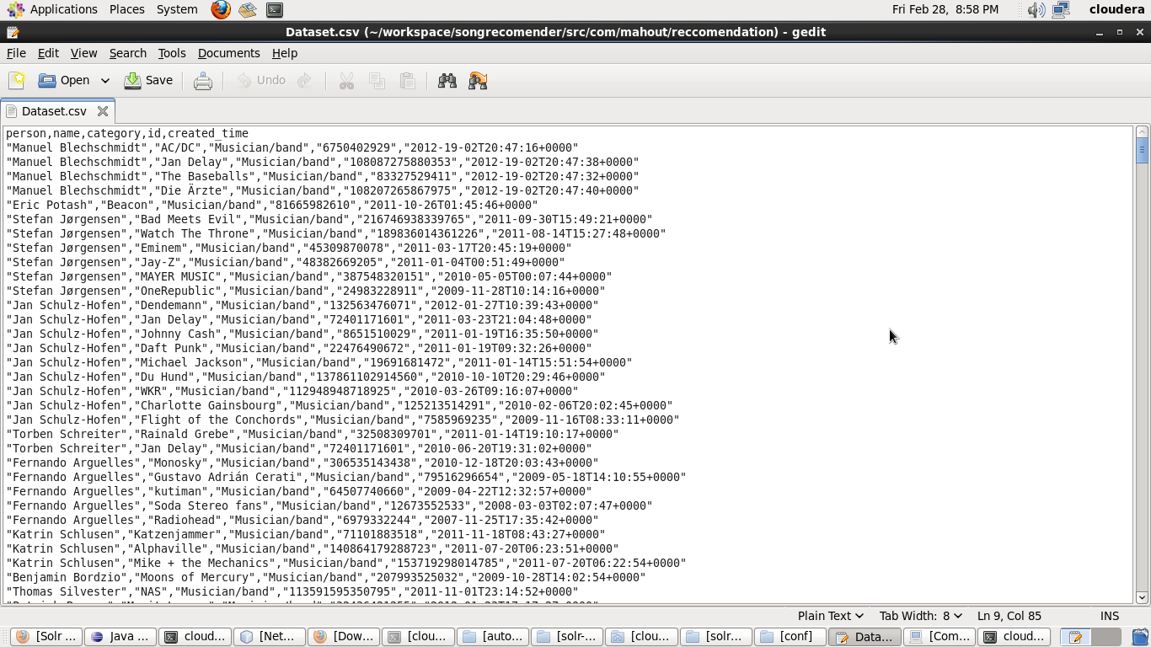

output:
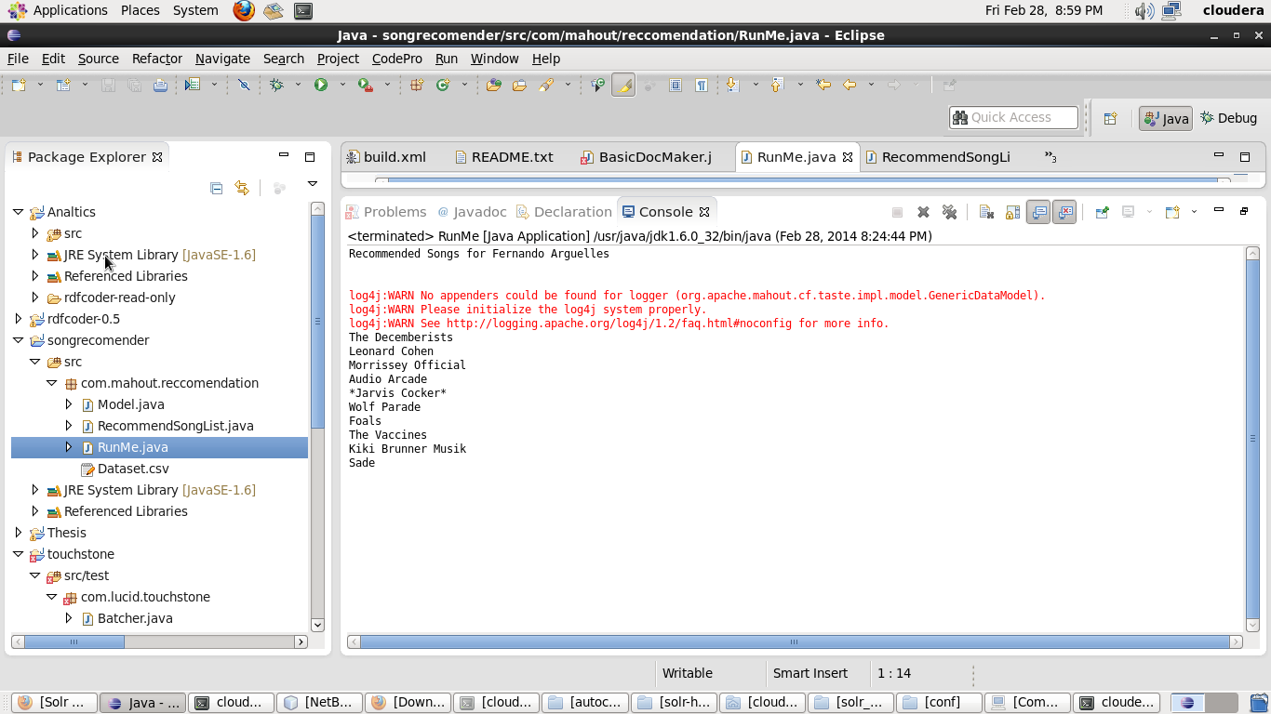

2) Mobile Application
USed JSfiddle to implement my mobile application
Here are the screenshots of my application
Code:
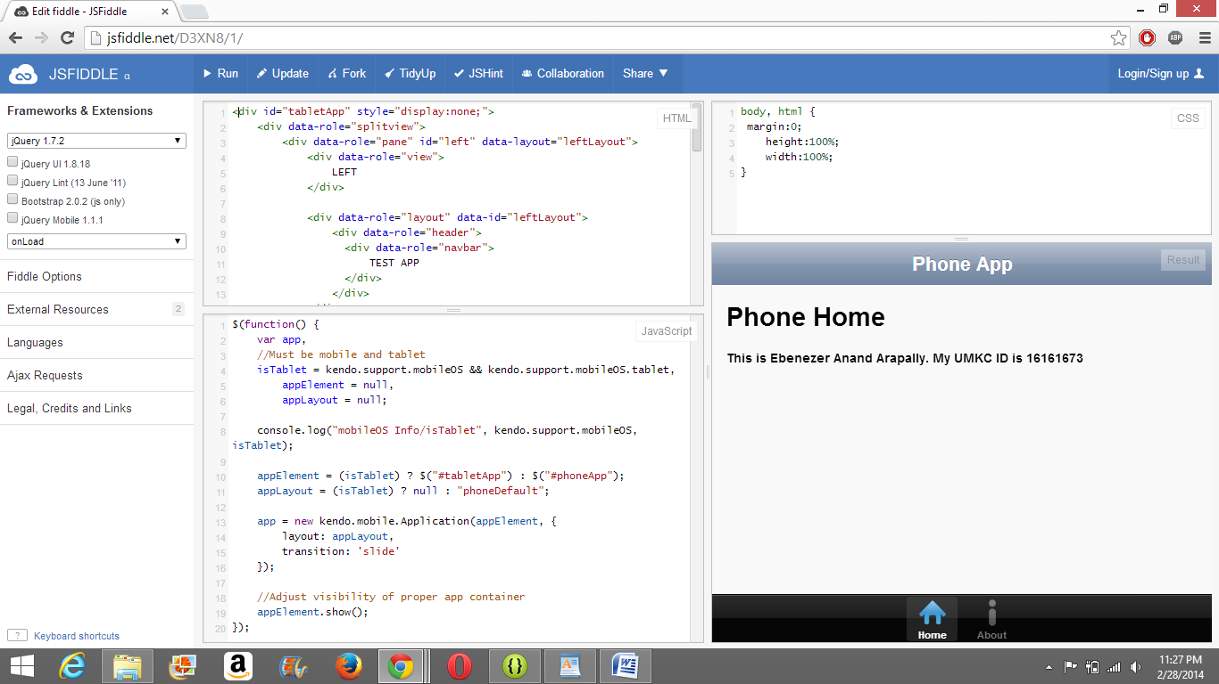

Output:
