|  |
| --- |
| Rolsa |
| Research Documents for Feedback |
| Toby Gore |

|  |
| --- |
|  |

Contents

How To Aid Future Development 3

Gathering Feedback 3

How to gather feedback 3

Making The Form 3

The Design 3

Technical Participants 3

Non-Technical Participants 3

How To Write A Good Questionnaire 4

Relevance 4

Conciseness 4

Clarity 4

Logical Sequencing 4

Sensitivity 4

Pilot Testing 4

Question Types 4

Closed Questions 4

Open Questions 5

Response Scales 5

What Questions To Include 5

The Questionnaire 6

The Sections 6

Section 1 6

Section 2 7

Section 3 9

Section 4 12

Section 5 13

Section 7 15

Section 8 17

Section 9 21

Gathering The Feedback 22

# # How To Aid Future Development

## ## Gathering Feedback

One should gather information on something is the best way to improve its quality. Gathering user feedback on a website is best medium to higher the standards. When taking feedback, it is important to gather critical information to the question at hand.

## ## How to gather feedback

The best way to gather feedback is to ask the user on a one-to-one basis; while this does work it becomes difficult to make charts of numbers. A more efficient way to give each user a questionnaire to fill out; this less of a human approach and things can go wrong with the site. The best of both would be to have a user fill out a form while being supervised: to ensure that the user gets a good experience of the site, and the form gets good data. To also have a backup of a power point of what the site is like, should features on the site stop workings, to show the user. To get a higher number of users to give feedback the best thing to do is to offer an incentive to them.

# # Making The Form

## ## The Design

When designing a questionnaire, a crucial initial step involves identifying the target demographic. In this instance, the participants can be broadly categorised into those with technical expertise and those without.

### ## Technical Participants

These individuals possess a demonstrable level of competence in computer systems and software development. Their experience may range from a foundational understanding to advanced proficiency in software engineering principles and practices.

### ## Non-Technical Participants

This group, conversely, lacks formal training or significant practical experience in software development or computer systems.

Accurately classifying participants is paramount for tailoring the questionnaire's language and complexity, ensuring its accessibility and relevance. While a direct "yes/no" question could offer a rudimentary classification, a more nuanced approach is preferable. This could involve a preliminary assessment of participants' educational background, professional experience, or self-reported technical skills. For example, participants could be asked to rate their proficiency in specific software or programming languages, or to describe their experience with software development methodologies.

## ## How To Write a Good Questionnaire

Crafting an effective questionnaire necessitates meticulous attention to detail and adherence to established best practices. The following principles are crucial.

### ### Relevance

Each question must directly contribute to the research objectives, avoiding extraneous or tangential inquiries, e.g. "do you like butter on your toast?".

### ### Conciseness

Questions should be brief and to the point, minimising cognitive load and maximising participant engagement.

### ### Clarity

Employing straightforward, unambiguous language is essential. Avoid jargon, technical terms, or overly complex sentence structures that may confuse respondents.

### ### Logical Sequencing

Questions should be arranged in a logical order, progressing from general to specific, and grouping related items thematically.

### ### Sensitivity

Handle sensitive or confidential data (e.g., personal information) with the utmost care, adhering to ethical guidelines and data protection regulations.

Neutrality: Questions should be phrased in a neutral, unbiased manner, avoiding leading questions or those that may influence responses.

### ### Pilot Testing

Before widespread distribution, the questionnaire should be rigorously tested with a representative sample to identify any potential ambiguities, inconsistencies, or areas for improvement.

## ## Question Types

### ### Closed Questions

These offer pre-defined response options, facilitating quantitative analysis and minimising response variability.

### ### Open Questions

While valuable for gathering rich, qualitative data, these require more time and effort from participants and are more challenging to analyse systematically. Their use should be judicious and purposeful. It is important to note that closed questions, whilst easier to analyse, can sometimes force respondents into categories that don't truly reflect their views. Therefore, a balance of both is often advocated.

### ### Response Scales

When using scales (e.g. Likert scales), avoid a neutral midpoint (e.g. "neither agree nor disagree") to encourage respondents to express a definite opinion.

Where to write the questionnaire, several platforms are available for creating and hosting online questionnaires. While platforms like Microsoft Forms offer branching logic and integration with other Microsoft products, my proficiency lies in leveraging Google Forms. This platform provides a user-friendly interface, robust data analysis capabilities, and seamless accessibility for participants. The selection of a platform should be driven by factors such as the researcher's familiarity, the platform's features branching logic, data export options, and its compliance with data protection regulations.

## ## What Questions to Include

The questionnaire should elicit information relevant to the research objectives. At a minimum, it should include the following.

#### ### Participant Identification

An email address and name are necessary for tracking responses and, if applicable, for follow-up communication. However, it's vital to consider data protection and anonymity requirements.

#### ### Technical Background

Questions regarding the participant's current employment or education are essential for categorising them as technical or non-technical. This section could be expanded to include specific questions about their experience with relevant technologies, programming languages, or software development methodologies.

#### ### Website Evaluation

Questions should assess the quality, usability, robustness, and aesthetic appeal (styles and colours) of the website under evaluation. These questions should be carefully crafted to elicit specific, actionable feedback.

Form Evaluation: An overview of the form itself is needed to gauge the accuracy and reliability of the collected data. This could include questions about the clarity of instructions, the ease of navigation, and the perceived length and complexity of the questionnaire.

# # The Questionnaire

## ## The Sections

The form has been split up into 9 bite-sized sections, this is to keep the user engaged with each section; each section covers a different part of the website with a few questions to answer; in each section covers the minimum number of questions for the user to answer.

### ### Section 1

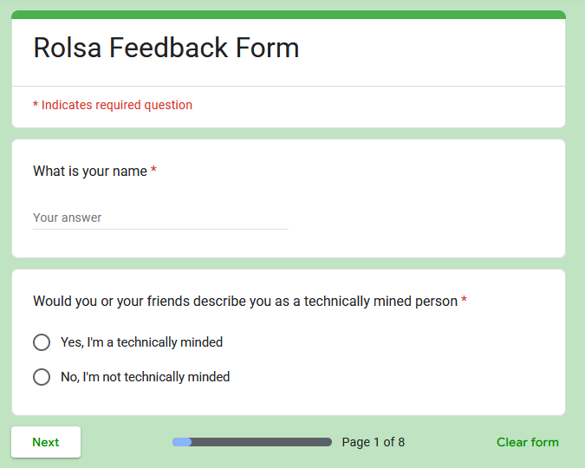

1. What is your name
   * this question aims to simply ask the user their name for later identification
2. Would you describe yourself as a technically minded person
   * this question aims to ask the user if they can be asked the more technical questions in the form
   * either answering “yes” or “no”

### ### Section 2

1. What is the title of the course you are studying
   * short text
   * this is to gauge a feel for how level the user is with technical experience
2. Looking at the screen shots, how do you feel robustness was handled
   * a range of 1 to 6, of poor to good
   * this aims to ask if they think error handling practices where to an acceptable level
3. How easily can you understand the code base
   * a range of 1 to 6, of unintelligible to easy
   * this aims to ask if the layout and formatting of the code works a treat or not
4. Would you be able to continue development on the website
   * a range of 1 to 6, of "not without great difficulty" to easily
   * this asks the user on the ability to read, understand, and write in the languages used

### ### Section 3

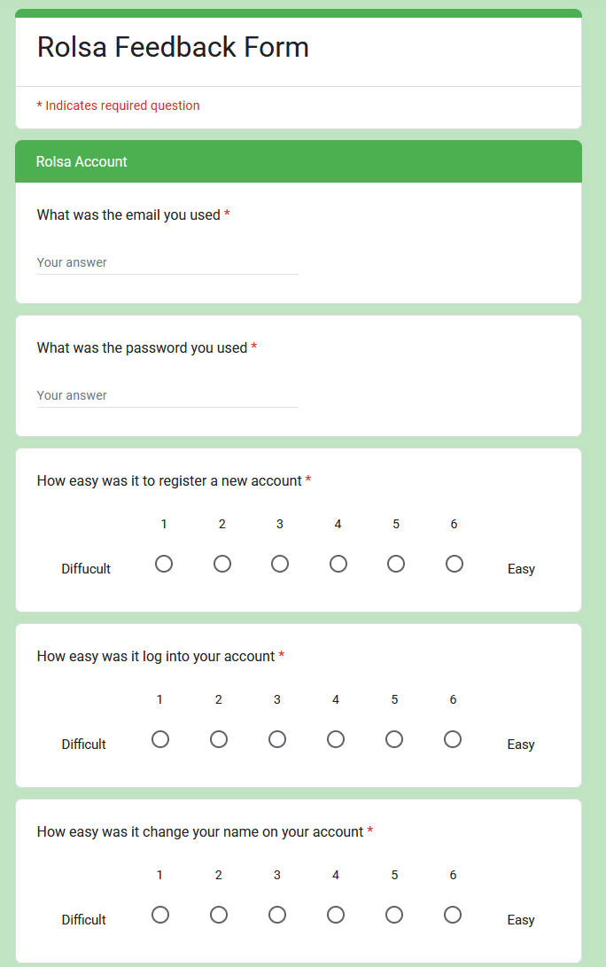

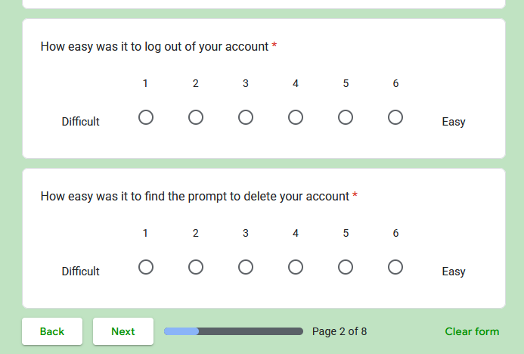

1. What was the email you used for the account
   * this question gets the user to make a copy of their email they used
   * the user’s email can be used later if needed to know what accounts can be deleted
2. What was the password you used for the account
   * this question aims to get the users password should the account need to be accessed later
3. How easy was it to register a new account
   * a range of 1 to 6, of difficult to easy
   * this aims to look for room to improvement in the account registration
4. How easy was it log into your account
   * a range of 1 to 6, of difficult to easy
   * this question aims to see if there was a part that could be used to help improve the login system
5. How easy was it change your name on your account
   * a range of 1 to 6, of difficult to easy
   * this question aims to indemnify how easy it was for a user how wants to change their name to do so
6. How easy was it to log out of your account
   * a range of 1 to 6, of difficult to easy
   * this question asks if there was any unintuitive design to being able to logout
7. How easy was it to find the prompt to delete your account
   * a range of 1 to 6, of difficult to easy
   * this question asks if there was any unintuitive design to being able to delete an account

### ### Section 4

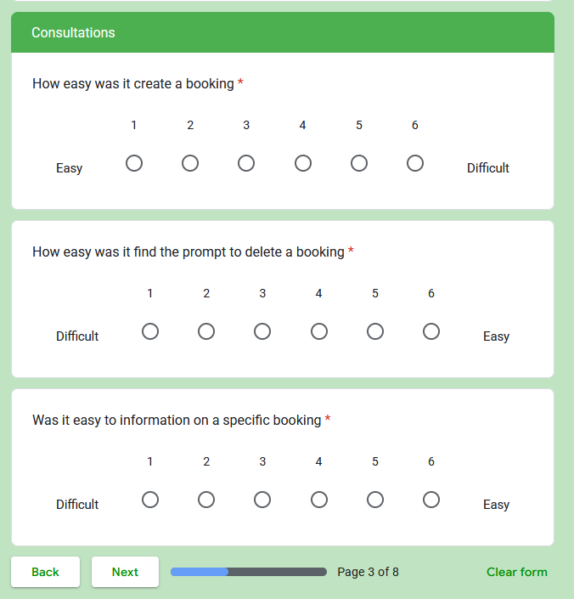

1. How easy was it create a booking
   * a range of 1 to 6, of difficult to easy
   * this question aims to answer the questions of "is there poor design choice in the booking system"
2. How easy was it find the prompt to delete a booking
   * a range of 1 to 6, of difficult to easy
   * this tries to pin-point any parts that might be unhelpful
3. Was it easy to information on a specific booking
   * a range of 1 to 6, of difficult to easy
   * when looking at the overview of bookings is it simple and easily understood information

### ### Section 5

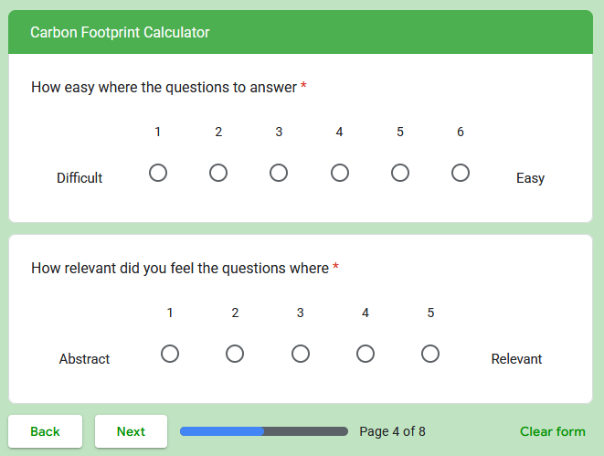

1. How easy where the questions to answer
   * a range of 1 to 6, of difficult to easy
   * this asks if there are any problems with language or design in the calculator
2. How relevant did you feel the questions where
   * a range of 1 to 6, of abstract to relevant
   * this aims to see if the questions' subjects need further refinement

##### ### Section 6

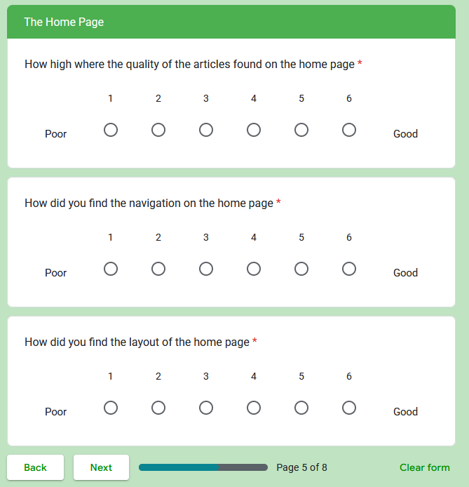

1. How high where the quality of the articles found on the home page
   * a range of 1 to 6, of poor to good
   * this points to further improvement with the articles and the website as whole, to it quality of language
2. How did you find the navigation on the home page
   * a range of 1 to 6, of poor to good
   * this aims to ask if the navigation and layout requires further iteration
3. How did you find the layout of the home page
   * a range of 1 to 6, of poor to good
   * this aims to see if the navigation was hindered by layout or macro design of the site

### ### Section 7

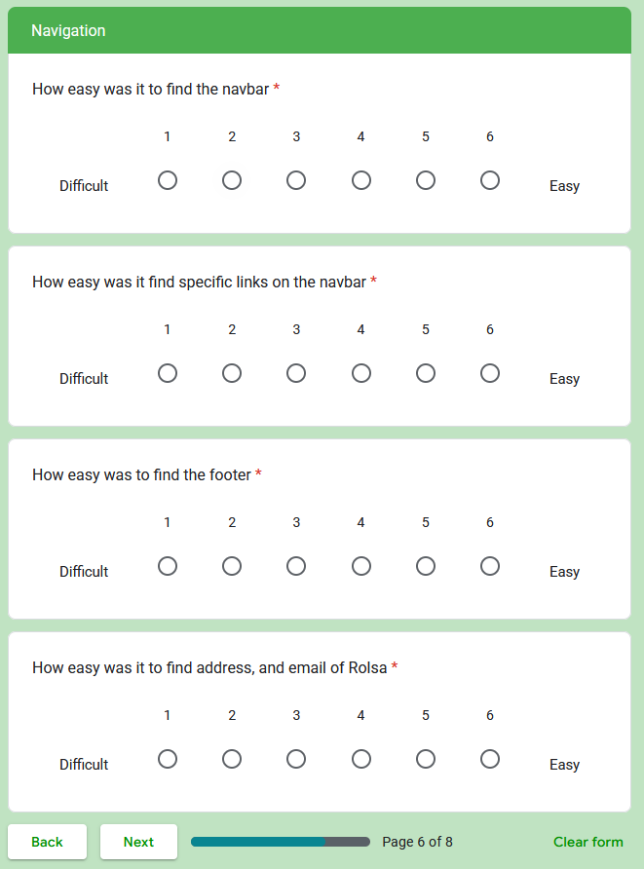

1. How easy was it to find the navbar
   * a range of 1 to 6, of difficult to easy
   * this aims to see if the macro design was that of an institutive design or not
2. How easy was it find specific links on the navbar
   * a range of 1 to 6, of difficult to easy
   * this question sees if there is an issue with using icons or text for any links or the layout of the navbar
3. How easy was to find the footer
   * a range of 1 to 6, of difficult to easy
   * this asks a question on the macro design of the website of how easy it was all to find
4. How easy was it to find address, and email of Rolsa
   * a range of 1 to 6, of difficult to easy
   * this asks the user 2 questions in 1
     + "Could you actually find the footer"
     + "Was the footer easy to find information inside of"

### ### Section 8

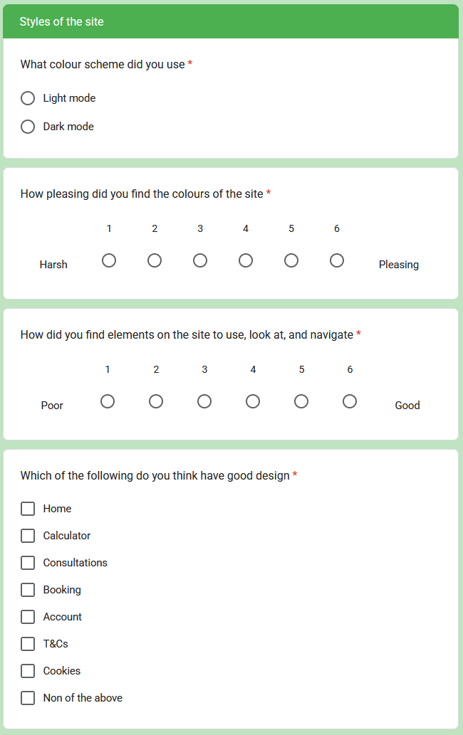

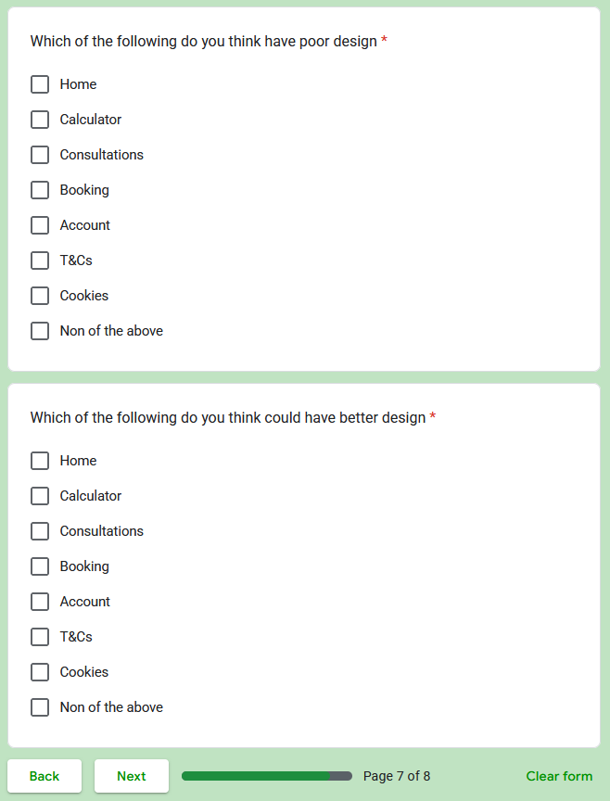

1. What colour scheme did you use
   * answers
     + light
     + dark
   * this gets 2 birds with 1 stone, asking
     + "Is light mode or dark mode preferred by most"
     + "Is there an issue with the macro design independent of colour scheme"
2. How pleasing did you find the colours of the site
   * a range of 1 to 6, of harsh to pleasing
   * this asks if any colour scheme needs improvement
3. How did you find elements on the site to use, look at, and navigate
   * a range of 1 to 6, of poor to good
   * this asks very directly if the navigation of macro design is poor but also asks if the on micro level, they need improvement
4. Which of the following do you think have good design
   * answers
     + Home
     + Calculator
     + Consultations
     + Booking
     + Account
     + T&Cs
     + Cookies
     + Non of the above
   * this asks which have design that can left in lower priority if they require further development
5. Which of the following do you think have poor design
   * answers
     + Home
     + Calculator
     + Consultations
     + Booking
     + Account
     + T&Cs
     + Cookies
     + Non of the above
   * this asks independently if a page has poor design, as some pages may have good and poor parts to its design
6. Which of the following do you think could have better design
   * answers
     + Home
     + Calculator
     + Consultations
     + Booking
     + Account
     + T&Cs
     + Cookies
     + Non of the above
   * very similar to the previous 2, this one ask if the user thinks the page may be good but still has head room to improve

### ### Section 9

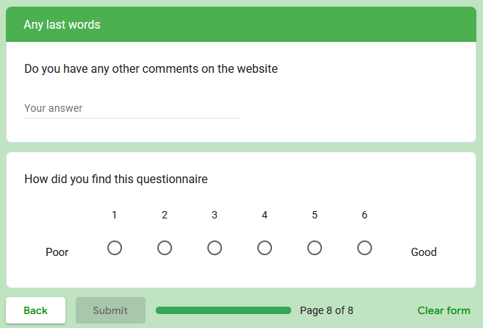

1. Do you have any other comments on the website
   * short text
   * optional
   * this asks for an open answer from the user to get more detailed and higher quality on the whole website
2. How did you find this questionnaire
   * a range of 1 to 6, of poor to good
   * optional
   * this asks how accurate the user's answers might be in response

## ## Gathering The Feedback

As mentioned at the top of the document, the users were asked in turn to look at the website.