Task 2: Test log
Description of test | Test data to be used (if required) | Expected outcome | Actual outcome | Comments and intended actions | Print screens
User sign up. The user is able to create a new account with Rolsa | Email: test@email.com  Name: test name  Password: password | The user should be added to the data base and be able to login | The user was added to the database and can login |  | 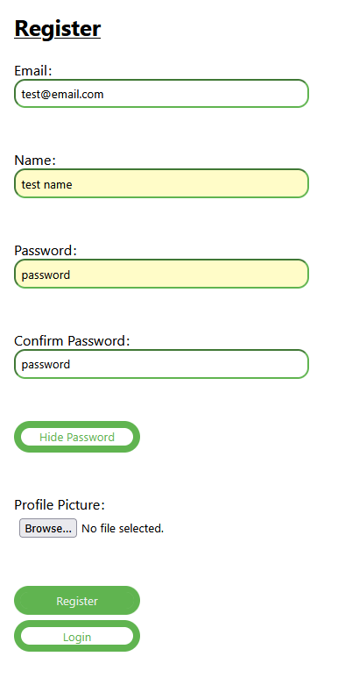
User log in. The user is able to log into their account with Rolsa | Email: test@email.com  Password: password | The user should be logged in and sent to the home page | Once the use presses login they are sent to the home page |  | 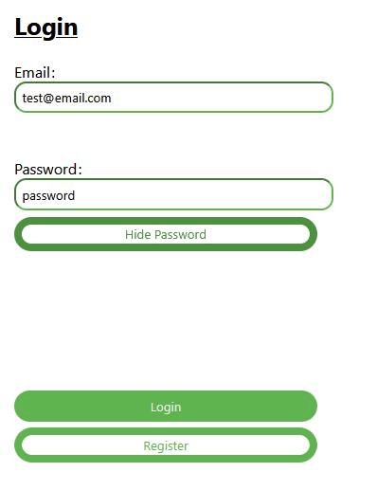  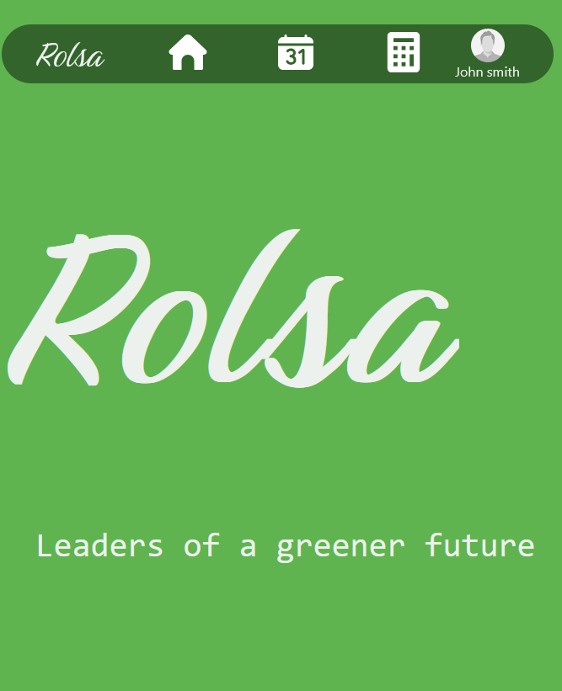
The user should be able to book a consultation | Solar panels  18/05/2025  64 IP2 7EX | The form should be part filled out with the email. Then the BOOK button is pressed, and the user is able to see the booking in their view | The form was part filled out and the form took the new booking |  | 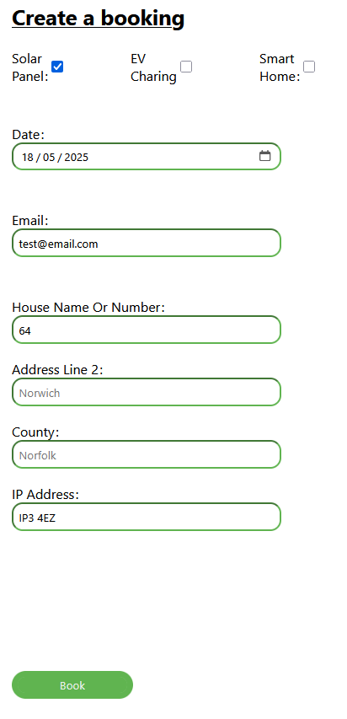  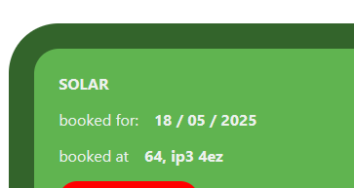
Change account information, with free reign | Test name -> john smith  test@email.com -> john.smith@gmail.com  password -> aBetterPassword | The new information should be updated and put info and be able to log in with their new information | The information was able to updated and changed for the account |  | 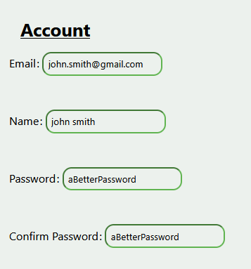  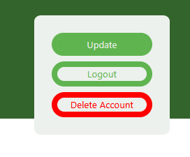
View and calculate carbon footprint |  | It should go question by question asking the user and then generate a score at the end. Then display the average and options | It went question by question and gave a score. With then the average and options |  | 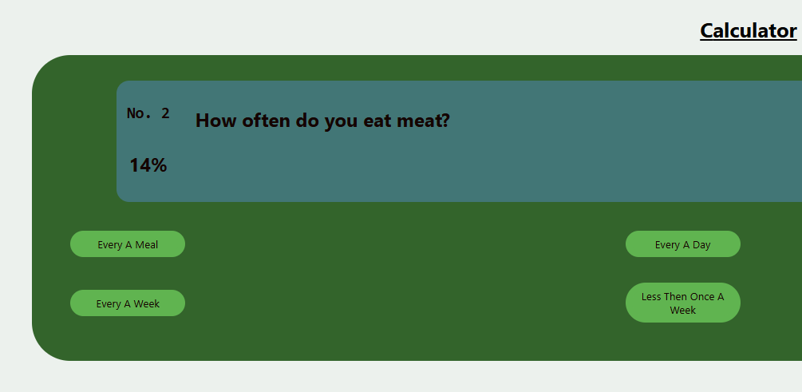  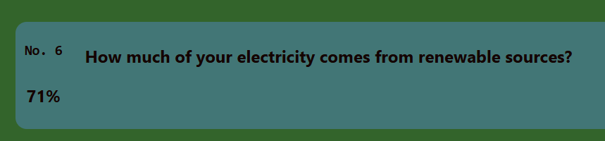  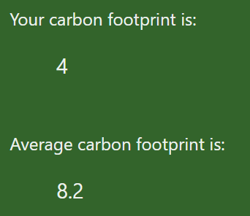  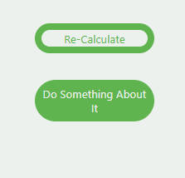
Is the site navigable |  | The site should take no longer than a few seconds per page and users should be able to do anything they are needed in a few clicks. | Timing with a digital stop watch, the site load within a few seconds. The site has passed tests with click maps and has followed standards for web-page layout |  | 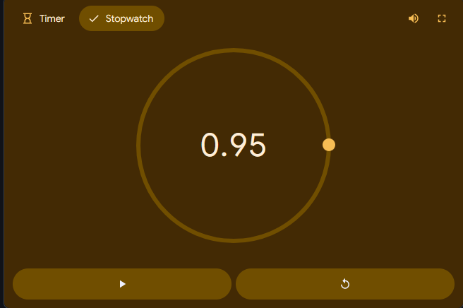  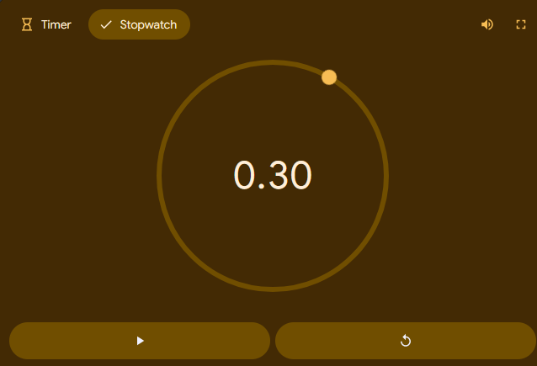  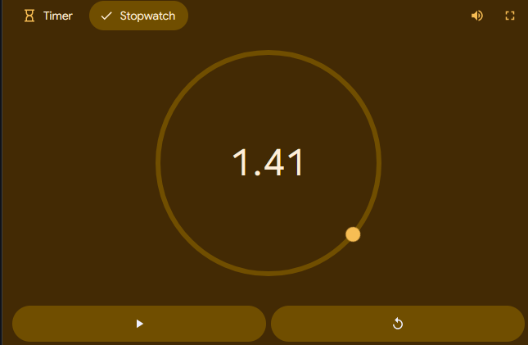  
Can a user cancel a consultation | Consultation 1,  (John.smith@gmail.com)’s account | The booking should have an attached delete booking with then requiring the users | Was |  | 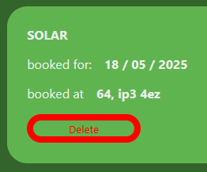  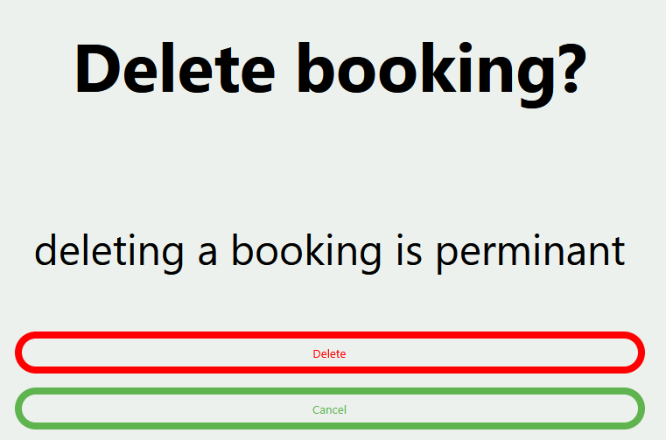  
Can the user log out | test@email.com  password | When the LOGOUT button is pressed the user should be logged out of their account | It logs the user out and updates the nav bar |  | 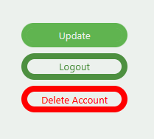  
Is the user able to delete their account | New.email@email.com  Password1 | The account should not be in the data base nor should the user be able to log into the email and the user is able to create a new account under that email | Was able to delete the account |  | 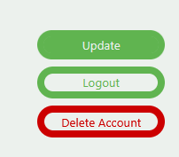  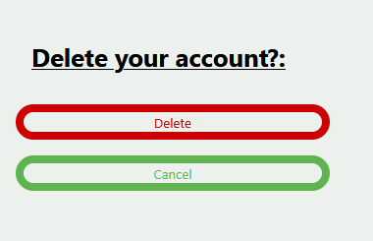
Suggestions on how to reduce carbon footprint |  | After the calculator has made its calculation | The button at current takes you make a booking after saving your score | In future with more data include better options and pages
Navigation to home |  | Can a user get home easily and quickly | Most routes lead to home as a default, and all pages link to home with a user expected standard of a home icon
Navigation to calculator, consultations, and account / login |  | Can a user get to calculator quickly and easily | All routes include the nav bar as part of the page, the nav bar includes links for the calculator, consultation, and account / login |  | 
Little to no PHP errors |  | All errors should be handled and delt with | During development no errors have occurred that weren’t logic errors
Home page with info an products |  | The home page should have lists of information about products and more | There are new articles shown on the home screen | Most on the page are place holder as leaving room in future for actual articles | 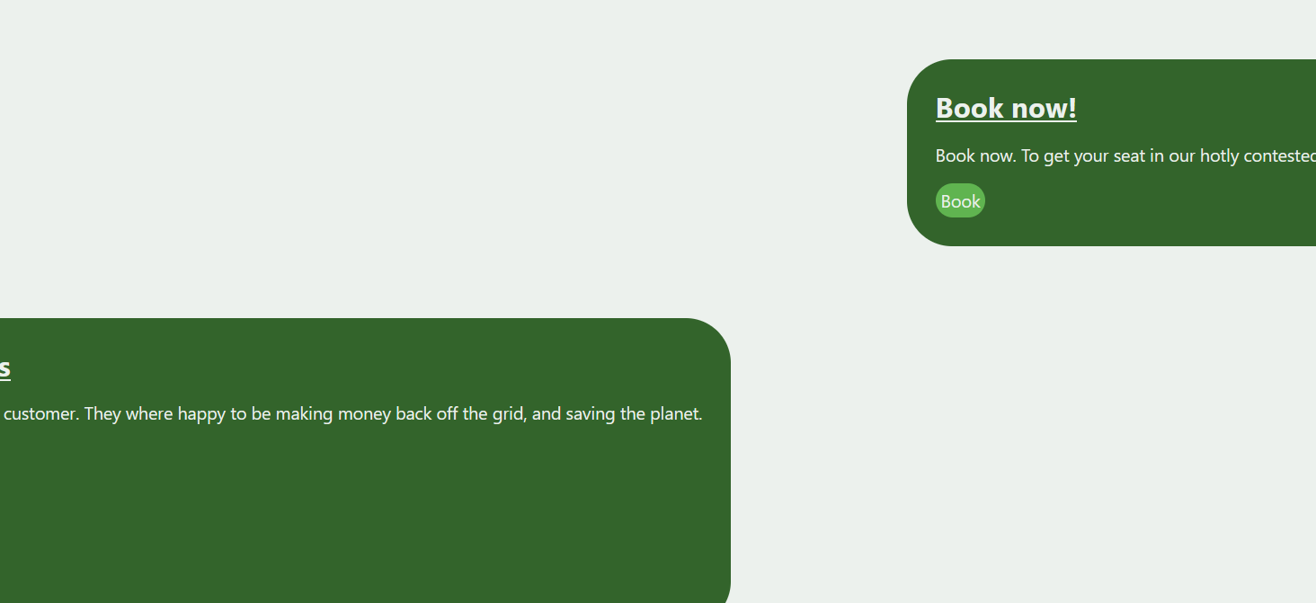
Consistency of colours |  | The colours found across the site should be consistent and same style guidelines | The colours and buttons use the same stylesheet found in SRC/CSS, and all element use the same system of creation
Light and dark mode |  | There should be equivalent light and dark modes for the website | There are light mode and dark modes for either type of user | It uses system settings, in future it should still do this but add a button as well, it should have better dark mode colour scheme for ledgeabilty
Logo, consistency |  | The logo should look the same across the site | The logo to different sizes looks the same |  |     
Consistent layouts |  | The same styles and layout should be kept for all the pages | The nav bar is always at the top, the foot the bottom, the headers changes and keeps the other meta data, styles and order of buttons is the same.
Browser compatibility | Edge, Crome, and Firefox | The site should look the same across the 3 browsers |  |  | Firefox: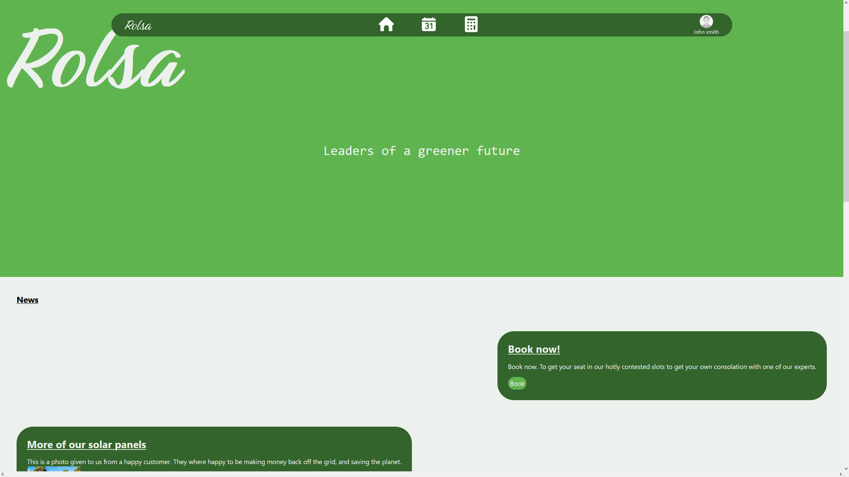  Edge:  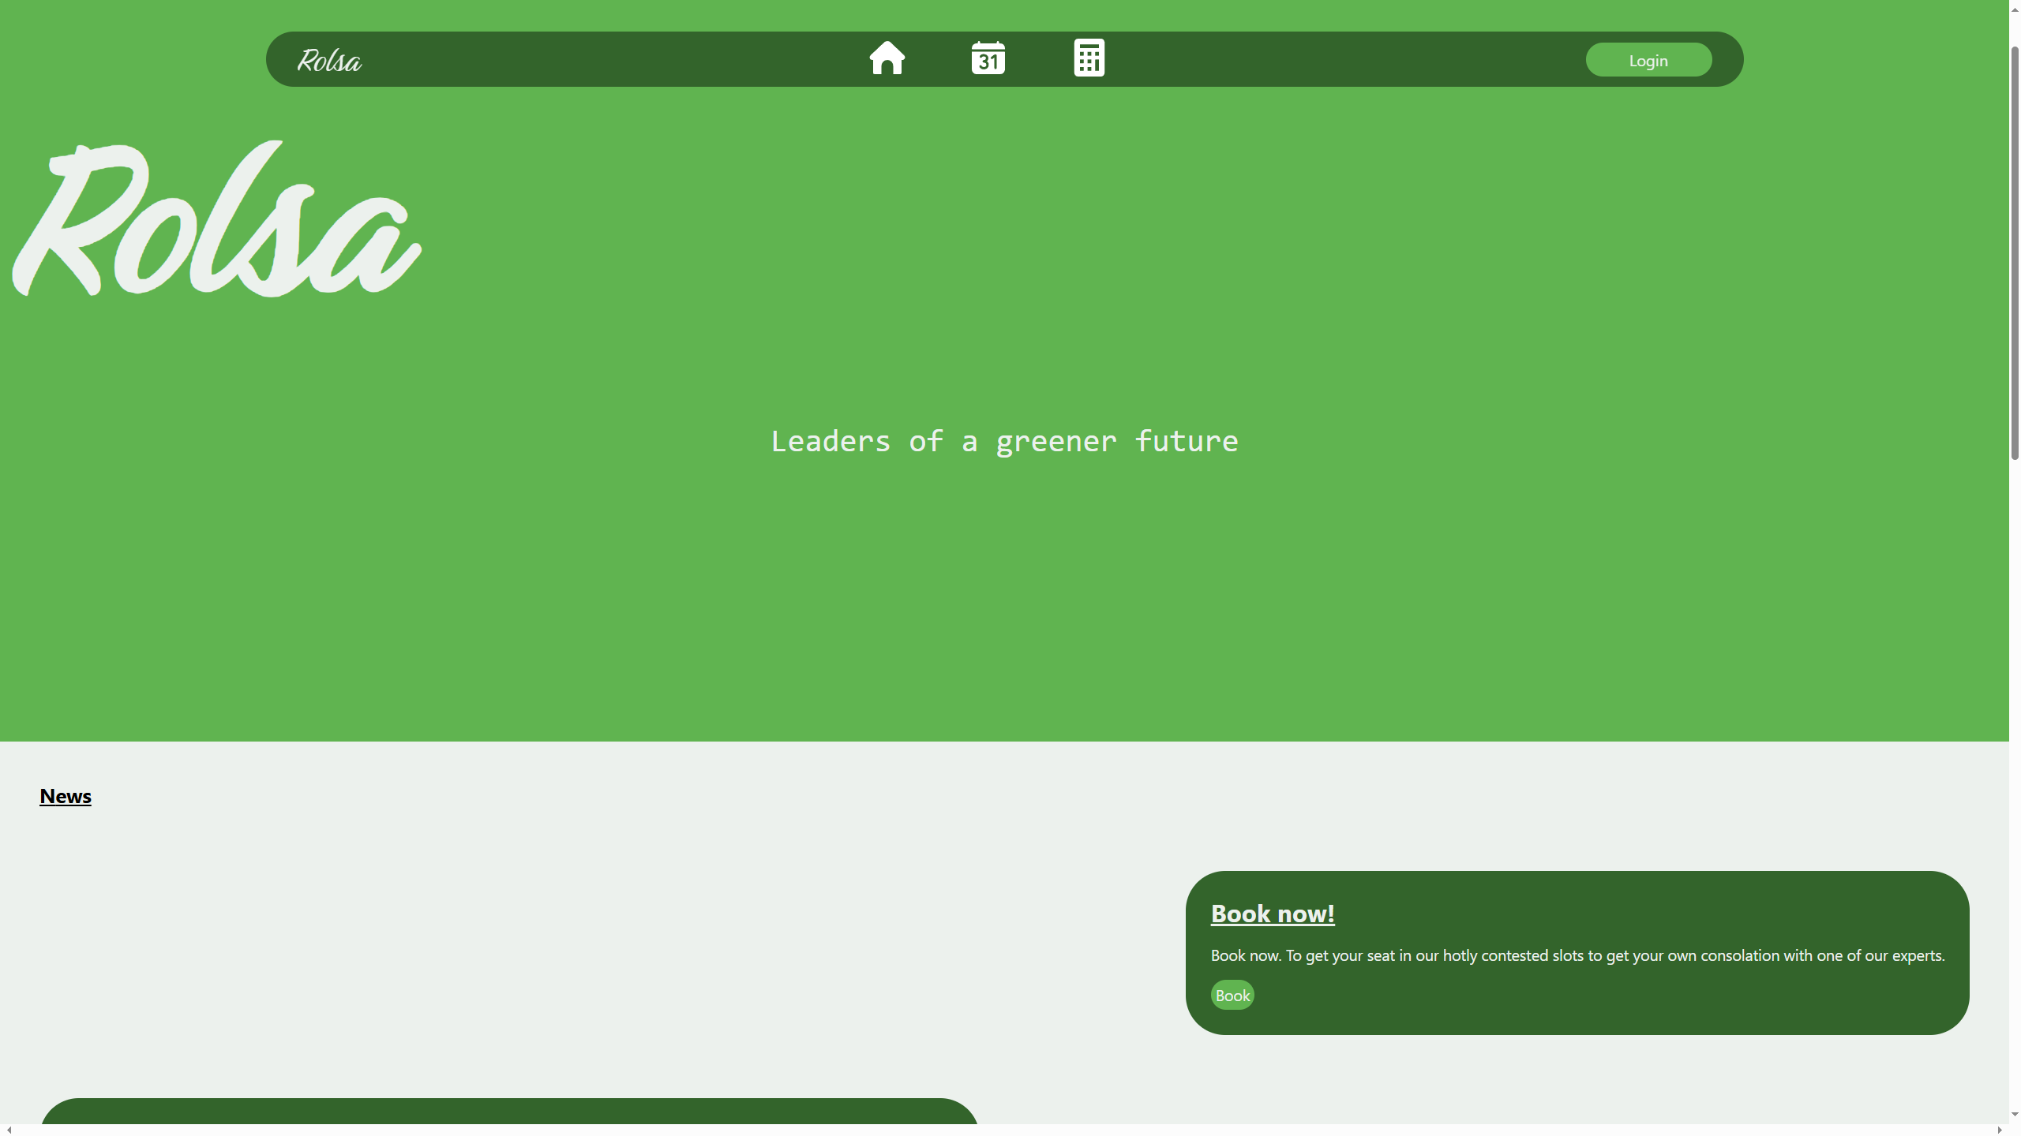  Crome:  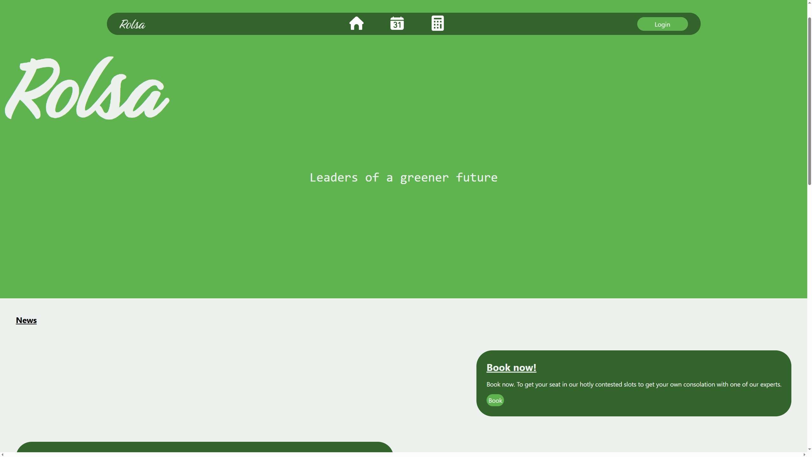  Side by side:  