Master Thesis – Plan
  - Bebelambou Ethan and Melih Taki

Acknowledgements

Abstract

Tables of Contents

List of Figures

List of Tables

List of Abbreviations

Introduction
Introduces the context of railway digital twins, the motivation behind this work, and the objectives pursued throughout the thesis.

Context and Motivation
Presents the challenges faced by modern railway systems and explains the growing need for simulation and digital technologies.

1.2 Problem Statement
Defines the research problem assessed in this thesis and identifies the limitations of existing approaches.

1.3 Objectives
Describes the objectives of the project and the expected outcomes of the proposed solution.

1.4 Thesis Structure
Provides an overview of the organization of the thesis.

State of the Art
Reviews the theoretical and technical foundations required for the development of a railway digital twin.

Digital Twins
Introduces the concept of digital twins and discusses their capabilities and challenges.

Definition, Capabilities and Limitations
Presents the fundamental concepts and characteristics of digital twins.

Recent Developments and Applications
Reviews recent advances and applications of digital twins across different domains.

Applications for Railway networks
Focuses on the adoption of digital twin railway systems.

Railway Systems
Introduces the main concepts of railway infrastructure and operations required for modelling and simulation

Railway Infrastructure
Presents the physical components that constitute a railway network.

Tracks
Description of tracks, tracks section, and their role in train circulation.

Switches and Junctions
Presentation of switches, crossings, and routing possibilities in the network.

Stations and Platforms
Description of stations, platforms and passengers exchange facilities.

Signaling Systems
Overview of signaling principles used to ensure safe railway operations.

Railway Operations
Introduces how railway traffic is organized and managed.

Train movements
Basic principles governing train circulation on railway networks.

Timetabling
Role of schedules and timetable planning in railway operations.

Capacity management
Concepts related to infrastructure capacity and traffic congestion.

Delay propagation
Mechanisms through which disruptions spread across the network.

Railway Network Representation
Presents different representations commonly used to model railway systems.

2.2.3.1 Graph-Based Modelling

2.2.3.2 Physics-Based Modelling

2.2.3.3 Logic-Based Modelling

2.2.4 Railway Data Sources
Reviews the main data sources used for railway modelling.

2.2.4.1 Infrastructure Data
Track topology, switches, stations and signaling information.

2.2.4.2 Operational Data
Train movements, delays, schedules, and traffic information.

Railway Simulators
Reviews the existing railway simulation platforms and compares their suitability for digital twin Applications.

Overview of Existing Simulators
Presents used railway simulation platforms.

Comparative Analysis
Compares the identified simulators according to technical and operational criteria.

SUMO: General Features
Introduces SUMO and its general simulation capabilities.

SUMO Backend Architecture
Describes the internal architecture and extensibility of SUMO.

SUMO for Railway Simulation
Presents the railway-specific functionalities available in SUMO.

Simulation Calibration

Research Gap
Summarizes the limitations identified in the literature and motivates the proposed work.

Proposed Methodology
Presents the original contributions of this thesis and positions of the proposed work with respect to existing research.

Positioning of This Work
Explains how the proposed approach addresses the limitations identified in the literature.

Framework
Presents the overall architecture of the proposed approach.

Why SUMO?
Justifies the choice of SUMO as the simulation platform.

Data Available
Describes the datasets used to construct and validate the digital twin.

Infrastructure Data
Presents infrastructure and network level datasets.

Macro-Level Data

Micro-Level Data

Operational Data
Presents operational data datasets such as train movements, delays, and punctuality records.

Implementation plan
Provides an overview of the implementation strategy and methodology.

Implementation
Describes the technical implementation of the proposed approach.

Macro-Level Modeling
Presents the generation of a railway network model from operational and macro infrastructure data.

Data Processing Pipeline
Describes the ETL pipeline used to collect, clean, and transform infrastructure and operational data.

Railway network Generation
Explains how the railway network is reconstructed and converted into a simulation-ready model.

Trip generation

Simulation
Presents the simulation environment and generated scenario.

Limitations
Discuss (briefly) the limitations of the macro-level model.

Micro-Level Modeling
Presents the generation of a railway network model from operational and micro infrastructure data.

Data Processing Pipeline
Describes the ETL pipeline used to collect, clean, and transform infrastructure and operational data.

Infrastructure Modeling
Presents the algorithms developed to model railway infrastructure elements.

Switch detection
Explains the identification of railway switches from infrastructure data.

Platform Detection
Presents the methodology used to identify station platforms.

Track segmentation
Explains how railway tracks are partitioned into operational segments.

Dual Graph Construction
Presents the dual graph representation used for routing and pathfinding.

Trip Generation

Random Trips

Real Data Trips

Simulation
Presents the simulation environment and generated scenario.

Limitations

Discuss (briefly) the limitations of the macro-level model.

Results
Presents and analyses the results obtained from the modeling and simulation processes.

Dataset Validation
Evaluates the quality and completeness of the generated railway dataset.

Station Coverage
Analyses the number of detected stations and their correspondence with the reference data.
 | Reference Data | Simulation Data | Coverage
Macro simulation | 1337 stations | 1327 stations | 98.80%
Micro simulation | 554 stations | 553 stations | 99.82%

Platform and Track Coverage
Evaluates the quality of platform and tracks.
 | Reference Data | Simulation Data | Coverage
Stations Platforms | 1560 platforms | 1551 | 99.42%
Tracks (Macro simulation) | 1385 tracks | 1385 tracks | 100%
Tracks (Micro simulation) | 25068 tracks | 26721 tracks | 106.59%

Infrastructure Modeling Results
Presents the performance of the infrastructure extraction algorithms.

Detected Stations, Platforms and Switches
Analyses the accuracy of the generated railway infrastructure.
 | Reference Data | Simulation Data | Coverage
Switches | 10379 switches | 12343 switches | 118.92%

References data is given from DTSC which has private data from Infrabel.
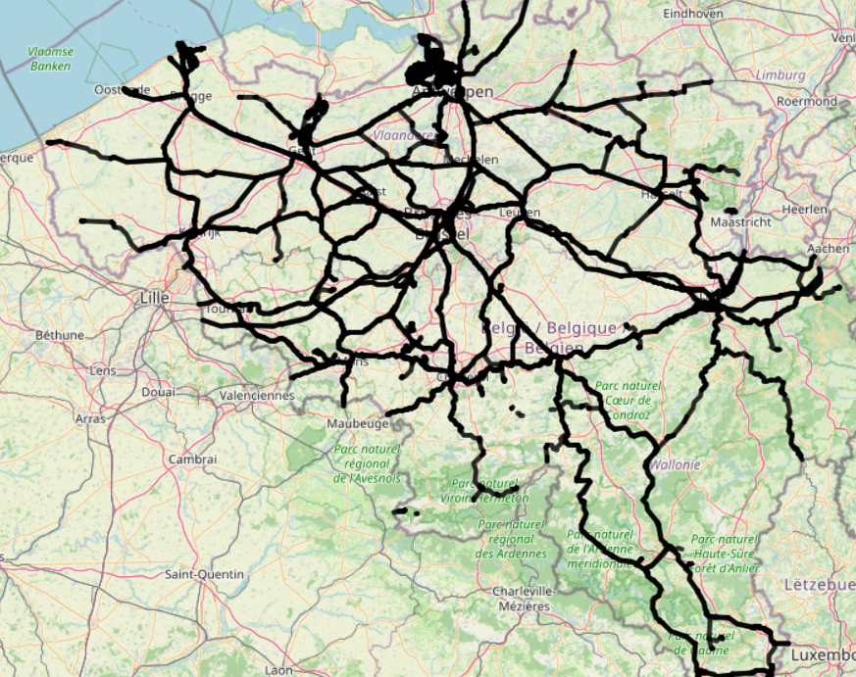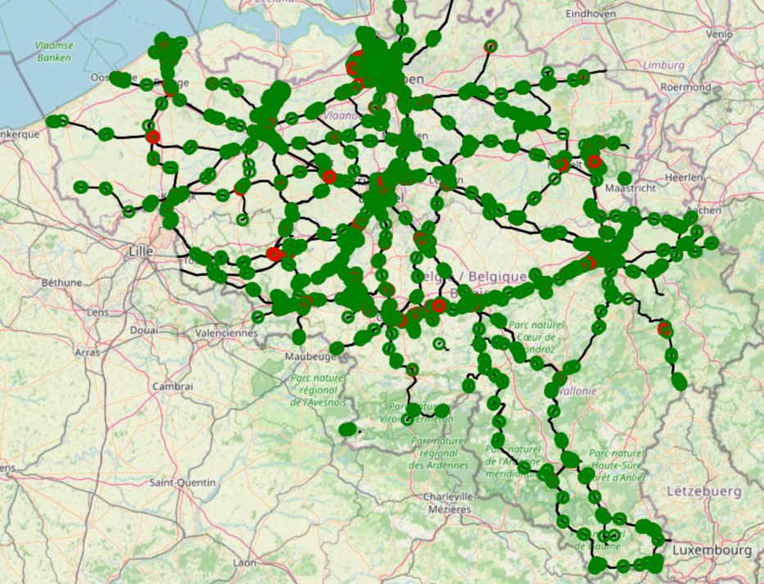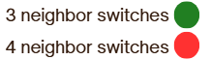
Network before (left) and after (right) Switch Detection

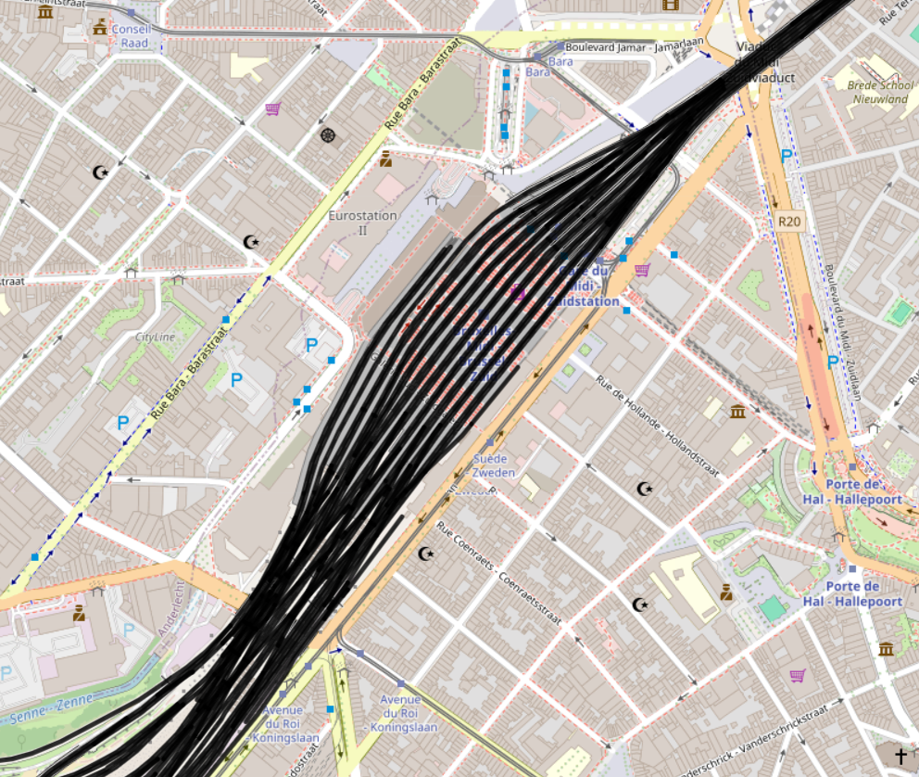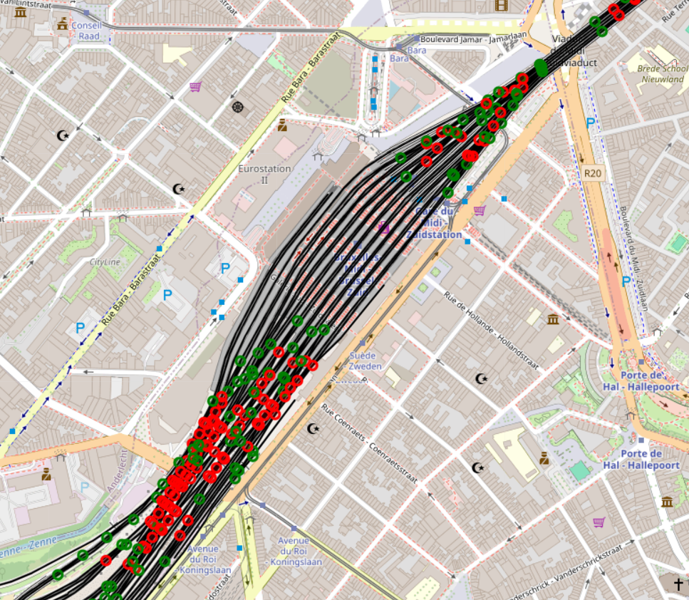
Bruxelles-Midi before (left) and after (right) Switch Detection
 | Detected percentage
Stations (Macro simulation) | 99.85%
Stations (Micro simulation) | 99.82%
Platforms (only Micro simulation) | 99.42%
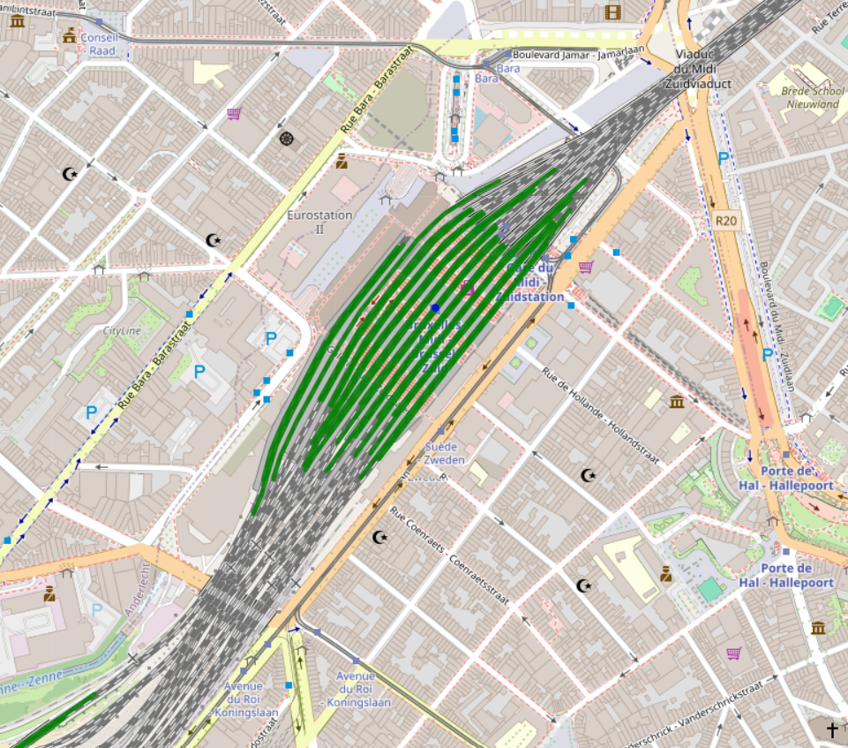
Plaform Matching result on Bruxelles-Midi
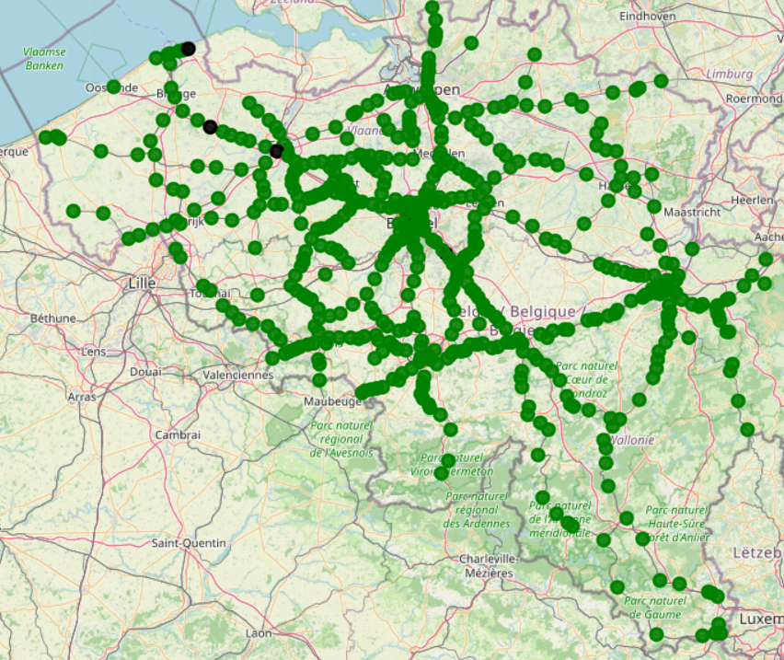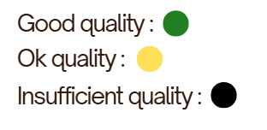
Platform Matching quality map
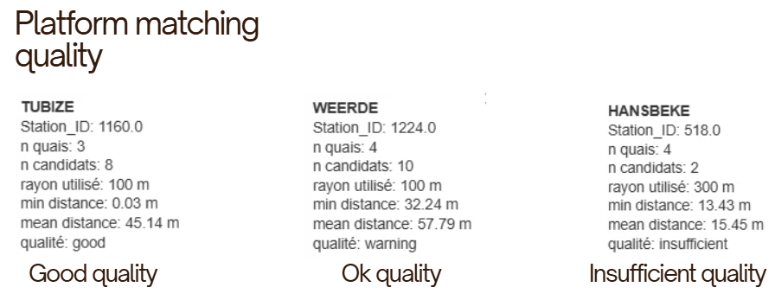

Simulation Results
Evaluates the behavior of the simulation.

Computational Performance
Analyses execution times, scalability, and computational requirements.

Discussion
Interprets the results and discuss their implications for railway digital twins.

Limitations
Discusses the main limitations of the proposed methodology and implementation.

Data Availability and Quality
Discusses the limitations related to infrastructure and operational datasets.

Modeling Assumptions
Analyses the assumptions made during network generation and simulation.

SUMO Constraints
Discuss limitations imposed by the simulation platform.

Generalization and Transferability
Evaluates the applicability of the proposed approach to other railway networks.

Conclusion
Summarizes the main contributions and findings of the thesis.

Summary of Contributions
Recalls the principal scientific and technical contributions of the work.

Key Findings
Highlights the most important results obtained during the project.

Practical Implications
Discusses the relevance of the proposed framework for railway operators and researchers.

Future Directions
Presents potential extensions and future research opportunities.

Counterfactual Simulation and What-If Scenarios

Tracks Works Planning

Real-Time Forecasting and Incident Propagation

Framework Generalization

Final Remarks
Concludes the thesis and reflects on the future of railway digital twins.

