Site Navigation

sample site URL – from beth:

<https://htmlpreview.github.io/?https://github.com/ebeebons/ccc/blob/master/index.html>

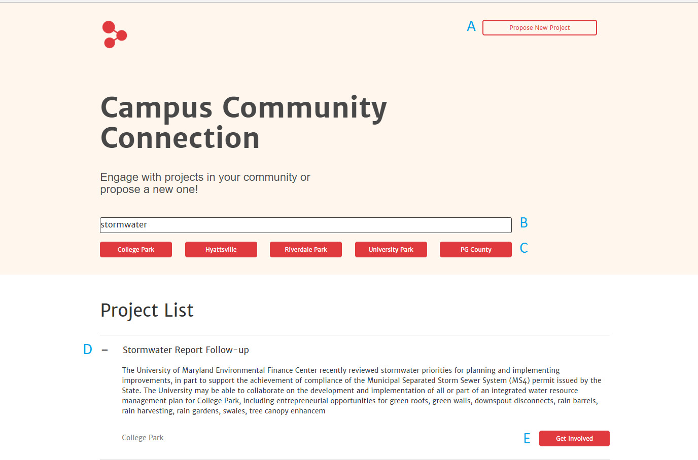

Each blue letter is a labeled interactive feature.

**A:** Button which links to a google form; which is filled out to propose a new posting to the admin.

**B:** Live filter search which eliminated projects from the project list irrelevant to the current terms.

**C:** Area based filter buttons. Clicking any of the buttons removes all projects outside that municipality.

**D:** + or – toggle button, which expands or collapses the relevant project entry (currently expanded).

**E:** Button which takes user to a google form for contact info to get in touch with project managers.

Proposing a Project

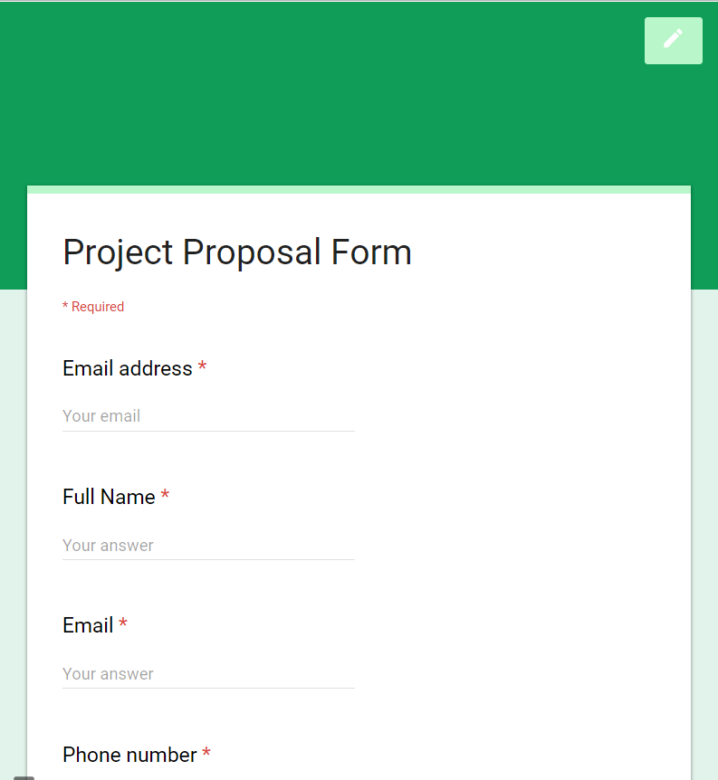

Item **A** from page 1 redirects to this form. Once the form is filled out and submitted, a consolidated email is sent to the admin’s google account. It is then the admin’s responsibility to reach out with further opinions.

Contributing to a Project

Item **E** from page 1 redirects to this form. Once the form is filled out and submitted, a consolidated email is sent to the admin’s google account. It is then the admin’s responsibility to reach out with further instructions on how to get involved. (There is a “Get Involved” button for each Project.)

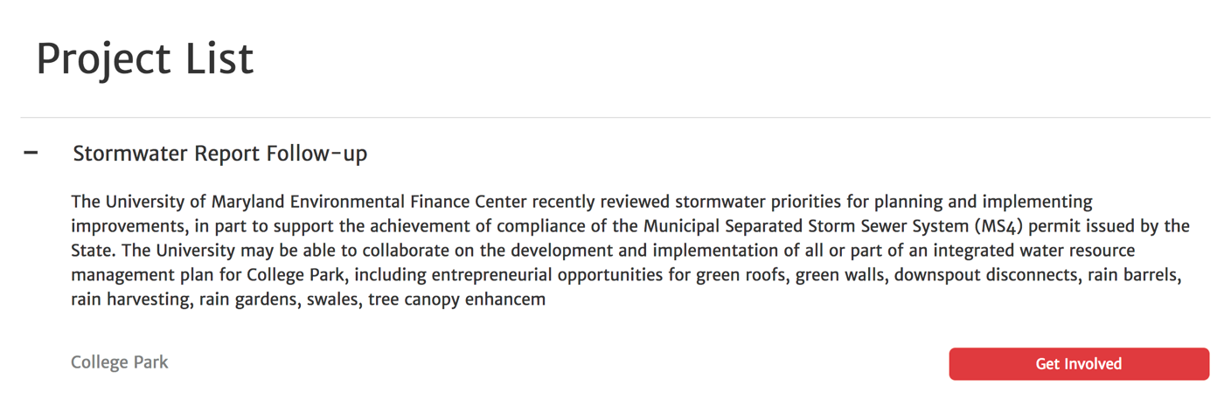

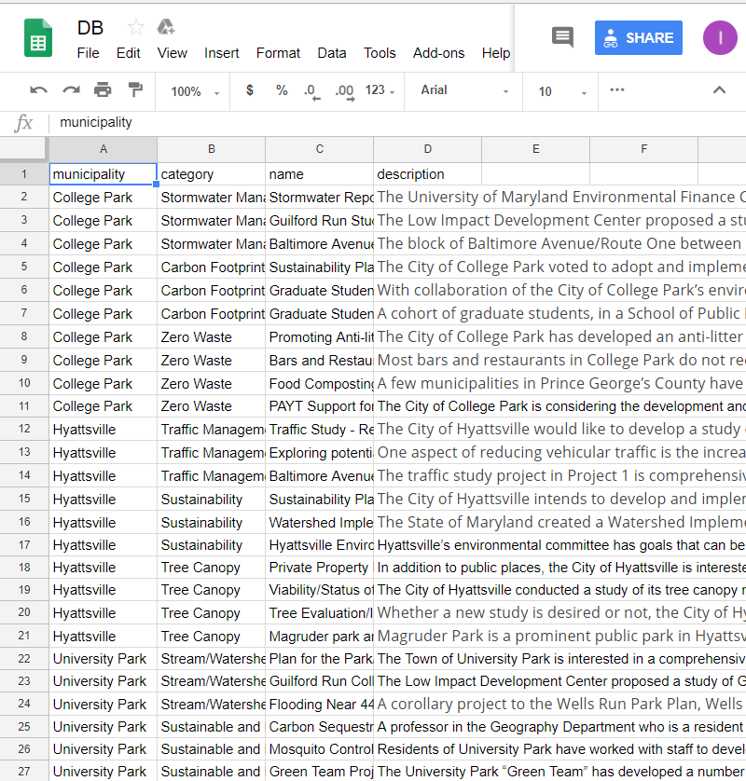Adding a Project Listing

1: Navigate to

<https://docs.google.com/spreadsheets/d/12TaWxdp5gRuULZsBL2eGdM01NpohOHqyKRv9-HGL2ZU/> while logged in to the google account with edit access.

2: Fill in individual columns at the bottom of the spreadsheet with the relevant information, making sure to spell municipalities correctly! The webpage will update automatically.