Eduardo Bellani
Brazil - SC - Florianopolis
✆ +55 48 96080745
☎ skype: eduardo.bellani
✉ email
✎ blog

Software Artisan & Interdisciplinary
Connector
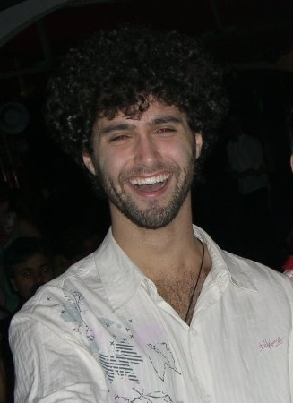

Curriculum Vitae

Open Source Projects

➥ DrFuzzy a file finder/opener for DrScheme based on Jamis Buck’s fuzzy file finder.

➥ Has many polymorphic friends, a rails plugin based on the has many friends.

➥ Anything else in github. It is pretty dynamic in there, since I work on several different things at a time. Feel free to browse around.

Technical Skills

➥ Programming Languages: Scheme, C, Ruby, Javascript, Bash

➥ Taste: I like to think that I have a little of that thing called taste.

➥ Design philosophy: I use design practices from competent sources [1, 2, 3] such as I can. I try my best to grow code from data analysis, using the paradigm that fits better to the problem.

➥ Programming practices: I try hard to do my work in an egoless and pragmatic fashion.

➥ OS: I mostly use Ubuntu, sometimes Debian or Suse. I’ve installed and played around with some BSDs.

➥ Preferred development tool: VIM, Emacs and DrScheme for all schemy things.

Professional Experience

2009 ➥ Educator and Researcher. I have been using HTDP and SICP textbooks to help colleagues develop programming skills and taste.

2009 ➥ Contractor for DevRepublic. Basically the default rails “web 2.0” contract gig, involving building a project manager.

2007 - 2008 ➥ Contractor for ELC a rails house developing a multitude of “web 2.0” services, from CMS to social networks.

2007 ➥ Developer for AuctionPal in their internal rails Auction Expert system. Mostly con- troller/model area of the MVC stack. Unfortunately the project was discontinued.

2007 ➥ Contractor for Ursa Minor in a Dupont green site. I was an all around developer for the site, doing stuff from the UI(mostly AJAX) to the background and cart functionality.
Professional Experience (continued)

2005 - 2007 ➥ Software Developer/Interface Engineer for LabSEC(UFSC’s security lab) Helping to build a crypto library in C++ called libcryptosec to facilitate the development of cryptography appli- cations. This was part of a larger Digital Certificate Management System called ywapa for the national Certificate Authority of the Brazilian Federal Government.

References

➥ Lex Sisney, CEO of ELC technologies, my old boss.

➥ Jose Eduardo de Lucca, Professor of UFSC, my thesis advisor. His CV.

➥ Ricardo Felipe Custodio, Professor of UFSC, and the chief of the security lab where I spent 2 of my college years. His CV.

Interests

➥ Law of accelerating returns: Ray Kurzweil’s works and vision about technology and society.

➥ Technology&Education: People like Seymour Papert, Alan Kay and Douglas Engelbart inspired me to start learning about learning and to investigate how technology can augment our cognitive abilities.

➥ JiuJitsu&Aikido&Surf&Parkour: Great ways to get in shape and to get in contact with your body.

➥ Writing: It’s a way to express myself that I find very appealing, in the same fashion as coding.

➥ Meeting new people and ideas: It’s the best way to keep your mind fresh and your beliefs in check.

Education&Miscellaneous

➥ College, Information Systems and CS - UFSC

➥ Articles
How Self-Determination Theory and Situative Learning are concomitant theories
A new production model for the competition in a progressively more integrated world
An emergent participatory design framework for higher education
Developing a programming design taste

➥ Languages: Portuguese, Fluent English, Basic Italian, Basic Spanish

➥ Presentations
Birds of a feather @ Rails Summit Latin America 2008
Article @ Squeakfest Brasil 2009

Some important books
