**THE MAHARAJA SAYAJIRAO UNIVERSITY OF BARODA**

**FACULTY OF SCIENCE**



**A Business Modeling Project Report**

on

**BOX OFFICE MANAGEMENT**

Guided By

Mrs. Mitali Hora

In Fulfillment for the Award of the Degree of

**BACHELOR OF COMPUTER APPLICATION**

in

Department of Computer Applications

April, 2019

Submitted by:

> Patel Priyansh Akash

> Harshit Chandani

> Ebenezer Isaac Veeraraju

> Iqram Abdul Karim Shaikh

> Hardik Palrecha

**INDEX**

* Acknowledgement
* Definition
* Scope
* Stake holders
* Actors
* Use case diagram
* Activity diagram
* Sequence diagram
* Class diagram

**ACKNOWLEDGEMENT**

* Success cannot be achieved single handedly. For this reason, I would like to express my deepest gratitude to all those involved in making this task a success. This project would not have been success fully completed without the help of the people.
* First of all, I would like to thank almighty for his grace and love showered on me.
* Secondly I thank Prof. S.R.Shrivastava (H.O.D.) who have me this opportunity to work for the project which will add to my experience for giving me a chance to prove my knowledge skill and abilities.
* I would also like to thank Mrs. Mitali Hora who provided me guidelines throughout the course of the project.
* Not missing to thank my own C.A Department, for giving me this opportunity to gain practical experience and enable me to understand the demand of the experience and professional environment. I gained valuable experience which has given me confidence and had enhanced out professional skill for my competent career.
* I would also like to thank all my teacher staff and family members and friends for helping, bearing, encouraging and boosting my moral throughout my studies especially during the project period. Last but not the least I would like to express my sincere gratitude to those who helped me in completing my project directly or indirectly.

**DEFINITION**

**What is box office management?**

**>**  A **box office** or **ticket office** is a place where tickets are sold to the public for admission to an event. It is a procedure of booking and managing tickets and relative information for respective shows and events. Its main purpose is to be an easy intermediate between costumer and theaters.

**Who is box office manager?**

**>**  A **Box Office Manager** is responsible for **managing** the **box office** and supervising the **box office** assistants and other staff.

**>**  Box office management is a desktop application that allows the receptionist to book tickets in their respective show across different theatres administered by the management from any box office, according the requirement of the customer.

**>**  The end users are not involved with the interface directly, the receptionist operated on behalf of the customers.

**>**  This application focuses on leveraging the vest of technology and building innovative solutions ground-up, that are relevant at global scale

**>**  A Box office management allows the customer to book tickets for other theatres owned by the management if the tickets in the current theatre have been sold out. The customer would not have to travel to another theatre to book his tickets for the show.

**>**  INOX Box Office Management is an example of such a software.

**SCOPE**

The Scope of this project is to understand all the elements of Box office Management, to understand how Box Office works and how all the factors are managed to perform process successfully .

A computer based management system is designed to handle the entire primary information required to manage the whole data. Separate database is maintained to handle the details required for the correct statement calculation and generations.

This project intends introduce more user friendly in the various activities such as record updating, maintenance, and searching. The objective and scope of this project is to give customers the ability to book tickets from a ticket counter for any of the theaters owned by the screening authority. The desktop application will give the ability to book tickets at another theater if the current theater has expired its tickets. This feature will be possible as all ticket counters will be interconnect with the help of internet. During implementation, every ticket counter operator will be given appropriate training to suit the specific needs of the customer.

**STAKE HOLDERS**

1. Manager
2. Admin
3. Receptionist
4. Maintenance Staff

**MODULES**

1. Registration
2. Ticket Booking
3. Management
4. Payment

**ACTORS**

1. Customer
2. Receptionist
3. Manager

**USE CASE DIAGRAMS**

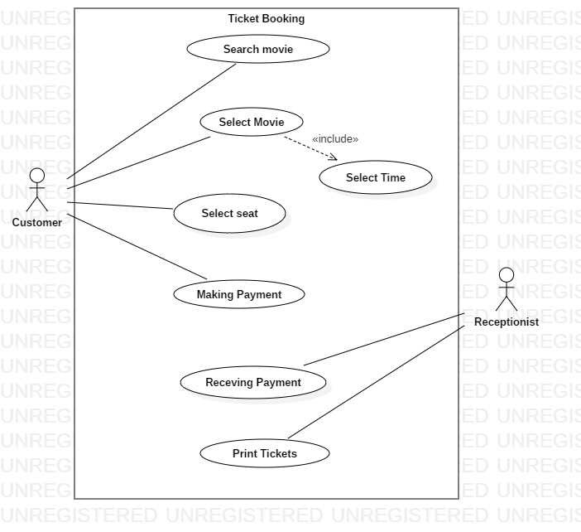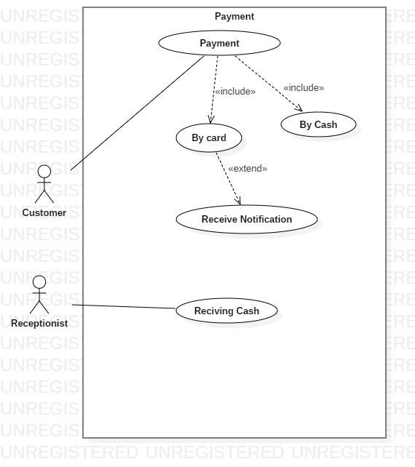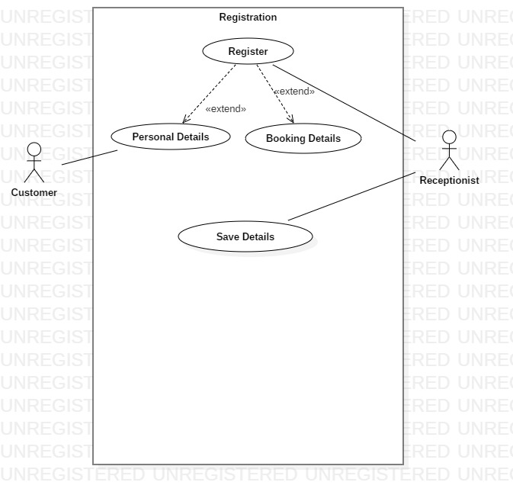

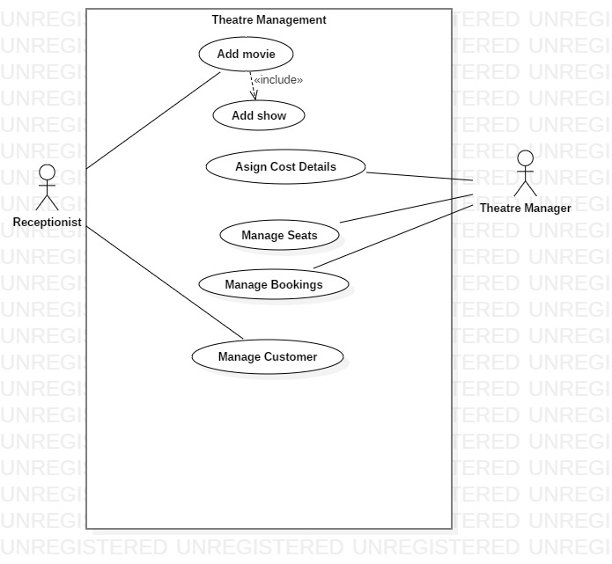

**ACTIVITY DIAGRAMS**

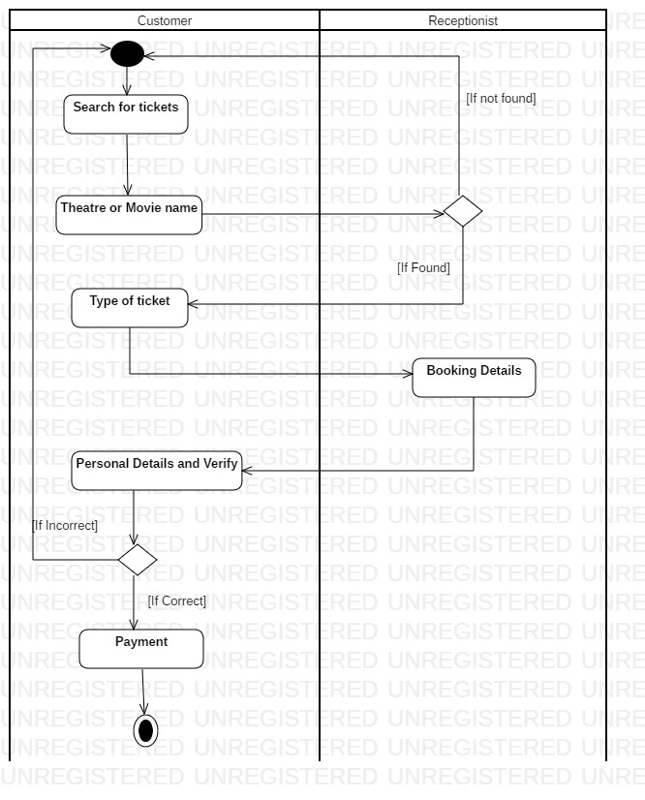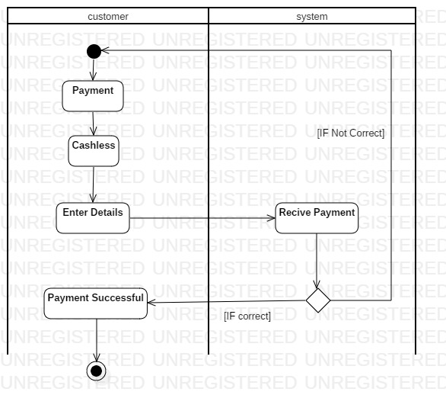

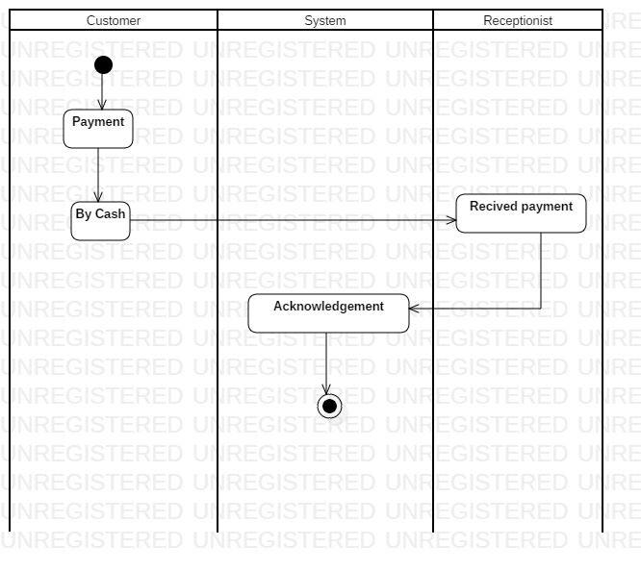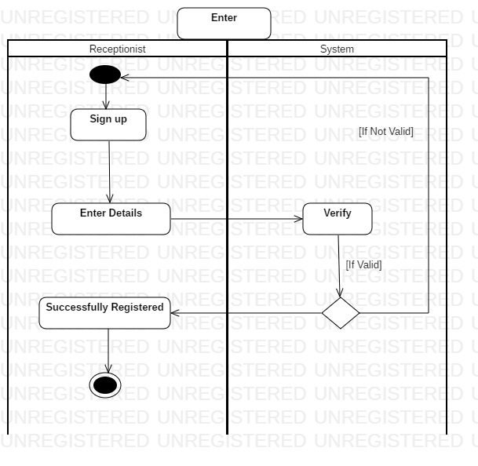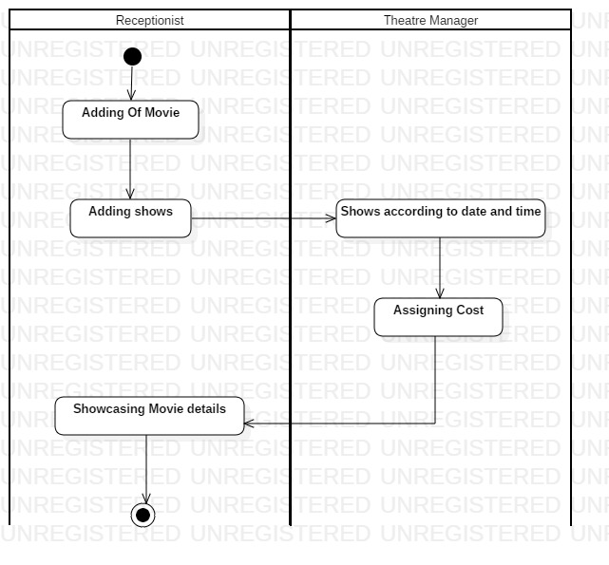

**SEQUENCE DIAGRAMS**

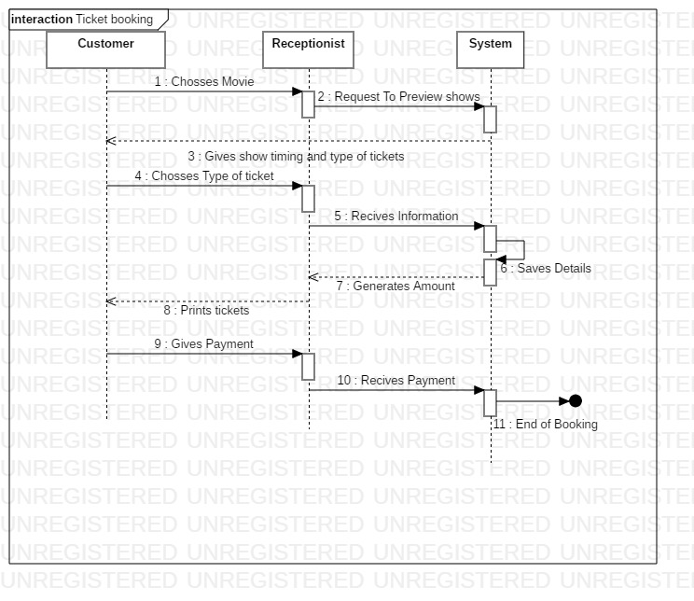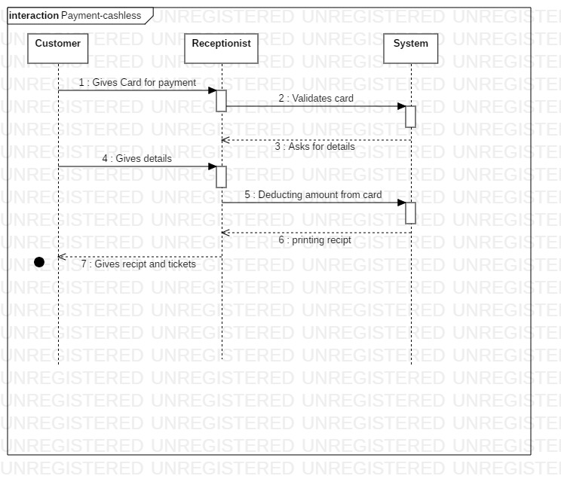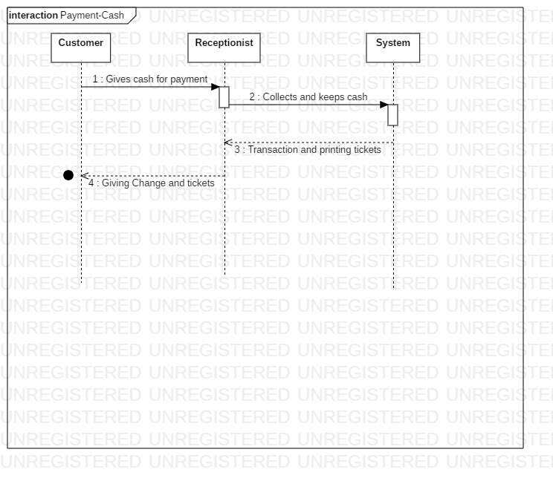

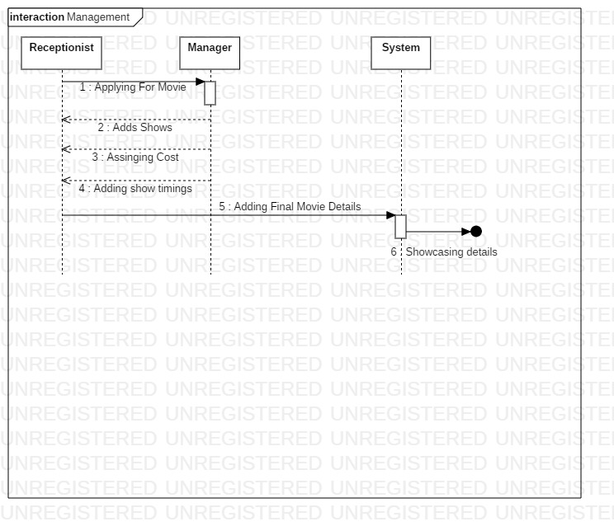

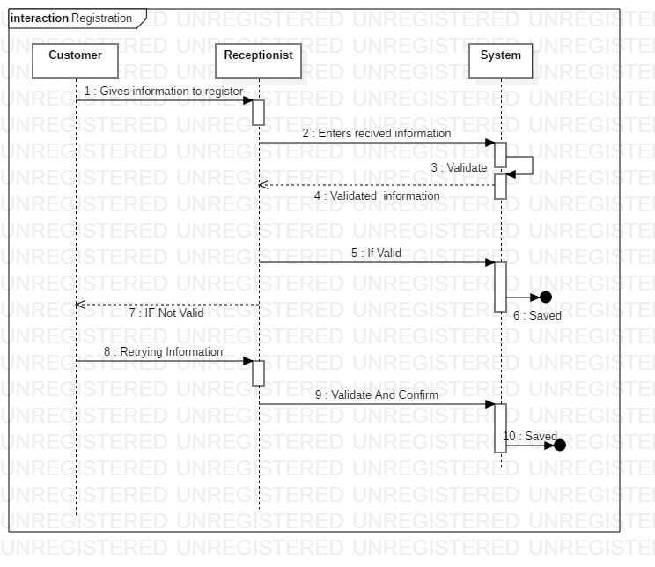

**CLASS DIAGRAM**

**BIBLIOGRAPHY**

**Use case**

[www.smartdraw.com](http://www.smartdraw.com)

[www.wikipedia.com](http://www.wikipedia.com)

**Activity Diagram**

[www.tutorialspoint.com](http://www.tutorialspoint.com)

[www.youtube.com](http://www.youtube.com)

**Sequence Diagram**

ww.geeksforgeeks.org

**Class Diagram**

www.wikipedia.com

**Books**

A Fragment Guide To Business Modelling

ByJohn Holt

**WORK DISTRIBUTION**

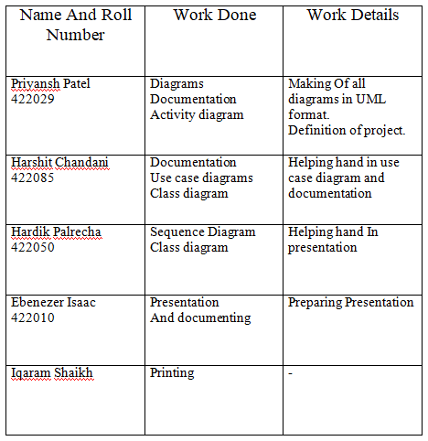

**TOOS USED**

**WhatsApp**

-Used For Communication

**StarUML**

-Used Fo making Diagrams

**Gmail**

-Used for sending files and documents