1. Create a class called Date that includes three instance variables—a month (type int), a day (type int) and a year (type int). Provide a constructor that initializes the three instance variables and assumes that the values provided are correct. Provide a set and a get method for each instance variable. Provide a method displayDate that displays the month, day and year separated by forward slashes (/).

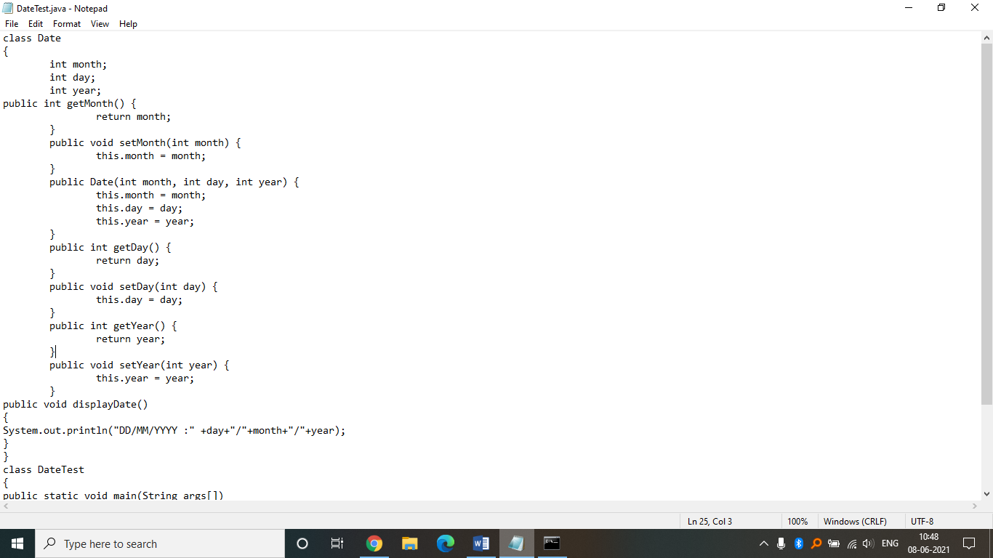

Output:

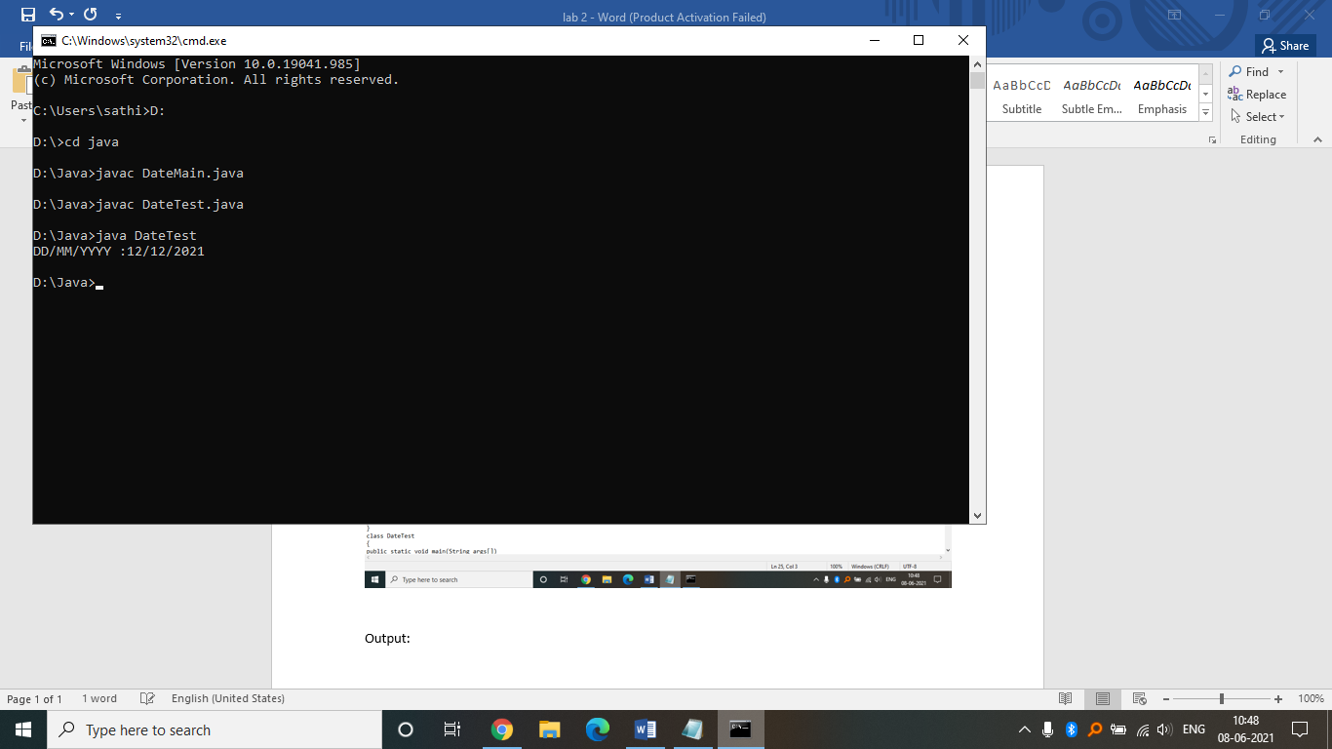

Source code:

class Date

{

int month;

int day;

int year;

public int getMonth() {

return month;

}

public void setMonth(int month) {

this.month = month;

}

public Date(int month, int day, int year) {

this.month = month;

this.day = day;

this.year = year;

}

public int getDay() {

return day;

}

public void setDay(int day) {

this.day = day;

}

public int getYear() {

return year;

}

public void setYear(int year) {

this.year = year;

}

public void displayDate()

{

System.out.println("DD/MM/YYYY :" +day+"/"+month+"/"+year);

}

}

class DateTest

{

public static void main(String args[])

{

Date obj=new Date(12,12,2021);

obj.displayDate();

}

}