Parking Charges solution:

Code:

class Parking

{

public int hours;

public String customerName;

public double price;

public Parking(int hours, String customerName) {

super();

this.hours = hours;

this.customerName = customerName;

}

public void calculateCharges()

{

if(hours<=3)

{

System.out.println("Your charge is Rs.2 | name: "+customerName);

}

else if(hours<=24)

{

price= hours\*0.5;

if(price>10)

{

price=10;

}

System.out.println("Your charge is Rs."+price +" | name: "+customerName);

}

else

{

System.out.println("You are not allowed to park more than 24 hours");

}

}

}

public class Lab3

{

public static void main(String args[])

{

Parking person1=new Parking(24,"Sathish");

person1.calculateCharges();

Parking person2=new Parking(2,"Manish");

person2.calculateCharges();

Parking person3=new Parking(10,"Karthik");

person3.calculateCharges();

Parking person4=new Parking(25,"Surya");

person4.calculateCharges();

}

}

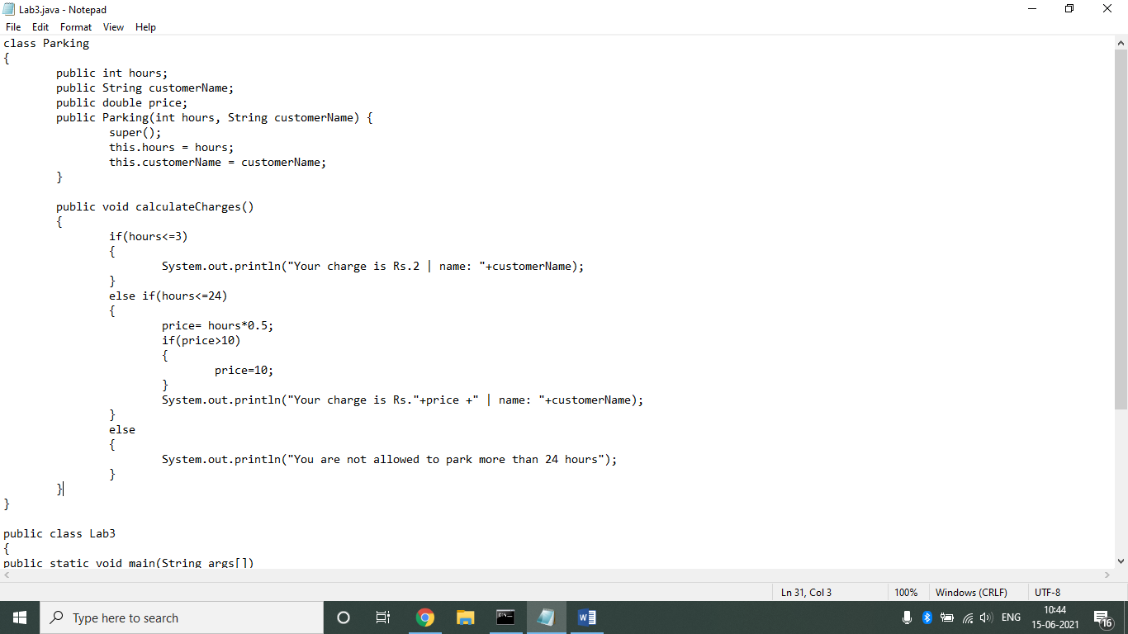

Output:

