Write an application draw random lines in random colors and random thicknesses. Use class Line2D.Double and method draw of class Graphics2D to draw the lines

Program

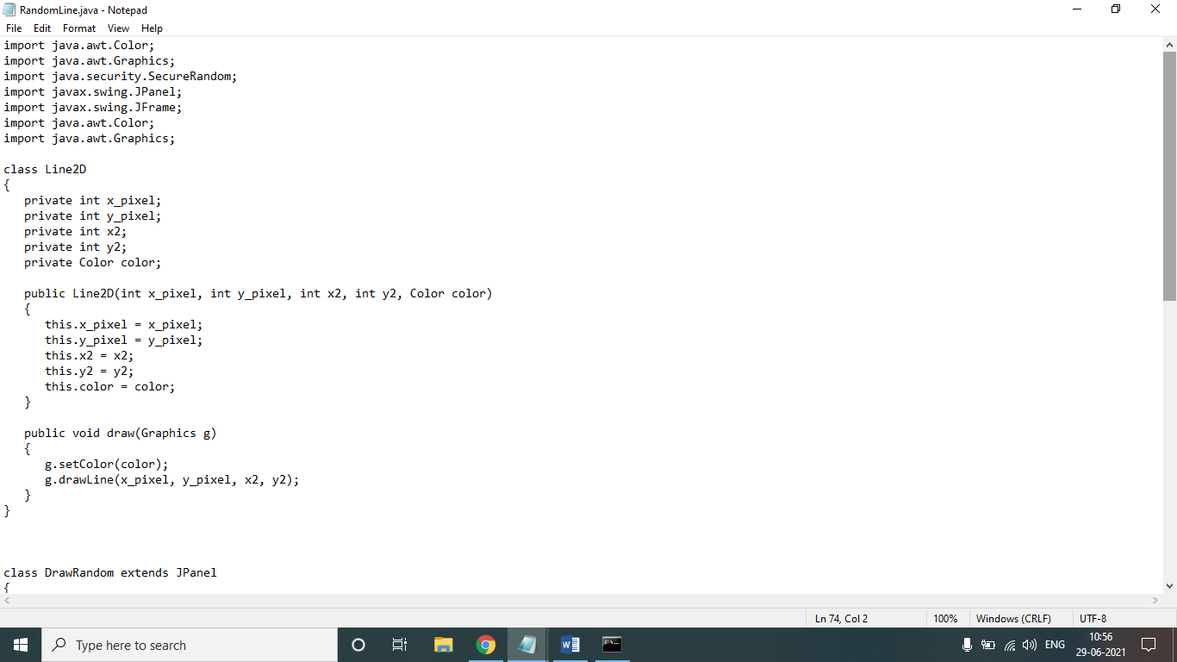

import java.awt.Color;

import java.awt.Graphics;

import java.security.SecureRandom;

import javax.swing.JPanel;

import javax.swing.JFrame;

import java.awt.Color;

import java.awt.Graphics;

class Line2D

{

private int x_pixel;

private int y_pixel;

private int x2;

private int y2;

private Color color;

public Line2D(int x_pixel, int y_pixel, int x2, int y2, Color color)

{

this.x_pixel = x_pixel;

this.y_pixel = y_pixel;

this.x2 = x2;

this.y2 = y2;

this.color = color;

}

public void draw(Graphics g)

{

g.setColor(color);

g.drawLine(x_pixel, y_pixel, x2, y2);

}

}

class DrawRandom extends JPanel

{

private SecureRandom randomNumbers = new SecureRandom();

private Line2D[] lines;

public DrawRandom()

{

setBackground(Color.WHITE);

lines = new Line2D[5 + randomNumbers.nextInt(5)];

for (int count = 0; count < lines.length; count++)

{

Color color = new Color(randomNumbers.nextInt(256),randomNumbers.nextInt(256), randomNumbers.nextInt(256));

int x1 = randomNumbers.nextInt(300);

int y1 = randomNumbers.nextInt(300);

int x2 = randomNumbers.nextInt(300);

int y2 = randomNumbers.nextInt(300);

lines[count] = new Line2D(x1, y1, x2, y2, color);

}

}

public void paintComponent(Graphics g)

{

super.paintComponent(g);

for (Line2D line : lines)

line.draw(g);

}

}

public class RandomLine

{

public static void main(String[] args)

{

DrawRandom draw = new DrawRandom();

JFrame frame = new JFrame();

frame.add(draw);

frame.setSize(300, 300);

frame.setVisible(true);

frame.setDefaultCloseOperation(JFrame.EXIT_ON_CLOSE);

}

}

Output:

