**Ebenezer Isaac Veeraraju (2020178014)**

**Cyber Security End Sem Lab Exam**

Question 1.

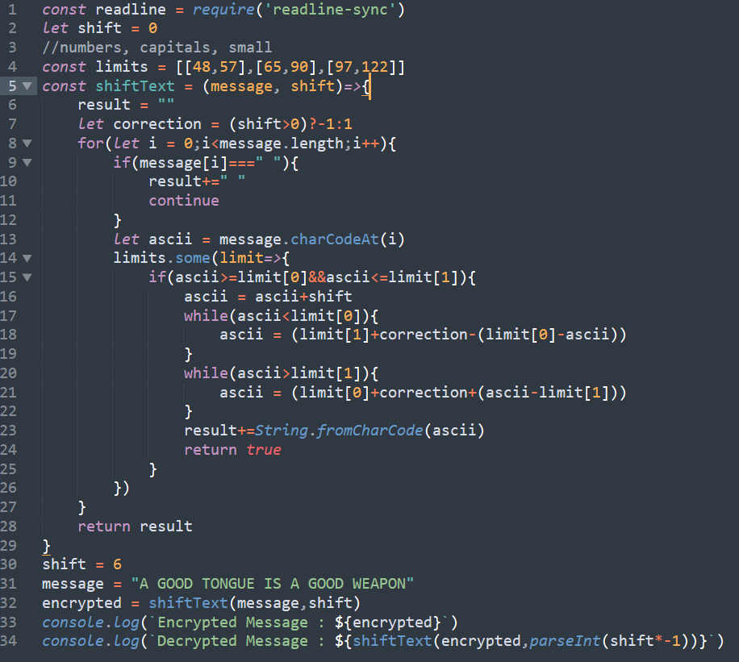

Output :

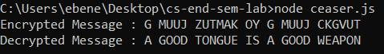

Question 2 :

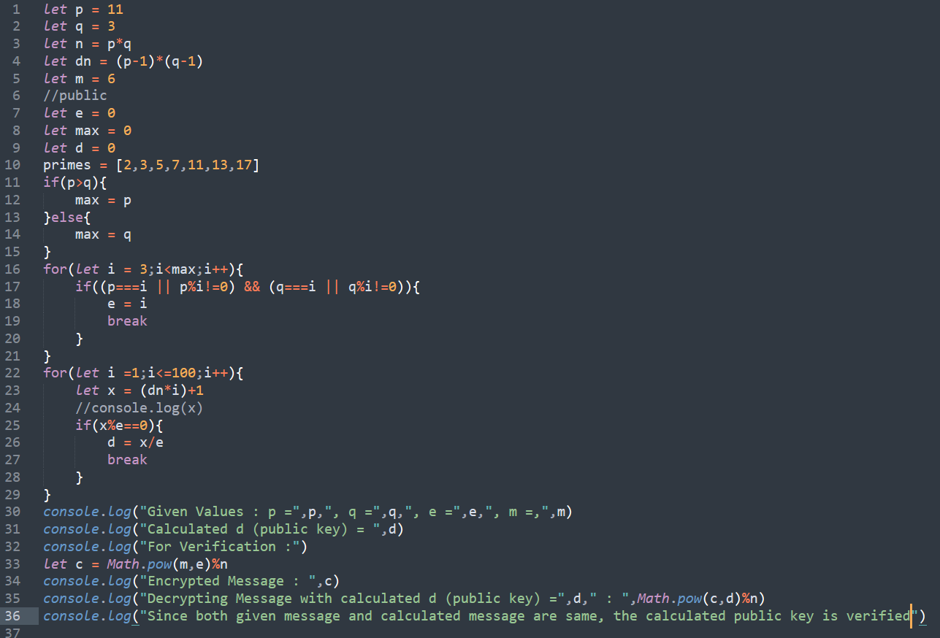

Output :

