**Ebenezer Isaac – 2020178014 (MCA-R)**

**Internet of Things (Lab) - Assignment 0**

1. **Task 1** : Watch YouTube Videos
2. **Task 2** : Setup Working Environment for Python Jupyter Notebook
3. **Task 3** : Surf Internet and provide brief answers
   1. **Question 1** : IoT Application Examples in the given fields
      1. Home

**Project/Product Name** : Silentium

**Problem Statement** : Unhealthy Urban Noise

**Solution**: Active Noise Cancellation Technology to eliminate 90% of low to medium level noise in a given environment

**Risk** : Privacy

* + 1. Healthcare

**Project/Product Name** : Remote ECG Tracking System

**Problem Statement** : Undetected Heart Attacks leading to death of patient

**Solution** : Monitor ECG of patient remotely and alert medical personal in case of any abnormalities.

**Risk** : Overheating/ explosion of device’s battery in high temperature environments, Harmful Radio Waves used by the device for communication, Security

* + 1. Transportation

**Project/Product Name** : Shipment Logistics

**Problem Statement** : Shipment containers getting lost/ delayed

**Solution** : Install GPS enabled devices on transport entities to track delays real-time

**Risk** : Privacy and Security

* + 1. Community

**Project/Product Name** : Smart Traffic Management System

**Problem Statement** : Waiting on a red signal timer to complete even though there are no other vehicles on the road

**Solution** : Efficiently green-light traffic lights for vehicles to pass from one signal to another by calculating average speed and also reduce waiting time on signals by detecting presence of vehicles nearby the traffic signal.

**Risk** : Privacy and Security

* 1. **Question 2** : Definitions
     1. IoT : The Internet of Things describes the network of physical objects that are embedded with sensors, software and other technologies for the purpose of connecting and exchanging data with other devices and systems over the internet
     2. RFID : Radio Frequency Identification refers to a wireless system comprised of two components: tags and readers. The reader is a device that has one or more antennas that emit radio waves and receive signals back from the RFID tag.
     3. WSN : Wireless Sensor Network is an infrastructure-less wireless network that is deployed in a large number of wireless sensors in an ad-hoc manner that is used to monitor the system, physical or environment conditions.
     4. MEMS : Micro Electro Mechanical Systems is a technology that in its most general form can be defined as miniaturized mechanical and electro-mechanical elements that are made using the techniques of micro-fabrication.
     5. Hype Cycle : The hype cycle is a graphical representation of the life cycle stages a technology goes through from conception to maturity and widespread adoption.
     6. IPv4 : Internet Protocol version 4 is the underlying technology that makes it possible for us to connect our devices over the web. It uses a 32 bit address to identify each device uniquely.
     7. IPv6 : Internet Protocol version 6 was born due to the insufficient capacity of Ipv4 to assign unique IP addresses to all devices on the network. Ipv6 has more advanced and better features and also packs a 64 bit addressing schema.
     8. QoS : Quality of Service is a set of technologies that work on a network to guarantee its ability to dependably run high-priority applications and traffic under limited network capacity.
     9. MAC : A Media Access Control address is a unique identifier assigned to a network interface controller for use as a network address in communications within a network segment.
     10. LED : Light Emitting Diode is a semiconductor diode which glows when voltage is applied, the intensity of the emitter can be controlled by altering the voltage supplied to it.
     11. Cloud Computing : The practice of using a network of remote servers hosted on the network to store, manage and process data rather than on a local server or a personal computer is called as cloud computing.
     12. Edge Computing : Edge computing is a form of computing that is done on site or near a particular data source, minimizing the need for data to be processed in a remote data center.

1. **Task 4** : Study and understand principles of different sensors
   1. Temperature Sensor : The temperature sensors work on the priciple of detecting the voltage across the diode terminals.

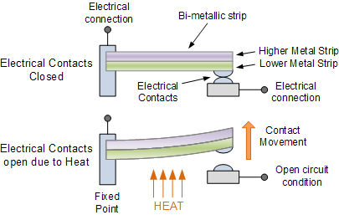

* 1. Proximity Sensor : Proximity Sensors convert information on the movement or presence of an object into an electrical signal

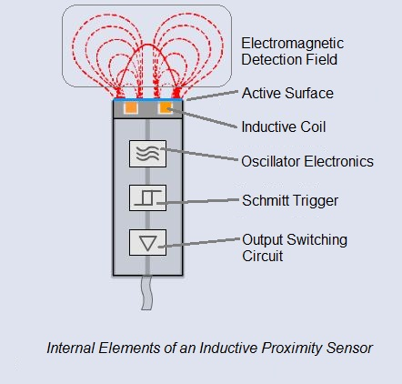

* 1. Pressure Sensor : A pressure sensor works by converting pressure into an analogue electrical signal

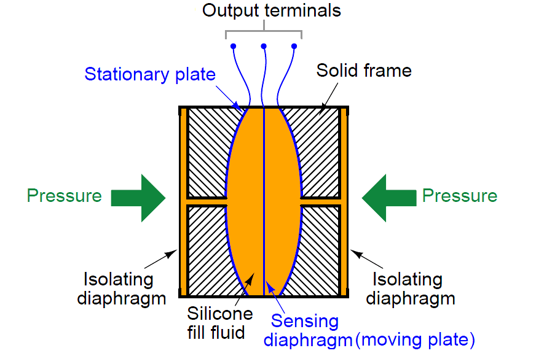

* 1. IR Sensor : By detecting change in photo-diode's resistance and output voltage change in proportion to the IR light received

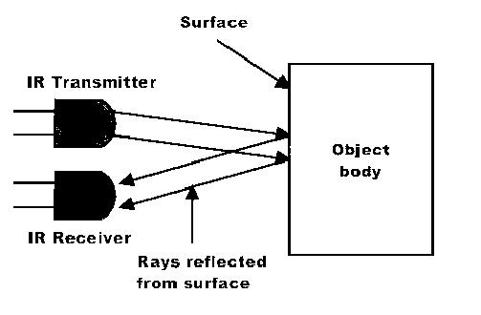

* 1. Ultrasonic Sensor : Ultrasonic sensors work by sending out a sound wave at a frequency above the range of human hearing.

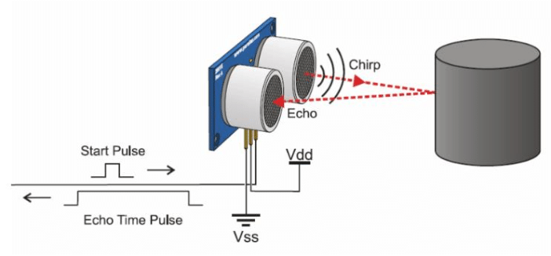

* 1. Humidity Sensor : Humidity sensors work by detecting changes that alter electrical currents or temperature in the air.

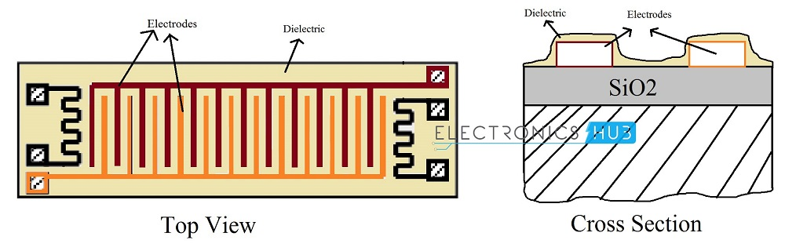

* 1. Motion Detection Sensor : Active ultrasonic sensors emit [ultrasonic sound waves](http://hyperphysics.phy-astr.gsu.edu/hbase/Sound/usound.html#:~:text=The%20term%20%22ultrasonic%22%20applied%20to,includes%20anything%20over%2020%2C000%20Hz.) at a frequency above the range of human hearing. These waves bounce off objects in the immediate vicinity and return to the motion sensor.

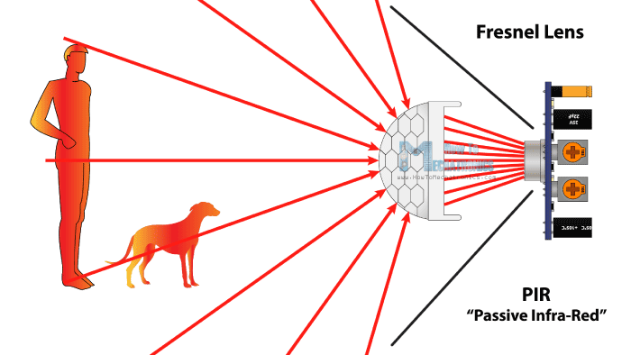

* 1. Level Sensor : Ultrasonic level sensors use the Time-of-Flight measuring principle to measure level.

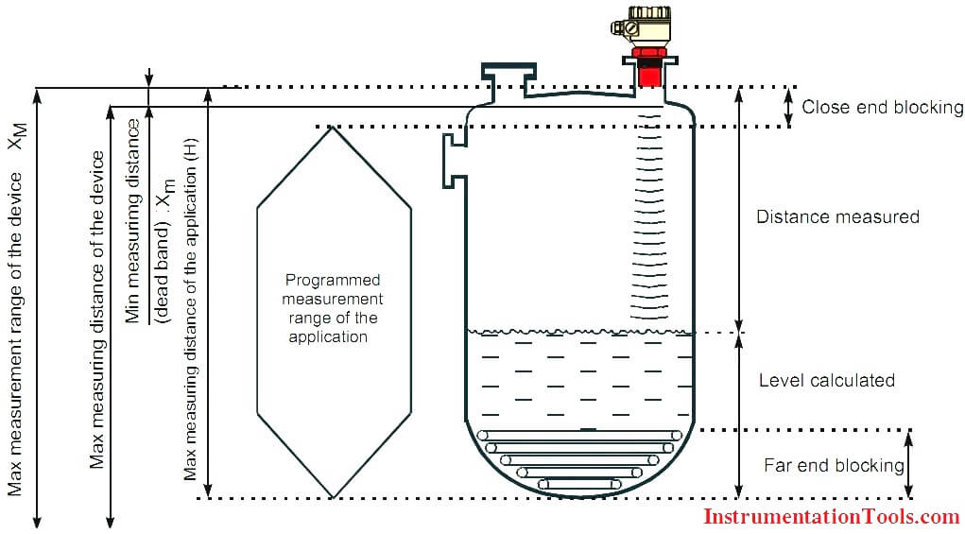

* 1. Accelerometer Sensor : it works by converting mechanical energy into electrical energy

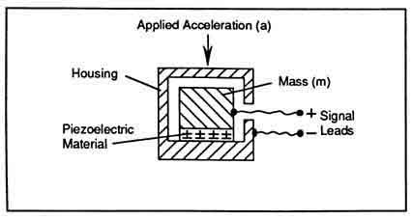

* 1. Gyroscope : It works on the principle of conservation of angular momentum

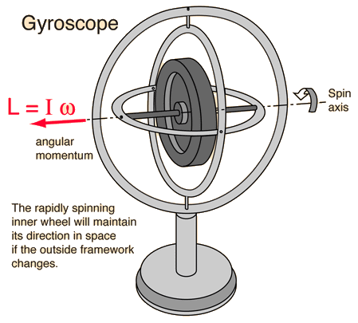

* 1. Optical Sensor : An optical sensor converts light rays into electronic signals. It measures the physical quantity of light and then translates it into a form that is readable by an instrument

