**Internet Of Things – Lab Worksheet 3**

Ebenezer Isaac Veeraraju (2020178014)

Dennis Churchill J (2020178011)

**Components Used:**

Arduino UNO x1

Bread Board x1

LED Lights x3

Resistors x3

Wires x4

**Circuit:**

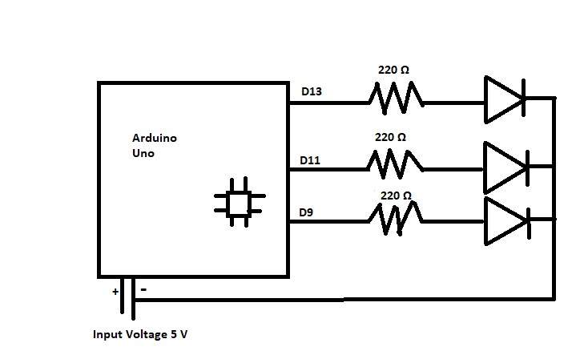

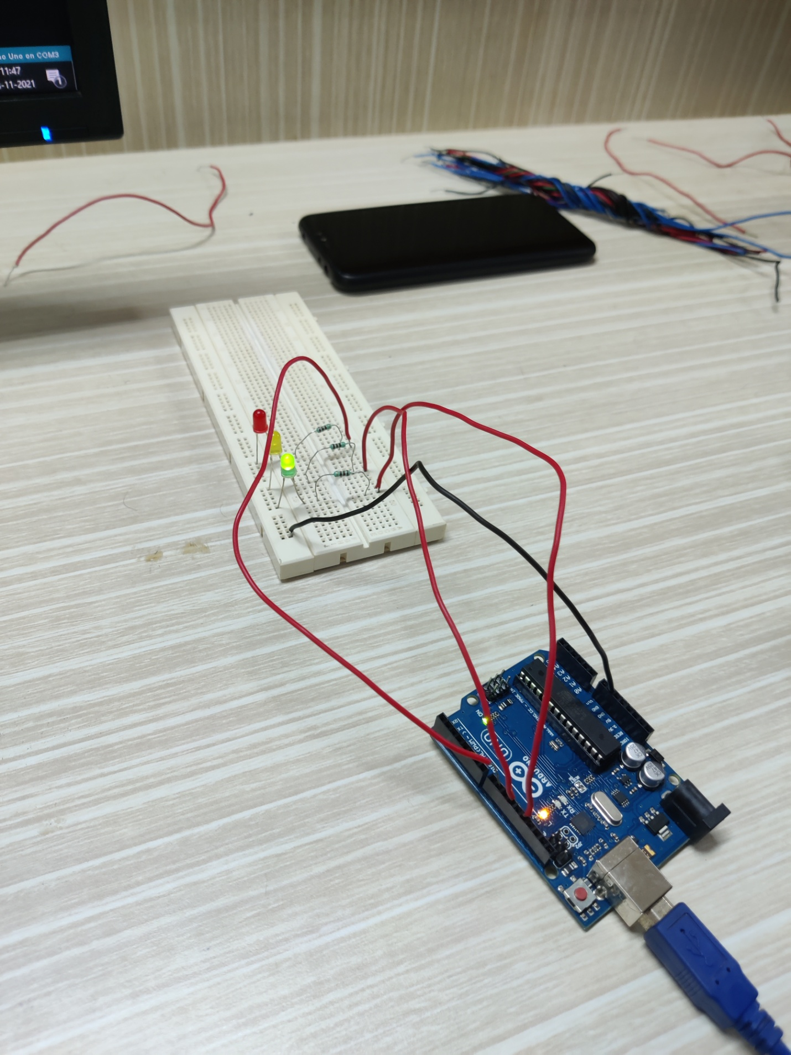

**Task 1**

**Aim :** Develop a BLINK sketch in Arduino

**Challenge 1a** – Blink with a 200ms second interval.

**Program :**

void setup() {

pinMode(13, OUTPUT);

pinMode(11, OUTPUT);

pinMode(9, OUTPUT);

}

void loop() {

digitalWrite(13, HIGH);

digitalWrite(11, HIGH);

digitalWrite(9, HIGH);

delay(200);

digitalWrite(13, LOW);

digitalWrite(11, LOW);

digitalWrite(9, LOW);

delay(200);

}

**Result:**  
The Output For Given Task Was Obtained Successfully.

**Challenge 1b** – Blink to mimic a heartbeat

**Program :**

void setup() {

pinMode(13, OUTPUT);

pinMode(11, OUTPUT);

pinMode(9, OUTPUT);}

void loop() {

digitalWrite(13, HIGH);

digitalWrite(11, HIGH);

digitalWrite(9, HIGH); delay(100);

digitalWrite(13, LOW);

digitalWrite(11, LOW);

digitalWrite(9, LOW); delay(100);

digitalWrite(13, HIGH);

digitalWrite(11, HIGH);

digitalWrite(9, HIGH);delay(100);

digitalWrite(13, LOW);

digitalWrite(11, LOW);

digitalWrite(9, LOW); delay(800);}

**Result:**  
The Output For Given Task Was Obtained Successfully.

**Challenge 1c** –find the fastest blink that the human eye can still detect.

**Program:**

void setup() {

pinMode(13, OUTPUT);

pinMode(11, OUTPUT);

pinMode(9, OUTPUT);}

void loop() {

digitalWrite(13, HIGH);

digitalWrite(11, HIGH);

digitalWrite(9, HIGH);

delay(12);

digitalWrite(13, LOW);

digitalWrite(11, LOW);

digitalWrite(9, LOW);

delay(12); }

**Result:**  
The Fastest Blink That A Human Eye Can Still Detect Is 12ms

**Task 2**

**Aim:** Develop traffic light using 3 LED’s (red, yellow, and green) that

▪Illuminates the green LED for 5 seconds

▪Illuminates the yellow LED for 2 seconds

▪Illuminates the red LED for 5 seconds

▪repeats the sequence

**Program :**

void setup() {

pinMode(9, OUTPUT);//RED

pinMode(11, OUTPUT);//YELLOW

pinMode(13, OUTPUT);//GREEN

}

void loop() {

digitalWrite(9, HIGH);

digitalWrite(11, LOW);

digitalWrite(13, LOW); delay(5000);

digitalWrite(9, LOW);

digitalWrite(11, HIGH);

digitalWrite(13, LOW);

delay(2000);

digitalWrite(9, LOW);

digitalWrite(11, LOW);

digitalWrite(13, HIGH);

delay(5000); }

**Result:** The Output For Given Task Was Obtained Successfully.

**Task 3**

**Aim:** Modify Task 2 to have an advanced green (blinking green LED) for 3 seconds before illuminating the green LED for 5 seconds

**Program :**

void setup() {

pinMode(9, OUTPUT);//RED

pinMode(11, OUTPUT);//YELLOW

pinMode(13, OUTPUT);//GREEN

}

void loop() {

digitalWrite(9, HIGH);

digitalWrite(11, LOW);

digitalWrite(13, LOW);

delay(5000);

digitalWrite(9, LOW);

digitalWrite(11, HIGH);

digitalWrite(13, LOW);

delay(2000);

digitalWrite(9, LOW);

digitalWrite(11, LOW);

digitalWrite(13, HIGH);

delay(500);

digitalWrite(9, LOW);

digitalWrite(11, LOW);

digitalWrite(13, LOW);

delay(500);

digitalWrite(9, LOW);

digitalWrite(11, LOW);

digitalWrite(13, HIGH);

delay(500);

digitalWrite(9, LOW);

digitalWrite(11, LOW);

digitalWrite(13, LOW);

delay(500);

digitalWrite(9, LOW);

digitalWrite(11, LOW);

digitalWrite(13, HIGH);

delay(500);

digitalWrite(9, LOW);

digitalWrite(11, LOW);

digitalWrite(13, LOW);

delay(500);

digitalWrite(9, LOW);

digitalWrite(11, LOW);

digitalWrite(13, HIGH);

delay(5000);}

**Result:**  
The Output For Given Task Was Obtained Successfully.

**Task 4**

**Aim:** Try adding other LEDs and develop your own morse code flashing How about? Knight rider? Disco? Police light??

**Program :**

void setup() {

pinMode(9, OUTPUT);//RED

}

void loop() {

// MORSE CODE : M C A

//m

digitalWrite(9, HIGH);

delay(1000);

digitalWrite(9, LOW);

delay(500);

digitalWrite(9, HIGH);

delay(1000);

//space

digitalWrite(9, LOW);

delay(1000);

//c

digitalWrite(9, HIGH);

delay(1000);

digitalWrite(9, LOW);

delay(500);

digitalWrite(9, HIGH);

delay(500);

digitalWrite(9, LOW);

delay(500);

digitalWrite(9, HIGH);

delay(1000);

digitalWrite(9, LOW);

delay(500);

digitalWrite(9, HIGH);

delay(500);

//space

digitalWrite(9, LOW);

delay(1000);

//a

digitalWrite(9, HIGH);

delay(500);

digitalWrite(9, LOW);

delay(500);

digitalWrite(9, HIGH);

delay(1000);

//off

digitalWrite(9, LOW);

delay(3000);

}

**Result:**  
The Output For Given Task Was Obtained Successfully.