**Tools**

1. Maze : Maze is a user testing platform for capturing feedback on design prototypes. ... It works with prototypes for desktop, mobile or tablet applications and all tests run in the browser. Features include click tests, missions for users to complete and open-ended or closed survey questions.

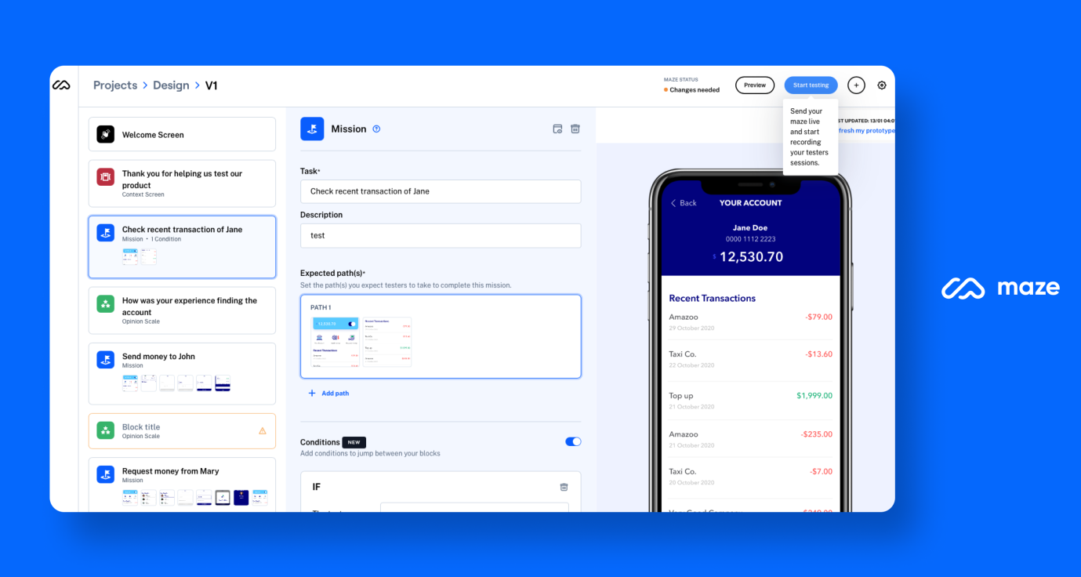

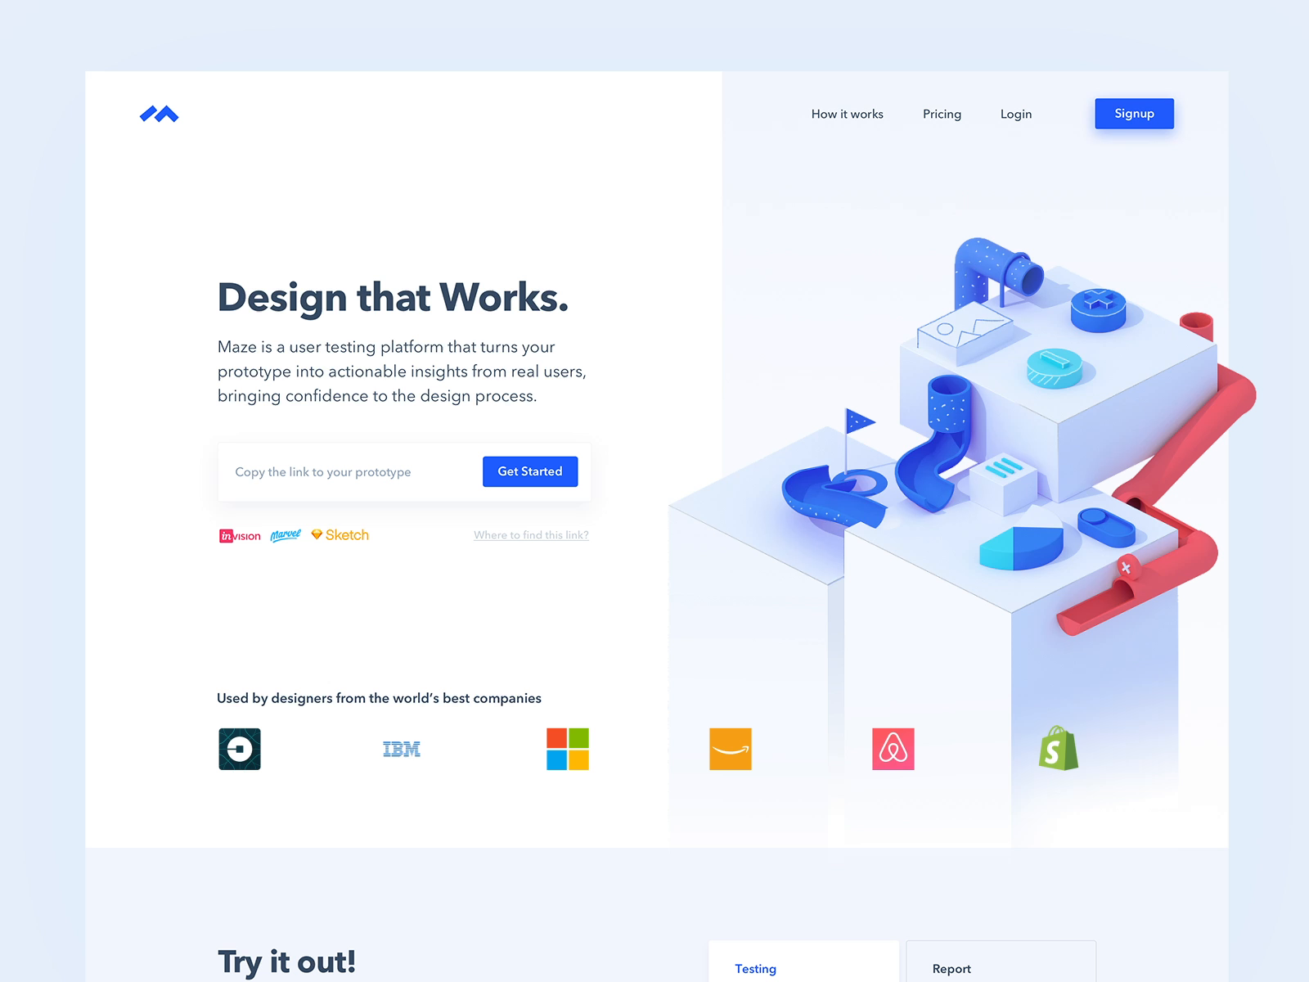

1. Sketch : Sketch is used primarily for designing the UI and UX of mobile apps and web. The files designed in Sketch are saved in its own . sketch file format, though . sketch files can be opened in Adobe Illustrator, Adobe Photoshop and other programs.

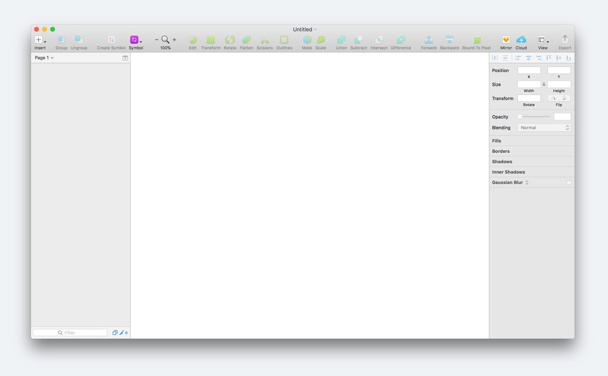



1. Adobe XD : Adobe XD is a powerful and easy-to-use vector-based experience design platform that gives teams the tools they need to craft the world's best experiences collaboratively. Available on Mac and Windows systems, XD meets teams where they're working with cross-platform compatibility.

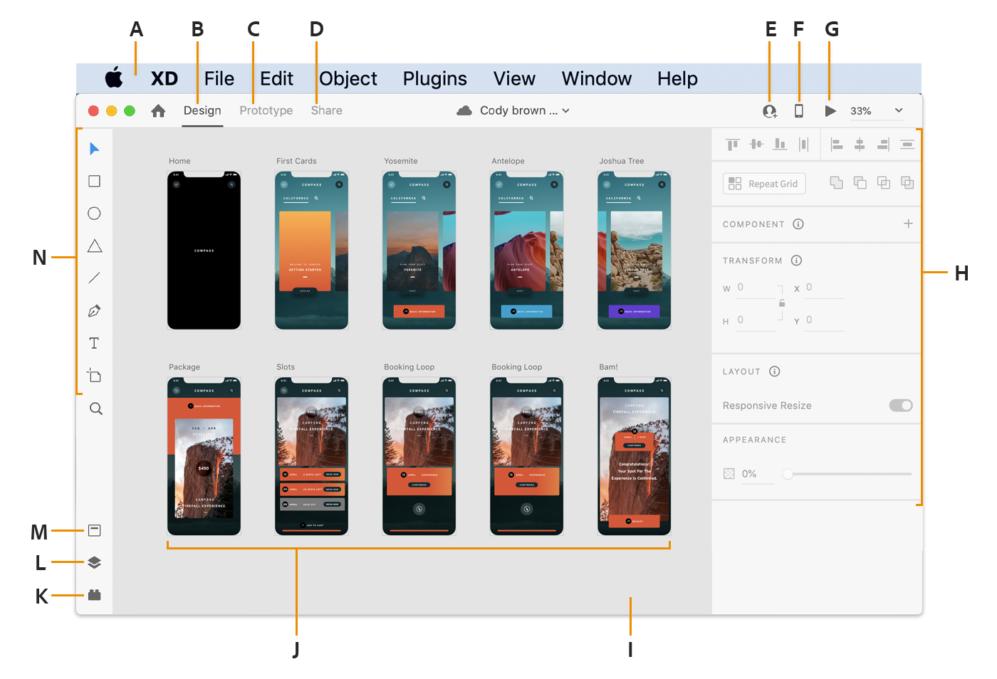

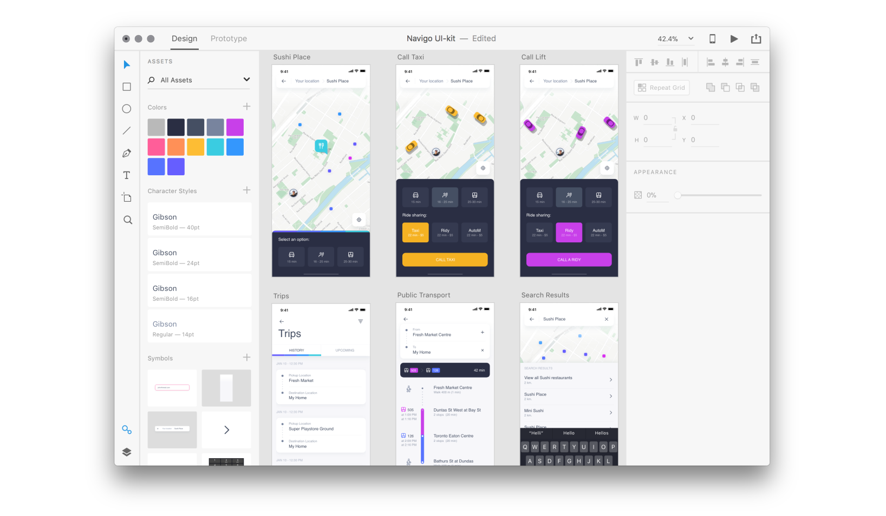

1. Balsamiq : Balsamiq Cloud is a web-based user interface design tool for creating wireframes (sometimes called mockups or low-fidelity prototypes). You can use it to generate digital sketches of your idea or concept for an application or website, to facilitate discussion and understanding before any code is written.

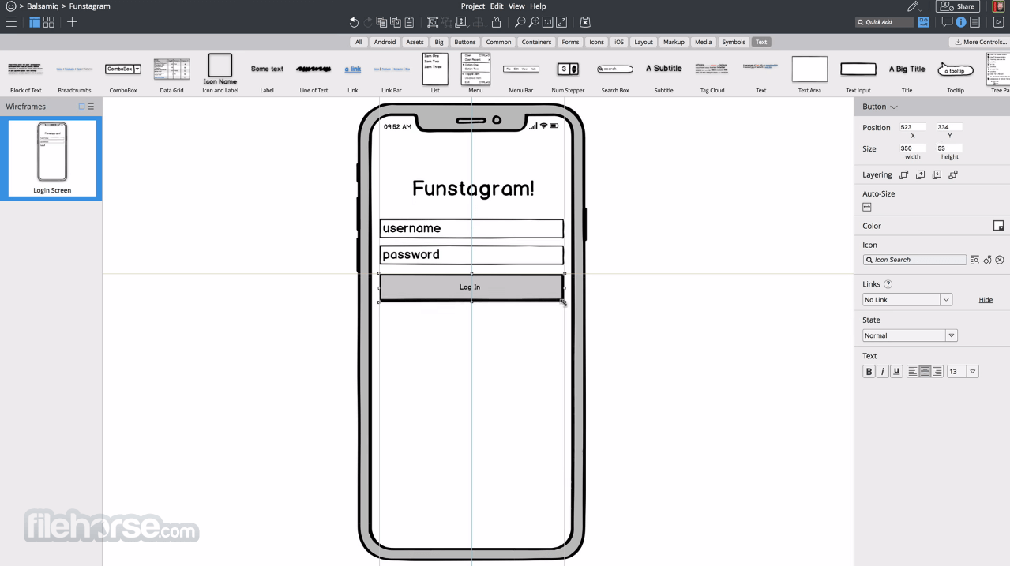

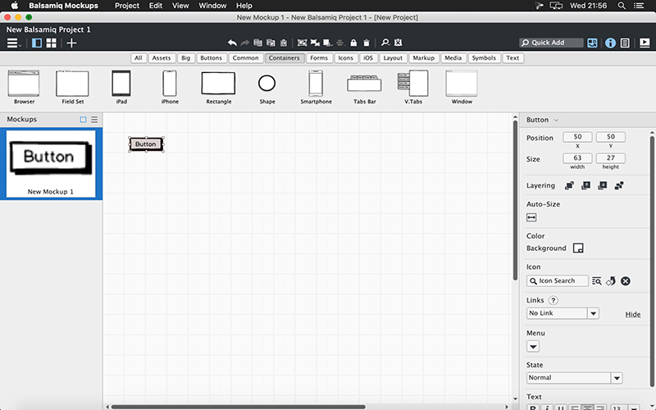

1. Figma : Figma is a web-based graphics editing and user interface design app. You can use it to do all kinds of graphic design work from wireframing websites, designing mobile app interfaces, prototyping designs, crafting social media posts, and everything in between. Figma is different from other graphics editing tools.

