**Lumincore - general instructions**

**Here are the main highlights you need to know in order to work with the lumincore:**

- The lumincore has 3 broad light sources - red, green/yellow, blue:

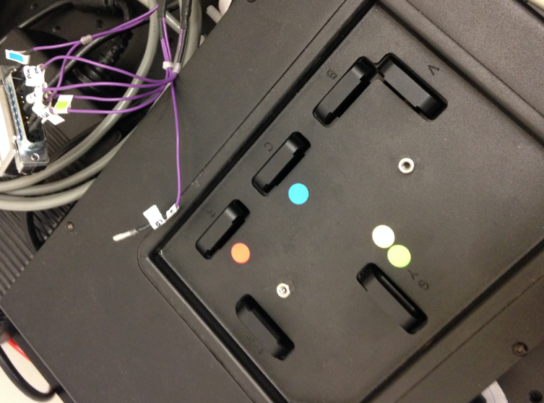

In order to use a specific channel, place the relevant filter from the oligochrome in the lumincore (avoid touching directly in the filter's surface, use gloves).

 When you place the filter back to the oligochrome, make sure you place it in the correct place:

**1** - 387 (purple)

**2** - 650 (red)

**3** - 560 (green)

**4** - 485 (blue)

**5**- 537 (yellow)

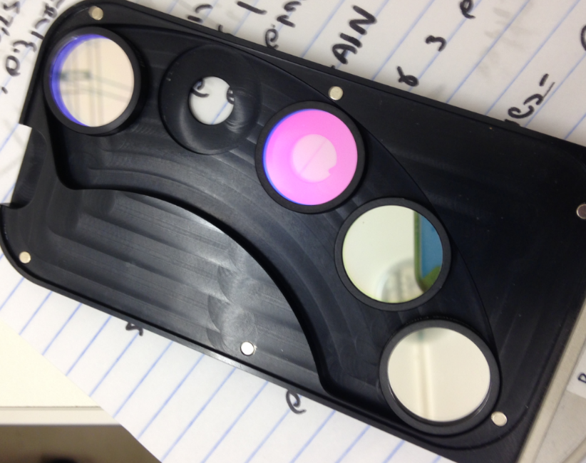

- Make sure you also move the optical fiber from the oligochrome to the lumincore (using the relevant adapter, and the screwdriver).

-**In the software**, once the starting menu appears, choose the option for lumincore, then "continue".

- T**he control on the intensity** is done by the EM gain and the exposure time only. Start from low EM gain (~30) then increase it if needed.

- **Protocols**: slightly different than what we usually have- choose the number of channels, then check the relevant excitation and choose the relevant emission:

