Assimp and OpenGL
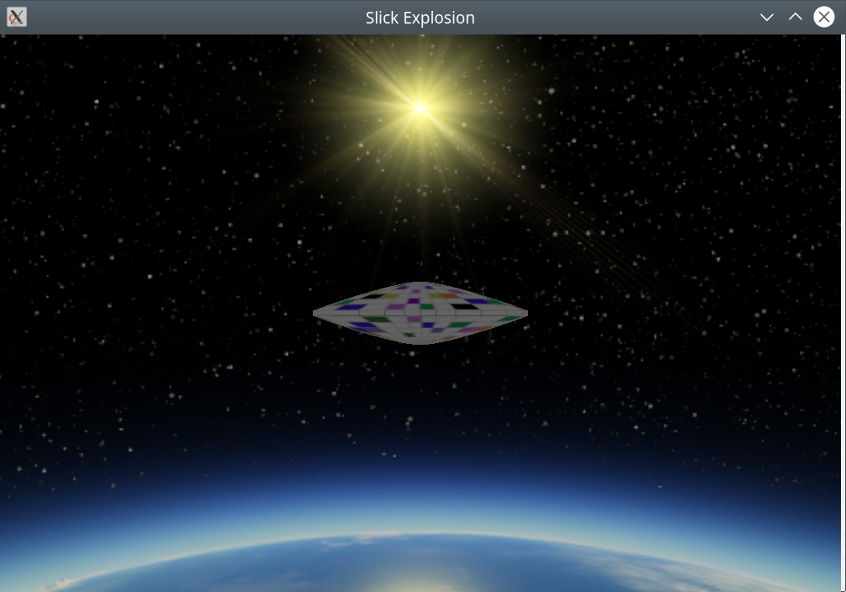
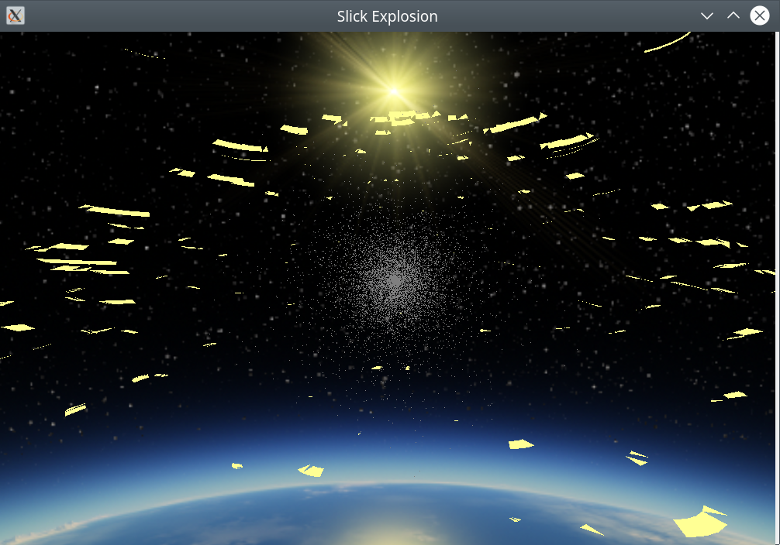

AssimpOpenGL is a library to take a variety of 3 dimensional drawings and turn them into OpenGL vertex buffers and textures for display in a C++ environment. The library’s interface is defined in assimpopengl.h and requires 3 shaders to run: One for the display of the object; one for the exploded object; and one for a gaseous cloud that appears during the explosion. It is an improvement over previous versions as there is only one Mesh class and the values for the mesh are only calculated once. The gaseous cloud is interesting in that the particles are calculated as spherical coordinates and, in the shader, are translated to the cartesian coordinate system.
What follows is the contents of the README.txt file.

libassimpopengl.so.1.0 A shared library to display arbitrary blender objects.

To use the library include assimpopengl-1.0/assimpopengl.h
and link to assimpopengl

The include file will be at:
/usr/include/assimpopengl-1.0/assimpopengl.h

The library binary will be at:
/usr/lib/libassimpopengl.so.1.0

For info on the interface look at:
/usr/share/doc/assimpopengl-doc-1.0/html/index.html
and examine the model class which is the
entry point.

to build the library on its own:

cd assimpopengl/build
cmake ..
sudo make
sudo make assimpdocs
sudo make install

The program was written and compiled on debian linux available at: www.debian.org.

You can reach me at <eberdeed@eberdeed.net>.

The sources I used to educate myself concerning OpenGL are
as follows:
"OpenGL ES 3.0 Programming Guide Second Edition"
by Dan Ginsburg and Budirijanto Purnomo published by Addison-Wesley 2014.
A valued resource has been:
www.learnopengl.com.
The various software packages used are:
GLEW http://glew.sourceforge.net, and
CMAKE http://www.cmake.org.
Doxygen http://www.doxygen.nl
GraphViz https://www.graphviz.org
Assimp https://www.assimp.org
OpenGL is generally available on any system as part
of the underlying graphics subsystem and GLEW will
get you access to it.

The program was written and compiled on debian linux available at: www.debian.org.

Edward Charles Eberle
May 6th 2021 San Diego, California United States of America

This program is licensed under the Lesser GNU Public license.
It can be found in the LGPL directory
and once installed it will be also found at
/usr/share/doc/assimpopengl-doc/LGPL. This
program is given as an instructional aid for learning
and using the libraries presented and is not to
be considered fit for any particular use.

