Astercube

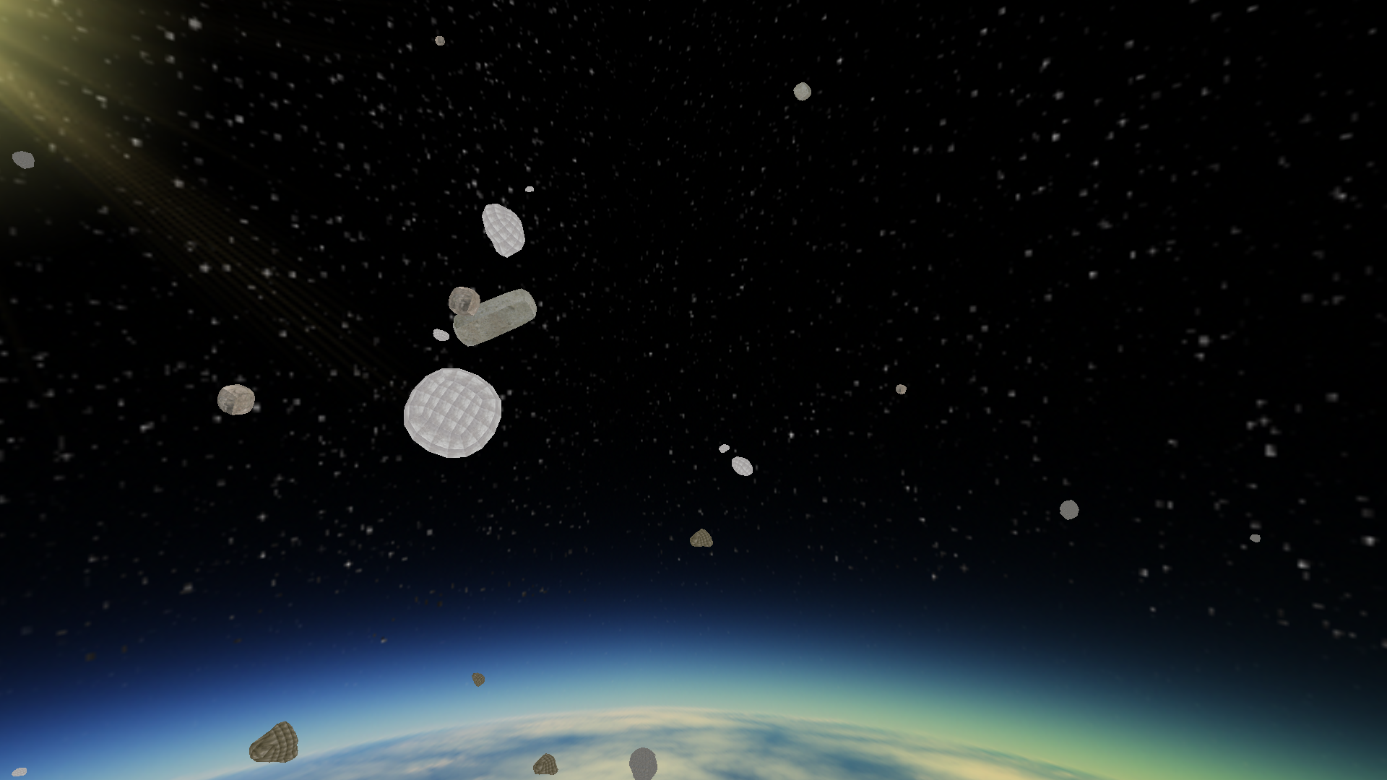
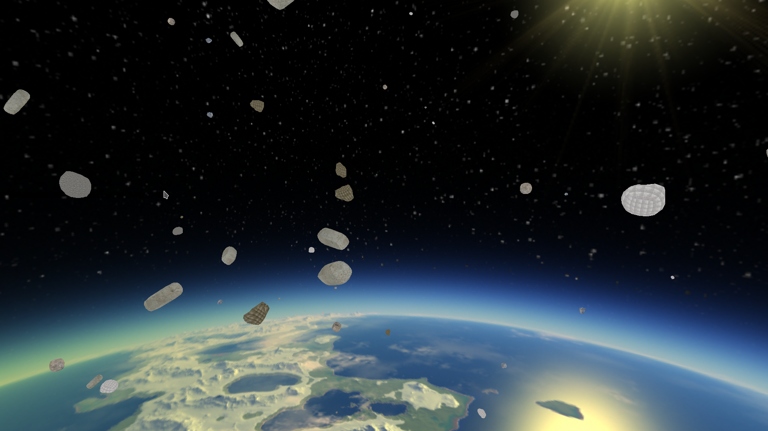
Astercube is a vista of an animated asteroid field. The asteroids are randomly distributed and will have different locations, velocities and rotations upon each run of the program. Further collision events are provided for.
There are a few variables you may want to know about. First, SCR_WIDTH and SCR_HEIGHT can be changed for the window to change the startup width and height for the window, however, the window can be dynamically resized. The variable string array “asteroids” in the objects.h will change the asteroids displayed for the given window, but be sure to change the AMOUNT define to account for the size of the asteroids array and make sure that AMOUNT * QUANTITY breaks down to an even cube root so the asteroids can be distributed properly. Finally you must change the NUM_INSTANCES value in the test.vs shader in openglresources/shaders to match the QUANTITY value in objects.h. Changing the skybox can be done in the skybox.h file.
What follows is the contents of the README.txt file:

astercube: A Program to display an asteroid field of instanced asteroids using
the SimpleDirect Media Layer and OpenGL.

This program requires:
The assimp library www.assimp.org,
the freeimageplus library www.sourceforge.net,
GLEW http://glew.sourceforge.net, and
CMAKE www.cmake.org.
SDL2 https://wiki.libsdl.org/FrontPage
the boost library www.boost.org,
Doxygen http://www.doxygen.nl
GraphViz https://www.graphviz.org for the "dot" program used by doxygen.
pthread https://www.gnu.org/software/hurd/libpthread.html
OpenGL is generally available on any system as part
of the underlying graphics subsystem and GLEW will
get you access to it, X11 used for window sizing is
part of the X windowing system used on most Linux systems.

To compile the program:

be super user or su
./compile.sh

to clean the program:

.clean.sh

To run the program:

astercube

The key layout is as follows:

wasd as usual motion keys.

Viewing direction:
Mouse: In order to change view direction mouse down to select start move and then mouse up to stop motion.

x reverse view.
z reset view.
Escape ends the program.

Mouse wheel forward zooms in.
Mouse wheel back zooms out.

wasd are the usual movement keys.
w forward.
a left.
s backward.
d right.

alt-enter will put you in fullscreen mode.

Documentation is available after install at:

/usr/share/doc/astecube-doc

The program was written and compiled on debian linux available at: www.debian.org.

Limitations of the underlying assimpopengl library are:

You must use separate instances if you have instanced and non-instanced objects.

You must use separate instances and separate shaders if your instanced objects
have different instance quantities of images produced.

Otherwise you are free to provide multiple objects to the model class and
have them displayed.

Note also that the universe has a -y direction as up.

You can reach me at <eberdeed@eberdeed.net>.

Edward Charles Eberle
San Diego, California United States of America

This program is licensed under the Lesser GNU Public license.
It can be found in the assimpopengl/LGPL directory
and once installed it will be also found at
/usr/share/doc/astecube-doc/LGPL. This
program is given as an instructional aid for learning
and using the libraries presented and is not to
be considered fit for any particular use.

