Bullet Dice for OpenGL Version 1.6
A program to emulate the throwing of a pair of dice.

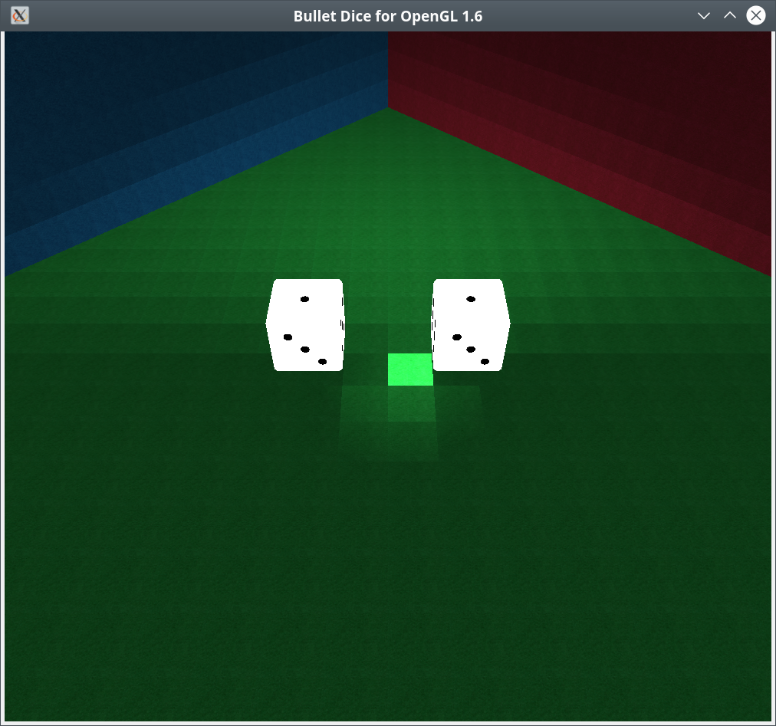
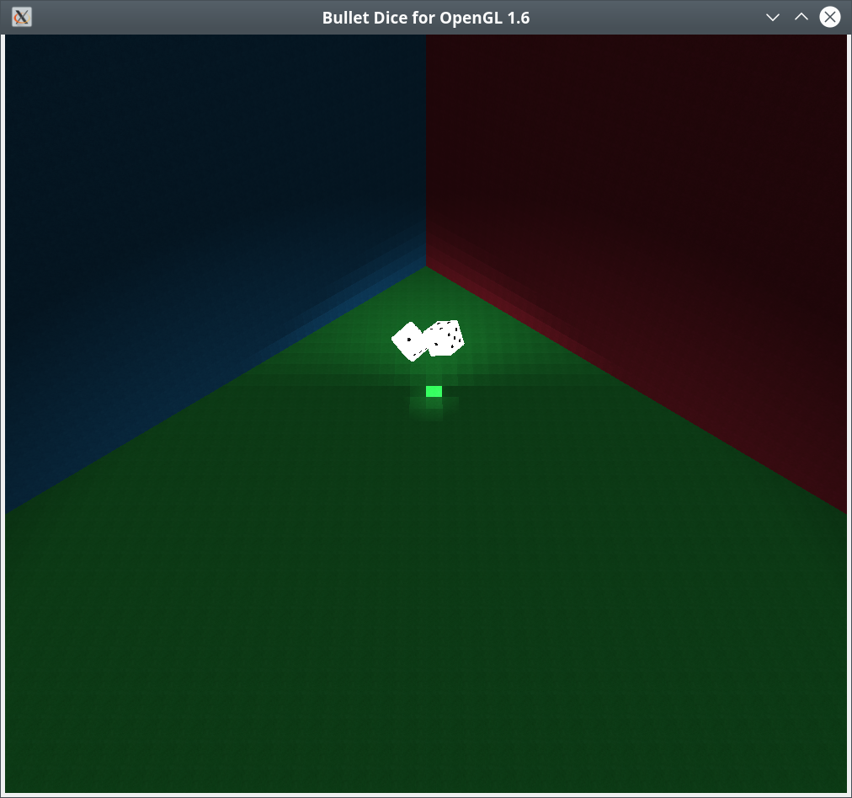
BulletDiceGL is a program that emulate the roll of a pair of dice in an OpenGL program. The program uses dice created in blender. Blender is an internationally known drawing program that can be downloaded for free from www.blender.org. This program relies on the assimp library, which is an open source object conversion library and can be obtained at www.assimp.org.
Below is the contents of README.txt, documentation can be found in the documentation directories.

bulletdicegl-1_6: A Program to emulate the roll of a pair
of dice using the Bullet Physics library the SimpleDirect
Media Layer and OpenGL.

This program requires:
The assimp library www.assimp.org,
the boost library www.boost.org,
the freeimageplus library www.sourceforge.net,
GLEW http://glew.sourceforge.net, and
CMAKE www.cmake.org.
SDL2 https://wiki.libsdl.org/FrontPage
Bullet Physics https://github.com/bulletphysics/bullet3
OpenGL is generally available on any system as part
of the underlying graphics subsystem and GLEW will
get you access to it.

To compile the program:
cd build
sudo cmake ..
sudo make
sudo make doc
sudo make install

To run the program:

bulletdicegl-1_6

The key layout is as follows:

wasd as usual motion keys.

Viewing direction:
Mouse: In order to change view direction mouse down to select start move and then mouse up to stop motion.

x reverse view.
z reset view.
p pauses the game.
Escape ends the program.

Mouse wheel forward zooms in.
Mouse wheel back zooms out.

Documentation is available after install at:

/usr/share/doc/bulletdicegl-1_6-doc

The program was written and compiled on debian linux available at: www.debian.org.

You can reach me at <eberdeed@eberdeed.net>.

Edward Charles Eberle
San Diego, California United States of America

This program is licensed under the Lesser GNU Public license.
It can be found in the assimpopengl/LGPL directory
and once installed it will be also found at
/usr/share/doc/bulletdicegl-1_6-doc/LGPL. This
program is given as an instructional aid for learning
and using the libraries presented and is not to
be considered fit for any particular use.

