GlutTransform – Transformation Feedback

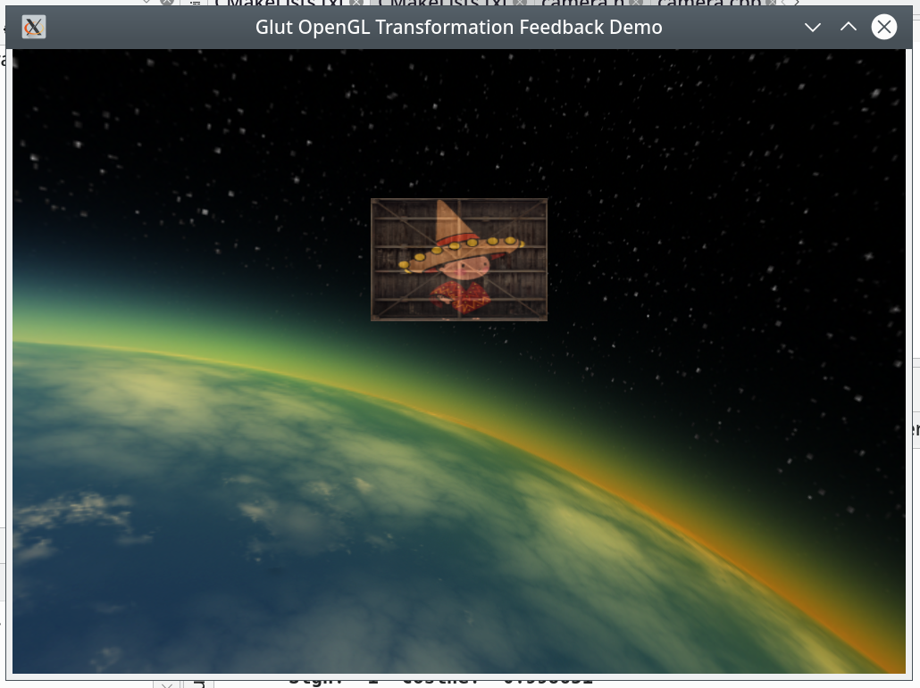
Translation
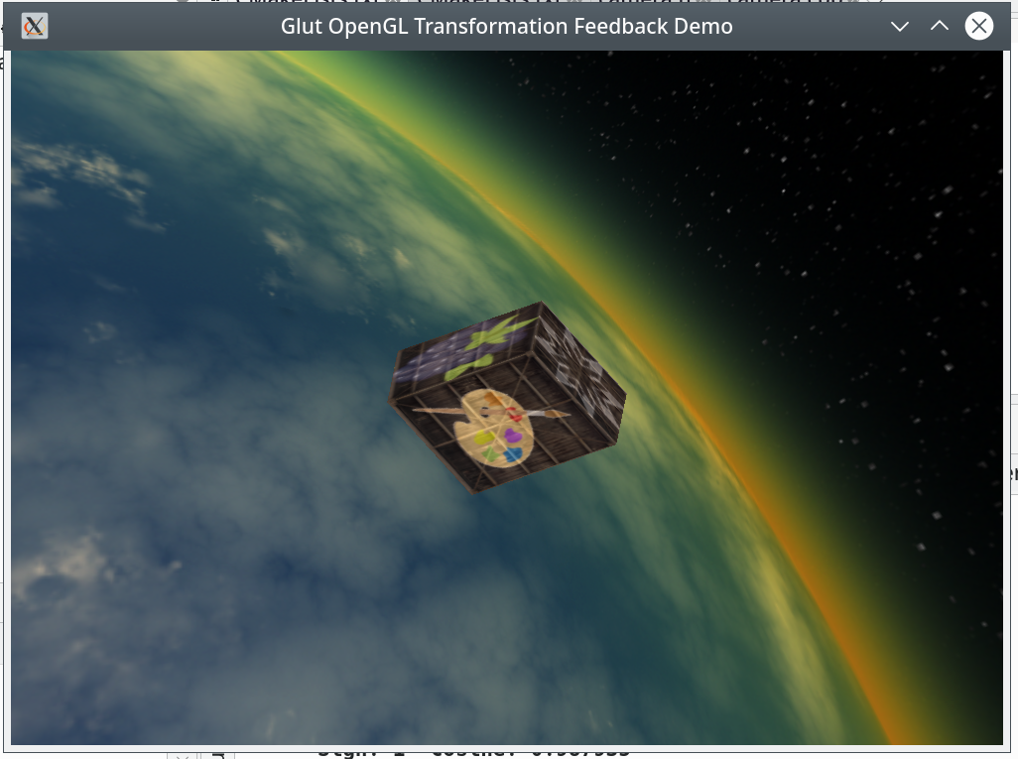
Rotation
Transformation feedback is the process of taking a defined OpenGL object buffer altering it in a shader passing it to another buffer instead of writing the object to the framebuffer and then taking that result and drawing it using a simple drawing shader and, once again, passing it to the alteration shader. By incrementing the values in the alteration shader one can rotate, translate or scale the object, but because the values are incrementations of the previous values, rotation and scaling cannot be done at the same time. To demonstrate these two techniques combined with scaling, the program provides two separate drawings that one can view by clicking on the screen two switch between them. To move the object in rotation mode simply move the mouse. In translation mode, use the WASD keys and R for up and F for down. The program is documented and comes in under the Lesser GNU Public License as an open source program. The real use as I see it for this technique, is for stationary objects that spin and/or oscillate or perhaps have a dying motion coming to rest.
What follows is the contents of the README.txt file:

GlutTransform is a program that displays two examples of
transformation feedback. One display is rotation and
scaling of an object and the other is translation and
scaling. You can cycle between the two displays by
clicking on the window. The rotation display can be
manipulated by moving the mouse. The translation display
has a number of keys enabled.
The keys are as follows.
a right
s back
d left
w forward
r up
f down

For both displays:
Escape ends the program
Alt+Return sets full screen.

To compile the program you will need the following libraries:
FreeImage, SDL2, Boost, GLEW and pthreads.
You must also have cmake and doxygen.
The commands are:

mkdir build
cd build
cmake ..
sudo make doc
sudo make install

To run a program use:

gluttransform

The documentation is located in:

/usr/share/doc/gluttransform-doc

The sources I used to educate myself concerning OpenGL are
as follows:
"OpenGL ES 3.0 Programming Guide Second Edition"
by Dan Ginsburg and Budirijanto Purnomo published by Addison-Wesley 2014.
www.learnopengl.com. On pages 380-385 you will find the example this
program was built from.
GLEW http://glew.sourceforge.net, and
CMAKE http://www.cmake.org.
Doxygen http://www.doxygen.nl
GraphViz https://www.graphviz.org for the "dot" program used by doxygen.
SDL2 https://wiki.libsdl.org/FrontPage
pthread https://www.gnu.org/software/hurd/libpthread.html
OpenGL is generally available on any system as part
of the underlying graphics subsystem and GLEW will
get you access to it.

The program was written and compiled on debian linux available at: www.debian.org.

You can reach me at <eberdeed@eberdeed.net>.
Updates will be available at www.eberdeed.net.
Edward Charles Eberle
April 17th, 2020 San Diego, California United States of America

This program is licensed under the Lesser GNU Public license.
It can be found in the LGPL directory
and once installed it will be also found at
/usr/share/doc/gluttransform-doc/LGPL. This
program is given as an instructional aid for learning
and using the libraries presented and is not to
be considered fit for any particular use.

