HTML Editor
Written in Python using PyQt5 and QScintilla

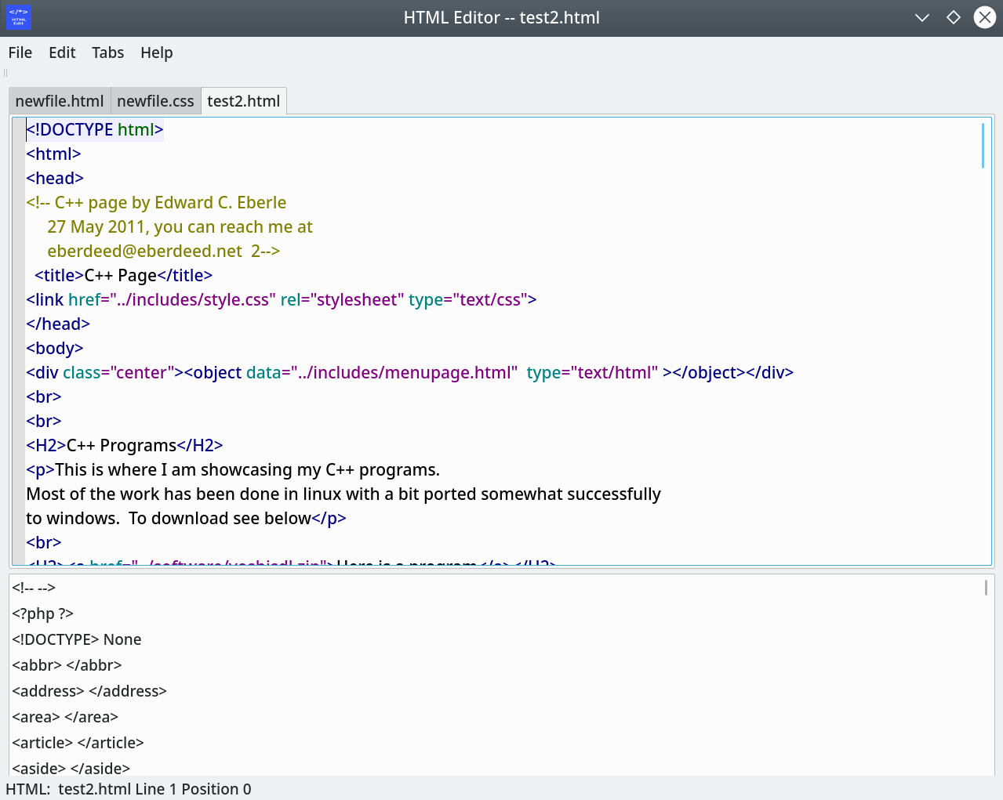
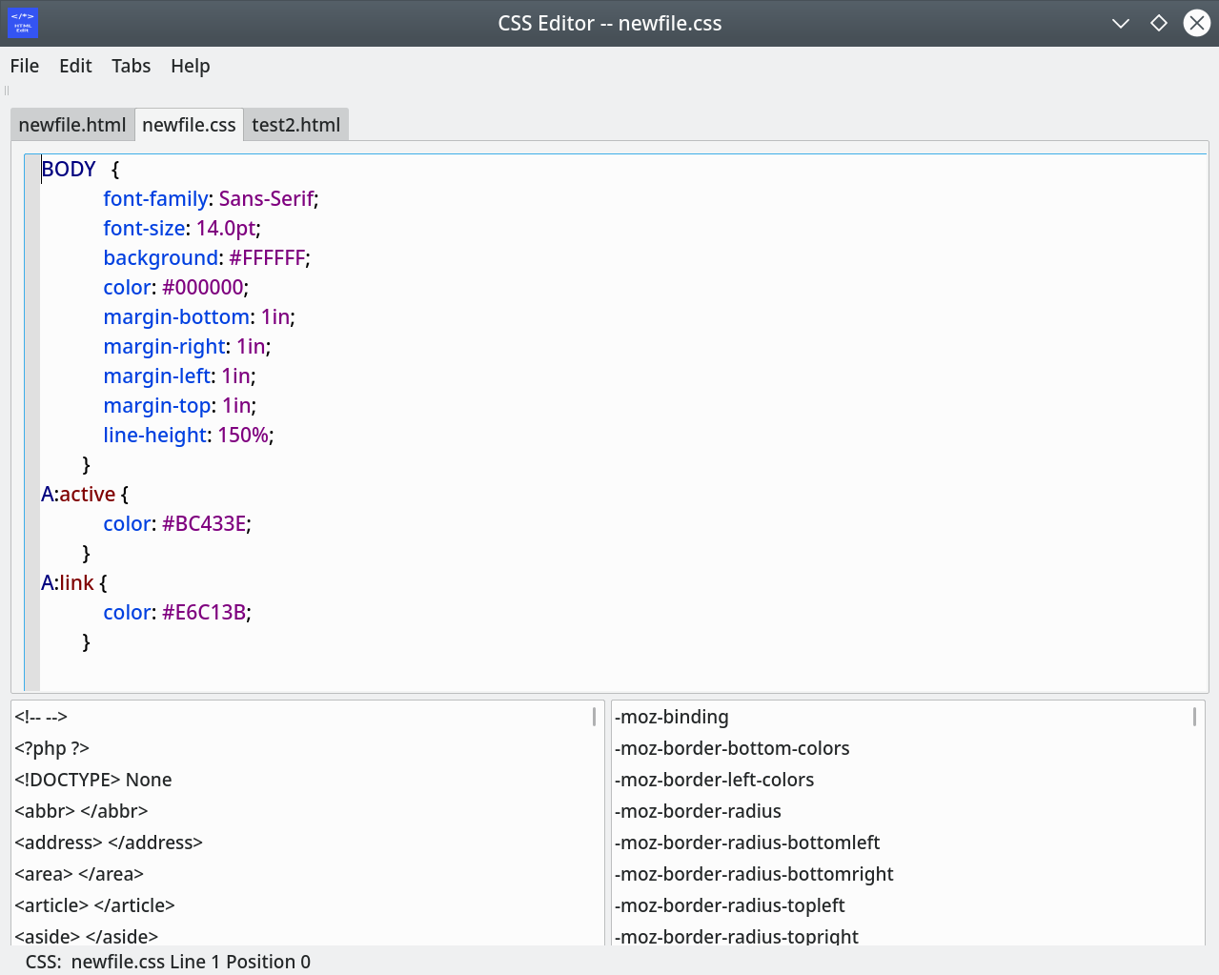
htmleditor.py is an HTML editor with element highlighting provided by QsciScintilla and using PyQt5 for the windowing system. It is a standard multi-document text editor with find and replace as well as the ability to add tags to the HTML files and tags and attributes to the CSS files.
Below is the contents of README, documentation can be found in the documentation directories.

The HTML Editor: A program to allow
the creation of well-formed HTML files.
It is written for Linux but could be
adapted for Windows.

This program requires Python >= 3.4
available at: www.python.org
PyQt >= 5.2.1, QsciScintilla >= 2.8
available at: www.pypi.org
and firefox-esr.
available at: https://www.mozilla.org/en-US/firefox/enterprise
Debian Linux >= 10.2
available at: www.debian.org

To install the program:

./setup.py install

To run the program:

htmleditor.py

The documentation is at:

/usr/share/doc/htmleditor-2.1-doc

The GNU Lesser Public License is at:

/usr/share/doc/htmleditor-2.1-doc/LPGL

This program is issued as is and is not to be
considered suitable for any purpose.

You can reach me for questions at:
<eberdeed@eberdeed.net>

Edward Charles Eberle
September 2020, San Diego California USA

