The OpenGL Window Demo

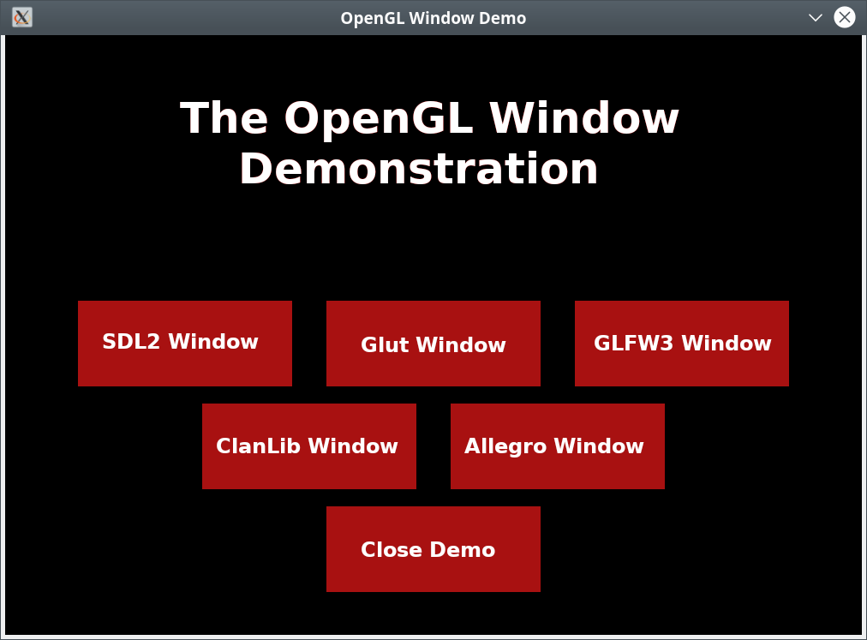

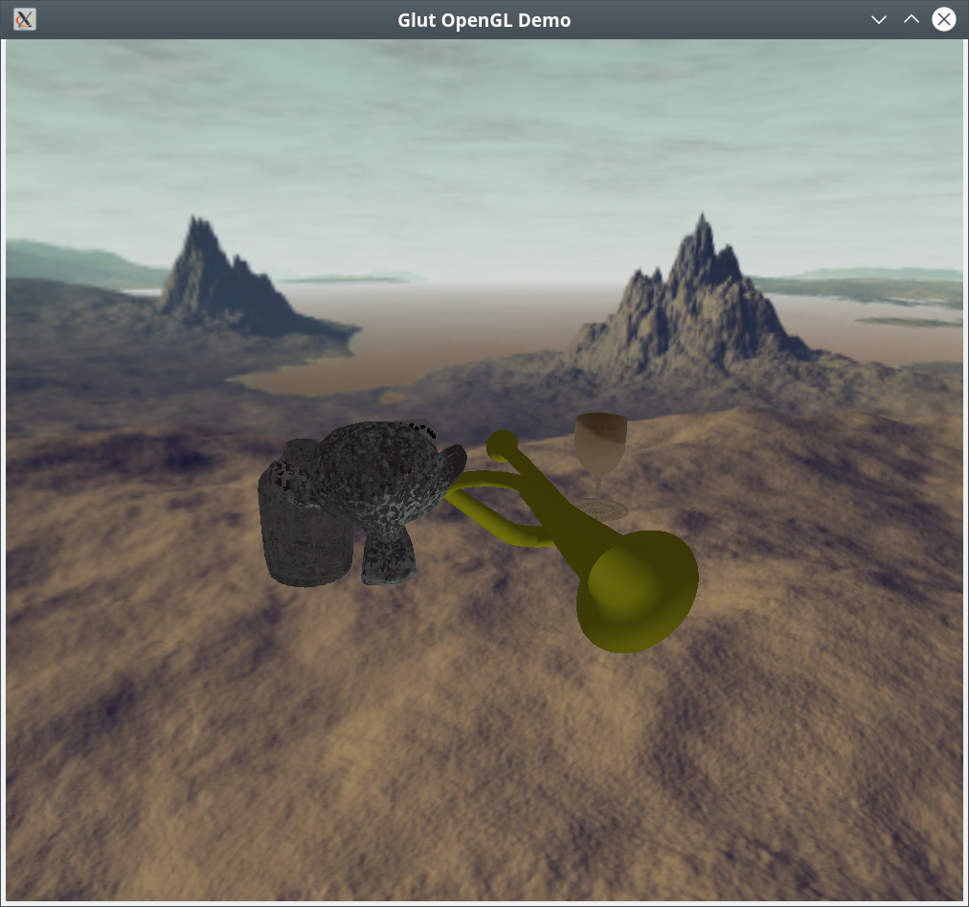
OpenGLWindow is a programmer’s resource that demonstrates how to create a window and provide content – an OpenGL scene and sound – in six different windowing libraries. Each window is its own self contained class, in which the class encapsulating the image is instantiated. The OpenGL scene is provided by a seperate set of classes that are contained in two libraries: libopenglscene.so and libassimpopengl.so. I did it this way so that the scene would be completely separate from the windows themselves.
There are a few variables you may want to know about. First, SCR_WIDTH and SCR_HEIGHT can be changed for each window to change the startup width and height for the window, however, the windows can be dynamically resized. The variable soundFile will change the music played for the given window and in the datagen/src/openglwindow.cpp file the item.path variable can be changed to add your own blender file, and item.location can be used to place it in the scene, also item.model can be used to orient your object, but please use item.location to define your item.model translation or your results may be various. If you are going to add new items, be sure to index the modelinfo vector, using item.idval so the vector can be restored to it’s original order inside the libassimpopengl.so library.
What follows is the contents of the README.txt file:

openglwindow is a program that displays a group
of different kinds of windows with sound using OpenGL.
Initially there is a selection screen to select
the type of window to display. Each display
has a number of keys enabled.
The keys are as follows.
a right
s back
d left
w forward
r up
f down
x reverse view.
z reset view.
Escape ends the program.
Alt+Return sets full screen.
Up arrow zooms in.
Down arrow zooms out.

To compile the program you will need the following libraries:
FreeImage, GLEW, boost, pthread, Assimp, GLM, Xlib, SFML, and
the window libaries, SDL2, freeglut, ClanLib-4.0, Allegro5, SFML,
and GLFW3. You must also have cmake and doxygen.
The commands are:

mkdir build
cd build
cmake ..
sudo make doc
sudo make install

To run a program use:

openglwindow

To run one individually use:

openglallegro
openglsdl2
openglglut
openglglfw3
openglcl40
openglsfml

The documentation is located in:

/usr/share/doc/openglwindow-doc

The assimpopengl subdirectory can be made into a separate program and
used to provide Assimp library support for any project you may
care to undertake. Just copy the assimpopengl directory:

cp -r openglwindow/datagen/assimpopengl yourlocation

and use it as you wish.

The sources I used to educate myself concerning OpenGL are
as follows:
"OpenGL ES 3.0 Programming Guide Second Edition"
by Dan Ginsburg and Budirijanto Purnomo published by Addison-Wesley 2014.
www.learnopengl.com.
GLEW http://glew.sourceforge.net, and
CMAKE http://www.cmake.org.
Doxygen http://www.doxygen.nl
GraphViz https://www.graphviz.org for the "dot" program used by doxygen.
SDL2 https://wiki.libsdl.org/FrontPage
Allegro https://liballeg.org
GLFW https://www.glfw.org
ClanLib http://freshmeat.sourceforge.net/projects/clanlib
Glut http://freeglut.sourceforge.net
Assimp https://www.assimp.org
SFML https://www.sfml-dev.org
pthread https://www.gnu.org/software/hurd/libpthread.html
OpenGL is generally available on any system as part
of the underlying graphics subsystem and GLEW will
get you access to it.

The program was written and compiled on debian linux available at: www.debian.org.

You can reach me at <eberdeed@eberdeed.net>.
Updates will be available at www.eberdeed.net.
Edward Charles Eberle
April 17th, 2020 San Diego, California United States of America

This program is licensed under the Lesser GNU Public license.
It can be found in the assimpopengl/LGPL directory
and once installed it will be also found at
/usr/share/doc/openglwindow-doc/LGPL. This
program is given as an instructional aid for learning
and using the libraries presented and is not to
be considered fit for any particular use.

