The Python OpenGL Multiple Cube Demo

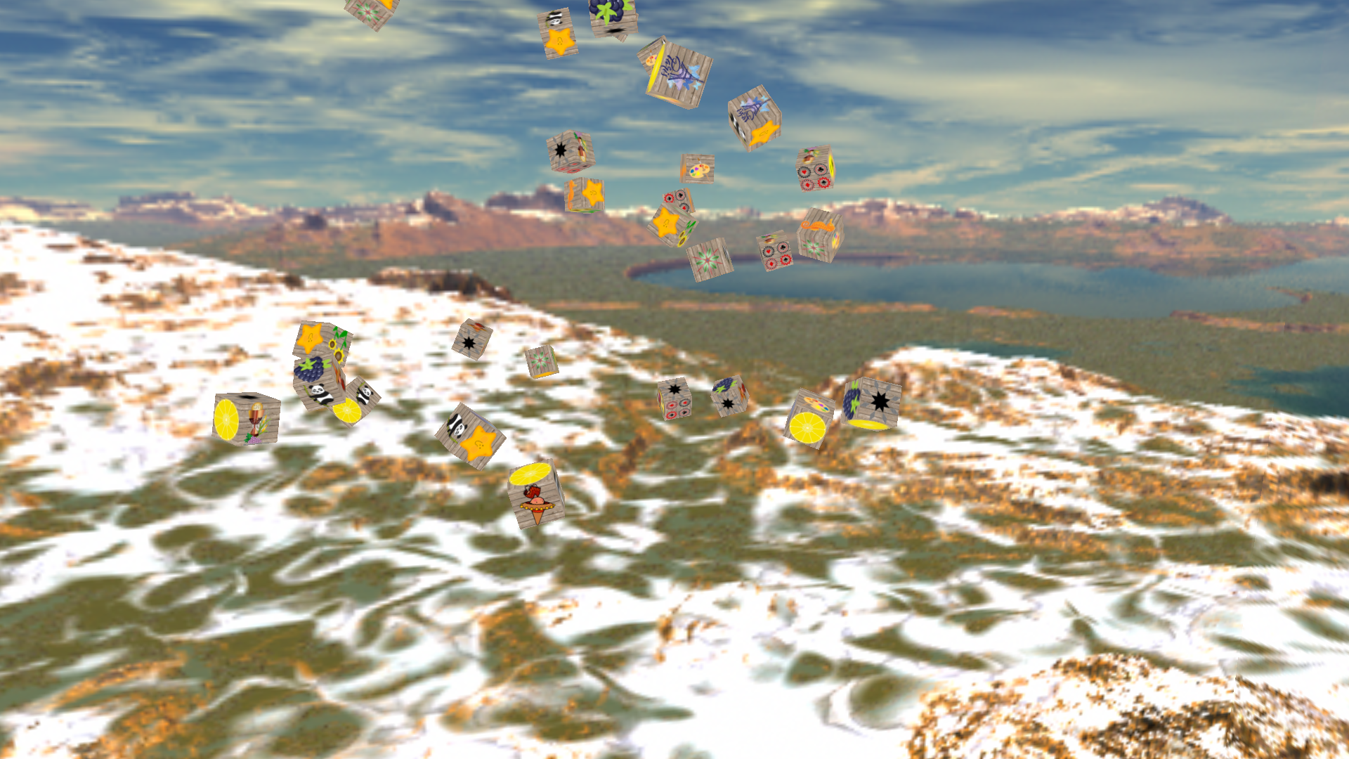
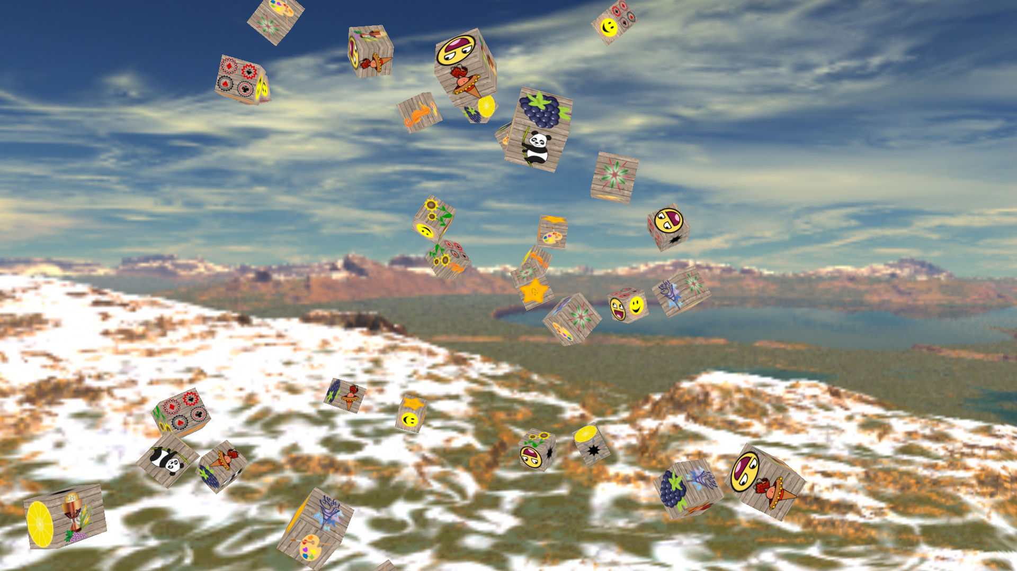
This is the python version of an earlier program I wrote in C++ called sidefogcube. It is a demonstration of writing multiple objects using OpenGL. I use the Glut windowing library for the window, which comes as part of PyOpenGL. I have a separate class that creates the cube called CubeMaker, a class for images called CreateImage and a separate camera class called Camera to move the viewer around the scene. I use the PIL (Python Imaging Library) to combine two images to give the effect of crates with images painted on the sides. I use both numpy and GLM to manage the transformations and other array based activities, and further, I use SFML to provide the music and some of the details of managing the viewport. Some of the variables one might want to manipulate are Width and Height for the startup size of the window. soundFile for the location of the background music, don’t forget to specify the number of seconds in sndMaker to wait for the music to play. The sky box is a list of file names in the skyfiles variable. If you wish to change the images on the boxes, use the boximages variable. The images should be 512x512 pixels and of PNG format.
What follows is the contents of the README.txt file:

multicube.py is a program that displays a number of
cubes randomly distributed and rotated. The display
has a number of keys enabled.
The keys are as follows.
a right
s back
d left
w forward
r up
f down
x reverse view.
z reset view.
Escape ends the program.
Alt+Return sets full screen.
Up arrow zooms in.
Down arrow zooms out.

To run the program you will need python 3.4 and the following libraries:
PyOpenGL, PIL, numpy, sfml, and GLM. For the documenation I use epydoc.

The installation command is:

sudo chmod +x multicube.py
sudo ./setup.py install

To run a program use:

multicube.py

The documentation is located in:

/usr/share/doc/multicube-doc

The sources I used to educate myself concerning OpenGL are
as follows:
"OpenGL ES 3.0 Programming Guide Second Edition"
by Dan Ginsburg and Budirijanto Purnomo published by Addison-Wesley 2014.
www.learnopengl.com.
For python I used David Lutz' books from Oreilly Press.

All of the software used is available at:
www.pypi.org
epydoc: http://epydoc.sourceforge.net
The program was written on debian linux available at: www.debian.org.

You can reach me at <eberdeed@eberdeed.net>.
Updates will be available at www.eberdeed.net.
Edward Charles Eberle
May 23rd, 2020 San Diego, California United States of America

This program is licensed under the Lesser GNU Public license.
It can be found in the assimpopengl/LGPL directory
and once installed it will be also found at
/usr/share/doc/multicube-doc/LGPL. This
program is given as an instructional aid for learning
and using the libraries presented and is not to
be considered fit for any particular use.

