SDL2 Fireworks

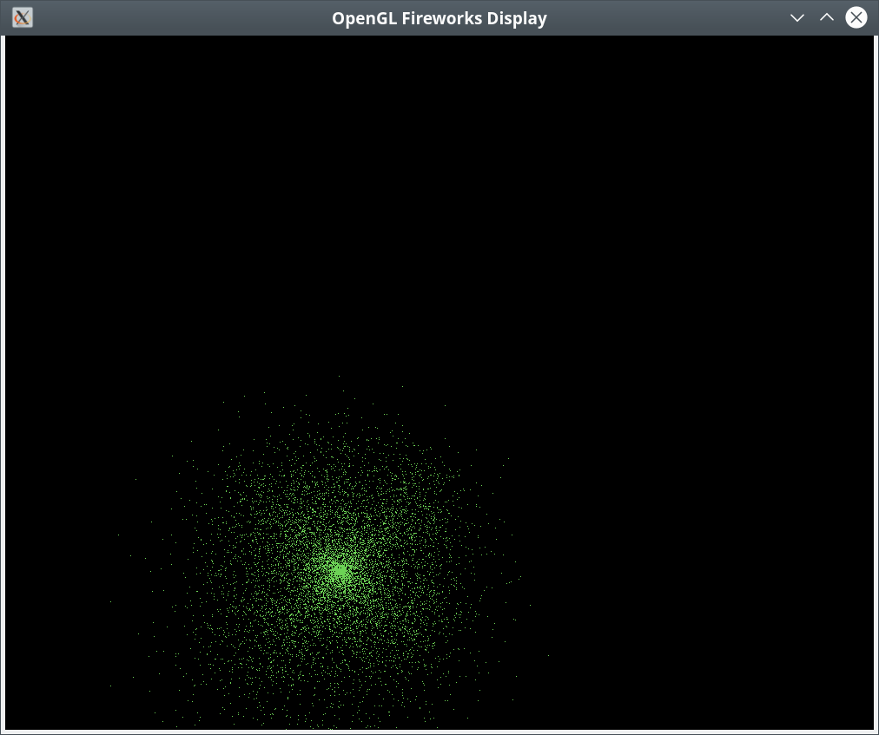
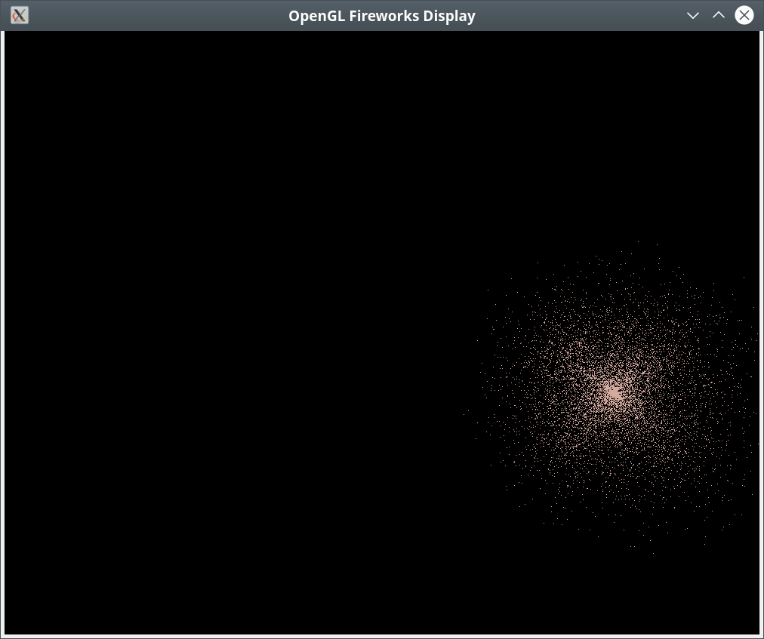
SDL2Firworks is an interesting program in that it is an OpenGL program with no vertex array. The display is a collection of points drawn on the screen as points from a buffer array.
The time standard used throughout is milliseconds and there are variables for time gap, number of explosions per second, time gap between explosions and the overall scale of the displayed image. You can find these variables in the defines in the file commonheader.h in the include directory. They are as follows:

//!The defines.
#define NUM_PARTICLES 10000 Total number of particles.
#define NUM_EXPLOSIONS 3 Number of explosions per second
#define EXP_GAP 200 Gap between explosions where EXP_GAP < 1000 / NUM_EXPLOSIONS
#define SCALE 15 Scale of the display.

You can adjust these to optimize the performance of the program on your system. Generally, reducing the number of particles and number of explosions increases performance.
What follows is the contents of the README.txt file.

Edward C. Eberle <eberdeed@eberdeed.net>
San Diego, California USA

sdl2fireworks is a program that displays a fireworks
display with sound. The keys are as follows.
a right
s back
d left
w forward
r up
f down
x reverse view.
z reset view.
Escape ends the program.
Alt+Return sets full screen.
Up arrow zooms in.
Down arrow zooms out.

To compile the program you will need the following libraries:
FreeImage, GLEW, SDL2, boost, pthread and GLM.
You must also have cmake.
The commands are:

cd build
cmake ..
sudo make
sudo make doc
sudo make install

To run the program:

sdl2fireworks

The documentation is located in:

/usr/share/doc/sdl2fireworks-doc

The sources I used to educate myself concerning OpenGL are
as follows:
"OpenGL ES 3.0 Programming Guide Second Edition"
by Dan Ginsburg and Budirijanto Purnomo published by Addison-Wesley 2014.
www.learnopengl.com.
GLEW http://glew.sourceforge.net, and
CMAKE www.cmake.org.
SDL2 https://wiki.libsdl.org/FrontPage
pthread https://www.gnu.org/software/hurd/libpthread.html
OpenGL is generally available on any system as part
of the underlying graphics subsystem and GLEW will
get you access to it.

Documentation is available after install at:

/usr/share/doc/sdl2fireworks-doc

The program was written and compiled on debian linux available at: www.debian.org.

You can reach me at <eberdeed@eberdeed.net>.
Updates will be available at www.eberdeed.net.
Edward Charles Eberle
April 17th, 2020 San Diego, California United States of America

This program is licensed under the Lesser GNU Public license.
It can be found in the assimpopengl/LGPL directory
and once installed it will be also found at
/usr/share/doc/sdl2fireworks-doc/LGPL. This
program is given as an instructional aid for learning
and using the libraries presented and is not to
be considered fit for any particular use.

