SDL2 OpenGL Demo
A program to display arbitrary blender objects
on a variety of sky box backgrounds.

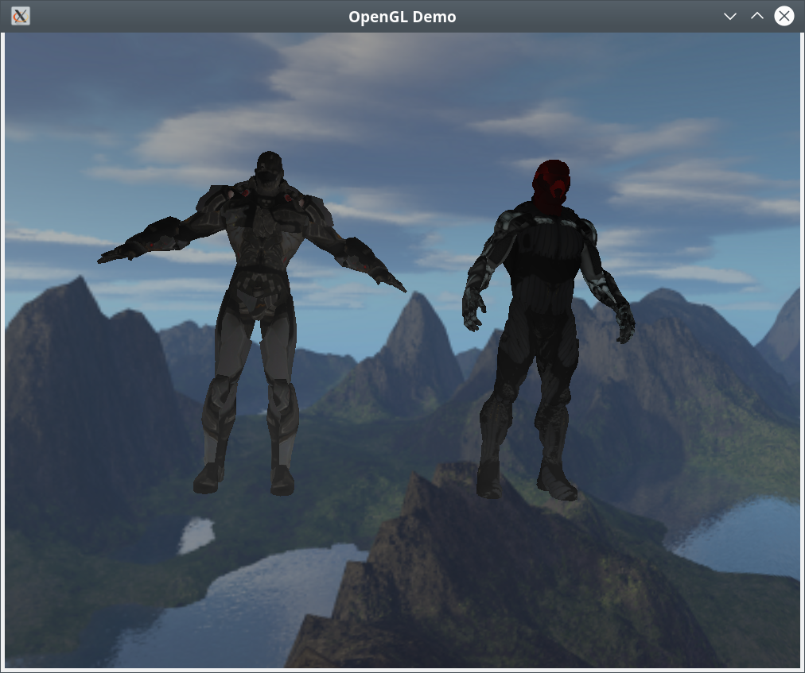
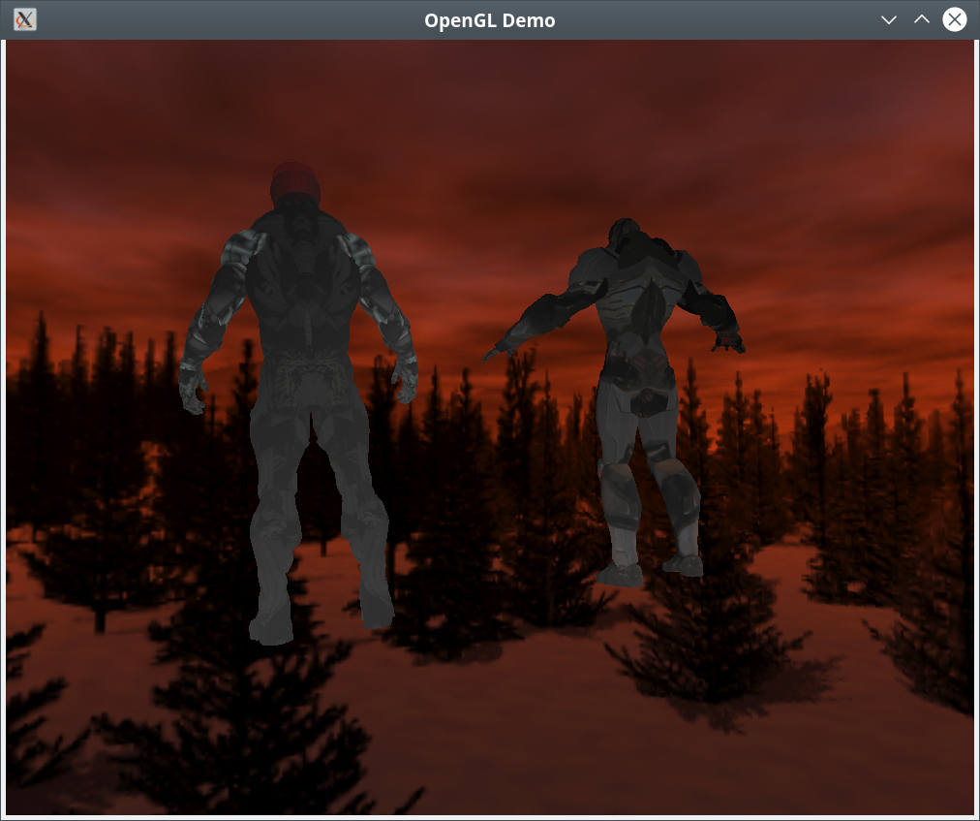
SDL2OpenGLDemo is a program that will display arbitrary 3 dimensional objects in a C++ program. Blender is an internationally known drawing program that can be downloaded for free from www.blender.org. This program relies on the assimp library, which is an open source object conversion library and can be obtained at www.assimp.org.
Below is the contents of README.txt, documentation can be found in the html or man directories at /usr/share/doc/sdl2opengldemo-doc.

sdl2opengldemo: A Program to display arbitrary blender objects
in a C++ program.

This program requires:
The assimp library www.assimp.org,
the boost library www.boost.org,
the freeimageplus library www.sourceforge.net,
GLEW http://glew.sourceforge.net, and
CMAKE www.cmake.org.
SDL2 https://wiki.libsdl.org/FrontPage
pthread https://www.gnu.org/software/hurd/libpthread.html
OpenGL is generally available on any system as part
of the underlying graphics subsystem and GLEW will
get you access to it.

To compile the program:

cd build
cmake ..
make
sudo make doc
sudo make install

To run the program:

sdl2opengldemo

The key layout is as follows:

Escape ends the program.
Alt + Enter set the program to full screen.

Documentation is available after install at:

/usr/share/doc/sdl2opengldemo-doc

The program was written and compiled on debian linux available at: www.debian.org.

You can reach me at <eberdeed@eberdeed.net>.
Updates will be available at www.eberdeed.net.
Edward Charles Eberle
April 17th, 2020 San Diego, California United States of America

This program is licensed under the Lesser GNU Public license.
It can be found in the assimpopengl/LGPL directory
and once installed it will be also found at
/usr/share/doc/sdl2opengldemo-doc/LGPL. This
program is given as an instructional aid for learning
and using the libraries presented and is not to
be considered fit for any particular use.

