Slick Explosion
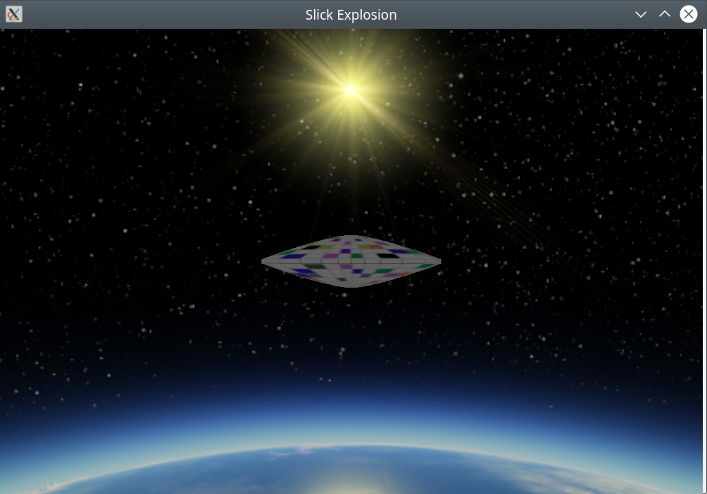
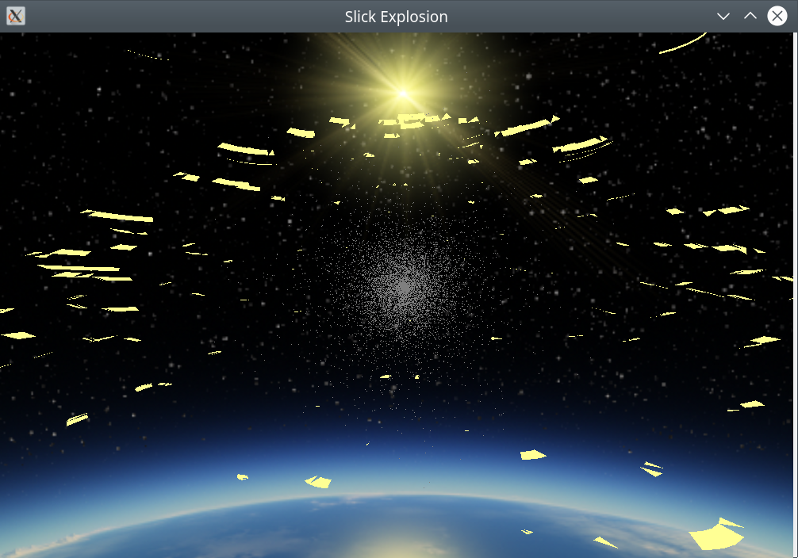
Slick explosion is an interesting program in that it is an OpenGL program with a component that has no vertex array. The cloud of particles are a collection of points drawn on the screen as points from a vertex array. The time standard used throughout is milliseconds and there are variables for time gap and the overall scale of the displayed image. You can find these variables in the defines in the file commonheader.h and smokecloud.h in the include directory. They are as follows:

The define in CommonHeader (adjusts sound timing):
SlickExplosion
#define EXP_GAP 2000
The defines in SmokeCloud:
AssimpOpenGL
#define NUM_PARTICLES 10000 Total number of particles.
#define SCALE 15 Scale of the display.
The define in CommonHeader (adjusts breakup of the object):
AssimpOpenGL
#define CHUNK_SIZE 10
You can adjust these to optimize the performance of the program on your system. Generally, reducing the number of particles and increasing the chunk size increases performance. And, of course, you may have to adjust the library setting in CMakeLists.txt.
What follows is the contents of the README.txt file.

Edward C. Eberle <eberdeed@eberdeed.net>
San Diego, California USA

Slick explosion is an interesting program in that it is an OpenGL program with an explosion and a smoke cloud. The cloud of particles are a collection of points drawn on the screen as points from a vertex array. The time standard used throughout is milliseconds and there are variables for time gap and the overall scale of the displayed image. You can find these variables in the defines in the file commonheader.h and smokecloud.h in the include directory. They are as follows:

The define in CommonHeader (adjusts sound timing):
SlickExplosion
#define EXP_GAP 2000
The defines in SmokeCloud:
AssimpOpenGL
#define NUM_PARTICLES 10000 Total number of particles.
#define SCALE 15 Scale of the display.
The define in CommonHeader (adjusts breakup of the object):
AssimpOpenGL
#define CHUNK_SIZE 10
You can adjust these to optimize the performance of the program on your system. Generally, reducing the number of particles and increasing the chunk size increases performance. And, of course, you may have to adjust the library setting in CMakeLists.txt.
What follows is the contents of the README.txt file.

Edward C. Eberle <eberdeed@eberdeed.net>
San Diego, California USA

slickexplosion is a program that displays an explosion with sound.
The keys are as follows.
a right
s back
d left
w forward
r up
f down
x reverse view.
z reset view.
Space toggles the explosion.
Escape ends the program.
Alt+Return sets full screen.
Up arrow zooms in.
Down arrow zooms out.

To compile the program you will need the following libraries:
FreeImage, GLEW, SDL2, boost, pthread and GLM.
You must also have cmake, doxygen, graphviz and dia.
The commands are:

cd build
cmake ..
sudo make
sudo make doc
sudo make install

To run the program:

slickexplosion

The documentation is located in:

/usr/share/doc/slickexplosion-doc

The sources I used to educate myself concerning OpenGL are
as follows:
"OpenGL ES 3.0 Programming Guide Second Edition"
by Dan Ginsburg and Budirijanto Purnomo published by Addison-Wesley 2014.
www.learnopengl.com.
GLEW http://glew.sourceforge.net, and
CMAKE www.cmake.org.
SDL2 https://wiki.libsdl.org/FrontPage
pthread https://www.gnu.org/software/hurd/libpthread.html
OpenGL is generally available on any system as part
of the underlying graphics subsystem and GLEW will
get you access to it.

Documentation is available after install at:

/usr/share/doc/slickexplosion-doc

The program was written and compiled on debian linux available at: www.debian.org.

You can reach me at <eberdeed@eberdeed.net>.
Updates will be available at www.eberdeed.net.
Edward Charles Eberle
March 25th, 2021 San Diego, California United States of America

This program is licensed under the Lesser GNU Public license.
It can be found in the assimpopengl/LGPL directory
and once installed it will be also found at
/usr/share/doc/slickexplosion-doc/LGPL. This
program is given as an instructional aid for learning
and using the libraries presented and is not to
be considered fit for any particular use.

