Resources:

Training: Udemy – Ansible <https://aetna.udemy.com/course/learn-ansible/learn/lecture/7133390#notes:~:text=Ansible%20for%20the%20Absolute%20Beginner%20%2D%20Hands%2DOn%20%2D%20DevOps>

Courses to take in Udemy:

Jenkins – The complete Tutorial|Master CICD by Renju Ratheesh

Automation with Ansible Playbooks – Hands On!! By Shikhar Verma

Automation with Ansible Playbooks by Narendra P

Ansible for the DevOps Beginners & System Admins by AR Shankar

[Ansible 101 by Jeff Geerling - YouTube streaming series | Jeff Geerling](https://www.jeffgeerling.com/blog/2020/ansible-101-jeff-geerling-youtube-streaming-series)

[www.docs.ansible.com/ansible/2.5/modules/copy_module.html](http://www.docs.ansible.com/ansible/2.5/modules/copy_module.html)

<https://www.youtube.com/c/AnsiblePilot> -- youtube

Vocab:#############################################################################

**Github --**this contains inventory of the hosts, source code via playbooks manages source code repository

<https://github.aetna.com/PEDBEngineering/ans_ent_oracle_playbook/tree/master/playbooks> -- stores all playbooks and pipeline.

Git location for Jag’s repository :

<https://github.aetna.com/0948333/ans_ent_java_vulernability>

Std2 = old parameters used by aetna hcb_dev.yml

Std1= newest standard

**Jenkins --** end to end need pipline from Jenkins to Ansible Ansible and playbooks. Application where can provide docker container and provide gui interface. (ans_ent_java_vulnerability_remediation)

(<https://Jenkins-digital.cvshealth.com>)

[All [DBEngineering » Oracle] [Jenkins] (cvshealth.com)](https://jenkins.cvshealth.com/job/DBEngineering/job/Oracle/)

Jenkins website:

<https://jenkins.cvshealth.com/job/DBEngineering/job/Oracle/>

https://jenkins.cvshealth.com/job/DBEngineering/

**Nexus** – Repository that holds zip files for downloads. Binaries, software large files, sometime shell scripts. Nexus directory - linux folder, oem_jdk_upgrade.sh (pbm_oracle-

upload files to nexus using curl command Ie:dbms_home_196.zip must push to nexus using personal id.

<https://nexus-ha.cvshealth.com:9443/#browse/welcome> -- Should be able to login with windows id.

Nexus:

[Browse - Nexus Repository Manager (cvshealth.com)](https://nexus-ha.cvshealth.com:9443/" \l "browse/browse:dba-oracle-hcvs:pbm-oracle%2Flinux)

[https://nexus-ha.cvshealth.com:9443/#browse/browse:dba-oracle-hcvs](https://nexus-ha.cvshealth.com:9443/" \l "browse/browse:dba-oracle-hcvs)

**Confluence** – contains Ansible documents used for resources.

https://wikiprod.aetna.com/login.action?os_destination=%2Fpages%2Ftinyurl.action%3FurlIdentifier%3DxYTiBQ&permissionViolation=true

Must merge file and then push

**Playbooks:**ie:cleanup_dbms.yml, install_oracle.yml,

**Pipeline** -- Ans_ent_oracle_install is a pipeline - Build with parameters – contains the form and actions.

**Repository url** -- shows code it is calling with the playbook location

**Task/Action** -- under choices has a playbook for that action. Ie: Action – Create CDB

**Inventory** – stores the hosts ansible will connect to /etc/ansible/hosts default location.

Inventory parameters: ansible_connection – ssh for linux or localhost, ansible_port = 22/5986, ansible_user – root/administrator, ansible_ssh_pass – xxx.

**Modules** – tasks executed within a playbook. Ie: system(lsvg,hostname,ping),commands(script,shell,expect=prompts),files(copy,find,script),Database(mysql),cloud,windows(win_copy),yum,service,become,copy

**Ansible-plyabook** – help ie:toor_orapbm@paz1ansapl10v /jag/roles/oemagentupgrade/defaults – holds variables.

**Yamllint.com** – you can paste the content of your playbook and it will tell you if you have a syntax error in it.

<https://atom.io/packages/linter-js-yaml> - a package you can download and install

(apm install linter-js-yaml) – command installs the package on your machine.

Login with aetna id:

xsvcaapm01p -- new server my aetna id=A841533

clone repository to xsvp

from your ansible server ti ssh key

ansible-lin

clone

Ansible Developer I need to be part of group id

ldap aetna

Created test environment

JRAFTEST - DB

paz1sprdpdr1 - server name

**LDAP website to check membership of our id.**

http://adhelp.aetna.com/objectsearch.asp

Need to request to be member of 2 ansible groups

Request my id be added to this member

https://itsm.cvs.com/sp_home?id=sc_cat_item&sys_id=f2405f5b1b15c190235015ff034bcb43&sysparm_category=dd3320ec1b60fc90ba5b77761a4bcb00

AnsibleDeveloper - submitted request to add my id to the member group REQ3080837

############ Access requirements ###################################################

Access needed: github, nexus,Jenkins,Ansible controller-dev-paz1ansadl10v,prod-paz1ansapl10v,confluence

Ansible controller server: (DEV,PROD) – request

Sample request for PBM **IT Service Center – REQ2723176, REQ2743925**

1. Request your individual id in HCB ansible controller like the example below.

JSETHI@paz1ansapl10v ~]$ id

uid=1677971202(JSETHI) gid=1677971202(JSETHI) groups=1677971202(JSETHI),101(staff),399(cvsdba),400(dba),150832(dba_sudo),1678464014(perotdba),1682048038(orapbm_sudo) context=unconfined_u:unconfined_r:unconfined_t:s0-s0:c0.c1023

1. Request sudo access for the above id as per the group needed.

[JSETHI@paz1ansapl10v ~]$ sudo -l

Matching Defaults entries for JSETHI on paz1ansapl10v:

    !visiblepw, always_set_home, env_reset, secure_path=/sbin\:/bin\:/usr/sbin\:/usr/bin, env_keep="COLORS DISPLAY HOSTNAME HISTSIZE

    INPUTRC KDEDIR LS_COLORS", env_keep+="MAIL PS1 PS2 QTDIR USERNAME LANG LC_ADDRESS LC_CTYPE", env_keep+="LC_COLLATE LC_IDENTIFICATION

    LC_MEASUREMENT LC_MESSAGES", env_keep+="LC_MONETARY LC_NAME LC_NUMERIC LC_PAPER LC_TELEPHONE", env_keep+="LC_TIME LC_ALL LANGUAGE

    LINGUAS _XKB_CHARSET XAUTHORITY", secure_path=/sbin\:/bin\:/usr/sbin\:/usr/bin, use_pty, logfile=/var/log/sudo.log

User JSETHI may run the following commands on paz1ansapl10v:

    (root) NOZOPAWD: /bin/su - toor_orapbm

    (toor) NOZOPAWD: /usr/local/bin/ansible *, /usr/local/bin/ansible-playbook *

1. From the ansible controller server get the ssh key of the toweragent(could be toor) and push those to all the targets.

nexus repo access contact  Tanubuddi, Eshwar (Contractor) [Eshwar.Tanubuddi@CVSHealth.com](mailto:Eshwar.Tanubuddi@CVSHealth.com)

 ########################################################

1. Gain access to ansible servers – Submit IT Care request
2. Setup ssh key to each host
3. Setup personal repository to store playbooks
4. Load playbooks into github
5. Load files into nexus zip files
6. Setup Jenkins
7. Request aetna id to login to confluence – [requestsn2@atena.com](mailto:requestsn2@atena.com) email

########################################################################

Goals: patch java using Ansible, install TFA.

Usage:

Ansible hosts -a command without playbook.

Ansible all -m ping -I inventory.txt – try to ping all servers in inventory.txt

source /opt/ansible/venv/ansible-4.4/bin/activate

ansible-lint -c /etc/ansible/ansible-lint.cfg   <path to code to lint or black for current directory>

#################### YAML sample playbook ###########################################

Sample playbook

-

Name: Test connectivity to targets – two spaces in front

Hosts: all

Tasks: -- this is an array

* Name: Ping test – name of first test
* Ping: --This is a module word ping

Yamllint.com – you can paste the content of your playbook and it will tell you if you have a syntax error in it.

Ansible-playbook playbook-pingtext.yml -I inventory.txt

Sample:

web3 ansible_host=server3.company.com ansible_connection=ssh ansible_user=root ansible_ssh_pass=xxx

db1 ansible_host=server4.company.com ansible_connection=winrm ansible_user=administrator ansible_zopa=xxx

########################## Sample pipeline setup ##################################

Pipeline example:

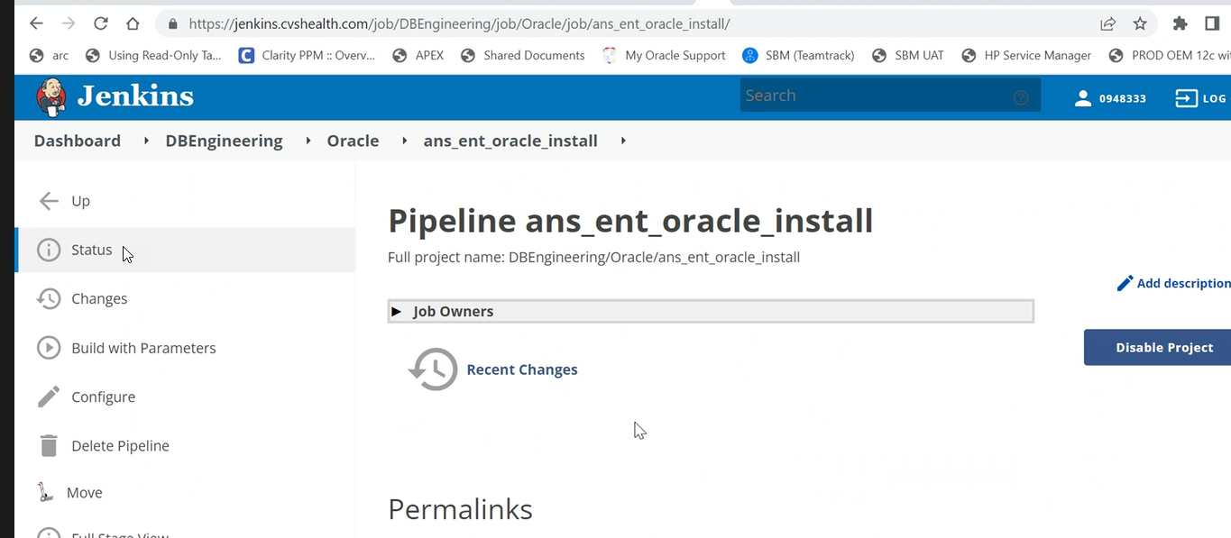

Action – task performing ie: Patch_DB, Create CDB

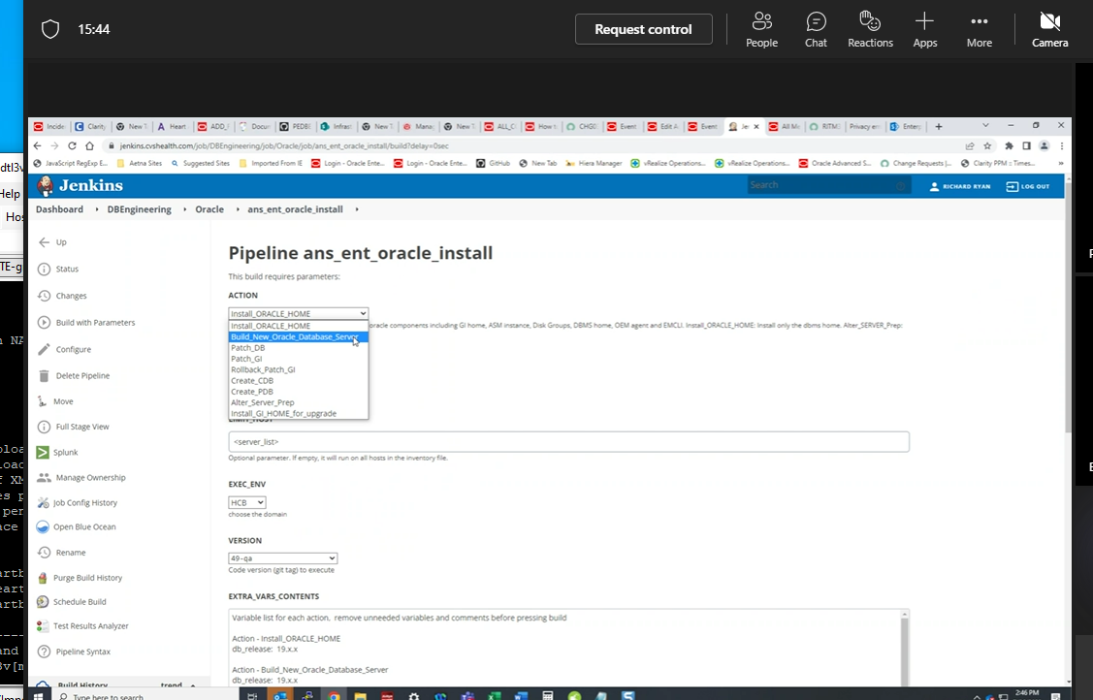

Github holds playbooks

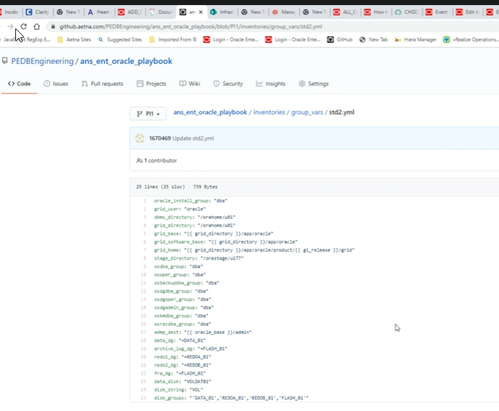

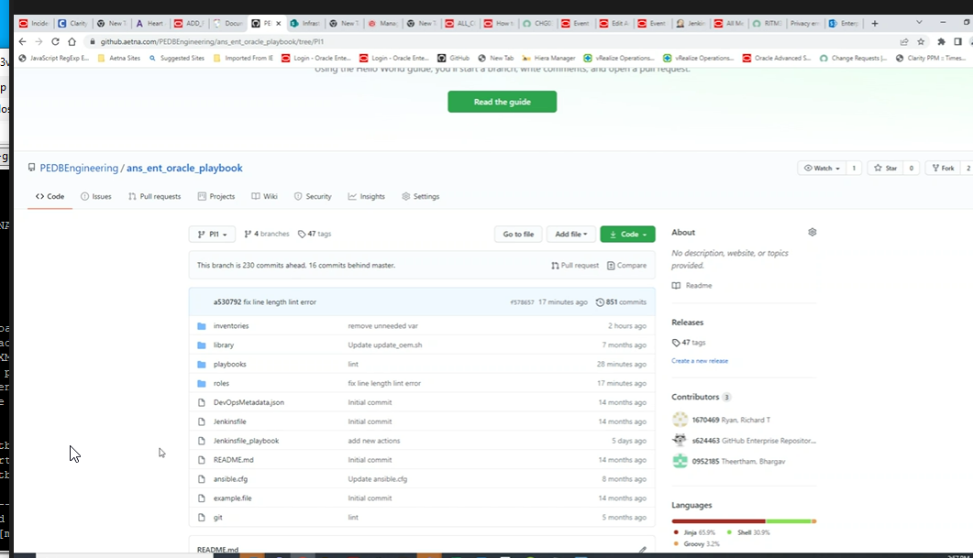

Need github is the inventory/repo that is code repository to store pipline.

They have gold vm they clone from original vm by applying patch to a server install release patching to run patch db this moves db to new oracle home. Tar up the patch once applied and stored on nexus repo.

You would upload your software.zip files into the repo. Sonatype Nexus Repository Manager

########################-- To create pipeline Jenkins -----##################################

Jenkins

Dashbaord – DBEngineering – Oracle – ans_ent_java_vulnerability_remediation – oem_agent_jdk_upgrade

jira

Build with parameters

Check This project is parameterized

Name: Action

Choices: oem_agent_jdk_upgrade

Name: Limit_host

Choice parameter env_exe

Multi-line string: EXTRAC_VARS_

Choice parameter-name -VERBOSE_LEVEL

Pipleline-Definition - Script from SCM

Branch - main

script path - Jenkinsfile

SAVE

ans_ent_java_vulneriabilty_remediation/Jenkinsfile

Dockerimage - same code dynamically generate new servers and create environment for you and preparing an ansible server for you.

It spins up a similar environment as our paz1ansapl10v server into a docker container and the container is used to run code from.

Devops team has already configured where going to run ansible from.

if action = oem_agent_jdk_upgradeenv

Execute playbook - env.PLAYBOOK = "./playbooks/opatch_db_grik_jdk_upgrade.yml"

Sample yaml

Name: copy file to target servers

Hosts: all

Tasks:

* Name: Copy file

Copy:

Src: /tmp/test-file.txt

Dest: /tmp/test-file.txt

###################### To execute playbook ##############################

Ansible-playbook playbook-copyfile.yaml -i inventory.txt

git hub stores playbook, and source code -- https://github.aetna.com/

ans_ent_java_vulnerability:

-playbooks-

-roles/oemagentupgrade

-jenkinsfile

-inventory,group_vars/all.yml

-ansible.cfg

ansible write play book

oem_agent_jdk_upgrade.yml - playbook

roles:

jag/roles/oemagentupgrade/has --defaults,tasks,files,vars,handlers, tests,templates

defaults - file_path: variables, JDK_

templates - file copy to a different server

handlers - error handlers readme files author

vars - variables

files - shell script file, oem_jdk_upgrade.sh(find agent home, find version of oms > 13.4 less then that will complain.),(Does a blackout, stops agent,copy existing jdk to different directory, copies patch and applies it.

or zip file big files won't load into github must go into nexus,

tasks - main.yml -- host mentioned in playbook already, pins hostname, cleans up old jdk, remove old log file, create temp directory, copy zip file, download shell script from nexus file, runs shell script which copies zip files using variables defined in defaults directory, remove old jdk file.

Jag/Inventory/hosts

Test0 – enter in the hosts working with

Ansible test0 -m ping – check to see if can reach them from ansible

Ansible-playbook playbooks/create_temp_dir.yml –syntax-check -- Checks syntax

Ansible-playbook playbooks/create_temp_dir.yml – executes the playbook

Github will need to be setup with your own ssh keys

Github – settings – ssh and gpg keys

######################To upload files to nexus:####################################

Upload:

curl -v -u 0948333 --upload-file "C:\PBM\Java_vulnerability\files\p34170400_180341_Linux-x86-64.zip" <https://nexus-ha.cvshealth.com:9443/repository/dba-oracle-hcvs/pbm-oracle/linux/p34170400_180341_Linux-x86-64.zip>  
curl -v -u 0948333 --upload-file "C:\PBM\Java_vulnerability\files\oem_jdk_upgrade.sh" <https://nexus-ha.cvshealth.com:9443/repository/dba-oracle-hcvs/pbm-oracle/linux/oem_jdk_upgrade.sh>

To download:

Go to cmd on laptop

################ How to setup SSH Key in Github #####################################

<https://github.aetna.com> – create repository –

Get on ansible non prod server with your own id – paz1ansapl10v

Run following from your own personal id account on unix ansible server.

ssh-keygen -t rsa -b 4096 – this will generate a ssh key

hit enter 3 times to take default

cd .ssh

ls -ltr

cat id_rsa.pub – copy entry to github website

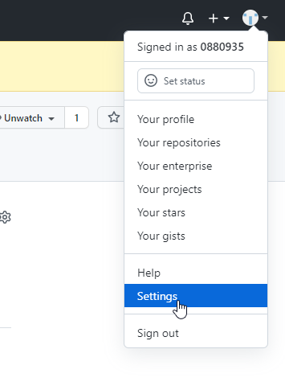

ssh and GPG keys

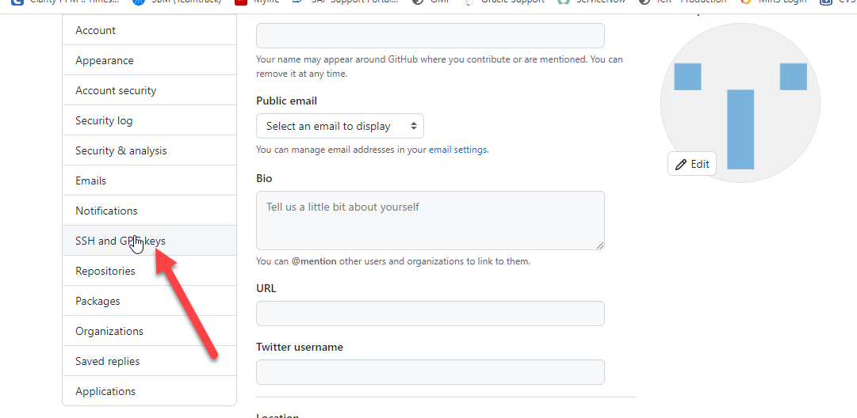

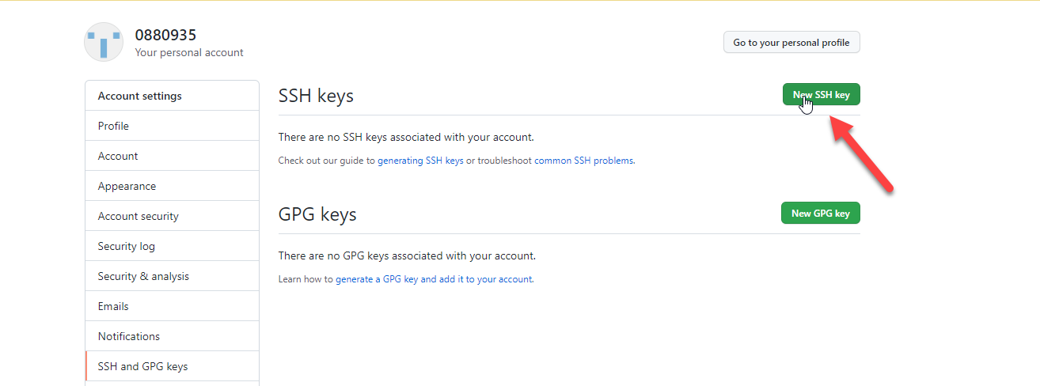

Paste key

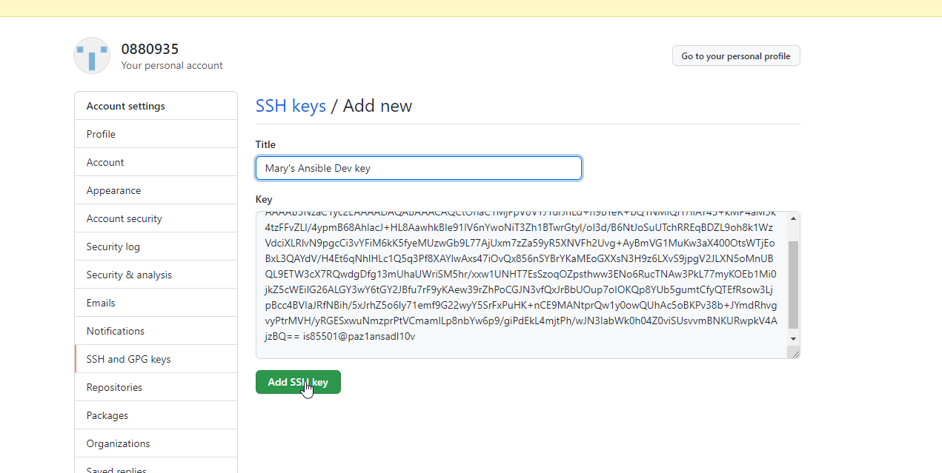

######################### How to create a branch in repository #####################

echo "# Mary" >> README.md

git init

git add README.md

git commit -m "first commit"

git branch -M main

git remote add origin git@github.aetna.com:0880935/Mary.git

git push -u origin main

Sample output:

The authenticity of host 'github.aetna.com (10.155.23.71)' can't be established.

ECDSA key fingerprint is SHA256:+wCd59hCuw+0ss9wi8UzGEJFGwFNvApGRv094IywY58.

ECDSA key fingerprint is SHA1:7H5peUfzeqL7YixoTC3SNLKTz+E.

Are you sure you want to continue connecting (yes/no)? yes

Warning: Permanently added 'github.aetna.com,10.155.23.71' (ECDSA) to the list of known hosts.

Counting objects: 3, done.

Writing objects: 100% (3/3), 262 bytes | 0 bytes/s, done.

Total 3 (delta 0), reused 0 (delta 0)

To git@github.aetna.com:0880935/Mary.git

* [new branch] main -> main

Branch main set up to track remote branch

########################################################

echo "# Mary" >> README.md

git init -- one time

git add README.md -- one time

git commit -m "first commit"

git branch -M main

git remote add origin git@github.aetna.com:0880935/Mary.git

git push -u origin main

############## How to push a new file ################

git config --global user.name "0880935"

git config --global user.email mary.allen@cvshealth.com

git add .

git commit -m "second commit"

git push origin main

#########################################################

############ Jenkins #####################################

To tie Jenkins to ansible server

In the inventory_file:

Jag folder under personal id/inventory

Git add .

Git status

Set -o vi

Git commit -m “Added more hosts”

Git push -u -- This will push updates to the github ans_ent_java_vulnerability/inventory

Jenkins: -- runs playbook for you against servers ou specidfy

Action:

Oem_agent_jdk_upgrade

Inventory_file:

./inventory/pbm_nonprod.yml

Limit_host

Only executing on hosts you list. You can use comma or colon to separate hosts.

Jenkins.cvshealth.com

https://jenkins.cvshealth.com/job/DBEngineering/

goes to docker library and spins ansible controler dynamically. Prepares image from docker image.

Dashboard-DBEngineering-Oracle-Pipeline name -

ans_ent_java_vulneriabilty_remediation

Action: - contains all playbooks will be developing from different teams

oem_agent_jdk_upgrade

Inventory_file

./inventory/pbm_nonprod.yml - contains hostnames

Limit_host - if want to run on specific host

EXE_ENV-PBM

EXTRA_VARS_CONTENTS

roles/oemagentupgrade/defaults/main.yml-containts

VERBOSE_LEVEL= shows level of debugging you want to see

BUILD - runs the pipeline

###################### Using a condition ##################

* Name: Check status of a service

Hosts: localhost

Tasks:

- Command: service httpd status

Register: result -- registers the results of the status

Mail:

To: [admin@company.com](mailto:admin@company.com)

Subject: Service Alert

Body: httpd service is down

When: result.stdout.find(‘down’) != -1 – email if output not down. If not found returns -1.

Ie:

name: 'Am I an Adult or a Child?'

hosts: localhost

vars:

age: 25

tasks:

-

command: 'echo "I am a Child"'

when: "age<18"

-

command: 'echo "I am an Adult"'

when: "age >= 18"

###################Using a loop ###########################

Name: create users

Hosts: localhost

Tasks:

* User: name= ‘{{ item.name }}’ state=present uid=’{{ item.uid }}’

Loop:

-name: joe

-uid: 1010

-name: George

-uid: 1011

-Sample:

name: 'Print list of fruits'

hosts: localhost

vars:

fruits:

- Apple

- Banana

- Grapes

- Orange

tasks:

-

command: 'echo "{{ item }}"'

with_items: '{{ fruits }}'

Sample:

name: 'Install required packages'

hosts: localhost

vars:

packages:

- httpd

- binutils

- glibc

- ksh

- libaio

- libXext

- gcc

- make

- sysstat

- unixODBC

- mongodb

- nodejs

- grunt

tasks:

-

yum:

name: '{{ item }}'

state: present

with_items: '{{ packages }}'

################# Git hub creating a branch ############################

<https://itsm.cvs.com/sp_home?id=sc_cat_item&sys_id=a062c43613f7ef80c2453998d144b013&sysparm_category=f68cef2a13f3ef80c2453998d144b03b>

git clone *******

git branch test

git checkout test

git status

git add

git commit

git push origin test

${BRANCH}

################################## Creating a new playbook ############################

1. Login with sudo su – toor_orapbm (paz1ansapl10v)
2. **Role:** Setup new roles directory

Cd /home/toor_orapbm/Mary/roles

Run command: ansible-galaxy init dbjdkupgrade

Created dbjdkupgrade

1. **Playbook:** Create playbook

/home/toor_orapbm/Mary/playbooks/dbjdkupgrade.yml

- hosts: dbjdk

gather_facts: false

user: "{{ root_user }}"

roles:

- dbjdkupgrade

1. **Tasks:** Setup new tasks main.yml file

/home/toor_orapbm/Mary/roles/dbjdkupgrade/tasks

################ Update inventory ####################################

Add to inventory

/home/toor_orapbm/jag/inventory/hosts

Created:

Execnonprod

Execprod

/Ansible execnonprod -m ping

Push new inventory to github

Update inventory/pbm_nonprod.yml file

Git status

Git add .

Git commit -m “modified inventory file”

Git push -u origin

############### To run a pipeline ########################################

Jenkins

Action: oem_agent_jdk_upgrade

Inventory_file

./

Limit_host:

Put in host want to run against

#################### To clone repository to personal ###################

mkdir ans_ent_java_vulernability

git init

git clone git@github.aetna.com:PEDBEngineering/ans_ent_java_vulernability.git

git config --global user.name "0880935"

git config --global user.email mary.allen@cvshealth.com

git add *

git commit -m "added new files"

git branch -M main

git remote add origin git@github.aetna.com:PEDBEngineering/ans_ent_java_vulernability.git

git push -u origin main

###########################################################