Session 216 issued UPDATE without commit

Session 218 issued UPDATE afterwards and hung

Below shows first (on top) that 216 is blocker

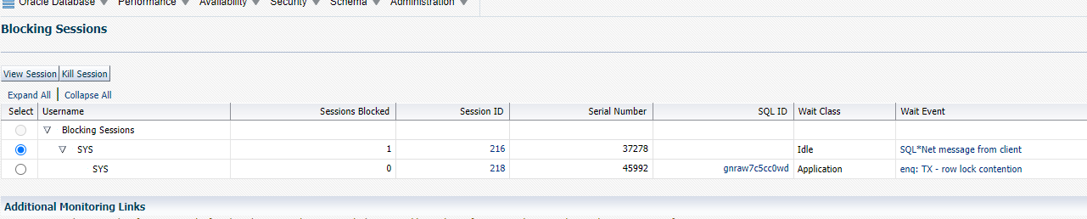

select sid,blocking_session,event,last_call_et,logon_time,lockwait from v$session

where lockwait is not null order by logon_time

Blocking_session shows 216 that is blocker

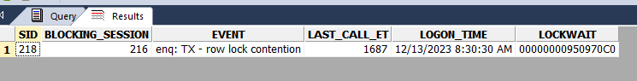

@?/rdbms/admin/utllockt.sql

Waiting session 216 is real blocker

WAITING_SESSION LOCK_TYPE MODE_REQUESTED

----------------- ----------------- ------------------------------------------

MODE_HELD LOCK_ID1 LOCK_ID2

------------------------------------------ ----------------- -----------------

216 None

218 Transaction Exclusive

Exclusive 65546 456286