SSH to **xhepydbw01d** server as oracle

. oraenv

HEPYDEV

Make sure your AID (DBA) P in HEPYDEV in sync with all other None Prod databases where you intend to add new user or reset password.

Get your AID (DBA) password for PROD from BT if you intend to add new user or reset password in PROD.

cd $SCRIPTS/security

!! Add user(s) into the file. Per example below

HEPYDEV> cd $SCRIPTS/security

HEPYDEV> vi new_users.txt

vi new_users.txt

A123456

A789526

N123456

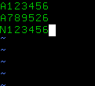

Example of executing the script with multiple databases

./create_user.sh HEPYUAT HEDWUAT HEPYQ HEPYQA2 HEPYQA3 HEDWQA3

Example of executing the script with one database

./create_user.sh HEPYUAT

Answer questions per example below. If you only have none production databases in your list you can just type something under **Enter Prod DataBase DBA Password**.

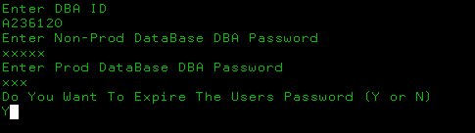

!! Please note if you are not part of DBA’s who regularly support HRP script will ask for your email (DBA)

Upon completion you should get message **Script Completed** per example below

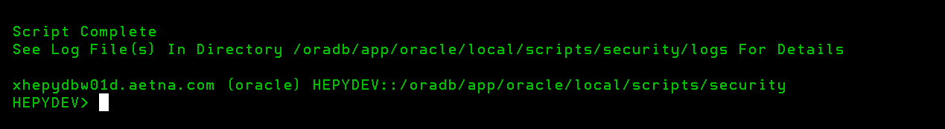

If you get message with error, it also should display error log location. However, you can always check log under **$SCRIPTS/logs** directory.

Upon successful completion email will be send to user(s) with you on CC. Look for email with subject **New Oracle Database Account** or **Oracle Database Account Temp Password**