

***Advanced Customer Support***

Oracle EBS Database

19c Install and XTTS migration to 19c IFSPROD

Prepared For

CVS



**Prepared by Advanced Customer Support**

Creation Date : 30-September-2022

Version : 1.0



Contents

**1.** **Summary - Introduction** 5

**1.1** **Purpose** 5

**2.** **Prepare the source database** 6

**2.1** **Precheck** 6

**3.** **Prepare the target database** 8

**3.1** **Install** 8

**3.2** **Post Install** 11

**3.3** **Create 9i data directory** 11

**3.4** **Copy appsutil** 12

**4.** **Create the 19C CDB** 13

**4.1** **Run datapatch on the new CDB database** 23

**4.2** **Add redo log groups to CDB** 24

**4.3** **Give grants on directory;** 24

**4.4** **Create target PDB** 24

**4.5** **Edit and run aucrdbpdb.sql** 25

**4.6** **Run audb19c.sql** 26

**4.7** **Run ausys19c.sql** 26

**4.8** **Install olap schema** 26

**4.9** **Check the CTXSYS schema objects** 26

**4.10** **Complete PDB setup** 27

**4.11** **Take a backup of the 19c database now.** 27

**5.** **Prepare the Source database** 28

**5.1** **Store the utlfile settings** 28

**6.** **Export Source system** 30

**6.1** **Take a guaranteed restore point now** 30

**6.2** **Create the export dump directory** 31

**6.3** **DROP un-used stats table** 31

**6.4** **Shut down APPS tier now if it isn’t already.** 32

**6.5** **Drop the SQLT schemas.** 32

**6.6** **Export OLAP analytical workspaces** 32

**6.7** **FIX UP PROBLEM TABLESPACES** 33

**6.8** **Upgrade DB timezone file** 33

**6.9** **Grant user rights to avoid ORA-01950 during expdp** 34

**6.10** **Stop the 12.1 listener** 35

**6.11** **Export any objects that are missing from the main export** 35

**6.12** **Record SYS grants** 35

**6.13** **Mark transport set read only** 35

**6.14** **Run the export** 35

**7.** **Import Target Database Objects** 37

**7.1** **Double check the database timezone on the pdb** 37

**7.2** **Copy the datafiles to correct locations.** 37

**7.3** **Modify import parameter file** 37

**7.4** **Create dba directory’s** 38

**7.5** **Import the transportable tablespace set** 39

**8.** **Post Import steps** 40

**8.1** **Import OLAP analytical workspaces** 40

**8.2** **Reset advanced queues** 40

**8.3** **Import any problem objects separately** 40

**8.4** **Run adgrants.sql** 40

**8.5** **Run post PDB script** 41

**8.6** **Gather system and fixed object statistics** 41

**8.7** **Import statistics** 41

**8.8** **Grant privs to CTXSYS** 42

**8.9** **Install SQLT into the USERSD tablespace.** 42

**8.10** **Recreate problem network ACL’s** 42

8.11 Run **ETCC** on target database 44

**8.12** **Take a guaranteed restore point now** 44

8.13 **Run custom variance report** and perform the validation before AutoConfig 44

**9.** Run AutoConfig 45

9.1 Step 1. Implement and run AutoConfig 45

9.2 Step 2. Create Oracle Text objects 46

9.3 Run custom Variance report 46

9.4 Populate CTXSYS.DR$SQE table 46

9.5 Run autoconfig on admin node 46

9.6 Reconfigure external integrations 46

9.7 Start the EBS application Tier 47

9.8 Execute the following scripts 47

**10.** **Validation** 48

**10.1** **Validate by logging on to the databases via sqlplus and running** 48

10.2 **Re-Run custom** variance report and perform the validation 48

**10.3** **Drop All DB Restore Points** 48

**11.** **Backout Plan** 49

11.1 Modify source tablespaces back to read/write mode 49

11.2 Revoke privilege from source SYSTEM schema 49

11.3 Import OLAP analytical workspaces 49

11.4 Re-install SQLT. 49

# **Summary - Introduction**

Oracle ACS is engaged by CVS Pharmacy to plan, manage, and execute database upgrades of EBS databases to 19c version.

This involves discovery, study, plan, and analysis and execute the implementation of upgrades of the databases listed in scope. The plan will also include testing upgrades and identify and fix performance regressions barring SQL rewriting and query tuning.

This document outlines the steps to migrate and upgrade the IFSPROD EBS database from 12.1.0.2 to 19.15 PDB using the transportable tablespace method.

## **Purpose**

This document will include step-by-step tasks needed to **upgrade 12.1.0.2 EBS database to 19.15c database using the transportable tablespace** method.

Using Transportable Tablespaces to Migrate Oracle E-Business Suite Release 12.2 Using Oracle Database 19c Enterprise Edition on a Multitenant Environment (Doc ID 2674405.1)

# **Prepare the source database**

## **Precheck**

On the Source 12.1 database, log in as sysdba

EXEC sys.dbms_tts.transport_set_check ('APPS_TS_SEED',TRUE);

Run pre TTS script as sys user

cd /oraexport/ifsuexport/expdmp/scripts

@/oraexport/ifsuexport/expdmp/scripts/auxttspre.sql

Make copies of the output files from this script particularly auimpfulltts.dat

Review the auxttspre.log file should consist of only one line message “***Transportable set check completed successfully.***”

If not then there are issues with the data that need to be addressed. The log will indicate problem tablespaces. These Tablespaces will have been left out of the generated transport set.

You can run a script to help identify the problem tablespace and objects

select distinct tablespace_name from dba_segments where owner in (select unique(name) from sys.ku_noexp_tab where OBJ_TYPE in

('USER','SCHEMA')) and tablespace_name not in ('SYSTEM','SYSAUX','APPS_UNDOTS1');

***Sample output***

*TABLESPACE_NAME*

*------------------------------*

*AEADMIN*

*AEDBA*

*AEMON*

*APPS_TS_TX_DATA*

*AUDIT_SPACE*

*INTERIM*

*NOETIXD*

*PM1*

*USERSD*

For each one of these tablespaces we need to identify the issue.

select OWNER,SEGMENT_NAME,SEGMENT_TYPE from dba_segments where owner in (select unique(name) from sys.ku_noexp_tab where OBJ_TYPE in

('USER','SCHEMA')) and tablespace_name='APPS_TS_TX_DATA';

**We do not need to deal with these issues now. We have run the auxttspre.sql script to create the necessary files to complete the setup of the 19c database and PDB. So move on with the rest of discovery and install/creation of the 19c Database.**

Check source database character set

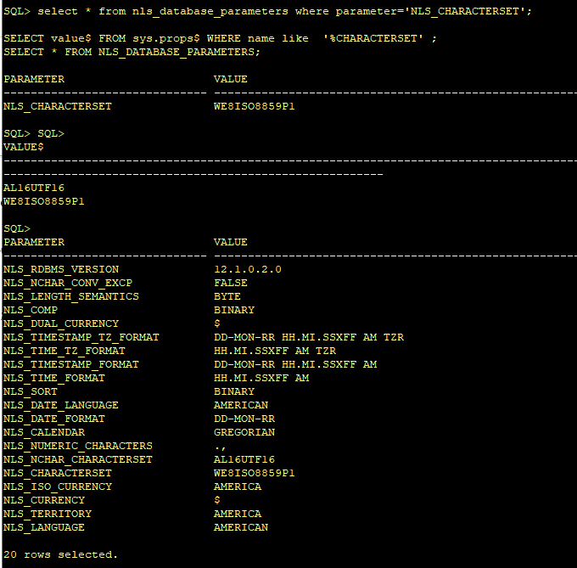

Check timezone file version

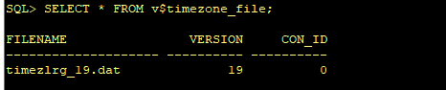

# **Prepare the target database**

## **Install**

Run the installer from the new unzipped 19c binaries

Gold image location to copy

/orastage/ifsustage/19cUpgrade/gold/db_gold.tar

Home will be **/orahome/allu01/app/oracle/product/19.0.0.0/db_ifsprod**

as root run /orahome/allu01/app/oracle/product/19.0.0.0/db_ifsprod/clone/rootpre.sh

Switch back to oracle user

cd /orahome/allu01/app/oracle/product/19.0.0.0/db_ifsprod

./runInstaller

*Use the following screenshots as guide.*

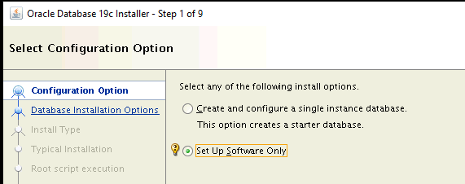

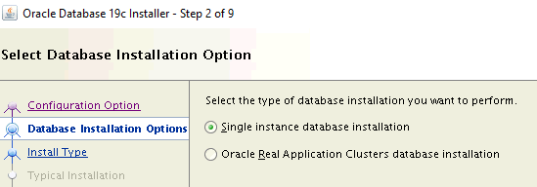

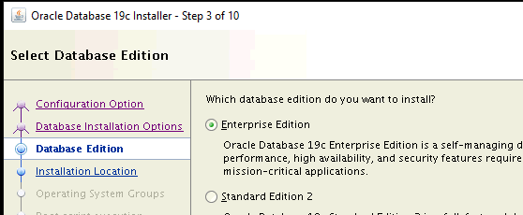

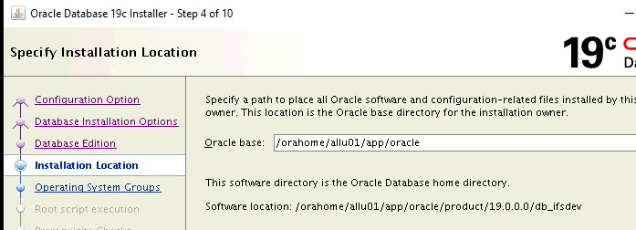

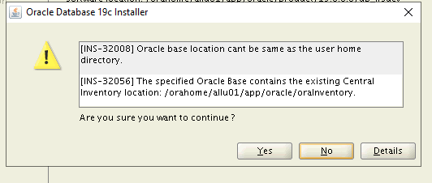

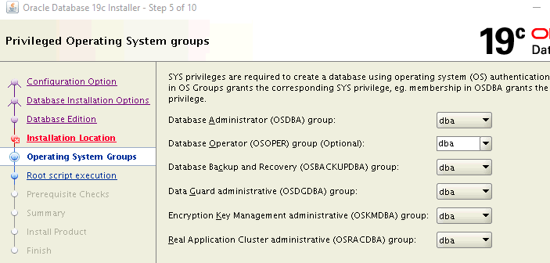

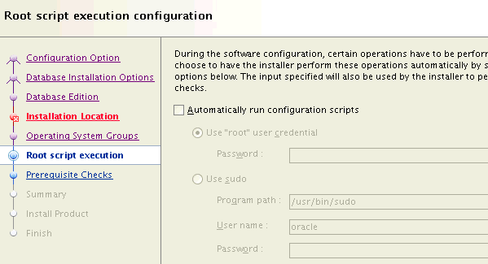

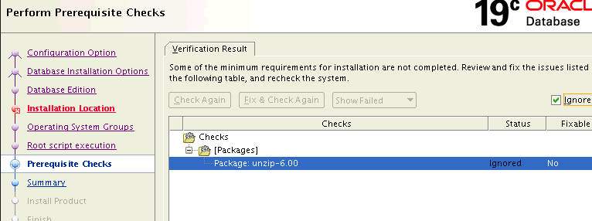

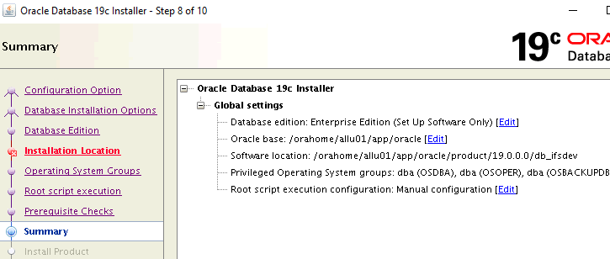

Click on INSTALL button to continue.

Send an email to CVS DBA to request that root.sh be run. Click on OK when confirmed.

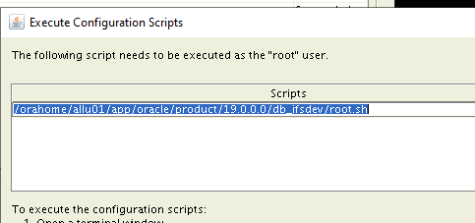

## **Post Install**

After the installation, make sure that:

1. The ORACLE_BASE environment variable is set accordingly.
2. The ORACLE_HOME environment variable points to the new 19c Oracle home.
3. The PATH environment variable includes $ORACLE_HOME/bin and the directory where the new perl executable is located (usually $ORACLE_HOME/perl/bin).
4. The LD_LIBRARY_PATH environment variable includes $ORACLE_HOME/lib.
5. The PERL5LIB environment variable points to the directories where the new perl libraries are located: $ORACLE_HOME/perl/lib/<*perl version*> and $ORACLE_HOME/perl/lib/site_perl/<*perl version*> for UNIX/Linux, or $ORACLE_HOME/perl/lib

## **Create 9i data directory**

Since we have gold image this directory just needs to be validated

perl $ORACLE_HOME/nls/data/old/cr9idata.pl

Creating directory /orahome/allu01/app/oracle/product/19.0.0.0/db_ifsprod/nls/data/9idata ...

Copying files to /orahome/allu01/app/oracle/product/19.0.0.0/db_ifsprod/nls/data/9idata...

Copy finished.

Please reset environment variable ORA_NLS10 to /orahome/allu01/app/oracle/product/19.0.0.0/db_ifsprod/nls/data/9idata!

## **Copy appsutil**

Create a tarball of the 12.1 home appsutil directory.

/orahome/allu01/app/oracle/product/12.1.0.2_210420/db_ifsprod/appsutil

Then cd $ORACLE_HOME (19c)

cp /orahome/allu01/app/oracle/product/12.1.0.2_210420/db_ifsprod/appsutil.tar .

tar –xf appsutil.tar

# **Create the 19C CDB**

Pre create directories for cdb databases, archivelogs,redo,and temp

mkdir -p /oraarchlog/ifsuarchive/CIFSPROD

mkdir -p /orabackup/ifsubackup/CIFSPROD

mkdir -p /oratemp/ifsut200/CIFSPROD

mkdir -p /oraredo/ifsur200/CIFSPROD

mkdir -p /oraredo/ifsur201/CIFSPROD

mkdir -p /oraredo/ifsur202/CIFSPROD

mkdir -p /oraundo/ifsuu200/CIFSPROD

mkdir -p /oraindex/ifsui200/CIFSPROD

mkdir -p /oraindex/ifsui201/CIFSPROD

mkdir -p /oraindex/ifsui202/CIFSPROD

mkdir -p /oraindex/ifsui203/CIFSPROD

mkdir -p /oraindex/ifsui204/CIFSPROD

mkdir -p /oradata/ifsud200/CIFSPROD - system and sysaux

mkdir -p /oradata/ifsud201/CIFSPROD

mkdir -p /oradata/ifsud202/CIFSPROD

mkdir -p /oradata/ifsud203/CIFSPROD

mkdir -p /oradata/ifsud204/CIFSPROD

mkdir -p /oradata/ifsud205/CIFSPROD

mkdir -p /oradata/ifsud206/CIFSPROD

mkdir -p /oradata/ifsud207/CIFSPROD

mkdir -p /oradata/ifsud208/CIFSPROD

mkdir -p /oradata/ifsud209/CIFSPROD

From the new home run dbca to create a new CDB database

*Use the following screenshots as guide.*

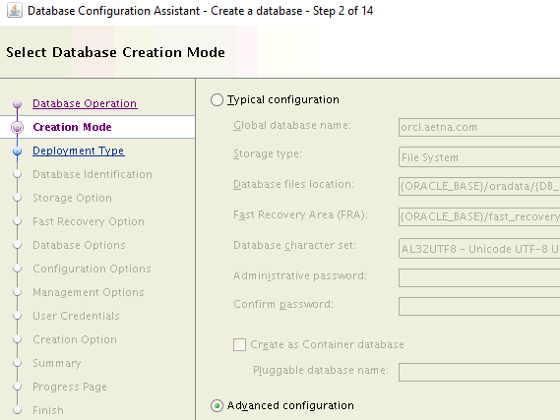

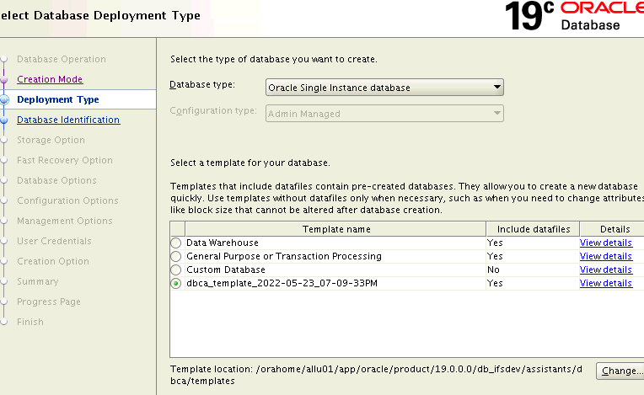



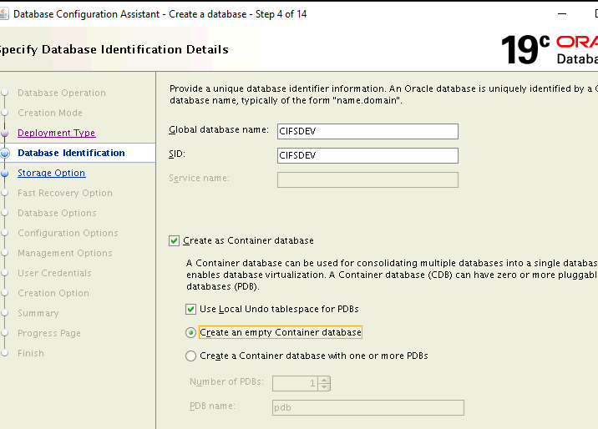

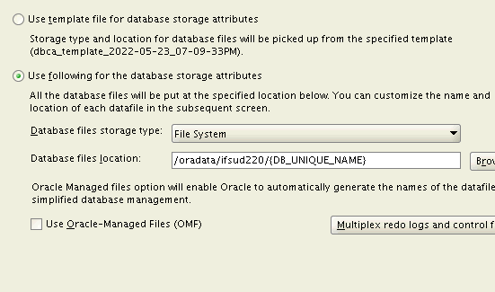

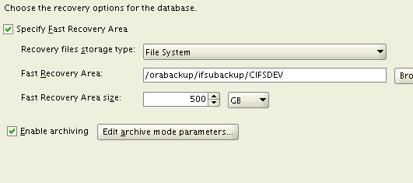

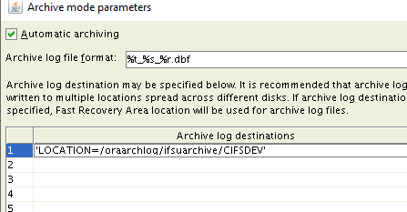

**Don’t create a listener**

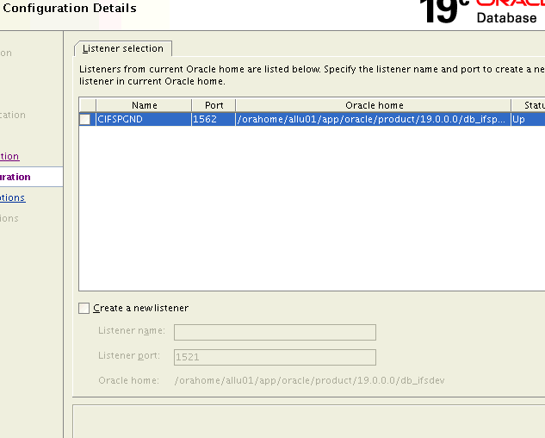

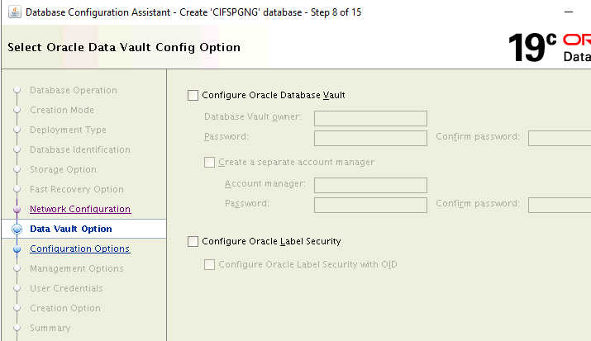

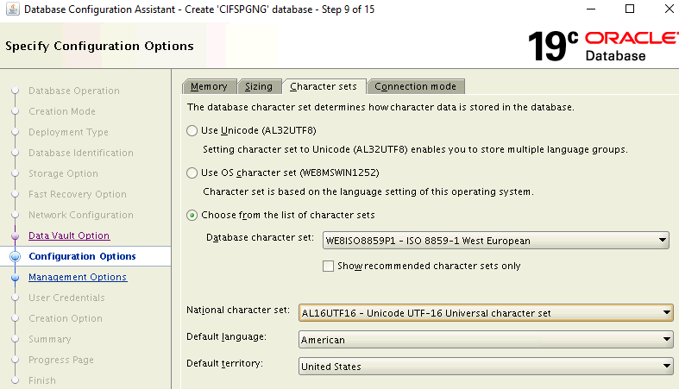

Choose small memory foot print for setup of database

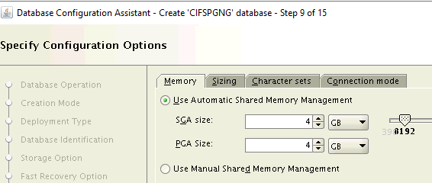

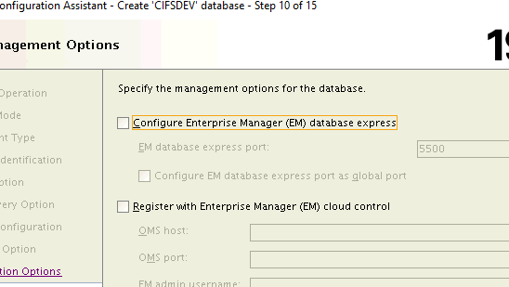

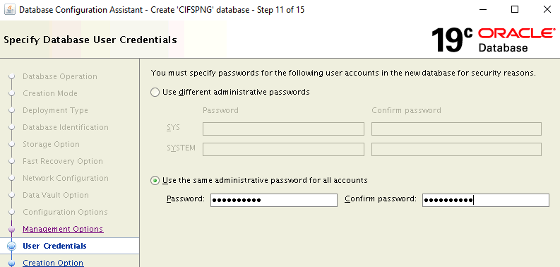

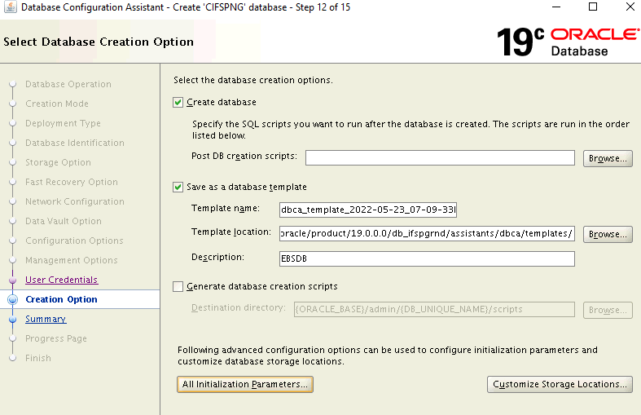

Select customize storage locations

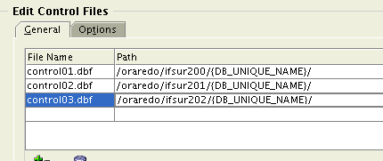



Check file storage

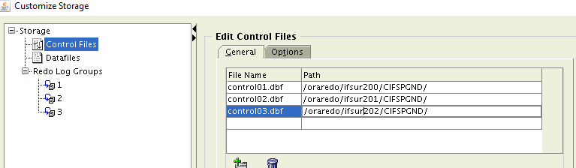

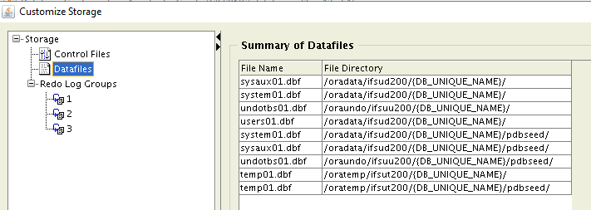

Go to customize storage locations and configure controlfiles, redo logs and customize datafile locations.

Set redo logs to 1GB. with the same format as source. We’ll add more later with SQL as it’s faster.

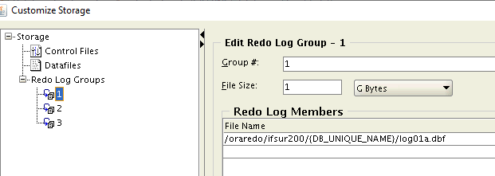

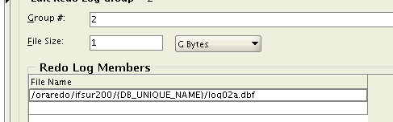

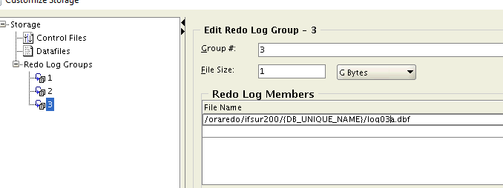

Validate **init.ora** prameters. Specifically check **db-create-file** and **db_create_online_log_dest** are NULL

Click next and then go to summary.

Review the summary page for correctness and press finish

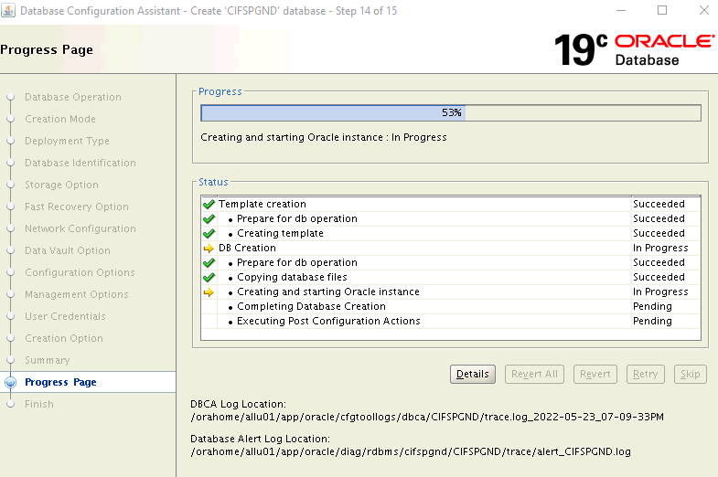

## **Run datapatch on the new CDB database**

**cd $ORACLE_HOME/Opatch**

**./datapatch**

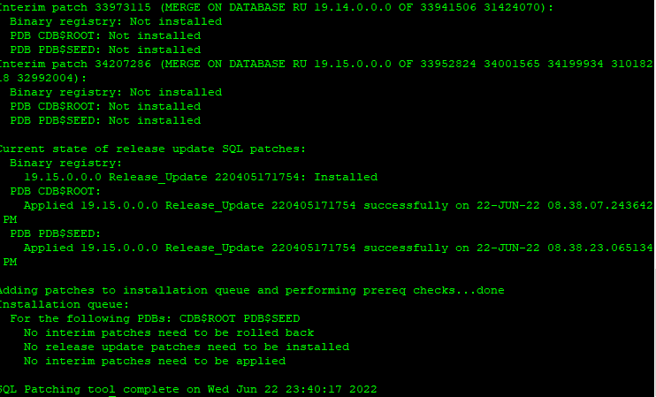

## **Add redo log groups to CDB**

ALTER DATABASE ADD LOGFILE GROUP 4 ('/oraredo/ifsur200/CIFSPROD/log04a.dbf','/oraredo/ifsur201/CIFSPROD/log04b.dbf', '/oraredo/ifsur202/CIFSPROD/log04c.dbf') SIZE 1024M ;

ALTER DATABASE ADD LOGFILE GROUP 5 ('/oraredo/ifsur200/CIFSPROD/log05a.dbf','/oraredo/ifsur201/CIFSPROD/log05b.dbf', '/oraredo/ifsur202/CIFSPROD/log05c.dbf') SIZE 1024M ;

ALTER DATABASE ADD LOGFILE GROUP 6 ('/oraredo/ifsur200/CIFSPROD/log06a.dbf','/oraredo/ifsur201/CIFSPROD/log06b.dbf', '/oraredo/ifsur202/CIFSPROD/log06c.dbf') SIZE 1024M ;

ALTER DATABASE ADD LOGFILE MEMBER '/oraredo/ifsur201/CIFSPROD/log01b.dbf' TO GROUP 1;

ALTER DATABASE ADD LOGFILE MEMBER '/oraredo/ifsur202/CIFSPROD/log01c.dbf' TO GROUP 1;

ALTER DATABASE ADD LOGFILE MEMBER '/oraredo/ifsur201/CIFSPROD/log02b.dbf' TO GROUP 2;

ALTER DATABASE ADD LOGFILE MEMBER '/oraredo/ifsur202/CIFSPROD/log02c.dbf' TO GROUP 2;

ALTER DATABASE ADD LOGFILE MEMBER '/oraredo/ifsur201/CIFSPROD/log03b.dbf' TO GROUP 3;

ALTER DATABASE ADD LOGFILE MEMBER '/oraredo/ifsur202/CIFSPROD/log03c.dbf' TO GROUP 3;

## **Give grants on directory;**

grant read, write on directory ORACLE_OCM_CONFIG_DIR to ORACLE_OCM;

## **Create target PDB**

Be careful here as we cannot overwrite the source Db files which are on the same server.

sqlplus / as sysdb

create pluggable database "IFSPROD" admin user pdbadmin identified by IFSupg_19c file_name_convert=('pdbseed','IFSPROD');

grant DATAPUMP_IMP_FULL_DATABASE to system;

grant IMP_FULL_DATABASE to system;

alter pluggable database IFSPROD open;

alter pluggable database IFSPROD save state;

show pdbs;

## **Edit and run aucrdbpdb.sql**

Log back into the PDB

cd /oraexport/ifsuexport/expdmp/scripts

vi aucrdbpdb.sql

REM BEFORE RUNNING THE SCRIPT YOU MUST REVIEW

REM IT FOR THE FOLLOWING:

REM - Location and size of the data files

REM - Undo Tablespace information

REM - Temporary Tablespace information

ALTER TABLESPACE SYSTEM ADD DATAFILE

ALTER TABLESPACE SYSTEM ADD DATAFILE

'/oradata/ifsud220/CIFSPROD/IFSPROD/system02.dbf' SIZE 31G

/

alter database datafile '/oradata/ifsud220/CIFSPROD/IFSPROD/system01.dbf' resize 31G

/

alter database datafile'/oradata/ifsud220/CIFSPROD/IFSPROD/sysaux01.dbf' resize 31G

/

CREATE UNDO TABLESPACE "APPS_UNDOTS1" DATAFILE

'/oraundo/ifsuu201/CIFSPROD/IFSPROD/undo01.dbf' SIZE 31G,

'/oraundo/ifsuu201/CIFSPROD/IFSPROD/undo02.dbf' SIZE 31G,

'/oraundo/ifsuu201/CIFSPROD/IFSPROD/undo03.dbf' SIZE 31G,

'/oraundo/ifsuu201/CIFSPROD/IFSPROD/undo04.dbf' SIZE 31G,

'/oraundo/ifsuu201/CIFSPROD/IFSPROD/undo05.dbf' SIZE 31G,

'/oraundo/ifsuu201/CIFSPROD/IFSPROD/undo06.dbf' SIZE 31G

/

CREATE TEMPORARY TABLESPACE "TEMP4U"

TEMPFILE

'/oratemp/ifsut201/CIFSPROD/IFSPROD/temp4u_01.dbf' SIZE 2048M

EXTENT MANAGEMENT LOCAL UNIFORM SIZE 1M

/

CREATE TEMPORARY TABLESPACE "TEMPBM"

TEMPFILE

'/oratemp/ifsut201/CIFSPROD/IFSPROD/tempbm_01.dbf' SIZE 2048M

EXTENT MANAGEMENT LOCAL UNIFORM SIZE 1M

/

CREATE TEMPORARY TABLESPACE "TIVOLIORTEMPTS"

TEMPFILE

'/oratemp/ifsut201/CIFSPROD/IFSPROD/tivoliortempts_01.dbf' SIZE 1G

EXTENT MANAGEMENT LOCAL UNIFORM SIZE 1M

/

ALTER DATABASE DEFAULT TEMPORARY TABLESPACE "TEMP4U";

drop tablespace TEMP including contents and datafiles;

CREATE TEMPORARY TABLESPACE TEMP

TEMPFILE

'/oratemp/ifsut201/CIFSPROD/IFSPROD/temp01.dbf' SIZE 31G,

'/oratemp/ifsut201/CIFSPROD/IFSPROD/temp02.dbf' SIZE 31G

;

ALTER DATABASE DEFAULT TEMPORARY TABLESPACE TEMP;

prompt

prompt Ignore any errors related to the setting

prompt of the default temporary tablespace

prompt

sqlplus / as sysdba

show pdbs -- should only show the IFSPROD pdb not the seed.

@/oraexport/ifsuexport/expdmp/scripts/aucrdbpdb.sql

## **Run audb19c.sql**

@/oraexport/ifsuexport/expdmp/scripts/audb19c.sql

**Log off DB**

## **Run ausys19c.sql**

Connect as system to the PDB

@/oraexport/ifsuexport/expdmp/scripts/ausy19c.sql

**Log off DB**

sqlplus / as sysdba

@?/rdbms/admin/catmgd.sql

(Note: MGD does not show up in dba_registry. This is normal for 12.2 and above)

grant text datastore access to public;

alter system enable restricted session;

@$ORACLE_HOME/appsutil/admin/adstats.sql

sqlplus / as sysdba

alter system disable restricted session;

## **Install olap schema**

Both cdb and PDB

@?/olap/admin/olap.sql SYSAUX TEMP;

Run others on PDB

@?/rdbms/admin/dbmsxdbschmig.sql;

@?/rdbms/admin/prvtxdbschmig.plb;

Install utl_mail

@?/rdbms/admin/utlmail.sql

@?/rdbms/admin/prvtmail.plb

grant execute on utl_mail to public;

grant DATAPUMP_IMP_FULL_DATABASE to system;

grant IMP_FULL_DATABASE to system;

## **Check the CTXSYS schema objects**

Do this check on the new CDB , PDB

set pages 1000

col object_name format a40

col object_type format a20

col comp_name format a30

column library_name format a8

column file_spec format a60 wrap

spool text_install_verification.log

-- check on setup

select comp_name, status, substr(version,1,10) as version from dba_registry where comp_id = 'CONTEXT';

select * from ctxsys.ctx_version;

select substr(ctxsys.dri_version,1,10) VER_CODE from dual;

select count(*) from dba_objects where owner='CTXSYS';

-- Get a summary count

select object_type, count(*) from dba_objects where owner='CTXSYS' group by object_type order by object_type;

-- Any invalid objects

select object_name, object_type, status from dba_objects where owner='CTXSYS' and status != 'VALID' order by object_name;

spool off

If there are any invalid objects then try this fix

alter session set current_schema=CTXSYS;

@?/ctx/admin/drixmd.plb

conn / as sysdba

set serveroutput on;

exec VALIDATE_CONTEXT();

check invalids are gone

select object_name, object_type, status from dba_objects where owner='CTXSYS' and status != 'VALID' order by object_name;

## **Complete PDB setup**

alter system set undo_tablespace =APPS_UNDOTS1 scope=both;

Alter system set undo_retention=1800 scope=both;

Double check the database timezone

**SELECT DBTIMEZONE FROM DUAL;**

## **Take a backup of the 19c database now.**

RMAN cold backup

Backup location /orabackup/ifsubackup/CIFSPROD/backupset/2022_06_26/

unset ORACLE_PDB_SID

Shutdown database 19c target database

Mount the database

rman

connect target /

Backup as compressed backupset database include current controlfile;

exit

Sqlplus / as sysdba

Shutdown immediate

# **Prepare the Source database**

On the SOUREC 12c database

## **Store the utlfile settings**

Set environment for the 12c source database and Reset the perl environment

export PERL5LIB=/orahome/allu01/app/oracle/product/12.1.0.2_210420/db_ifsprod/perl/lib/5.14.4:/orahome/allu01/app/oracle/product/12.1.0.2_210420/db_ifsprod/perl/lib/site_perl/5.14.4:/orahome/allu01/app/oracle/product/12.1.0.2_210420/db_ifsprod/appsutil/perl

Run the txkCfgUtlfileDir.pl script in getUtlFileDir mode using the following command:

perl $ORACLE_HOME/appsutil/bin/txkCfgUtlfileDir.pl \

-contextfile=/orahome/allu01/app/oracle/product/12.1.0.2_210420/db_ifsprod/appsutil/IFSPROD_aebsw1q.xml \

-oraclehome=/orahome/allu01/app/oracle/product/12.1.0.2_210420/db_ifsprod \

-outdir=/oraexport/ifsuexport/expdmp \

-upgradedhome=/orahome/allu01/app/oracle/product/19.0.0.0/db_ifsprod -mode=getUtlFileDir -servicetype=onpremise

Enter the APPS Password:

Script Name : txkCfgUtlfileDir.pl

Script Version : 120.0.12020000.15

Started : Wed May 25 19:20:34 EDT 2022

Log File : /oraexport/ifsuexport/expdmp/TXK_UTIL_DIR_Wed_May_25_19_19_26_2022/txkCfgUtlfileDir.log

Context file: /orahome/allu01/app/oracle/product/12.1.0.2_210420/db_ifsprod/appsutil/IFSPROD_aebsw1q.xml exists.

==============================================================================

Successfully generated the below file with UTL_FILE_DIR content:

/orahome/allu01/app/oracle/product/12.1.0.2_210420/db_ifsprod/dbs/IFSPROD_utlfiledir.txt

==============================================================================

Completed : Wed May 25 19:20:36 EDT 2022

Successfully Completed the script

ERRORCODE = 0 ERRORCODE_END

Check these are all valid. Create directories if required.

Store values in source database

perl $ORACLE_HOME/appsutil/bin/txkCfgUtlfileDir.pl \

-contextfile=/orahome/allu01/app/oracle/product/12.1.0.2_210420/db_ifsprod/appsutil/IFSPROD_aebsw1q.xml \

-oraclehome=/orahome/allu01/app/oracle/product/12.1.0.2_210420/db_ifsprod \

-outdir=/oraexport/ifsuexport/expdmp \

-upgradedhome=/orahome/allu01/app/oracle/product/19.0.0.0/db_ifsprod \

-mode=setUtlFileDir -servicetype=onpremise

Enter the APPS Password:

Enter the SYSTEM Password:

Script Name : txkCfgUtlfileDir.pl

Script Version : 120.0.12020000.15

Started : Wed May 25 19:29:01 EDT 2022

Log File : /oraexport/ifsuexport/expdmp/TXK_UTIL_DIR_Wed_May_25_19_28_01_2022/txkCfgUtlfileDir.log

Context file: /orahome/allu01/app/oracle/product/12.1.0.2_210420/db_ifsprod/appsutil/IFSPROD_aebsw1q.xml exists.

Value for s_applptmp on Apps Tier nodes is valid

Completed : Wed May 25 19:29:11 EDT 2022

Successfully Completed the script

ERRORCODE = 0 ERRORCODE_END

Check they are stored in the database

Select value from v$parameter where name =’utl_file_dir’;

Select * from apps.v$parameter;

Select * from apps.v$parameter2;

Run ADZDSHOWIOBJS.sql and Check if application is clean

# **Export Source system**

Downtime starts

Ask CVS APPS admin to confirm EBS is down and that adop cycle is cleaned up.

## **Take a guaranteed restore point now**

Sqlplus / as sysdba

create restore point before_setup guarantee flashback database;

Custom steps for CVS environments

• **Record Advanced Queue settings**

Advanced Queue settings are not propagated in the target database instance during the export/import process. Therefore, you must record them beforehand and enable them in the target database instance afterwards. [Patch 31405457](https://support.oracle.com/epmos/faces/ui/patch/PatchDetail.jspx?parent=DOCUMENT&sourceId=2707504.1&patchId=31405457) contains auque1.sql, which generates the script auque2.sql. You can use auque2.sql to enable the settings in the target database instance.

Copy the auque1.sql script from the $AU_TOP/patch/115/sql directory in the administration server node to the working directory in the source database server node.

cd /oraexport/ifsuexport/expdmp/scripts

$ **sqlplus "/ as sysdba"**  
 **@auque1.sql**

• **Remove rebuild index parameter in spatial indexes and modify unusable spatial indexes**

Ensure that you do not have the rebuild index parameter in the spatial indexes and you do not have any unusable spatial indexes.

To see if you have any rebuild index parameters, on the source database server node, as the owner of the source database server file system and database instance, use SQL*Plus to connect to the source database as SYSDBA and run the following command:

$ **sqlplus "/ as sysdba"**

**Set lines 180 pages 200**  
 **select * from dba_indexes where index_type='DOMAIN' and upper(parameters) like '%REBUILD%';**

e.g

alter index HR.HR_LOCATIONS_SPT rebuild parameters ('sdo_indx_dims=2 sdo_rtr_pctfree=10 tablespace=APPS_TS_TX_IDX');

check for unusable indexes

select * from dba_indexes where status='UNUSABLE';

rebuild if any….

select 'alter index '||owner||'.'||index_name||' rebuild;' from dba_indexes where status='UNUSABLE';

**Synchronize Text indexes**

**col PND_INDEX_OWNER format a10**

**select pnd_index_owner,pnd_index_name,count(*) from ctxsys.ctx_pending group by pnd_index_owner,pnd_index_name order by 1;**

PND_INDEX_ PND_INDEX_NAME COUNT(*)

---------- ------------------------------ ----------

APPLSYS FND_LOBS_CTX 13031

IBC IBC_ATTRIBUTE_BUNDLES_CTX 28

JTF JTF_AMV_ITEMS_DESC_CTX 1132

JTF JTF_AMV_ITEMS_NAME_CTX 1132

JTF JTF_AMV_ITEMS_TEXT_CTX 1132

exec ctx_ddl.sync_index('APPLSYS.FND_LOBS_CTX');

exec ctx_ddl.sync_index('IBC.IBC_ATTRIBUTE_BUNDLES_CTX');

exec ctx_ddl.sync_index('JTF.JTF_AMV_ITEMS_DESC_CTX') ;

exec ctx_ddl.sync_index('JTF.JTF_AMV_ITEMS_NAME_CTX');

exec ctx_ddl.sync_index('JTF.JTF_AMV_ITEMS_TEXT_CTX');

## **Create the export dump directory**

sqlplus system/pass

create directory dmpdir as '/oraexport/ifsuexport/expdmp';

## **DROP un-used stats table**

Connect as APPS

exec DBMS_AQADM.DROP_QUEUE_TABLE (queue_table =>JTF_PF_LOGGING_TABLE', force => TRUE);

Export statistics

select owner, table_name, stattype_locked

from dba_tab_statistics

where stattype_locked is not null and owner not in ('SYS','SYSTEM') order by 1;

then unlock the stats for each schema e.g.

exec dbms_stats.unlock_schema_stats ('APPLSYS');

exec dbms_stats.unlock_schema_stats ('DOCSAVI');

exec dbms_stats.unlock_schema_stats ('WMS');

exec fnd_stats.gather_schema_statistics(schemaname=>'ALL',estimate_percent=>dbms_stats.auto_sample_size,options=>'GATHER AUTO');

exec dbms_stats.upgrade_stat_table('APPLSYS','FND_STATTAB');

set verify off

whenever sqlerror exit failure rollback;

whenever oserror exit failure rollback;

DECLARE

BEGIN

FND_STATS.BACKUP_SCHEMA_STATS(schemaname => 'ALL', statid => 'stats_export ');

EXCEPTION

WHEN OTHERS THEN

RAISE_APPLICATION_ERROR(-20000, sqlerrm ||' Error while executing FND_STATS.BACKUP_SCHEMA_STATS package.');

END;

/

exit;

## **Shut down APPS tier now if it isn’t already.**

## **Drop the SQLT schemas.**

cd /orastage/u177/sqlt/sqlt/install

sqlplus / as sysdba

@sqdrop.sql

purge dba_recyclebin;

DBA Recyclebin purged.

grant exempt access policy to system;

grant export_full_database to system;

grant SELECT_CATALOG_ROLE to apps;

## **Export OLAP analytical workspaces**

Perform the detailed steps **1-3** as documented in My Oracle Support Knowledge [Document 352306.1](https://support.oracle.com/epmos/faces/DocumentDisplay?parent=DOCUMENT&sourceId=2707504.1&id=352306.1),

col owner format a15

col aw_name format a15

select OWNER, AW_NAME ,PAGESPACES from dba_aws

where owner != 'SYS' order by 1,2;

OWNER AW_NAME PAGESPACES

--------------- --------------- ----------

APPS ODPCODE 1241

APPS XWDEVKIT 1183

APPS XWDEVKIT_BACKUP 1183

FPA FPAPJP 551

exec dbms_aw.execute('aw attach APPS.ODPCODE rw');

exec dbms_aw.execute('allstat');

exec dbms_aw.execute('export all to eif file ''DMPDIR/OLAP1.eif''');

exec dbms_aw.execute('aw detach APPS.ODPCODE');

exec dbms_aw.execute('aw attach APPS.XWDEVKIT_BACKUP rw');

exec dbms_aw.execute('allstat');

exec dbms_aw.execute('export all to eif file ''DMPDIR/OLAP2.eif''');

exec dbms_aw.execute('aw detach APPS.XWDEVKIT_BACKUP');

exec dbms_aw.execute('aw attach FPA.FPAPJP rw');

exec dbms_aw.execute('allstat');

exec dbms_aw.execute('export all to eif file ''DMPDIR/OLAP3.eif''');

exec dbms_aw.execute('aw detach FPA.FPAPJP');

exec dbms_aw.execute('aw attach APPS.XWDEVKIT rw');

exec dbms_aw.execute('allstat');

exec dbms_aw.execute('export all to eif file ''DMPDIR/OLAP4.eif''');

exec dbms_aw.execute('aw detach APPS.XWDEVKIT');

exec dbms_aw.execute('aw delete APPS.ODPCODE');

exec dbms_aw.execute('aw delete APPS.XWDEVKIT_BACKUP');

exec dbms_aw.execute('aw delete APPS.XWDEVKIT');

exec dbms_aw.execute('aw delete FPA.FPAPJP');

## **FIX UP PROBLEM TABLESPACES**

Backup any customized scripts from auxttspre.sql then run auxttspre.sql script one more time to validate there are no issues. The logs should be clear.

Sqlplus / as sysdba

@/oraexport/ifsuexport/expdmp/scripts/auxttspre.sql

Sqlplus / as sysdba

cat auxttspre.log

Transportable set check completed successfully.

## **Upgrade DB timezone file**

On CDB

SELECT * FROM v$timezone_file;

FILENAME VERSION CON_ID

-------------------- ---------- ----------

timezlrg_32.dat 32 0

On source

FILENAME VERSION CON_ID

-------------------- ---------- ----------

timezlrg_18.dat 19 0

Result: need to upgrade TZ version at source.

Follow note: Applying the DSTv32 update for the Oracle Database (Doc ID 2463100.1)

to apply the patch

For 12.1.0.2:  
* Request (if needed) and download the 12.1.0.2 DSTv32 [Patch 28125601](https://support.oracle.com/epmos/faces/ui/patch/PatchDetail.jspx?parent=DOCUMENT&sourceId=2463100.1&patchId=28125601) for your platform

* Unzip the RDBMS DSTv32 [Patch 28125601](https://support.oracle.com/epmos/faces/ui/patch/PatchDetail.jspx?parent=DOCUMENT&sourceId=2463100.1&patchId=28125601)   
* Apply the RDBMS DSTv32 [Patch 28125601](https://support.oracle.com/epmos/faces/ui/patch/PatchDetail.jspx?parent=DOCUMENT&sourceId=2463100.1&patchId=28125601) using Opatch.   
Note: in 11.2 and up there is no need to shut down or stop the database or other processes seen you are simply adding new files, not replacing used ones.  
For Opatch questions please see [Note 242993.1](https://support.oracle.com/epmos/faces/DocumentDisplay?parent=DOCUMENT&sourceId=2463100.1&id=242993.1) OPATCH FAQ  
* Then update all databases using this home by:

or using the scripts in [note 1585343.1](https://support.oracle.com/epmos/faces/DocumentDisplay?parent=DOCUMENT&sourceId=2463100.1&id=1585343.1) Scripts to automatically update the RDBMS DST (timezone) version in an 11gR2 or 12cR1 database .

or following [note 1509653.1](https://support.oracle.com/epmos/faces/DocumentDisplay?parent=DOCUMENT&sourceId=2463100.1&id=1509653.1) Updating the RDBMS DST version in 12c Release 1 (12.1.0.1 and up) using DBMS_DST from step 3a) using 32 as (<the new DST version number>) in that note.

cd /orastage/ifsustage/19cUpgrade/DBpatches/28125601

$ORACLE_HOME/OPatch/opatch apply

Run scripts to perform TZ upgrade in the database

TZ upgrade scripts from note 1585343.1 have been copied to below.

Needs the listener UP.

cd /oraexport/ifsuexport/expdmp/scripts/DBMS_DST_scriptsV1.9

Sqlplus / as sysdba

create restore point before_tz guarantee flashback database;

spool countstatsTSTZ.log  
@countstatsTSTZ.sql  
spool off

spool upg_tzv_check.log  
@upg_tzv_check.sql  
spool off

A successful run will show at the end:

 INFO: A newer RDBMS DST version than the one currently used is found.   
 INFO: Note that NO DST update was yet done.   
 INFO: Now run upg_tzv_apply.sql to do the actual RDBMS DST update.   
 INFO: Note that the upg_tzv_apply.sql script will    
 INFO: restart the database 2 times WITHOUT any confirmation or prompt.

If above is seen upg_tzv_apply.sql can be run.

**This script will restart the database 2 times WITHOUT any confirmation or prompt.**

@upg_tzv_apply.sql

Should look like this at the end

able list: "SQLTXPLAIN"."SQLT$_DBA_HISTGRM_STATS_VERSN"

Number of failures: 0

Table list: "SQLTXPLAIN"."SQLT$_DBA_COL_STATS_VERSIONS"

Number of failures: 0

Table list: "SQLTXPLAIN"."SQLT$_DBA_AUTOTASK_CLIENT_HST"

Number of failures: 0

Table list: "SQLTXPLAIN"."SQLI$_STATTAB_TEMP"

Number of failures: 0

INFO: Total failures during update of TSTZ data: 0 .

An upgrade window has been successfully ended.

INFO: Your new Server RDBMS DST version is DSTv32 .

INFO: The RDBMS DST update is successfully finished.

INFO: Make sure to exit this sqlplus session.

INFO: Do not use it for timezone related selects.

Exit the sql session. Log in again to check TZ

SQL> SELECT * FROM v$timezone_file;

FILENAME VERSION CON_ID

-------------------- ---------- ----------

timezlrg_32.dat 32 0

purge dba_recyclebin;

## **Grant user rights to avoid ORA-01950 during expdp**

alter user A665751 quota unlimited on sysaux;

**Avoid errors with granting global_rewite during import**

update system_privilege_map set name ='GLOBAL QUERY REWRITE' where name='GLOBAL REWRITE';  
commit;

Take another guaranteed restore point

create restore point before_export guarantee flashback database;

## **Stop the 12.1 listener**

lsnrctl stop IFSPROD

## **Export any objects that are missing from the main export**

Missing objects to be exported, trigger definitions etc.

grant create database link to AETNADBA;

grant create database link to READ;

alter sequence cn.CN_CLRL_API_S restart start with 1;

## **Record SYS grants**

Create scripts to create grants for users

sqlplus / as sysdba

@missing_grants.sql

This will create the objs_upg19.sql script which we’ll run after the import

## **Mark transport set read only**

Set tablespaces read-only on source

cd /oraexport/ifsuexport/expdmp/scripts

**sqlplus "/ as sysdba" @auxttsread.sql**

## **Run the export**

Check the dat file excludes the non-transportable tablespaces

directory=dmpdir

metrics=y

dumpfile=xttsfulltts%U.dmp

filesize=1048576000

full=y

exclude=STATISTICS

exclude=tablespace:"IN('INTERIM','AEMON')"

logfile=expfulltts.log

parallel=8

transportable=always

logtime=all

expdp system parfile= /oraexport/ifsuexport/expdmp/scripts/auexpfulltts.dat

While this is running check/finalise the file copy scripts to be used for copy of the datafiles.

# **Import Target Database Objects**

All the following Steps are carried out in the 19c PDB unless otherwise specified.

alter system set undo_tablespace =APPS_UNDOTS1 scope=both;

alter system set undo_retention=1800 scope=both;

## **Double check the database timezone on the pdb**

**SELECT DBTIMEZONE FROM DUAL;**

Should be -4

ADJUST 19C PGA/SGA settings to match the source

## **Copy the datafiles to correct locations.**

Shut down the source database before copying the files.

AIX does not allow the file copy if in use by the database.

When export completed shut down the 12c Database and copy the datafiles to new locations.

## **Modify import parameter file**

Edit the /oraexport/ifsuexport/expdmp/scripts/auimpfulltts.dat  
 file for the locations of the datafiles to be imported.

directory=dmpdir

metrics=y

dumpfile=xttsfulltts%U.dmp

full=y

logfile=impfulltts.log

parallel=4

logtime=all

transport_datafiles=

'/oradata/ifsud210/CIFSPROD/IFSPROD/APPS_TS_MEDIA07.dbf',

'/oradata/ifsud210/CIFSPROD/IFSPROD/APPS_TS_MEDIA13.dbf',

'/oradata/ifsud210/CIFSPROD/IFSPROD/APPS_TS_SUMMARY07.dbf',

'/oradata/ifsud210/CIFSPROD/IFSPROD/APPS_TS_SUMMARY08.dbf',

'/oradata/ifsud210/CIFSPROD/IFSPROD/APPS_TS_TX_DATA106.dbf',

'/oradata/ifsud210/CIFSPROD/IFSPROD/APPS_TS_TX_DATA109.dbf',

'/oradata/ifsud210/CIFSPROD/IFSPROD/APPS_TS_TX_DATA123.dbf',

'/oradata/ifsud210/CIFSPROD/IFSPROD/APPS_TS_TX_DATA128.dbf',

'/oradata/ifsud210/CIFSPROD/IFSPROD/APPS_TS_TX_DATA131.dbf',

'/oradata/ifsud210/CIFSPROD/IFSPROD/APPS_TS_TX_DATA144.dbf',

'/oradata/ifsud210/CIFSPROD/IFSPROD/APPS_TS_TX_DATA184.dbf',

'/oradata/ifsud210/CIFSPROD/IFSPROD/APPS_TS_TX_DATA54.dbf',

'/oradata/ifsud210/CIFSPROD/IFSPROD/APPS_TS_TX_DATA75.dbf',

'/oradata/ifsud210/CIFSPROD/IFSPROD/APPS_TS_TX_DATA94.dbf',

'/oradata/ifsud210/CIFSPROD/IFSPROD/docsavi_data01.dbf',

'/oradata/ifsud211/CIFSPROD/IFSPROD/aeadmin01.dbf',

'/oradata/ifsud211/CIFSPROD/IFSPROD/aedbax01.dbf',

'/oradata/ifsud211/CIFSPROD/IFSPROD/aedbax02.dbf',

'/oradata/ifsud211/CIFSPROD/IFSPROD/aedbax03.dbf',

………………………………………………………………………

'/oraindex/ifsui205/CIFSPROD/IFSPROD/APPS_TS_TX_IDX62.dbf',

'/oraindex/ifsui205/CIFSPROD/IFSPROD/APPS_TS_TX_IDX73.dbf',

'/oraindex/ifsui205/CIFSPROD/IFSPROD/APPS_TS_TX_IDX74.dbf',

'/oraindex/ifsui205/CIFSPROD/IFSPROD/APPS_TS_TX_IDX82.dbf',

'/oraindex/ifsui205/CIFSPROD/IFSPROD/APPS_TS_TX_IDX90.dbf',

'/oraindex/ifsui205/CIFSPROD/IFSPROD/APPS_TS_TX_IDX91.dbf',

'/oraindex/ifsui205/CIFSPROD/IFSPROD/APPS_TS_TX_IDX97.dbf',

'/oraindex/ifsui205/CIFSPROD/IFSPROD/APPS_TS_TX_IDX98.dbf'

## **Create dba directory’s**

create or replace directory AEAR_FTPIN as '/aetnas46/oracmprod/IFSPROD/aear/ftp/in' ;

create or replace directory AEAR_FTPOUT as '/aetnas46/oracmprod/IFSPROD/aear/ftp/out' ;

create or replace directory AEEDI_FTPIN as '/aetnas46/oracmprod/IFSPROD/aeedi/ftp/in' ;

create or replace directory AEEDI_FTPOUT as '/aetnas46/oracmprod/IFSPROD/aeedi/ftp/out' ;

create or replace directory AEFA_FTPIN as '/aetnas46/oracmprod/IFSPROD/aefa/ftp/in' ;

create or replace directory AEFA_FTPOUT as '/aetnas46/oracmprod/IFSPROD/aefa/ftp/out' ;

create or replace directory AEFND_FTPIN as '/aetnas46/oracmprod/IFSPROD/aefnd/ftp/in' ;

create or replace directory AEFND_FTPOUT as '/aetnas46/oracmprod/IFSPROD/aefnd/ftp/out' ;

create or replace directory AEFS_FTPIN as '/aetnas46/oracmprod/IFSPROD/aefs/ftp/in' ;

create or replace directory AEFS_FTPOUT as '/aetnas46/oracmprod/IFSPROD/aefs/ftp/out' ;

create or replace directory AEGL_FTPIN as '/aetnas46/oracmprod/IFSPROD/aegl/ftp/in' ;

create or replace directory AEGL_FTPOUT as '/aetnas46/oracmprod/IFSPROD/aegl/ftp/out' ;

create or replace directory AEIN_FTPIN as '/aetnas46/oracmprod/IFSPROD/aein/ftp/in' ;

create or replace directory AEIN_FTPOUT as '/aetnas46/oracmprod/IFSPROD/aein/ftp/out' ;

create or replace directory AEPO_FTPIN as '/aetnas46/oracmprod/IFSPROD/aepo/ftp/in' ;

create or replace directory AEPO_FTPOUT as '/aetnas46/oracmprod/IFSPROD/aepo/ftp/out' ;

create or replace directory APPO_RESP as '/aetnas46/oracmprod/IFSPROD/utl_dir' ;

create or replace directory APPS_DATA_FILE_DIR as '/orahome/allu01/app/oracle/product/12.1.0.2_210420/db_ifsprod/appsutil/outbound/IFSPROD_aebsw1q' ;

create or replace directory COMMON_LOG as '/sifsdbm1pu04/app/IFSPRODcomn/admin/log/IFSPROD_sifsdbm1p' ;

create or replace directory COMMON_OUT as '/sifsdbm1pu04/app/IFSPRODcomn/admin/out/IFSPROD_sifsdbm1p' ;

create or replace directory CSR_XML_TOP as '/ifsu01/app/IFSPROD/fs1/EBSapps/appl/csr/12.0.0/patch/115/xml' ;

create or replace directory DMPDIR as '/oraexport/ifsuexport/expdmp' ;

create or replace directory EBS_DB_DIR_UTIL as '/aetnas46/oracmprod/IFSPROD/utl_dir' ;

create or replace directory EBS_UTL_FILE_DIR_4784775248999 as '/orahome/allu01/app/oracle/product/19.0.0.0/temp/IFSPROD' ;

create or replace directory ECX_UTL_LOG_DIR_OBJ as '/orahome/allu01/app/oracle/product/19.0.0.0/temp/IFSPROD' ;

create or replace directory ECX_UTL_XSLT_DIR_OBJ as '/orahome/allu01/app/oracle/product/19.0.0.0/temp/IFSPROD' ;

create or replace directory ENKEY as '/opt/oracle/test/test111/enkey' ;

create or replace directory ENKEY2 as '/opt/filepath/enkey2' ;

create or replace directory ENKEY3 as '/aetnas27/oracmardev/IFSPROD' ;

create or replace directory ENKEY4 as '/aetnas27/oracmardev/IFSPROD/enkay4' ;

create or replace directory ENKEY5 as '/aetnas27/oracmardev/IFSPROD/enkey5' ;

create or replace directory FND_DIAG_DIR as '/orahome/allu01/app/oracle/diag/rdbms/cIFSPROD/CIFSPROD/trace' ;

create or replace directory OUT_FILE_LOC as '/tmp' ;

create or replace directory PREUPGRADE_DIR as '/orahome/u01/app/oracle/cfgtoollogs/IFSPROD/preupgrade/' ;

create or replace directory SQLT$DIAG as '/orahome/allu01/app/oracle/diag/rdbms/cIFSPROD/CIFSPROD/trace' ;

create or replace directory TEST_KEY as '/aetnas27/oracmardev/IFSPROD' ;

create or replace directory TEST_KEY2 as '/ifsu01/app/IFSPROD/apps/apps_st/appl/aeap/ftp/out' ;

create or replace directory TIMEZDIF_DIR as '/sifsdbm1pu01/app/oracle/product/10.2.0/db_ifsprod/oracore/zoneinfo' ;

create or replace directory TIVOLIOR_TEMP as '/opt/Tivoli/itm/tmp' ;

create or replace directory TRACE_DIR_SRC_4_TCB as '/orahome/allu01/app/oracle/diag/rdbms/cifsprod/CIFSPROD/trace' ;

mkdir –p /orahome/allu01/app/oracle/product/19.0.0.0/db_ifsprod/QOpatch

grant create procedure to CTXSYS;

#set ctxsys password and unlock account

GRANT GLOBAL QUERY REWRITE TO "SYSTEM"

## **Import the transportable tablespace set**

Ensure both CDB and PDB are running read/write and environment is set

Make sure ORACLE_PDB_SID is set

impdp system parfile=/oraexport/ifsuexport/expdmp/scripts/auimpfulltts.dat

# **Post Import steps**

**All the following steps connect to the PDB unless otherwise specified.**

## **Import OLAP analytical workspaces**

Perform the detailed step 7 as documented in My Oracle Support Knowledge [Document **352306.1**](https://support.oracle.com/epmos/faces/DocumentDisplay?parent=DOCUMENT&sourceId=2707504.1&id=352306.1) to import the OLAP analytical workspaces that were previously exported from the source machine.

[execute each line separately. Validate against the exports done on the source DB]

exec dbms_aw.execute('aw create APPS.ODPCODE');

--- Replace ALIAS_DIR with a defined directory alias

exec dbms_aw.execute('import all from eif file ''DMPDIR/OLAP1.eif'' data dfns');

exec dbms_aw.execute('update');

commit;

exec dbms_aw.execute('aw detach APPS.ODPCODE');

exec dbms_aw.execute('aw create APPS.XWDEVKIT_BACKUP');

exec dbms_aw.execute('import all from eif file ''DMPDIR/OLAP2.eif'' data dfns');

exec dbms_aw.execute('update');

commit;

exec dbms_aw.execute('aw detach APPS.XWDEVKIT_BACKUP');

exec dbms_aw.execute('aw create FPA.FPAPJP');

exec dbms_aw.execute('import all from eif file ''DMPDIR/OLAP3.eif'' data dfns');

exec dbms_aw.execute('update');

commit;

exec dbms_aw.execute('aw detach FPA.FPAPJP');

exec dbms_aw.execute('aw create APPS.XWDEVKIT');

exec dbms_aw.execute('import all from eif file ''DMPDIR/OLAP4.eif'' data dfns');

exec dbms_aw.execute('update');

commit;

exec dbms_aw.execute('aw detach APPS.XWDEVKIT');

## **Reset advanced queues**

sqlplus / as sysdba

@/oraexport/ifsuexport/expdmp/scripts/auque2.sql

## **Import any problem objects separately**

If any

## **Run adgrants.sql**

grant READ on DIRECTORY FND_DIAG_DIR to "APPS"

grant read,write,execute on directory OPATCH_INST_DR to apps;

grant read,write,execute on directory OPATCH_LOG_DR to apps;

grant read,write,execute on directory OPATCH_SCRIPT_DR to apps;

GRANT GLOBAL QUERY REWRITE TO "APPS"

grant execute on utl_mail to apps;

@?/appsutil/admin/adgrants.sql APPS

Get some erros. As per note 2507343.1 they can be ignored.

grant SELECT_CATALOG_ROLE to apps;

grant select any dictionary to apps;

grant execute on DBMS_CRYPTO to APPS;

@objs_upg19.sql  **( script created before export)**

## **Run post PDB script**

Note this is run against the CDB

cd $ORACLE_HOME/appsutil

unset ORACLE_PDB_SID

. ./txkSetCfgCDB.env dboraclehome=/orahome/allu01/app/oracle/product/19.0.0.0/db_ifsprod

cd bin

Double check PORT!

perl txkPostPDBCreationTasks.pl -dboraclehome=/orahome/allu01/app/oracle/product/19.0.0.0/db_ifsprod \

-outdir=/orahome/allu01/app/oracle/product/19.0.0.0/db_ifsprod/appsutil/log -cdbsid=CIFSPROD \

-pdbsid=IFSPROD \

-appsuser=apps -dbport=1542 -servicetype=onpremise

Log back into the PDB

export ORACLE_PDB_SID=IFSPROD

## **Gather system and fixed object statistics**

**sqlplus "/ as sysdba"**  
 **connect system/<system password>;**

**set timing on**  
**exec dbms_stats.gather_schema_stats(ownname=>'SYS',options=>'GATHER AUTO');**  
**exec dbms_stats.gather_schema_stats(ownname=>'SYSTEM',options=>'GATHER AUTO');**  
**exec dbms_stats.gather_dictionary_stats;**  
**exec dbms_stats.gather_fixed_objects_stats;**

exec dbms_stats.upgrade_stat_table('SYSTEM','EXP_STATS');

exec dbms_stats.gather_table_stats(ownname=>'SYSTEM',tabname=>'EXP_STATS');

exec dbms_stats.import_database_stats('EXP_STATS');

## **Import statistics**

**connect "/ as sysdba";**  
 **alter system enable restricted session;**  
 @/orahome/allu01/app/oracle/product/19.0.0.0/db_ifsprod/appsutil/admin**/adstats.sql**  
 **sqlplus "/ as sysdba"**  
**alter system disable restricted session;**

## **Grant privs to CTXSYS**

grant create procedure to CTXSYS;

## **Install SQLT into the USERSD tablespace.**

Scripts located : /orastage/u177/sqlt/sqlt/install

sqlplus / as sysdba

@sqcreate.sql

Specify optional Connect Identifier (as per Oracle Net)

Include "@" symbol, ie. @PROD

If not applicable, enter nothing and hit the "Enter" key.

You *MUST* provide a connect identifier when installing

SQLT in a Pluggable Database in 12c

This connect identifier is only used while exporting SQLT

repository everytime you execute one of the main methods.

Optional Connect Identifier (ie: @PROD): @IFSPROD

Password for user SQLTXPLAIN: IFSupg_19c

Re-enter password:

The Tablespace name is case sensitive.

Do you want to see the free space of each tablespace

or is it ok just to show the list of tablespace [NO]?

Type YES or NO [Default NO]:NO

Specify PERMANENT tablespace to be used by SQLTXPLAIN.

Tablespace name is case sensitive.

Default tablespace [UNKNOWN]: USERSD

Specify TEMPORARY tablespace to be used by SQLTXPLAIN.

Tablespace name is case sensitive.

Temporary tablespace [UNKNOWN]: TEMP

## **Recreate problem network ACL’s**

check source and target with..

set lines 200 pages 200

col host format a10

col ACL format a50

col ACL_OWNER format a10

col principal format a20

col privilege format a10

select * from dba_network_acls order by ACL;

select ACL,PRINCIPAL,PRIVILEGE,ACL_OWNER from dba_network_acl_privileges order by 2,1;

Recreate missing ACLS.

BEGIN

DBMS_NETWORK_ACL_ADMIN.CREATE_ACL(

acl => 'OracleEBS.xml',

description => 'Network permissions for APPS',

principal => 'APPS',

is_grant => TRUE,

privilege => 'connect');

END;

/

begin

dbms_network_acl_admin.add_privilege (

acl => 'OracleEBS.xml',

principal => 'APPS',

is_grant => TRUE,

privilege => 'resolve');

END;

/

BEGIN

DBMS_NETWORK_ACL_ADMIN.SET_HOST_ACL(

acl => 'OracleEBS.xml',

host => 'devifs',

lower_port => 443,

upper_port => 443);

END;

/

BEGIN

DBMS_NETWORK_ACL_ADMIN.SET_HOST_ACL(

acl => 'OracleEBS.xml',

host => 'xifsapw3d',

lower_port => 8041,

upper_port => 8041);

END;

/

Check the 19 PDB matches the source database now

select * from dba_network_acls order by ACL;

select ACL,PRINCIPAL,PRIVILEGE,ACL_OWNER from dba_network_acl_privileges order by 2,1;

e.g.

select * from dba_network_acls order by ACL;

select ACL,PRINCIPAL,PRIVILEGE,ACL_OWNER from dba_network_acl_privileges order by 2,1;

HOST LOWER_PORT UPPER_PORT ACL ACLID ACL_OWNER

---------- ---------- ---------- -------------------------------------------------- ---------------- ----------

devifs 443 443 /sys/acls/OracleEBS.xml 0000000080002788 SYS

xifsapw3d 8041 8041 /sys/acls/OracleEBS.xml 0000000080002788 SYS

* NETWORK_ACL_8939E990888400DEE0530AF11A199560 0000000080002724 SYS

localhost NETWORK_ACL_E0855F14947702E2E053A74526B81E22 0000000080002760 SYS

ACL PRINCIPAL PRIVILEGE ACL_OWNER

-------------------------------------------------- -------------------- ---------- ----------

/sys/acls/OracleEBS.xml APPS resolve SYS

/sys/acls/OracleEBS.xml APPS connect SYS

NETWORK_ACL_8939E990888400DEE0530AF11A199560 APPS resolve SYS

NETWORK_ACL_8939E990888400DEE0530AF11A199560 APPS connect SYS

NETWORK_ACL_8939E990888400DEE0530AF11A199560 GGSYS resolve SYS

NETWORK_ACL_8939E990888400DEE0530AF11A199560 GSMADMIN_INTERNAL resolve SYS

NETWORK_ACL_E0855F14947702E2E053A74526B81E22 ORACLE_OCM resolve SYS

7 rows selected.

## Run **ETCC** on target database

The create ctxsys objects step requires that ETCC check be run against the database before adop can run

Source the EBS database environment file

. $ORACLE_HOME/

cd /orastage/ifsustage/19cUpgrade/ETCC/April2022

./checkDBpatch.sh

This will show a missing patch 31424070. This is not applied as it clashes with the consolidated datapump patch required for import. We will have to fix this up later.

## **Take a guaranteed restore point now**

sqlplus / as sysdba

create restore point after_upgrade_1 guarantee flashback database;

## **Run custom variance report** and perform the validation before AutoConfig

# Run AutoConfig

**ON the applications Tier**

## Step 1. Implement and run AutoConfig

On each application tier server node, modify the TNS entries and the context files to point to the new database. Then, run AutoConfig on each application tier server node.

To modify the TNS entries, use a text editor and edit the $TNS_ADMIN/tnsnames.ora files to specify the CDB instance name. The following is an example of the new TNS entry.

IFSPROD=

(DESCRIPTION=

(ADDRESS=(PROTOCOL=tcp)(HOST=aebsw1q.aetna.com)(PORT=1562))

(CONNECT_DATA=

(SERVICE_NAME=ebs_IFSPROD)

(INSTANCE_NAME=CIFSPROD)

)

)

Update the following values in the context file of every application tier server node.

|  |  |
| --- | --- |
| **Variable Name** | **Value** |
| s_dbhost | New database hostname **n/a** |
| s_dbdomain | New database domain name **n/a** |
| s_dbGlnam | **CIFSPROD** |
| s_dbport | 1542 |
| s_applptmp | Directory (not /usr/tmp) defined in UTL_FILE_DIR |

S_applptmp should be one of these

/aetnas46/oracmprod/IFSPROD/utl_dir

/orahome/allu01/app/oracle/product/19.0.0.0/temp/IFSPROD

To identify the allowable directories for s_applptmp use, connect to the Oracle E-Business Suite database instance as the apps user and run the following query:

select value from v$parameter where name='utl_file_dir';

Run AutoConfig using the following command.

$INST_TOP/admin/scripts/adautocfg.sh

**Note: AutoConfig will fail because jtfictx.sql requires AD_CTX_DDL, which is created in a later step. AutoConfig will be run again after AD_CTX_DDL has been created.**

Run the correct Oracle E-Business Suite file system environment file again, in a new window to ensure the correct environment variables are loaded. (Existing windows logged into the application tier may have the old environment variables loaded.) Shut down and restart all Oracle E-Business Suite application tier processes to load the new environment settings.

## Step 2. Create Oracle Text objects

Certain Oracle Text objects are not preserved by the import process. The consolidated export/import utility patch that you applied to the administration server node in Section 4 contains a perl script, dpost_imp.pl, that you can run to generate an AutoPatch driver file. You use this driver file to call the scripts that create these objects. Run the following command.

$ **cd $AU_TOP/patch/115/bin**  
$ **mkdir 6924477**  
$ **perl dpost_imp.pl u6924477.drv <source database version>**  
$ **mv u6924477.drv 6924477**  
$ **adop phase=apply hotpatch=yes patchtop=$AU_TOP/patch/115/bin patches=6924477 options=forceapply**

**On Database host**

## Run custom Variance report

Validate once again after the CVS APPS admin team

## Populate CTXSYS.DR$SQE table

To populate the CTXSYS.DR$SQE table, use SQL*Plus on the database server node to connect to the Oracle E-Business Suite database instance as apps and run the following command:

$ **sqlplus apps@IFSPROD**   
 **exec icx_cat_sqe_pvt.sync_sqes_for_all_zones;**

**Compile invalid objects**

CREATE OR REPLACE PUBLIC SYNONYM "V$SYSTEM_PARAMETER2" FOR "SYS"."V_$SYSTEM_PARAMETER2" ;

grant select on sys.V_$SYSTEM_PARAMETER2 to apps ;

grant select on sys.aux_stats$ to apps;

grant select on DBA_STAT_EXTENSIONS to apps;

grant select on dba_tables to apps;

grant select on WRI$_OPTSTAT_TAB_HISTORY to apps;

grant select on WRI$_OPTSTAT_IND_HISTORY to apps;

Sqlplus / as sysdba

@?/rdbms/admin/utlrp

**Back on the Apps node**

## Run autoconfig on admin node

**$INST_TOP/admin/scripts/adautocfg.sh**

## Reconfigure external integrations

External applications will need a copy of the new DBC file or changes to the TNS connect string

IFSPROD=

(DESCRIPTION=

(ADDRESS=(PROTOCOL=tcp)(HOST=aebsw1q.aetna.com)(PORT=1562))

(CONNECT_DATA=

(SERVICE_NAME=ebs_IFSPROD)

(INSTANCE_NAME=CIFSPROD)

)

)

## Start the EBS application Tier

Start all the application tier server processes. You can allow users to access the system at this time.

## Final Scripts that need to be run for FND_FILE_utl_file workaround

GRANT READ,WRITE on directory EBS_DB_DIR_UTIL to AEFA;

GRANT READ,WRITE on directory EBS_DB_DIR_UTIL to AEAP;

GRANT READ,WRITE on directory EBS_DB_DIR_UTIL to AEGL;

GRANT READ,WRITE on directory EBS_DB_DIR_UTIL to AEPO;

GRANT READ,WRITE on directory EBS_DB_DIR_UTIL to AEFND;

GRANT READ,WRITE on directory EBS_DB_DIR_UTIL to APPS;

GRANT EXECUTE on directory EBS_DB_DIR_UTIL to APPS;

## Execute the following scripts

Located at NAS Mount in IFSPROD at /aetnas67/oracmprod/IFSPROD/aeap/ftp/in

1. ITPR054071_Docsavi_ProcessingQ_Recreate.sql (Run as DOCSAVI)  
2. ITPR054071_Docsavi_ProcessingQ_Synonyms.sql (Run as APPS)  
3. ITPR044081_grants_to_docsavi_objects_45.sql and when prompted for input please enter S038882 (Run as SYS)  
4. ITPR044081_grants_to_related_objects_45.sql and when prompted for input please enter S038882 (Run as SYS)  
5. ITPR044081_grants_to_docsavi_objects_45.sql and when prompted for input please enter S038882 (Run as APPS)  
6. ITPR044081_grants_to_related_objects_45.sql and when prompted for input please enter S038882 (Run as APPS)

# **Validation**

## **Validate by logging on to the databases via sqlplus and running**

set lines 400

col host_name for a20

col db_unique_name for a13

col VERSION for a10

col OPEN_MODE for a15

col INSTANCE_NAME for a10

col NAME for a10

col LOGINS for a10

col STATUS for a10

col DATABASE_ROLE for a16

col log_mode for a15

col TO_CHAR(STARTUP_TIME,'DD-MON-YYYYHH24:MI:SS') for a30

SELECT name,db_unique_name,VERSION,open_mode,logins,INSTANCE_NAME,host_name,dbid,TO_CHAR(STARTUP_TIME,'DD-MON-YYYY HH24:MI:SS'),STATUS,database_role,log_mode FROM v$database,gv$INSTANCE;

## **Re-Run custom** variance report and perform the validation

Post migration validation activity – Recompile/get invalids, the count & list of database objects and their status (valid, invalid) from the IFSPROD environment – only the list will be taken

## **Drop All DB Restore Points**

Execute below in CDB

set line 400

col time for a50

col name for a50

select name,time from v$restore_point;

select NAME,SCN,TIME,DATABASE_INCARNATION#,GUARANTEE_FLASHBACK_DATABASE,  
 STORAGE_SIZE  
 from v$restore_point;

DROP RESTORE POINT Restore_point_name;

# **Backout Plan**

## Modify source tablespaces back to read/write mode

If the source database is still to be used, as the owner of the source database file system and database instance, use SQL*Plus to connect to the source PDB as SYSDBA and run the auxttswrite.sql script.

$ sqlplus "/ as sysdba" @auxttswrite.sql

DO THIS BEFORE FLASHBACK

If we do no flashback then the following would also need to be done.

## Revoke privilege from source SYSTEM schema

If the source database is still to be used, revoke the exempt access policy privilege from SYSTEM by using SQL*Plus to connect to the PDB as SYSDBA and run the following commands.

$ sqlplus "/ as sysdba"  
SQL> revoke EXEMPT ACCESS POLICY from system;

## Import OLAP analytical workspaces

exec dbms_aw.execute('aw create APPS.ODPCODE');

exec dbms_aw.execute('import all from eif file ''DMPDIR/OLAP1.eif'' data dfns');

exec dbms_aw.execute('update');

commit;

exec dbms_aw.execute('aw detach APPS.ODPCODE');

exec dbms_aw.execute('aw create APPS.XWDEVKIT_BACKUP');

exec dbms_aw.execute('import all from eif file ''DMPDIR/OLAP2.eif'' data dfns');

exec dbms_aw.execute('update');

commit;

exec dbms_aw.execute('aw detach APPS.XWDEVKIT_BACKUP');

exec dbms_aw.execute('aw create FPA.FPAPJP');

exec dbms_aw.execute('import all from eif file ''DMPDIR/OLAP3.eif'' data dfns');

exec dbms_aw.execute('update');

commit;

exec dbms_aw.execute('aw detach FPA.FPAPJP');

exec dbms_aw.execute('aw create APPS.XWDEVKIT');

exec dbms_aw.execute('import all from eif file ''DMPDIR/OLAP4.eif'' data dfns');

exec dbms_aw.execute('update');

commit;

exec dbms_aw.execute('aw detach APPS.XWDEVKIT');

## Re-install SQLT.

cd /orastage/u177/sqlt/sqlt/install

sqlplus / as sysdba

@sqcreate.sql