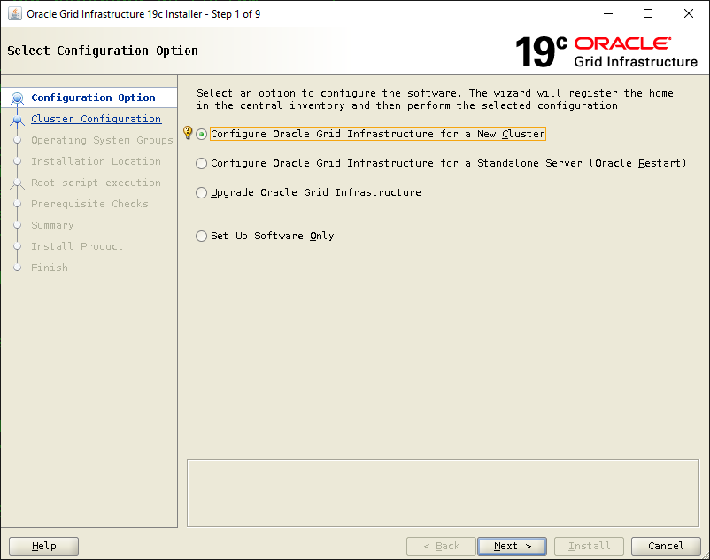

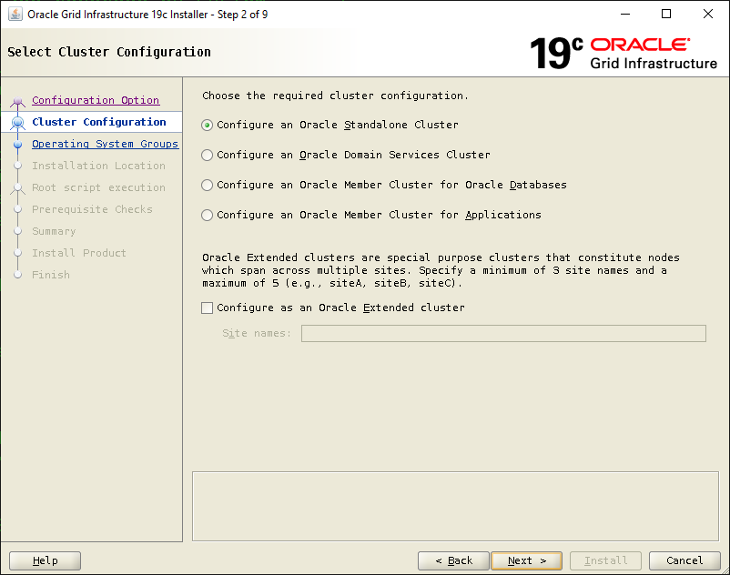

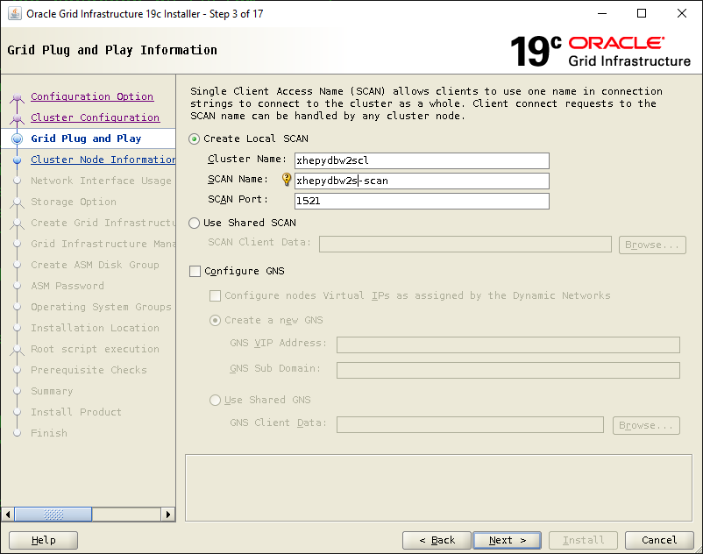

Click Add

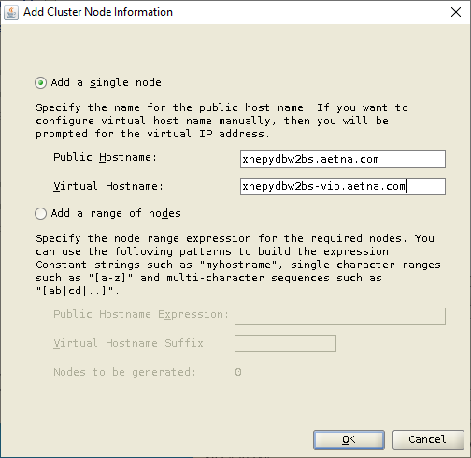

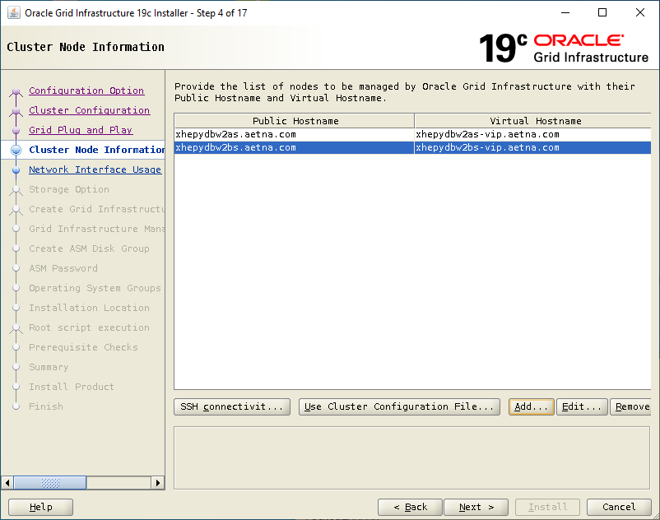

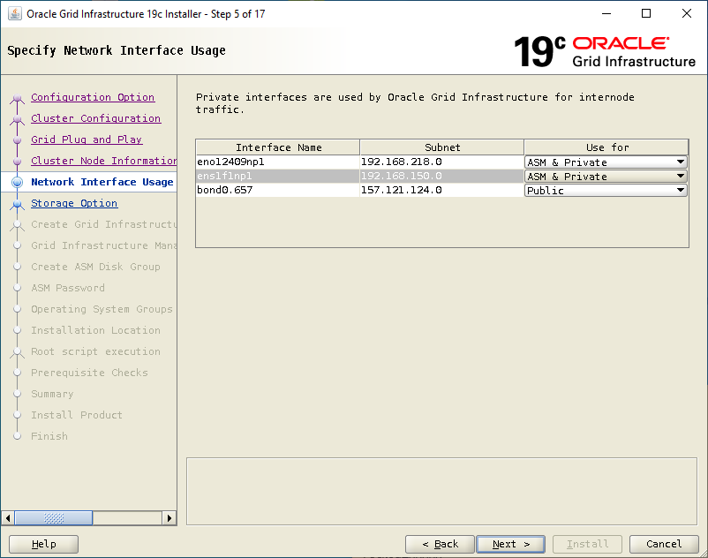

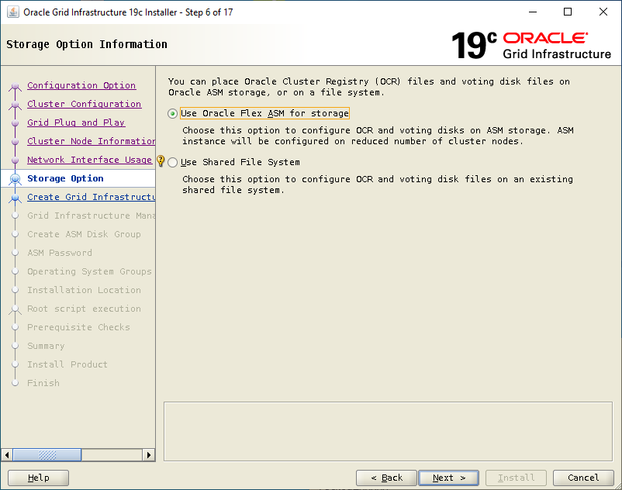

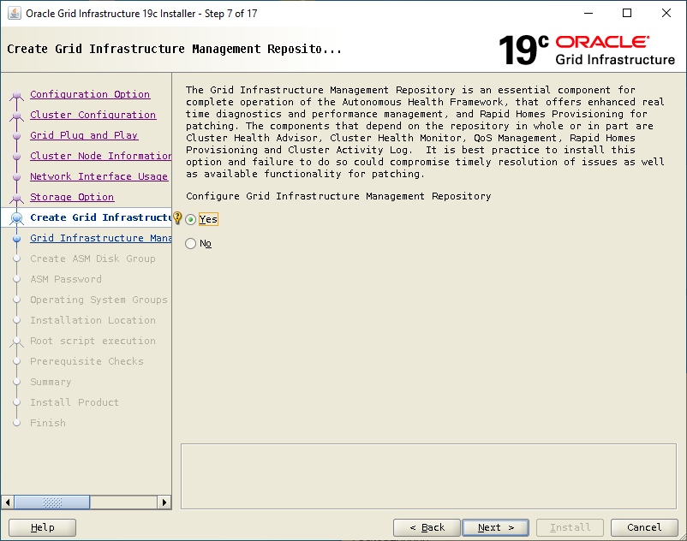

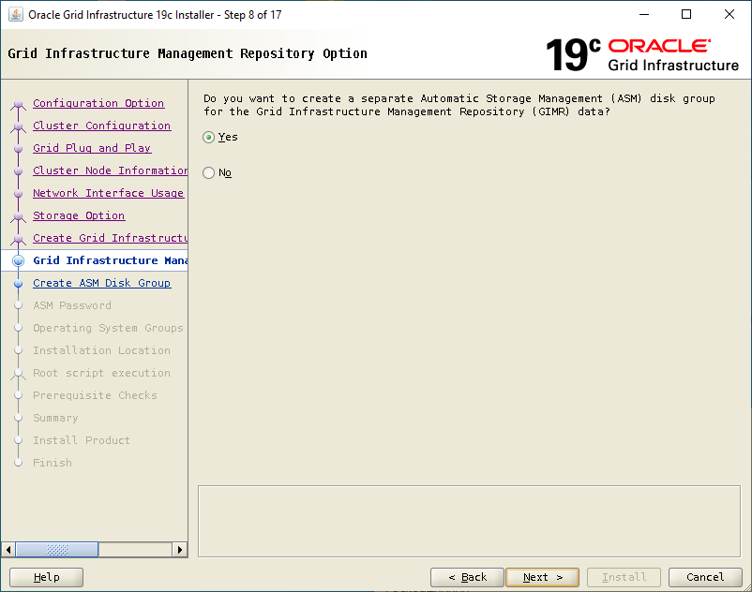

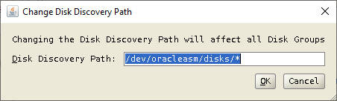

Disk Group: crsconfig

Check ASMCL001 through ASMCL006

Allocation Unit: 4 M

Select External

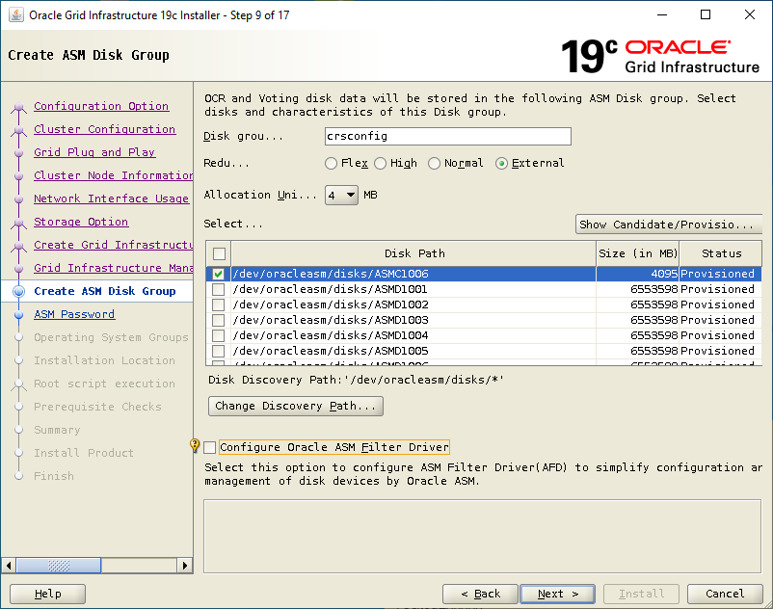

Disk Group: MGMTREPO

Check ASMMR101 and ASMMR102

Allocation Unit: 4 M

Select External

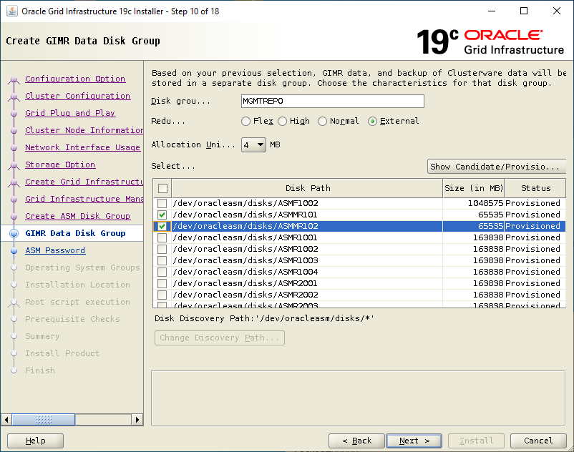

Use following P..: ASMPWD#1

Ignore warning for not strong P…

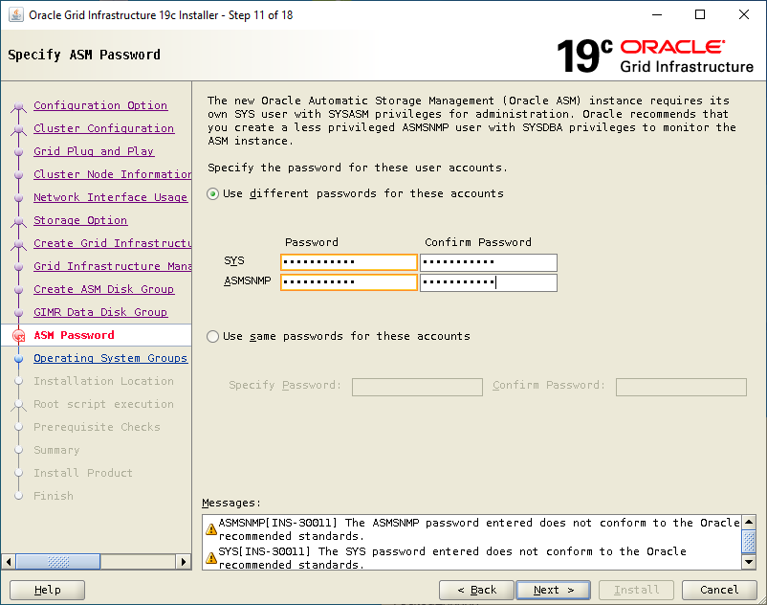

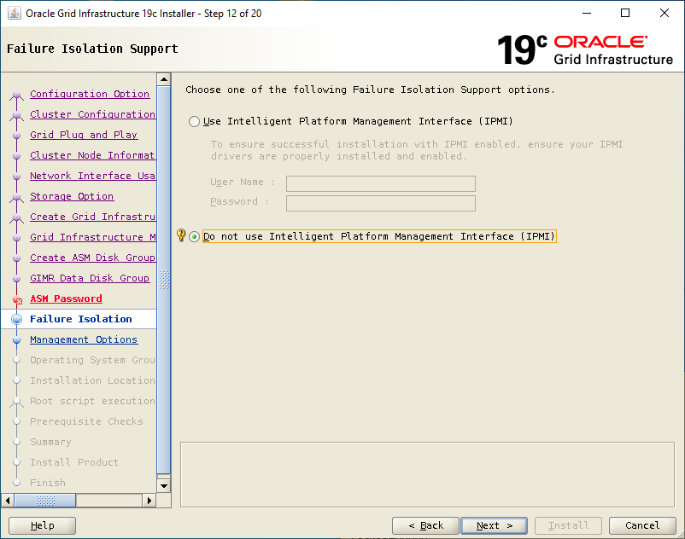

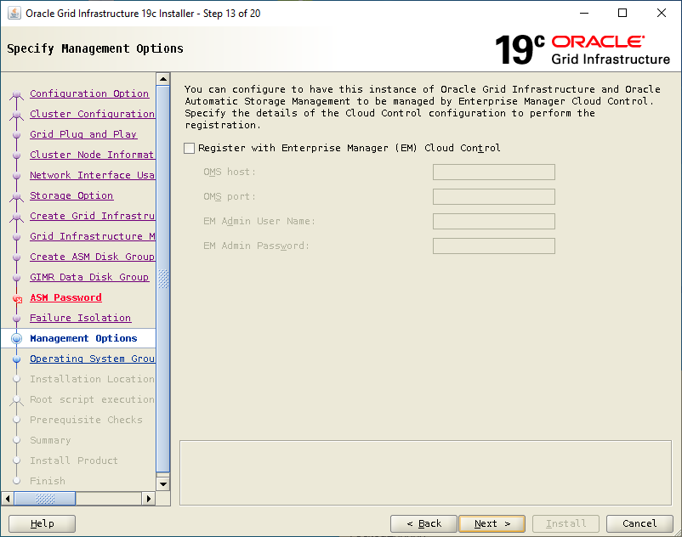

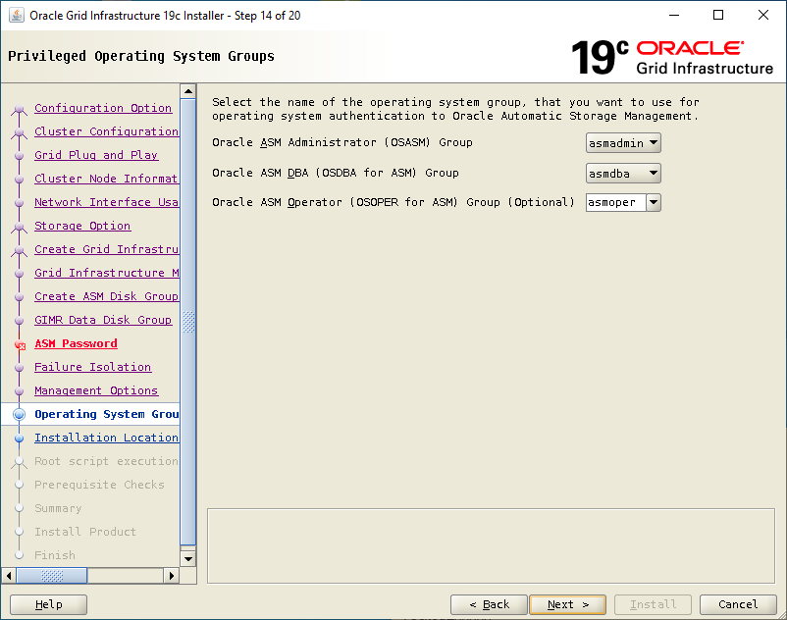

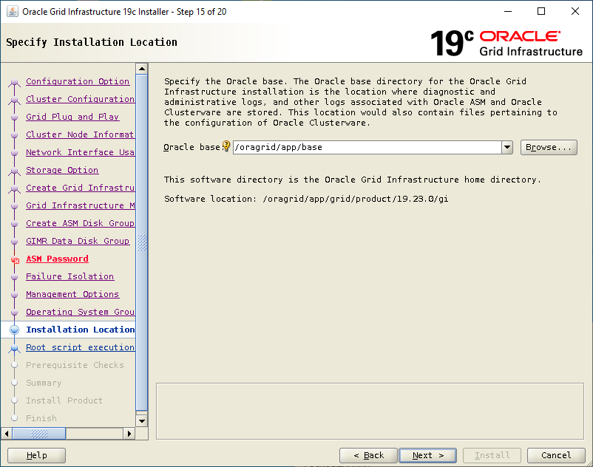

On B server (if dir already there remove it)

cd /oragrid/app/grid/product

ls

19.23.0

rm -rf 19.23.0

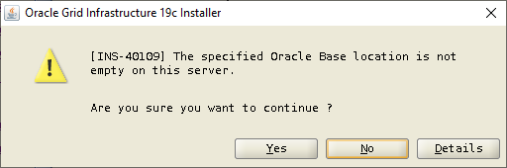

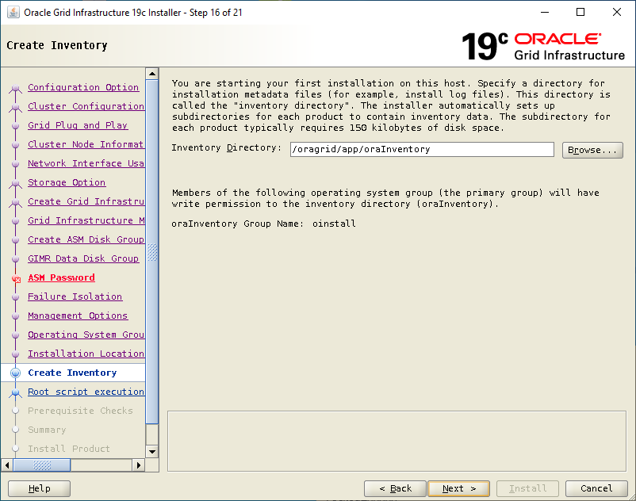

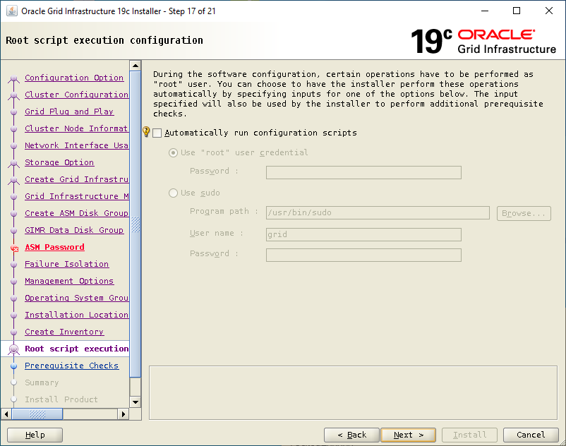

Select Ignore All if nothing else

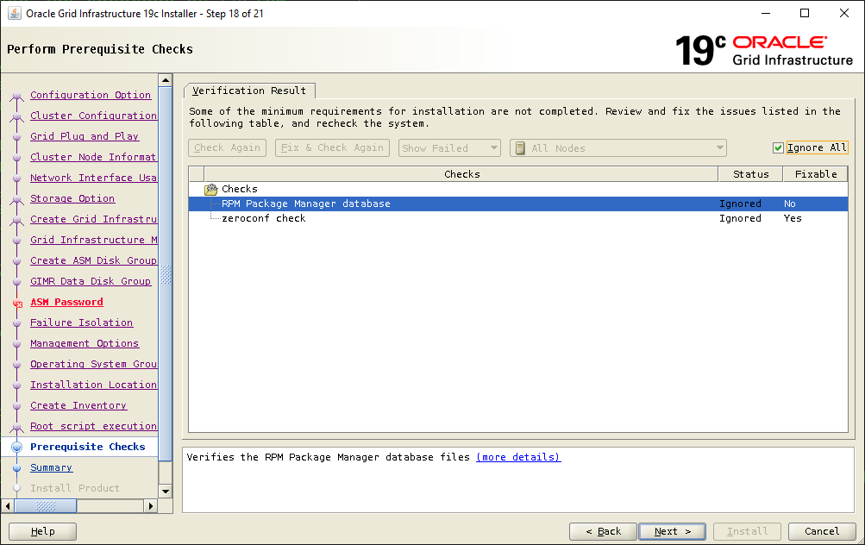

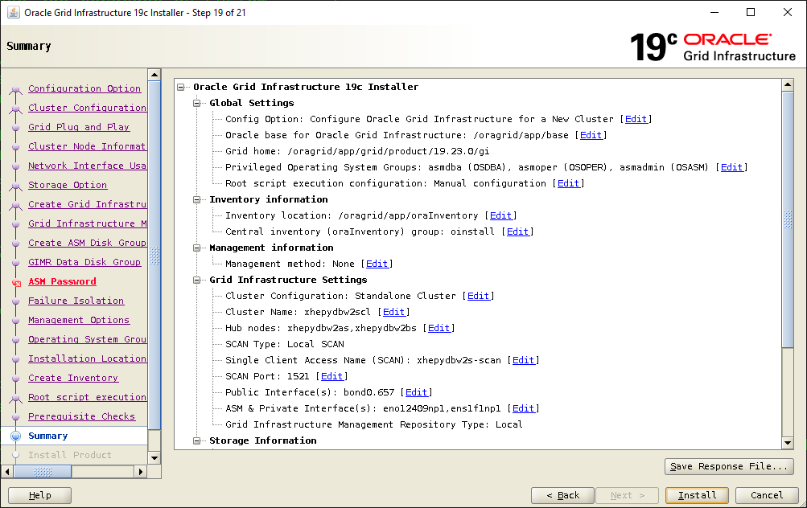

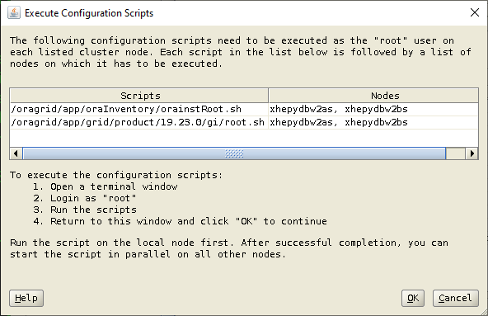

Take defaults and No to overwrite oraenv

Also specify to run scripts on NodeA first and then on NodeB

Check log on both Nodes after Linux Admin competes them

  /oragrid/app/base/crsdata/<ServerName>/crsconfig

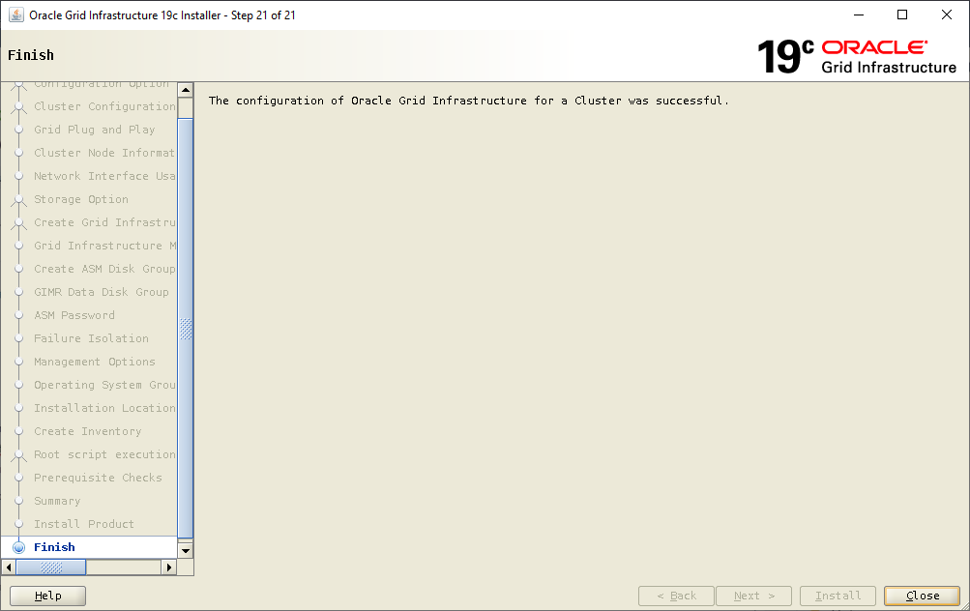

**\*\*\*\*\*\*\*\*\*\*\*\*\*\*\*\*\*\*\* If above install failed or need to uninstall for whatever reason \*\*\*\*\*\***

Have Unix Amin run those under root

On NodeB first

perl /oragrid/app/grid/product/19.23.0/gi/crs/install/rootcrs.pl -verbose -deconfig -force

On NodeA after

perl /oragrid/app/grid/product/19.23.0/gi/crs/install/rootcrs.pl -verbose -deconfig -force -lastnode

Remove Grid Home on both Nodes after.